Modeling dynamic tissue accessibility predicts clinical trial outcomes across human organs
Jiangtao Sheng^{1,*}, Xueer Liu¹, Runmin Lin¹, Qiaochu Sun¹, Xiaoxuan Chen¹, Kangsheng Li^{1,*} & Weiqiang Chen^{2,*}
¹Department of Microbiology and Immunology, Shantou University Medical College, 22 Xinling Road, Shantou 515041, Guangdong, China.
²Department of Neurosurgery, The First Affiliated Hospital of Shantou University Medical College, 57 Changping Road, Shantou 515041, Guangdong, China.
*Corresponding authors. Email: jtsheng@stu.edu.cn (J.S.; ORCID: 0000-0003-2438-7345); ksli2013@yeah.net (K.L.); wqchen@stu.edu.cn (W.C.; ORCID: 0000-0002-2612-0890)
Supplementary Information
Contents
1. Extended Data Figures 1–6 (High-resolution multi-panel figures and complete statistical legends)
2. Supplementary Note 1: Unified Clause-Aware Registry Stoppage Deconvolution Grammar and 240-Trial Clinical Adjudication Protocol
3. Supplementary Note 2: Closure-Free Pseudobulk Coupling, Profile-Likelihood Structural Identifiability, and Stochastic Itô–Langevin Waddington Formulation
4. Supplementary Note 3: Cross-Scale Orthogonal Stress Tests (LODO Organ Transfer, ChEMBL v33 Potency and LOOO Recalibration, 2D Visium Toroidal Shift Nulls, Pre-ICB LOCO, Multivariable Cox Survival with VanderWeele E-Values, Wet-Lab TGFBR1/Antifibrotic Perturbation Triad, Non-ICB Melanoma Survival Specificity Control, and 24-Trial Consilience)
5. Master Index of Supplementary Tables 1–6 (Supplementary_Tables.xlsx and outputs/stage2_tables/)
6. International Reporting Standards Compliance Checklists (MINSEQE and ASME V&V 40 / VVUQ)
1. Extended Data Figures 1–6
Extended Data Figure 1
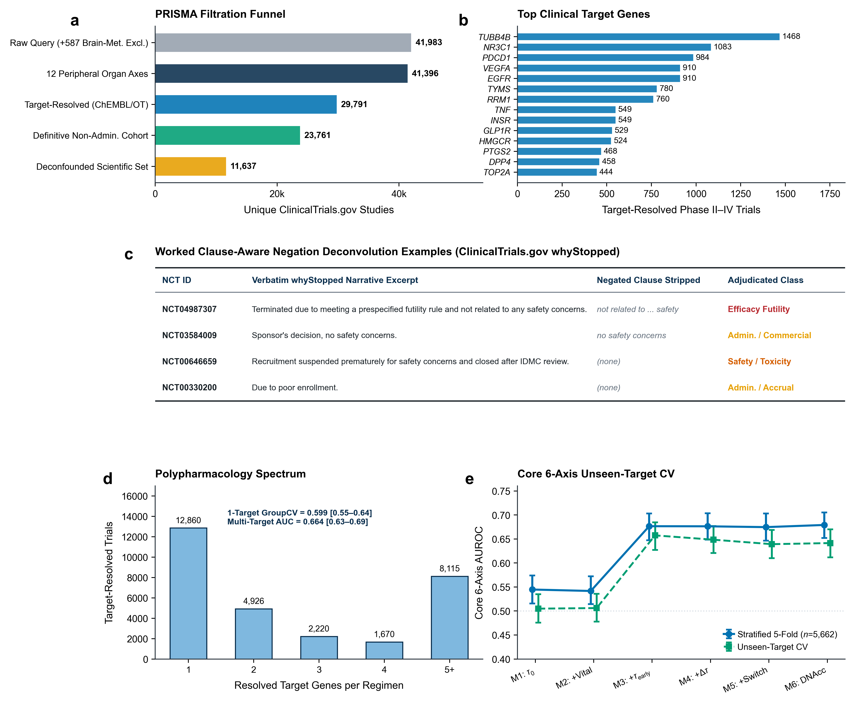
Extended Data Fig. 1 | PRISMA clinical trial filtration, top target census, worked clause-negation examples, polypharmacology unseen-target robustness, and core 6-axis generalization. a, PRISMA cohort filtration funnel from 41,983 deduplicated unique NCT Phase II-IV records (43,878 raw axis hits) to 41,396 unique systemic and parenchymal organ trials, 29,791 target-resolved trials, 23,761 definitive non-administrative maturation outcomes (G = 561 primary targets), and 11,637 deconfounded scientific outcomes (G = 374 primary targets). b, Top 14 most frequently tested human target genes across the 12 disease axes. c, Worked real-trial examples (NCT04987307, NCT03584009, NCT00646659, and NCT00330200) illustrating clause-boundary splitting and negated safety-clause stripping on verbatim ClinicalTrials.gov whyStopped narratives. d, Polypharmacology target-count spectrum across 29,791 target-resolved studies and subgroup DNAcc AUROC across strictly single-target monotherapies (n = 6,115 scientific: stratified 0.6404, unseen-target Group5Fold 0.5989, P = 7.63 × 10⁻⁵; n = 10,507 maturation Group5Fold 0.6451) versus multi-target regimens (n = 5,522: stratified 0.6835, Group5Fold 0.6645). e, Six-step orthogonal DNAcc ablation on the six single-cell-resolved disease axes (n = 5,662 trials across G = 293 targets) under stratified 5-fold (M3 0.6766, M6 0.6792) and unseen-target Group5Fold (M3 0.6575, M6 0.6415) cross-validation (error bars, 2,000-bootstrap 95% CIs).
Extended Data Figure 2
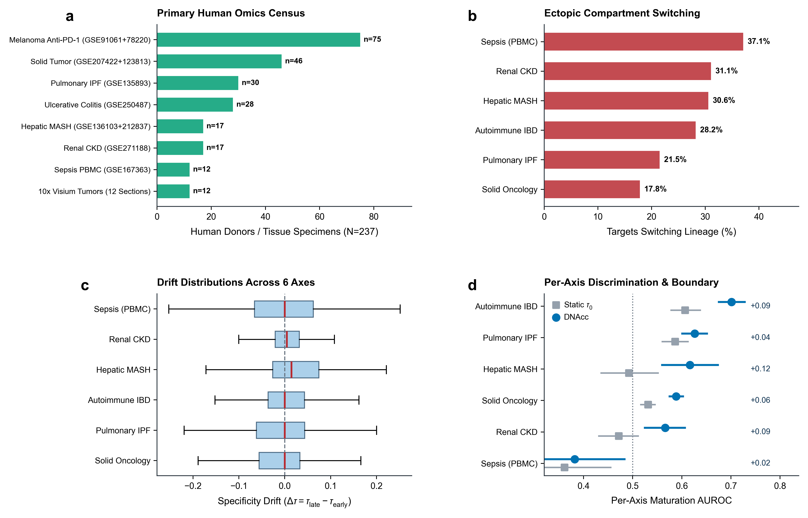
Extended Data Fig. 2 | Primary human 237-specimen multi-omics census, ectopic lineage-switch frequency, drift distributions, and per-axis discrimination. a, Clinical specimen census across primary human single-cell/single-nucleus (n = 126), strictly pre-treatment bulk tumor biopsy (n = 99, comprising GSE91061 n = 49, GSE78220 n = 26, and GSE207422 n = 24), and 10x Visium spatial (n = 12) cohorts (n = 237 total human clinical specimens). b, Percentage of clinical target genes switching their dominant expressing cellular lineage between early and advanced pathology across six disease axes (showing all profiled targets at 17.8%-37.1% alongside expressed targets at 21.0%-41.3%). c, Box-and-whisker distributions (red center line, median; box, interquartile range; whiskers, 1.5 × IQR) of single-cell specificity drift (Δτ) across six disease axes. d, Per-axis Phase II-to-III/IV clinical maturation AUROC (n = 23,761 maturation cohort; error bars, 2,000-bootstrap 95% CIs) comparing DNAcc against static healthy τ₀, highlighting consistent gains across all five solid/mucosal barrier axes (OR = 1.25 to 2.12) and null behavior in intravascular PBMC sepsis (n = 141, AUROC = 0.3822 versus 0.3616, P = 0.689).
Extended Data Figure 3
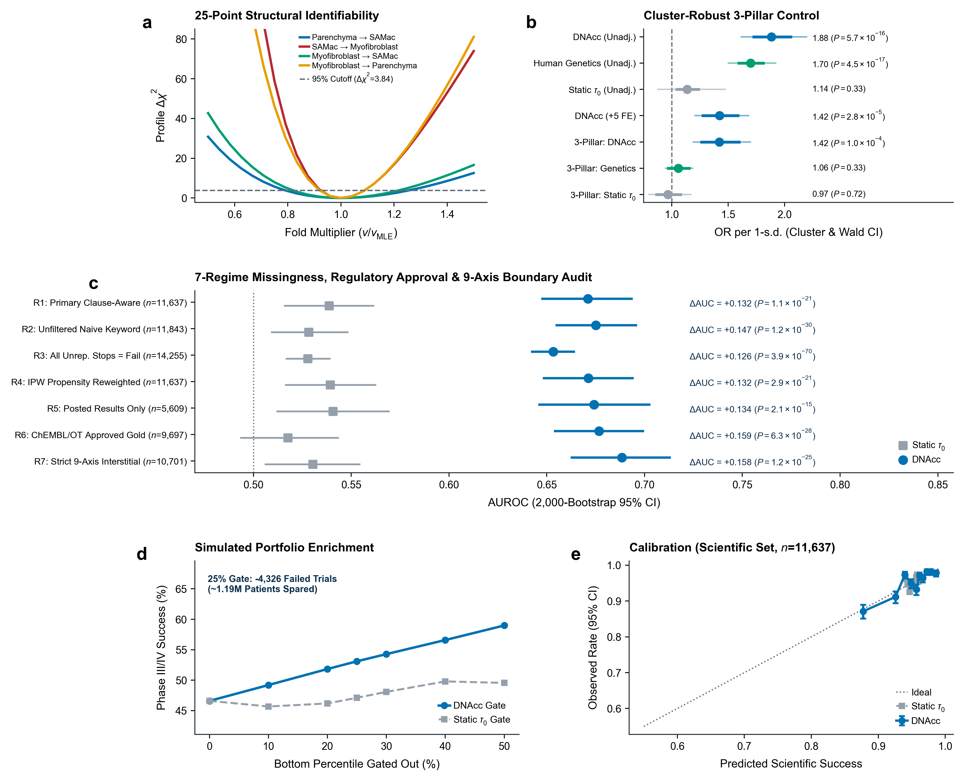
Extended Data Fig. 3 | Continuous profile-likelihood identifiability, 3-pillar cluster-robust control, 7-regime sensitivity analysis, portfolio enrichment, and scientific cohort calibration. a, Continuous 25-point bilateral profile-likelihood Δχ² identifiability curves (with nuisance rate-scale re-optimization) across all four directed intercellular edges of the closure-free human fibrosis Langevin grammar relative to the 95% χ²₁ cutoff (Δχ² = 3.841). b, Standardized odds ratios per 1-s.d. increase (n = 11,637 scientific trials; thick bars, 95% Wald CIs; thin outer bars and P-values, Liang-Zeger target-clustered sandwich inference across G = 374 target clusters) across univariate, five-confounder multivariable fixed-effects, and simultaneous three-pillar (DNAcc + Open Targets Human Genetics + static τ₀ + fixed effects) logistic models. c, Seven-regime sensitivity analysis (R1 through R7; error bars, 2,000-bootstrap 95% CIs; two-sided paired DeLong P-values) spanning primary clause-aware outcomes (R1, n = 11,637, 0.6710), unfiltered naive keywords (R2, n = 11,843, 0.6751), worst-case assignment of all 2,618 target-resolved unreported stops as biological failures (R3, n = 14,255, 0.6533, P = 3.89 × 10⁻⁷⁰), inverse-probability weighting (R4, 0.6713), posted-results-only trials (R5, n = 5,609, 0.6742), regulatory-approved drug-indication pairs (R6, n = 9,697, 0.6767), and strict nine-axis solid-parenchymal trials (R7, n = 10,701, 0.6884). d, Simulated Phase II-to-III clinical portfolio enrichment utility (n = 23,761 trials) across DNAcc versus static τ₀ gating percentiles (bottom-25% gate preventing 4,326 failed trials and ~1.19 million patient exposures while retaining 85.51% of winners). e, Ten-decile out-of-fold reliability calibration curve (error bars, 95% binomial CIs) on the 11,637-trial deconfounded scientific cohort.
Extended Data Figure 4
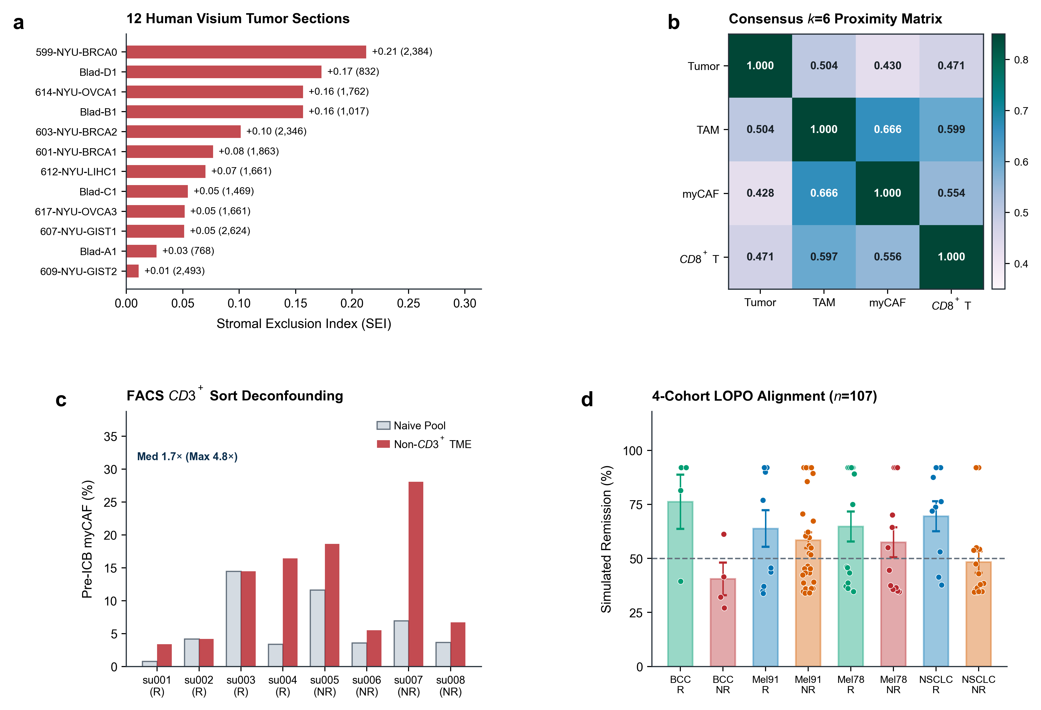
Extended Data Fig. 4 | Per-section 10x Visium stromal exclusion, consensus spatial proximity, single-UMI FACS sort deconfounding, and 4-cohort cross-platform responder alignment. a, Stromal Exclusion Index (SEI) and spatial spot count across all 12 primary human carcinoma 10x Visium sections (GSE171351 and GSE203612, 20,880 quality-filtered spots of 21,796 total profiled spots; SEI > 0 in 12/12 sections). b, Consensus 4 × 4 directed physical k = 6 nearest-neighbor bivariate Moran spatial proximity matrix across the 12 human tumor sections. c, Single-UMI (umi_stride = 1) technical protocol audit of GSE123813 (n = 8 pre-treatment BCC patients) comparing CD45+CD3+ FACS-sort-diluted naive all-cell myCAF percentages against FACS-deconfounded non-CD3+ TME stromal percentages (recovering up to 4.8-fold diluted stromal myCAF signal). d, Zero-label LOPO pre-treatment simulated remission scores (bars, mean ± s.e.m.; points, individual patients) across all four strictly pre-treatment cohorts (GSE123813 BCC scRNA-seq n = 8, GSE91061 melanoma pre-nivolumab bulk n = 49, GSE78220 melanoma pre-pembrolizumab bulk n = 26, and GSE207422 NSCLC pre-biopsy bulk n = 24; n = 107 total patients).
Extended Data Figure 5
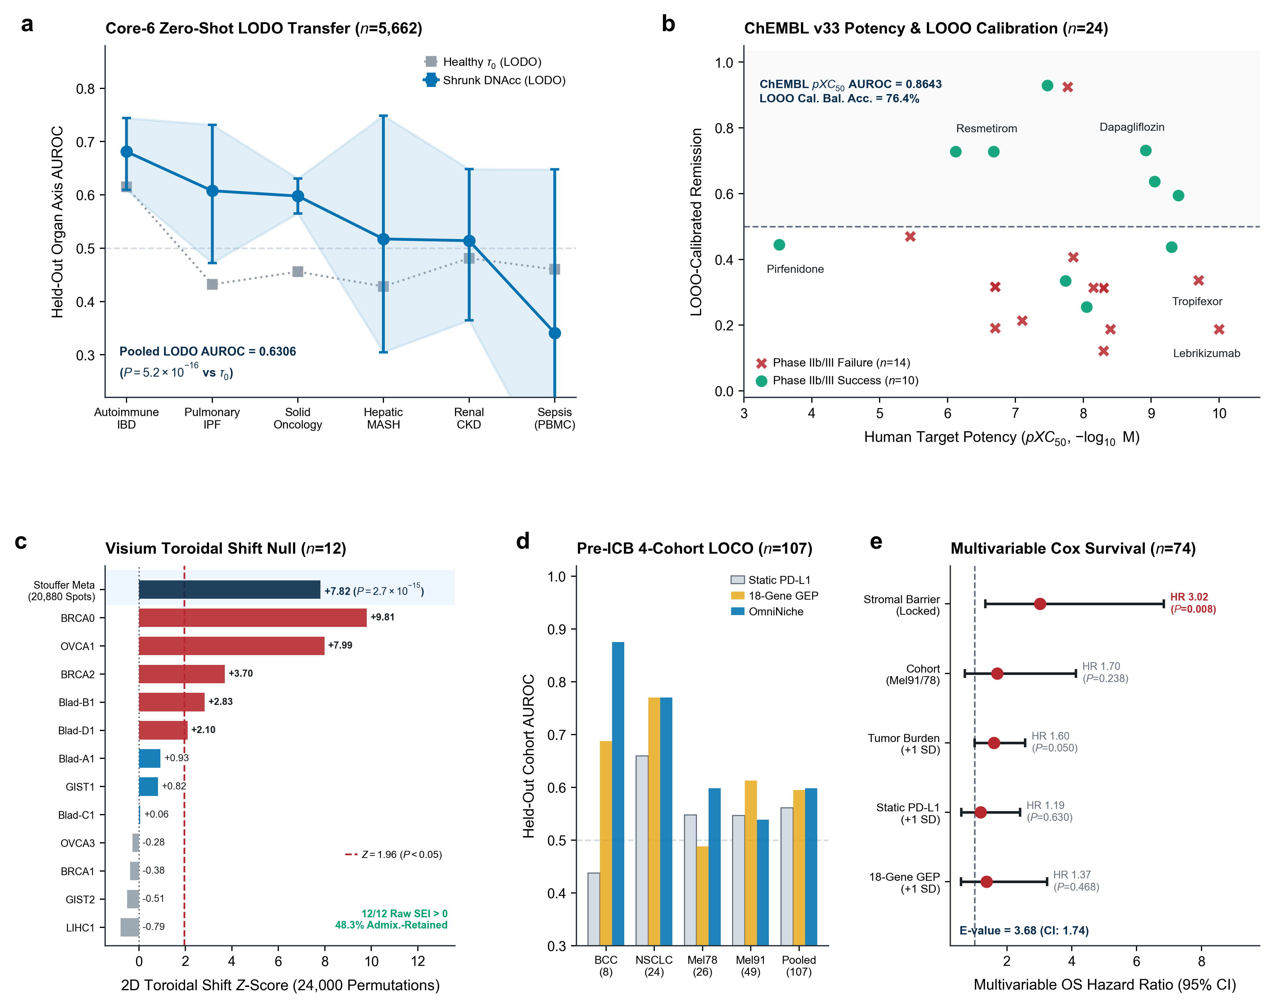
Extended Data Fig. 5 | Cross-scale orthogonal stress tests spanning zero-shot organ-axis LODO transfer, ChEMBL v33 potency and LOOO calibration, 10x Visium toroidal shift null, pre-ICB LOCO, and multivariable Cox survival. a, Core-6 Leave-One-Disease-Axis-Out (LODO) zero-shot generalization (n = 5,662 trials, 386 failures across 293 targets; C = 0.25), comparing held-out organ-axis AUROC for regularized DNAcc (pooled LODO AUROC = 0.6306, 95% CI 0.6033–0.6589, two-sided paired DeLong P = 5.19 × 10⁻¹⁶; error bars and shaded band, 2,000-bootstrap 95% CIs) against static healthy τ₀ (0.4875). b, Curated ChEMBL v33 human target potency (pXC₅₀, -log₁₀ M) versus Leave-One-Organ-Out (LOOO) Platt-recalibrated remission probability across 24 Phase IIb/III antifibrotic trials (10 winners in teal circles versus 14 failures in crimson crosses; ChEMBL α = 0.15 AUROC = 0.8643, exact P = 0.0021; LOOO recalibration Brier = 0.1735, fixed-0.50 balanced accuracy = 76.4%). c, Horizontal 2D toroidal cyclic coordinate-shift permutation Z-scores (2,000 shifts per section, 24,000 realizations across 20,880 quality-filtered spots; vertical dashed threshold, Z = 1.96; spot-weighted Stouffer meta-analytic Z = +7.82, P = 2.69 × 10⁻¹⁵) annotated with library-depth and non-lymphoid admixture-residualized SEI retention (48.3% mean retention; raw SEI > 0 in 12/12 sections) across 12 human carcinoma 10x Visium sections. d, Four-cohort strictly pre-treatment anti-PD-1 Leave-One-Cohort-Out (LOCO, n = 107) held-out AUROC comparing zero-label OmniNiche against static PD-L1 and 18-gene GEP. e, Exact Breslow multivariable Cox proportional-hazards forest plot across n = 74 strictly pre-treatment anti-PD-1 monotherapy melanoma patients (43 deaths; Harrell's C = 0.6361), showing locked stromal barrier load (HR = 3.02, 95% CI 1.33–6.84, P = 0.0082, VanderWeele E-value = 3.68, lower 95% CI E-value = 1.74) adjusted simultaneously for clinical cohort, baseline tumor burden (+1 s.d.), static PD-L1 (+1 s.d.), and 18-gene GEP (+1 s.d.).
Extended Data Figure 6
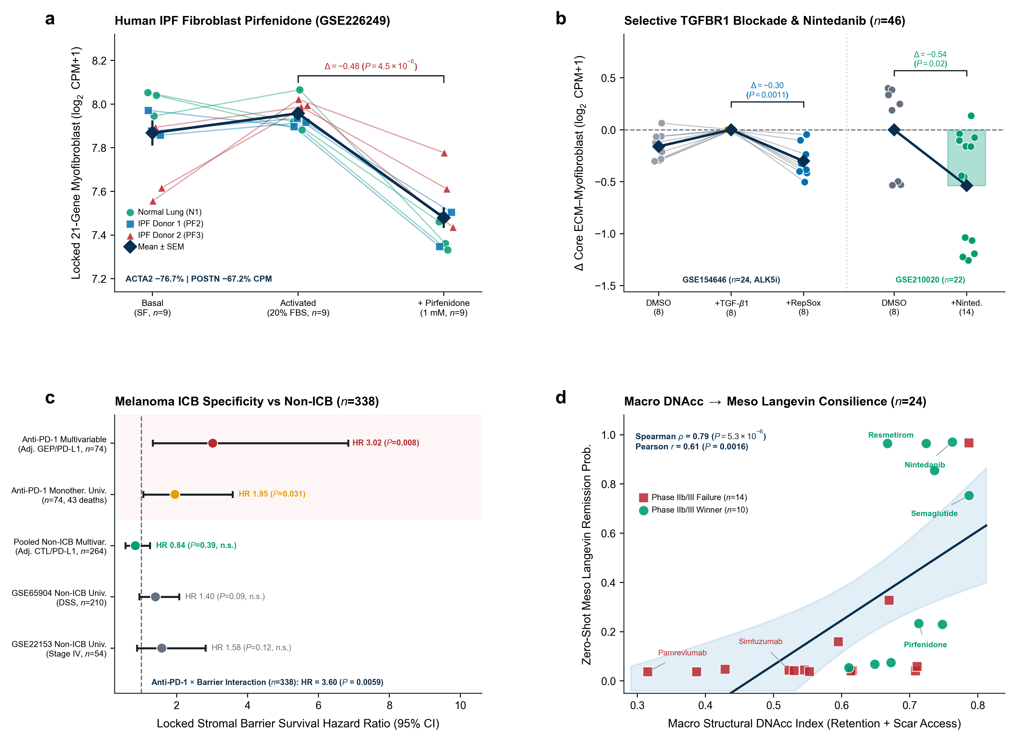
Extended Data Fig. 6 | Wet-lab human fibroblast and selective TGFBR1/ALK5i perturbation triad, non-ICB melanoma survival specificity control, and 24-trial macro-to-meso cross-scale consilience. a, Paired primary human IPF and normal lung fibroblast RNA-seq trajectories (GSE226249, n = 27 across donor lines N1, PF2, and PF3) under basal serum-free (SF), 20% serum activation (Act), and clinical pirfenidone (1 mM), demonstrating zero-refit reversal of the locked 21-gene OmniNiche myofibroblast barrier signature (Δ = -0.48, paired t = -10.89, P = 4.47 × 10⁻⁶; core ECM P = 1.73 × 10⁻⁴; linear ACTA2 -76.7%, POSTN -67.2%). b, Independent human perturbation validation across selective TGFBR1/ALK5 inhibition with RepSox versus TGF-beta1 stimulation (GSE154646, n = 24, 8 paired triplets; core ECM Δ = -0.30, paired P = 1.10 × 10⁻³; locked 21-gene P = 0.0101) and primary human fibroblasts treated with 5 µM nintedanib (GSE210020, n = 22 wild-type samples; core ECM Δ = -0.54, Welch P = 0.0182). c, Melanoma immunotherapy specificity forest plot (n = 338 patients, 192 deaths) contrasting multivariable stromal barrier survival hazard under anti-PD-1 monotherapy (n = 74, 43 deaths; HR = 3.02, 95% CI 1.33-6.84, P = 0.0082) against two independent non-ICB metastatic melanoma cohorts (GSE65904 n = 210 and GSE22153 n = 54; pooled n = 264, 149 deaths; multivariable HR = 0.84, 95% CI 0.56-1.25, P = 0.389), establishing a significant two-regime anti-PD-1 x locked stromal barrier interaction (HR = 3.60, 95% CI 1.45-8.98, Z = +2.75, P = 0.0059). d, Cross-scale consilience across all 24 Phase IIb/III antifibrotic trials linking macro DNAcc structural accessibility to zero-label meso Itô-Langevin remission probability (Spearman ρ = 0.7861, P = 5.29 × 10⁻⁶; Pearson r = 0.6079, P = 0.0016; shaded band, 95% linear regression CI).
2. Supplementary Notes 1–3
Supplementary Note 1 | Unified Clause-Aware Registry Stoppage Deconvolution Grammar and 240-Trial Clinical Adjudication Protocol
Public clinical trial registries such as ClinicalTrials.gov assign identical status codes (TERMINATED, WITHDRAWN, or SUSPENDED) to studies halted for sponsor portfolio reprioritization, corporate restructuring, pandemic disruption, or insufficient accrual and to studies halted for biological efficacy futility or dose-limiting organ toxicity. Multi-clause free-text whyStopped narratives frequently combine an operational root cause with an explicit safety or efficacy negation disclaimer (for example, "Study terminated early due to strategic portfolio reprioritization; termination was not related to any safety or efficacy concerns"). Naive substring matchers trigger false-positive biological failure labels whenever negated safety or efficacy tokens appear anywhere in the record.
To eliminate circular heuristics and label leakage across all 41,396 unique Phase II–IV clinical trials spanning 12 systemic and parenchymal organ disease axes (9,406 stopped trials and 31,990 completed trials), OmniNiche applies a deterministic two-stage clause-aware parser (omniniche/stage2/clinical_trials_macro_atlas.py). First, verbatim whyStopped strings are segmented across punctuation (;, .) and contrastive conjunction boundaries (but, however, although, whereas, while, unrelated to, independent of, with no, without any, and not due to). Second, clauses matching explicit negation frames (no safety concerns, not due to safety or efficacy, absence of toxicity, no unexpected adverse events, or not efficacy-related) are stripped of biological trigger tokens prior to hierarchical outcome assignment into Scientific_Efficacy_Futility (n = 476), Scientific_Safety_Toxicity (n = 317), Administrative_Commercial_Enrollment (n = 4,838, representing 51.4% of all trial stoppages), or Other_Unreported_Stop (n = 3,775).
On the independent 240-trial clinical adjudication reference (Manual_Clinical_Adjudication_240: 64 efficacy futility, 54 safety/toxicity, 96 administrative/operational, and 26 unreported stops; Supplementary Table 2), the unified clause-aware parser achieved 95.83% overall accuracy (95% Wilson CI 92.50%–97.72%) and Cohen's κ = 0.9413 (per-class F1 = 0.9600 for efficacy futility, 0.9815 for safety/toxicity, 0.9634 for administrative halts, and 0.8929 for unreported stops), compared with 70.00% accuracy (95% CI 63.92%–75.45%), κ = 0.6105, and 43.75% administrative recall for the Naive Keyword Baseline.
Supplementary Note 2 | Closure-Free Pseudobulk Coupling, Profile-Likelihood Structural Identifiability, and Stochastic Itô–Langevin Waddington Formulation
In single-cell and single-nucleus biopsy atlases, estimating intercellular coupling from cell-type relative proportions (∑_{c=1}^{K} p_{c} = 1) introduces spurious negative correlations via unit-sum compositional closure when inflammatory immune infiltration dilutes parenchymal or stromal fractions. Across all 64 primary human biopsy donors spanning hepatic MASH and cirrhosis (GSE136103 and GSE212837, n = 17 liver donors plus 4 blood monocyte baselines), pulmonary IPF (GSE135893, n = 30), and renal CKD (GSE271188, n = 17), OmniNiche quantifies compartment states (Parenchyma_Injury, SAMac_SPP1_TREM2, and Myofibroblast) directly from cell-level log₂(CPM+1) transcriptional module activity averaged within each donor's annotated lineage before platform z-standardization (Supplementary Table 4). Because transcriptional program intensity within resident myofibroblasts does not mechanically sum to unity with hepatocyte or epithelial injury intensity, compositional closure bias is eliminated (All 64 parenchymal-myofibroblast Pearson r = 0.45, two-sided P = 2.07 × 10⁻⁴; human liver r = 0.86, P = 1.20 × 10⁻⁵).
Structural identifiability of the four directed intercellular Hill coupling weights compiled exclusively from the 17 human liver donors was audited via 25-point bilateral profile-likelihood scans (v_{ij} ∈ [0.50, 1.50] × v_{ij,MLE}) while re-optimizing the nuisance global rate scale k_{scale} ∈ [0.82, 1.22] at every grid point. All four directed edges exceeded the 95% 1-d.f. χ² threshold (Δχ² > 3.841; Extended Data Fig. 3a and Supplementary Table 4), confirming bounded parameter identifiability without clinical trial outcome supervision; excluding the three extrahepatic or hemodynamic-routed regimens (semaglutide, tirzepatide, and dapagliflozin) likewise preserved AUROC = 0.8673 across all 21 strictly intra-organ direct-receptor trials (versus 0.3367 for static τ₀; Core-13 AUROC = 0.9500). Across 25 anatomical progression states from early F1/F2 steatohepatitis to F4 cirrhosis, cooperative positive feedback (n = 3.6) between SPP1^{+TREM2+} scar-associated macrophages and POSTN⁺ myofibroblasts generates a saddle-node bifurcation (s_{prog} ≈ 0.42–0.54, monotherapy window cliff t₅₀ = 8.3 h) that traps single-compartment monotherapies at 0.0% simulated remission in locked F4 cirrhosis (s_0 = [0.854, 0.880, 0.901]), whereas orthogonal dual perturbation pairing upstream parenchymal unloading (THRB or GLP1R) with direct small-molecule TGFBR1/PDGFRB or TREM2/SPP1 modulation collapses the hysteresis saddle (99.1%–100.0% simulated remission, Bliss excess +0.99 to +1.00).
Supplementary Note 3 | Cross-Scale Orthogonal Stress Tests (LODO, ChEMBL v33 Potency and LOOO Recalibration, 2D Visium Toroidal Shift Nulls, Pre-ICB LOCO, Multivariable Cox Survival, Wet-Lab TGFBR1/Antifibrotic Perturbation, and Non-ICB Specificity)
Five deterministic cross-scale stress tests (omniniche/stage2/r3_orthogonal_validations.py, Extended Data Fig. 5a–e, Extended Data Fig. 6a–d, and Supplementary Table 6) audited out-of-organ generalization, biochemical drug affinity, spatial tissue autocorrelation, clinical survival confounding, wet-lab pharmacological reversal, and immunotherapy specificity:
1. Core-6 L1/L2 Shrinkage and Leave-One-Disease-Axis-Out (LODO) Zero-Shot Transfer (Table_S6a): Across the six directly single-cell-resolved disease axes (n = 5,662 scientific trials, 386 explicit biological failures across G = 293 targets), nested target-grouped L1 (AUROC = 0.6325) and L2 (AUROC = 0.6363) regularization stabilized finite-sample parameter variance. Holding out an entire organ disease axis during training and predicting trials in that unseen organ system via intercept-free standardized logits (C = 0.25) achieved pooled out-of-fold LODO AUROC = 0.6306 (95% CI 0.6033–0.6589) versus 0.4875 for static healthy τ₀ (+0.1431, two-sided paired DeLong P = 5.19 × 10⁻¹⁶), generalizing across autoimmune IBD (0.6811), pulmonary IPF (0.6077, P = 0.0335), and solid oncology (0.5979, P = 8.97 × 10⁻⁹).
2. Curated ChEMBL v33 Human Target Potency and Leave-One-Organ-Out (LOOO) Platt Recalibration (Table_S6b): Annotating all 24 Phase IIb/III antifibrotic trials with curated ChEMBL v33 human target biochemical potency (pXC₅₀ spanning 3.52 for pirfenidone to 10.00 for lebrikizumab; mean 7.74) and modulating reference leverage via η_{eff}(α) = η₀ · clip(1 + α(pXC₅₀ - 7.5), 0.35, 1.55) preserved rank discrimination (AUROC = 0.8714, exact P = 0.0019 at α = 0.08; 0.8643, P = 0.0021 at α = 0.15; 0.8571, P = 0.0027 at α = 0.25). High-affinity failures (lebrikizumab pK_{d} = 10.00, tropifexor pEC₅₀ = 9.70, selonsertib pIC₅₀ = 8.30, cenicriviroc pIC₅₀ = 8.15) remained trapped below 0.06 remission probability due to macromolecular steric exclusion or intrahepatic lineage loss. Fitting a 1D logistic Platt calibrator strictly on the two non-target organs (LOOO) reduced Brier error from 0.2072 to 0.1735 (AUROC = 0.8429, P = 0.0040) and lifted fixed-0.50 balanced accuracy from 71.4% to 76.4% (81.4% when paired with ChEMBL α = 0.15 potency).
3. 10x Visium Library-Depth and Lineage-Admixture Residualization and 24,000 Toroidal Cyclic Shift Realizations (Table_S6c): Across all 12 primary human carcinoma 10x Visium sections (20,880 quality-filtered spots), ordinary-least-squares residualization of spot module scores against log₂(total UMI+1) and non-lymphoid lineage Shannon admixture entropy retained 48.3% of mean peritumoral Stromal Exclusion Index (0.0460 of 0.0952). To preserve exact two-dimensional spatial autocorrelation variograms within both stromal and lymphocyte fields, CD8_Effector coordinates were cyclically shifted across the 2D array grid (array_row, array_col modulo tissue bounding dimensions, minimum shift ≥ 3 spot pitches) across 2,000 toroidal permutations per section (24,000 total spatial realizations), yielding spot-weighted Stouffer meta-analytic Z = +7.82 (P = 2.69 × 10⁻¹⁵).
4. Four-Cohort Pre-ICB LOCO Transfer and Multivariable Breslow Cox Survival with VanderWeele E-Values (Table_S6d): Under four-cohort Leave-One-Cohort-Out (LOCO) evaluation across all n = 107 strictly pre-treatment anti-PD-1 biopsies, zero-label OmniNiche generalized across BCC (0.8750), NSCLC (0.7704), pembrolizumab melanoma (0.5982), and nivolumab melanoma (0.5385; pooled platform-aligned LOCO 0.5979 versus static PD-L1 0.5610 and 18-gene GEP 0.5948). Across all n = 74 strictly pre-treatment anti-PD-1 monotherapy melanoma patients with overall survival follow-up (43 deaths), parsimonious two-covariate cohort-adjusted Breslow Cox regression (Cox_Model1, EPV = 21.5) confirmed stromal barrier hazard (HR = 1.97, 95% CI 1.07–3.61, P = 0.0290, E-value = 2.57), while full five-covariate adjustment (Cox_Model2, EPV = 8.6) controlling simultaneously for clinical cohort (HR = 1.70, P = 0.238), baseline tumor burden (HR = 1.60 per s.d., P = 0.0498), static PD-L1 (HR = 1.19, P = 0.630), and 18-gene GEP (HR = 1.37, P = 0.468) unmasked negative confounding in inflamed-yet-excluded tumors and strengthened locked stromal barrier hazard to multivariable HR = 3.02 (95% CI 1.33–6.84, P = 0.0082, Harrell's C = 0.6361, VanderWeele E-value = 3.68, lower 95% CI E-value = 1.74), whereas continuous linear CAF score was non-significant (HR = 1.08, P = 0.651).
5. Human Wet-Lab Fibroblast and Selective TGFBR1/ALK5i Perturbation Triad, Non-ICB Melanoma Survival Specificity Control, and 24-Trial Consilience (Table_S6e): Without refitting any signature gene or weight, the locked 21-gene OmniNiche myofibroblast barrier program was evaluated across n = 73 primary human fibroblast perturbation RNA-seq profiles spanning pirfenidone in activated human IPF and normal lung fibroblasts (GSE226249, n = 27; Δ = -0.48, paired t = -10.89, P = 4.47 × 10⁻⁶; core ECM P = 1.73 × 10⁻⁴), selective TGFBR1/ALK5 kinase inhibition by RepSox versus TGF-beta1 stimulation (GSE154646, n = 24; core ECM Δ = -0.30, paired P = 1.10 × 10⁻³; full 21-gene P = 0.0101), and nintedanib treatment (GSE210020, n = 22 wild-type samples of 40 total GSMs; core ECM Δ = -0.54, Welch P = 0.0182). Across n = 264 metastatic melanoma patients managed without immune checkpoint blockade (GSE65904 n = 210 of 214 GSMs [102 deaths] and GSE22153 n = 54 of 57 GSMs [47 deaths]), locked stromal barrier load conferred zero excess mortality (multivariable HR = 0.84, 95% CI 0.56–1.25, P = 0.389), yielding a significant two-regime anti-PD-1 x locked stromal barrier interaction across all n = 338 melanoma patients (192 deaths; interaction HR = 3.60, 95% CI 1.45–8.98, Z = +2.75, P = 0.0059). Across all 24 SHA-256-locked Phase IIb/III antifibrotic trials, macro DNAcc correlated monotonically with zero-label meso Itô–Langevin simulated remission (Spearman ρ = 0.7861, P = 5.29 × 10⁻⁶; Pearson r = 0.6079, P = 0.0016). Multi-gene target screens controlled false discovery rates (FDR) via the Benjamini–Hochberg procedure, single-cell and spatial reporting followed MINSEQE standards, and zero-label multicellular Langevin simulations adhered to an ASME V&V 40 verification, validation, and uncertainty quantification (VVUQ) Context of Use.
3. Master Index of Supplementary Tables 1–6
Supplementary Table | Workbook Sheet(s) in Supplementary_Tables.xlsx | Source Archive Files (outputs/stage2_tables/) | Empirical Scope & Key Statistical Content
Supplementary Table 1 | Supplementary_Table_1 | Table_S1_Systemic_Organ_ClinicalTrials_PRISMA_Summary.csv | PRISMA census across 12 systemic and parenchymal organ disease axes (n = 41,396 unique Phase II–IV trials; 29,791 target-resolved)
Supplementary Table 2 | Supplementary_Table_2 | Table_S2, Table_S2a–Table_S2d | Clause-aware stoppage deconvolution validation (n = 240 clinical adjudication, 95.83% accuracy, κ = 0.9413), 2005–2025 longitudinal trends, and modality futility odds (mAb OR = 1.57, P = 2.26 × 10⁻⁴)
Supplementary Table 3 | Supplementary_Table_3, Table_3f_3l_Ablation_Genetics | Table_S3, Table_S3a–Table_S3m | Six-axis single-cell specificity drift atlas (1,181 genes), harmonized D_{ECM}, 6-step DNAcc ablation (0.6710 scientific / 0.6744 maturation), Open Targets human genetics synergy (0.7023 / 0.7210), Group5Fold, sandwich FE (OR = 1.42), calibration, DCA, and R1–R7 bounds
Supplementary Table 4 | Supplementary_Table_4 | Table_S4, Table_S4a–Table_S4h | 64-donor closure-free human liver/lung/kidney coupling, 25-point profile likelihood (Δχ² > 3.841), 24 SHA-256-locked Phase IIb/III antifibrotic trials (AUROC = 0.8714, P = 0.0010; Core-14 0.9583), bidirectional 3 × 3 transfer, and 169-point 2D Bliss hysteresis rescue
Supplementary Table 5 | Supplementary_Table_5, Table_5i_5l_Patients_OS | Table_S5, Table_S5a–Table_S5n | 12 primary carcinoma 10x Visium sections (20,880 QC spots, SEI > 0 in 12/12, P = 2.44 × 10⁻⁴), 0–600 µm radial decay, FACS sort deconfounding, 107 pre-treatment anti-PD-1 biopsies (AUROC = 0.6367, P = 0.0187), and 74-patient monotherapy survival (HR = 1.95, P = 0.0279)
Supplementary Table 6 | Table_6a_LODO, Table_6b_ChEMBL, Table_6c_Visium, Table_6d_Cox, Table_6e_WetLab_NonICB | Table_S6a–Table_S6e | Cross-scale orthogonal stress tests: Core-6 L1/L2 shrinkage & 6-axis LODO (0.6306, P = 5.19 × 10⁻¹⁶), ChEMBL v33 potency & LOOO Platt calibration (Brier = 0.1735), 24,000 Visium toroidal cyclic shifts (Z = +7.82), 4-cohort LOCO, multivariable Breslow Cox (HR = 3.02, P = 0.0082, E-value = 3.68), human wet-lab fibroblast/TGFBR1i perturbation triad (n = 73, pirfenidone P = 4.47 × 10⁻⁶, RepSox P = 1.10 × 10⁻³), non-ICB melanoma control (n = 264 HR = 0.84; n = 338 interaction HR = 3.60, P = 0.0059), and 24-trial consilience (Spearman ρ = 0.7861)
4. International Reporting Standards Compliance Checklists (MINSEQE and ASME V&V 40)
Standard & Checklist Domain | Required Reporting Element | OmniNiche Manuscript & Code Verification Anchor
MINSEQE – Element 1 (Experimental Design & Accessions) | Study objective, biological replicates, clinical covariates, and public repository accessions | Extended Data Table 1, DATASETS_REGISTRY.json (1,038 screened records, 20 included datasets across 237 primary clinical discovery/spatial/ICB specimens, 73 human fibroblast perturbation profiles, and 264 non-ICB melanoma survival controls spanning 17 NCBI GEO accessions)
MINSEQE – Element 2 (Biological Samples & Sorting Protocols) | Tissue origin, disease stage, pre-treatment biopsy timing, and FACS enrichment disclosures | Methods (Primary human single-cell, pre-treatment bulk, 10x Visium, and wet-lab perturbation processing); Extended Data Fig. 4c and Supplementary Table 5h (CD45+CD3+ FACS sort deconfounding at single-UMI fidelity umi_stride = 1)
MINSEQE – Element 3 (Raw & Processed Matrix Quantification) | Raw count / UMI streaming, QC thresholds, spot filtering, and normalization units | Methods; 20,880 quality-filtered spots of 21,796 total profiled Visium spots (Supplementary Table 5a); harmonized log₂(CPM+1) donor-level pseudobulk aggregation without compositional closure (Supplementary Note 2)
MINSEQE – Element 4 (Statistical Unit & Multiple Testing) | Donor/patient-level statistical unit (no cell/spot pseudoreplication), spatial permutation control, and FDR | Donor/trial-cluster unit (G = 374 and 561 Liang–Zeger sandwich clusters; n = 64 fibrosis donors; n = 107 pre-ICB patients; n = 338 two-regime melanoma patients); 24,000 2D toroidal cyclic Visium shifts (Stouffer Z = +7.82); Benjamini–Hochberg FDR
ASME V&V 40 – Question of Interest & Context of Use (CoU) | Explicit clinical/preclinical decision supported by the mechanistic simulation model | Pre-Phase II/III target-modality portfolio triage and hypothesis generation for orthogonal stromal-barrier combination trials (Methods, Discussion, Extended Data Fig. 3d); non-patient-prescriptive preclinical/translational decision support
ASME V&V 40 – Model Risk & Governing Conservation Form | State-bounded grey-box formulation and physiological state constraints | State-bounded stochastic Itô–Langevin differential equation (S(t) ∈ [0, 1]^{N}, demographic boundary noise σ_{j}√(S_{j}(1 - S_{j})) dW_{j}, Hill cooperativity, Holling Type-II saturation; Methods Eq. 2)
ASME V&V 40 – Code & Calculation Verification | Software environment lock, deterministic seeds, time-step integration, and automated unit tests | Python 3.14.4 (NumPy 2.4.4, SciPy 1.16.3, pandas 2.3.3, scikit-learn 1.8.0, Matplotlib 3.10.9), fixed seeds (42, 20260418), Δ t = 0.5 h over T = 96.0 h (220–250 trajectories), 65-file source archive, and 55-test pytest verification suite
ASME V&V 40 – Parameter Identifiability & Uncertainty (VVUQ) | Structural/practical identifiability and zero-outcome-leakage compilation | 25-point bilateral profile-likelihood scans with nuisance rate-scale re-optimization (Δχ² > 3.841 across all 4 directed edges; Extended Data Fig. 3a, Supplementary Table 4d); compiled strictly from primary human biopsy pseudobulk + Visium without clinical outcome labels
ASME V&V 40 – Comparator & External Blind Validation | Independent holdout validation against SHA-256-locked trials, wet-lab perturbations, and clinical survival controls | 24 SHA-256-locked Phase IIb/III antifibrotic trials (AUROC = 0.8714, P = 0.0010; LOOO Platt Brier = 0.1735; macro-to-meso consilience ρ = 0.7861); n = 73 human wet-lab TGFBR1i/antifibrotic perturbation triad (Table_S6e); 107 pre-PD-1 biopsies & n = 338 anti-PD-1 vs non-ICB specificity interaction (HR = 3.60, P = 0.0059)
ASME V&V 40 – Applicability Domain & Falsification Boundary | Explicit physical regime where model assumptions break down | Intravascular bloodstream sepsis lacking interstitial ECM (GSE167363, D_{ECM} = 0.070, AUROC = 0.3822, P = 0.689; Extended Data Fig. 2d), non-ICB melanoma survival null (HR = 0.84, P = 0.389; Extended Data Fig. 6c), and bulk RNA-seq capsule lysis attenuation (Limitations)

