LA Strain Algorithm Using Guide
Paper: Fully Automatic Left Atrial Strain Quantification via Multi-task Learning on Cardiac Cine MRI

Scope. This document describes how to run the released inference pipeline on a folder of 2-ch or 4-ch long-axis cine DICOM frames and how to inspect the generated strain-related outputs.

1. Overview
The released pipeline performs three main operations:
- DICOM preprocessing: reading a folder of single-frame cine DICOM files and converting them into a normalized tensor for model inference.
- Model inference: applying the trained multi-task network to obtain the first-frame left atrial myocardium mask and deformation fields across the cardiac cycle.
- Strain post-processing and quality control: generating strain/strain-rate curves and saving visual outputs for segmentation and tracking inspection.
The current integrated script is strain_pipeline.py. It merges the preprocessing and inference steps and automatically attempts to read heart rate and space resolution from the DICOM metadata.

2. Required Files and Folder Organization
Item | Description
strain_pipeline.py | Integrated inference pipeline for DICOM preprocessing, model inference, strain calculation, and quality control visualization.
netJoint.pkl | Released trained model checkpoint.
./CombinedNetwork,  ./strain  ./layers  ./utils | Supporting modules required by the pipeline.
./examples | An example folder containing one anonymized 2-ch and one anonymized 4-ch cine MRI sequence.
./output | Folder where processed tensors and quality control files will be saved.
The DICOM files are sorted by the last numerical token in the filename. Therefore, users should ensure that filenames preserve the temporal order of the cine sequence (e.g. 0001.dcm to 0025.dcm, see ./examples for details).

3. Software Environment
The pipeline was developed in Python and requires PyTorch together with standard medical image and scientific computing packages. A typical environment includes:
- Python 3.8 or later
- PyTorch with CUDA support if GPU inference is used
- pydicom
- numpy
- scipy
- matplotlib
- pillow
Please install the PyTorch build appropriate for the local CUDA version.

4. Running the Pipeline
We provide two anonymized examples. Run the integrated script from the repository root:
python strain_pipeline.py \
--dicom_folder "./examples/4ch_anonymized" \
--model_path "./netJoint.pkl" \
--output_dir "./output" \
--idx "4ch"
For a 2-chamber sequence, set --idx to 2ch and use the corresponding DICOM folder:
python strain_pipeline.py \
--dicom_folder "./examples/2ch_anonymized" \
--model_path "./netJoint.pkl" \
--output_dir "./output" \
--idx "2ch"

5. Command-line Arguments
Argument | Default | Meaning | Notes
--dicom_folder | ./examples/4ch_anonymized | Input folder containing .dcm files. | Required.
--model_path | ./netJoint.pkl | Path to the trained checkpoint. | Use the released checkpoint.
--output_dir | ./output | Output directory. | Created automatically if missing.
--idx | 4ch | View identifier. | Use 2ch or 4ch.
--target_x | 1.5 | Target in-plane resolution used during preprocessing. | The default matches model training.
--target_z | 25 | Target number of cine frames after temporal interpolation. | The default matches model training.
--crop_size | 160 | Center crop size in pixels. | The default matches the model input size.
--no_save_processed | False | Skip saving the processed tensor. | Optional.

6. Input Requirements and Preprocessing
The input should be one cine MRI sequence stored as a folder of single-frame DICOM files. The expected preprocessing steps are:
1. Read each DICOM frame and convert the pixel array to float32.
2. Use PixelSpacing to resample the in-plane resolution to 1.5 x 1.5 mm.
3. Apply a center crop to 160 x 160 pixels.
4. Resample the temporal dimension to 25 frames.
5. Normalize the resulting tensor and format it as [1, 160, 160, 25].
The final model input tensor has shape [1, H, W, T]. During inference, the script adds a batch dimension internally before passing the tensor to the network.

7. Heart Rate Handling
Heart rate is required for strain-rate calculation because the temporal dimension is normalized to 25 frames rather than a fixed physical time interval. The script reads heart rate using the following priority:
1. HeartRate / DICOM tag (0018,1088), interpreted as beats per minute.
2. NominalInterval / DICOM tag (0018,1062), interpreted as the R-R interval in milliseconds; HR is calculated as 60000 / NominalInterval.
3. If neither field is available, the script prints a warning and uses HR = 60 bpm as a fallback.
The heart rate used in the run is printed to the console. Users should check this value before interpreting strain-rate outputs.

8. Outputs
Output | Location | Purpose
<idx>_processed.pt | output_dir | Preprocessed tensor used for model inference.
segmentation_<idx>.jpg | output_dir | First-frame segmentation preview overlaid on the cine image for quality control.
tracking_<idx>.gif | output_dir | Tracking visualization across the cardiac cycle for qualitative inspection.
Strain and strain-rate curves | Generated by strain_calculation | Longitudinal strain and strain rate profiles.

9. Orientation and Quality-control Notes
The model was developed and tested primarily on cine MRI images following the common clinical display conventions, which were also the dominant orientations in our training data. Therefore, optimal performance is expected when the input sequence follows a similar view presentation.
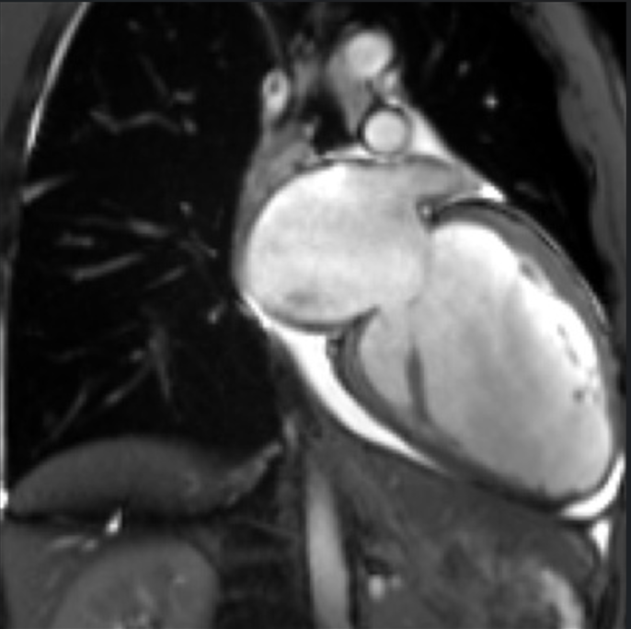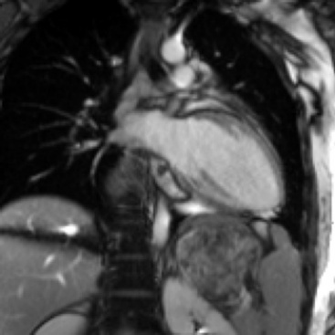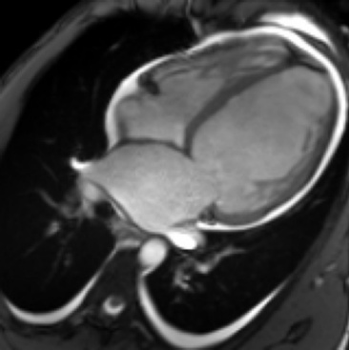
In typical cases, the left atrium is visualized in the upper-left or upper-right region for 2-chamber views, and in the lower-left region for 4-chamber views. After inference, Users are encouraged to inspect the automatically generated segmentation_<idx>.jpg and tracking_<idx>.gif files as routine visual quality control. These files provide an intuitive check of whether the input image appearance, segmentation, and temporal tracking are consistent with expected cine MRI anatomy.
For cases with uncommon display orientation or markedly different image appearance, visual QC can help determine whether simple preprocessing adjustment, such as rotation or flipping before inference, is appropriate. Quantitative strain interpretation should be based on cases with visually plausible segmentation and tracking results.

10. Common Issues
Issue | Suggested check
No .dcm files found. | Confirm that --dicom_folder points to the frame folder.
Frames appear out of temporal order. | Check file naming. The script sorts by the last numerical token in each filename.
Resized image is smaller than crop size. | Check PixelSpacing and image matrix size, or reduce --crop_size only for diagnostic testing.
Heart rate warning appears. | Check whether DICOM tags HeartRate or NominalInterval are available. If absent, HR=60 bpm is used.
Poor segmentation or tracking visualization. | Check view type, image orientation, crop center, and whether the data are similar to the cine MRI distribution used for training.
CUDA out-of-memory or unavailable GPU. | Run on CPU or set CUDA_VISIBLE_DEVICES to an available GPU.

11. Reproducibility and User-use Notes
The released files are intended to allow users to verify the inference behavior of the proposed framework on representative cine DICOM data. To ensure quality, please use the default preprocessing parameters unless a specific diagnostic check is being performed.
Because DICOM metadata and orientation conventions vary across scanners and export workflows, user-side results may require orientation inspection and basic quality control. The provided segmentation and tracking visualizations should be reviewed before interpreting the numerical strain outputs.

12. Notice and Disclaimer
This code package is provided solely for the purpose of research. They are not intended for clinical diagnosis, treatment decision-making, or any direct clinical use. The authors do not guarantee performance on data that differ substantially from the imaging protocol, view orientation, preprocessing assumptions, or input format described in this guide.

13. Citations
For use of the code, please cite [Citation information to be updated after publication].

