Design Choices & Reflection Statement
I chose MongoDB Atlas because it allowed me to easily store inventory items inside of a cloud database and connect it to Node.js using the MongoDB driver. I also pick MongoDB to make use of its built-in functions like insertOne(), findOne(), updateOne(), and deleteOne(), to work with the database instead of using the in-memory array from assignment 8.
I used ChatGPT to help me understand and convert my existing API logic to work with MongoDB functions. It also helped me to debug properly use async and await in the logic so the API can handle database operations that take time to complete without breaking.
1. GET http://localhost:3000/api/items/
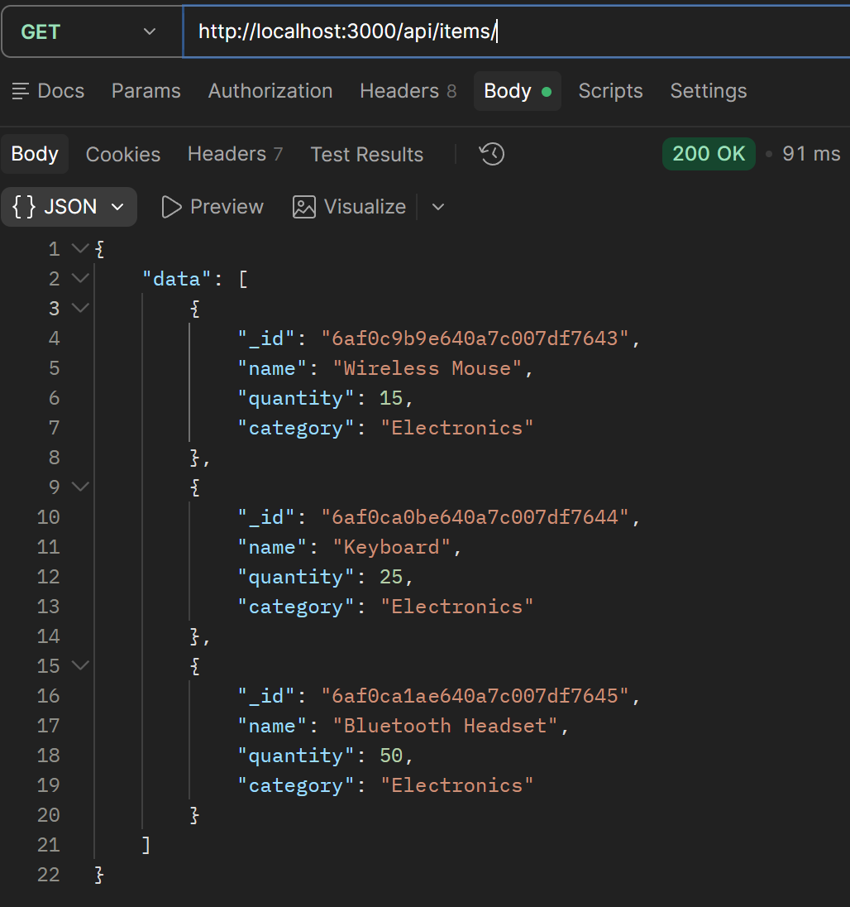

2. GET http://localhost:3000/api/items/6af0c9b9e640a7c007df7643/
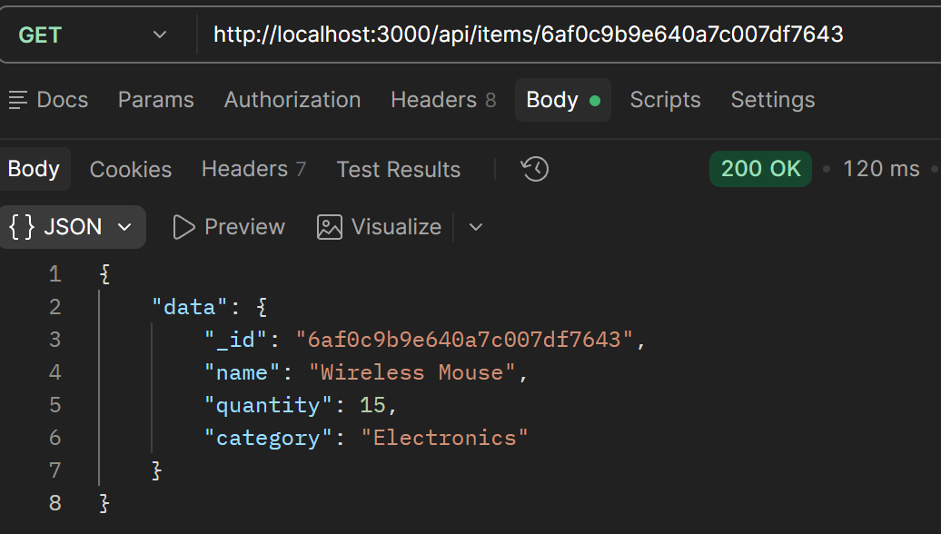
3. POST http://localhost:3000/api/items
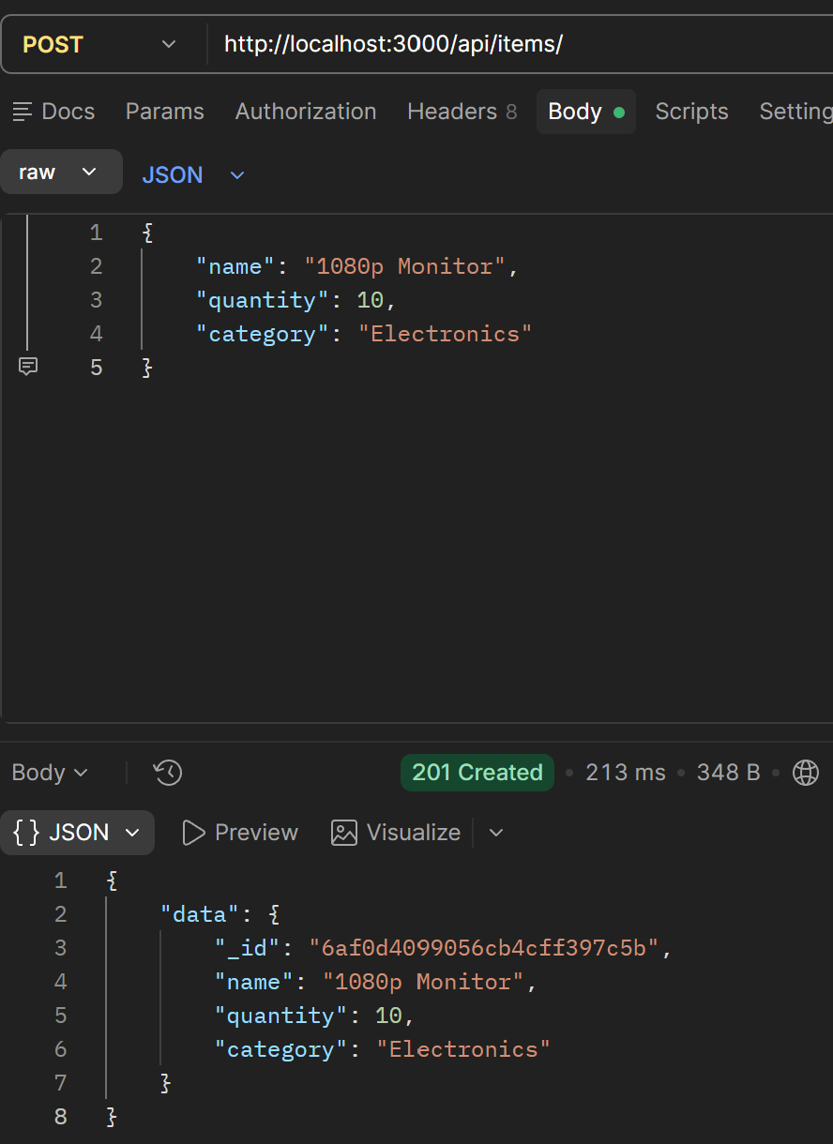
4. PUT http://localhost:3000/api/items/6af0d4099056cb4cff397c5b
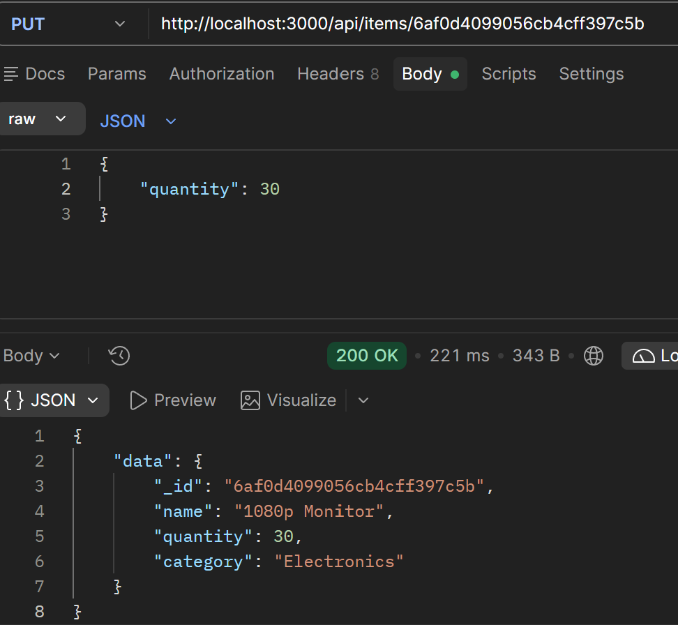
5. Invalid POST http://localhost:3000/api/items/
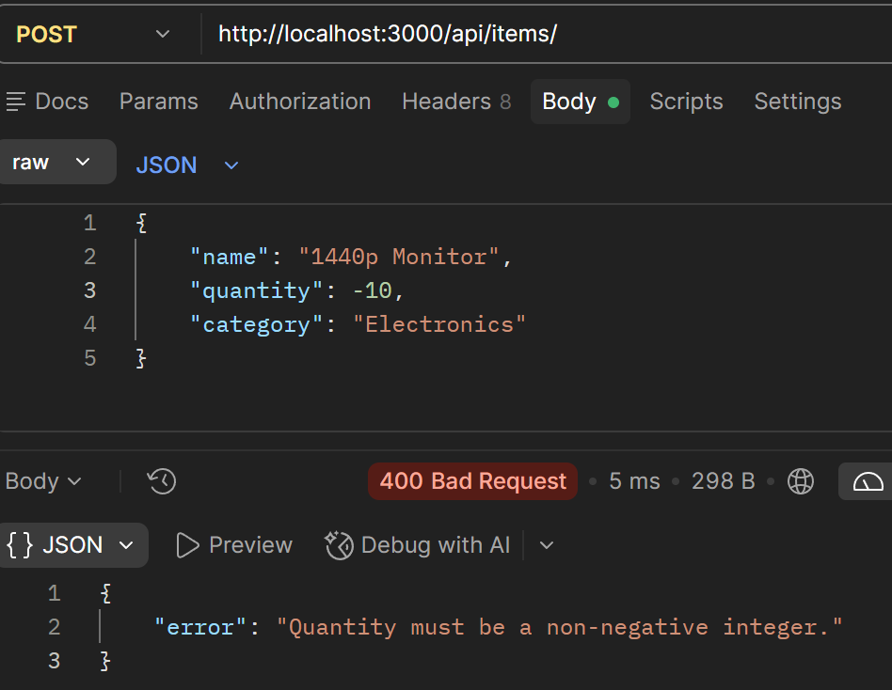
6. Invalid GET / DELETE http://localhost:3000/api/items/00000
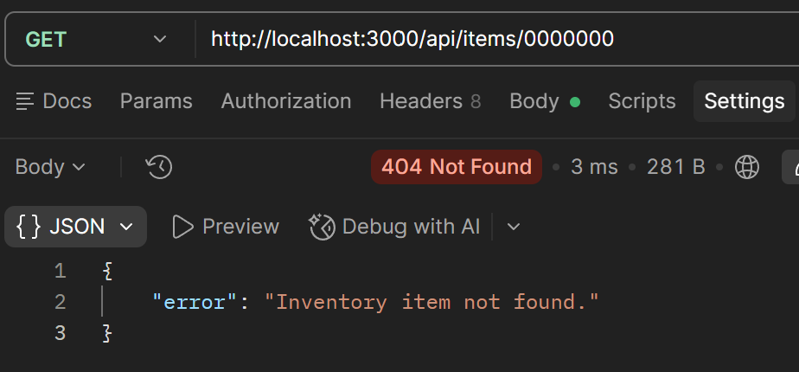
7. DELETE http://localhost:3000/api/items/6af0d4099056cb4cff397c5b


