Supply Chain Data Analytics

Analyzing and Forcasting Supermarket Sales

2024-12-11

## 1 Data selection

We analyze, forecast and interpret the [Superstore sales](https://public.tableau.com/app/sample-data/sample_-_superstore.xls) provided by [Tableau](https://public.tableau.com/app/learn/sample-data) using different statistical and machine learning methods.

The dataset provided contains information about products, sales and profits of a fictitious US company. The dataset contains about 10,000 rows with 1,850 unique product names and 17 product subcategories, covering four consecutive years on a daily basis.

We describe our work in the PDF version. However, we would like to recommend reading our quarto manuscript *here* as it contains the **relevant** R code in the Article Notebook.

## 2 Data Pre-processing

The superstore data set we selected is of high quality: At first glance (which needs to be verified during the visualization), the data appears to have been recorded regularly and without interruptions. There is no sign of a sudden structural change. Since the data are consumer products, it should contain both trends and seasonality. Nevertheless, we have included hypothetical steps to demonstrate our understanding of the data preprocessing procedure. In detail, we did:

Source: [Article Notebook](https://SJbrou.github.io/Supply_Chain_Data_Analysis/index.qmd.html)

* Remove whitespaces from column names
* Remove the Row_ID column as it can be inferred by it’s index
* Remove all columns with a single unique value, as storing these would be [redundant](https://few.vu.nl/~molenaar/courses/StatR/chapters/B-06-raw_data.html)
* Ensure machine-readable date formats in yyyy-mm-dd as these usually differ per locale.
* Ensure proper decimal separators
* Calculate the number of missing values (both NA and empty string ““) per column.

Source: [Article Notebook](https://SJbrou.github.io/Supply_Chain_Data_Analysis/index.qmd.html)

After these steps (and transposing the table for better document formatting), the data looks as follows:

First 3 Rows of the Data (Transposed)

|  |  |  |  |
| --- | --- | --- | --- |
| Order_ID | CA-2016-152156 | CA-2016-152156 | CA-2016-138688 |
| Order_Date | 2016-11-08 | 2016-11-08 | 2016-06-12 |
| Ship_Date | 2016-11-11 | 2016-11-11 | 2016-06-16 |
| Ship_Mode | Second Class | Second Class | Second Class |
| Customer_ID | CG-12520 | CG-12520 | DV-13045 |
| Customer_Name | Claire Gute | Claire Gute | Darrin Van Huff |
| Segment | Consumer | Consumer | Corporate |
| City | Henderson | Henderson | Los Angeles |
| State | Kentucky | Kentucky | California |
| Postal_Code | 42420 | 42420 | 90036 |
| Region | South | South | West |
| Product_ID | FUR-BO-10001798 | FUR-CH-10000454 | OFF-LA-10000240 |
| Category | Furniture | Furniture | Office Supplies |
| Sub_Category | Bookcases | Chairs | Labels |
| Product_Name | Bush Somerset Collection Bookcase | Hon Deluxe Fabric Upholstered Stacking Chairs, Rounded Back | Self-Adhesive Address Labels for Typewriters by Universal |
| Sales | 261.96 | 731.94 | 14.62 |
| Quantity | 2 | 3 | 2 |
| Discount | 0 | 0 | 0 |
| Profit | 41.9136 | 219.5820 | 6.8714 |

Source: [Article Notebook](https://SJbrou.github.io/Supply_Chain_Data_Analysis/index.qmd.html)

We did not find any missing values, confirming the quality of the data set. There is some more processing to do, for instance the removal of outliers. However, by doing so we impose our own assumptions on the data. Let’s start by evaluating the descriptive statistics of our data and check if further processing is required.

Source: [Article Notebook](https://SJbrou.github.io/Supply_Chain_Data_Analysis/index.qmd.html)

Descriptive Statistics for Numeric Columns

| Column | Min | Max | Mean | Median | StdDev |
| --- | --- | --- | --- | --- | --- |
| Postal_Code | 1040 | 99301 | 55190.38 | 56430.5 | 32063.69 |
| Sales | 0.444 | 22638.48 | 229.858 | 54.49 | 623.2451 |
| Quantity | 1 | 14 | 3.789574 | 3 | 2.22511 |
| Discount | 0 | 0.8 | 0.1562027 | 0.2 | 0.206452 |
| Profit | -6599.978 | 8399.976 | 28.6569 | 8.6665 | 234.2601 |

Descriptive Statistics for Date Columns

| Column | Earliest | Latest |
| --- | --- | --- |
| Order_Date | 2014-01-03 | 2017-12-30 |
| Ship_Date | 2014-01-07 | 2018-01-05 |

Source: [Article Notebook](https://SJbrou.github.io/Supply_Chain_Data_Analysis/index.qmd.html)

We inspect the orders with the lowest and highest Sales amount (in USD). The most expensive orders were professional printers, cameras and teleconferencing units with high unit prices. The orders with the lowest sales amount were often binders and had a high Discount rate.

Interestingly there are orders with a negative profit. They typically have high Discount rates and often concern the same item, such as the “Cubify CubeX 3D Printer Triple Head Print”. The orders with a negative Profit were often part of a larger order (for instance CA-2016-108196), and placed by customers with multiple orders. We suspect these negative Profit’s to be caused by items of lower quality that receive discounts, general discount codes, or volume discounts. However, due to the high discounts especially on orders with negative profit, we assume these to be valid orders.

** Some negative profit products **

In figure x we plotted the quantities of the most sold products. Unfortunately, the sold quantities of individual products were too low to determine any meaningful trends.

Source: [Article Notebook](https://SJbrou.github.io/Supply_Chain_Data_Analysis/index.qmd.html)

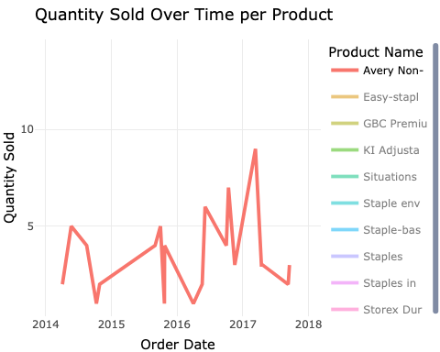

Figure X Sale quantity of the most popular products

Source: [Article Notebook](https://SJbrou.github.io/Supply_Chain_Data_Analysis/index.qmd.html)

Our proposed workaround is to aggregate Product_Name by Sub_Category, and treat it as a single product for the rest of the assignment, which we plotted in figure X.

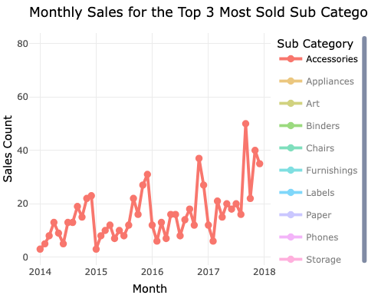

Source: [Article Notebook](https://SJbrou.github.io/Supply_Chain_Data_Analysis/index.qmd.html)

This aggregated Quantity starts to show trends and seasonality, and is much more useful to base predictions on! We will use these aggregated sub-categories for the rest of the assignment.

To properly finish our data preprocessing we ran some statistics on Quantity aggregated by Sub_Category. Table x contains some descriptive statistics.

Statistics for Sub_Category quantity

| Sub_Category | Min | Mean | Max | Sd | CI_lower | CI_upper |
| --- | --- | --- | --- | --- | --- | --- |
| Accessories | 1 | 3.84 | 14 | 2.28 | 3.68 | 4.00 |
| Appliances | 1 | 3.71 | 14 | 2.12 | 3.52 | 3.90 |
| Art | 1 | 3.77 | 14 | 2.13 | 3.62 | 3.92 |
| Binders | 1 | 3.92 | 14 | 2.29 | 3.80 | 4.04 |
| Bookcases | 1 | 3.81 | 13 | 2.28 | 3.51 | 4.11 |
| Chairs | 1 | 3.82 | 14 | 2.28 | 3.64 | 4.00 |
| Copiers | 1 | 3.44 | 9 | 1.83 | 3.01 | 3.87 |
| Envelopes | 1 | 3.57 | 9 | 2.05 | 3.32 | 3.82 |
| Fasteners | 1 | 4.21 | 14 | 2.41 | 3.89 | 4.53 |
| Furnishings | 1 | 3.72 | 14 | 2.16 | 3.58 | 3.86 |
| Labels | 1 | 3.85 | 14 | 2.35 | 3.61 | 4.09 |
| Machines | 1 | 3.83 | 11 | 2.17 | 3.43 | 4.23 |
| Paper | 1 | 3.78 | 14 | 2.23 | 3.66 | 3.90 |
| Phones | 1 | 3.70 | 14 | 2.19 | 3.56 | 3.84 |
| Storage | 1 | 3.73 | 14 | 2.19 | 3.58 | 3.88 |
| Supplies | 1 | 3.41 | 10 | 1.84 | 3.15 | 3.67 |
| Tables | 1 | 3.89 | 13 | 2.45 | 3.62 | 4.16 |

Source: [Article Notebook](https://SJbrou.github.io/Supply_Chain_Data_Analysis/index.qmd.html)

The statistics for Quantity aggregated by Sub_Category looks valid. We can visualize it as histogram and check for anomalies. Figure y contains histograms of Quantity per Sub_Category.

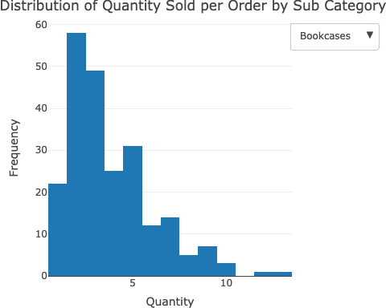

Source: [Article Notebook](https://SJbrou.github.io/Supply_Chain_Data_Analysis/index.qmd.html)

The histograms show that the quantities a right-skewed distributed. This is to be expected since most orders contain only a small number of items. We will not remove the outliers with large quantities since they appear valid..

## 3 Forecasting Method Evaluation

### Forecasting top 3 product categories (4a)

Let’s forecast sold quantities for the three most sold sub-categories:

The steps taken for data preparation were:

* Identifying Top Subcategories: The top three subcategories are selected from our dataset based on their sold quantities. The top three were: Binders, furnishing and paper.
* The sold quantities are aggregated monthly to create a time series object which we can use in the forecasting.
* A KPSS showed that the data is non stationary. First-order differencing is applied to transform the data from non-stationary to stationary. The KPSS results in a p-value >0.05 showing the stationarity.

Source: [Article Notebook](https://SJbrou.github.io/Supply_Chain_Data_Analysis/index.qmd.html)

Three models are applied to each subcategory to forecast it. The models we use are: ARIMA, Holt-Winters and ETS. We have chosen these models because of their level of suitability for discrete time series data with all different levels of trend and seasonality. To evaluate the methods and its effectiveness , the data is split into a training set (70%) and testing set (30%).

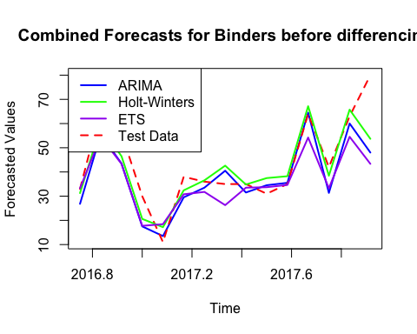

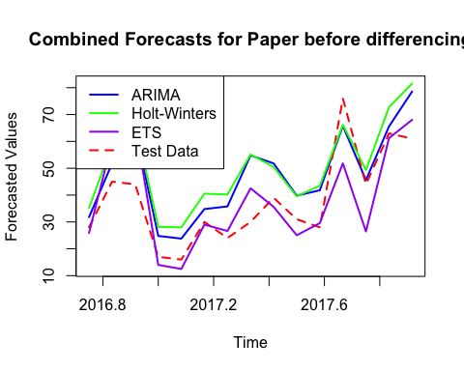

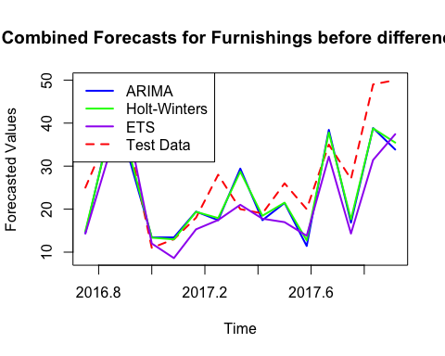

Source: [Article Notebook](https://SJbrou.github.io/Supply_Chain_Data_Analysis/index.qmd.html)

To assess the results, we use the following performance metrics: ME, RMSE, MAE and MAPE. They are calculated for the training and testing phases of the forecast.

Training Set Forecast Accuracy

|  | Sub_Category | Method | Dataset | ME | RMSE | MAE | MPE | MAPE | MASE | ACF1 | Theil_U |
| --- | --- | --- | --- | --- | --- | --- | --- | --- | --- | --- | --- |
| 1 | Binders | ARIMA | Training set | 0.771 | 4.643 | 2.982 | 0.687 | 12.912 | 0.485 | 0.044 | NA |
| 3 | Binders | HoltWinters | Training set | 0.867 | 5.215 | 3.790 | -0.404 | 15.365 | 0.617 | -0.389 | NA |
| 5 | Binders | ETS | Training set | 0.743 | 4.713 | 3.656 | 1.359 | 15.417 | 0.595 | -0.223 | NA |
| 7 | Paper | ARIMA | Training set | 1.117 | 6.309 | 3.828 | 1.702 | 14.322 | 0.547 | -0.007 | NA |
| 9 | Paper | HoltWinters | Training set | 1.510 | 7.280 | 4.855 | 3.325 | 16.413 | 0.694 | -0.027 | NA |
| 11 | Paper | ETS | Training set | 0.609 | 6.205 | 4.475 | -1.662 | 18.732 | 0.639 | 0.005 | NA |
| 13 | Furnishings | ARIMA | Training set | 0.005 | 3.874 | 2.568 | -6.625 | 20.210 | 0.556 | -0.202 | NA |
| 15 | Furnishings | HoltWinters | Training set | 0.914 | 4.165 | 3.475 | 7.490 | 24.756 | 0.752 | -0.433 | NA |
| 17 | Furnishings | ETS | Training set | 0.737 | 3.467 | 2.852 | 0.430 | 20.852 | 0.617 | -0.209 | NA |

Source: [Article Notebook](https://SJbrou.github.io/Supply_Chain_Data_Analysis/index.qmd.html)

As we can see on the forecasting results ARIMA performed well for binders. We can state this because of the lowest RMSE.

For the subcategory furnishings we can see that the ETS forecasting method is the most stable across the training and testing phase.

For the last subcategory and product paper the ETS model is again the most consistent, comparing the statistics for training and test set. The high variability in the test data leads to larger forecasting errors in all the 3 models.

Concerning the residual diagnostics, the checks show no real autocorrelation for ARIMA models. Which indicates a good fitting forecast.

### Conclusion (4a)

The most effective model is not the same in all the subcategories. Each model was validated based on its ability to capture seasonality and trend. ARIMA performed better for Binders, while ETS performed better for Furnishings and Paper.

### Clustering Subcategories and forecasting (4b)

Steps Taken:

* Trend strength, random variation and seasonal strength were calculated for the subcategory using the time series we have.

Clustering:

The clustering method used is the hierarchical clustering method. To group subcategories into three different clusters based on features which are normalized. The hierarchical clustering gave the following results:

* Cluster 1: Stronger seasonality
* Cluster 2: moderate trend and seasonality
* Cluster 3: Lower trend and seasonal strength

For each different cluster we also used the models introduced in 4A (ARIMA, Holt-Winters, ETS). These results where all aggregated at the level of each cluster so we can assess mean RMSE and MAPE for each different model.

Forecast Accuracy Results

|  | Sub_Category | Method | Dataset | ME | RMSE | MAE | MPE | MAPE | MASE | ACF1 | Theil_U |
| --- | --- | --- | --- | --- | --- | --- | --- | --- | --- | --- | --- |
| 2 | Binders | ARIMA | Test set | 5.941 | 10.784 | 7.616 | 10.368 | 17.329 | 1.240 | 0.049 | 0.357 |
| 4 | Binders | HoltWinters | Test set | 2.247 | 8.712 | 6.243 | 0.160 | 16.022 | 1.016 | -0.002 | 0.278 |
| 6 | Binders | ETS | Test set | 7.440 | 12.216 | 8.825 | 10.667 | 20.936 | 1.437 | 0.061 | 0.377 |
| 8 | Paper | ARIMA | Test set | -9.014 | 12.231 | 10.376 | -30.104 | 31.895 | 1.482 | 0.109 | 0.698 |
| 10 | Paper | HoltWinters | Test set | -12.037 | 14.481 | 13.347 | -39.792 | 41.516 | 1.907 | 0.100 | 0.845 |
| 12 | Paper | ETS | Test set | 0.085 | 11.304 | 8.247 | -0.085 | 20.476 | 1.178 | 0.342 | 0.583 |
| 14 | Furnishings | ARIMA | Test set | 3.952 | 7.783 | 6.238 | 10.720 | 22.753 | 1.351 | -0.036 | 0.610 |
| 16 | Furnishings | HoltWinters | Test set | 3.637 | 7.201 | 5.673 | 9.724 | 20.501 | 1.228 | 0.018 | 0.569 |
| 18 | Furnishings | ETS | Test set | 6.097 | 8.354 | 6.691 | 20.728 | 23.553 | 1.449 | 0.373 | 0.746 |

Source: [Article Notebook](https://SJbrou.github.io/Supply_Chain_Data_Analysis/index.qmd.html)

KPSS Test Results for Top 3 Subcategories

| Sub_Category | KPSS_Statistic | P_Value | Null_Hypothesis |
| --- | --- | --- | --- |
| Binders | 0.785 | 0.01 | Rejected (Non-Stationary) |
| Paper | 0.738 | 0.01 | Rejected (Non-Stationary) |
| Furnishings | 0.764 | 0.01 | Rejected (Non-Stationary) |

Source: [Article Notebook](https://SJbrou.github.io/Supply_Chain_Data_Analysis/index.qmd.html)

KPSS Test for Level Stationarity  
  
data: ts_diff  
KPSS Level = 0.10182, Truncation lag parameter = 3, p-value = 0.1  
  
  
 KPSS Test for Level Stationarity  
  
data: ts_diff  
KPSS Level = 0.061982, Truncation lag parameter = 3, p-value = 0.1  
  
  
 KPSS Test for Level Stationarity  
  
data: ts_diff  
KPSS Level = 0.098438, Truncation lag parameter = 3, p-value = 0.1

Source: [Article Notebook](https://SJbrou.github.io/Supply_Chain_Data_Analysis/index.qmd.html)

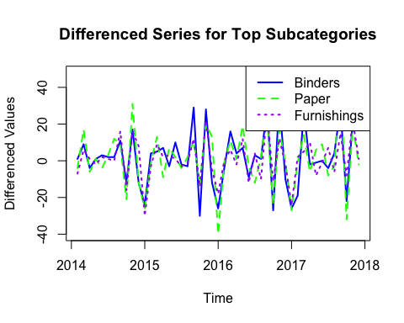

Source: [Article Notebook](https://SJbrou.github.io/Supply_Chain_Data_Analysis/index.qmd.html)

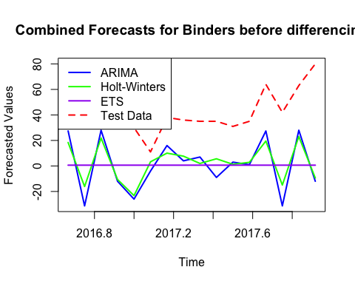

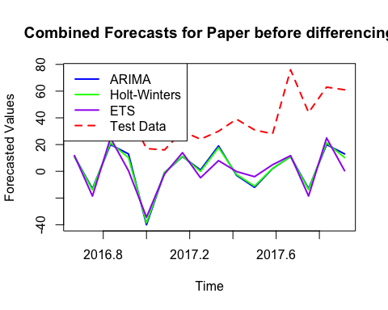

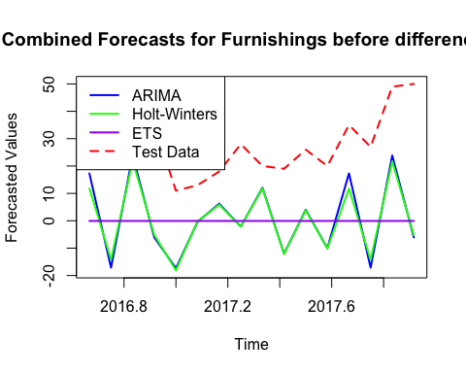

Source: [Article Notebook](https://SJbrou.github.io/Supply_Chain_Data_Analysis/index.qmd.html)

KPSS Test for Differenced Sub-Category: Binders   
  
 KPSS Test for Level Stationarity  
  
data: ts_current  
KPSS Level = 0.10182, Truncation lag parameter = 3, p-value = 0.1  
  
  
KPSS Test for Differenced Sub-Category: Paper   
  
 KPSS Test for Level Stationarity  
  
data: ts_current  
KPSS Level = 0.061982, Truncation lag parameter = 3, p-value = 0.1  
  
  
KPSS Test for Differenced Sub-Category: Furnishings   
  
 KPSS Test for Level Stationarity  
  
data: ts_current  
KPSS Level = 0.098438, Truncation lag parameter = 3, p-value = 0.1

Source: [Article Notebook](https://SJbrou.github.io/Supply_Chain_Data_Analysis/index.qmd.html)

### Clustering (4b)

Results for Cluster_1   
  
Sub-Category: Binders   
  
ARIMA Accuracy:  
 ME RMSE MAE MPE MAPE MASE  
Training set 0.7706014 4.643476 2.982256 0.6865304 12.91204 0.4854835  
Test set 5.9407398 10.783528 7.616473 10.3681817 17.32927 1.2398909  
 ACF1 Theil's U  
Training set 0.04429472 NA  
Test set 0.04929320 0.3573866  
  
Holt-Winters Accuracy:  
 ME RMSE MAE MPE MAPE MASE  
Training set 0.8668058 5.215491 3.789990 -0.4040374 15.36545 0.6169751  
Test set 2.2473496 8.712049 6.243226 0.1597635 16.02219 1.0163391  
 ACF1 Theil's U  
Training set -0.389045966 NA  
Test set -0.001830843 0.2777843  
  
ETS Accuracy:  
 ME RMSE MAE MPE MAPE MASE  
Training set 0.743354 4.712561 3.656409 1.358692 15.41708 0.5952293  
Test set 7.439784 12.216161 8.825094 10.667088 20.93561 1.4366433  
 ACF1 Theil's U  
Training set -0.2225537 NA  
Test set 0.0608554 0.3767484  
  
  
Results for Cluster_2   
  
Sub-Category: Paper   
  
ARIMA Accuracy:  
 ME RMSE MAE MPE MAPE MASE  
Training set 1.117384 6.309464 3.827714 1.702165 14.32157 0.5468163  
Test set -9.014128 12.230774 10.375521 -30.103886 31.89519 1.4822173  
 ACF1 Theil's U  
Training set -0.007064333 NA  
Test set 0.108516273 0.6984566  
  
Holt-Winters Accuracy:  
 ME RMSE MAE MPE MAPE MASE  
Training set 1.509544 7.27986 4.854547 3.325281 16.41309 0.6935067  
Test set -12.036865 14.48061 13.347292 -39.791842 41.51609 1.9067560  
 ACF1 Theil's U  
Training set -0.02710216 NA  
Test set 0.10006713 0.845232  
  
ETS Accuracy:  
 ME RMSE MAE MPE MAPE MASE  
Training set 0.60941117 6.204628 4.474990 -1.66197953 18.73240 0.6392842  
Test set 0.08500424 11.304488 8.247017 -0.08462612 20.47598 1.1781453  
 ACF1 Theil's U  
Training set 0.005205508 NA  
Test set 0.341519997 0.582549  
  
  
Results for Cluster_3   
  
Sub-Category: Furnishings   
  
ARIMA Accuracy:  
 ME RMSE MAE MPE MAPE MASE  
Training set 0.0050974 3.873555 2.567868 -6.624673 20.20958 0.5559302  
Test set 3.9523810 7.782677 6.238095 10.720079 22.75340 1.3505155  
 ACF1 Theil's U  
Training set -0.20160077 NA  
Test set -0.03570035 0.6102339  
  
Holt-Winters Accuracy:  
 ME RMSE MAE MPE MAPE MASE  
Training set 0.9137655 4.164677 3.475419 7.490317 24.75583 0.7524103  
Test set 3.6371987 7.200985 5.673333 9.724318 20.50134 1.2282474  
 ACF1 Theil's U  
Training set -0.43317305 NA  
Test set 0.01804785 0.5689788  
  
ETS Accuracy:  
 ME RMSE MAE MPE MAPE MASE  
Training set 0.7370579 3.466690 2.851745 0.4301648 20.85220 0.617388  
Test set 6.0973038 8.354163 6.690832 20.7276401 23.55317 1.448531  
 ACF1 Theil's U  
Training set -0.2087083 NA  
Test set 0.3729315 0.7455977

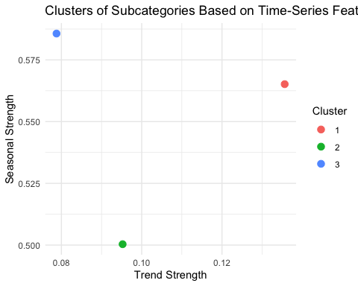

Residual Diagnostics for Sub-Category: Binders

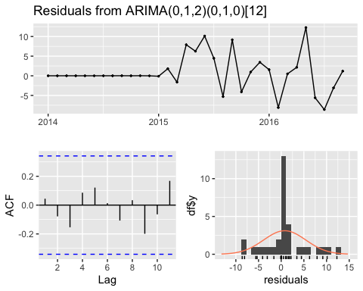

Ljung-Box test  
  
data: Residuals from ARIMA(0,1,2)(0,1,0)[12]  
Q* = 2.6295, df = 5, p-value = 0.7569  
  
Model df: 2. Total lags used: 7  
  
  
Residual Diagnostics for Sub-Category: Paper

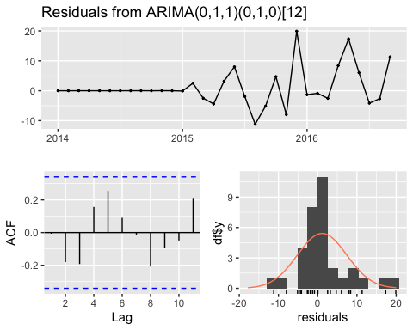

Ljung-Box test  
  
data: Residuals from ARIMA(0,1,1)(0,1,0)[12]  
Q* = 6.6676, df = 6, p-value = 0.3527  
  
Model df: 1. Total lags used: 7  
  
  
Residual Diagnostics for Sub-Category: Furnishings

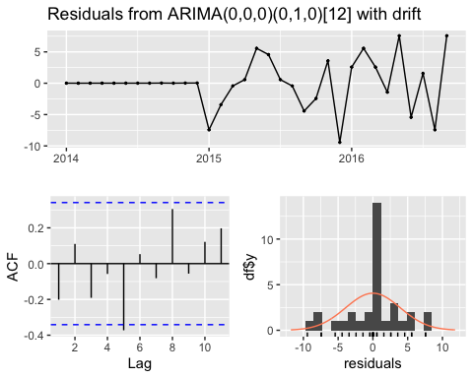

Ljung-Box test  
  
data: Residuals from ARIMA(0,0,0)(0,1,0)[12] with drift  
Q* = 9.5952, df = 7, p-value = 0.2127  
  
Model df: 0. Total lags used: 7

Cluster MeanRMSE MeanMAPE  
1 Cluster_1 10.783528 17.32927  
2 Cluster_2 12.230774 31.89519  
3 Cluster_3 7.782677 22.75340

Source: [Article Notebook](https://SJbrou.github.io/Supply_Chain_Data_Analysis/index.qmd.html)

Cluster 1 (e.g., Binders): ARIMA outperformed other methods due to significant autocorrelation and trend components.

Cluster 2 (e.g., Furnishings): ETS was the most accurate method, effectively balancing trend and seasonality.

Cluster 3 (e.g., Paper): ETS also performed best, with ARIMA showing higher error rates due to variability in random components.

Residual diagnostics were performed for all ARIMA models, confirming no significant autocorrelation (p > 0.05).

Cluster-Level Metrics based on mean RMSE and MAPE show: - Cluster 1 had the lowest RMSE using ARIMA. - Cluster 2 and 3 were better modeled with ETS

### Conclusion (4b)

Clustering allows for tailored forecasting strategies. We conclude that for the given data set ARIMA is more effective for clusters with strong trends, while ETS is preferable for clusters with mixed seasonal and trend characteristics. The approach aligns with lecture notes, emphasizing the importance of adapting models based on time series characteristics.

## 4 Forecasting future values

### Forecasting 3 products (5a)

In this session, we focused on evaluating different forecasting models (ARIMA, Holt-Winters, and ETS) for multiple sub-categories by analyzing their accuracy metrics, such as RMSE, MAPE, and residual diagnostics. Based on the evaluation results, we selected the best-performing model for each sub-category. We then used these models to forecast the future outcomes for each sub-category, projecting the data for the next year.

Series: binders_ts   
ARIMA(1,1,1)(0,1,0)[12]   
  
Coefficients:  
 ar1 ma1  
 -0.4781 -0.4819  
s.e. 0.2324 0.2426  
  
sigma^2 = 51.18: log likelihood = -117.97  
AIC=241.94 AICc=242.72 BIC=246.61  
  
Training set error measures:  
 ME RMSE MAE MPE MAPE MASE ACF1  
Training set 0.864453 5.931761 4.092168 -1.363101 15.06142 0.558023 -0.03746012

Point Forecast Lo 80 Hi 80 Lo 95 Hi 95  
Jan 2018 32.48390 23.31571 41.65208 18.462370 46.50543  
Feb 2018 23.77181 14.59632 32.94731 9.739103 37.80452  
Mar 2018 45.85265 35.59989 56.10541 30.172412 61.53289  
Apr 2018 46.20475 35.63662 56.77287 30.042185 62.36730  
May 2018 44.08009 32.93968 55.22051 27.042295 61.11789  
Jun 2018 44.61784 33.06359 56.17210 26.947139 62.28855  
Jul 2018 40.36072 28.34867 52.37277 21.989869 58.73157  
Aug 2018 44.48366 32.05796 56.90937 25.480189 63.48714  
Sep 2018 73.42488 60.58630 86.26346 53.789962 93.05979  
Oct 2018 51.45299 38.22024 64.68573 31.215253 71.69072  
Nov 2018 72.43955 58.82134 86.05775 51.612293 93.26680  
Dec 2018 89.44597 75.45417 103.43777 68.047363 110.84458

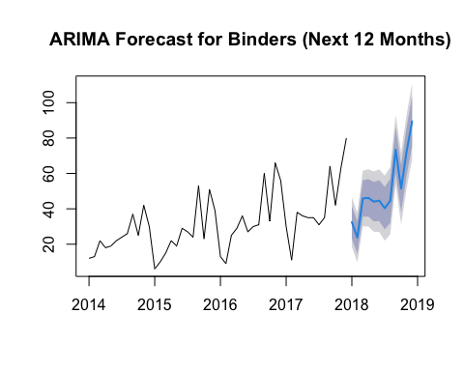

ETS(M,N,A)   
  
Call:  
ets(y = paper_ts)  
  
 Smoothing parameters:  
 alpha = 0.3075   
 gamma = 1e-04   
  
 Initial states:  
 l = 22.5954   
 s = 17.4472 16.5763 -4.1253 15.2986 0.421 -5.102  
 -0.6145 -0.0341 -7.985 -2.6766 -15.6576 -13.5481  
  
 sigma: 0.2365  
  
 AIC AICc BIC   
365.1517 380.1517 393.2197   
  
Training set error measures:  
 ME RMSE MAE MPE MAPE MASE ACF1  
Training set 1.450303 6.386648 4.166875 1.75373 14.03399 0.5245018 0.03600045

Point Forecast Lo 80 Hi 80 Lo 95 Hi 95  
Jan 2018 30.45588 21.22661 39.68516 16.34092 44.57085  
Feb 2018 28.34651 19.27484 37.41819 14.47258 42.22044  
Mar 2018 41.32776 28.18367 54.47185 21.22561 61.42990  
Apr 2018 36.01933 23.73891 48.29976 17.23804 54.80062  
May 2018 43.97017 29.09477 58.84557 21.22021 66.72013  
Jun 2018 43.39031 28.07408 58.70653 19.96616 66.81445  
Jul 2018 38.90220 24.12853 53.67588 16.30782 61.49659  
Aug 2018 44.42410 27.84663 61.00158 19.07104 69.77717  
Sep 2018 59.30522 38.44478 80.16566 27.40193 91.20850  
Oct 2018 39.87917 22.81850 56.93984 13.78712 65.97122  
Nov 2018 60.58102 38.27853 82.88352 26.47230 94.68975  
Dec 2018 61.45110 38.17748 84.72473 25.85717 97.04504

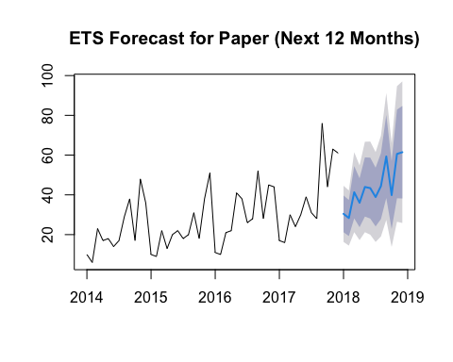

ETS(M,A,A)   
  
Call:  
ets(y = furnishings_ts)  
  
 Smoothing parameters:  
 alpha = 0.0438   
 beta = 0.0437   
 gamma = 2e-04   
  
 Initial states:  
 l = 15.4275   
 b = -0.1137   
 s = 13.3158 15.6269 -2.2962 10.1503 -5.0017 -2.448  
 -3.4406 -1.0728 -1.1262 -4.3688 -11.689 -7.6497  
  
 sigma: 0.2527  
  
 AIC AICc BIC   
338.8888 359.2888 370.6992   
  
Training set error measures:  
 ME RMSE MAE MPE MAPE MASE  
Training set 0.6402485 3.793384 2.884208 -0.8302416 16.2441 0.5352139  
 ACF1  
Training set 0.04613441

Point Forecast Lo 80 Hi 80 Lo 95 Hi 95  
Jan 2018 21.37433 14.45350 28.29515 10.789837 31.95882  
Feb 2018 18.56644 12.52244 24.61044 9.322944 27.80994  
Mar 2018 27.11574 18.26943 35.96205 13.586481 40.64500  
Apr 2018 31.58782 21.22159 41.95404 15.734048 47.44158  
May 2018 32.87189 21.95559 43.78819 16.176845 49.56693  
Jun 2018 31.73384 20.95052 42.51717 15.242170 48.22551  
Jul 2018 33.95710 22.18459 45.72960 15.952604 51.96159  
Aug 2018 32.63192 20.83816 44.42569 14.594916 50.66893  
Sep 2018 49.01546 31.92061 66.11032 22.871140 75.15979  
Oct 2018 37.79884 23.38308 52.21460 15.751844 59.84584  
Nov 2018 56.95159 36.44698 77.45621 25.592490 88.31070  
Dec 2018 55.87232 34.96477 76.77986 23.896983 87.84765

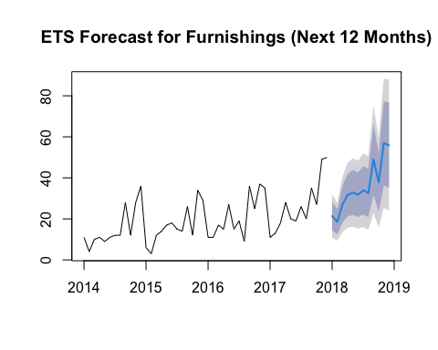

Source: [Article Notebook](https://SJbrou.github.io/Supply_Chain_Data_Analysis/index.qmd.html)

### Applying to all data (5b)

In this session, we first grouped the sub-categories into clusters based on key time-series features, including trend strength, seasonal strength, and random strength, using hierarchical clustering. Once the clusters were formed, we applied and evaluated multiple forecasting models—ARIMA, Holt-Winters, and ETS—on each sub-category within its respective cluster, comparing their accuracy metrics such as RMSE and MAPE. Based on the evaluation results, we selected the best-performing model for each sub-category and used it to forecast the future outcomes within a year, leveraging the clustering to enhance the accuracy and relevance of our predictions.

Point Forecast Lo 80 Hi 80 Lo 95 Hi 95  
Oct 2016 31.26733 24.51360 38.02106 20.938398 41.59627  
Nov 2016 58.57211 51.81274 65.33147 48.234553 68.90966  
Dec 2016 46.52209 39.75006 53.29412 36.165163 56.87901  
Jan 2017 20.60516 13.81068 27.39965 10.213895 30.99643  
Feb 2017 17.19081 10.36138 24.02023 6.746097 27.63551  
Mar 2017 32.40031 25.52088 39.27975 21.879129 42.92150  
Apr 2017 36.54419 29.59727 43.49111 25.919798 47.16858  
May 2017 42.60581 35.57173 49.63990 31.848113 53.36351  
Jun 2017 34.81156 27.66868 41.95444 23.887472 45.73565  
Jul 2017 37.46761 30.19266 44.74256 26.341532 48.59368  
Aug 2017 38.24466 30.81304 45.67627 26.878978 49.61034  
Sep 2017 67.16755 59.55368 74.78141 55.523142 78.81195

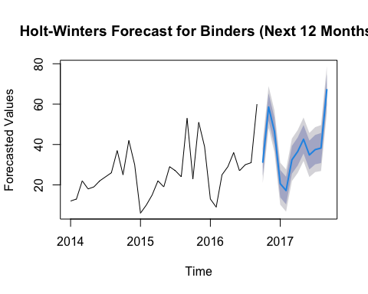

Point Forecast Lo 80 Hi 80 Lo 95 Hi 95  
Oct 2016 25.88021 14.987312 36.77312 9.2209588 42.53947  
Nov 2016 59.89171 33.023650 86.75978 18.8005561 100.98287  
Dec 2016 66.56848 34.945434 98.19153 18.2052047 114.93176  
Jan 2017 14.00226 6.995420 21.00910 3.2862229 24.71830  
Feb 2017 12.48362 5.931497 19.03574 2.4630129 22.50422  
Mar 2017 29.00633 13.095755 44.91690 4.6732073 53.33945  
Apr 2017 26.62997 11.410973 41.84896 3.3545236 49.90541  
May 2017 42.52022 17.268520 67.77192 3.9010776 81.13936  
Jun 2017 35.62513 13.690064 57.56019 2.0783432 69.17191  
Jul 2017 25.03347 9.084935 40.98201 0.6422896 49.42466  
Aug 2017 29.56385 10.109840 49.01785 -0.1884895 59.31618  
Sep 2017 51.80976 16.651800 86.96771 -1.9596973 105.57921

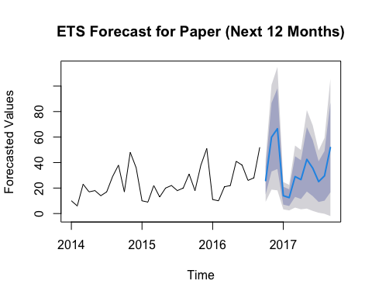

Point Forecast Lo 80 Hi 80 Lo 95 Hi 95  
Oct 2016 14.89552 9.559730 20.23131 6.735134 23.05590  
Nov 2016 36.06019 30.724406 41.39598 27.899811 44.22058  
Dec 2016 32.74939 27.413606 38.08518 24.589010 40.90978  
Jan 2017 13.37457 8.038784 18.71036 5.214189 21.53496  
Feb 2017 12.97277 7.636978 18.30855 4.812382 21.13315  
Mar 2017 19.37898 14.043187 24.71476 11.218592 27.53936  
Apr 2017 17.92073 12.584940 23.25652 9.760344 26.08111  
May 2017 28.71390 23.378112 34.04969 20.553516 36.87428  
Jun 2017 18.46131 13.125525 23.79710 10.300929 26.62170  
Jul 2017 21.50610 16.170317 26.84189 13.345721 29.66649  
Aug 2017 12.73905 7.403259 18.07484 4.578664 20.89943  
Sep 2017 37.80356 32.467775 43.13935 29.643179 45.96395

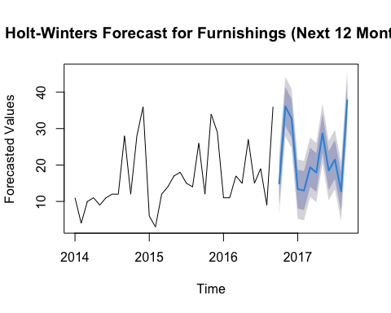

Source: [Article Notebook](https://SJbrou.github.io/Supply_Chain_Data_Analysis/index.qmd.html)

## 5 Forecast interpretation

Source: [Article Notebook](https://SJbrou.github.io/Supply_Chain_Data_Analysis/index.qmd.html)

Source: [Article Notebook](https://SJbrou.github.io/Supply_Chain_Data_Analysis/index.qmd.html)