ALL SECTIONS

* The code isn’t the most robust thing. Will likely leave some blanks in the data
* Also takes a very long time to run if the provided datasets are too large (on the test dataset with 2000 people, would take approximately 60 hours)
* Tower seems suspiciously high to me. Does it look too high to you? Any ideas why?
* Different car models more specific than the data we have (e.g.) Toyota Corolla Fielder G/S/Z
* Should we add more options for Incidents?
  + E.g. AA example below
* What licence do you hold (AMI and STATE)
  + Spreadsheet only has NZ learners, restricted, full and ‘International’. Should I get more specific (e.g. UK, Aus, South Africa)
    - Currently map AMI ‘international’ to “International / Other overseas licence”
    - Currently map State ‘internationa’ to United Kingdom
* Agreed Value
  + There are minimum and maximum limits that the agreed value that is input sometimes exceeds
    - Am current just simply round down/up to limit
    - Need to decide what to do in terms of adjusting the excess in the output excel file
    - **Does it matter if the agreed values are different for different websites**

AA

* Car events (e.g. accidents theft)

1. Allows multiple car events (spreadsheet does not)
2. Mapping inconsistencies
   * Excel spreadsheet contains 4 options for Type_incident
3. At fault – other vehicle involved (Mapped to AA tab “At Fault”)
4. At fault – no other vehicle involved (Mapped to AA tab “At Fault”)
5. Not at fault – other vehicle involved (Mapped to AA tab “Any claims where no excess was payable”)
6. Not at fault – no other vehicle involved (Mapped to AA tab “Natural Disaster Event”)

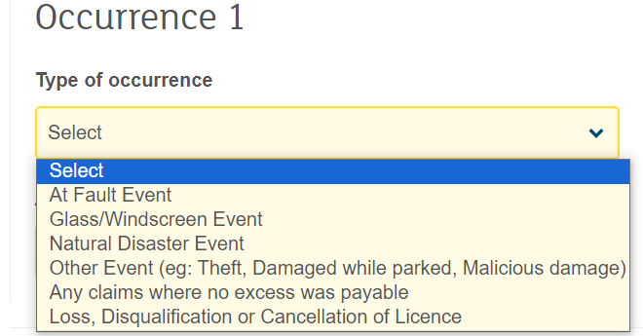

* Current Insurer
  + Who is your current or most recent insurer is an option for AA
    - I added Current Insurer column with all values being “No current insurer” (D we want to adjust
* After Market modifications
  + Should I consider the fact that some cars might have modifications
* Does it matter if a house is 14 example street vs 14C example street?
* Excesses
  + Cannot choose the excess exactly if a strange one input
  + Currently selects the smallest excess that is larger than or equal to the desired excess
* Car selecting mapping issue.
  + There are several scenarios where I can’t determine the what the most correct option is. I default to just selecting the shortest length option (least number of characters), because this is often correct (as the problem is often that the variant name we are looking for is a subset of another potential variant name, thus meaning the shorter one is more likely to be correct)
* Selecting car variant
  + This is a mapping issue

  
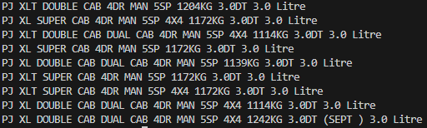

AMI

* The amount of excess paid is sometimes not adjustable. (Our default value of excess is 500 for all cars)
  + Is this an issue?, could simply remove this example from the final output if it will generate inconsistencies

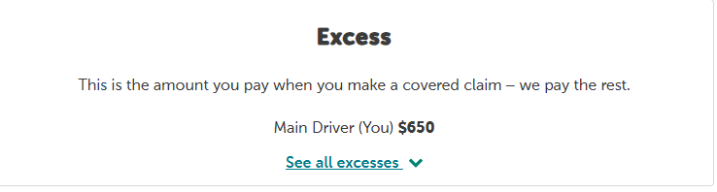

State

* Should I create a column for this in the dataset (or just assume No- what I’m currently doing)

* May not be possible to automate with selenium.
  + Always goes to this page, never loads the actual premium

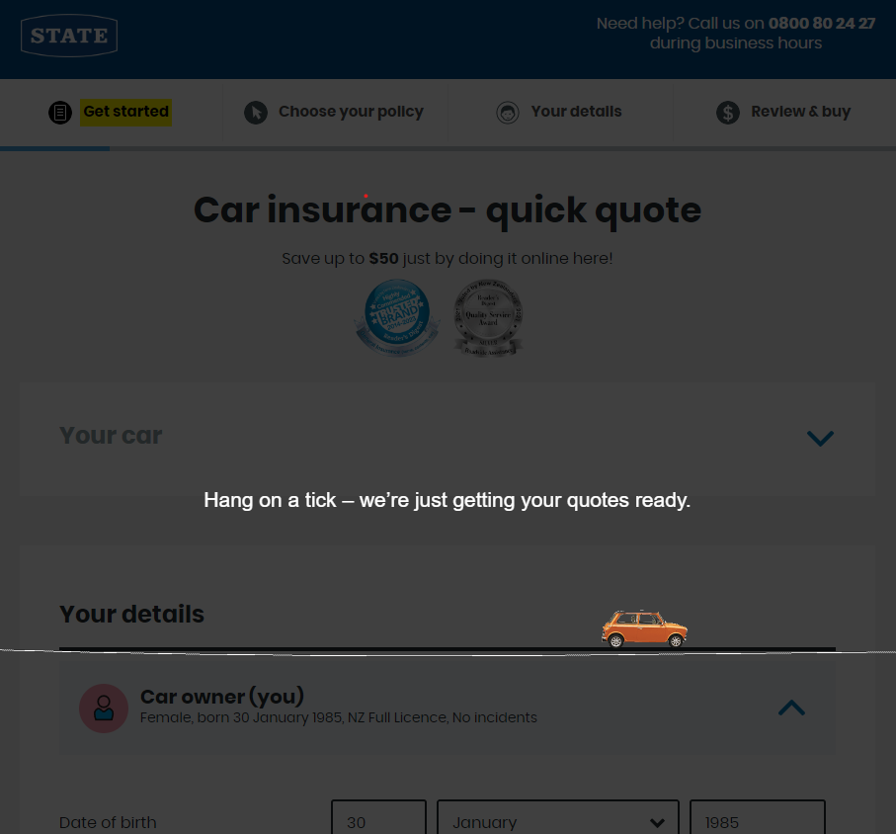

Tower

* Needs drivers name (is not currently a field in the excel spreadsheet)
  + Am currently just using john/jane doe as the name
* Excesses
  + Cannot choose the excess exactly if an unusual value is input (I believe that all our example excesses on the spreadsheet are exactly 500, so this is not currently a big issue)
  + Currently selects the smallest excess that is larger than or equal to the desired excess
* Sometimes I can’t find cars with the specifications listed.
  + For example, see below. There is no option for 1.8i and 4sp. In these cases, I chose to go with the engine size (1.8i)

|  |  |  |  |  |  |  |
| --- | --- | --- | --- | --- | --- | --- |
| 2005 | Nissan | Tiida | Hatchback | Aspirated | 1798 | 4 Sp Automatic |

* Tower Incident Options

|  |  |
| --- | --- |
|  | “At fault – other vehicle involved”: Mapped to “Collision”  “At fault – Fire damage or Theft”: Mapped to “Theft”  “Not at fault – other vehicle involved”: Mapped to “Collision”  “Not at fault – no other vehicle involved”: mapped to “Broken windscreen” |

* Info for this for if the person had to pay an excess if they made a claim
  + I used the incident type data and mapped all “at faults” to yes and all “not at faults” to no

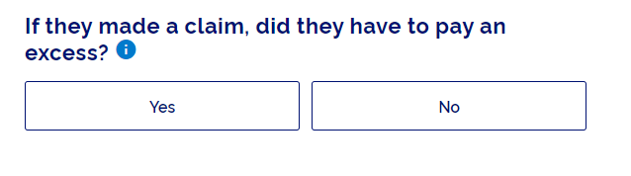

* License cancelled. The webpage asks if the driver has had their license cancelled for any reason in the last 3 years.
  + This information in not in the excel spreadsheet
  + I currently choose to just assume No
* Asks if the policy is going to be owned by a business or trust
  + This info is also not on the current excel spreadsheet
  + I currently assume no
* I currently enter fake details for the following
  + Person’s name: (Either Jane or John Doe)
  + Person’s email: (Either Jane.Doe@email.com or John.Doe@email.com)
  + Person’s phone number: (022 123 456)
* Legal information
  + Am asked to say that I understand the legal information they provide
* The information you give us will be used to confirm if we can provide this insurance and to help with any claim you may make.
* Your answers here are a legal disclosure, and must cover all people who may drive your vehicle, use your property or who live at your house. If the policy is to be for a company or a trust, this includes any director, shareholder or trustee.
* It’s your responsibility to answer the questions truthfully, accurately and completely and let us know immediately if your answers change. Otherwise, your claim may not be paid or your cover may be cancelled
  + Currently just say yes
* Am asked about past insurance history
  + This information is not included in the spreadsheet
  + In the last seven years have you or any other person to be covered by this policy had insurance refused or cancelled by an insurance company or had any special terms applied (other than non-payment of premiums)?
  + I currently just say No
* They ask about claims history
  + In the last seven years have you or any other person to be covered by this policy:
  + **Had a claim declined?**
  + If you've had a claim declined, your insurance company would have let you know in writing. This can happen for various reasons, like non-disclosure of information relevant to your cover or claim, misstatement, or fraud. You need to let us know about these types of things before we can offer cover and while your policy is active.
  + Withdrawing a claim is different - you might have withdrawn a claim if the value of the claim was more than your excess, or if your policy didn't provide cover for the loss or damage. You don't need to tell us about these situations
  + **Had a policy avoided?**
  + Having a policy avoided means that it was cancelled by your insurer for a reason other than non-payment of premium. This can be due to things like non-disclosure of information relevant to your cover, and your insurance company would have let you know this in writing.
  + Currently just select “No”
* Finance
  + Asks if the driver has purchase the vehicle on finance. This info is already available
  + If Yes, then asks who the provider of the finance is.
    - What should I do for this? What should I assume. Should I add into spreadsheet?
    - Currently Just say “Kiwibank Limited” everytime