AA

* Car events (e.g. accidents theft)

1. Allows multiple car events (spreadsheet does not)
2. Mapping inconsistencies
   * Excel spreadsheet contains 4 options for Type_incident
3. At fault – other vehicle involved (Mapped to AA tab “At Fault”)
4. At fault – no other vehicle involved (Mapped to AA tab “At Fault”)
5. Not at fault – other vehicle involved (Mapped to AA tab “Any claims where no excess was payable”)
6. Not at fault – no other vehicle involved (Mapped to AA tab “Natural Disaster Event”)

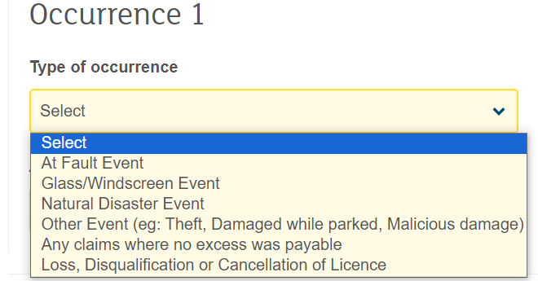

* Current Insurer
  + Who is your current or most recent insurer is an option for AA
    - I added Current Insurer column with all values being “No current insurer” (D we want to adjust