NPRT63 — Project (ICT 3rd Year)
Requirements Specification
PHASE 2


MEDISYNC SA: Digital Healthcare Management System

Group Members
Simamkele Jokose – 202424701 (Group Leader)
Nokukhanya Mkhize – 202407968
Nontethelelo Gumede – 202410803 Rebecca
Rebecca Tshelane – 202412895

Lecture: Mr Melvin Kisten
Due Date: 20 April 2026

Table of Contents
Business Processes for MediSync SA 3
Non-functional Requirements 5
Functional Requirements 6
Use Case Diagram 8
Activity Diagram 9
State Diagram 10
Class Diagram 11
Sequence Diagram 12
Component Diagram 12
Deployment Diagram 13
Work breakdown Structure 14
Gantt Chart Table 16
Gantt Chart Diagram 18

Business Processes for MediSync SA
Based on the identified problem statement for MediSync SA and proposed solution provided, the following five core business processes have also been identified:
1st Process: Patient Registration and Digital Record Creation
Trigger: A new patient chooses whether they go to visit a healthcare facility or register online.
Activities:
1. Patient is required to provide a 13-digit SA ID number and personal details for the registration process.
2. System validates patient ID number and patient credentials.
3. System checks for repeated patient records and verifies a patient record.
4. If there’s no existing record, then a new digital patient file is successfully created in the central database of MediSync.
5. Patient creates login with their credentials (SA ID + OTP authentication).
6. System to keep patient records safe and store data in a POPIA-compliant manner.
• Expected Outcome: A unique and verified digital patient record created.

2nd Process: Online Appointment Booking
  - Trigger: Patient logs into their portal.
  - Activities:
- Patient views color-coded calendar, to see available schedules.
- Patient are required to select a date, department they’re attending, and doctor they should be scheduled with.
- The system checks doctor’s availability and available schedules.
- Patient confirms appointment.
- System sends automated confirmation SMS to a patient regarding reminders and full details of the booked appointment.
- Patient appointments show in the patient's history dashboard.

  - Outcome: An Appointment can be booked without visiting the facility but on the MediSync SA system that is made available to the patient.

3rd Process: Automated Appointment Reminders
  - Trigger: Scheduled appointment booked at 09h00am is approaching, kindly arrive 10 minutes earlier.
  - Activities:
- System checks Scheduled appointments in daily basis.
- At 72h00 before it sends first SMS reminder to a patient.
- At 24h00 before it sends second SMS reminder.
- At 02h00 it sends final SMS reminder.
- System logs all reminders that were sent.

  - Expected Outcome: This feature is expected to reduce missed appointments.

4th Process: Digital Queue Management & Patient Check-in
  - Trigger: A patient arrives at the healthcare amenities.
  - Activities:
- Patient or staff verifies if a patient has arrived at the reception.
- Patient is then added to hospital digital queue.
- System ensures to display the patient's position in the existing queue.
- Staff should have patient status updated (waiting, with doctor, completed).
- The doctor accesses the patient record instantly using their SA ID to search.

- Expected Outcome: This process is expected to reduce waiting times and organize patient flow.

5th Process: Patient Prescription & Medical Record Management
- Trigger: The doctor should be able to access and update patient’s medical history.
- Activities:
- Doctor have access to logging into staff or admin portal.
- Doctor can search their assigned patient’s SA ID number.
- System retrieves complete digital medical history.
- Doctor updates on what is required for patients e.g., diagnosis, or treatment, or creates digital prescription/referral.
- System logs all changes.
- Information is saved and backed up.

- Expected Outcome: All outcomes should be accurate, complete, and accessible medical records.

Non-functional Requirements

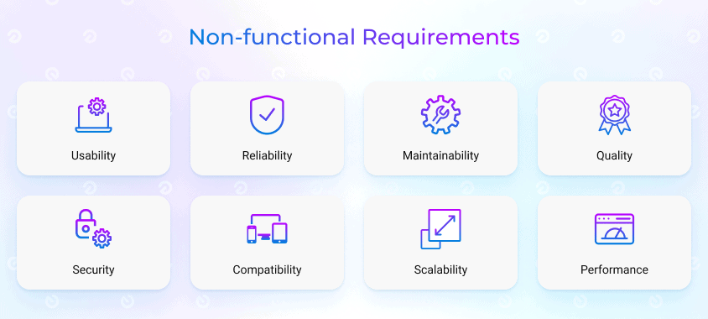
- The system shall return search results within 5 seconds.
- The system shall not slow down noticeably
- The system must be able to support more than 100 users concurrently
- The system shall encrypt all sensitive patient data.
- The system shall comply with POPIA regulations.
- The system shall implement secure authentication (OTP-based login).
- The system shall be usable by first-time users with minimal training.
- The system shall provide a simple and intuitive interface for both patients and staff.
- The system shall have 99% uptime.
- The system shall recover data within 5 minutes after a failure.
- The system shall support expansion to multiple hospitals without major redesign.
- The system shall handle increasing patient records over time.
- The system shall be modular to allow easy updates and debugging.
- The system shall follow MVC architecture for separation of concerns.
- The system shall be accessible 24/7 via web browsers.
- To support availability the system shall be accessible on mobile devices for patients
- For the system to be compatible major web browsers should be able to access the system
- The system shall support integration with SMS gateway services.

Functional Requirements
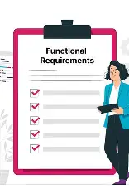
- The system shall allow patients to register using their South African identification number.
- The system shall allow staff to search for a patient using their South African ID number
- Before making a record, the system must confirm that the Identification number is unique
- They system shall allow login using ID number and OTP verification
- The system shall allow staff to create, update, and delete patient records.
- The system shall store medical history linked to a unique patient ID.
- The system shall retrieve patient records within 5 seconds of search.
- The system shall restrict the creation of multiple record files with one and the same ID number.
- The system shall prevent duplicate submissions and alert staff when an overlap is identified.
- The system shall allow doctors to generate digital prescriptions linked to a patient's medical record
- The system shall allow patients to book appointments online.
- The system shall display available and unavailable slots using a color-coded calendar.
- The system shall prevent double-booking of time slots
- The system shall allow staff to create, update, and cancel appointments.
- The system shall allow staff to manage a digital queue
- The system shall provide administrators with the ability to allocate specific doctors to available time slots within the schedule
- The system shall send SMS notification reminders to patients starting from 72 hours prior to the appointment booked, 24 hours and 2 hours before the appointment
- The system shall notify patients of booking confirmations
- The system shall limit functional access based on your role in the hospital database to ensure data safety
- The system shall log all user actions in the system.
- The system shall generate reports on appointments, missed visits, and patient activity.
- The system shall maintain an audit log of system usage.

Use Case Diagram
The use case diagram illustrates the permissions and responsibilities within the system. Each actor(Patient, Receptionist, Nurse, Doctor , and Administrator) is connected to functions they can perform.
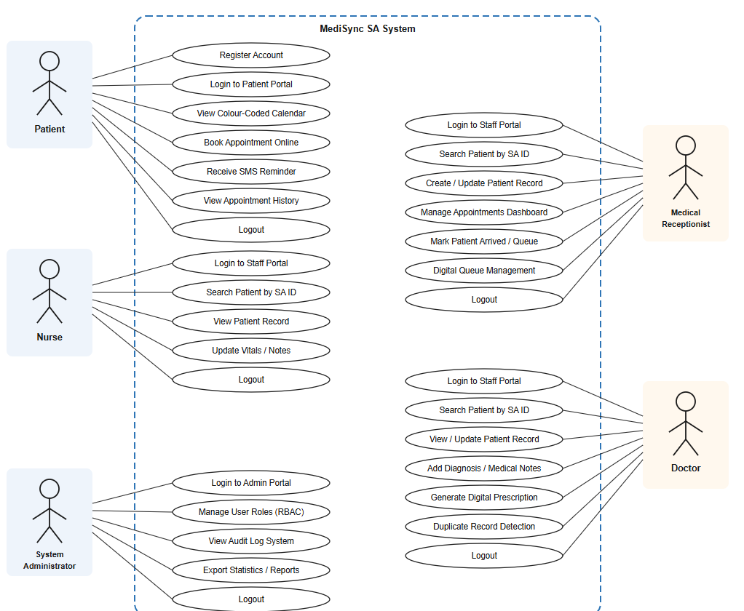

Activity Diagram
Shows the sequence of actions in a process. Here, it tracks how a patient books an online appointment, including decisions points such as checking whether a time slot is available.
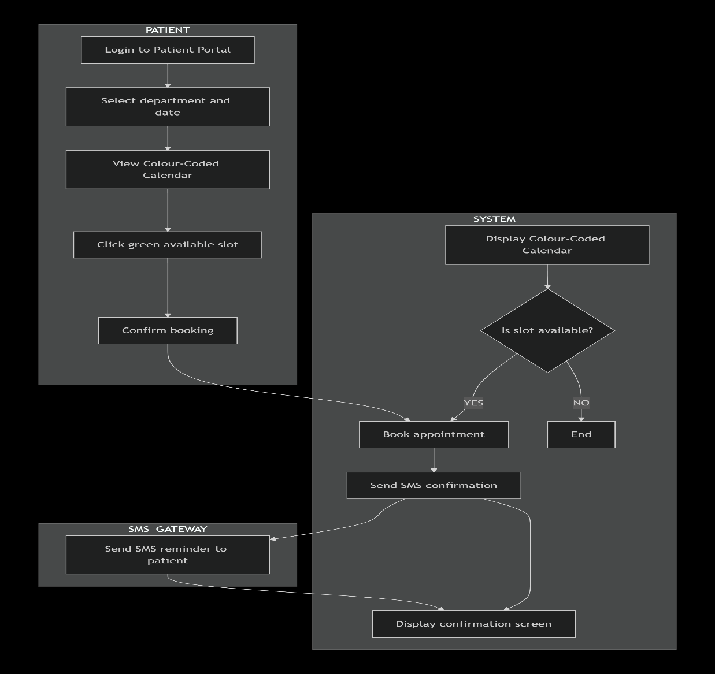

State Diagram
Represents the different stages in an appointment’s lifecycle. How it changes from “Slot Created” to “Completed” or “Cancelled” depending on the events.
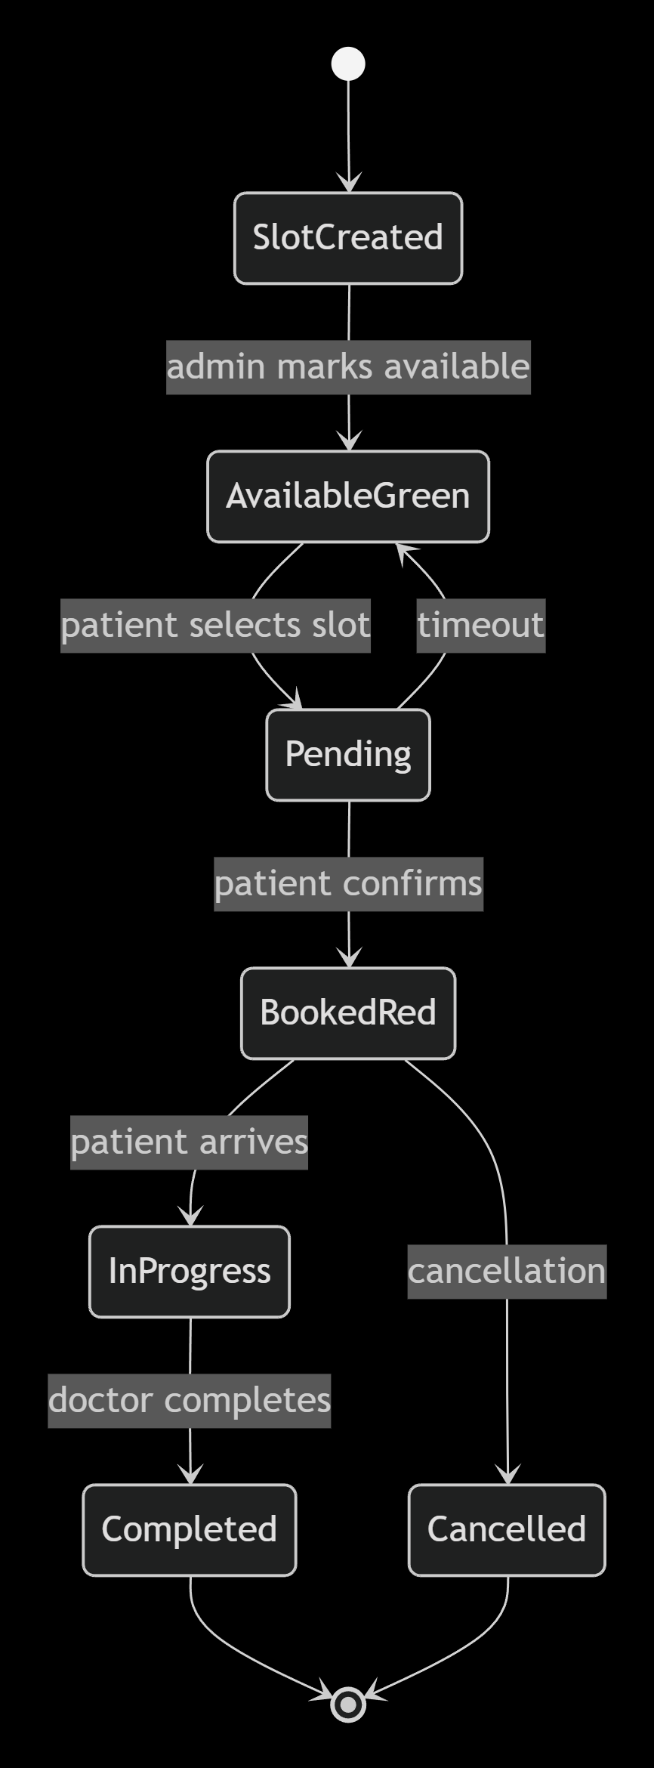

Class Diagram
Illustrates the system’ structure by outlining classes, their attributes and methods, as well as the relationship between the(inheritance, associations).
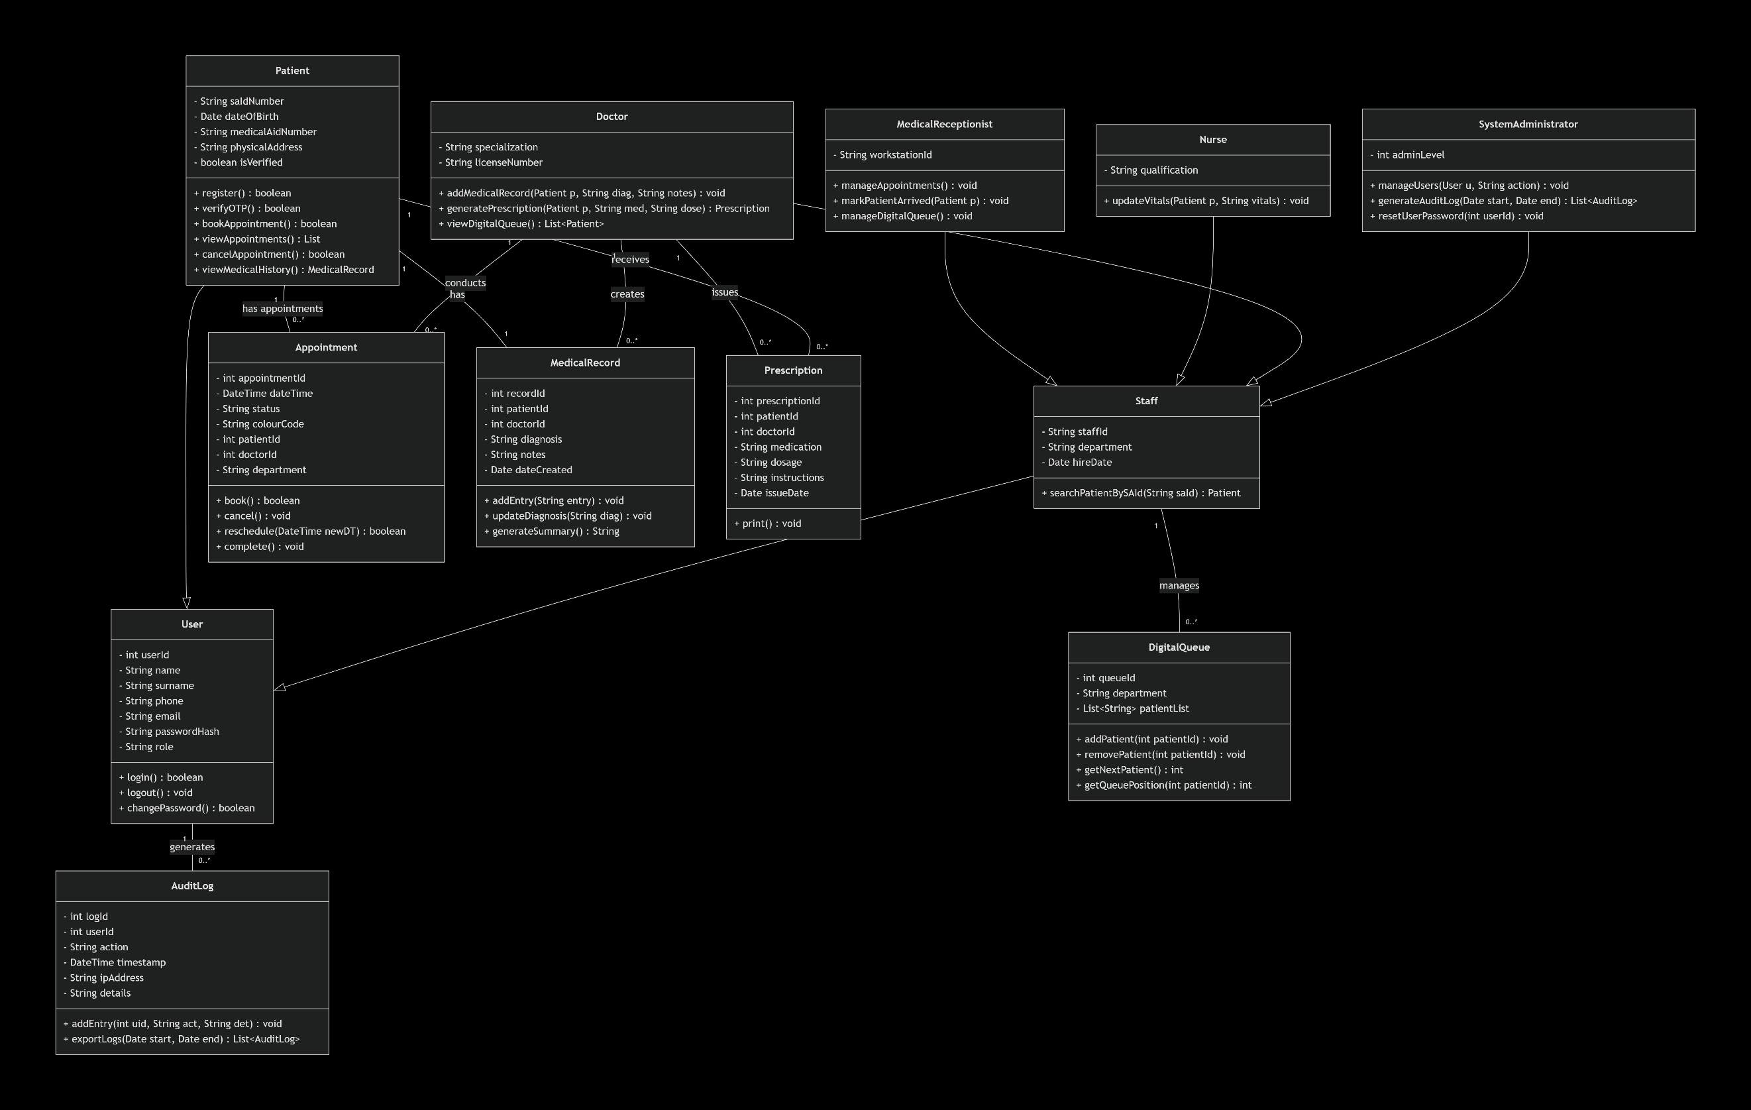

Sequence Diagram
Depicts the flow of interaction between objects in a time-based order. It illustrates a doctor searching for a patient and then receiving the patient’s medical record.
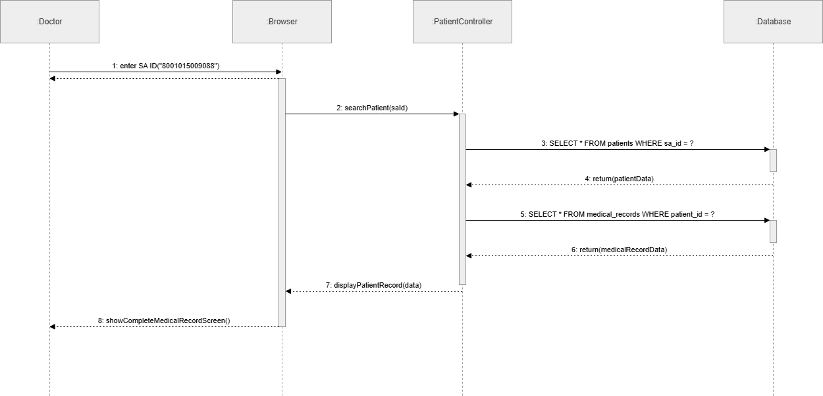

Component Diagram
This diagram shows the different software layers of the system(Presentation, Application, Database, External) and shows how the various components rely on and interact with one another.
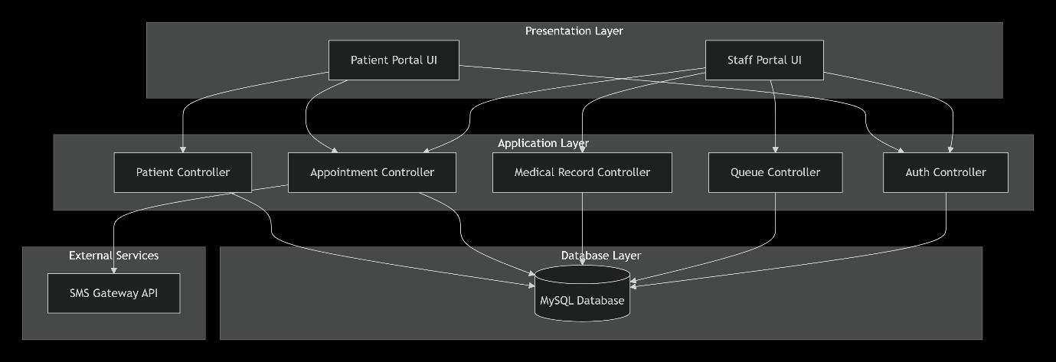

Deployment Diagram
Shows the physical infrastructure of the system, such as user devices, the web server, database server, and external SMS gateway, and illustrates how these components communicate with each other.
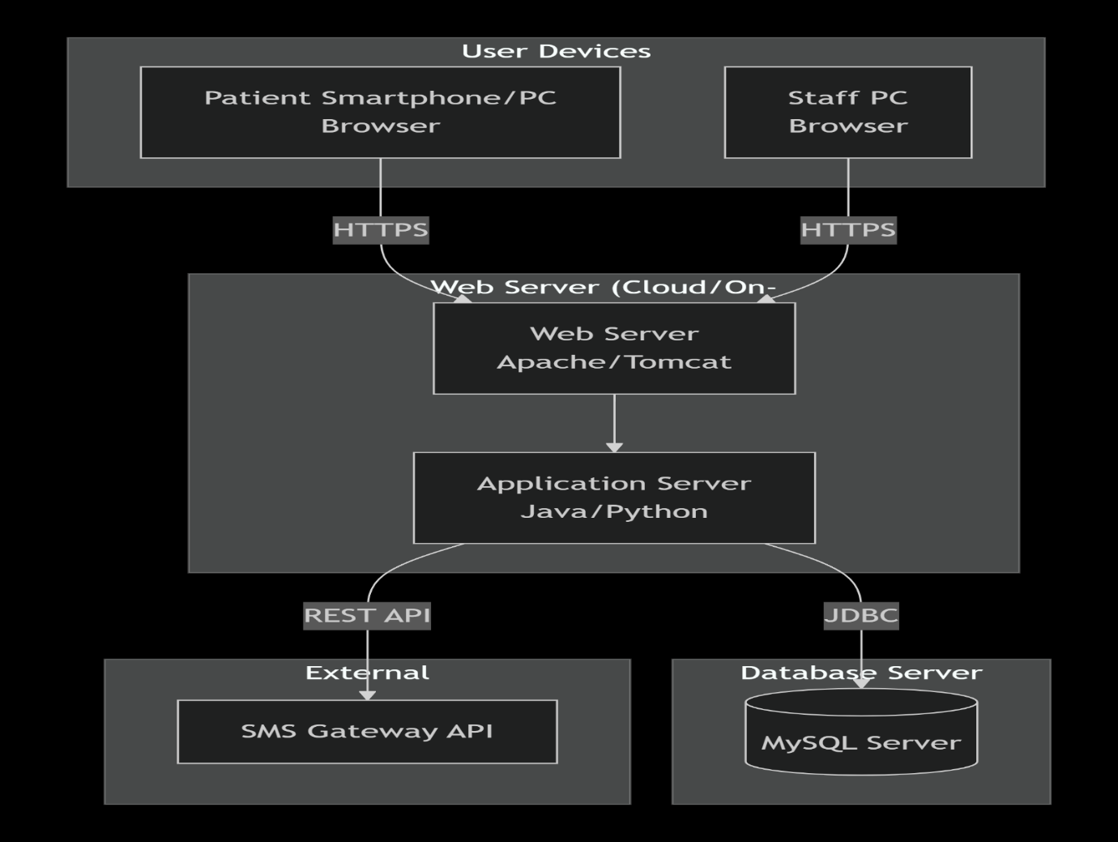

Work breakdown Structure
1.0 MediSync SA System
│
├── 1.1 Planning Phase
├── 1.1.1 Define project scope
├── 1.1.2 Identify stakeholders
├── 1.1.3 Gather requirements
│ ├── 1.1.4 Define objectives
└── 1.1.5 Identify usability goals
│
├── 1.2 System Design
├── 1.2.1 System architecture (MVC)
├── 1.2.2 Database design
├── 1.2.3 Staff/Admin interface design
├── 1.2.4 Patient portal design
│ └── 1.2.5 Security design
│
├── 1.3 Development Phase
├── 1.3.1 Backend Development
├── 1.3.1.1 Patient record system
├── 1.3.1.2 Duplicate detection (SA ID)
├── 1.3.1.3 Appointment system
├── 1.3.1.4 SMS integration
└── 1.3.1.5 Role-based access control
│ │
├── 1.3.2 Frontend Development
├── 1.3.2.1 Admin dashboard
├── 1.3.2.2 Patient registration/login
├── 1.3.2.3 Appointment booking UI
├── 1.3.2.4 Colour-coded calendar
└── 1.3.2.5 Appointment history
│ │
└── 1.3.3 Database Implementation
├── 1.3.3.1 Patient table
├── 1.3.3.2 Staff/Admin table
├── 1.3.3.3 Appointment database
└── 1.3.3.4 Data validation rules
│
├── 1.4 Testing Phase
├── 1.4.1 Unit testing
├── 1.4.2 Integration testing
│ ├── 1.4.3 System testing
└── 1.4.4 User acceptance testing
│
├── 1.5 Deployment Phase
├── 1.5.1 System installation
├── 1.5.2 Data migration
├── 1.5.3 System configuration
└── 1.5.4 User training
│
└── 1.6 Maintenance Phase
├── 1.6.1 Bug fixing
├── 1.6.2 System updates
├── 1.6.3 Performance monitoring
└── 1.6.4 Security updates (POPIA)

Deliverables
- Functional system (patient + admin portal)
Milestones
- Backend completed
- Frontend completed
Resources
- Developers
- Database Administrator
Dependencies
- Completion of system design
Risks
- Integration failures
- SMS API not working
Contingency Plans
- Use alternative SMS service
- Debug and modular testing

Gantt Chart Table
Task | Start Date | End Date | Duration
1.0 Project Management | 16-Mar | 22-Jun | 98
2.0 Analysis & Design | 16-Mar | 29-Mar | 13
2.1 Architecture Diagram | 16-Mar | 22-Mar | 6
2.2 Database Design | 23-Mar | 29-Mar | 6
3.0 Backend Development | 30-Mar | 26-Apr | 27
3.1 SA ID Validation | 30-Mar | 12-Apr | 13
3.2 Central Database | 13-Apr | 26-Apr | 13
3.3 RBAC & POPIA | 20-Apr | 26-Apr | 6
4.0 Frontend Development | 27-Apr | 17-May | 20
4.1 Staff Portal | 27-Apr | 10-May | 13
4.2 Patient Portal + Calendar | 04-May | 17-May | 13
5.0 Integration | 18-May | 31-May | 13
5.1 SMS Reminders | 18-May | 24-May | 6
5.2 Digital Queue | 25-May | 31-May | 6
6.0 Testing & QA | 01-Jun | 14-Jun | 13
6.1 Unit + Integration | 01-Jun | 07-Jun | 6
6.2 UAT + Security | 08-Jun | 14-Jun | 6
7.0 Deployment & Training | 15-Jun | 22-Jun | 7

Gantt Chart Diagram
The above Gantt Chart presents timeframe of the things should be completed in building the entire system to function in an expected way.

