  - NPRT63 — Project (ICT 3rd Year)
  - Requirements Specification
  - PHASE 3


  - MEDISYNC SA: Digital Healthcare Management System

  - Group Members
  - Simamkele Jokose – 202424701 (Group Leader)
  - Nokukhanya Mkhize – 202407968
  - Nontethelelo Gumede – 202410803
  - Rebecca Tshelane – 202412895

  - Lecture: Mr Melvin Kisten
  - Due Date: 12 May 2026

Contents
MOCKS-UP’s 3
User Feedback 8
Design Iteration 9
Entity Relationship Diagram 10
ENTITY DESCRIPTIONS 11
RELATIONSHIP JUSTIFICATION 14
TECHNOLOGY CHOICE & JUSTIFICATION 15

MOCKS-UP’s
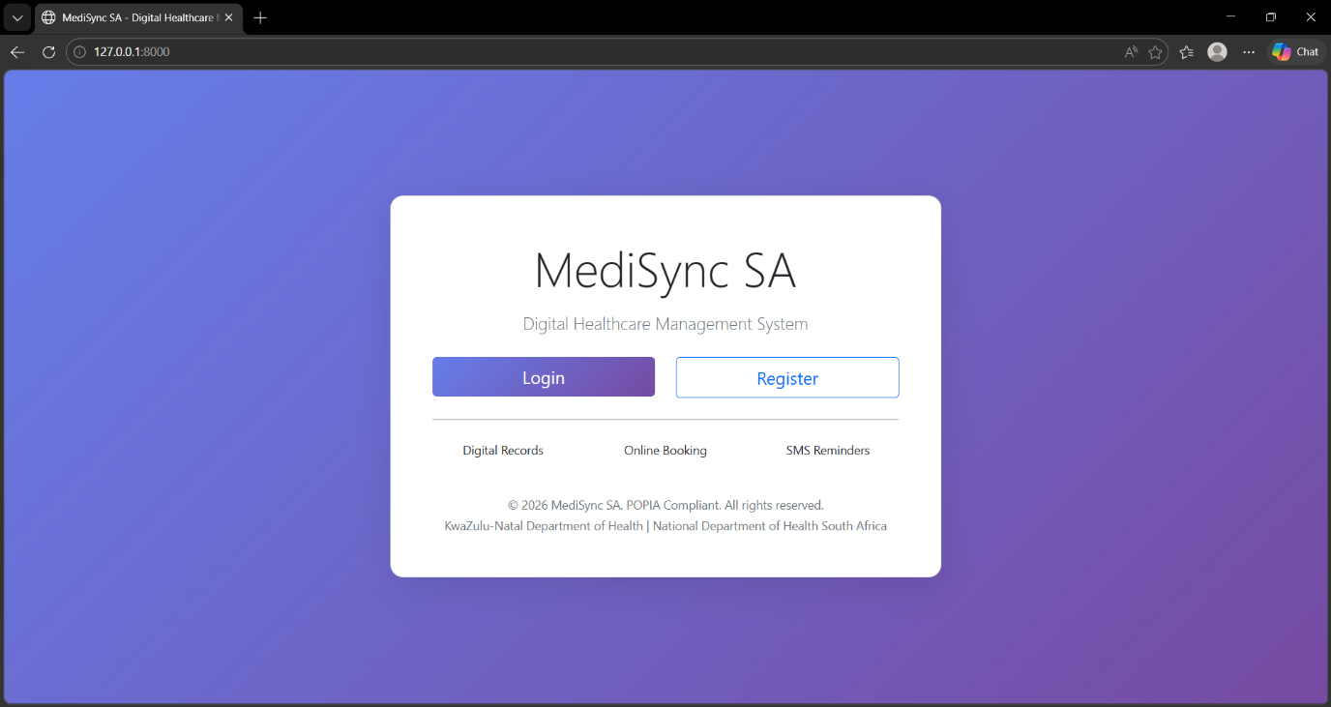
The screenshot shows the Home Page of the MediSync SA Digital Healthcare Management System. This is the first screen users see when they visit the website. It serves as the entry point for both new and existing users.
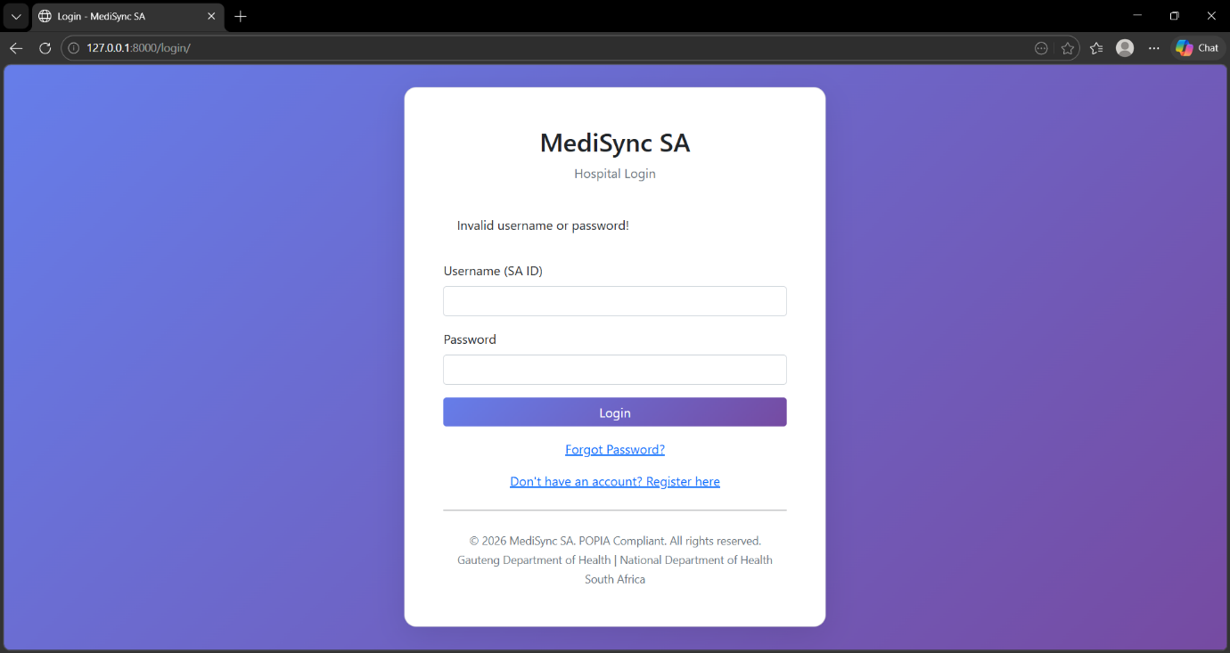
The login screen features a gradient purple background with a white card in the centre. Users can log in using their SA ID number (13 digits), along with their password.
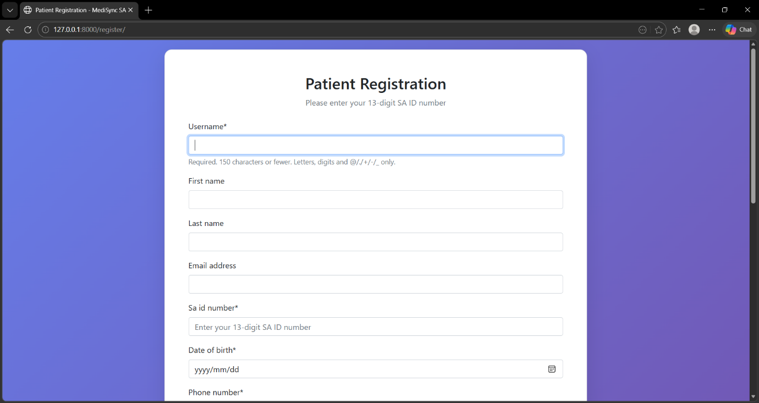
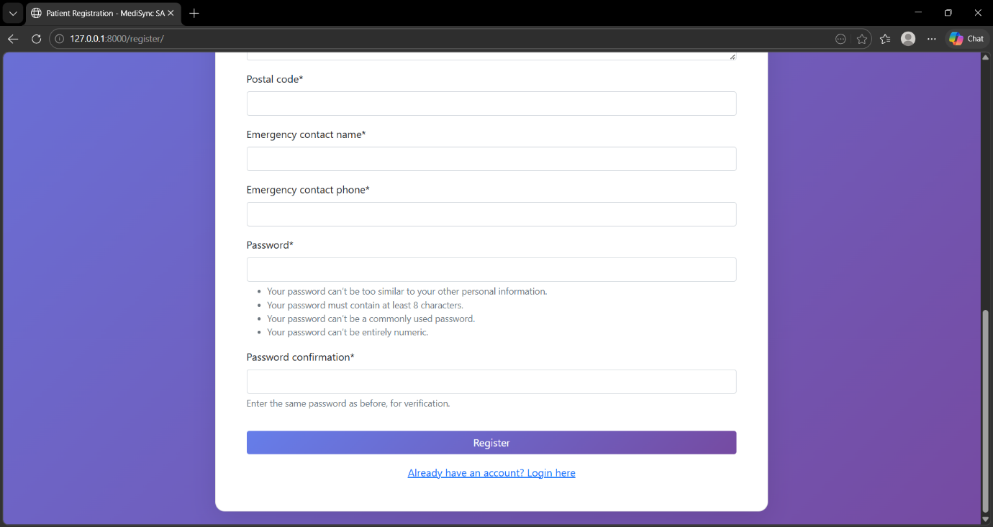
The screenshot shows the Patient Registration Form - a comprehensive data entry screen where new patients create their accounts in the MediSync SA system. This form collects personal information, contact details, emergency contacts, and secure password credentials.
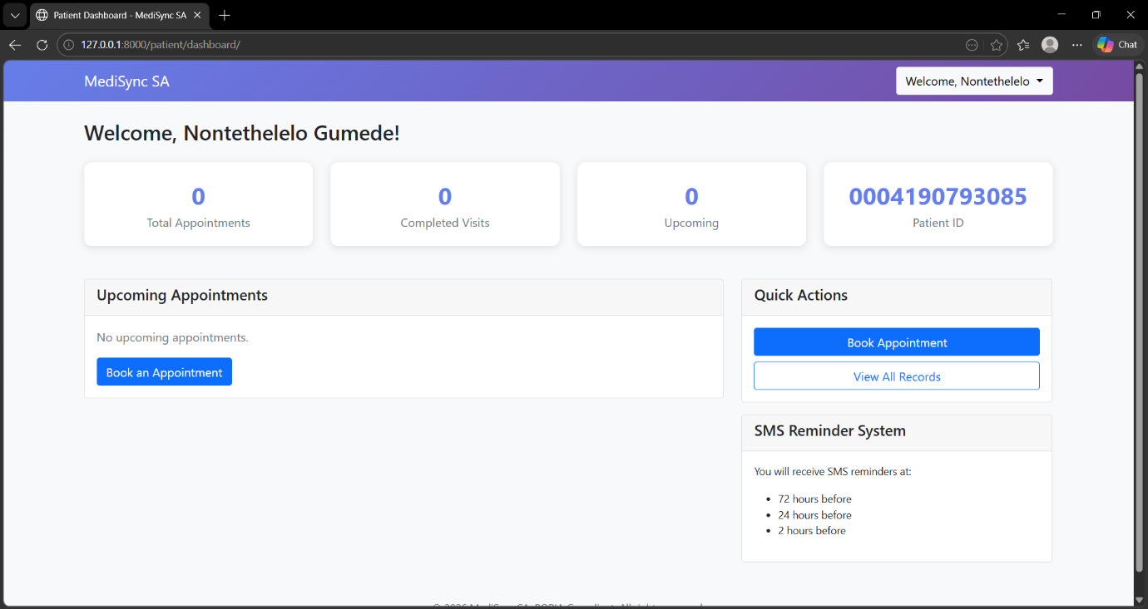
The screenshot shows the Patient Dashboard - the main interface patients/Staff see immediately after successfully logging into the MediSync SA system. This is the central command centre where patients/staff can view healthcare activity, manage appointments, and access key features.
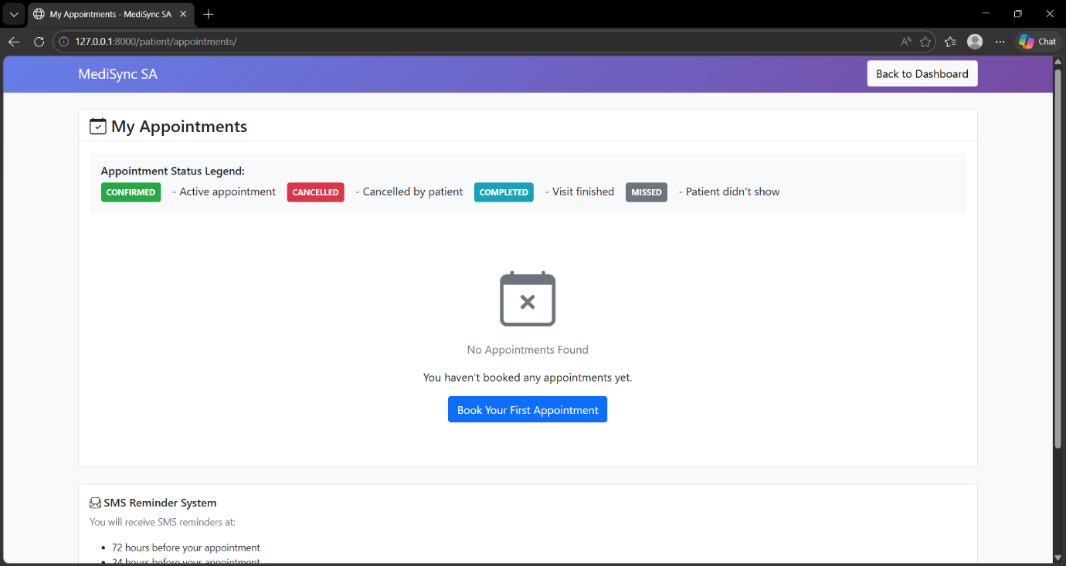
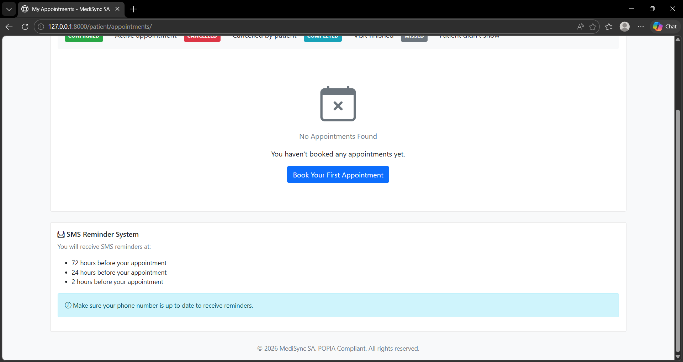
The screenshot shows the My Appointments Screen - a dedicated page where patients can view their complete appointment history, track appointment statuses, and manage future appointments. This serves as both a historical record and a management interface for upcoming visits.
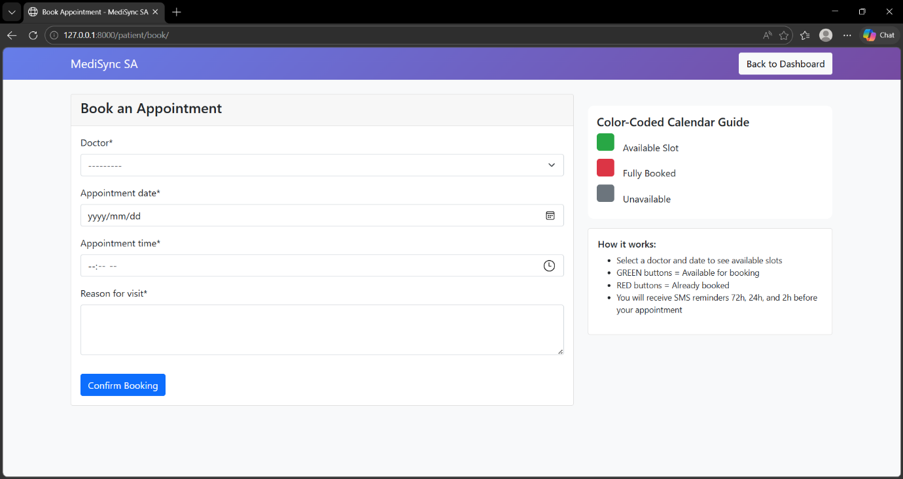
The screenshot shows the Book Appointment Screen - a data entry form where patients schedule new medical appointments. This is the primary interface for patients to book, view availability, and confirm appointments with healthcare providers.
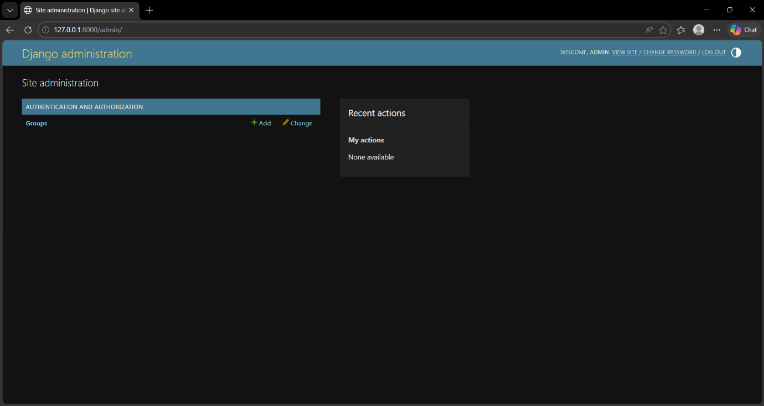
The screenshot shows the Django Administration Panel - the built-in administrative interface provided by Django. This is the default admin panel that comes with Django, NOT the custom MediSync SA admin panel. This panel is used by superusers to manage Django's core components like user groups and permissions.

User Feedback
User feedback was collected during the testing phase of the MediSync SA Digital Healthcare Management System. After engaging with systems prototypes and mock-up screens, diverse types of users such as patients, receptionists, doctors, nurses, and administrators received feedback. The aim of collecting feedback was to determine whether the system was user-friendly, efficient, and appropriate for the health environment.
The development team used questionnaires, interviews, and User Acceptance Testing (UAT) sessions to gather user feedback. During these sessions, users evaluated important system functions such as patient registration, login authentication, appointment booking, digital queue management, medical records access, and SMS notification.
Patients stated that the appointment booking process was easy to understand, but some users struggled to locate the “Book Appointment” button on the dashboard because it was too small and was placed at the bottom of the screen. Some patients also requested that SMS reminders to include the clinic location and appointment time in a clearer format.
Receptionists expressed concern that the patient search functionality needed to be improved because manually searching for records was too long. They suggested adding search filters using the patient’s South African ID number and surname to make the search of the patient faster and more efficient.
Doctors and nurses stated that the prescription and diagnosis text fields were too small to be used to enter detailed medical information. They also requested a self-saving feature to prevent accidental loss of patient data during consultations.
The administrators proposed simplifying the dashboard because too many menus were displayed at simultaneously, making navigation difficult for first-time users. They recommend aggregating related features together to improve usability and reduce confusion.
In general, user feedback assisted the development team in identifying usability issues, enhancing system performance, and guaranteed that the MediSync SA system fulfilled the requirements of both healthcare personnel and patients.

Design Iteration
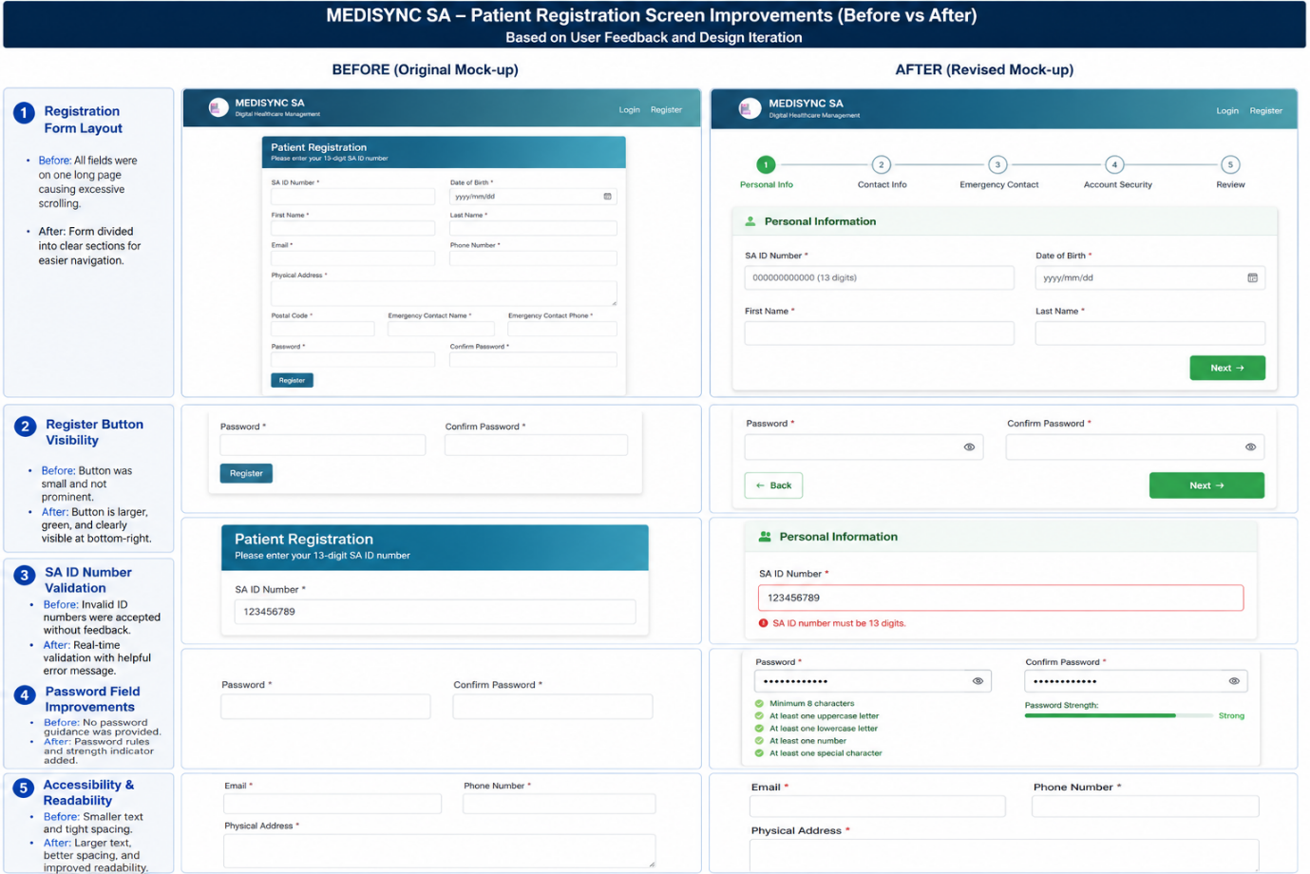
Design iteration refers to the process of improving and modifying the design of the MediSync SA system based on the feedback collected from users during the testing. After analyzing patients, healthcare staff and administrators feedback, the development team revised some system interfaces and functions to improve user experience, accessibility, and overall system performance.
One of the main changes in the design was the appointment booking feature. Users reported that it was difficult to find the booking button on the dashboard. In response, the development team expanded the “Book Appointment” button, changed it to green for better visibility, and moved it to the upper-right section of the dashboard, where users could easily access it.
The patient search function was also redesigned after receptionists explained that it took too long to find patient records. Additional search filters have been introduced to enable staff members to search with the patient’s South African ID, surname, or appointment number. This significantly reduced the time required to obtain patient information.
Based on the feedback of physicians and nurses, the prescription and diagnosis text fields have been expanded to more easily to enter medical information. A self-saving feature has also been added to automatically save patient notes while doctors write, reducing the risk of losing information during consultations.
The dashboard layout was simplified after administrators reported that the interface was overcrowded. Related menu options were grouped under categories such as “Patient Management,” “Appointments,” and “Reports.” This creates a cleaner and more organized interface that improves user navigation.
The SMS reminder design has also been improved. Initially, the reminder messages displayed only displayed the appointment date and time. After receiving patient feedback, the message was updated, including the clinic location, doctor’s name, and instructions to arrive 10 minutes early.
These design improvements were again evaluated by users to ensure that the problems were successfully resolved. The design iteration process allows the MediSync SA system to be more user-friendly, more efficient, and more in line with the practical needs of the medical environments.

Entity Relationship Diagram
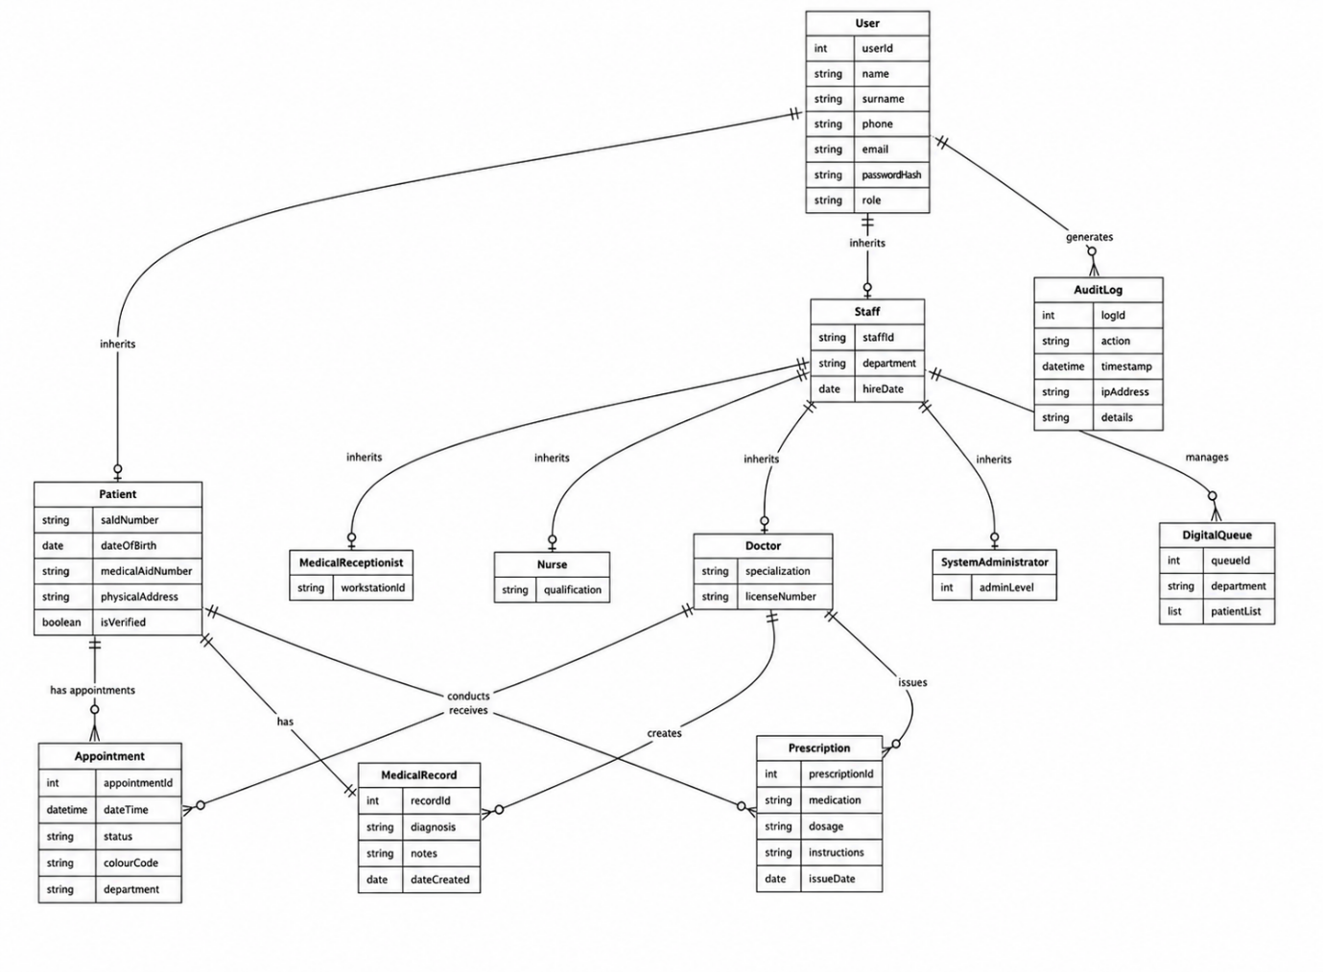

ENTITY DESCRIPTIONS
Presented below are the detailed descriptions of each entity(table) with the field names, descriptions, datatypes, and field lengths.
- User
Field | Description | Data Type | Length | Constraints
userId | Unique user identifier | INT | - | PRIMARY KEY, AUTO_INCREMENT
name | User’s first name | VARCHAR | 50 | NOT NULL
surname | User’s last name | VARCHAR | 50 | NOT NULL
phone | Contact number | VARCHAR | 15 | NOT NULL
email | Email address | VARCHAR | 100 | UNIQUE, NOT NULL
passwordHash | Hashed password (bcrypt) | VARCHAR | 255 | NOT NULL
role | User role (Patient, Receptionist, Nurse, Doctor, Administrator) | ENUM | 20 | NOT NULL

- Patient
Field | Description | Data Type | Length | Constraints
saIdNumber | South African ID (13 digits) | CHAR | 13 | UNIQUE, NOT NULL
dateOfBirth | Date of birth | DATE | - | NOT NULL
medicalAidNumber | Medical aid policy number | VARCHAR | 30 | NULL
physicalAddress | Home address | TEXT | 255 | NULL
isVerified | OTP verification flag | BOOLEAN | - | DEFAULT FALSE
userId | Foreign key to User | INT | - | REFERENCES User(userId) ON DELETE CASCADE

- Staff
Field | Description | Data Type | Length | Constraints
staffId | Unique staff identifier | VARCHAR | 20 | UNIQUE, NOT NULL
department | Department name | VARCHAR | 50 | NOT NULL
hireDate | Employment date | DATE | - | NOT NULL
userId | FK to User | INT | - | REFERENCES User(userId)

- Medical Receptionist(inherits from staff)
Field | Description | Data Type | Length | Constraints
workstationId | Workstation number | VARCHAR | 20 | NOT NULL
staffId | Foreign key to Staff | INT | 20 | REFERENCES Staff(staffId)

- Nurse
Field | Description | Data Type | Length | Constraints
qualification | Nursing qualification | VARCHAR | 100 | NOT NULL
staffId | FK to Staff | INT | 20 | REFERENCES Staff(staffId)

- Doctor
Field | Description | Data Type | Length | Constraints
specialization | Medical field (e.g., Cardiology) | VARCHAR | 100 | NOT NULL
licenseNumber | Medical license number | VARCHAR | 30 | NOT NULL
staffId | FK to Staff | INT | 20 | REFERENCES Staff(staffId)

- System Administrator
Field | Description | Data Type | Length | Constraints
adminLevel | Privilege level (1-5) | INT | - | NOT NULL
staffId | FK to Staff | INT | 20 | REFERENCES Staff(staffId)

- Appointment
Field | Description | Data Type | Length | Constraints
appointmentId | Primary key | INT | - | PRIMARY KEY, AUTO_INCREMENT
dateTime | Date and time of appointment | DATETIME | - | NOT NULL
status | Available, Booked, Completed, Cancelled | ENUM | 30 | NOT NULL
colourCode | Green, Red, Grey | VARCHAR | 10 | NOT NULL
department | Department name | VARCHAR | 50 | NOT NULL
patientId | Foreign key to Patient | INT | - | REFERENCES Patient(patientId)
doctorId | Foreign key to Doctor | INT | - | REFERENCES Doctor(doctorId)

- Medical Record
Field | Description | Data Type | Length | Constraints
recordId | Primary key | INT | - | PRIMARY KEY, AUTO_INCREMENT
diagnosis | Medical diagnosis text | TEXT | - | NULL
notes | Clinical notes | TEXT | 255 | NULL
dateCreated | Date record created | DATE | 1000 | NOT NULL
patientId | Foreign key to Patient | INT | - | REFERENCES Patient(patientId)
doctorId | Foreign key to Doctor | INT | - | REFERENCES Doctor(doctorId)

- Prescription
Field | Description | Data Type | Length | Constraints
prescriptionId | Primary key | INT | - | PRIMARY KEY, AUTO_INCREMENT
medication | Medicine name | VARCHAR | 100 | NOT NULL
dosage | Dosage instructions (e.g., “2x daily”) | VARCHAR | 50 | NOT NULL
instructions | Additional notes | TEXT | 255 | NULL
issueDate | Date prescribed | DATE | - | NOT NULL
patientId | Foreign key to Patient | INT | - | REFERENCES Patient(patientId)
doctorId | Foreign key to Doctor | INT | - | REFERENCES Doctor(doctorId)

- AuditLog
Field | Description | Data Type | Length | Constraints
logId | Primary key | INT | - | PRIMARY KEY, AUTO_INCREMENT
action | Action type (LOGIN, VIEW, EDIT, DELETE) | VARCHAR | 100 | NOT NULL
timestamp | The time action occurred | DATETIME | - | NOT NULL
ipAddress | Client IP address | VARCHAR | 45 | NULL
details | Additional JSON or text details | TEXT | 500 | NULL
userId | Foreign key to User | INT | - | REFERENCES User(userId) ON DELETE SET NULL

- Digital Queue
Field | Description | Data Type | Length | Constraints
queueId | Primary key | INT | - | PRIMARY KEY, AUTO_INCREMENT
department | Department name | VARCHAR | 50 | NOT NULL
patientList | Comma-separated | TEXT | - | NOT NULL
staffId | Foreign key to Staff (who manages the queue) | INT | - | REFERENCES Staff(staffId)

RELATIONSHIP JUSTIFICATION
The following table explains how each entity (table) connects to another, the type of relationship, and why that relationship exists in MediSync SA.
Relationship | Type | Justification
User → Patient | One-to-one (1:1) | Each user record belongs to either a patient or a staff member, never both. One user has exactly one patient record.
User → Staff | One-to-one (1:1) | Each user record belongs to either a staff member or a patient. One user has exactly one staff record.
Staff → Medical Receptionist | One-to-one (1:1) | A staff member can have only one role. If they are a receptionist, they have one matching record in the Medical Receptionist table.
Staff → Nurse | One-to-one (1:1) | A staff member can be a nurse only once. One staff record links to one nurse record.
Staff → Doctor | One-to-one (1:1) | A staff member can be a doctor only once. One staff record links to one doctor record.
Staff → System Administrator | One-to-one (1:1) | A staff member can be an administrator only once. One staff record links to one admin record.
Patient → Appointment | One-to-many (1:*) | One patient can book many appointments over time (e.g., multiple visits for different dates or departments).
Doctor → Appointment | One-to-many (1:*) | One doctor can conduct many appointments (e.g., treat many patients on different days).
Patient → Medical Record | One-to-one (1:1) | Each patient has exactly one active medical record (though the record can be updated many times).
Doctor → Medical Record | One-to-many (1:*) | One doctor can create many medical records (for different patients or different visits of the same patient).
Doctor → Prescription | One-to-many (1:*) | One doctor can issue many prescriptions (for different patients or for the same patient over time).
Patient → Prescription | One-to-many (1:*) | One patient can receive many prescriptions (from different doctors or for different conditions).
Staff → Digital Queue | One-to-many (1:*) | One staff member (receptionist, nurse, or doctor) can manage multiple digital queues (e.g., different departments or different times).
User → Audit Log | One-to-many (1:*) | One user generates many audit log entries (every login, view, edit, delete action is logged).

TECHNOLOGY CHOICE & JUSTIFICATION
Database: MySQL
Why MySQL?
- Cost: MySQL is free (Community Edition)- Making it appropriate for public healthcare budgets.
- POPIA Compliance: Supports encryption for stored data and data transmitted through TLS.
- Performance: Indexing on saIdNumber allows fast patient search and supports more than 100 concurrent users.
- Integration: Uses Java (JDBC) and Python (MySQL connector).
- ACID Compliance: Data integrity is ensured by this compliance meaning no missed appointments or duplicate records.
- Audit Logging: MySQL provides built-in logging features, enhanced using application-level audit logs.

Alternative considered: Oracle
While Oracle provides more advanced features, it is also pricier and more complicated to oversee. MySQL provides the essential functionalities at no cost.
Conclusion: MySQL stands out as the ideal option for MediSync SA due to its cost-effectiveness, security capabilities, smooth integration assistance, and strong data integrity.

