NPRT63 — Project (ICT 3rd Year)

Project Proposal (Final Document)
PHASE 1


MEDISYNC SA: Digital Healthcare Management System

Group Members
Simamkele Jokose – 202424701 (Group Leader) Nokukhanya Mkhize – 202407968 Nontethelelo Gumede – 202410803 Rebecca Rebecca Tshelane – 202412895

Lecture: Mr Melvin Kisten
Due Date: 13 March 2026

P a g e |
TABLE OF CONTENTS

INTRODUCTION ............................................................................................................Page 3

BACKGROUND INFORMATION ......................................................................................page 3-4

PROBLEM STATEMENT ..................................................................................................page 4-5

SYSTEM OBJECTIVES .....................................................................................................Page 5

USABILITY GOALS ..........................................................................................................Page 5-6

PROPOSED SOLUTION……………………………………………………………………………………………………….Page 6-7

STAFF/ADMIN TABLE ......................................................................................................Page 8

PATIENT TABLE ................................................................................................................page 8

ARCHITECTURE DIAGRAM ..............................................................................................page 9

REFERENCE LIST ..............................................................................................................page 10

P a g e | 2

INTRODUCTION
The South African public healthcare amenities have traditionally relied on manual system for the management of patient records and also appointments, mostly with public clinics and hospitals storing medical histories in physical files and scheduling appointments in person. Critical administrative and clinical challenges have led the lost of patient files, long waiting times, duplicate records and high percentage of missed records. Patients must then travel long distances to be present on medical appointments, which add more time and costs. This may be risky to individual with chronic conditions like diabetes, HIV/AIDS, tuberculosis, stroke, heart disease and Patient with epilepsy encounter challenges. Hence their treatment relies on constant availability of an accurate and complete medical document. (Katurura and Cilliers, 2018; Gauteng Department of Health, 2024; National Department of Health,2024).
Taking this into account, MediSync SA has been advanced as a web-based healthcare management system aiming to address the administrative and clinical issues that are faced by public healthcare facilities in South Africa. The system is developed by the use of Java, Python, and a MySQL database and provides 2 main interfaces, a Staff and Administrator portal for handling patient records and appointments, and a patient portal that permits users to book appointments online and then receive automated SMS reminders for their appointments.
The system also involves digital queue control, role-based access control, repeated record detection, patient proof of identity and authentication using South African ID numbers, colorcoded appointment booking, and POPIA-compliant data. These attributes directly respond to the problems marked that include lost files, duplicate records, long waiting periods, unavailable booking systems, and missed appointments, which persist to impact the quality of healthcare services in South Africa’s public sectors(Gauteng Department of Health, 2024; National Department of Health, 2024).

BACKGROUND AND CONTEXT
The Gauteng Department of Health established a massive project in 2024 to digitize paperbased patient records in all the province’s public hospitals, in response to these systemic challenges. The action plan for this started at pilot premises such as Rahima Moosa Mother and Child Hospital and Chris Hani Baragwanath Academic Hospital, the biggest hospital in Africa, with the aim of enlarging the system across all 37 public hospitals in Gauteng. This project target is to digitize at least 800 million patient paper-based records in 36 months by using cloud-based eHealth technology to develop organized system, Dependable digital patient file system(Gauteng Department of Health, 2024).
At national level, the National Department of Health South Africa is executing the Health
Systems Digital Information scheme under the National Health Insurance framework, which

P a g e |
targets to establish a compatible Health Patient Record System (HPRS) that allows a portable electronic health record for patients and assist improved preparation, reduced duplicated information and enhanced patient care across the country. This system will assist to guarantee continuity of care by enabling medical information to follow the patient across healthcare facilities, reducing unnecessary repetition of tests, treatment, and care, while improving healthcare planning and service delivery (National Department of Health, 2024).
Though these government programs display promising effort, a completely digital patientrecord and appointment management system has not yet been regularly implemented all over public hospitals and clinics in South Africa. Many healthcare facilities, especially smaller community health centres, still works without integrated digital systems. The Human Information System implemented by the Gauteng Department of Health has currently been launched in all 37 hospitals and 33 community health facilities for patient administrative tasks such as patient registration, billing, and finance functions, with clinical modules only fully working at selected hospitals such as Mamelodi Hospital and Charlotte Maxeke Johannesburg Academic Hospital.
This irregular implementation emphasizes the urgent need for scalable, web-based digital solutions that can be easily introduced across different types of healthcare facilities with minimal infrastructure requirements (Gauteng Department of Health, 2024; Katurura and Cilliers, 2018). Review shows that SMS reminder systems can significantly reduce missed appointments, with review indicating improvements in patient attendance rates between 14% and 25% when several SMS reminders are provided to patients (Opon et al., 2020). Although reliable issues related to SMS use in African healthcare environments exist, such as limited network connectivity and changing levels of mobile literacy, these challenges can be addressed through appropriate system design(Makkink et al., 2022).

PROBLEM STATEMENT
In government hospitals, the management of patients’ files relies heavily on a manual paperbased filling system. This system causes numerous problems in providing quality healthcare services.

Firstly, patients files are often lost or misplaced. This affects patients(mostly), doctors, nurses, and administrative staff. When files are lost or damaged, doctors may lack complete information regarding a patients’ medical history, which lead to delays in treatment. This is particularly dangerous for patients with chronic conditions such as HIV, TB, or diabetes.
Secondly, the paper filling system often leads to duplicate records. This happens when an old file cannot be found a new one is created. As a result, the patient’s medical history becomes

P a g e | 4
fragmented and incomplete, making it difficult for healthcare workers to access accurate information.
Thirdly, waiting times at hospitals increase because staff spend a long time searching for files in registers or on shelves. This can result in patients waiting for many hours before being seen by a doctor.
Furthermore, many hospitals still use a booking system that requires patients to visit the hospitals in person. This creates difficulties for patients living in rural areas, the elderly, the disabled, or those who are employed, because they are required to travel long distances just to book an appointment to see a doctor.
Finally, due to the lack of a system to remind patients of their appointments, there is a high rate of missed appointments. This result in a waste of time and hospital resources.
Therefore, there is a need to develop a digital system for managing patient files and online appointments booking to improve hospital efficiency, reduce the loss of files, shorten waiting times, and enhance patients’ healthcare.

System Objectives
Develop a central digital database for patient records.
- Giving an access to instant patient search using SA ID number.
- Eliminate dependence on paper folders.
- Enable patients to book appointments online.
- Provide the use of green/red indicators for appointment availability.
- Send auto SMS reminders.
- Ensure POPIA compliance throughout the process.

USABILITY GOALS
The system aims to make interactions easy and efficient for healthcare staff and patients, supporting faster service delivery.
- Effectiveness: The system should allow instant search and retrieval of patient records using SA ID numbers.
- Efficiency: There should be quick registration, updates, and appointment management to reduce waiting times.
- Learnability: A simple interface so there can be minimal training needed for inexperienced users.
- Safety: The system should prevent duplicate records by validating SA ID numbers.
- Waiting Time Reduction: Fast access to records and appointment management.
P a g e |

Benefits
- Improving efficiency with digital records reduces the time for searching files
- Reduced waiting times, so there's fast service
- Enhanced patient care with quick access to medical histories
- Less duplicate records with SA ID validation
- Improved communication with automated SMS reminders Proposed Solution
This project proposes MediSync SA, a web-based healthcare management system designed to enhance patient record management and appointment scheduling in South African public healthcare facilities, to address the administrative and clinical issues mentioned in the problem statement. The system’ goal is to replace manual, paper-based processes with a secure digital platform that improves staff-patient communication and enables efficient access to patient data.
MediSync SA will offer two main interfaces, a staff/administrator portal and a patient portal. The staff/administrator is for healthcare workers to effectively manage patient records, appointments, and clinical data and a patient portal will enable patients to safely register, schedule appointments from a distance, and get reminders to reduce missed appointments.
The system will improve healthcare by cutting administrative delays, preventing duplicate records, and ensuring professional have accurate patient information.

Key System Functionalities

Centralized Digital Patient Record Management
• The system will create a centralized electronic database that will safely store patients medical records, removing the need for paper-based files.

Patient Search Using South African ID number
• Using the patients South African ID, healthcare staff will be able to quickly search and retrieve patient records. This reduces time and makes things easy for the staff.

Duplicate Records Detection
• The system will automatically identify and avoid duplicate patient records, by patient ID is connected to just one medical record.

Online Appointment Booking
• Using the patient portal, patients will be able to schedule medical appointments online without physically visiting the healthcare facility.
P a g e |

Color-Coded Appointments Calendar
• Appointments will appear on a calendar with easy-to-read colours, green for open slots, red for fully booked, and grey for times when no appointments are available.

Automated SMS Reminders for Appointments
• The system will automate SMS reminders that will be sent to patients 72, 24, and 2 hours before their scheduled appointments to reduce missed appointments.

Role-Based Access
• To ensure that only authorized users, such as doctors or nurses, can access or alter sensitive patient information, the system will implement role-based permissions.

Digital Queue Management
• Patients are added to a digital queue and marked present on arrival to speed up patient flow and reduce waiting times.

Appointment Management Dashboard
• This dashboard will allow administrative staff to control doctor schedules, department availability, and appointments times.

Appointment History Tracking
• The system will enable patients to see their past and upcoming appointments, keeping them on track with their healthcare schedules.

Secure Patient Authentication
• To protect personal data, patients will register and log in using their South African ID number and encrypted authentication methods.

POPIA-Compliant Information
• The system is going to ensure that patient data is dealt with and safeguarded in compliance with the Protection of Personal Information Act (POPIA).

By applying these characteristics, MediSync SA aims to greatly increase administrative effectiveness, lower medical errors driven by incomplete records, reduce waiting times, and enhance patient access to quality healthcare services across South African’s public healthcare sectors.

P a g e |

Staff / Admin Portal
3.1 Staff / Admin Portal – Notes  Features | Description | Purpose
1 | Provide Access to Search patient by SA ID number | Resolve issues of lost files and long waiting times
2 | Develop and update digital medical records | Resolve issues of duplicate records
3 | Provide duplicate detection system | Prevents more than one record per ID, each ID should have one record.
4 | Role-based access control for  Admins, Doctors, Nurses, Receptionists | Guarantee secure and controlled access
5 | Provide Appointment management dashboard | Administers slots per doctor and department
6 | Eliminate Digital queue management | Patients marked as arrived and added to a queue
7 | Provide digital prescriptions and referral letters | Facilitates electronic generation of prescriptions and referrals
8 | Evaluate log system | Keeps track of all system activities

Patient Portal
Features | Description | Purpose
9 | Protect registration and login using SA ID and OTP | secure patient access
10 | Colour-coded calendar Green indicates available, Red indicates fully booked, Grey indicates unavailable | Assist patients identify available dates easily on the calendar
11 | Provide Online appointment booking | Facilitates remote booking
12 | Provide Automated SMS reminders before appointments it can be sent 72h, 24h and 2h earlier | Eliminates_missed appointments
13 | Provide appointment history dashboard | Enable patients to view past and upcoming appointments

P a g e |

MediSync SA MVC Architectural Diagram
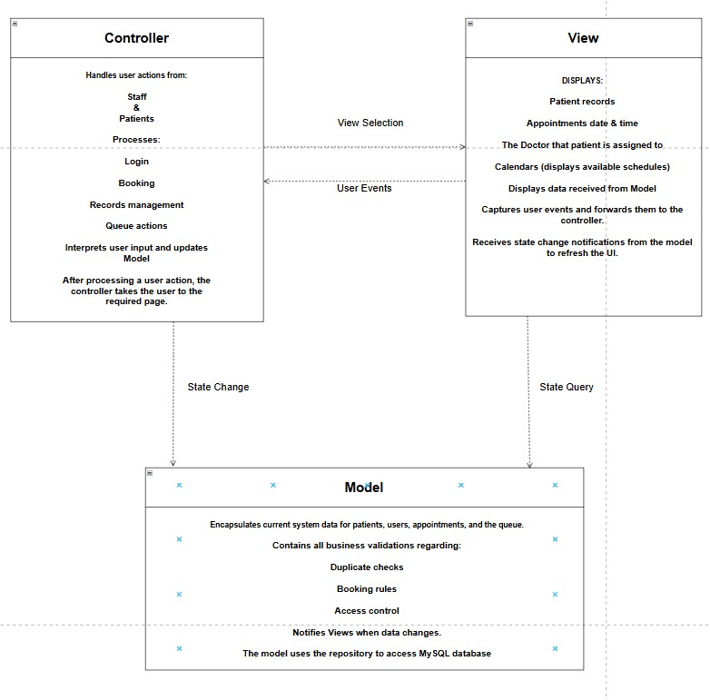

P a g e | 9

References
- Gauteng Department of Health (2024) Gauteng Health embarked on digitisation of patient files, 17 May. Available at: https://www.gov.za/news/media-advisories/gauteng-healthembarked-digitisation-patient-files-17-may-2024 (Accessed: 12 March 2026).
- Katurura, M.C. and Cilliers, L. (2018) 'Electronic health record system in the public health care sector of South Africa: A systematic literature review', African Journal of Primary Health Care and Family Medicine, 10(1), pp. 1–8. Available at: https://doi.org/10.4102/phcfm.v10i1.1746 (Accessed: 12 March 2026).
- Makkink, A., Tshoaedi, M. and Nkosi, M. (2022) 'Understanding barriers of receiving short message service appointment reminders across African regions: a systematic review', BMC
Health Services Research, 22(1). Available at: https://pmc.ncbi.nlm.nih.gov/articles/PMC9693653/ (Accessed: 12 March 2026).
- National Department of Health (no date) Chief Directorate: Health Systems Digital Information. Available at: https://www.health.gov.za/nhi-cd-hs/ (Accessed: 12 March 2026).
- Opon, S.O., Njoroge, N. and Mwaura, W. (2020) 'The effect of patient reminders in reducing missed appointment in medical settings: a systematic review', PAMJ – One Health, 2(9). Available at: https://www.one-health.panafrican-med-journal.com/content/article/2/9/full/ (Accessed: 12 March 2026).

P a g e | 9

