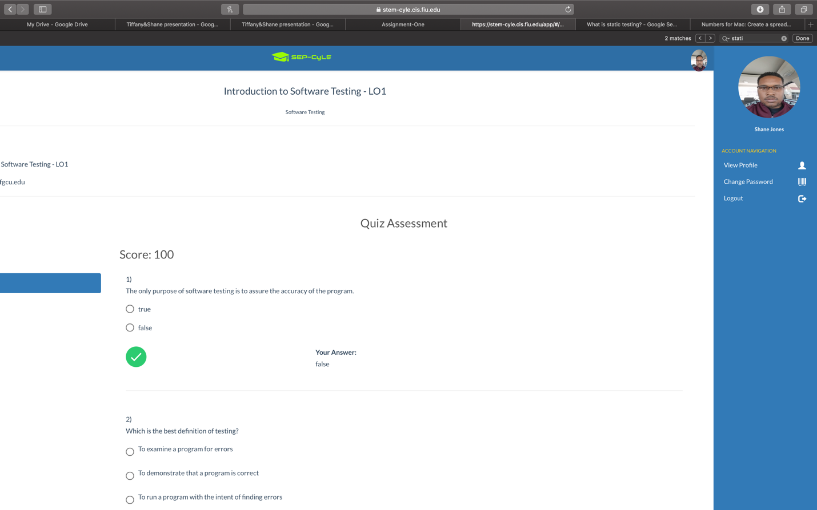

In lo1 it did help me remember some of the thing that we learned in the previous courses. The content helped getting a little bit of a better understand of what the module wanted. The quiz didn’t have all of the information that was asked in the questions. I hope this improved as the course goes on.

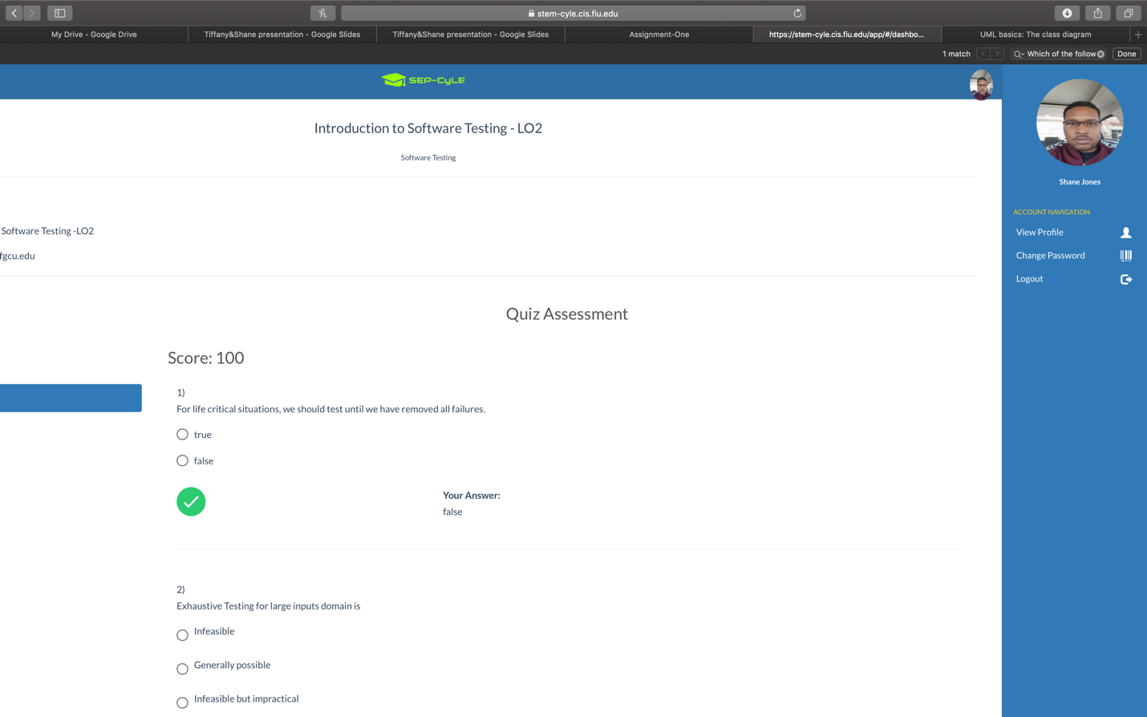

The introduction to software testing covered something that I didn’t really know. It was exhausted testing which is something I didn’t really understand. I am glad it gave me more information about it. But I wasn’t sure on all of the information provided. One of the questions did not seem correct at all. Which caused an issue of concern

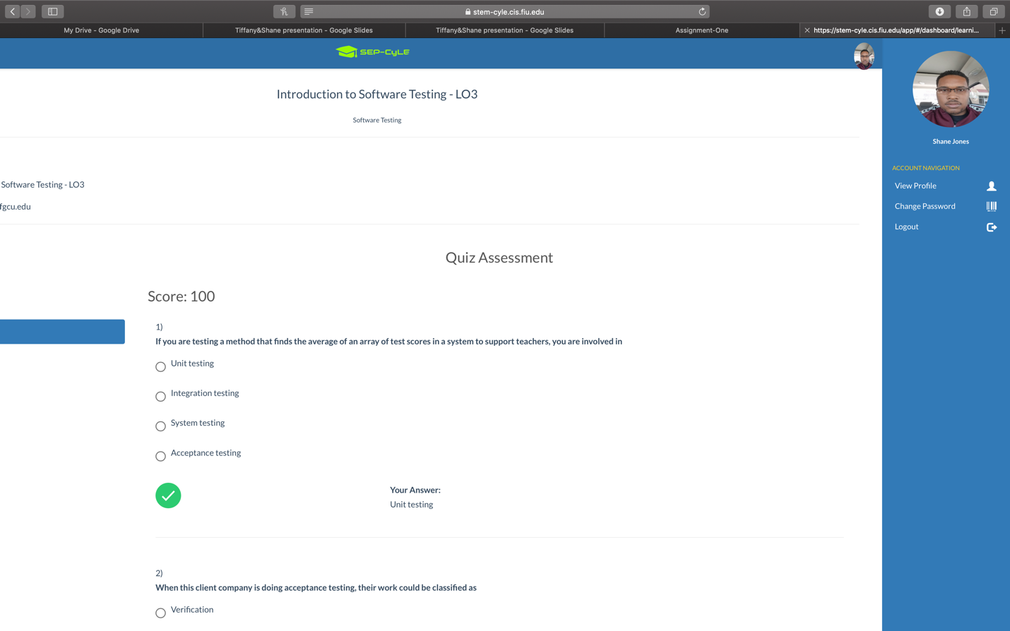

This module covered the different type of testing. I am happy that this module went in depth on the different categories of testing. I am hoping that there will be more information or exercises on other types oftesting.

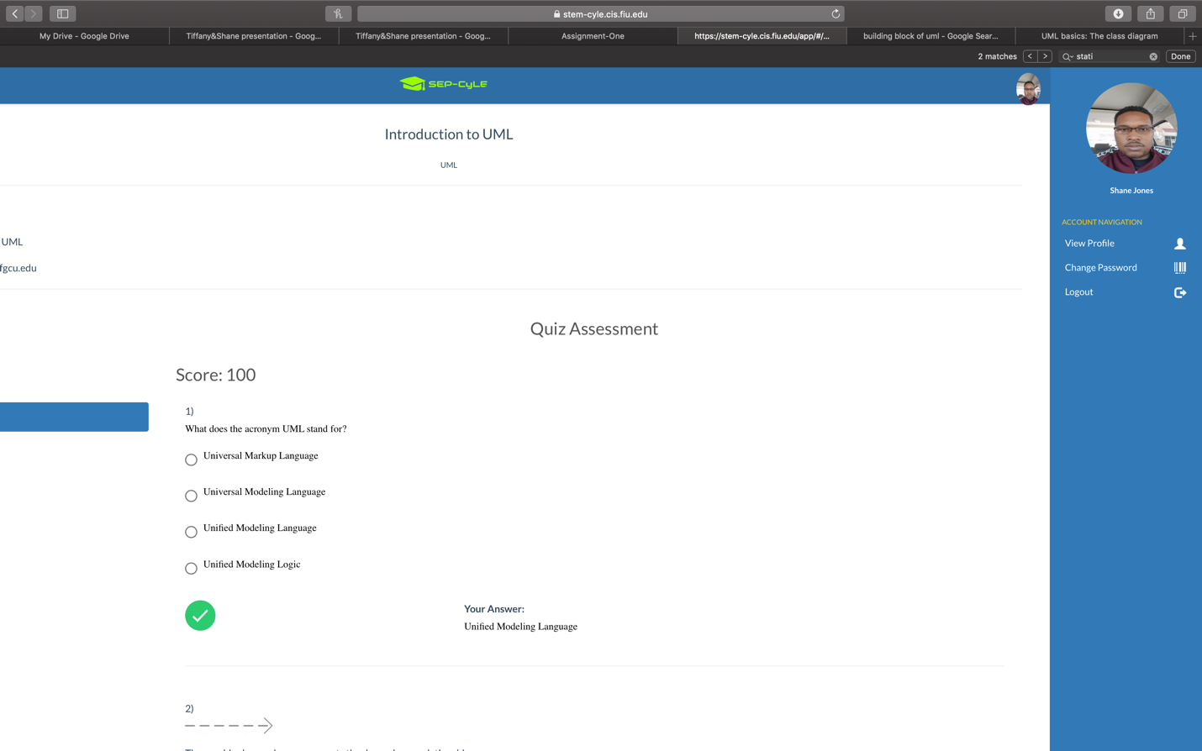

The Uml module did go more in-depth then what I expected to go. It covered more than what I thought would be covered. The content covered in this module made me realize there are than just classes in attributes. I would also say that the quiz was a little confusing and would need better improvement.