Telco Customer Churn
Prediction & Insights Report

Author: Suraj Joshi

Dataset: Telco Customer Churn (7,043 customers, 21 attributes)

Source: https://www.kaggle.com/datasets/blastchar/telco-customer-churn

Context: Prepared for the AICTE | IBM SkillsBuild Data Analytics with AI Internship 2026 (BharatCares)

1. Executive Summary
This project analyzes customer churn in a telecommunications dataset. It answers two practical questions: which customers are most likely to leave, and what factors connect to that decision. After cleaning the data, I analyzed churn patterns, tested primary relationships statistically, and trained a machine learning model to identify high-risk accounts.
Metric | Value
Total Customers | 7,043
Churned Customers | 1,869
Churn Rate | 26.54%

2. Data Cleaning

Total Charges: Converted from text to numeric format. This step identified 11 blank entries, all belonging to customers with a tenure of 0 months. Because these were new accounts with no billed history, the blanks were replaced with 0 rather than deleting the rows.

SeniorCitizen: Recoded from binary values (0/1) to categorical labels (No/Yes) to improve readability.

CustomerID: Excluded from predictive modeling because it serves strictly as a record identifier.

3. Exploratory Data Analysis

3.1 Overall Churn
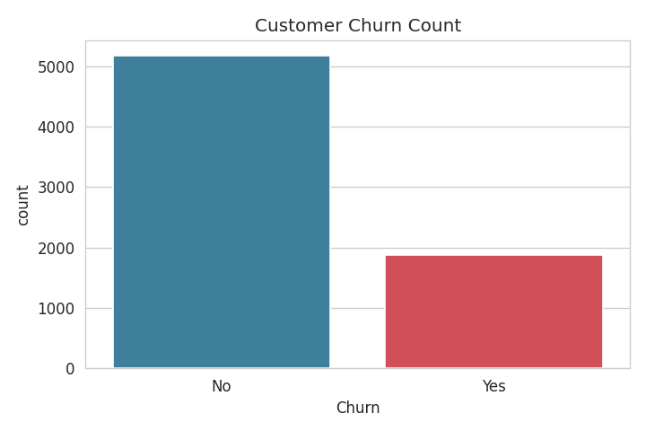

Overall, 26.54% of the customers in the dataset churned (1,869 out of 7,043). About one out of every four customers left the service.

3.2 Churn by Contract Type
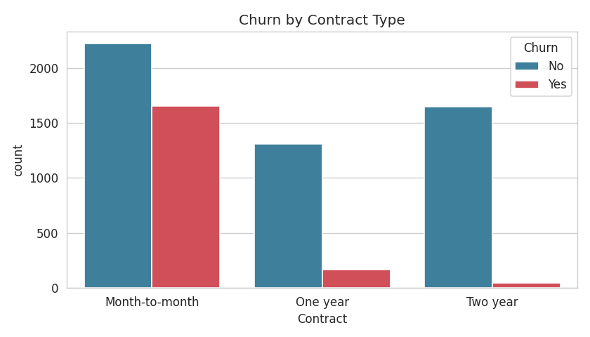

Churn rates vary by contract duration. Customers on month-to-month contracts churned at higher rates compared to those on one-year or two-year contracts.

4. Statistical Significance Test
A chi-square test of independence evaluated the relationship between contract type and churn.

Test | Result
Chi-square statistic | 1184.6
p-value | 5.86 x 10⁻²⁵⁸
Conclusion | Statistically significant (p < 0.001)

The p-value is below the 0.05 threshold, showing strong evidence of an association between contract type and churn. Contract type and churn are not independent in this dataset.

A logistic regression model was also fitted to evaluate individual variable coefficients and provide statistical context alongside the tree-based model.

5. Prediction Model
Because churn accounts for 26.54% of total observations, evaluation focused on precision, recall, and F1 score alongside accuracy. A Random Forest Classifier with 300 trees, a maximum depth of 8, and class-balanced weighting was trained on an 80/20 train-test split.
.
Metric | Value
Accuracy | 75.2%
Precision (Churn) | 52.1%
Recall (Churn) | 79.4%
F1 Score | 62.9%

Recall served as the primary evaluation metric. A recall of 79.4% means the model identified 297 out of 374 churned customers in the test set. In a retention setting, missing a customer who leaves costs more than contacting a customer who stays.

5.1 Confusion Matrix
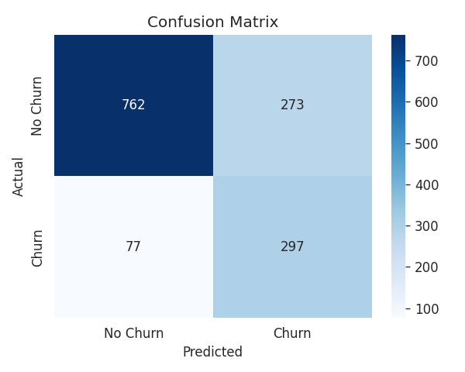

Out of 374 actual churned customers in the test set, the model correctly identified 297, reaching a recall of 79.4%.

5.2 Top Churn Drivers
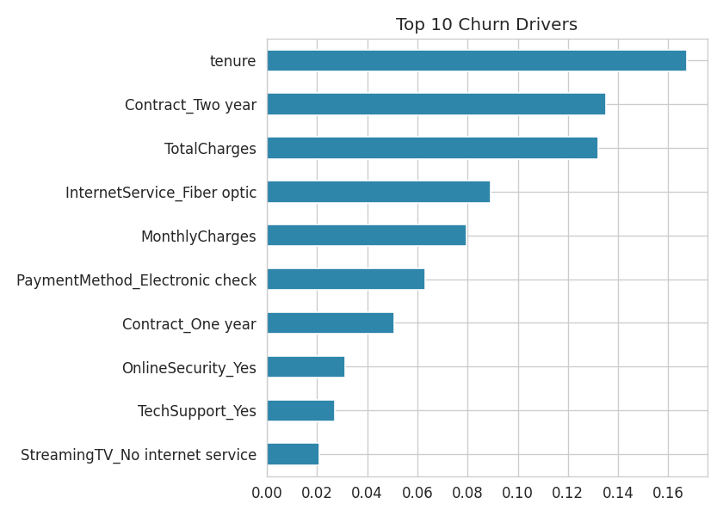
The model assigns the highest feature importance to tenure, contract type, total charges, fiber optic internet service, and monthly charges.

6. Recommendations and Practical Actions

6.1 Contract Length

Fact: Contract type has a statistically significant relationship with churn (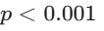) and ranks among the highest predictors in the model.

Observation: Differences across contract types indicate that contract structure directly relates to retention.

Opportunity: Encourage eligible customers to select multi-year contracts.

Action: Test targeted incentives for month-to-month customers who transition to one-year or two-year contracts, focusing on customers in their first year.

6.2 Tenure & Early Churn Risk
- Fact: Tenure is the strongest predictor in the model.
- Observation: Accounts in their first few months show higher churn rates.
- Opportunity: Improve the onboarding process during early tenure.
- Action: Apply the prediction model to flag new accounts with high risk scores and initiate check-ins during their initial months.

6.3 Fiber Optic Service

Fact: Fiber optic internet service ranks among the top predictors of churn.

Observation: The model indicates an association with churn, though specific causes such as pricing or service quality require separate investigation.

Opportunity: Examine satisfaction levels and pricing structures for fiber optic accounts.

Action: Gather customer feedback from fiber optic subscribers and test targeted retention efforts for accounts flagged as high risk.

6.4 Payment Method
- Fact: Electronic check payment is associated with higher churn in the model.
- Observation: This association shows a pattern but does not prove direct causation.
- Opportunity: Encourage adoption of automated payment methods.
- Action: Test voluntary incentives for customers who switch from electronic checks to automated bank or card payments.

7. Conclusion
The Random Forest model identified 79.4% of churned customers in the test set. Statistical testing confirmed a clear relationship between contract type and churn. Practical next steps include testing longer contract options, improving early tenure onboarding, examining fiber optic service feedback, and offering automated payment incentives.

