Windows Memory Forensics Investigation using Volatility

1. Scenario
The Security Operations Center (SOC) detected unusual activity on an employee’s Windows 10 workstation. A non‑standard process was observed listening on a high TCP port late at night. The user account belongs to an employee who was recently placed under disciplinary review.
The workstation was isolated and a memory dump was captured before the system was shut down. The objective of this investigation is to analyze the memory image using the Volatility framework to identify suspicious processes, determine how they were executed, and uncover potential data exfiltration activity.

2. Tools Used
• Volatility 3 – Memory forensic framework used to analyze the memory image
• Strings – Used to extract readable text from raw memory dumps
• Windows Command Line – Used to execute forensic commands

3. Memory Image Information
File Name: DESKTOP-GQ5C8C6-20260305-145319.raw
Operating System: Windows 10
Purpose: Capture the contents of RAM for forensic investigation.

4. Investigation Steps

Task 1 – Identify Suspicious Processes
Objective: Identify suspicious processes running in the system.
Command Used:
python vol.py -f DESKTOP-GQ5C8C6-20260305-145319.raw windows.pslist
Explanation:
The windows.pslist plugin lists all processes running in memory along with their Process ID (PID), Parent Process ID (PPID), and additional metadata. This helps investigators identify abnormal or suspicious processes.
Finding:
Process Name: svch0st.exe
PID: 4116
Parent PID: 8756
Analysis:
The process name 'svch0st.exe' closely resembles the legitimate Windows process 'svchost.exe'. Attackers commonly use similar names to disguise malicious programs and avoid detection.
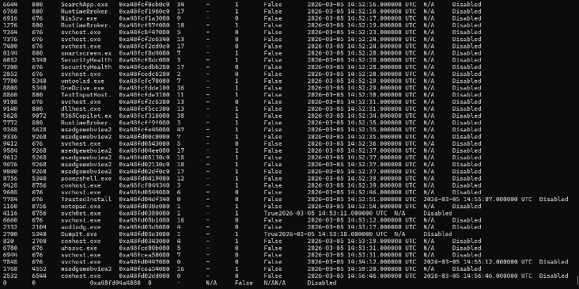

Task 2 – Identify Parent Process
Command Used:
python vol.py -f DESKTOP-GQ5C8C6-20260305-145319.raw windows.pstree --pid 4116
Explanation:
The windows.pstree plugin displays the hierarchical relationship between processes. This helps determine which process launched the suspicious process.
Finding:
Parent Process: winlogon.exe
Analysis:
The suspicious process was spawned from winlogon.exe, which may indicate that the malicious program attempted to appear as a legitimate system process.
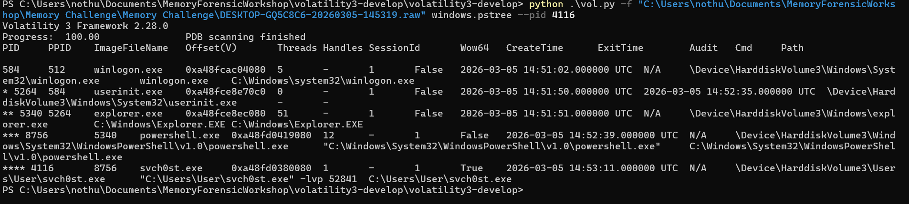

Task 3 – Examine Command Line Arguments
Command Used:
python vol.py -f DESKTOP-GQ5C8C6-20260305-145319.raw windows.cmdline
Finding:
"C:\Users\User\svch0st.exe" -lvp 52841
Analysis:
The '-lvp' parameter is commonly associated with Netcat, a networking utility often used by attackers to create reverse shells or listening backdoors. This suggests the process may have been used to open a listening port for remote access.
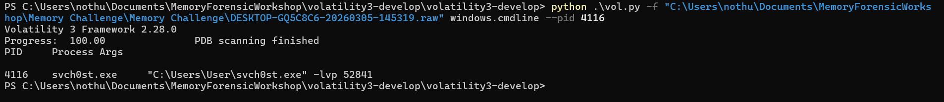

Task 4 – Network Activity Analysis
Command Attempted:
python vol.py -f DESKTOP-GQ5C8C6-20260305-145319.raw windows.netscan
Explanation:
The windows.netscan plugin identifies active or recently closed network connections in memory.
Observation:
The plugin did not return results. This may occur due to compatibility limitations between the memory image and the Volatility plugin version.

Task 5 – Sensitive File Discovery
Finding:
secret_plan.txt
Analysis:
The presence of a file named 'secret_plan.txt' suggests that the user may have been preparing sensitive information for exfiltration.

Task 6 – Identify Exfiltration IP Address
Command Used:
python vol.py -f DESKTOP-GQ5C8C6-20260305-145319.raw windows.memmap --pid 1160 --dump
Followed by:
strings pid.1160.dmp > pid.1160.txt
Search Keyword:
MIDNIGHT
Finding:
192.168.1.50
Analysis:
The keyword 'MIDNIGHT' was discovered in the extracted memory strings along with the IP address 192.168.1.50, suggesting that the attacker planned to exfiltrate data to this address at midnight.

5. Conclusion
The memory forensic investigation revealed the presence of a suspicious process named 'svch0st.exe', which appears to mimic the legitimate Windows process 'svchost.exe'. Analysis of the command line arguments suggests that the process was likely used to establish a listening backdoor using Netcat.
Additionally, evidence of a sensitive file named 'secret_plan.txt' was discovered. Further analysis of memory strings revealed the IP address 192.168.1.50, which appears to be the planned destination for data exfiltration at midnight.
These findings indicate potential malicious activity performed on the system prior to the workstation being isolated.

