Rate Map

Create zones by clicking button 1 then click at least 3 points on the map. With overlapping zones the last zone added has priority. When variable rate is enabled and no zone exists the base rate is used.

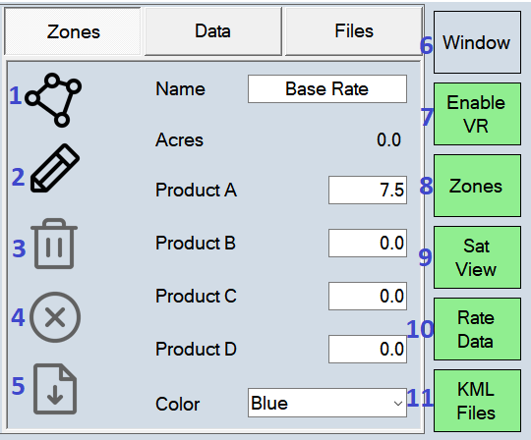
- Create a new rate zone.
- Edit rate zone properties.
- If creating a zone, delete corner. If editing a zone, delete zone.
- Cancel edits.
- Save edits.
- Preview window.
- Enable variable rate control.
- Toggle rate zones.
- Toggle satellite view.
- Toggle applied rate display.
- Toggle KML display.

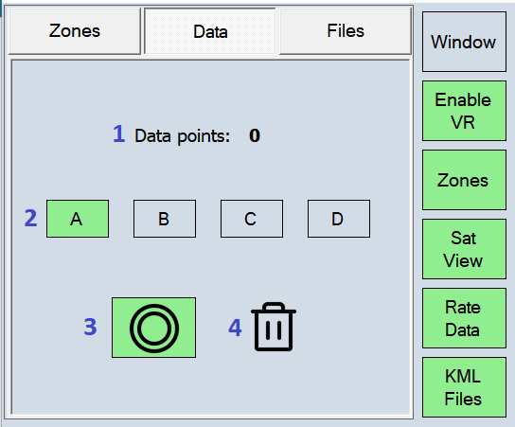

- Data Records.
- Product applied rate to display.
- Record applied rates.
- Delete applied rate data.

