Rate Map

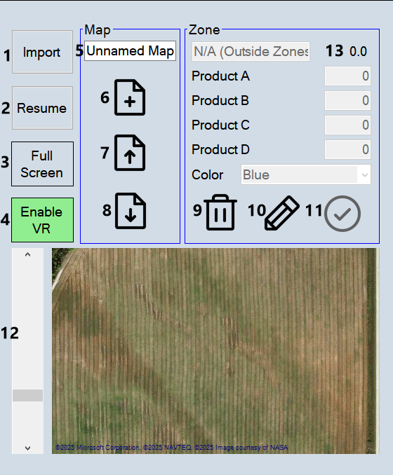

- Import
  - Load shape files.
  - Cross reference RC shape file attributes with matching attributes from the file loaded.
  - The file is then saved as a RC shape file.

- Resume
  - Load previous file.

- Full Screen

- Enable VR
  - Enable variable rate control. Each product uses variable rate control. All zones must define a rate for each product used.

- Map name.

- New map.

- Load map.

- Save map.

- Delete zone.

- Edit zone.

- Save edit.

- Map zoom.

- Area, hectares or acres.

Files are save in the folder ‘RateMap’ in ‘Documents’. Each map has its own folder in ‘RateMap’. There is also the folder ‘MapCache’. This is a cache of the maps so that the map can be used offline.

To create a zone click the edit button. Enter a zone name. Enter rates for each product used. Click the map to define the boundaries of the zone. Click save zone and save map when finished. If two zones overlap, the last zone counts. For a new field create a zone for the field first. Then create other zones over top of the main zone for the field.

