Applied Rates Data

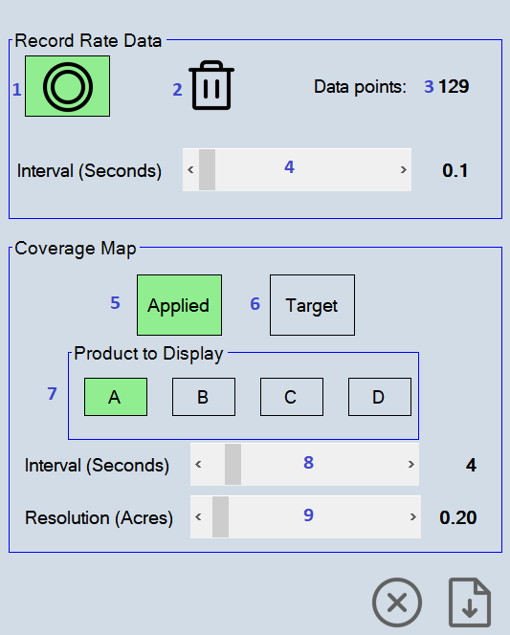

- Enable recording.
- Delete recorded data.
- Number of data records saved.
- How often in seconds that data points are saved.
- Show Applied rates on map.
- Show Target rates on map.
- Choose product rates to show on map.
- Map refresh interval in seconds to update the rate data display.
- The size of the area to average the rates in acres or hectares.

