Jobs

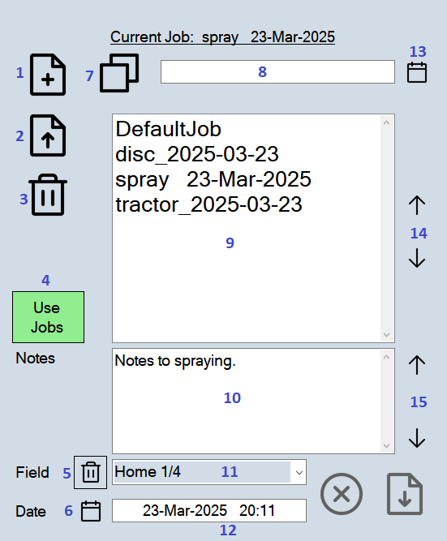
- New file.
- Load selected job.
- Delete selected job.
- If selected, RateController will use job files to record notes, field names and dates. Jobs also allows the recording of product application rates and the use of rate maps.
- Delete a field name from the list of field names.
- Insert today’s date and time.
- Copy file from selected job.
- File name for the new or copied job.
- List of jobs.
- Notes to job.
- Name of field. To add fields type the new name.
- Date of job.
- Append date to job name. Allows the job list to sort similar jobs by date.
- Page up/down job list.
- Page up/down notes.

