Profiles

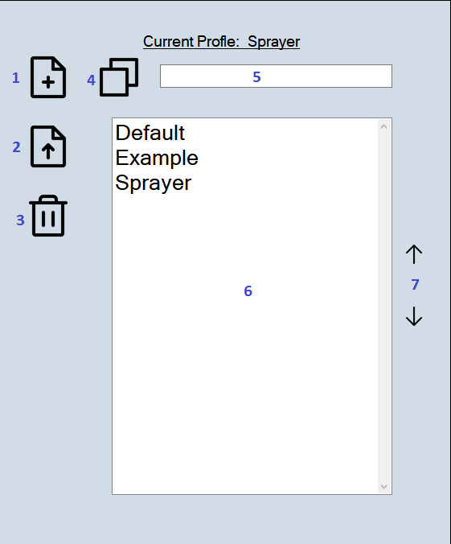

- New | - Load
- Delete | - Copy
- File name for New/Copy | - Files to select
- Page Up/Down

