Modules Config
- Relays
0. no relays
    - GPIOs, use the micro-controller pins.
    - PCA9555, use 8 relay module.
    - PCA9555 , use 16 relay module.
    - MCP23017
    - PCA9685
    - PCF8574

- Pins

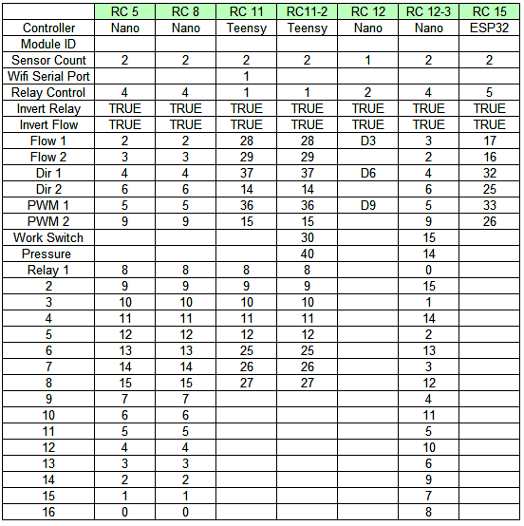

- Nano Pins

