Modules - Network

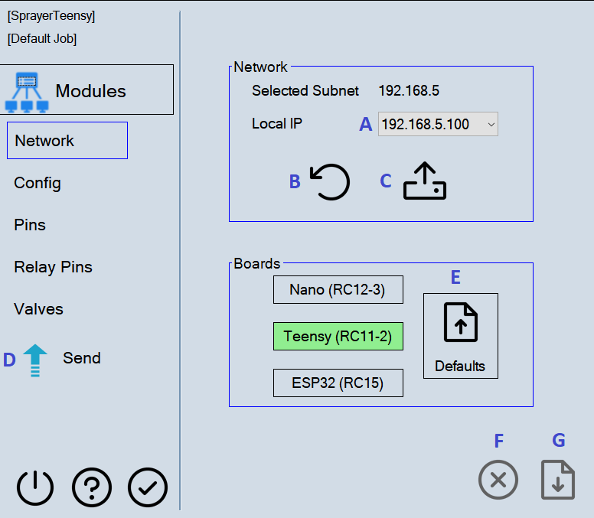

- Refresh IP list with (B). Select an IP with (A). Send to module at (C).

- The mod icon should turn green. 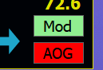 The module must be connected before sending any other settings.

- Select a board that is similar to what is used on the module. The defaults button with (E) will be selected. Save changes with (G) or cancel with (F).

- Make necessary changes on the remaining module pages, save with (G) on each page. Once all edits are complete send the settings to the module with (D). (D) can also be used for single page edits.

