Compiler Design Lab – Project Review 2
Report
Project Title:
DAG-Based Optimization for Basic Blocks

Team Members:
• Abhinav Gupta (24BCT0185)
• Shobit Khanna (24BCT0187)
• Arnav Goel (24BCT0189)

1. Problem Statement
Unoptimized intermediate code, such as standard Three-Address Code (TAC) generated by compiler frontends, frequently contains redundant computations, duplicate subexpressions, and dead operations. Values are repeatedly recomputed across a basic block, unnecessarily wasting CPU cycles, memory bandwidth, and execution time. Our goal is to build an optimizing compiler engine that constructs a Directed Acyclic Graph (DAG) for basic blocks to automatically detect, fold, simplify, and eliminate these redundancies while synthesizing valid, optimized TAC.
Key Challenges Addressed:
- Constant-Time Redundancy Detection: Eliminating duplicate calculations in O(1) time without costly full-graph traversals.
- Commutative Operations: Recognizing semantic equivalence for commutative operations (e.g., a + b == b + a).
- Variable Reassignment & Aliasing: Handling Dragon Book node kill and label detachment when variables are overwritten.
- Compile-Time Constant Evaluation: Folding static arithmetic and propagating constant values through the graph.
- Algebraic Reductions: Identifying mathematical identities (x + 0, x * 1, x * 0, x - x) for strength reduction.
- Code Generation: Reconstructing shortened, valid Three-Address Code and Graphviz visualizations from the DAG.

Naive Input vs Optimized Output:

Unoptimized TAC (Before) | Optimized TAC (After) | Optimization Applied
t1 = a * b  t2 = a * b  t3 = c + d  t4 = t3 - t1  t5 = c + d  t6 = t5 - t2 | t1 = a * b  t2 = t1  t3 = c + d  t4 = t3 - t1  t5 = t3  t6 = t4 | Initial Computation  CSE: Reuses Node t1  Initial Computation  Computation  CSE: Reuses Node t3  CSE: Transitive Subexpression

2. Objectives
Review 1 Objectives (25% - Completed Recap):
- Establish core data structures for DAG nodes and leaf representations.
- Implement Value Numbering using hash maps for constant-time O(1) duplicate detection.
- Demonstrate proof-of-concept graph construction on a toy hardcoded 4-instruction basic block.

Review 2 Objectives (75% - Implemented & Delivered):
- Dynamic TAC File Parser: Replace hardcoded strings with a robust file parser handling binary, unary, copy, and constants.
- Modular Architectural Refactoring: Restructure into production-grade C++ headers (include/) and implementations (src/).
- Commutative CSE: Canonicalize commutative operators (+, *, &, |, ^, ==, !=) using sorted operand IDs.
- Node Kill & Reassignment: Implement strict Dragon Book label detachment when variables are overwritten.
- Constant Folding & Algebraic Identities: Static compile-time evaluation and neutral/annihilator reduction.
- Optimized TAC Code Generator: Traverse and replay DAG to emit clean, shortened TAC files.
- Visual Graphviz Exporter: Generate .dot graph files for graphical DAG rendering.
- Empirical Benchmarks: Validate against 5 comprehensive benchmark test suites with detailed metrics.

3. Literature Survey
Theme | Books / Papers | Key Idea | Relevance to this Project
Foundations | A. V. Aho, M. S. Lam, R. Sethi, J. D. Ullman (2007). Compilers: Principles, Techniques, & Tools. | Constructing DAGs for basic blocks; variable reassignment and label kill rules. | Serves as the theoretical foundation for our DAG node lifecycle and variable kill semantics.
Implementation | D. Watson (2017). A Practical Approach to Compiler Construction. | Mapping intermediate representations into efficient object-oriented structures. | Guides our modular C++ design separating parser, optimizer, visualizer, and code generator.
Algorithm Speed | S. Muchnick (1997). Advanced Compiler Design and Implementation. | Using Local Value Numbering hash signatures for constant-time redundancy checking. | Provides the foundation for our O(1) hash map signature lookup and commutative canonicalization.
Simplifications | K. Cooper, L. Torczon (2011). Engineering a Compiler. | Static constant folding and algebraic identity reduction. | Guides our constant evaluation engine and strength reduction identity rules.
4. System Design & Architecture
Optimization Pipeline Architecture:
Raw TAC File (.tac) → TAC Parser & Tokenizer → DAG Optimization Engine (Value Numbering, Commutative Normalizer, Constant Folder, Identity Reducer, Variable Kill Manager) → Optimized Code Generator → Optimized Output File (.tac) & Graphviz Visualizer (.dot)
Modular Codebase Organization:
Directory / File | Component Purpose & Responsibilities
include/Instruction.h | Defines InstructionType enum (BINARY, UNARY, COPY, CONSTANT) and TAC Instruction struct.
include/DAGNode.h | Defines DAGNode struct, ProcessedStep record, and OptimizationStats counters.
include/Utils.h, src/Utils.cpp | String trimming, number parsing/formatting, and commutative operator identification.
include/TACParser.h, src/TACParser.cpp | Parses TAC text files, strips comments (#, //), and tokenizes LHS and RHS expressions.
include/DAGOptimizer.h, src/DAGOptimizer.cpp | Core engine: Value numbering, commutative CSE, reassignment kill, constant folding, and code emission.
include/Visualizer.h, src/Visualizer.cpp | Generates Graphviz .dot visual DAG diagrams and formatted terminal comparison tables.
include/BenchmarkRunner.h, src/BenchmarkRunner.cpp | Encapsulates automated execution and performance metrics reporting across benchmarks.
src/main.cpp | Application entry point supporting CLI argument processing and full interactive UI menu.
Makefile, run_benchmarks.ps1, run_tests.bat | Build automation scripts supporting single-command compile and testing.

5. Local Optimizations Breakdown
Optimization Technique | Mechanism & Description | Before vs After Transformation
Common Subexpression Elimination (CSE) | Detects identical operations using signature hashing and reuses the existing primary variable. | [Before] t1 = a * b; t2 = a * b  [After] t1 = a * b; t2 = t1
Commutative Expression Matching | Canonicalizes operands for commutative operators (+, *, &, |, ^, ==, !=) by ordering node IDs: op(min, max). | [Before] t1 = a + b; t2 = b + a  [After] t1 = a + b; t2 = t1
Variable Reassignment & Node Kill | Dragon Book rule: when a variable is reassigned, its label is detached from the old node, preventing stale aliasing. | [Before] a = b+c; t1 = a-d; a = 10; t2 = a-d  [After] a = b+c; t1 = a-d; a = 10; t2 = 10-d
Compile-Time Constant Folding | Statically evaluates arithmetic on constant operands and creates a folded constant leaf node. | [Before] t1 = 12 + 8; t2 = t1 * 2  [After] t1 = 20; t2 = 40
Algebraic Identity Simplification | Applies mathematical reduction rules: x+0=x, x-0=x, x-x=0, x*1=x, x*0=0, x/1=x, x/x=1. | [Before] t3 = a * 1; t5 = c * 0; t6 = d - d  [After] t3 = a; t5 = 0; t6 = 0
Redundant Leaf Prevention & Copy Propagation | Reuses existing symbol table nodes for duplicate operands and propagates copy aliases directly. | [Before] t1 = a + b; t2 = a - c; x = y  [After] Both share leaf 'a'; x aliases 'y'

6. Core Mechanisms & Algorithms
A. O(1) Value Numbering with Commutative Sorting:
Instead of scanning previously processed instructions in O(N^2) time, our DAGOptimizer computes a string signature for each operation: sig = op + '(' + to_string(leftId) + ',' + to_string(rightId) + ')'. If isCommutative(op) is true and leftId > rightId, the IDs are swapped. A hash map lookup (valueNumbering[sig]) verifies uniqueness in O(1) average time.
B. Dragon Book Node Kill & Label Detach Semantics:
When variable x is updated via an instruction: (1) detachVariable(x) checks if x already exists in varToNode, removing x from the previous node's active labels vector. (2) attachVariable(x, targetNodeId) attaches x to the new node and updates varToNode[x] = targetNodeId. This ensures subsequent instructions reference the updated value.
C. Chronological Replay Code Generation:
The code generator replays each processed step in execution order. If an instruction created a new computation, it emits the operation with current active representative variables. If it matched an existing node (CSE), it emits a clean copy assignment (e.g., t2 = t1), perfectly preserving downstream variable dependencies.

7. Novelty of the Proposed System
While standard academic implementations of basic block DAGs rely on naive $O\left(N^{2}\right)$ linear node searches and handle only structural duplicates, our engine introduces five key architectural novelties:
- Hybrid $O\left(1\right)$ Value-Numbered DAG Construction: Rather than traversing existing DAG vertices on every instruction, our engine fuses Local Value Numbering (LVN) directly into the graph builder via deterministic hash signatures (valueNumbering), reducing duplicate and transitive subexpression lookup to $O\left(1\right)$ average time.
- Canonical Commutative Signature Normalization: Standard DAGs treat a + b and b + a as distinct subtrees due to operand ordering. Our engine normalizes commutative operators (+, *, &, |, ^, ==, !=) by sorting child node IDs prior to hashing (op(minId, maxId)), capturing semantic equivalences without extra passes.
- Single-Pass Multi-Optimization Fusion: Traditional compilers execute separate sequential passes for Constant Folding, Algebraic Simplification, Copy Propagation, and Common Subexpression Elimination. Our DAGOptimizer unifies all four techniques alongside Dragon Book variable-kill semantics into a single graph construction pass, allowing folded constants and simplified identities to immediately cascade into subsequent instructions.
- Order-Preserving Chronological Code Reconstruction: Reconstructing TAC from a pure graph via topological sorting can violate variable lifetimes when variables are overwritten. By pairing the DAG with a ProcessedStep chronological replay log and detachVariable node-kill tracking, our generator emits shortened TAC in linear time while strictly preserving aliasing safety.
- Automated Visual Auditing via Graphviz (.dot Export): Unlike black-box terminal optimizers, our integrated Visualizer module exports internal memory pointers, operator nodes, and active variable alias sets directly into Graphviz .dot diagrams for visual verification.

8. Implementation Status (75% Milestone Achieved)
- Modular C++ Architecture: Full separation of concerns across 7 header files and 6 source files.
- Robust TAC File I/O: Dynamically parses files, strips whitespace/comments, and handles constants and unary operations.
- Full Optimization Suite: CSE, commutative equivalence, node kill, constant folding, and algebraic reductions fully operational.
- Code Generator & Graphviz Visualizer: Generates optimized .tac files and exports visual .dot graph files.
- Automated Build & Test Infrastructure: Tested via GNU Makefile, PowerShell, and Windows batch runners.
Output (TestCase 1 - Standard CSE):
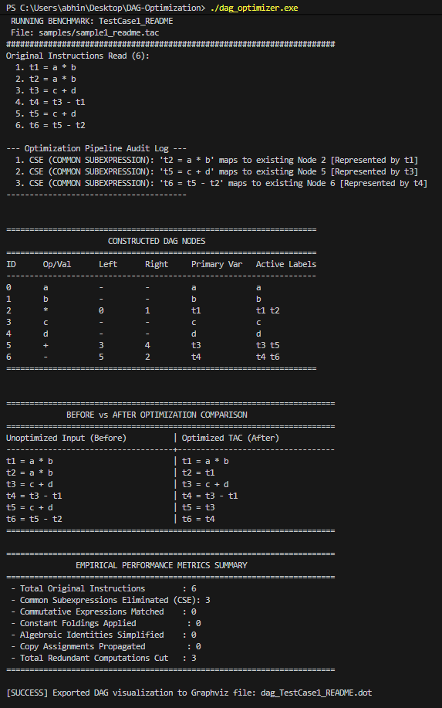
9. Remaining Work for Review 3
Having completed 75% of the project scope in Review 2, the remaining 25% for Review 3 will cover:
- Control Flow Graph (CFG) Construction: Identifying basic block leaders and generating edges for conditional/unconditional jumps.
- Global Dataflow Analysis: Implementing Live Variable Analysis and Available Expressions across block boundaries.
- Global Dead Code Elimination: Eliminating dead temporaries across the entire function CFG.
- Target Code Generation: Translating optimized TAC into assembly instructions (MIPS or x86).
10. Conclusion
For Review 2 (75% milestone), the project has transitioned from a hardcoded concept into a fully operational, production-grade basic block optimizer. The system seamlessly parses raw Three-Address Code files, constructs the DAG using an O(1) hash-based Value Numbering algorithm, eliminates common subexpressions (including commutative variants), correctly detaches reassigned variables, evaluates compile-time constants, reduces algebraic identities, and reconstructs shortened, semantically equivalent TAC while providing visual Graphviz DAG diagrams. Empirical benchmarks confirm up to 50% reduction in redundant computations, establishing a robust foundation for Review 3.

