Project 1

**Analysis of Airline Passenger Satisfaction**

**Bootcamp: DATA-PT-WEST-SEPTEMBER-091624-MTTH-CONS**

**Original data set is taken from this source:

https://mavenanalytics.io/data-playground?order=date_added%2Cdesc&search=travel

**Created and Performed by Group 2**

**Contributors**: Tanner Bingham and Anya Bocharova

The data we got consists of survey results from 129,880 Airline passengers.

The survey was created like 0-5 scored system, together with some data about passengers itself who answered following questions:

|  |  |
| --- | --- |
| *Type of Travel* | Purpose of the flight (Business/Personal) |
| *Class* | Travel class in the airplane for the passenger seat |
| *Flight Distance* | Flight distance in miles |
| *Departure Delay* | Flight departure delay in minutes |
| *Arrival Delay* | Flight arrival delay in minutes |
| *Departure and Arrival Time Convenience* | Satisfaction level with the convenience of the flight departure and arrival times from 1 (lowest) to 5 (highest) - 0 means "not applicable" |
| *Ease of Online Booking* | Satisfaction level with the online booking experience from 1 (lowest) to 5 (highest) - 0 means "not applicable" |
| *Check-in Service* | Satisfaction level with the check-in service from 1 (lowest) to 5 (highest) - 0 means "not applicable" |
| *Online Boarding* | Satisfaction level with the online boarding experience from 1 (lowest) to 5 (highest) - 0 means "not applicable" |
| *Gate Location* | Satisfaction level with the gate location in the airport from 1 (lowest) to 5 (highest) - 0 means "not applicable" |
| *On-board Service* | Satisfaction level with the on-boarding service in the airport from 1 (lowest) to 5 (highest) - 0 means "not applicable" |
| *Seat Comfort* | Satisfaction level with the comfort of the airplane seat from 1 (lowest) to 5 (highest) - 0 means "not applicable" |
| *Leg Room Service* | Satisfaction level with the leg room of the airplane seat from 1 (lowest) to 5 (highest) - 0 means "not applicable" |
| *Cleanliness* | Satisfaction level with the cleanliness of the airplane from 1 (lowest) to 5 (highest) - 0 means "not applicable" |
| *Food and Drink* | Satisfaction level with the food and drinks on the airplane from 1 (lowest) to 5 (highest) - 0 means "not applicable" |
| *In-flight Service* | Satisfaction level with the in-flight service from 1 (lowest) to 5 (highest) - 0 means "not applicable" |
| *In-flight Wifi Service* | Satisfaction level with the in-flight Wifi service from 1 (lowest) to 5 (highest) - 0 means "not applicable" |
| *In-flight Entertainment* | Satisfaction level with the in-flight entertainment from 1 (lowest) to 5 (highest) - 0 means "not applicable" |
| *Baggage Handling* | Satisfaction level with the baggage handling from the airline from 1 (lowest) to 5 (highest) - 0 means "not applicable" |
| *Satisfaction* | Overall satisfaction level with the airline (Satisfied/Neutral or unsatisfied) |

Before diving into the analysis, it’s essential to clarify certain service terms to ensure accuracy and avoid potential misunderstandings in our conclusions. Specifically, we need to distinguish between “In-flight Service” and “On-board Service,” as they serve distinct roles in the passenger experience: "in-flight service" and "on-board service" are not the same thing,

**In-flight Service**: refers to overall amenities and activities provided during the flight, such as entertainment (movies, music, games), Wi-Fi, in-flight meal and beverage options, and sometimes services like duty-free shopping during the flight. It focuses on keeping passengers comfortable and entertained throughout the flight.

While **On-board Service**: This term is broader and includes all services offered by the cabin crew from the moment passengers board the aircraft until they disembark. It covers the overall experience on the plane, including assistance with luggage, cleanliness of the cabin, safety briefings, and overall customer care provided by the crew.

In short, **In-flight Service** centers on amenities during flight time, while **On-board Service** covers the entire passenger experience from boarding to exit.

Additionally, to further streamline the analysis:

• **“Online Boarding”** will be referred to as **Online Check-in**, representing the service of checking-in online before arrival at the airport.

• **“Check-in Service”** refers to the assistance received at the airline check-in counter at the airport.]

So lets begin.

**Part 1. General Analysis of Airline data:**

|  |  |  |  |
| --- | --- | --- | --- |
|  | **Mean** | **Median** | **Mode** |
| **Age** | 39.42795 | 40.0 | 39.0 |
| **Flight Distance** | 1190.316392 | 844.0 | 337.0 |
| **Departure Delay** | 14.713713 | 0.0 | 0.0 |
| **Arrival Delay** | 15.091129 | 0.0 | 0.0 |

1. **Age**

**Mean (39.43)**: **Median (40)**: **Mode (39)**:

All three parameters are close to each other’s, showing the most frequent and common travelers age.

The age profile suggests the airline might be popular with middle-aged travelers, which could inform targeted services, marketing, or in-flight offerings aligned with this age group’s preferences.

**2. Flight Distance**

**Mean (1190.32 miles)**: **Median (844 miles)**: **Mode (337 miles)**:

This mix indicates the airline operates in diverse markets, serving both short-haul and long-haul routes. Understanding this distribution can help the airline optimize resources and improve services for each flight length category.

**Departure and Arrival Delay**

**Median (0)** and **Mode (0)**: for both indicate that the majority of flights depart on time or with minimal delays, which is a positive sign for operational efficiency.

**Mean -around 15** **mins** indicates normal distribution of delays even though some of them could be 0 and some others could be are super long delays over an 1hr. But in general, this should not be an issue or a bad indicator of Airline work. And a sign of good relationship with Airports.

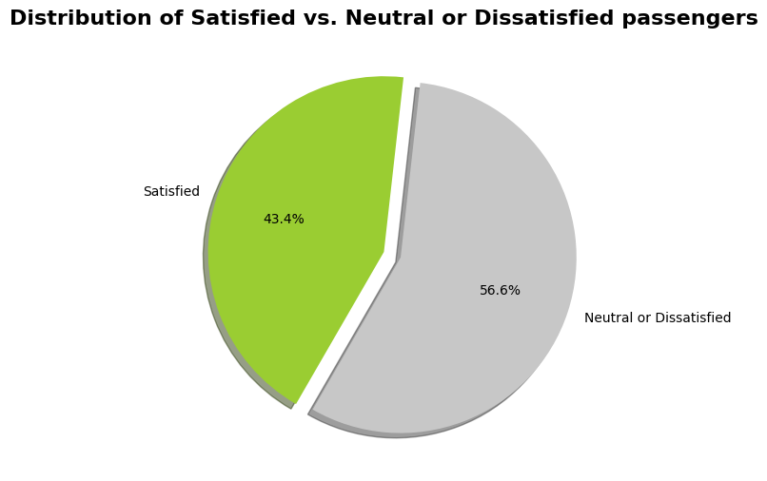

The general Satisfaction of Airline Services is a little disturbing, so we are doing Analysis to figure out most common groups of people who could possible be unhappy with Airline Services.

Also we figured out Top 5 and Bottom 5 airline services by survey:  
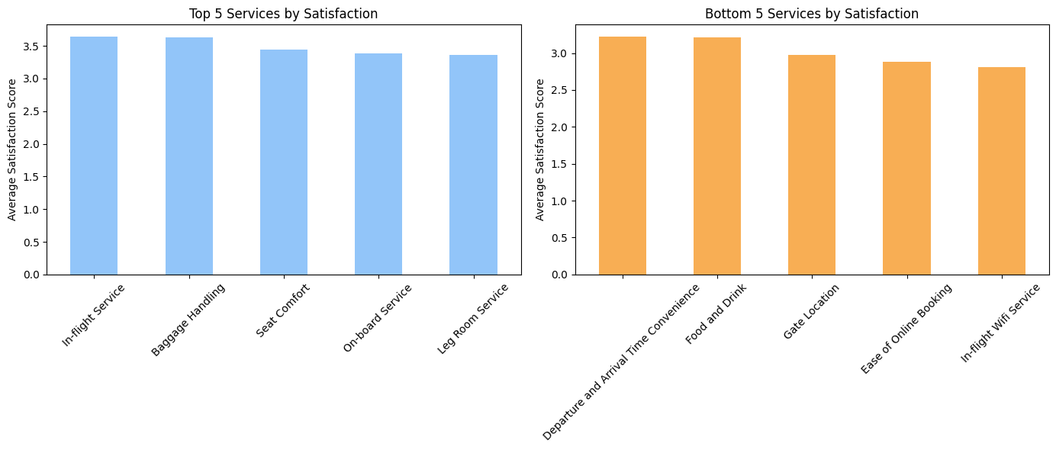

**Part 2. Performing Data Analysis:**

* New Passengers who consist of 18.3% of all passenger are most unhappy group of people. Only 24% of them are satisfied with services.
* Business class passengers seem to be most satisfied and happy with the Airline,

which is 47.9% of passengers’ flow

* More than a half of 44.9% passengers of economy class looks totally unhappy.
* Economy plus is only **7.2%** of overall passengers and also more than a half look unsatisfied.
* By the age group we can see that majority of passenger before 35 age looks not very happy.

Especially kids under age of 12. And their disturbing parameters are **Cleanliness, Food & Drink and in-flight Wifi Service, In-flight Entertainment, Seat Comfort** and **Ease of On-line booking** while they highly appreciate **In-flight Service and Departure and Arrival Time.**

**Key Passenger Insights**

Our analysis shows that **business class passengers over 35** and **returning customers** are among the most satisfied passengers, suggesting the frequent flyer program is effectively supporting loyalty. Meanwhile, **younger, first-time passengers in economy class** report lower satisfaction levels, highlighting areas for targeted improvements.

**Part 3. Recommendations for Improvement**

1. **Age-Targeted Onboard Amenities**

• **Young Travelers**: Offer kid-friendly entertainment, such as coloring books, plush toy souvenirs, and a dedicated children’s menu. Ensure ample family-friendly movie options.

• **Adult Passengers**: Provide comfort items like socks, blankets, or earplugs for a relaxing journey.

2. **Enhancing Online Booking Accessibility**

Simplifying and optimizing the online booking system could positively impact satisfaction, cause all of passenger types rate this service as a low point. An intuitive, accessible interface could make a significant difference.

3. **Onboard WiFi Access as a Value Add**

Offering free WiFi to passengers who leave a review could improve satisfaction ratings and encourage positive feedback. This would address one of the frequently mentioned pain points while promoting engagement with the airline’s services.

4. **Incentivize Feedback through Rewards**

To gather valuable insights, consider offering loyalty points or small perks for passengers who complete a post-flight survey. This feedback can drive continuous service improvement and create a sense of customer appreciation.

5. **Promote Loyalty Program Benefits**

Make sure passengers are aware of the perks of joining the loyalty program, perhaps through in-flight announcements, video ads, or reminders from the flight crew. Highlight upgrades, rewards, and other advantages to boost membership and engagement.

6. **Health-Conscious Food Options**

With wellness trends on the rise, consider including healthy snack options, especially in economy class. These might include:

• Fresh fruits (apples, bananas), or dried fruit and veggie chips

• Roasted nuts and seeds, popcorn, or protein snacks like string cheese

• Hummus, guacamole, or whole-grain crackers with dark chocolate for a sweet treat

7. **Refining the Passenger Questionnaire**

Design a new, more engaging feedback form that covers relevant service areas while being easy and quick to complete. This could provide clearer insights into areas needing attention and keep passengers engaged in improving their travel experience.

**Improved questionnaire for next reviews**

|  |  |
| --- | --- |
| *Type of Travel* | Purpose of the flight (Business/Personal/Vacation) |
| *Class* | Travel class in the airplane for the passenger seat |
| *Flight Distance* | Flight distance in miles |
| *Departure Delay* | Flight departure delay in minutes |
| *Arrival Delay* | Flight arrival delay in minutes |
| *Date of Flight* | Yyyy/mm/dd |
| *Airport of Departure* | Airport of departure |
| *Airport of Arrival* | Airport of arrival |
| *Departure and Arrival Time Convenience* | Satisfaction level with the convenience of the flight departure and arrival times from 1 (lowest) to 5 (highest) - 0 means "not applicable" |
| *Ease of Online Booking* | Satisfaction level with the online booking experience from 1 (lowest) to 5 (highest) - 0 means "not applicable" |
| *Check-in Service* | Satisfaction level with the check-in service from 1 (lowest) to 5 (highest) - 0 means "not applicable" |
| *Online Check-in* | Satisfaction level with the online boarding experience from 1 (lowest) to 5 (highest) - 0 means "not applicable" |
| *Gate Location* | Satisfaction level with the gate location in the airport from 1 (lowest) to 5 (highest) - 0 means "not applicable" |
| *In-flight Service* | Satisfaction level with the on-boarding service in the airport from 1 (lowest) to 5 (highest) - 0 means "not applicable" |
| *Seat Comfort* | Satisfaction level with the comfort of the airplane seat from 1 (lowest) to 5 (highest) - 0 means "not applicable" |
| *Leg Room Service* | Satisfaction level with the leg room of the airplane seat from 1 (lowest) to 5 (highest) - 0 means "not applicable" |
| *Cleanliness* | Satisfaction level with the cleanliness of the airplane from 1 (lowest) to 5 (highest) - 0 means "not applicable" |
| *Food and Drink* | Satisfaction level with the food and drinks on the airplane from 1 (lowest) to 5 (highest) - 0 means "not applicable" |
| *In-flight Wifi Service* | Satisfaction level with the in-flight Wifi service from 1 (lowest) to 5 (highest) - 0 means "not applicable" |
| *In-flight Entertainment* | Satisfaction level with the in-flight entertainment from 1 (lowest) to 5 (highest) - 0 means "not applicable" |
| *Baggage Handling* | Satisfaction level with the baggage handling from the airline from 1 (lowest) to 5 (highest) - 0 means "not applicable" |
| *Satisfaction* | Overall satisfaction level with the airline (Satisfied/Neutral or unsatisfied) |

We added questions about **departure and arrival airports** because it’s essential for the airline to monitor performance on aspects closely tied to airport services, such as **Gate Location** and **Baggage Handling**. As these services are managed by the airport, understanding their impact on passenger satisfaction allows the airline to address potential issues in collaboration with airport authorities.

We removed the **On-Board Service** row from the questionnaire because the existing questions already cover specific aspects of this area. The overall performance of the crew is effectively captured under **In-flight Service**, eliminating any potential redundancy.