UniSketch TCP Client (aka “Raw Panel”)
The UniSketch TCP Client device core (also known as "Raw Panel") connects to an external server on port 9923. This server would typically be a third party host system implementing the logic behind the commands sent from the “SKAARHOJ Raw Panel”, but it could even be another SKAARHOJ panel with the “TCP Server” device core active in which case the client can “remote control” the server panel. The actions in the table below all relates to such a remote control scenario.

Raw Panel mode essentially is to let the server be a software application written to support the UniSketch TCP Client protocol and thus use a SKAARHOJ panel to simply send triggers such as keypresses, pulses and analog values over to the server which in turn maps them to actions in its domain. This has also historically been referred to as “dumb panel” since the panel does not know anything about the application it’s being used in. In case of Raw Panel implementations, only the action “Tie to Remote HWC” is likely to be relevant.
TCP Server Mode
The device core actually does have an option to create a TCP server instead of being a TCP client. This has been implemented due to popular request. However, just keep in mind that most of this manual is written as if the SKAARHOJ panel is always the TCP client connecting to a server, but it's actually possible to inverse this. Read more about it further down in the documentation.

This is a table of UniSketch actions for UniSketch TCP Client:

Tie to Remote HWC  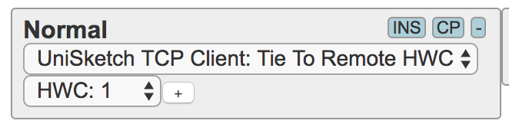 | Will send down / up / encoder pulses / analog values / speed values to the remote HWC by the number listed (unless zero is selected in which case the current HWC number is used). So for instance, if this is applied to a push button, when that button is pressed down, a Down action for that HWC is sent to the TCP Server we are connected to.  Likewise, the return value of this element will be the return value retrieved from the remote UniSketch controller.  Button colors: Respond to the return value of “HWC#xx=“ and "HWCc#xx=" (both are necessary)  Displays: Responds to “HWCg#xx” and “HWCt#xx” which lets the server send text and formatting or graphics to the client.
Shift Level  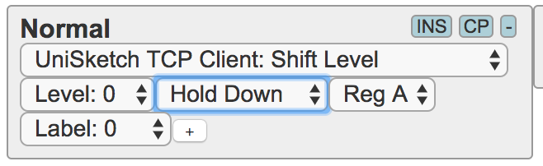 | See description for “Shift Level” from the System Device Core - only this all applies to shift levels on a remote UniSketch controller running "TCP Server" device core, not the local.
State  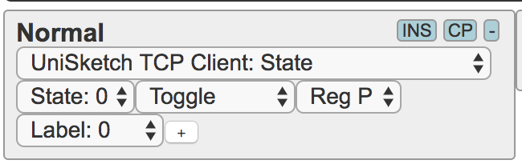 | See description for “Shift Level” from the System Device Core - only this all applies to shift levels on a remote UniSketch controller running "TCP Server" device core, not the local.
Memory  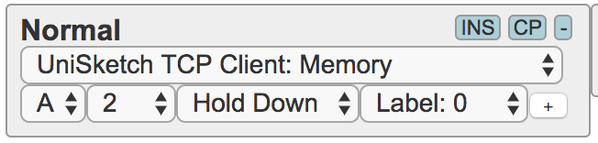 | See description for “Memory” from the System Device Core - only this all applies to memories on a remote UniSketch controller running "TCP Server" device core, not the local.  Notice that “Persist” is not implemented either.
Flags  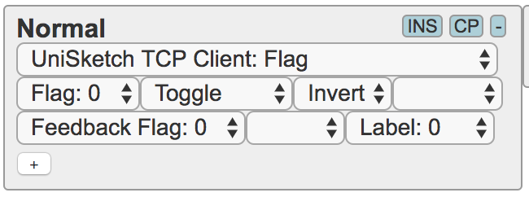 | See description for “Flags” from the System Device Core - only this all applies to flags on a remote UniSketch controller running "TCP Server" device core, not the local.
Change Notification  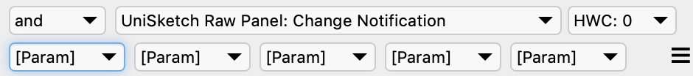 | Inserting this element can lead to automatically sending a message like "HWCmsg#8=CN:0,8,0,0,64" to the server. The message is a change notification which is triggered when any of the five [Param] fields change their value. The values are included in the message as the five comma separated values and can assume any meaning depending on the server side application.  On the client side - in the SKAARHOJ Raw Panel - the five parameters can take values like this:  - Static value 0-31  - Content of memory A-H  - Shift registers (Default, A-D)  - State registers (Default, P-S)  - Flags (grouped in 8 bits)  - Time period triggered (1/8s to 64s)  The main idea with this element is to create generic notifications to a Raw Panel server which supplies content for displays and/or button colors based on a controller state change such as a camera selection or shift level change which should lead to the external system sending new graphics for displays. The timed element would be a way to make sure a change request is also sent out periodically.

API for “Raw Panels”
UniSketch TCP Client can be used to set up an essentially “dumb panel” that only sends action triggers such as keypresses to the server and receives color values for a button and text or graphics for displays. This method is used when UniSketch TCP Client connects to a TCP Server on another SKAARHOJ controller. Likewise any other piece of hardware or software can implement a TCP Server that simply uses the same API to exchange information. The function of a “dumb panel” is implemented by using the “Tie to Remote HWC” action on any hardware interface component that is intended to work as such. Thus a “dumb panel” is only dumb to the extend that hardware interface components are consistently mapped to this action - in other words, a configuration mixed with other device cores or system actions is perfectly possible although that introduces more autonomy and “intelligence” in the panel itself.

Notes on Clients and Servers
In the following the term “client” is used for the SKAARHOJ panel with the UniSketch TCP Client device core running and the term “server” is used to indicate the hardware or software to which the client connects. However, as it has already been noted and will be documented further down, it's possible to reverse this so the panel hosts a TCP server and any external system can connect to it as a TCP client instead. If that is done, the in- and outbound commands between the panel and external system will of course still be the exact same, it's only the method of connection that changes.

TCP settings
A SKAARHOJ controller with the “UniSketch TCP Client” device core will need to be set up with an IP address and it will attempt a connection to this IP address on port 9923. (See further down for how to change this port number.)
All communication forth and back is ASCII lines and terminated by <NL> (newline, “\n”)

Handshaking
After the TCP server responding on port 9923 accepts the connection, it will receive the command “list<NL>” from the UniSketch TCP Client. In response to this command, the server must respond with any initial data it wishes to dump followed (or preceded) by “<NL>ActivePanel=1<NL>” (Notice: text and graphics must come after “<NL>ActivePanel=1<NL>” is sent, in fact text and graphics should probably respond to the “map” command). This will confirm to the UniSketch TCP Client that it has been initialized and it will start to evaluate actions for the panels hardware interface components.
Periodically (like every 3 seconds) the UniSketch TCP Client will send the command “ping<NL>” to which the server must respond in some unspecified way, suggested “ack<NL>” for example. If the server does not respond to pings, the client will disconnect and try to reconnect. Note that the TCP client will wait to send out the 'ping' command while there are incoming commands since incoming commands work as confirmations of connection as well.
Periodically (like every 60 seconds) the UniSketch TCP Client will send the command “list<NL>” to which the server can respond with state information (like button colors, including graphics, text). It’s not mandatory, more like a provision to compensate for any lost communication that might have resulted in the panel being out of sync with the server - something that ideally should not happen of course since all state information should have been perfectly shared over time.
The client will send “BSY<NL>” to the server if it feels it receives content quicker than it can process it. The server should respond by holding back new content until “RDY<NL>” or a “ping<NL>” is received from the client. Generally a whole bunch of data (like graphics and text) can be offloaded at any one time without fear of overload or missing packets since transport layers in TCP will take care of queuing, but the BSY / RDY commands are here to make sure the queue doesn’t grow out of hand. If it does, the panel will keep processing the queue and seem to lag behind in processing new commands.
The server is of course responsible to continuously update the client with new state information as necessary in relation to changes on the server.

Server Mode - no handshake!
Notice: In server mode the “UniSketch TCP Client” device core does not require any handshaking. This will be up to the connecting client to implement as it sees fit.

Inbound TCP commands - from external system to SKAARHOJ panel
In general, see the documentation for the “TCP Server” device core which lists the basic command set supported. However, for the application of “Dumb panels” we will not use any of the registers (shift, state, flags, mem etc.) and focus only on exchange of information in relation to hardware interface components (HWCs).
The basic incoming commands to the panel that the external system could send are listed in this table:
Command | Description
HWC#xx=yy | Status On/Off/Dimmed  xx is the HWC number, yy is a byte defining the state of the component.  The state, “yy”, often translates into a light intensity state such as off / dimmed / on, but may also contain simple on/off binary and color information:  Bit 0-3 forms a number from 0-15:  - 0 = Off  - 2,3,4 = On (where 2=red, 3=green, 4=“On” color (white by default))  - 5 = dimmed “On” color.  Bit 4: Blink flag for monocolor buttons. If set, a monocolor button will blink. This is to provide a way to indicate a different “on” value like a red (2) or green (3) but for a button that can otherwise just show “on”. [Legacy]  Bit 5: Output bit (32); If this is set, a binary output will be set if coupled with this HWC. Generally: Let bit 5 follow whether the “On” color (2,3 or 4) is commanded and let it be off if 0 or 5 is commanded.  Bit8-11: Blink bits: If set 0001, the button will blink with a frequency of about 4 Hz, If set to 1000, the button will blink with a frequency of about 0.5Hz, if set to 1100 it will blink with a 0.5Hz frequency and a 75% duty cycle. The bits are a simple enabling mask against the systems millisecond clock and other combinations can create other blinking patterns.  Most typically you would send these values back: 0 (“Off”), 36 (32+4 for “On”) and 5 (for “Dimmed”). Notice that this only sets the highlight state and most likely you will want to combine this command with "HWCc" in order to also set the RGB color of the button.
HWCx#xx=yy | Extended return values  xx is the HWC number, yy is a 16 bit word defining the extended output of the component.  The rightmost 10 bits of this word is the value.  Bits 11 and 12 are reserved for the individual output types to define.  The leftmost 4 bits of this word is the output type:  0=none  1=Output Strength: Value from 0-1000, used to set a strength indication on and LED bar or position of a motorized fader.  2=Directional Output Strength: [future, todo]  3=Shows steps 0 (no LEDs, off), 1=first, 2=second, 3=third etc. If beyond the number of LEDs, the full bar will light up dimmed.  4=VU metering for audio (values 0-1000)  5=Fader move to position. Like output type 1, but a one time setting that clears itself afterwards. This is useful for faders in many cases: When you receive inputs from a motorized fader, you should either acknowledge the new value by returning it immediately with HWCx#xx=(4096+value) (=type 1) so the fader knows it should stay in this position. If not, then you will experience that the fader moves back to the last position it was set to using output type 1. Alternatively, if you use output type 5, the faders previously set position from the external system was a one-off event and the panel is not trying to maintain this position - and therefore won't care if you move the slider to somewhere else.
HWCc#xx=yy | Button color: index or rrggbb  xx is the HWC number, yy is a byte defining the color of the component if it is supposed to be set externally and not reflect the panel default  Bit 7: If set, the color of the component is defined by this value, otherwise the panel default will be used (it’s an enable-bit)  Bit 6: Defines the interpretation of bits 5-0; If set, bits 5-0 represents the component color with “rrggbb”. If clear, bits 5-0 represents an index from 0-16 pointing to a preset color from this list (all of which are selected to be visually distinct from each other):  - 0: DEFAULT_COLOR, // Default (+bit 7 on = 128)  - 1: 0, // Off (+bit 7 on = 129)  - 2: 0b111111, // White (+bit 7 on = 130)  - 3: 0b111101, // Warm White (+bit 7 on = 131)  - 4: 0b110000, // Red (Bicolor) (+bit 7 on = 132)  - 5: 0b110101, // Rose (+bit 7 on = 133)  - 6: 0b110011, // Pink (+bit 7 on = 134)  - 7: 0b010011, // Purple (+bit 7 on = 135)  - 8: 0b110100, // Amber (Bicolor) (+bit 7 on = 136)  - 9: 0b111100, // Yellow (Bicolor) (+bit 7 on = 137)  - 10: 0b000011, // Dark blue (+bit 7 on = 138)  - 11: 0b000111, // Blue (+bit 7 on = 139)  - 12: 0b011011, // Ice (+bit 7 on = 140)  - 13: 0b001111, // Cyan (+bit 7 on = 141)  - 14: 0b011100, // Spring (Bicolor) (+bit 7 on = 142)  - 15: 0b001100, // Green (Bicolor) (+bit 7 on = 143)  - 16: 0b001101, // Mint (+bit 7 on = 144)  The colors marked “(Bicolor)” are the only ones recommended for use with red/green bicolor buttons on panels.
HWCt#xx=string | Display text (tokenized string)  xx is the HWC number, string is a string tokenized by a vertical pipe character, “|”, where each position represents a given parameter being either an integer, boolean or string.  The format of string follows this:  [value]|[format]|[fine]|[Title]|[isLabel]|[label 1 ]|[label 2]|[value2]|[values pair]|[scale]|[scale range low]|[scale range high]|[scale limit low]|[scale limit high]|[img]|[font]|[font size]|[advanced settings]  string may not be longer than 63 chars  - [value] is a 32 bit integer representing the numerical value to be shown. If empty, it will not render at all (like format=7).  - [format] defines how [value] is formated: 0=Integer, 1=10e-3 Float w/2 dec. points, 2=Percent, 3=dB, 4=Frames, 5=1/[value], 6=Kelvin, 7=Hidden, 8=10e-3 Float w/3 dec., 9=10e-2 Float w/2 dec., 10=1 Textline (Title & value=size 1-4), 11=2 Textlines (Label 1, Label 2 & value=size 1-2). Default if empty is Integer.  - [fine] is used to set various icons  - [Title] defines the title string shown in the top of the display. Up to 10 chars long.  - [isLabel] is a boolean (0/1) that sets if the title bar should be rendered as a “label”. This is a convention used on SKAARHOJ controllers to indicate whether the content of a display shows the state of a given parameter (the current value) or if the display shows a label that indicates what will happen if the associated control component is triggered. Default is to show “state” which is indicated by a solid bar underlying the text. In “label” mode the title is rendered with only a thin line underneath.  - [label 1] First text line under title. If [label 2] is omitted it will be printed in large font. Up to 25 chars long. If small text is preferred without invoking [label 2], please set [value2] to something.  - [label 2] Second text line under title. If not empty, both [label 1] and [label 2] will print in small letters.  - [value2] Represents a second value. This is used if you use [label 1] and [label 2] as prefixes for [value] and [value2] along with settings for[values pair]  - [values pair] ranges from 1-4 and indicates 4 variations of boxing of value pairs.  - [scale][scale range low]|[scale range high]|[scale limit low]|[scale limit high] indicates different types of scales in the bottom of the graphic that can show a range of a given value.  - [img] is an index to a system stored media graphic file.  - [font] is font face (0-2)  - [font size] is font sizes horizontal and vertical for both content and title  - [advanced] is some other settings  Please check out the section later in this document for examples and a table with a better overview.  Caching (future, not yet implemented):  To speed up repeated usage of the same content, you can assign a 15 bit hash number which can be used to recall it again. To indicate that a string should be cached, simply prefix it with "{CS:xxxxx}" where xxxxx is a 15 bit decimal unique non-zero idenfication number of your choice. To later set the same content again, but using the cached content, simply send a string with "{CR:xxxxx}" and nothing more.  Notice that a successful recall may only work for the same display type, otherwise it can appear scrambled. Also caching will only work for 64x32 displays.  Caching has to be enabled and there is a limited number of slots available.... (more to come)
HWCg#xx=yy:string | Display graphic (monochrome)  xx is the HWC number, yy is an index 0-2 and string is 1/3 of the image data encoded in base64 (true for 64x32 images, legacy format)  Please check out the section later for more information on sending image data to Raw Panel.  Description of the 64x32 legacy format:  Sending a 64x32 monochrome images to the panel is done by sending three consecutive lines, each representing 86, 86 and 84 bytes of the image data respectively, totalling 256 bytes. The index from 0-2 is used to indicate which part of the image is represented in the line. Always send them in this order. When index 2 reaches the client it will assume that all image data has been received and write it to the display.  The 256 byte monochrome image data itself represents the image starting with bit 7 in the first byte being the upper left pixel (1=on, 0=off) and then progressing to the right and down (reading direction).  Caching (future, not yet implemented):  To speed up repeated usage of the same content, you can assign a 15 bit hash number which can be used to recall it again. To indicate that an image should be cached, simply send "{CS:xxxxx}" where xxxxx is a 15 bit non-zero decimal unique idenfication number of your choice before sending the three parts of the graphic content. For example "HWCg#xx={CS:xxxxx}". To later set the same content again, but using the cached content, simply send a string with "HWCg#xx={CRxxxxx}" and nothing more.  Notice that a successful recall may only work for the same display type, otherwise it can appear scrambled. Also caching will only work for 64x32 displays.  Caching has to be enabled and there is a limited number of slots available.... (more to come)
HWCgRGB#xx=yy:string | Display RGB graphic (requires color displays)  Format is similar to the advanced version of sending monochrome data with "HWCg". See also the dedicated section later and the sample Python scripts in GitHub.
Clear | Clears all values sent by HWC, HWCx, HWCc (LED colors) and Display content
ClearLEDs | Clears only LED content (HWC, HWCx, HWCc)
ClearDisplays | Clears display content
Reboot | Reboots the panel (returns text "Rebooting...\n")
ActivePanel=1 | Activates panel  Send this to activate the panel when “list” is received from the panel.  It's recommended to append ActivePanel with <NL> in order to make sure, the full command gets noticed. Cases with short disconnects of the connection has proven to be vulnerable to missing this command which results in no initialization.
list | Asks panel to reveal some information about itself  Returns _serial and _model and _version
ping | Keep-alive, panel returns “ack<NL>”
map | Sends the map again (which is also sent when initially connecting as a client)
PanelTopology? | Asks panel to send SVG and JSON data for topology
Mem, Flag#, Shift, State... | See TCP Server device core (as mentioned previously in this document) for these commands – they are typically not relevant for Raw Panel implementations in third party systems.
SleepTimer=xx | Sets the global sleep timer in milliseconds: This is the number of millisseconds that shall pass before the panel will enter sleep. If zero, sleep is disabled.
SleepTimer? | Will request the global sleep timer value from the panel.
WakeUp! | Will wake up the panel if it was asleep.
encoderPressMode=xx | In xx:  bit 0: If set, encoders will return "Press" on "act down" (as well as press after holding down for 1 second). Default is 1.
PanelBrightness=x,y | Brightness for LEDs (x) and OLEDs (y). x and y goes from 0-8. If ",y" is omitted from the command, the x-value will apply to both LEDs and OLEDs (displays).
Webserver=x | Webserver on (x=1) and off (x=0)
(Unknown command) | returns “nack<NL>”

Outbound TCP commands - from panel to external system
This lists the outgoing commands from the SKAARHOJ panel and which the external system should understand and respond to.
Command | Description
HWC#xx[.mask]=string | Trigger action from hardware component  xx is the HWC number, string contains information about the trigger.  Fourway buttons will also add the mask, which is a period followed by a number 1,2,4, or 8 indicating which edge was pressed on the button, respectively Up, Left, Down, and Right.  string can have any of these forms:  - “Down” : the component (typically a button or a GPI trigger or encoder knob) is pressed down (or held down for one second with encoders)  - “Up” : the component is released again  - “Press” : represents that Down and Up happened essentially simultaneously - a pulse  - “Abs:yy” : A change, yy, to an absolute position (for example a T-bar). yy ranges 0 to 1000  - “Speed:yy” : A change, yy, to a speed (for example a spring loaded joystick). yy ranges -500 to 500  - “Enc:yy” : Pulses, yy, from an encoder. The sign indicates direction.
map=zz:xx | Local HWC to External HWC mapping information  zz is the native HWC number on the client panel and xx is the external HWC number used in communication with the server (the xx found in any other HWC command in this API). The command is issued initially and when changes in this mapping appears. It can be helpful for the server to know which HWCs are actually active on the panel. The information about the native HWC number can be of interest in relation to servers which use the topology information. Notice how an external HWC may be associated with multiple native HWCs.  Changes in the map can be used to track if a display may need update. For instance, the map is zeroed out in case of a sleep timeout on the panel and regains its values when it returns from sleep, thus giving the server a chance to repopulate the displays of the hardware components.
BSY | Busy message. Hold back with sending new data until RDY.
RDY | Ready message. You can send data to the panel again now.
list | Initialization status request, return “<NL>ActivePanel=1<NL>”
ack | Acknowledgement to "ping" command
nack | Unknown incoming command
_model | _model=[Model / Product Key]
_serial | _serial=[Serial number]
_version | Software version from panel.
_panelTopology_svgbase | Panel base SVG
_panelTopology_HWC | JSON with HWC (HardWare Component) data
_state:[reg]=xx | Informs about the panels state register value (sent when changed)
_shift:[reg]=xx | Informs about the panels shift register value (sent when changed)
_isSleeping=[0/1] | Informs about the panels whether the panel sleeps or not (sent when changed)
_sleepTimer=xx | Returns the sleep timer in milliseconds: This is the number of milliseconds that shall pass before the panel will enter sleep. If zero, sleep is disabled.

Server Mode
Using a device core option (see further down, compile time setting) you can enable the device core as a TCP server instead. This turns out to be more convenient for some external systems, sometimes due to redundancy considerations. It also turns out to be fairly nice to test, since the server mode implements no handshake requirements from the panel, so you can basically telnet to the panel and have your fun.
You may want to make sure your telnet application sends \n at the end of a string. "telnet" seems not to do this, but netcat is more compliant:

nc 192.168.10.99 9923

This would connect to a SKAARHOJ panel with UniSketch TCP Client in server mode on IP 192.168.10.99 and the default port (9923).
After connecting, try to write "ping" + return and you should see "ack" coming back at you. From that point you can try working through the various commands listed above in the section about Inbound commands.

Get started with test servers written in Python 3
We have written a few Python 3 scripts that will help you to get started quickly implementing support for SKAARHOJ panels in your software application. They can be downloaded from GitHub: https://github.com/SKAARHOJ/Support/tree/master/Files/UniSketchTCPClient
When you run any of the scripts they will set up a TCP server on the host computer and listen on port 9923. A SKAARHOJ panel working as a UniSketch TCP Client and trying to connect to the IP address of the host computer will interact with the scripts.
They are a great resource to learn from and experiment with to get up to speed with integrating SKAARHOJ panels with your broadcast software or hardware solution.
We have put videos on YouTube as well that demonstrates these scripts with panels.

See https://www.skaarhoj.com/support/raw-panel/

Text based graphics
The displays on SKAARHOJ controllers are graphical displays in varying resolutions (see later) - we call them “tiles”. Sometimes many of them are pooled together on a single, larger display, other times they are individual LCDs on a SmartSwitch.
The easiest way to leverage the displays is to send a string with text / value content to the display. This is done with the command “HWCt#xx=string” as documented in the table of inbound commands. This section lists a number of example strings along with their rendered result. In the table you will find the string that resulted in a given graphic just below the graphic itself. The string is in italics and a comment is given below the string as well:

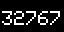 | 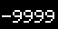 | 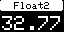 | 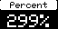 | 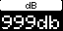 | 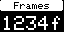
32767  16 bit integer | -9999  16 bit integer, negative | 32767|1||Float2  Float with 2 decimal points | 299|2||Percent  Integer value in Percent | 999|3||dB  Integer value in dB | 1234|4||Frames  Integer in frames
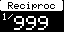 | 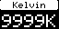 | 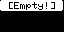 | 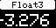 | 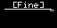 | 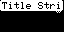
999|5||Reciproc  Reciprocal value of integer | 9999|6||Kelvin  Integer formated as Kelvin | 9999|7||[Empty!  format 7 = empty! | -3276|8||Float3  Float with 3 decimal points, optimized for 5 char wide space. Op to +/-9999 | ||1|[Fine]|1  Fine marker set (the curvy thing on the right of the line), title as "label" | ||1|Title String  no value, just title string (and with "fine" indicator)
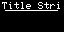 | 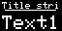 | 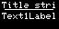 | 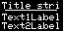 | 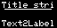 | 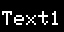
|||Title String|1  Title string as label (no "bar" in title) | |||Title string|1|Text1Label  Text1label - 5 chars in big font | |||Title string|1|Text1Label||0  Adding the zero (value 2) means we will print two lines and the text label will be in smaller printing | |||Title string|1|Text1Label|Text2Label  Printing two labels of 10 chars - automatically the size is reduced | |||Title string|1||Text2Label  Printing only the second line - automatically the size is reduced | |||||Text1Label  Text1label - 5 chars in big font, no title bar.
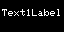 | 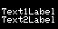 | 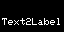 | 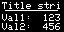 | 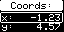 | 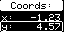
|||||Text1Label||0  Adding the zero (value 2) means we will print two lines and the text label will be in smaller printing | |||||Text1Label|Text2Label  Printing two labels - automatically the size is reduced | ||||||Text2Label  Printing only the second line - automatically the size is reduced | 123|||Title string|1|Val1:|Val2:|456  First and second value is printed in small characters with prefix labels Val1 and Val2 | -1234|1||Coords:||x:|y:|4567|2  A box around the first label/value line | -1234|1||Coords:||x:|y:|4567|3  A box around the second label/value line
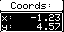 | 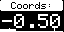 | 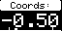
-1234|1||Coords:||x:|y:|4567|4  A box around the both label/value lines | -500|1||Coords:||||||1|-1000|1000|-700|700|1  A solid bar scale added below value | -500|1||Coords:||||||2|-1000|1000|-700|700|2  A moving dot scale added below value

These graphics are generated from the test Python scripts. They can be very useful to experiment with other combinations. A good script to use for testing would be the script "TCPserver_colorAndDisplayTestByButtonPress.py" as it has a large number of text and image combinations to learn from.

The formatting of text in the displays is based on tokenizing the string with vertical pipe (|) and each part starting with index 0 is described in this table.
Notice, the total text string itself cannot be longer than 64 characters. Only ASCII from 32-127 is supported.

Index | internal name | Name | Description
0 | _extRetValue[0] | Value, 32 bit integer | Integer value to show in the display. Subject to formatting options in index 1.  If empty string, the display format will be set to 7 (value not printed)
1 | _extRetFormat  (bit 0-3) | Formatting type | Determines how the integer value from index 0 (as well as index 7) is formatted in the display:  0 = as a signed integer  1 = float from 10^3 (X.XX). Deprecated, use format 9  2 = XX%  3 = XXdb  4 = XXf  5 = 1/XX  6 = XXK  7 = Blank (not printed)  8 = float from 10^3 (X.XXX)  9 = float from 10^2 (XX.XX)  10 = one text line (index 0 will be your fortsize, 1-4) rendered from index 3 (title).  11 = two text lines (index 0 will be your fortsize, 1-2) rendered from index 3 (title).  12 = float from 10^1 (XXX.X)
2 | _extRetFormat  (bit 4-5) | Icon | Bit 0-1 value (0-3):  0 = No icon  1 = Fine-flag (speedy wave lines under title bar, right)  2 = Lock icon (in title bar, right)  3 = No Access icon (lower right)  Bit 3-5: (Corner icons below title bar in right side, 8x8 pixels) value (0-7)  (0 : No icon)  1 (8) : Cycle icon (return arrow)  2 (16): Down (down arrow)  3 (24): Up (Up arrow)  4 (32): Hold (Down arrow pointing to line)  5 (40): Toggle (zig-zag)  6 (48): OK (check mark)  7 (56): Question mark
3 | _extRetShort  _extRetLong  (24 chars) | Title | Sets title of the tile. If title is blank, the title area is not rendered.
4 | is label | Label (1) or Value (0, default) | 0 = Generates bar behind title (shall indicate that the content shows current value / state)  1 = Line under title (shall indicate that the content shows a description of what the function does)
5 | extRetValTxt, 0 | First line of text, string 24 chars
6 | extRetValTxt, 1  (enables it also) | Second line of text, string 24 chars
7 | _extRetValue[1] | Value of second line, integer 32 bit | Will be subject to formatting from index 1.
8 | _extRetPair | Pair mode, 0-4 | 0 = Not a pair  1 = A label/value pair is shown: On the first line, index 5 and 0 is shown, on the second line index 6 and 7 is shown  2 = The upper label/value pair is marked  3 = The lower label/value pair is marked  4 = Both label/value pairs are marked
9 | _extRetScaleType | Scale type | 1 = strength bar (from left)  2 = centered marker  3 = centered bar (from center of range)
10 | _extRetRangeLow (integer) | Range low | Low range value
11 | _extRetRangeHigh (integer) | Range high | High range value
12 | _extRetLimitLow  (integer) | Limit low | Limit low marker (set to same as range low if you don't want it. Must be set!)
13 | extRetLimitHigh  (integer) | Limit high | Limit high marker (set to same as range high if you don't want it. Must be set!)
14 | extRetValImage  (integer) | Image reference, zero is first image | Reference to an internally stored image (compiled into the firmware from cores.skaarhoj.com)
15 | _extRetAdvancedFontFace |  | Bit 0-2: General font face, Bit 3-5: Title font face, Bit 6: 1=Fixed Width
16 | _extRetAdvancedFontSizes |  | Bit 0-1: Text Size H, Bit 2-3: Text Size V, Bit 4-5: Title Text Size H, Bit 6-7: Title Text Size V
17 | _extRetAdvancedSettings |  | Bit 0-1: Title bar padding, Bit 2-4: Extra Character spacing (pixels)
18 | _extRetInvert | Various color settings | Bit 1: Rendering is inverted
19 | _extRetPixelColor | Pixel color (only for color displays) | 1-15: Raw Panel Indexed colors (see HWCc command for table)  Bit 6 (64) enables RGB mode where bit 0-5 is 2-bit RGB values
20 | _extRetBckgColor | Pixel color (only for color displays) | 1-15: Raw Panel Indexed colors (see HWCc command for table)  Bit 6 (64) enables RGB mode where bit 0-5 is 2-bit RGB values

Pixel graphics
Totally custom pixel graphics are another format you can use to generate content for the displays. Find sample graphics here:
https://github.com/SKAARHOJ/Support/tree/master/64x32_Graphics

Format
To facilitate images in varying sizes, an extended format for base64 encoding the images has been introduced. Instead of three lines of fixed lengths, you can encode the image over an arbitrary amount of lines, although they have a practical limit of around 250 bytes length (corresponding to 170 bytes of image data)

The format is this for the starting line (sequence number zero):
HWCg#[HWC]=[sequence number, zero is first]/[Last number in sequence],[width, pixels]x[height, pixels],[x-coordinate from upper left],[y-coordinate from upper left]:[base64 encoded data]

The x and y coordinates (blue) are optional and if left out (or equal to the default value of -1) the image will be centered in that dimension.

For subsequent lines it looks like this:
HWCg#[HWC]=[sequence number]:[base64 encoded data]

Example:
# TEST 64x38
'HWCg#{}=0/15,64x38://///////////////////8QhCA==',
'HWCg#{}=1:QhCEIQvEIQhCEIQhC////////w==',
'HWCg#{}=2:///EIQhCEIQhC8QhCEIQhCELxA==',
'HWCg#{}=3:IQhCEIQhC8QhCEIQhCEL/////w==',
'HWCg#{}=4://///8QhCEIQhCELxCEIQhCEIQ==',
'HWCg#{}=5:C8QBCEIQAAELxAAAAgAAAQv8fg==',
'HWCg#{}=6:AwAHwfH/xP4HAA/juQvAwA8AAA==',
'HWCg#{}=7:YxgLwMAfHMBjGAvA/BsPgOO4Cw==',
'HWCg#{}=8:+P4zD4fB8P/AxncHAGO4C8DGfw==',
'HWCg#{}=9:hwBjGAvAxgcPgGMYC8TuAx3P4w==',
'HWCg#{}=10:uQv8fAMYz8Hx/8QAAAAAAAELxA==',
'HWCg#{}=11:AQgAAAABC8QhCEIQhCELxCEIQg==',
'HWCg#{}=12:EIQhC///////////xCEIQhCEIQ==',
'HWCg#{}=13:C8QhCEIQhCELxCEIQhCEIQvEIQ==',
'HWCg#{}=14:CEIQhCEL///////////EIQhCEA==',
'HWCg#{}=15:hCEL/////////////////////w==',

where {} is the HWC number.

Please see "TCPserver_colorAndDisplayTestByButtonPress.py" for examples.

If your SKAARHOJ controller integrates color displays you can send RGB images to it and set background color and pixel color.
Sending images is done using the command "HWCgRGB". Please see "TCPserver_colorImages.py" for examples.

Important disclaimer: Color displays and RGB images take up 16 times more space and processing power on the controllers than the standard monochrome displays does, so the practical framerates are much, much lower. It's therefore important to have realistic expectations to what can be achieved with color displays. Anecdotally; you can achieve to send over 6 RGB images of 96x64 pixels a second to a panel. That's far from showing moving pictures on a display tile. This limitation cannot easily be overcome with our current technology stack, but we didn't feel that this should keep us from providing the feature which, if used "responsibly" could be a huge benefit in the right context.

Conventions on using displays on SKAARHOJ controllers
SKAARHOJ panels use many different display tile dimensions, and the text based format has been developed to generally adapt to any display associated with a hardware component. It will look great regardless of whether it's a small or large display and theoretically you shouldn't have to know as the sender. However, sometimes you will want to fine tune your content to a given display size. When sending images to a display, knowing its size would be beneficial so you can design the image to the display. The display tile sizes are revealed through the JSON topology data from the panel.

Tile sizes
The typical tiles you will find on a SKAARHOJ controller are these:
Tile size | Comment
64x32 | The most typical tile size you will find on a SKAARHOJ controller! This is the reference and any content should render reasonably on this tile size.
112x32 | A wide tile type mostly found as a display for encoder knobs, but also found for some buttons
64x48 | A new type of tile with larger display area than the classic 64x32 pixel tiles
256x20 | Wide title line - on large controllers
52x24 | Mini tiles, 24 pixels high and more narrow than the standard tiles. Used on large controllers as labels for buttons.
48x24 | Mini tiles, 24 pixels high and more narrow than the standard tiles. Used on large controllers as labels for buttons.
128x32 | Tile size seen once in a while. For example on the RCP (ID display)
64x38 | Color OLED display (physically 64x48 pixels, active area 64x38) on a NKK SmartSwitch
86x48 | Color OLED display (physically 96x64 pixels, active area 86x48) on a NKK SmartSwitch
96x64 | Color OLED display 94x64 pixels.

For your information: When text based tiles are placed next to each other on shared displays, the tile is rendered one pixel smaller in the relevant dimension and a blank row or column of pixels is placed between them (hShrink and wShrink). Does not apply to graphics.

"Labels" or "Values"
Another significant convention is how the title bar on a tile should be rendered. The flag "is label" (index 4) is used to determine if the title area is rendered as a solid bar (is label = 0, default) or if it's rendered as a string of text with a line under (is label = 1).
This is how you should use it:
- If the display shows the current value of anything - the "status" -, then set "is label" to 0 so it renders as a solid bar. An example is if the display shows the current source name on an Aux bus or if it shows the current state "on" for a given feature. Typically this will be the case for cycling buttons, encoders or toggle buttons.
- If the display shows the label of a function - what it will "do" - then set "is label" to 1 so it renders with just a line under. An example is if the display shows the source name that you will route to the aux bus if pressed, or shows "on" because a button press will actually turn something "on". Typically this is the case for non-cyclic and non-toggle buttons.

Topology
A powerful concept with Raw Panel is the ability to query the panel for its topology. This is delivered as a SVG background graphic and a JSON data structure that documents the hardware components on the controller in a way that will allow you to render a beautiful configuration interface. The JSON holds visual information as well as various properties for each hardware component.
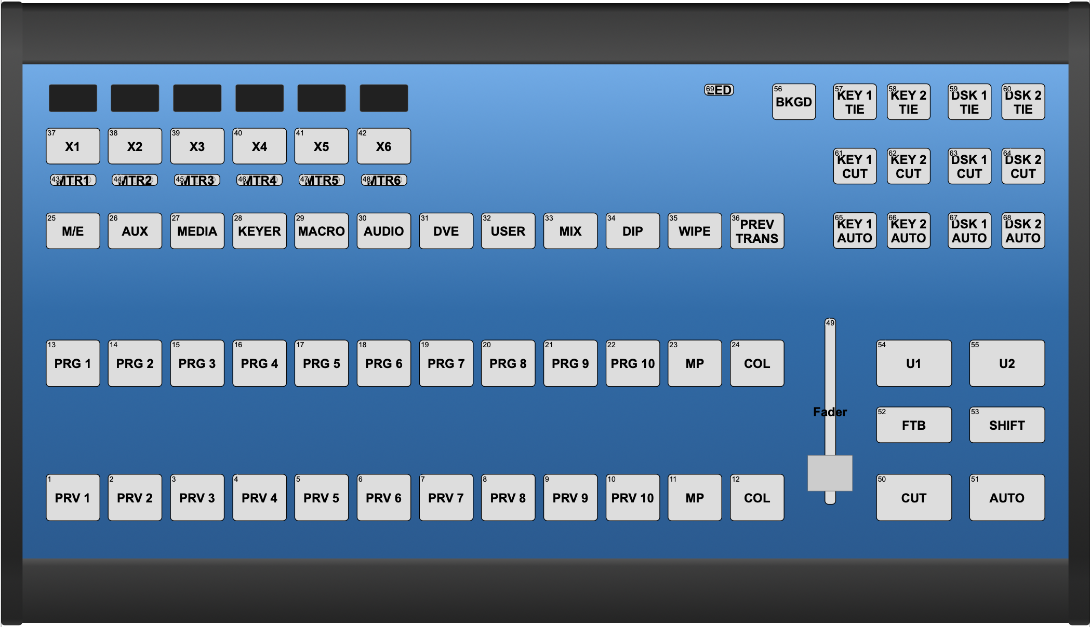

SVG background
The SVG background for the Air Fly rendered above would look like this:

<svg xmlns="http://www.w3.org/2000/svg" viewBox="0 0 3040 1858" width="100%" id="ctrlimg" style="display:block;">
<defs>
<linearGradient id="frontplate" x1="0%" y1="0%" x2="0%" y2="100%">
<stop offset="0%" style="stop-color:rgb(99, 171, 235);stop-opacity:1" />
<stop offset="50%" style="stop-color:rgb(25, 108, 173);stop-opacity:1" />
<stop offset="100%" style="stop-color:rgb(26, 90, 147);stop-opacity:1" />
</linearGradient>
<linearGradient id="topedge" x1="0%" y1="0%" x2="0%" y2="100%">
<stop offset="0%" style="stop-color:rgb(13,13,13);stop-opacity:1" />
<stop offset="8%" style="stop-color:rgb(39,39,39);stop-opacity:1" />
<stop offset="15%" style="stop-color:rgb(60,60,60);stop-opacity:1" />
<stop offset="92%" style="stop-color:rgb(76,76,76);stop-opacity:1" />
<stop offset="100%" style="stop-color:rgb(40,40,40);stop-opacity:1" />
</linearGradient>
<linearGradient id="bottomedge" x1="0%" y1="0%" x2="0%" y2="100%">
<stop offset="0%" style="stop-color:rgb(86,86,86);stop-opacity:1" />
<stop offset="12%" style="stop-color:rgb(61,61,61);stop-opacity:1" />
<stop offset="92%" style="stop-color:rgb(38,38,38);stop-opacity:1" />
<stop offset="100%" style="stop-color:rgb(37,37,37);stop-opacity:1" />
</linearGradient>
<linearGradient id="sides" x1="0%" y1="0%" x2="0%" y2="100%">
<stop offset="0%" style="stop-color:rgb(24,24,24);stop-opacity:1" />
<stop offset="1%" style="stop-color:rgb(47,47,47);stop-opacity:1" />
<stop offset="1.2%" style="stop-color:rgb(62,62,62);stop-opacity:1" />
<stop offset="8%" style="stop-color:rgb(80,80,80);stop-opacity:1" />
<stop offset="89%" style="stop-color:rgb(36,36,36);stop-opacity:1" />
<stop offset="93%" style="stop-color:rgb(41,41,41);stop-opacity:1" />
<stop offset="99%" style="stop-color:rgb(36,36,36);stop-opacity:1" />
<stop offset="100%" style="stop-color:rgb(52,52,52);stop-opacity:1" />
</linearGradient>
</defs>
<style>
text {font-family:Sans,Arial;}
.sections {
stroke: white;
stroke-width: 3;
fill: gray;
fill-opacity: 0.4;
stroke-opacity: 0.2;
stroke-dasharray: 20, 10;
}
</style>
<rect width="2940" height="172" x="50" y="67" style="fill:url(#topedge);" />
<rect width="2940" height="1380" x="50" y="239" style="fill:url(#frontplate);" />
<rect width="2940" height="180" x="50" y="1619" style="fill:url(#bottomedge);" />
<rect width="60" height="1743" x="0" y="63" style="fill:url(#sides);" rx="10" ry="10" />
<rect width="60" height="1743" x="2980" y="63" style="fill:url(#sides);" rx="10" ry="10" />

<rect width="1052" height="260" x="110" y="270" rx="10" ry="10" class="sections"/>
<rect width="1052" height="60" x="110" y="530" rx="10" ry="10" class="sections"/>
<rect width="1390" height="140" x="110" y="630" rx="10" ry="10" class="sections"/>
<rect width="700" height="140" x="1500" y="630" rx="10" ry="10" class="sections"/>
<rect width="2090" height="175" x="110" y="980" rx="10" ry="10" class="sections"/>
<rect width="2090" height="175" x="110" y="1355" rx="10" ry="10" class="sections"/>
</svg>

It would look like this:

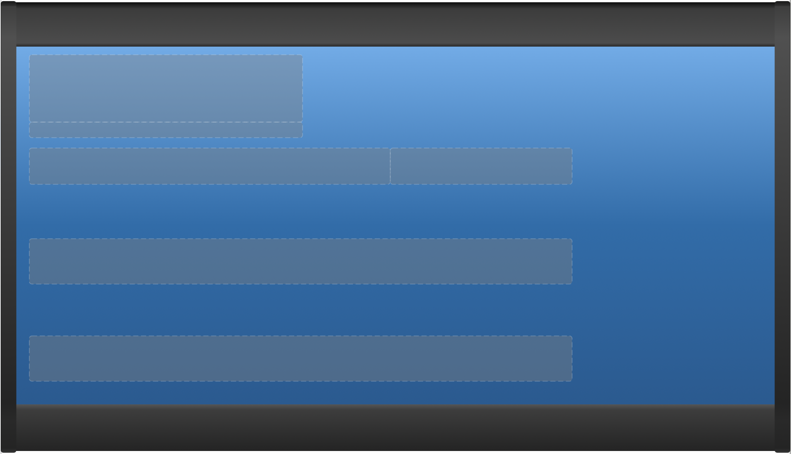

JSON Topology Data
The JSON data for the hardware components has two keys on the first level, "HWc" and "typeIndex". Here a few examples from the Air Fly is shown (first three hardware components):

"HWc": [
{
"id": 1,
"x": 201,
"y": 1449,
"txt": "PRV 1",
"type": 132
},
{
"id": 2,
"x": 374,
"y": 1449,
"txt": "PRV 2",
"type": 132
},
{
"id": 3,
"x": 548,
"y": 1449,
"txt": "PRV 3",
"type": 132
},
.....

Key | Description
id | The HWC id of the component.  It's important to understand this id in relation to the "map=zz:xx" command: This id - the native ID - will correspond to "zz" in the map command. Keep in mind that strictly, you are not supposed to render a hardware component unless you have received a map= command for it! The map command basically confirms that the hardware component is configured to send you data (it may not always be).  More background about map=  If you receive a map from the controller like "map=23:23" it means that hardware componet with id 23 will send commands as "id 23". (However, if you receive a map command like "map=23:47" it means that whenever hardware component with id 23 is triggered, the commands will be sent from the controller as if they came from id 47).
x  y | These are the x / y coordinates of the hardware component on the controllers SVG graphic
txt | This is the default label of the hardware component. You are invited to let users edit it in your application.
type | This number is a reference to a type of component and it's an index into the "typeIndex" part of the JSON.
typeOverride | If you find keys in here for a given HWC it's meant to override the same key in the typeIndex. This allows you to make customizations and extensions on a per-HWC basis.  Example:  {  "id": 69,  "x": 1312,  "y": 912,  "txt": "D58-6",  "type": 76,  "typeOverride": {  "disp": {  "w": 64,  "h": 58  }  }  },  In this case, typeOverride is used to indicate the display dimensions is 64x58. It was likely necessary because the type 76 has other pixel dimensions that didn't fit in this case.  Example:  {  "id": 9,  "x": 180,  "y": 909,  "txt": "Knob A",  "type": 15,  "typeOverride": {  "disp": {  "w": 64,  "h": 32,  "subidx": 0  },  "sub": [  {  "_": "r",  "_x": -55,  "_y": -550,  "_w": 190,  "_h": 95,  "rx": 5,  "ry": 5,  "style": "fill:rgb(33,33,33);"  }  ]  }  },  In this case, typeOverride is used to add a whole "sub" sections which didn't even exist plus set the display dimensions and refer to the first sub element (index 0) to represent the display in the drawing.

The "typeIndex" part describes each hardware component type used on the controller. The numbers won't change between controllers. All SKAARHOJ controllers would carry the same set of data about a given number (assuming the same firmware version).

The "typeIndex" looks like this (example):

"typeIndex": {
"15": {
"w": 160,
"out": "rgb",
"in": "pb",
"desc": "Encoder"
},
"28": {
"w": 30,
"h": 710,
"in": "av",
"ext": "pos",
"subidx": 0,
"desc": "Motorized Fader 60mm",
"sub": [
{
"_": "r",
"_x": -63,
"_y": 53,
"_w": 125,
"_h": 250
}
]
},
"36": {
"w": 570,
"h": 151,
"disp": {
"w": 128,
"h": 32
},
"desc": "OLED Display Tile"
},
"40": {
"w": 250,
"h": 40,
"in": "gpi",
"desc": "Opto-isolated Input (to GND)"
},
....

The first type, "15", is an encoder. Since only "w" is given, it must be rendered as a circle with the diameter 160. "out" indicates that it can accept RGB color information (background LED ring most likely) and "in" has the value "pb" which means "pulses + button" which corresponds to an encoder with push function.

The second type, "28" has both "w" and "h" and by convention should be rendered as a rectangle. The "in" (input type) indicates with "av" that it's an absolute component oriented vertically (like a T-bar). "ext" has the value "pos" which indicates that sending the extended return value back will let the component position itself (which makes sence, since the description reveals it's a motorized fader). The "sub" element holds additional data when the component has more visual elements than it's bases circle or rectangle. This is the case with many components that has displays for example. Or sliders that tend to have a rectangle on top to represent the handle/knob. In the "sub" element, "_" tells us it's a rectangle we should draw in position "_x","_y" with "_w" and "_h" for width and height.

Type "36" is just a display. It has no indication of input or output type. It should be rendered as a rectangle and we are told its pixel dimensions is 128x32.

Type "40" is a GPI input. The "in" type is set to "gpi"

Key | Description
in | Input type:  - b = Standard button  - b4 = Fourway button  - gpi = GPI trigger  - pb = encoders (pulses + button)  - p = encoders (pulses, no button)  - av = Absolute vertical (Faders)  - ah = Absolute horizontal (Potentiometers)  - ar = Absolute rotation  - iv = Intensity vertical (Joysticks)  - ih = Intensity horizontal (Joysticks)  - ir = Intensity rotation  Parse input type by splitting with a comma. There may be more parameters to it, for example "ar,steps=16" could indicate an analog component which would have only 16 steps in its input value (like a binary selector)
subidx | A reference to the index of an element in the "sub" element which has a "special" meaning. For analog (av, ah, ar) and intensity (iv, ih, ir) elements, this would be an element suggested for being used as a handle for a fader or joystick.
out | Output type:  - gpo = GPO output  - mono = mono LED / LEDBAR  - rg = Red/Green LED / LEDBAR  - rgb = RGB colored LED / LEDBAR
disp | Indicates display dimensions in keys "w" and "h".  Furthermore you can sometimes find the "type" key set to a value like "gray" (future) and "color" to indicate the display capability. The default is black or white pixels.  Finally, if the disp element has the key "subidx" set, it indicates an index of an element in the "sub" element which shall represent the display of the component instead of the main component. This is used a lot as many components not being displays themselves has their display offset from their center.
ext | Support for extended return values:  - pos - indicates a self-positioning components, like a motorized fader  - steps - indicates an element that can respond to steps, like an LED bar. The number of steps shall be determined by iterating over elements inside "sub" and look for their "_idx" property which determines the order they should be used in.
desc | Description
sub | Inside "sub" you will find one or more sets of properties, each one representing additional SVG elements to be rendered.  Example:  "sub": [  {  “_idx”: 1,  "_": "r",  "_x": -67,  "_y": -190,  "_w": 134,  "_h": 76,  "rx": 5,  "ry": 5,  "style": "fill:rgb(33,33,33);"  }  ]  - "_" - if "r" means render SVG rectangle, if "c" means SVG circle  - "_x", "_y" - the x/y offset of this SVG element from the component center  - "_w", "_h" - the width/diameter and height of the element  - Any key NOT prefixed with "_": Is added as a standard SVG element attribute, hence "rx", "ry" and "style" in the above example would be added as such elements.

Make sure to check out the raw panel support page on www.skaarhoj.com for a link to a video that walks through rendering with the SVG / JSON topology data.

Reference for rendering
A reference Python script that documents the recommended rendering method is available ("renderHWCs.py") in a zip-archive which also contains the current collection of SKAARHOJ controllers as JSON/SVG pairs. This is available from this link:

http://staging.skaarhoj.com/controllerTopologies/SKAARHOJ_Controllers_Toplogies.zip

Device Configurations
Device configuration options exist:
- Index 0: Port number: If different from 0, then this is the port number the controller will try to connect to on the device core IP (or the port number of the TCP server in server mode)
Example: If two UniSketch TCP Client device cores are active on the same IP 192.168.10.250, then setting “D1:0=9234” will mean that the second device core (because of “1”) will try to connect on port 9234 instead of port 9923.
- Index 1: Server Mode: If set to 1 the device core will not try to connect to as a TCP client but rather set up a TCP server on port 9923 (or the port defined by device core index 0) and allow up to 8 external TCP clients to connect and interact with it. In this case, the IP address of the device core will not matter of course.
Example: Setting up UniSketch TCP Client (assuming it's the first device core (zero)) in server mode, listening on port 9930 “D0:0=9930;D0:1=1”.

Changelog
January 2019:
- Pushing an encoder will now send the “Press” action to the server. This was previously done only after holding for 1 second (still does so in any case)
- Added format “9” (XX.XX float) to graphics rendering
- Added format 10 and 11 for graphics rendering
- Added software version output to Raw Panel (UniSketch TCP Client)
- Added commands for handling, changing and reading sleep mode
- Added command (HWCx) for extended return values (like strength, VU meters, setting value of motorised faders).
- Internal changes in State, Shift and sleep mode is reported automatically to host system
- Recommends now to prepend ActivePanel=1 with <NL> to avoid missing initialisation in some cases of disconnect/reconnect

May 2019:
- Added command for receiving panel topology

August 2019:
- Added server mode
- Added "nack" response to unknown commands
- Added "Clear" command
- Added Extended output type 5 useful for faders so they don't need to have their positions updated by the remote system.
- Added "Reboot" command

January 2020:
- Multiple improvements for text rendering in UniSketch has been supported, including:
  - support for 8x8 and 5x5 fonts, separate horizontal and verical text scaling sizes
  - proportional fonts (typically more characters fits in the lines now)
  - Better automatic usage of display tiles regardless of their size (however, it can be overridden by forced values for text sizes, fonts and other things)
  - ASCII range 32-127 supported
  - Increased length of most strings to 24 chars instead of 16/10 etc.
- Support for other image sizes than 64x32, including increased number of image buffers (8)
- Correct centering of images
- Increased number of HWcs from 128 to 255
- Fixed potential bug where if two images was received for the same HWc and buffered at the same time, the first received image would be rendered only (so now we scan the buffered images backwards)
- Added support for 32 bit integers as values in Raw Panel protocol
- Added Raw Panel support for setting icons
May 2020:
- Fixed bug that slowed down sending content in server mode significantly
- Added ClearLEDs and ClearDisplays commands
- Added PanelBrightness and Webserver commands
August 2020:
- Documented quite a bit about topology

