**Step 1 - Install Packages Dependencies**

First, we will update the Ubuntu repository and install some packages dependencies for the Nagios installation.

Update the Ubuntu repository using the apt command below.

*sudo apt update*

And you've installed packages dependencies for Nagios server.

**Step 2 - Install Nagios Core 4.4.6**

In this step, we will install the latest stable version Nagios Core 4.4.6. And we will install it manually from the source.

**- Download Nagios Core 4.4.6**

Go to your home directory and download the Nagios Core source code.

*cd ~/  
wget https://github.com/NagiosEnterprises/nagioscore/archive/nagios-4.4.6.tar.gz*

Extract the Nagios package and go to the extracted Nagios directory.

*tar -xf nagios-4.4.6.tar.gz  
cd nagioscore-*/*

* apt-get install build-essential

**- Compile and Install Nagios**

First, compile Nagios source code and define the Apache virtual host configuration for Nagios.

*sudo ./configure --with-httpd-conf=/etc/apache2/sites-enabled  
sudo make all*

[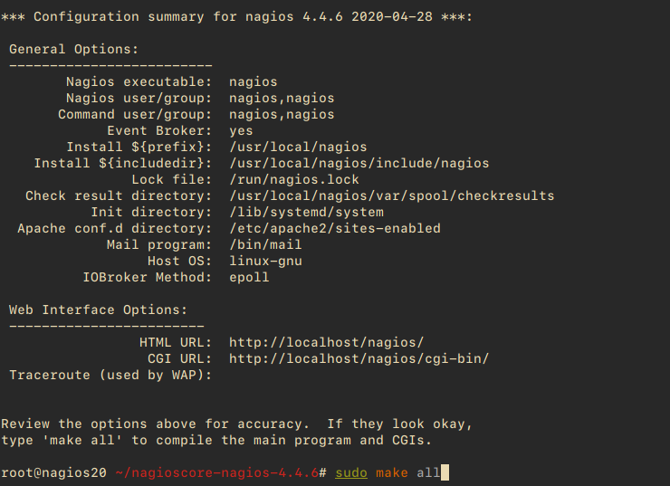](https://www.howtoforge.com/images/how_to_install_nagios_on_ubuntu_2004/big/1.png)

Create the Nagios user and group, and add the 'www-data' Apache user to the 'nagios' group.

*sudo make install-groups-users  
sudo usermod -a -G nagios www-data*

[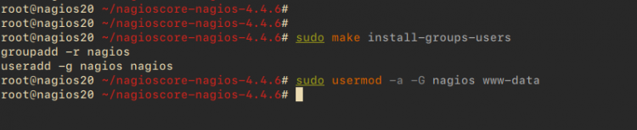](https://www.howtoforge.com/images/how_to_install_nagios_on_ubuntu_2004/big/2.png)

Install Nagios binaries, service daemon script, and the command mode.

*sudo make install  
sudo make install-daemoninit  
sudo make install-commandmode*

After that, install the sample script configuration.

*sudo make install-config*

Then install the Apache configuration for Nagios and activate the mod_rewrite and mode_cgi modules.

*sudo make install-webconf  
sudo a2enmod rewrite cgi*

Now restart the Apache service.

*systemctl restart apache2*

And you've installed the Nagios Core 4.4.6.Advertisement

[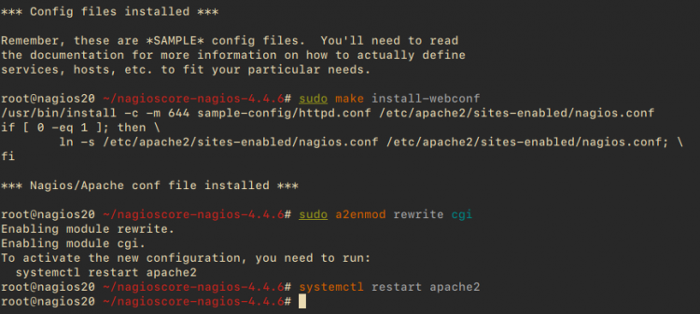](https://www.howtoforge.com/images/how_to_install_nagios_on_ubuntu_2004/big/3.png)

**- Create nagiosadmin user**

After installing the Nagios Core, we will add the basic authentication for accessing the Nagios dashboard. And we will be using the basic Apache authentication.

Create a new apache basic authentication for the user the "nagiosadmin".

*sudo htpasswd -c /usr/local/nagios/etc/htpasswd.users nagiosadmin*

Type your strong password.

[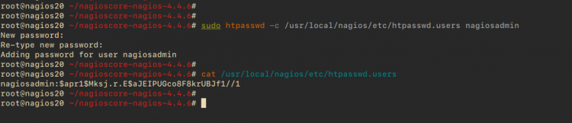](https://www.howtoforge.com/images/how_to_install_nagios_on_ubuntu_2004/big/4.png)Advertisement

And you've created a new user 'nagiosadmin' for the Nagios dashboard authentication.

**- Setup UFW Firewall**

For the firewall configuration, you will need to add the Apache service and the Nagios server port to the UFW firewall.

Add the SSH and Apache HTTP port using the ufw command below.

*for svc in Apache ssh  
do  
ufw allow $svc  
done*

Next, start the UFW firewall service and add it to the system boot.

*ufw enable*

Type '**y**' and the UFW firewall service will be activate.

Now check all available rules using the command below.

*ufw status numbered*

Now you will get both the SSH and Apache services added to the UFW firewall.

[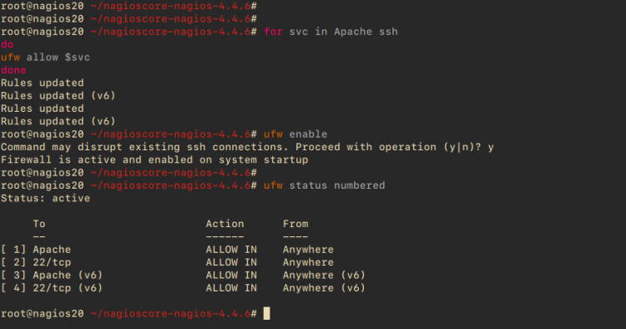](https://www.howtoforge.com/images/how_to_install_nagios_on_ubuntu_2004/big/5.png)

And finally, you've completed the Nagios Core installation on the Ubuntu 20.04 server.

**Step 3 - Install Nagios Plugins and NRPE Plugin**

After installing the Nagios Core, we will install the Nagios Plugins and NRPE Plugins.Advertisement

Both Nagios and NRPE plugins are available by default on the Ubuntu repository. You can install those packages using the apt command below.

*sudo apt install monitoring-plugins nagios-nrpe-plugin*

Once the installation is complete, go to the nagios installation directory "/usr/local/nagios/etc" and create a new directory for for storing all server hosts configuration.

*cd /usr/local/nagios/etc  
mkdir -p /usr/local/nagios/etc/servers*

Next, edit the Nagios configuration 'nagios.cfg' using vim editor.

*vim nagios.cfg*

Uncomment the 'cfg_dir' option that will be used for sotring all server hots configurations.

cfg_dir=/usr/local/nagios/etc/servers

Save and close.

Next edit the configuration file "resource.cfg" and define the path binary files of Nagios Monitoring Plugins.

*vim resource.cfg*

Define the Nagios Monitoring Plugins path by changing the default configuration as below.

$USER1$=/usr/lib/nagios/plugins

Save and close.

After that, add the nagios admin email contacts by editing the configuration file "objects/contacts.cfg".

*vim objects/contacts.cfg*

Change the email address with your own.

define contact{  
        ......  
        email email@host.com  
}

Save and close.

Now define the nrpe check command by editing the configuration file "objects/commands.cfg".

*vim objects/commands.cfg*

Add the following configuration to the end of the line.

define command{  
        command_name check_nrpe  
        command_line $USER1$/check_nrpe -H $HOSTADDRESS$ -c $ARG1$  
}

Save and close, and the Nagioscore configuration has been completed.

Next, start the Nagios service and add it to the system boot.

*systemctl start nagios  
systemctl enable nagios*

[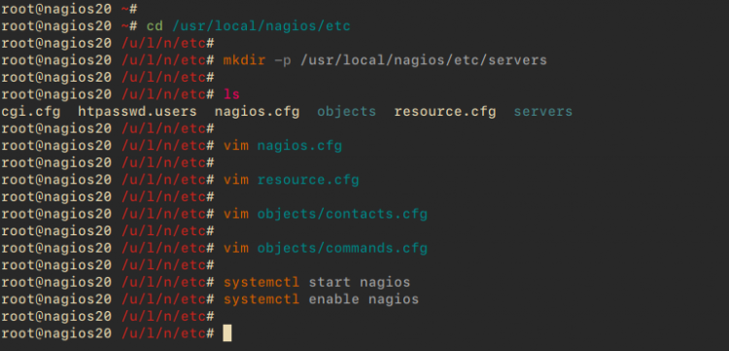](https://www.howtoforge.com/images/how_to_install_nagios_on_ubuntu_2004/big/6.png)

The Nagios service is up and running, check using the following command.

*systemctl status nagios*

Below is the result.

[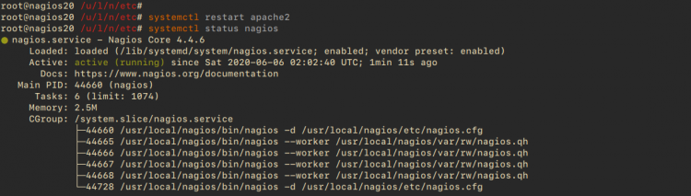](https://www.howtoforge.com/images/how_to_install_nagios_on_ubuntu_2004/big/7.png)

As a result, the Nagios service is up and running. Now we need to restart the Apache service to apply a new Nagios configuration.

*systemctl restart apache2*

And the Nagios configuration has been completed.

Open your web browser and type the server IP address following the "nagios" URL path.Advertisement

***http://172.16.0.5/nagios/***

Log in with the user "nagiosadmin" and type your password.

**Step 5 - Add Linux Host to Monitor**

In this step, we will add the Ubuntu server with hostname "client01" and the IP address "172.16.0.6" to the Nagios server.

**- Install NRPE Server on the Client01 Server**

Log in to the "client01" server using your ssh.

*ssh root@172.16.0.6*

Once you've logged in, update the Ubuntu repository and install Nagios Plugins and NRPE Server.

*sudo apt update  
sudo apt install nagios-nrpe-server monitoring-plugins*

Next, go to the NRPE installation directory "/etc/nagios" and edit the configuration file "nrpe.cfg".

*cd /etc/nagios/  
vim nrpe.cfg*

Uncomment the "server_address" line and change the value with the "client01" IP address.

server_address=172.16.0.6

One the "allowed_hosts" line, add the Nagios Server IP address "172.16.0.5".

allowed_hosts=127.0.0.1,::1,172.16.0.5

Save and close.

Next, edit the "nrpe_local.cfg" configuration.

*vim nrpe_local.cfg*

Change the IP address with the "client01" IP address, and paste the configuration into it.

command[check_root]=/usr/lib/nagios/plugins/check_disk -w 20% -c 10% -p /  
command[check_ping]=/usr/lib/nagios/plugins/check_ping -H 172.16.0.6 -w 100.0,20% -c 500.0,60% -p 5  
command[check_ssh]=/usr/lib/nagios/plugins/check_ssh -4 172.16.0.6  
command[check_http]=/usr/lib/nagios/plugins/check_http -I 172.16.0.6  
command[check_apt]=/usr/lib/nagios/plugins/check_apt

Save and close.

Now restart the NRPE service and add it to the system boot.

*systemctl restart nagios-nrpe-server  
systemctl enable nagios-nrpe-server*

And the Nagios NRPE server is up and running.

[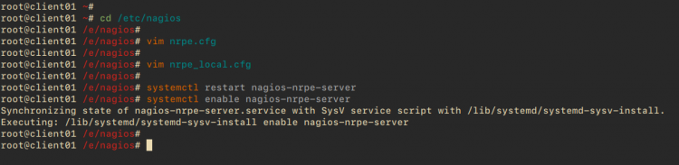](https://www.howtoforge.com/images/how_to_install_nagios_on_ubuntu_2004/big/10.png)

Check the NRPE service using the following command.

*systemctl status nagios-nrpe-server*

The NRPE service is up and running.

[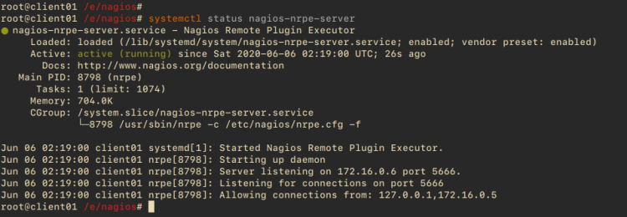](https://www.howtoforge.com/images/how_to_install_nagios_on_ubuntu_2004/big/11.png)

Next, back to the Nagios Server and check the "client01" NRPE server.

*/usr/lib/nagios/plugins/check_nrpe -H 172.16.0.6  
/usr/lib/nagios/plugins/check_nrpe -H 172.16.0.6 -c check_ping*

And you will get the result as below.

[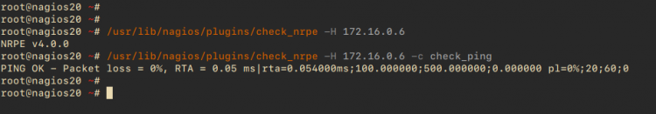](https://www.howtoforge.com/images/how_to_install_nagios_on_ubuntu_2004/big/12.png)

And you've installed the Nagios NRPE Server and Nagios Plugins on the "client01" host.

**- Add Hosts Configuration to the Nagios Server**

Back to the Nagios server terminal, go to the "/usr/local/nagios/etc" directory and create a new configuration "server/client01.cfg".

*cd /usr/local/nagios/etc  
vim servers/client01.cfg*

Change the IP address and the hostname with your own and paste the configuration into it.

# Ubuntu Host configuration file1  
  
define host {  
        use                          linux-server  
        host_name                    client01  
        alias                        Ubuntu Host  
        address                      172.16.0.6  
        register                     1  
}  
  
define service {  
      host_name                       client01  
      service_description             PING  
      check_command                   check_nrpe!check_ping  
      max_check_attempts              2  
      check_interval                  2  
      retry_interval                  2  
      check_period                    24x7  
      check_freshness                 1  
      contact_groups                  admins  
      notification_interval           2  
      notification_period             24x7  
      notifications_enabled           1  
      register                        1  
}  
  
define service {  
      host_name                       client01  
      service_description             Check Users  
      check_command                   check_nrpe!check_users  
      max_check_attempts              2  
      check_interval                  2  
      retry_interval                  2  
      check_period                    24x7  
      check_freshness                 1  
      contact_groups                  admins  
      notification_interval           2  
      notification_period             24x7  
      notifications_enabled           1  
      register                        1  
}  
  
define service {  
      host_name                       client01  
      service_description             Check SSH  
      check_command                   check_nrpe!check_ssh  
      max_check_attempts              2  
      check_interval                  2  
      retry_interval                  2  
      check_period                    24x7  
      check_freshness                 1  
      contact_groups                  admins  
      notification_interval           2  
      notification_period             24x7  
      notifications_enabled           1  
      register                        1  
}  
  
define service {  
      host_name                       client01  
      service_description             Check Root / Disk  
      check_command                   check_nrpe!check_root  
      max_check_attempts              2  
      check_interval                  2  
      retry_interval                  2  
      check_period                    24x7  
      check_freshness                 1  
      contact_groups                  admins  
      notification_interval           2  
      notification_period             24x7  
      notifications_enabled           1  
      register                        1  
}  
  
define service {  
      host_name                       client01  
      service_description             Check APT Update  
      check_command                   check_nrpe!check_apt  
      max_check_attempts              2  
      check_interval                  2  
      retry_interval                  2  
      check_period                    24x7  
      check_freshness                 1  
      contact_groups                  admins  
      notification_interval           2  
      notification_period             24x7  
      notifications_enabled           1  
      register                        1  
}  
  
define service {  
      host_name                       client01  
      service_description             Check HTTP  
      check_command                   check_nrpe!check_http  
      max_check_attempts              2  
      check_interval                  2  
      retry_interval                  2  
      check_period                    24x7  
      check_freshness                 1  
      contact_groups                  admins  
      notification_interval           2  
      notification_period             24x7  
      notifications_enabled           1  
      register                        1  
}

Save and close.

Now restart the Nagios Server.

*systemctl restart nagios*

[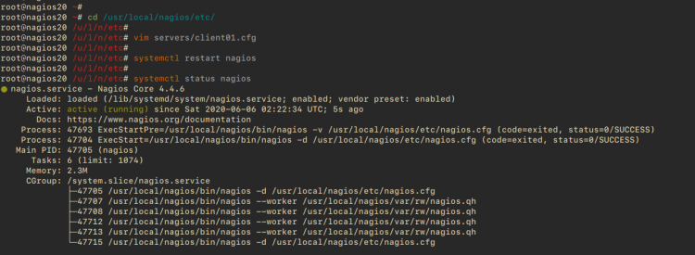](https://www.howtoforge.com/images/how_to_install_nagios_on_ubuntu_2004/big/13.png)

**Step 5 - Testing**

Back to your browser and wait for some minutes.

Click on the "**Hosts**" menu and you will get the "client01" has been added.

[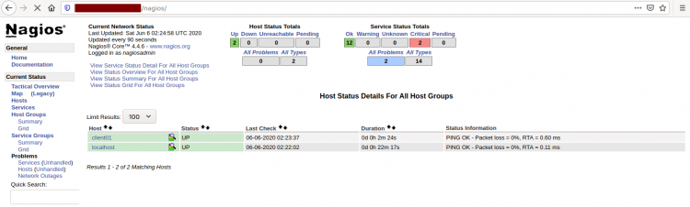](https://www.howtoforge.com/images/how_to_install_nagios_on_ubuntu_2004/big/14.png)

Below are details monitoring about the "client01" server.

[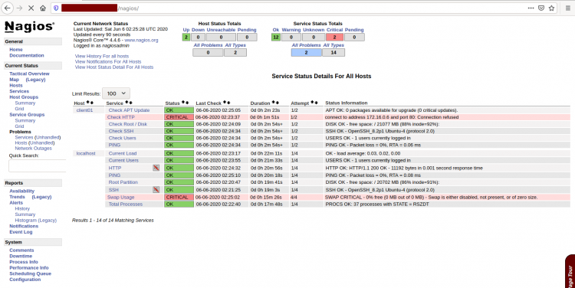](https://www.howtoforge.com/images/how_to_install_nagios_on_ubuntu_2004/big/15.png)

Now you've added Host to monitor to the Nagios Server.

And the installation of Nagios on Ubuntu 20.04 Server has been completed successfully.