Network Traffic Analysis with Wireshark

Analyst: Mohamed Asmy
Date: 2025-10-15
Tool: Wireshark v4.x
Case File: 2024-10-23-Redline-Stealer.pcap
Source: https://www.malware-traffic-analysis.net/2024/10/23/index.html

01. Project Overview
This project involves analysing a suspicious network capture (PCAP) to identify potential malicious communication, data exfiltration, or C2 activity.
The analysis uses Wireshark to trace HTTP, DNS, and TCP patterns associated with Redline Stealer malware.

02. Objective
To investigate a suspicious .pcap file and detect indicators of compromise by:
- Identifying unusual or repetitive traffic patterns
- Detecting DNS queries to malicious domains
- Finding POST/GET HTTP requests that transmit data externally
- Correlating the timeline of the malicious session

03. Tools Used
Wireshark v4.x Network packet capture analysis
Microsoft Word Documentation and reporting

04. Evidence Overview
File Name | Source | Type | Password | Notes
2024-10-23-Redline-Stealer.pcap | Malware-Traffic-Analysis.net | PCAP | Infected_20241023 | Contains Redline Stealer traffic

05. Traffic Summary
Source IP | Destination IP | Protocol | Info | Notes
10.10.23.101 | 188.190.10.10 | HTTP/XLM | POST/HTTP/1.1 | Outbound suspicious POST
10.10.23.101 | 10.10.23.1 | DNS | Query for api.ip.sb | Domain reconnaissance

06. Suspicious Findings
# | Observation | Description
1 | Multiple HTTP POST requests | Consistent outbound POSTs from internal host to external IP
2 | Suspicious DNS query | api.ip.sb queried, likely reconnaissance or IP check
3 | XML data transfer | POST payload contained XML content typical of C2 data
4 | Periodic connection attempts | Suggests beaconing behaviour

07. Timeline Analysis
Time (s) | Source IP | Destination IP | Event
0.343 | 10.10.23.101 | 188.190.10.10 | Initial HTTP POST
5.722 | 10.10.23.101 | 188.190.10.10 | Second POST detected
10.292 | 10.10.23.101 | 188.190.10.10 | Large POST payload
18.783 | 10.10.23.101 | 188.190.10.10 | Continued beaconing

08. Indicators of Compromise (IOCs)
Type | Value | Description
|IP Address | 188.190.10.10 | Redline Stealer C2 Server
Domain | api.ip.sb | Used for host IP reconnaissance
Host | 10.10.23.101 | Infected internal workstation

09. Conclusion
The analysis confirms that the internal host 10.10.23.101 communicated with a known Redline Stealer C2 server (188.190.10.10).
Multiple HTTP POST requests containing XML data and DNS queries to api.ip.sb indicate data exfiltration and C2 activity.
This confirms a malware infection and potential credential theft.

10. Recommendations
- Isolate the affected host immediately.
- Block `188.190.10.10` and `api.ip.sb` at the firewall.
- Run a full malware scan and collect endpoint logs.
- Rotate all user credentials on the compromised system.
- Conduct user awareness training about phishing downloads.

11. Screenshots & Evidence
1. DNS query to api.ip.sb
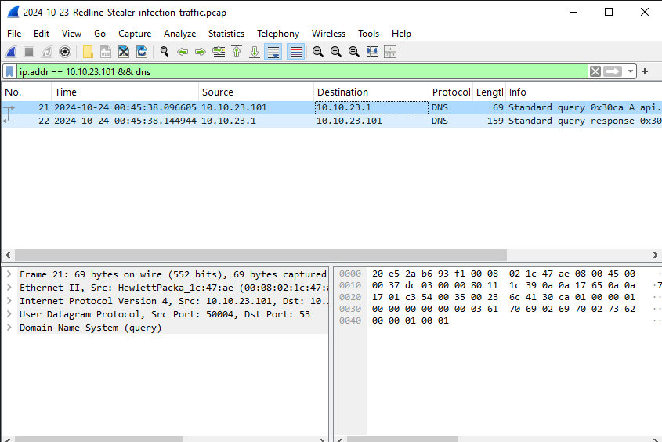

2. HTTP POST request to C2 server
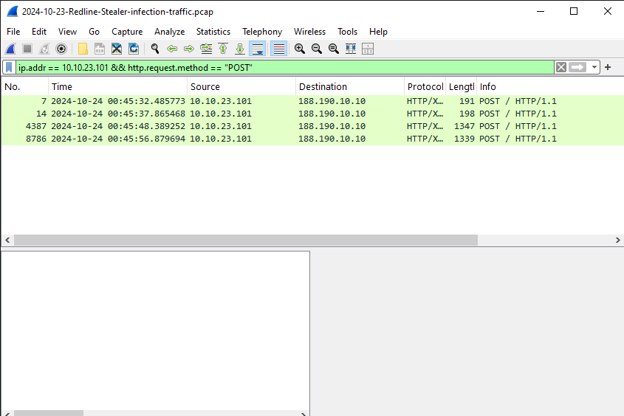

3. TCP stream of Redline payload
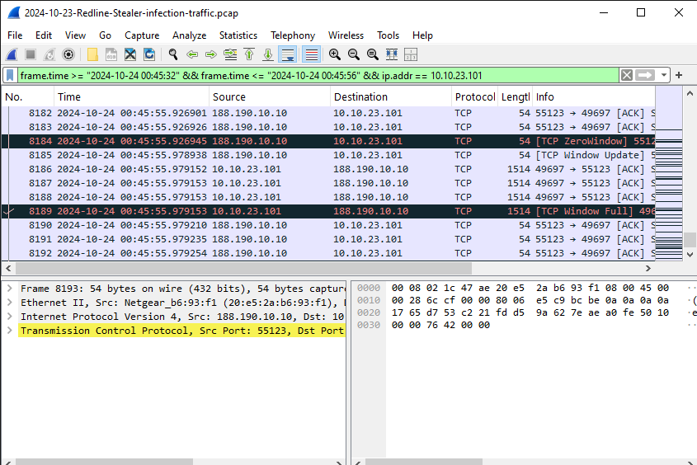

04. Full traffic overview timeline
