Stranger following scenario

[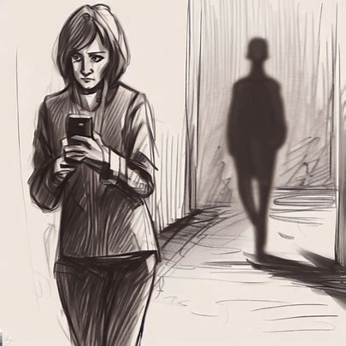](https://www.bing.com/images/create/sketch-of-a-person-walking-alone-in-a-street-and-f/64b8c1f88e4044a49eca8659b1313180?id=YJajORFe61%2bsG8x%2b80zFPw%3d%3d&view=detailv2&idpp=genimg&FORM=GCRIDP) [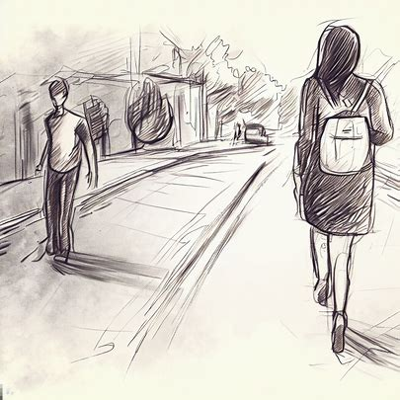](https://www.bing.com/images/create/sketch-of-a-person-walking-alone-in-a-street-and-f/64b8c19954e34e81890748663ffda4d6?id=52CFbWjGd0XkVm52%2bGw21g%3d%3d&view=detailv2&idpp=genimg&FORM=GCRIDP)

Notices for some time

[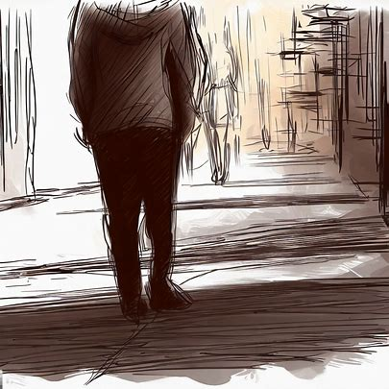](https://www.bing.com/images/create/sketch-a-person-walking-alone-ina-street/64b8b7de1d6b49fdb2d15d779c61a5db?id=M61%2byLCq%2f26adLi08Rzc7Q%3d%3d&view=detailv2&idpp=genimg&FORM=GCRIDP)

Tries to contact ….

[[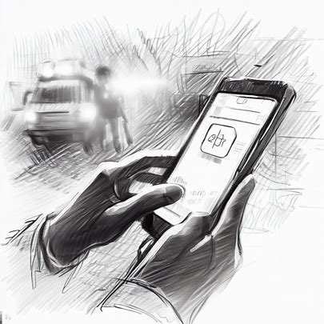](https://www.bing.com/images/create/sketch-of-a-person-using-an-application-on-his-mob/64b8c1629e6644f59151f351e36620af?id=O2qQrtS6FvkKDDkcGVUiMw%3d%3d&view=detailv2&idpp=genimg&FORM=GCRIDP)[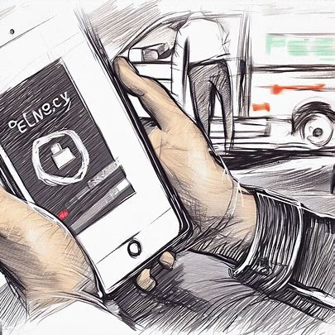](https://www.bing.com/images/create/sketch-of-a-person-using-an-application-on-his-mob/64b8c1629e6644f59151f351e36620af?id=u1zktNraPEk3muRNcBIErg%3d%3d&view=detailv2&idpp=genimg&FORM=GCRIDP)[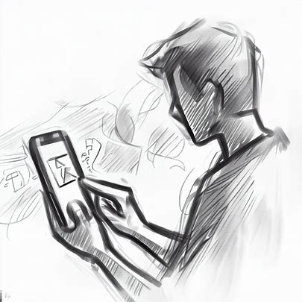](https://www.bing.com/images/create/sketch-of-a-person-using-an-application-on-his-mob/64b8c1629e6644f59151f351e36620af?id=qqusgiscubIGZugkcTwnbg%3d%3d&view=detailv2&idpp=genimg&FORM=GCRIDP)](https://www.bing.com/images/create/sketch-of-a-person-using-an-application-on-his-mob/64b8c1629e6644f59151f351e36620af?id=O2qQrtS6FvkKDDkcGVUiMw%3d%3d&view=detailv2&idpp=genimg&FORM=GCRIDP" \t "_blank)

* 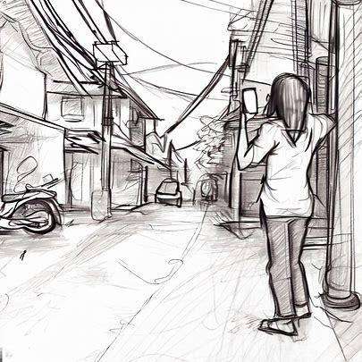

In case of Hurricane or Flood or Forest fire or any Natural disaster

[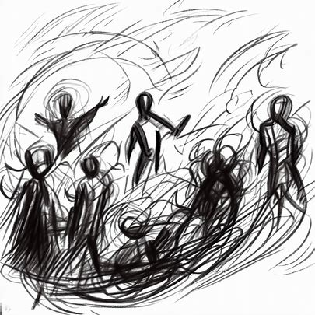](https://www.bing.com/images/create/sketch-people-who-are-in-hurricane/64b8b433b2f944c8970a00caac9f2c18?id=rrT%2fS8vuujnmhCYfZHvjfg%3d%3d&view=detailv2&idpp=genimg&FORM=GCRIDP)[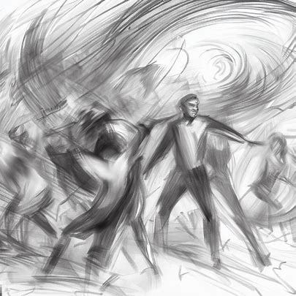](https://www.bing.com/images/create/sketch-people-who-are-in-hurricane/64b8b433b2f944c8970a00caac9f2c18?id=hZ7pwXsf%2bCWH4OWj%2bD74cg%3d%3d&view=detailv2&idpp=genimg&FORM=GCRIDP)[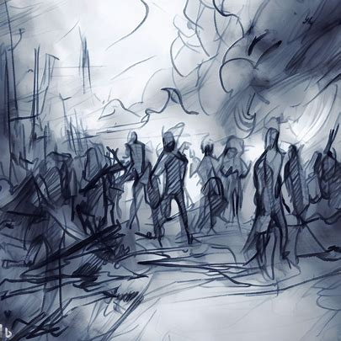](https://www.bing.com/images/create/sketch-people-in-a-natural-disaster/64b8b786196b474b8d7c411ac28ac279?id=tm5PEZq1pH5W5RsXxEOifg%3d%3d&view=detailv2&idpp=genimg&FORM=GCRIDP)

Analysing social media posts or customer business reviews

[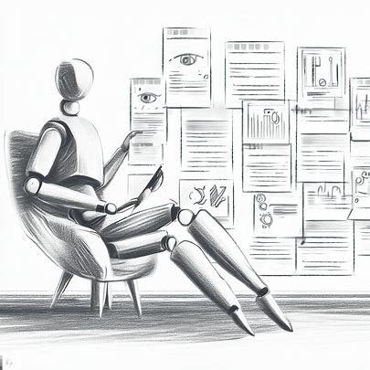](https://www.bing.com/images/create/sketch-a-scenario-where-ai-is-analzying-social-med/64b8f128d86d414bbf09e116f7cda179?id=vU6V8kZ6ZmfzEP2ICNy%2fkg%3d%3d&view=detailv2&idpp=genimg&FORM=GCRIDP)[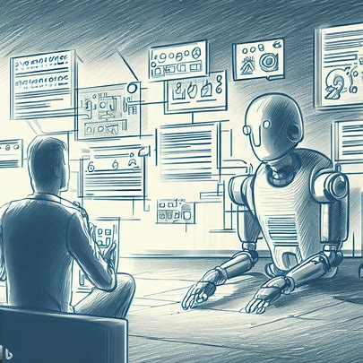](https://www.bing.com/images/create/sketch-a-scenario-where-ai-is-analzying-social-med/64b8f128d86d414bbf09e116f7cda179?id=L99fH3yVnQypdlmMpWS0hg%3d%3d&view=detailv2&idpp=genimg&FORM=GCRIDP)

People who need mental support

* [](https://www.bing.com/images/create/sketch-a-person-having-emotional-breakdown/64b8aebe25904aa19e2d7f1ca298e6a8?id=ITvJoZssTCQUqxsmJ32tqA%3d%3d&view=detailv2&idpp=genimg&FORM=GCRIDP)[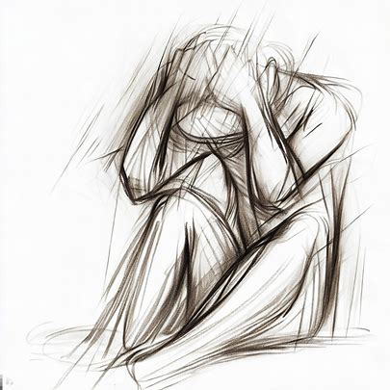](https://www.bing.com/images/create/sketch-a-person-having-emotional-breakdown/64b8aebe25904aa19e2d7f1ca298e6a8?id=RayWy0W%2bOkg2e0yjxxKnpg%3d%3d&view=detailv2&idpp=genimg&FORM=GCRIDP)

[](https://www.bing.com/images/create/sketch-a-person-having-emotional-breakdown/64b8aebe25904aa19e2d7f1ca298e6a8?id=bClhny1Ak93RKBiFBJe3gw%3d%3d&view=detailv2&idpp=genimg&FORM=GCRIDP)

Redirecting call to the respective authority for further assistance…

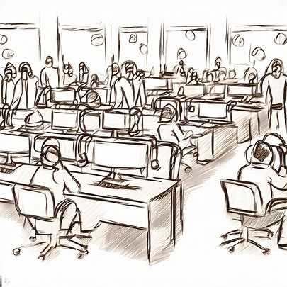

Support is on the way…

