Họ và tên: Trần Gia Long Môn: Xử lý ảnh

MSSV: N20DCCN035

Lớp: D20CQCNPM01-N

**Homework 5**

**Bài làm**

**Phần 1:**

**Câu a:**

Khai báo thư viện:

import numpy as np

import matplotlib.pylab as plt

Tạo hàm đọc file và cân bằng ảnh

def read_file(filename,size):

    img=np.fromfile(filename,dtype=np.uint8)

    img=img.reshape((size,size))

    return img

def full_scale_contrast(img):

    min=np.min(img)

    max=np.max(img)

    if min == max:

        return img

    scale=255/(max-min)

    img=(img-min)*scale

    img=np.round(img) # hoặc img=img.astype(np.uint8)

    return img

Hiển thị ảnh đầu

img=read_file('salesman.bin',256)

print(img.shape)

plt.imshow(img,cmap='gray')

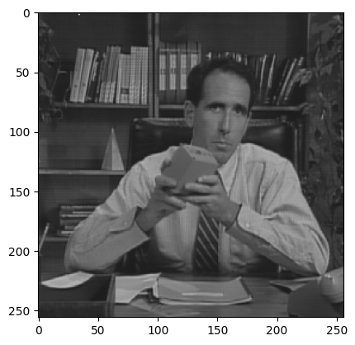

Sử dụng image domain convolution để tạo output image

img2= np.zeros((262,262)) # padding_image

img2[3:259,3:259]=img # 3 to 258 = 256

img3= np.zeros((262,262))# result

filter = np.ones((7,7))/49

for row in range(3,259):

    for col in range(3,259):

        img3[row,col]=np.sum(img2[row-3:row+4,col-3:col+4]*filter) # 3-3: 3+4 = 0:6 (range(0,7))

Hiển thị kết quả

plt.figure(figsize=(10,10))

plt.subplot(1,2,1)

plt.title('Original Image')

plt.imshow(img,cmap='gray')

plt.subplot(1,2,2)

plt.title('Filterd Image')

plt.imshow(full_scale_contrast(img3),cmap='gray')

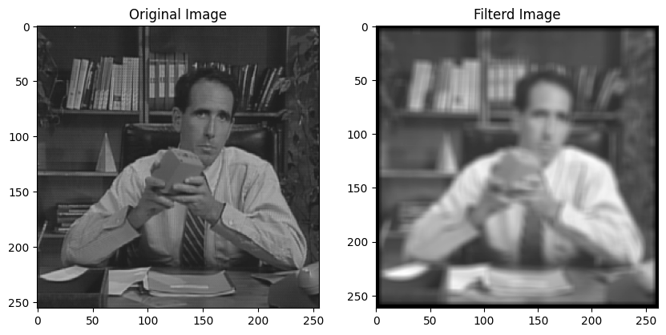

**Câu b:**

Tạo impulse response image

H=np.zeros((128,128)) # impulse response image

center= 128//2

H[center-3:center+4,center-3:center+4]=1/49 # = np.ones((7,7))/49

Khởi tạo kích cỡ phù hợp cho kết quả

zero_padded_size=256 + 128 - 1

print(zero_padded_size)

Tính các output yêu cầu của đề bài

# zero_padded_original_img

ZPO=np.zeros((zero_padded_size,zero_padded_size))

ZPO[:256,:256]=img

# zero_padded_impulse_response_img

ZPI=np.zeros((zero_padded_size,zero_padded_size))

ZPI[:128,:128]=H

#DFT

ZPOtilde=np.fft.fft2(ZPO)

ZPItilde=np.fft.fft2(ZPI)

#centered DFT log-magnitude spectrum

ZPOtilde_center=np.log(1+np.abs(np.fft.fftshift(ZPOtilde)))

ZPItilde_center=np.log(1+np.abs(np.fft.fftshift(ZPItilde)))

#zero padded output image

OItilde= ZPOtilde* ZPItilde

OI= (np.fft.ifft2(OItilde)).real

#centered DFT log-magnitude spectrum of the zero padded output image

OItilde_center= np.log(1+np.abs(np.fft.fftshift(OItilde)))

#final 256 × 256 output image

FI=OI[64:320,64:320]

Hiển thị kết quả

plt.figure(figsize=(16,8))

plt.subplot(2,4,1)

plt.title('Origin image')

plt.imshow(full_scale_contrast(img),cmap='gray')

plt.subplot(2,4,2)

plt.title('Zero padded original image')

plt.imshow(full_scale_contrast(ZPO),cmap='gray')

plt.subplot(2,4,3)

plt.title('Zero padded impulse response image')

plt.imshow(full_scale_contrast(ZPI),cmap='gray')

plt.subplot(2,4,4)

plt.title('centered DFT ZPO')

plt.imshow(full_scale_contrast(ZPOtilde_center),cmap='gray')

plt.subplot(2,4,5)

plt.title('centered DFT ZPI')

plt.imshow(full_scale_contrast(ZPItilde_center),cmap='gray')

plt.subplot(2,4,6)

plt.title('centered DFT output')

plt.imshow(full_scale_contrast(OItilde_center),cmap='gray')

plt.subplot(2,4,7)

plt.title('output image')

plt.imshow(full_scale_contrast(OI),cmap='gray')

plt.subplot(2,4,8)

plt.title('final image')

plt.imshow(full_scale_contrast(FI),cmap='gray')

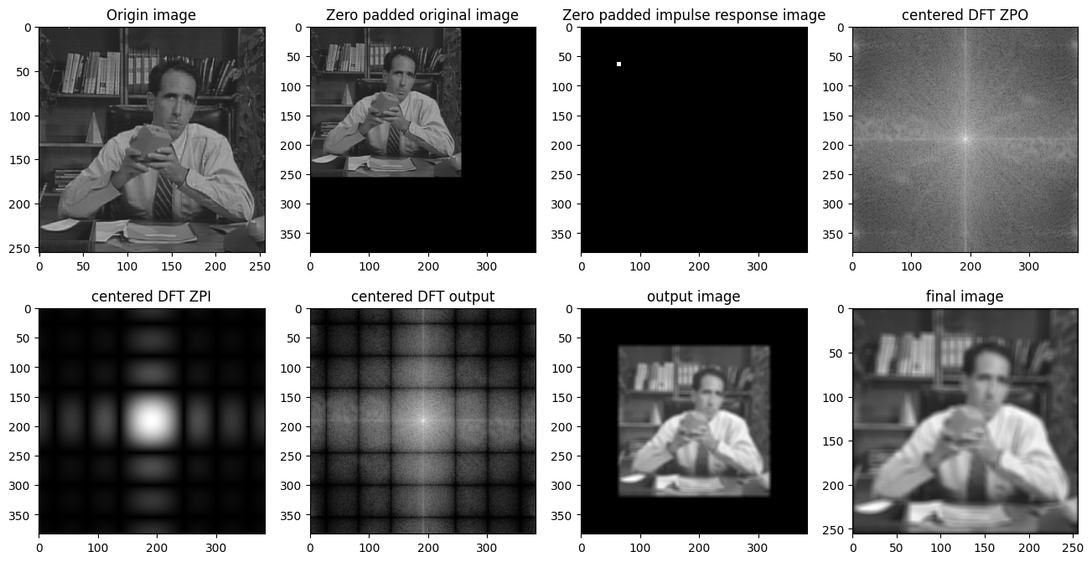

So sánh kết quả với câu a

#Verify that the output image is the same as the one in part (a)

#Y1a=img3, Y1b=FI

Y1a=full_scale_contrast(img3[3:262-3,3:262-3])

Y1b=full_scale_contrast(FI)

max_difference_before=np.max(np.abs(FI-img3[3:262-3,3:262-3]))

max_difference_after=np.max(np.abs(Y1b-Y1a))

print('Sự khác nhau Y1a và Y1b (chưa full scale constrast): '+str(max_difference_before))

print('Sự khác nhau Y1a và Y1b (full scale constrast): '+str(max_difference_after))



**Câu c:**

Tính các yêu cầu của bài toán

#zero-phase impulse response image

H= np.zeros((256,256))

H[125:132,125:132]=1/49

H2=np.fft.fftshift(H)

# zero_padded_original_img

ZPO2=np.zeros((512,512))

ZPO2[:256,:256]=img

# zero padded zero-phase impulse response image

ZPI2=np.zeros((512,512))

ZPI2[:128,:128]=H2[:128,:128]

ZPI2[:128,384:512]=H2[:128,128:256]

ZPI2[384:512,:128]=H2[128:256,:128]

ZPI2[384:512,384:512]=H2[128:256,128:256]

#final 256 × 256 output image

FI2=np.fft.ifft2(np.fft.fft2(ZPO2)*np.fft.fft2(ZPI2))

FI2=FI2.real[:256,:256]

Hiển thị kết quả

plt.figure(figsize=(20,8))

plt.subplot(1,4,1)

plt.title('Origin image')

plt.imshow(full_scale_contrast(img),cmap='gray')

plt.subplot(1,4,2)

plt.title('Zero-phase impulse response image')

plt.imshow(full_scale_contrast(H2),cmap='gray')

plt.subplot(1,4,3)

plt.title('Padded zero-phase impulse response image')

plt.imshow(full_scale_contrast(ZPI2),cmap='gray')

plt.subplot(1,4,4)

plt.title('Final output image')

plt.imshow(full_scale_contrast(FI2),cmap='gray')

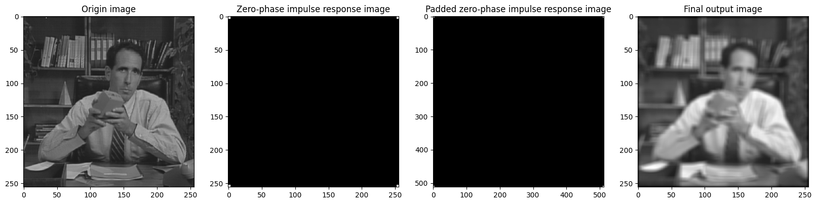

So sánh với câu a

#Verify that the output image is the same as the one in part (a)

#Y1a=img3, Y1c=FI2

Y1c=full_scale_contrast(FI2)

max_difference_before=np.max(np.abs(FI2-img3[3:262-3,3:262-3]))

max_difference_after=np.max(np.abs(Y1c-Y1a))

print('Sự khác nhau Y1a và Y1c (chưa full scale constrast): '+str(max_difference_before))

print('Sự khác nhau Y1a và Y1c (full scale constrast): '+str(max_difference_after))



**Phần 2:**

**Câu a:**

Đọc file và tính MSE của 2 trường hợp hi-pass Gaussian và broadband Gaussian so với ảnh gốc

girl=read_file('girl2.bin',256)

girl_N=read_file('girl2Noise32.bin',256)

girl_NH=read_file('girl2Noise32Hi.bin',256)

#Hàm tính MSE

def mse(b,a=girl):

    return np.mean((b-a)**2)

mse_girl_N=mse(girl_N,girl)

mse_girl_NH=mse(girl_NH,girl)

Hiển thị kết quả

print('MSE girl2Noise32 & girl2: '+ str(mse_girl_N))

print('MSE girl2Noise32Hi & girl2: '+ str(mse_girl_NH))

plt.figure(figsize=(16,8))

plt.subplot(1,3,1)

plt.title('Tiffany')

plt.imshow(girl,cmap='gray')

plt.subplot(1,3,2)

plt.title('Tiffany has broadband Gaussian white noise')

plt.imshow(girl_N,cmap='gray')

plt.subplot(1,3,3)

plt.title('Tiffany has hi-pass Gaussian white noise')

plt.imshow(girl_NH,cmap='gray')

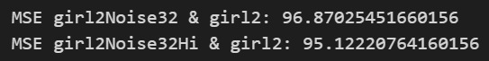

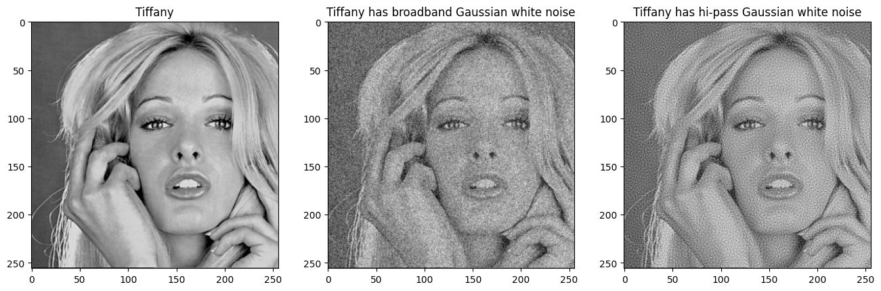

**Câu b:**

Tạo hàm low-pass filter áp dụng vào hình ảnh

def apply_ideal_lpf(img,cutoff=64):

    # 2 mảng (mảng [-128,127] chạy hàng, chạy cột) (u,v)

    u,v=np.meshgrid(np.arange(-128,128),np.arange(-128,128)) #(-row//2,row//2),(-col//2,col//2)

    hltilde_center=np.double(np.sqrt(u**2+v**2)<=cutoff)

    hltilde=np.fft.fftshift(hltilde_center)

    result=np.fft.ifft2(np.fft.fft2(img)*hltilde).real # real để loại bỏ phức

    return result

Áp dụng filter vào các hình và tính MSE, ISNR

#áp dụng filter

u_cutoff=64

lpf_girl=apply_ideal_lpf(girl,u_cutoff) # real để loại bỏ phức

lpf_girl_N=apply_ideal_lpf(girl_N,u_cutoff)

lpf_girl_NH=apply_ideal_lpf(girl_NH,u_cutoff)

#tính MSE cho hình sau khi áp dụng filter (lpf)

mse_lpf_girl=mse(lpf_girl,girl)

mse_lpf_girl_N=mse(lpf_girl_N,girl)

mse_lpf_girl_NH=mse(lpf_girl_NH,girl)

#tính ISNR

isnr_girl_N=10*np.log10(mse_girl_N/mse_lpf_girl_N)

isnr_girl_NH=10*np.log10(mse_girl_NH/mse_lpf_girl_NH)

Kết quả MSE, ISNR

print('MSE ideal low-pass filter on girl2: ',mse_lpf_girl)

print('MSE ideal low-pass filter on girl2Noise32: ',mse_lpf_girl_N)

print('ISNR ideal low-pass filter on girl2Noise32:',isnr_girl_N)

print('MSE ideal low-pass filter on girl2Noise32Hi: ',mse_lpf_girl_NH)

print('ISNR ideal low-pass filter on girl2Noise32Hi: ',isnr_girl_NH)

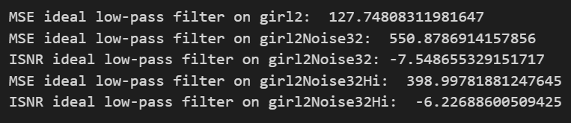

Hiển thị kết quả hình sau khi áp dụng LPF

plt.figure(figsize=(16,8))

plt.subplot(1,3,1)

plt.title('Tiffany (lpf)')

plt.imshow(full_scale_contrast(lpf_girl),cmap='gray')

plt.subplot(1,3,2)

plt.title('Tiffany (lpf) has broadband Gaussian white noise')

plt.imshow(full_scale_contrast(lpf_girl_N),cmap='gray')

plt.subplot(1,3,3)

plt.title('Tiffany (lpf) has hi-pass Gaussian white noise')

plt.imshow(full_scale_contrast(lpf_girl_NH),cmap='gray')

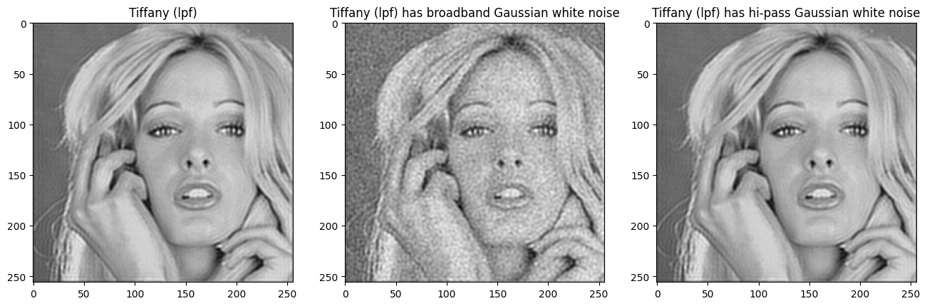

**Câu c:**

Tạo hàm áp dụng Gaussian low-pass filter

def apply_ideal_lpf_gaussian(img,cutoff=64):

    sigma_h=0.19*256/ cutoff

    u,v=np.meshgrid(np.arange(-128,128),np.arange(-128,128)) #(-row//2,row//2),(-col//2,col//2)

    htilde_center=np.exp((-2*np.pi**(2*sigma_h**2))/((256**2)*(u**2+v**2)))

    htilde=np.fft.fftshift(htilde_center)

    H = np.fft.ifft2(htilde).real

    H2=np.fft.fftshift(H)

    ZPH2=np.zeros((512,512))

    ZPH2[:256,:256]=H2

    ZPO3=np.zeros((512,512))

    ZPO3[:256,:256]=img

    result=np.fft.ifft2(np.fft.fft2(ZPO3)*np.fft.fft2(ZPH2)).real

    return result[128:384,128:384]

Áp dụng GLPF cho các hình ảnh và tính MSE, ISNR

#Áp dụng vào các hình gaussian lpf

u_cutoff_h=64

glpf_girl=apply_ideal_lpf_gaussian(girl,u_cutoff_h)

glpf_girl_N=apply_ideal_lpf_gaussian(girl_N,u_cutoff_h)

glpf_girl_NH=apply_ideal_lpf_gaussian(girl_NH,u_cutoff_h)

#Tính MSE

mse_glpf_girl=mse(glpf_girl,girl)

mse_glpf_girl_N=mse(glpf_girl_N,girl)

mse_glpf_girl_NH=mse(glpf_girl_NH,girl)

#Tính ISNR

isnr_glpf_girl_N=10*np.log10(mse_girl_N/mse_glpf_girl_N)

isnr_glpf_girl_NH=10*np.log10(mse_girl_NH/mse_glpf_girl_NH)

Hiển thị kết quả MSE, ISNR

print('MSE ideal low-pass filter on girl2: ',mse_glpf_girl)

print('MSE ideal low-pass filter on girl2Noise32: ',mse_glpf_girl_N)

print('ISNR ideal low-pass filter on girl2Noise32:',isnr_glpf_girl_N)

print('MSE ideal low-pass filter on girl2Noise32Hi: ',mse_glpf_girl_NH)

print('ISNR ideal low-pass filter on girl2Noise32Hi: ',isnr_glpf_girl_NH)

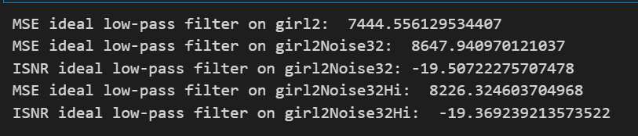

Hiển thị hình ảnh đã áp dụng GLPF

plt.figure(figsize=(16,8))

plt.subplot(1,3,1)

plt.title('Tiffany (glpf)')

plt.imshow(full_scale_contrast(glpf_girl),cmap='gray')

plt.subplot(1,3,2)

plt.title('Tiffany (glpf) has broadband Gaussian white noise')

plt.imshow(full_scale_contrast(glpf_girl_N),cmap='gray')

plt.subplot(1,3,3)

plt.title('Tiffany (glpf) has hi-pass Gaussian white noise')

plt.imshow(full_scale_contrast(glpf_girl_NH),cmap='gray')

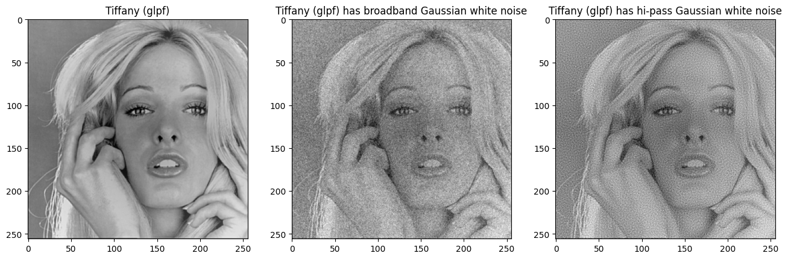

Câu d:

Áp dụng GLPF với cutoff = 77.5

#Áp dụng vào các hình gaussian lpf

u_cutoff_h=77.5

glpf_girl2=apply_ideal_lpf_gaussian(girl,u_cutoff_h)

glpf_girl_N2=apply_ideal_lpf_gaussian(girl_N,u_cutoff_h)

glpf_girl_NH2=apply_ideal_lpf_gaussian(girl_NH,u_cutoff_h)

#Tính MSE

mse_glpf_girl2=mse(glpf_girl2,girl)

mse_glpf_girl_N2=mse(glpf_girl_N2,girl)

mse_glpf_girl_NH2=mse(glpf_girl_NH2,girl)

#Tính ISNR

isnr_glpf_girl_N2=10*np.log10(mse_girl_N/mse_glpf_girl_N2)

isnr_glpf_girl_NH2=10*np.log10(mse_girl_NH/mse_glpf_girl_NH2)

Hiển thị

print('MSE ideal low-pass filter on girl2: ',mse_glpf_girl2)

print('MSE ideal low-pass filter on girl2Noise32: ',mse_glpf_girl_N2)

print('ISNR ideal low-pass filter on girl2Noise32:',isnr_glpf_girl_N2)

print('MSE ideal low-pass filter on girl2Noise32Hi: ',mse_glpf_girl_NH2)

print('ISNR ideal low-pass filter on girl2Noise32Hi: ',isnr_glpf_girl_NH2)

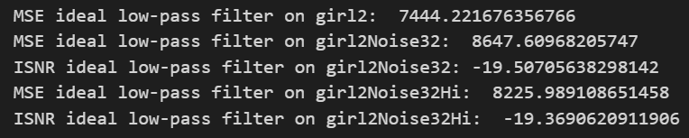

plt.figure(figsize=(16,8))

plt.subplot(1,3,1)

plt.title('Tiffany (glpf)')

plt.imshow(full_scale_contrast(glpf_girl2),cmap='gray')

plt.subplot(1,3,2)

plt.title('Tiffany (glpf) has broadband Gaussian white noise')

plt.imshow(full_scale_contrast(glpf_girl_N2),cmap='gray')

plt.subplot(1,3,3)

plt.title('Tiffany (glpf) has hi-pass Gaussian white noise')

plt.imshow(full_scale_contrast(glpf_girl_NH2),cmap='gray')

