

**Software-Subject Recommendation Site**

**Proposal**

2021.04.29.

**Open Source Software Practice**

**TEAM 24**

Chi Hyun Lee [ych2717@naver.com](mailto:ych2717@naver.com)

Sae Ha Yoo [saeha5160@gmail.com](mailto:saeha5160@gmail.com)

Kwan Yong Jung [rhks7410dyd@naver.com](mailto:rhks7410dyd@naver.com)

1. Application Type

The function of our team’s project is suggesting a subject with entered students’ information. Two main functions are suggesting next subjects to take and listing subjects that must be preceded to take a certain subject. It is very time-consuming for users to enter all their information each time they want recommendation. So, we decided to make it as a web page and include a log-in function for the users who do not want that kind of effort.

1. Topic

Most of the subjects in software college requires a certain level of knowledge of precedent subjects. Nevertheless, many freshmen and people who learns software by double majoring are taking higher-level classes without taking classes that must be preceded. To resolve this problem, we devised a webpage that suggests appropriate subjects to take this semester, by entering subjects they already took.

1. Sketch

Main page

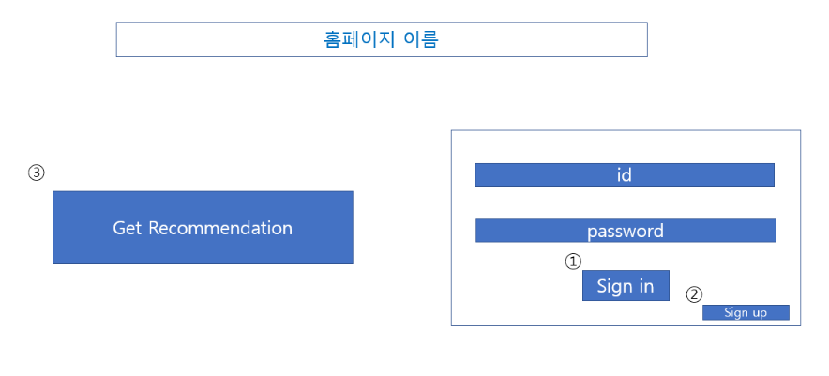

Recommendation for logged in user

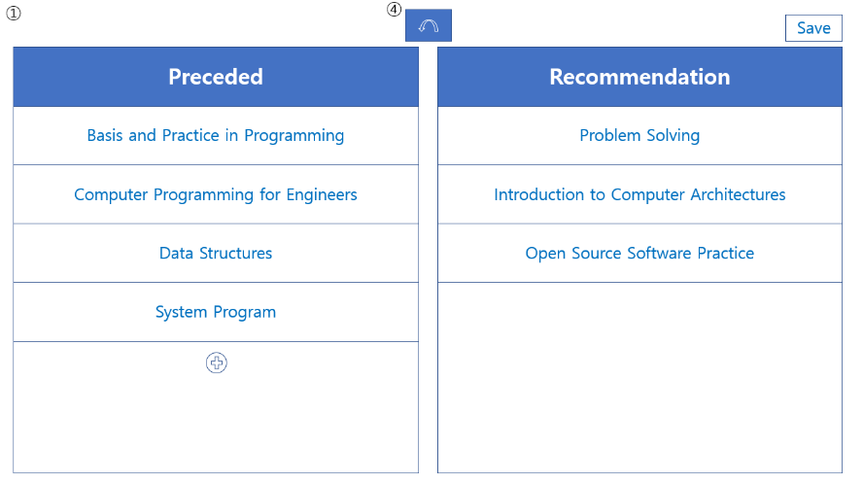

Sign-up

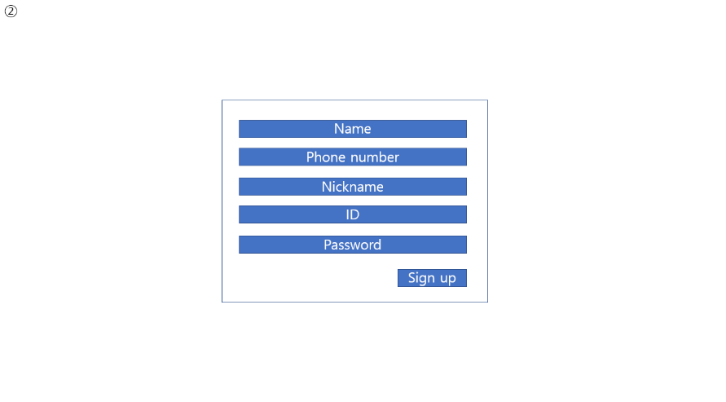

Recommendation for not logged in user

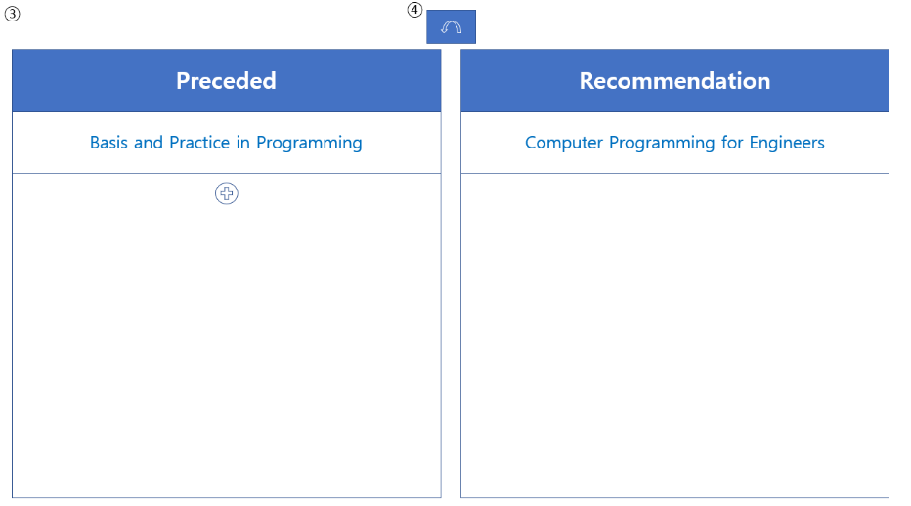

List subjects that has to be preceded

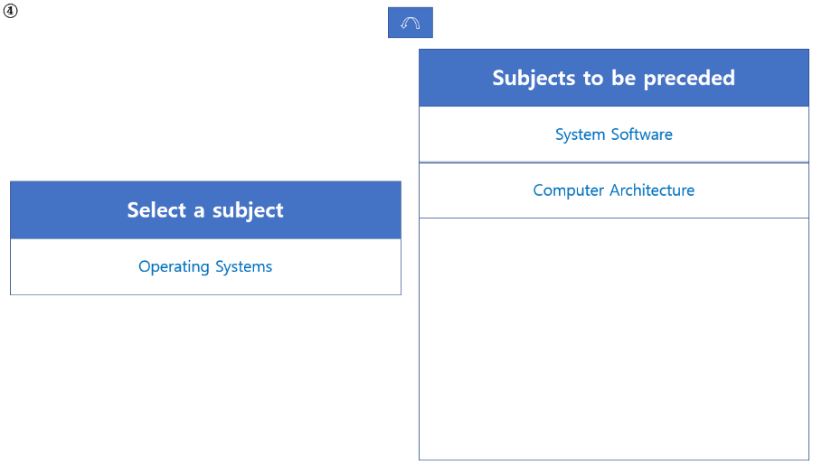

1. Features

The biggest feature of our website is that it can be converted to a user-participating website. The current plan is only about software departments and we plan to provide direct information, but we can expand it to websites available to many schools and departments, such as the famous mobile phone application 'every time'.

And in the current situation due to covid-19, and to tell each professor's characteristics, it is difficult for a senior to recommend a prior course to the juniors and to tell each professor's characteristics. This website can help many freshmen.

1. Usage scenario

The new software student in 21st class starts to make a timetable after the first semester. The student made a meaningful timetable based on the information provided by the student council in the first semester, but he had no experience making a timetable himself. In this situation, enter our website. You can log in our website if you provide name, nickname, phone number, id, and password. Once you input the preceded classes, this website will show the recommended subjects for the next semester.

The software student who is planning to return to school this semester has difficulty making his timetable. The two-year leave of absence has cut off relationships with and he is worried about what subjects he should study in the future. In this situation, the curriculum recommended by seniors who have already graduated on our website can be of great help to them.

1. Task assignment

| **Name** | **Tasks** |
| --- | --- |
| Chi Hyun Lee | Get data from every time. Make algorism to recommend class |
| Sae Ha Yoo | Make UI(html and javascript) |
| Kwan Yong Jung | Make Database for users and classes. |