HEART DISEASE PREDICTION
USING MACHINE LEARNING
Project Analysis Report

1. Project Overview
This project analyzes patient medical information and develops machine learning classification models to predict the presence of heart disease. The workflow includes data integration, data understanding, cleaning, exploratory data analysis (EDA), preprocessing, model training, model comparison, and Random Forest hyperparameter tuning.

2. Problem Statement and Objectives
The objective is to use available patient health attributes to predict whether heart disease is present. The project aims to understand the dataset, identify patterns associated with the target variable, compare classification algorithms, and select a promising model based on evaluation metrics.
- Perform EDA to understand patient health characteristics.
- Clean and preprocess the dataset for machine learning.
- Train and compare multiple classification models.
- Evaluate models using Accuracy, Precision, Recall, and F1 Score.
- Tune the selected Random Forest model and provide data-based hospital recommendations.

3. Dataset Description
The project uses two separate files: a medical features file and a target labels file. The medical features file contains 14 columns, including patient_id and 13 medical features. The target file contains patient_id and heart_disease_present. The files were integrated using patient_id, producing a merged dataset of 180 patient records and 15 columns: one identifier, 13 input features, and one target variable.
The target variable, heart_disease_present, is binary: 0 indicates no heart disease and 1 indicates heart disease.

4. Data Preparation and Understanding
The two files were checked for duplicate patient identifiers and merged using patient_id. The analysis reported no duplicate patient IDs, no missing values, and no duplicate records in the merged dataset.
Descriptive statistics showed an average age of approximately 54.81 years, average resting blood pressure of 131.31 mmHg, average serum cholesterol of 249.21 mg/dL, average maximum heart rate of 149.48 bpm, and average ST depression of 1.01. Approximately 44.44% of records belonged to the heart disease class.

5. Exploratory Data Analysis (EDA)
EDA was performed using histograms, count plots, categorical comparisons by target, and box plots. The following figures are taken from the project's notebook.

5.1 Numerical Feature Distributions
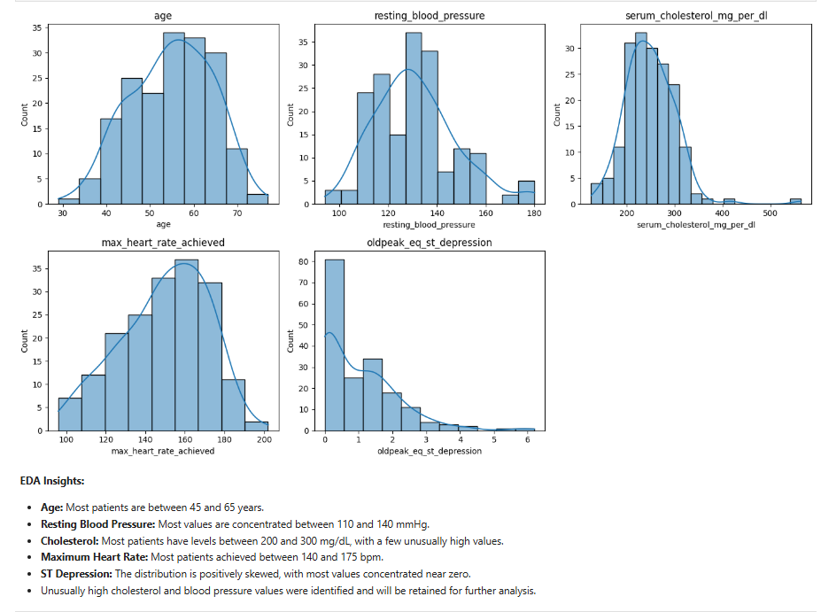
Figure 1. Histograms of age, resting blood pressure, serum cholesterol, maximum heart rate, and ST depression.
- Age: Most patients are between 45 and 65 years.
- Resting blood pressure: Most values are concentrated between 110 and 140 mmHg.
- Cholesterol: Most patients have values between 200 and 300 mg/dL, with a few unusually high values.
- Maximum heart rate: Most patients achieved values between 140 and 175 bpm.
- ST depression: The distribution is positively skewed, with most values concentrated near zero.
- Unusually high cholesterol and blood pressure values were retained for further analysis.

5.2 Categorical Feature Distributions
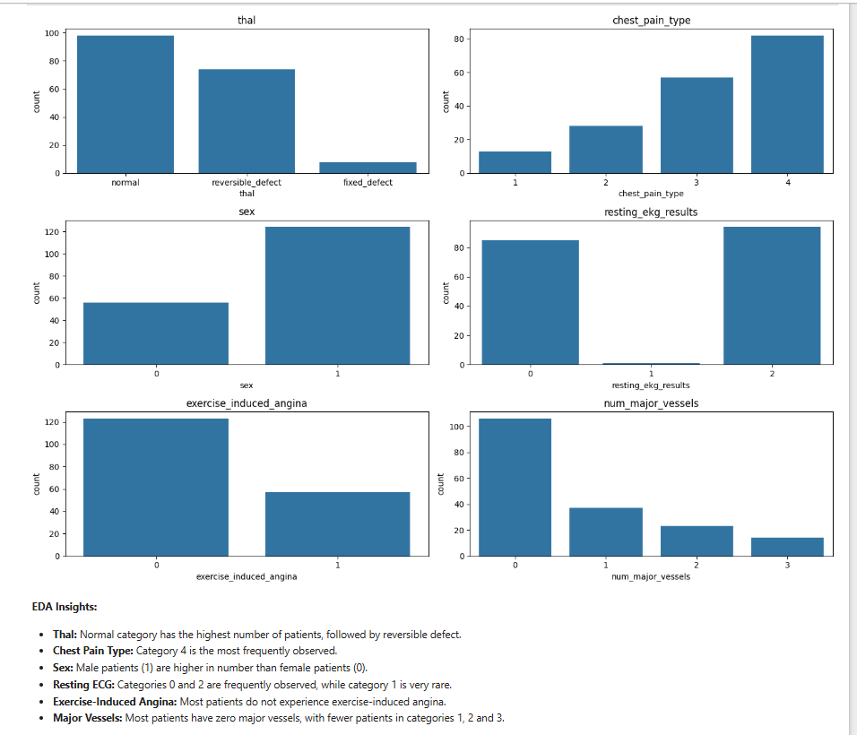
Figure 2. Counts of categorical features, including thal, chest pain type, sex, resting ECG, exercise-induced angina, and number of major vessels.
- Thal: The normal category has the highest number of patients, followed by reversible defect.
- Chest pain type: Category 4 is the most frequently observed.
- Sex: Male patients (coded 1) are higher in number than female patients (coded 0).
- Resting ECG: Categories 0 and 2 are frequently observed, while category 1 is rare.
- Exercise-induced angina: Most patients do not experience exercise-induced angina.
- Major vessels: Most patients have zero major vessels, with fewer patients in categories 1, 2, and 3.

5.3 Categorical Features Compared with Heart Disease
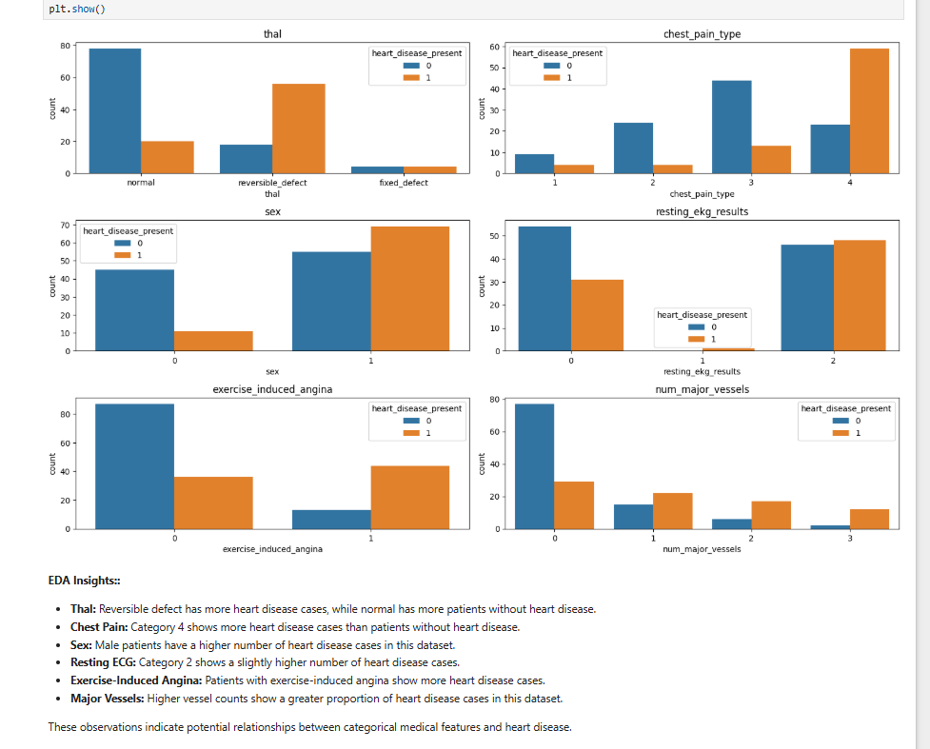
Figure 3. Counts of categorical feature values split by heart_disease_present (0 = absent, 1 = present).
- Thal: Reversible defect has more heart disease cases, while normal has more patients without heart disease.
- Chest pain: Category 4 shows more heart disease cases than patients without heart disease.
- Sex: Male patients have a higher number of heart disease cases in this dataset.
- Resting ECG: Category 2 shows a slightly higher number of heart disease cases.
- Exercise-induced angina: Patients with this feature show more heart disease cases.
- Major vessels: Higher vessel counts show a greater proportion of heart disease cases in this dataset.
These plots show counts, so category sizes differ. The observations describe patterns in this dataset and should not be interpreted as proof of causation.

5.4 Numerical Features Compared with Heart Disease
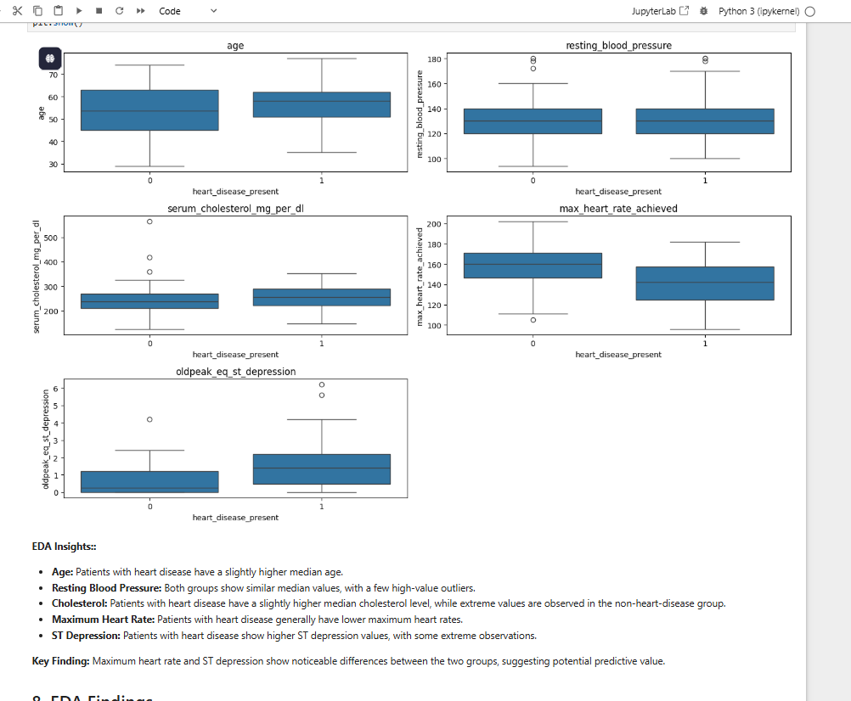
Figure 4. Box plots comparing numerical features for patients without heart disease (0) and with heart disease (1).
- Age: Patients with heart disease have a slightly higher median age.
- Resting blood pressure: Both groups show similar median values, with a few high-value outliers.
- Cholesterol: Patients with heart disease have a slightly higher median cholesterol level, while extreme values are observed in the non-heart-disease group.
- Maximum heart rate: Patients with heart disease generally have lower maximum heart rates.
- ST depression: Patients with heart disease show higher ST depression values, with some extreme observations.
Key finding: Maximum heart rate and ST depression show noticeable differences between the two groups, suggesting potential predictive value.

6. Feature Preprocessing and Model Development
The patient identifier and target variable were excluded from the input features. The categorical thal feature was converted using one-hot encoding. The dataset was split into training and testing subsets using an 80:20 split with stratification. Feature scaling was applied for Logistic Regression, KNN, and SVM.
Six classification algorithms were trained: Logistic Regression, K-Nearest Neighbors (KNN), Decision Tree, Random Forest, Support Vector Machine (SVM), and Gaussian Naive Bayes.

7. Model Evaluation and Comparison
The initial comparison showed that Random Forest, SVM, and Naive Bayes achieved the highest initial testing accuracy of 86.1%. Random Forest and Naive Bayes achieved an initial F1 Score of 85.7%, while SVM achieved 84.8%.
The original Random Forest achieved 100% training accuracy and 86.1% testing accuracy, indicating possible overfitting. GridSearchCV with 5-fold cross-validation was used to tune the Random Forest model.

8. Final Tuned Random Forest Results
The selected tuned Random Forest used max_depth=5, min_samples_leaf=2, min_samples_split=2, and n_estimators=100.
Evaluation Metric | Result
Training Accuracy | 92.4%
Testing Accuracy | 91.7%
Precision | 84.2%
Recall | 100%
F1 Score | 91.4%
The 100% recall means that all actual positive cases in the 36-record test set were identified by this model. It does not guarantee the same result on future patients.

9. Hospital Recommendations
- Encourage appropriate screening and follow-up for patients with concerning cardiovascular indicators.
- Monitor blood pressure and cholesterol as part of routine health assessments.
- Ensure that patients reporting chest pain or exercise-induced angina receive appropriate clinical evaluation.
- Consider thal category, ST depression, and maximum heart rate as part of a broader clinical assessment.
- Treat machine learning predictions only as supplementary screening support, not as a diagnosis or replacement for a clinician.

10. Challenges and Limitations
- The patient features and target labels were supplied in separate files and needed to be integrated.
- The categorical thal feature required encoding before model training.
- The original Random Forest showed possible overfitting, so hyperparameter tuning was performed.
- The dataset contains only 180 records, and the test set contains only 36 records.
- The model has not been clinically validated and may not generalize to other patient populations.

11. Conclusion
This project demonstrated a complete machine learning workflow for exploring patient health data and predicting the presence of heart disease. Data integration and EDA helped describe the patient records and identify patterns associated with the target variable. Six classification algorithms were compared, and the Random Forest model was tuned using GridSearchCV. The selected tuned Random Forest achieved 91.7% testing accuracy, 84.2% precision, 100% recall, and a 91.4% F1 Score on the available test set. These results are promising for this learning project and show how data analysis and machine learning can support risk-assessment research. However, the dataset is small and the model has not been clinically validated, so it must not be used as a standalone medical diagnostic tool.

