ASIA PACIFIC INSTITUTE OF INFORMATION TECHNOLOGY

IN COLLABORATION WITH

STAFFORDSHIRE UNIVERSITY UK

BSc / BEng (Hons) in Software Engineering





**Individual Assignment**

**CB005916 [IF15A1SE]**

**Sasith Koralagoda**

**CE00856-2- Database System**

**Instructor:**

Miss. Malsha Fernando

**Word count**

3281

Acknowledgment

The success and final outcome of this report required lot of guidance from many people. Therefore I extremely thank to that people, especially our lecturer Madam. Malsha Fernando. Our lecturer provide us knowledge and energy for complete this report well that how I hope.

I would like to thank who guides me at every step and every aspect of this assignment. And my father always support me to do every work clearly and correctly. So I would thankful to my father.

Table of Contents

1. Software Development Life Cycle 7

2. Design Requirements and Assumptions 8

3. ER diagram 9

4. Functional Dependencies 10

Warehouses table 10

Suppliers table 10

Retail_shops table 10

Employees table 10

Customer table 10

Loyal_Customer table 10

5. Normalization 11

UNF 11

1NF 11

2NF 12

3NF 12

Normalized tables 13

6. Constraints 15

7. Create Table Statements 17

8. Insert Statements 19

9. SQL Queries 28

10. Conclusion 38

11. Reference 39

Figure 2: SDLC (Author's work) 7

Figure 3: ER diagram (Author’s work) 9

Figure 4: Suppliers table (Author's work) 13

Figure 5: Retail_shop table (Author's work) 13

Figure 6: Garment table (Author's work) 13

Figure 7: Garment_details table (Author's work) 13

Figure 8:Supplier_meterial table (Author's work) 13

Figure 9; Warehouse table (Author's work) 14

Figure 10: Loyal_customer table (Author's work) 14

Figure 11: Invoice table (Author's work) 14

Figure 12: Employee table (Author's work) 14

Figure 13: Customer table (Author's work) 14

Figure 14: Created table (Author's work) 18

Figure 15: Garment table values (Author's work) 19

Figure 16: Garment_details table values (Author's work) 20

Figure 17: Warehouse table values (Author's work) 20

Figure 18: Suppliers table values (Author's work) 21

Figure 19: Supplier_meterial table values (Author's work) 22

Figure 20: Loyal_customer table values (Author's work) 23

Figure 21: Customer table values (Author's work) 24

Figure 22: Retail_shop table values (Author's work) 25

Figure 23: Employee table values (Author's work) 26

Figure 24: Invoice table values (Author's work) 27

Figure 25: Query 01 (Author's work) 28

Figure 26 : Query 02 (Author's work) 28

Figure 27: Query 03 (Author's work) 29

Figure 28: Query 04 (Author's work) 29

Figure 29: Query 05 (Author's work) 30

Figure 30: Query 06(Author's work) 30

Figure 31: Query 07 I (Author's work) 31

Figure 32: Query 01 II (Author's work) 31

Figure 33: Query 07 Executed (Author's work) 31

Figure 34: Query 08 (Author's work) 32

Figure 35: Query 09 (Author's work) 32

Figure 36: Query 10 (Author's work) 33

Figure 37: Query 11 (Author's work) 33

Figure 38: Query 12 (Author's work) 34

Figure 39: Query 13 (Author's work) 34

Figure 40: Query 14 (Author's work) 34

Figure 41: Query 15 (Author's work) 35

Figure 42: Query 16 (Author's work) 35

Figure 43: Query 17 (Author's work) 36

Figure 44: Query 18 (Author's work) 36

Figure 45: Query 19 (Author's work) 37

Introduction

This report is based on a company called RLD (Rich look design) which deals with manufacturing and selling different types of garments. There are 18 retail shops in total, 2 in the western province and 1 each in the remaining 8 provinces. Each warehouse and retail shop has a separate manager, in addition each retail shop has 2 sales persons and each warehouse has 2 workers. There are several suppliers for RLD, who supply thread, buttons, cloth and etc. The warehouse store raw materials and finished garments.

The garments are sold to customers via retail shops. Customers can classify as either ‘Normal’ customer or ‘Loyal’ customers. A normal customer can obtain a loyalty card from any retail shop. The company also sends a birthday card to the senior citizen customers as a kind gesture.

In this case study the author is supposed to generate a detailed set of Data Base design requirements. The design is implemented including entity relationship diagrams, values and SQL queries for the given scenario.

To complete this, the author has used a software development life cycle, entity relationship diagram, SQL statements and normalization to organize the data in a prescribed manner.

# Software Development Life Cycle

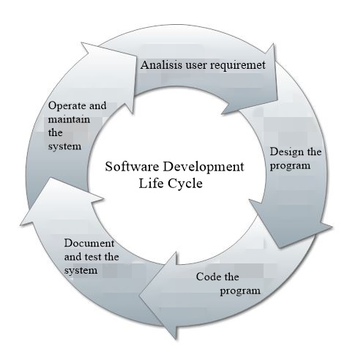Software development life cycle is a process that describes plan for good software build. It consists of a detailed plan describing how to develop, maintain, replace and enhance specific software. There are typically five steps starting with the analysis and requirements gathering and ending with the implementation.

Figure 1: SDLC (Author's work)

* Analysis user requirement-

This is critical to the success of the project. Author needs to know expectations of the program.

Technical design requirements are prepared in this step by lead author.

* Design the program -

This step is the actual coding and [unit testing](https://www.slideshare.net/assembla/assembla-airbrake-webinar-production-monitoring-and-continuous-delivery-may-2013) of the process

* Code the program -
* Document and test - the system

Once the application is migrated to a test environment, different types of testing will be performed including integration and system testing.

* Operate and maintain - Author’s need to describe how to operate to user and need to do update.   (Airbrake.io)

# Design Requirements and Assumptions

# 2.1 Design Requirement

Firstly need to identify the prototypes of the system scenario. Next step is creation of entity relation diagram. It wants to include correct relationships between tables. Then ERD redesign with foreign keys from logical mapping. Next step is normalization from ERD tables. After create database need to create tables according to normalized tables and insert values to relevant table. Finally queries can implement.

2.2 Assumptions

* One garment must store in many warehouses and one warehouse must be store by one garment.
* One supplier must sell to one warehouse and one warehouse must be selling by many supplies.
* One warehouse must supply many retailshop and one retailshop must be suppling by one warehouse.
* One Employee must work in one warehouse and one warehouse must be worked by many employees.
* One Employee must work in one retailshop and one retailshop must be worked by many employees.
* One retailshop must issue many invoice and one invoice must be issued by one retailshop.
* One invoice must receive to one employee and one employee may be received by many invoices.
* One invoice must receive to one customer and one customer may be received by many invoices.
* One employee may become one customer and one customer may be become by many employees.
* One customer may become one loyal customer and one loyal customer must be become by one customer.
* All attributes which hold price are subjected to be LKR.
* There are 10 retail shops that 2 in western province and others are in remaining 8 province

# ER diagram

Figure 2: ER diagram (Author’s work)

# Functional Dependencies

## Warehouses table

Warehouse_id Geopraphical_province, City

## Suppliers table

Rowmeterial_id Rowmeterial_name

## Retail_shops table

Retailshop_id Province, City

## Employees table

Employee_id Loyalcustomer_id

## Customer table

Customer_id, Customer_password

## Loyal_Customer table

Loyalcustomer_id Customer_name, Customer_address, date of birth, Customer_id

# Normalization

## UNF

Garments (garment_id, garment_type, garment_color, garment_design, retail_price, garment_size, sale_items ) Warehouses (warehouse_id, geopraphical_province, city, garment_id[FK]) Suppliers ( rowmeterial_id, rowmeterial_type, rowmeterial_name, cost_price, no_rowmeterial, total_costprice, reorder_date,warehouse_id[FK])

Retail_shops (retailshop_id, province, city, garment_catagory, warehouse_id[FK]) Invoice( invoice_no, noof_items, total_price, date, cutomer_id[FK], employee_id[FK], retailshop_id[FK] ) Employees (employee_id, employee_name, employee_position, employee_office, work_city, work_province, retailshop_id[FK], warehouse_id[FK], customer_id[FK])

Customer (Customer_id, Customer_password) Loyal_Customer ( loyalcustomer_id, customer_name, customer_address, date of birth, gender, Customer_id[FK])

1NF Garments (Garment_id, Garment_type, Garment_color, Garment_design, Garment_size) Garment_details(Garment_id, Retail_price, Sale_items) Warehouses (Warehouse_id, Geopraphical_province, City, Garment_id[FK]) Supplier_meterial(Rowmeterial_id, Rowmeterial_type) Suppliers ( rowmeterial_id, rowmeterial_name, cost_price, no_rowmeterial, total_costprice, reorder_date,warehouse_id[FK])

Retail_shops (retailshop_id, province, city, garment_catagory, warehouse_id[FK]) Invoice( invoice_no, noof_items, total_price, date, cutomer_id[FK], employee_id[FK], retailshop_id[FK] ) Employees (employee_id, employee_name, employee_position, employee_office, work_city, work_province, retailshop_id[FK], warehouse_id[FK], customer_id[FK])

Customer (Customer_id, Customer_password) Loyal_Customer ( loyalcustomer_id, customer_name, customer_address, date of birth, gender, Customer_id[FK])

2NF

Garments (Garment_id, Garment_type, Garment_color, Garment_design, Garment_size) Garment_details(Garment_id, Retail_price, Sale_items) Warehouses (Warehouse_id, Geopraphical_province, City, Garment_id[FK]) Supplier_meterial(Rowmeterial_id, Rowmeterial_type) Suppliers ( rowmeterial_id, rowmeterial_name, cost_price, no_rowmeterial, total_costprice, reorder_date,warehouse_id[FK])

Retail_shops (retailshop_id, province, city, garment_catagory, warehouse_id[FK]) Invoice( invoice_no, noof_items, total_price, date, cutomer_id[FK], employee_id[FK], retailshop_id[FK] ) Employees (employee_id, employee_name, employee_position, employee_office, work_city, work_province, retailshop_id[FK], warehouse_id[FK], customer_id[FK])

Customer (Customer_id, Customer_password) Loyal_Customer ( loyalcustomer_id, customer_name, customer_address, date of birth, gender, Customer_id[FK])

3NF

Garments (Garment_id, Garment_type, Garment_color, Garment_design, Garment_size) Garment_details(Garment_id, Retail_price, Sale_items) Warehouses (Warehouse_id, Geopraphical_province, City, Garment_id[FK]) Supplier_meterial(Rowmeterial_id, Rowmeterial_type) Suppliers ( rowmeterial_id, rowmeterial_name, cost_price, no_rowmeterial, total_costprice, reorder_date,warehouse_id[FK])

Retail_shops (retailshop_id, province, city, garment_catagory, warehouse_id[FK]) Invoice( invoice_no, noof_items, total_price, date, cutomer_id[FK], employee_id[FK], retailshop_id[FK] ) Employees (employee_id, employee_name, employee_position, employee_office, work_city, work_province, retailshop_id[FK], warehouse_id[FK], customer_id[FK])

Customer (Customer_id, Customer_password) Loyal_Customer ( loyalcustomer_id, customer_name, customer_address, date of birth, gender, Customer_id[FK])

## Normalized tables

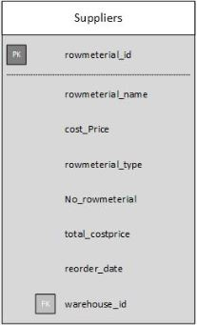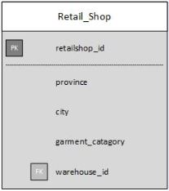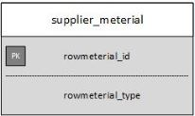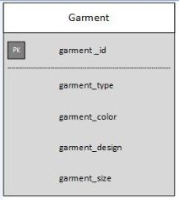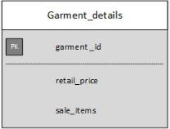

Figure 3: Suppliers table (Author's work)

Figure 4: Retail_shop table (Author's work)

Figure 5: Garment table (Author's work)

Figure 6: Garment_details table (Author's work)

Figure 7:Supplier_meterial table (Author's work)

## 

Figure 8; Warehouse table (Author's work)

Figure 9: Loyal_customer table (Author's work)

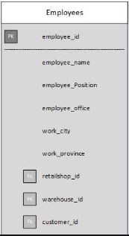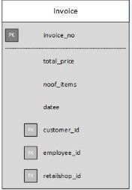

Figure 10: Invoice table (Author's work)

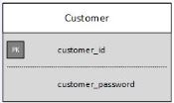

Figure 11: Employee table (Author's work)

Figure 12: Customer table (Author's work)

# Constraints

**Garment table**

* garment_id is the primary key in this table which cannot be null.
* garment_id is a foreign key for the Garment_id in Warehouse table.

**Garment_details table**

* garment_id is the primary key in this table which cannot be null.
* garment_id is a foreign key for the Garment_id in Warehouse table.

**Warehouse table**

* warehouse_id is the primary key in this table which cannot be null.
* warehouse_id is a foreign key for the warehouse_id in Employee table.
* warehouse_id is a foreign key for the warehouse_id in Suppliers table.
* warehouse_id is a foreign key for the warehouse_id in Retail_shop table.

**Retail_shop table**

* retailshop_id is the primary key in this table which cannot be null.
* retailshop_id is a foreign key for the retailshop_id in Employee table.
* retailshop_id is a foreign key for the retailshop_id in Invoice table.

**Suppliers table**

* rowmeterial_id is the primary key in this table which cannot be null.

**Supplier_meterial table**

* rowmeterial_id is the primary key in this table which cannot be null.

**Loyal_customer table**

* loyalcustomer_id is the primary key in this table which cannot be null.

**Customer table**

* cutomer_id is the primary key in this table which cannot be null.
* cutomer_id is a foreign key for the cutomer_id in Loyal_customer table.
* cutomer_id is a foreign key for the cutomer_id in Employee table.
* cutomer_id is a foreign key for the cutomer_id in Invoice table.

**Employee table**

* employee_id is the primary key in this table which cannot be null.
* employee_id is a foreign key for the employee_id in Invoice table.

**Invoice table**

* invoice_no is the primary key in this table which cannot be null.

# Create Table Statements

create table garment

(garment_id varchar(5) not null primary key,

garment_type varchar(12) not null,

garment_color varchar(10) not null,

garment_design varchar(15),

garment_size varchar(12),

);

create table garment_details

(garment_id varchar(5) not null primary key,

retail_price float,

sale_items int

);

create table warehouse

(warehouse_id varchar(5) not null primary key,

geopraphical_province varchar(20) not null,

city varchar(20),

garment_id varchar(5) foreign key references garment(garment_id)

);

create table supplierr

(rowmeterial_id varchar(6) not null primary key,

rowmeterial_name varchar(15),

cost_price int,

No_rowmeterial int,

total_costprice int,

reorder_date varchar(15),

warehouse_id varchar(5) foreign key references warehouse(warehouse_id)

);

create table supplier_meterial

(rowmeterial_id varchar(6) not null primary key,

rowmeterial_type varchar(15)

);

create table customer

(customer_id varchar(5) not null primary key,

customer_password varchar(25),

customer_name varchar(25)

);

create table loyalcustomer

(loyalcustomer_id varchar(5) not null primary key,

loyalcustomer_name varchar(30) not null,

loyalcustomer_address varchar(50),

dateof_birth varchar(15) not null,

gender varchar(6),

customer_id varchar(5) foreign key references customer(customer_id)

);

create table retail_shop

(retailshop_id varchar(5) not null primary key,

province varchar(18) not null,

city varchar(18) ,

garment_catagory varchar(10),

warehouse_id varchar(5)foreign key references warehouse(warehouse_id)

);

create table employee

(employee_id varchar(5) not null primary key,

employee_name varchar(30) not null,

position varchar(20),

employee_office varchar(20) not null,

work_city varchar(20),

work_province varchar(20),

retailshop_id varchar(5) foreign key references retail_shop

(retailshop_id),

warehouse_id varchar(5)foreign key references warehouse(warehouse_id),

customer_id varchar(5)foreign key references customer(customer_id)

);

create table invoice

(invoice_no varchar(10) not null primary key,

noof_items int,

total_price float,

datee varchar(12),

cutomer_id varchar(5) foreign key references customer(customer_id),

employee_id varchar(5) foreign key references employee(employee_id),

retailshop_id varchar(5) foreign key references retail_shop

(retailshop_id),

);

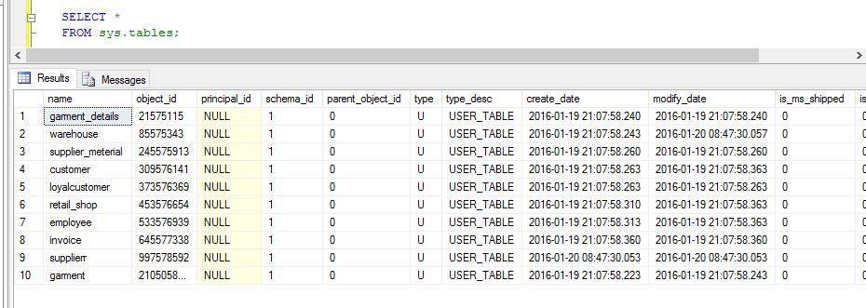

Figure 13: Created table (Author's work)

# Insert Statements

**Garment table**

insert into garment values('GA001','casual','dark blue','doted','medium');

insert into garment values('GA002','formal','red','thinblack lines','small');

insert into garment values('GA003','summer','pink','boxes','medium');

insert into garment values('GA004','summer','white','doted','larger');

insert into garment values('GA005','winter','red,blue','dot&lines','extra large');

insert into garment values('GA006','autumn','yellow','wrap','larger');

insert into garment values('GA007','spring','brown','dot&wave','extra small');

insert into garment values('GA008','wedding','white','plain','extra large');

insert into garment values('GA009','party','red,black','dot&lines','medium');

insert into garment values('GA010','spring','ash,blue','plain','small');

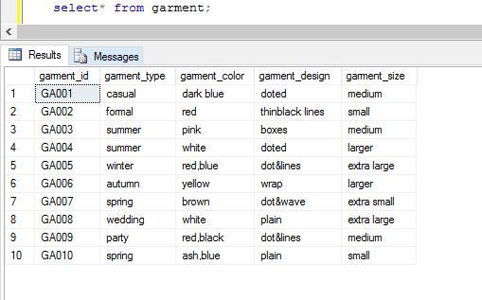

Figure 14: Garment table values (Author's work)

**Garment_details table**

insert into garment_details values('GA001',2200,500);

insert into garment_details values('GA002',2800,300);

insert into garment_details values('GA003',2300,150);

insert into garment_details values('GA004',1800,200);

insert into garment_details values('GA005',3200,250);

insert into garment_details values('GA006',4200,200);

insert into garment_details values('GA007',1400,150);

insert into garment_details values('GA008',10200,50);

insert into garment_details values('GA009',4800,180);

insert into garment_details values('GA010',1700,100);

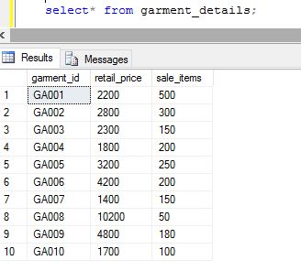

Figure 15: Garment_details table values (Author's work)

**Warehouse table**

insert into warehouse values('WH001','Western','Colombo','GA001');

insert into warehouse values('WH002','Central','Kandy','GA003');

insert into warehouse values('WH003','Sabaragamuwa','Rathnapura','GA004');

insert into warehouse values('WH004','Southern','Matara','GA002');

insert into warehouse values('WH005','North central','Anuradhapura','GA005');

insert into warehouse values('WH006','Northern','Jaffna','GA007');

insert into warehouse values('WH007','Eastern','Ampara','GA006');

insert into warehouse values('WH008','Uva','Monaragala','GA010');

insert into warehouse values('WH009','North Western','Kurunegala','GA009');

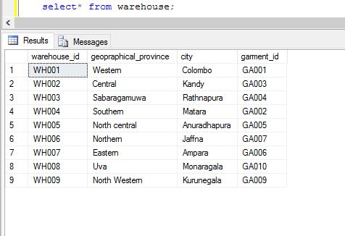

Figure 16: Warehouse table values (Author's work)

**supplierr table**

insert into supplierr values('RAW001','buttons',8,100,800,'2016/01/01','WH001');

insert into supplierr values('RAW002','thread',25,300,7500,'2015/08/04','WH003');

insert into supplierr values('RAW003','cloth',300,3000,900000,'2015/09/06','WH004');

insert into supplierr values('RAW004','pins',4,150,600,'2016/02/07','WH005');

insert into supplierr values('RAW005','paint(1l)',950,150,142500,'2017/06/04','WH002');

insert into supplierr values('RAW006','paper cloth',10,18,1800,'2017/02/03','WH006');

insert into supplierr values('RAW007','zipper',5,500,2500,'2016/05/07','WH007');

insert into supplierr values('RAW008','sticker',11,200,2200,'2017/08/02','WH008');

insert into supplierr values('RAW009','plasticbag',4,500,2000,'2016/03/02','WH009');

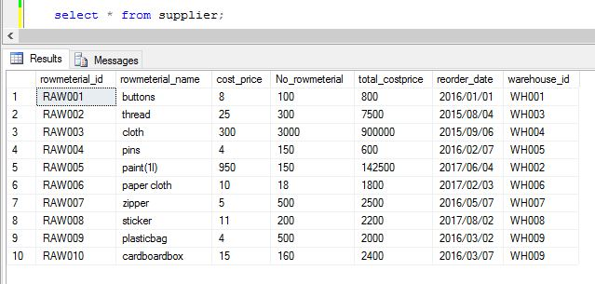insert into supplierr values('RAW010','cardboardbox',15,160,2400,'2016/03/07','WH009');

Figure 17: Suppliers table values (Author's work)

**Supplier_meterial table**

insert into supplier_meterial values('RAW001','Shirt');

insert into supplier_meterial values('RAW004','blouse');

insert into supplier_meterial values('RAW003','skirt');

insert into supplier_meterial values('RAW005','jacket');

insert into supplier_meterial values('RAW002','trouser');

insert into supplier_meterial values('RAW006','blazer');

insert into supplier_meterial values('RAW007','short');

insert into supplier_meterial values('RAW008','t-shirt');

insert into supplier_meterial values('RAW009','dresses');

insert into supplier_meterial values('RAW010','dresses');

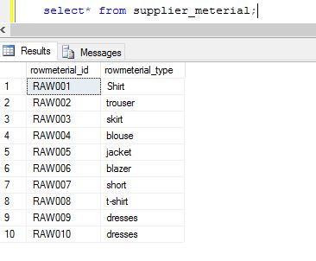

Figure 18: Supplier_meterial table values (Author's work)

**Loyal_customer table**

insert into loyalcustomer values('LC005','John smith','564,duplication road,boralla','1990/02/01','male','Cu005');

insert into loyalcustomer values('LC001','Sk koralagoda','564,akurugoda road,pelawatta','1994/03/05','male','Cu001');

insert into loyalcustomer values('LC004','Sasanki malape','No.30,hidellana,road,rathnapura','1981/02/12','female','Cu004');

insert into loyalcustomer values('LC003','Pramuk perera','No.30/6,oldkotte road,rajagiriya','1989/02/27','male','Cu002');

insert into loyalcustomer values('LC002','Sanduni perera','No.12/6,kolonnawa,IDH','1994/06/17','female','Cu006');

insert into loyalcustomer values('LC006','Sanidu umesh','No.20,koswatta,north','1990/04/25','male','Cu014');

insert into loyalcustomer values('LC007','Sachini rajapaksha','No.78/1,pannipitiya road,kottawa','1981/02/22','female','Cu007');

insert into loyalcustomer values('LC008','shehan awishka','No.11, pahala road,ampara','1985/11/12','male','Cu011');

insert into loyalcustomer values('LC009','Waruni wikunagoda','No.30, kandy road, kandy','1989/02/27','female','Cu012');

insert into loyalcustomer values('LC010','Lakshan pradeep','No.22/2,kuliyapitiya,kurunegala','1980/01/05','male','Cu009');

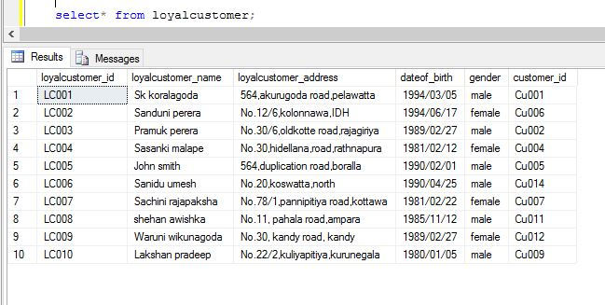

Figure 19: Loyal_customer table values (Author's work)

**Customer table**

insert into customer values('Cu001','Sk@pw','Sk koralagoda');

insert into customer values('Cu002','dil@.394','Pramuk perera');

insert into customer values('Cu003','this&pw','Lakshan');

insert into customer values('Cu004','malape.q23','Sasanki malape');

insert into customer values('Cu005','jon12345','John smith');

insert into customer values('Cu006','sandu12','Sanduni perera');

insert into customer values('Cu007','sachi@11','Sachini rajapaksha');

insert into customer values('Cu008','lai678','Lahiru paranawithana');

insert into customer values('Cu009','laksh@me','Lakshan pradeep');

insert into customer values('Cu010','dhami@22','Dhamme');

insert into customer values('Cu011','sheha@me.22','shehan awishka');

insert into customer values('Cu012','waru4566','Waruni wikunagoda');

insert into customer values('Cu013','thil@you','Thilini wijesekara');

insert into customer values('Cu014','sani@ja','Sanidu umesh');

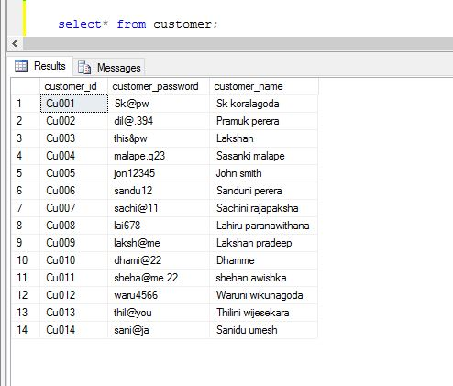

Figure 20: Customer table values (Author's work)

**Retail_shop table**

insert into retail_shop values('RE001','Western','Colombo','ladies','WH001');

insert into retail_shop values('RE002','Western','Gampaha','mens','WH001');

insert into retail_shop values('RE003','Southern','Galle','mens','WH004');

insert into retail_shop values('RE004','Central','mathale','mens','WH002');

insert into retail_shop values('RE005','Sabaragamuwa','kegalla','mens','WH003');

insert into retail_shop values('RE006','North central','anuradhapura','ladies','WH005');

insert into retail_shop values('RE007','Northern','jaffna','mens','WH006');

insert into retail_shop values('RE008','Eastern','batticaloa','ladies','WH007');

insert into retail_shop values('RE009','Uva','monaragala','mens','WH008');

insert into retail_shop values('RE010','North Western','kurunegala','ladies','WH009');

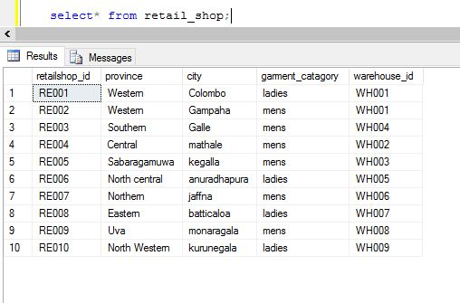

Figure 21: Retail_shop table values (Author's work)

**Employee table**

insert into employee values('EMP01','Sk koralagoda','Manager','Retail_shop','Colombo','Western','RE001',NULL,'Cu001');

insert into employee values('EMP02','Pramuk perera','Sales person','Retail_shop','Colombo','Western','RE001',NULL,'Cu002');

insert into employee values('EMP04','kasun subasighe','Sales person','Retail_shop','Colombo','Western','RE001',NULL,NULL);

insert into employee values('EMP03','Samudaya','Worker','Warehouse','Rathnapura','Sabaragamuwa',NULL,'WH003',NULL);

insert into employee values('EMP05','Samarasingha','Sales person','Retail_shop','kegalla','Sabaragamuwa','RE005',NULL,NULL);

insert into employee values('EMP06','Lakshan pradeep','Manager','Warehouse','kurunegala','North Western',NULL,'WH009','Cu009');

insert into employee values('EMP07','Suranga','Worker','Warehouse','kurunegala','North Western',NULL,'WH003',NULL);

insert into employee values('EMP08','Waruni wikunagoda','Manager','Warehouse','Kandy','Central',NULL,'WH002','Cu012');

insert into employee values('EMP09','Sukum udana','Worker','Retail_shop','Galle','Southern','RE003',NULL,NULL);

insert into employee values('EMP10','Sanduni perera','Manager','Warehouse','Colombo','Western',NULL,'WH001','Cu006');

insert into employee values('EMP11','kalkuni suttah','Worker','Retail_shop','batticaloa','Eastern','RE008',NULL,NULL);

insert into employee values('EMP12','Thilina lakruwan','Sales person','Retail_shop','mathale','Central','RE004',NULL,NULL);

insert into employee values('EMP13','Dumidu udayanga','Worker','Warehouse','Anuradhapura','North central',NULL,'WH005',NULL);

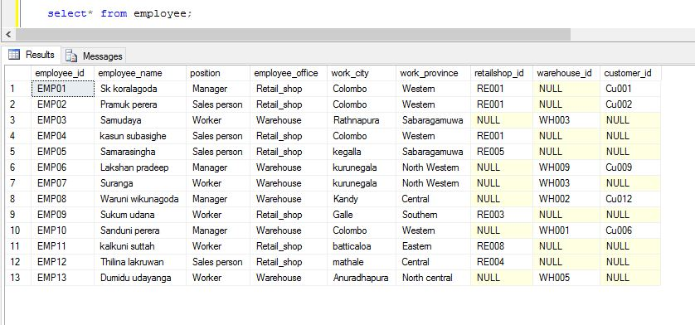

Figure 22: Employee table values (Author's work)

**invoice table**

insert into invoice values('INV001',10,8620,'2010/01/14','Cu003',NULL,'RE001');

insert into invoice values('INV002',5,4500,'2012/03/24','Cu003',NULL,'RE003');

insert into invoice values('INV003',12,10120,'2014/05/21','Cu001','EMP01','RE001');

insert into invoice values('INV004',8,5020,'2012/01/21','Cu007',NULL,'RE002');

insert into invoice values('INV005',6,4820,'2010/08/29','Cu005',NULL,'RE003');

insert into invoice values('INV006',2,2300,'2011/03/11','Cu005',NULL,'RE002');

insert into invoice values('INV007',14,14300,'2011/04/15','Cu009','EMP06','RE005');

insert into invoice values('INV008',9,8300,'2015/09/18','Cu006','EMP10','RE010');

insert into invoice values('INV009',5,5200,'2014/07/20','Cu010',NULL,'RE009');

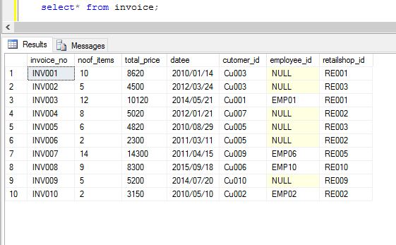insert into invoice values('INV010',2,3150,'2010/05/10','Cu002','EMP02','RE002');

Figure 23: Invoice table values (Author's work)

# SQL Queries

1. List all the employees that work in the warehouses and retail shops, along with the city where they work.

SELECT employee_id,retailshop_id,warehouse_id,work_city

FROM employee;

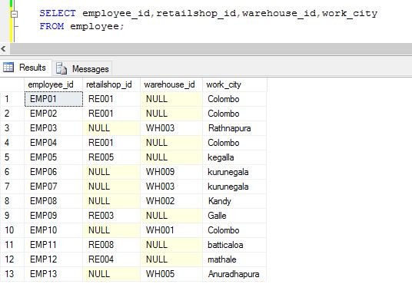

Figure 24: Query 01 (Author's work)

1. List the city and province where the retail shops are located

SELECT retailshop_id,city,province FROM retail_shop;

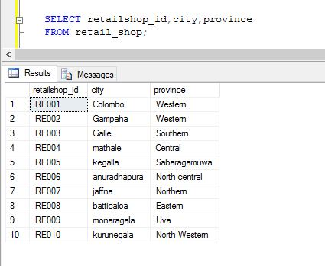

Figure 25 : Query 02 (Author's work)

1. List all employees who work in the western province

SELECT employee_id,work_province FROM employee

WHERE work_province='Western';

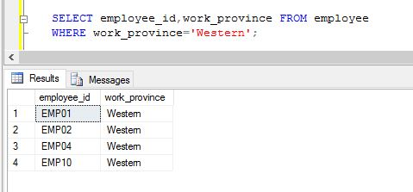

Figure 26: Query 03 (Author's work)

1. Add a garment to the inventory of items on sale

SELECT sale_items FROM garment_details;

UPDATE garment_details

SET sale_items = sale_items*3

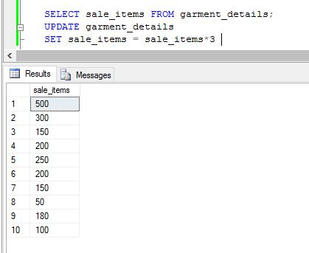

Figure 27: Query 04 (Author's work)

1. List the large garments, that have cost price less than 20% of the retail price

SELECT g.garment_id

FROM garment_details g,supplierr s, warehouse w

WHERE s.warehouse_id=w.warehouse_id and w.garment_id=g.garment_id

and s.cost_price < g.retail_price*20/100;

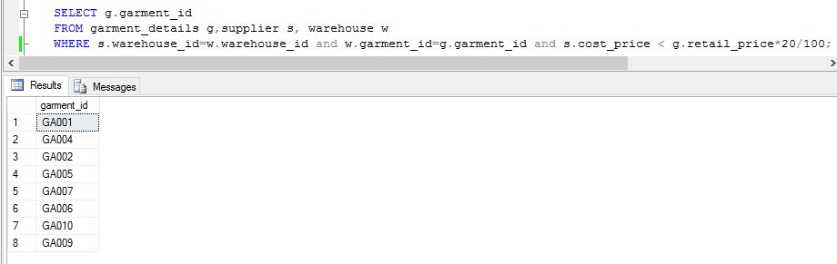

Figure 28: Query 05 (Author's work)

1. Search for ladies garments that are on sale in the Colombo retail shops

SELECT retailshop_id, city, garment_catagory

FROM retail_shop

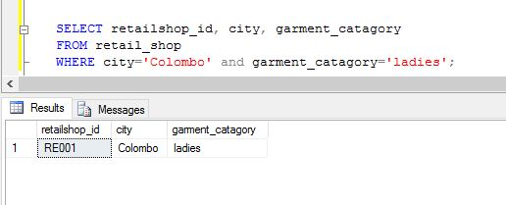 WHERE city='Colombo' and garment_catagory='ladies';

Figure 29: Query 06(Author's work)

1. Update the details about the manager and workers of the Colombo retail shops

UPDATE employee

SET employee_name ='Lakshitha madushanka'

WHERE position='manager' and warehouse_id='WH009';

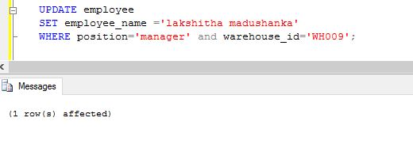

Figure 30: Query 07 I (Author's work)

UPDATE employee

SET employee_name ='Suranga lakmal'

WHERE position='Worker' and warehouse_id='WH003';

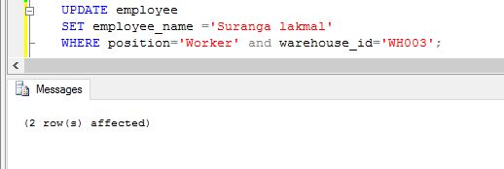

Figure 31: Query 01 II (Author's work)



Figure 32: Query 07 Executed (Author's work)

1. Find the cheapest and the most expensive garments on sales

SELECT Min(retail_price) as cheapest,

max(retail_price) as most_expensive

FROM garment_details;

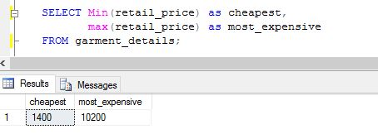

Figure 33: Query 08 (Author's work)

1. Update the retail price of all garments of type winter wear with a 10% reduction

UPDATE dbo.garment_details

SET retail_price = (retail_price - retail_price*10/100)

FROM garment_details gd

inner join dbo.garment g ON g.garment_id= gd.garment_id

WHERE garment_type ='winter';

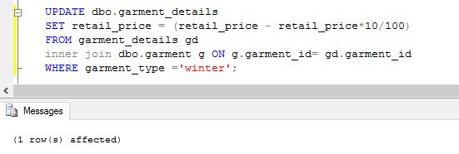

Figure 34: Query 09 (Author's work)

1. List all loyal customers (females only) whose birthdays are in the month of February

SELECT loyalcustomer_name,dateof_birth,gender

FROM loyalcustomer

WHERE gender='female' and dateof_birth LIKE '%/02/%';

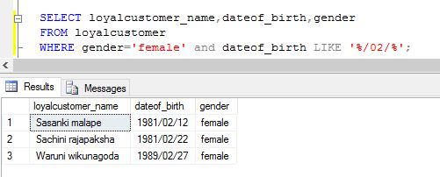

Figure 35: Query 10 (Author's work)

1. List the total price of the garments sold in month of January 2012

SELECT sum(total_price) as Totalsales

FROM invoice

WHERE datee like '%2012/01/%';

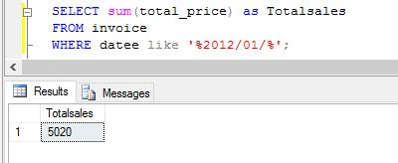

Figure 36: Query 11 (Author's work)

1. List all raw material that have reached the re order level

select rowmeterial_id,reorder_date from supplierr

order by reorder_date;

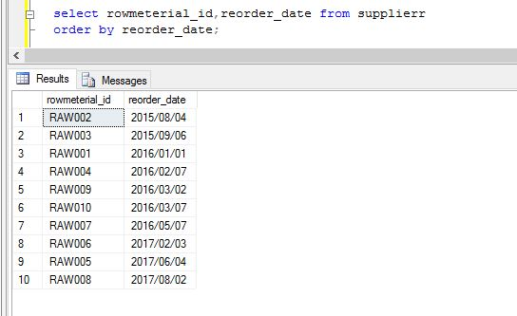

Figure 37: Query 12 (Author's work)

1. How my garment cost less than LKR 1000?

SELECT rowmeterial_id,rowmeterial_name,total_costprice

FROM supplierr

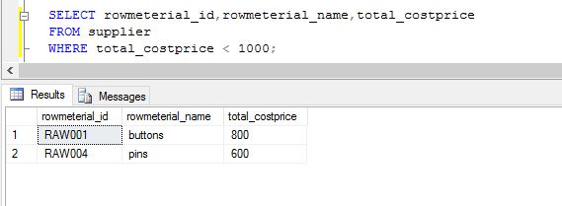 WHERE total_costprice < 1000;

Figure 38: Query 13 (Author's work)

1. Find the number of garments and sum of the price for all items bought by “John Smith”(a loyal customer)

SELECT sum(i.noof_items) AS Nub_of_garments,

sum(i.total_price) AS Total_Price

FROM customer c, invoice i

WHERE c.customer_id = i.cutomer_id and c.customer_name='John smith';

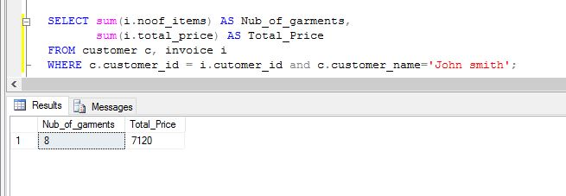

Figure 39: Query 14 (Author's work)

1. Find the number of garments bought by each loyal customer

SELECT loyalcustomer_id,

sum(i.noof_items) as Noof_garments

FROM loyalcustomer l, invoice I

WHERE l.customer_id=i.cutomer_id

GROUP BY loyalcustomer_id;

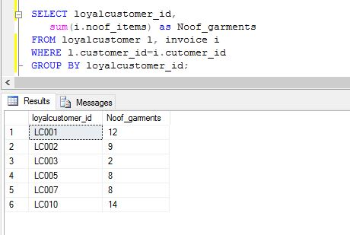

Figure 40: Query 15 (Author's work)

1. Record a new garment

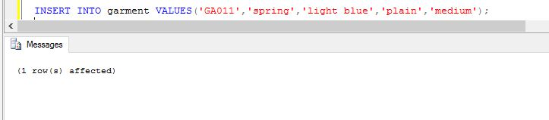INSERT INTO garment VALUES('GA011','spring','light blue','plain','medium');

Figure 41: Query 16 (Author's work)

1. Find all employees that are also the loyal customers of the company

SELECT employee_id,employee_name, loyalcustomer_id

FROM employee e, loyalcustomer lc

WHERE e.customer_id=lc.customer_id;

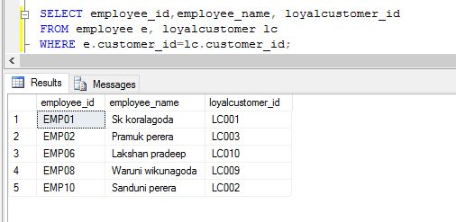

Figure 42: Query 17 (Author's work)

1. Find all employees that have made no purchases from their own company (out of loyal customers)

SELECT employee_id,employee_name,position

FROM employee

WHERE customer_id is null;

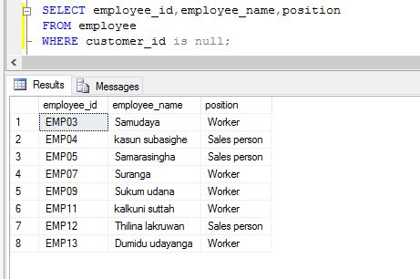

Figure 43: Query 18 (Author's work)

1. Summary of the total sales made by each retail shop

SELECT r.retailshop_id,city,

sum(total_price) as Total_Sales

FROM retail_shop r,invoice i

WHERE r.retailshop_id=i.retailshop_id

GROUP BY r.retailshop_id,city;

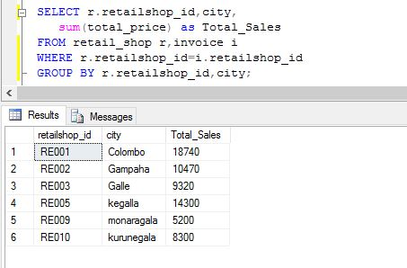

Figure 44: Query 19 (Author's work)

1. Delete all the garments that are of type summer

DELETE from garment

WHERE garment_type='summer';

# 10. Conclusion

Firstly the author has made the ERD Diagram according to system scenario. Then author has created 10 tables using create table *table_name* statements. Secondly inserted values using insert into *table_name* values statements relevant table.

Finally author had able to implement all the queries according to the given scenarios.

# 11. Reference

Airbrake.io,. "What Is The Software Development Life Cycle?". N.p., 2013. Web. [Accessed 02 Jan. 2016]

Garcia-Molina, Hector, Jeffrey D. Ullman, and Jennifer Widom. DATABASE SYSTEMS. 2nd ed. 2008. Print. [ONLINE] Available [Accessed 05 Jan. 2016]