Codebook for password_data

Autogenerated data summary from dataReporter

2024-03-20 16:51:52.078542

# Data report overview

The dataset examined has the following dimensions:

| Feature | Result |
| --- | --- |
| Number of observations | 500 |
| Number of variables | 8 |

# Codebook summary table

| Label | Variable | Class | # unique values | Missing | Description |
| --- | --- | --- | --- | --- | --- |
|  | **rank** | integer | 500 | 0.00 % |  |
|  | **password** | character | 500 | 0.00 % |  |
|  | **category** | character | 10 | 0.00 % |  |
|  | **value** | numeric | 15 | 0.00 % |  |
|  | **time_unit** | character | 7 | 0.00 % |  |
|  | **offline_crack_sec** | numeric | 16 | 0.00 % |  |
|  | **strength** | integer | 22 | 0.00 % |  |
|  | **font_size** | integer | 19 | 0.00 % |  |

# Variable list

## rank

| Feature | Result |
| --- | --- |
| Variable type | integer |
| Number of missing obs. | 0 (0 %) |
| Number of unique values | 500 |
| Median | 250.5 |
| 1st and 3rd quartiles | 125.75; 375.25 |
| Min. and max. | 1; 500 |

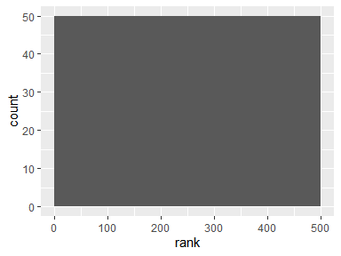

## password

* The variable is a key (distinct values for each observation).

## category

| Feature | Result |
| --- | --- |
| Variable type | character |
| Number of missing obs. | 0 (0 %) |
| Number of unique values | 10 |
| Mode | “name” |

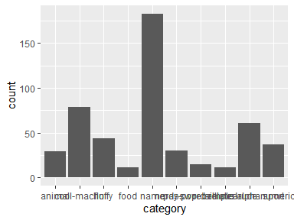

* Observed factor levels: "animal", "cool-macho", "fluffy", "food", "name", "nerdy-pop", "password-related", "rebellious-rude", "simple-alphanumeric", "sport".

## value

| Feature | Result |
| --- | --- |
| Variable type | numeric |
| Number of missing obs. | 0 (0 %) |
| Number of unique values | 15 |
| Median | 3.72 |
| 1st and 3rd quartiles | 3.43; 3.72 |
| Min. and max. | 1.29; 92.27 |

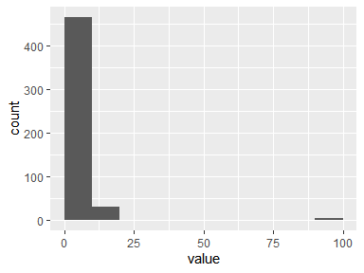

## time_unit

| Feature | Result |
| --- | --- |
| Variable type | character |
| Number of missing obs. | 0 (0 %) |
| Number of unique values | 7 |
| Mode | “days” |

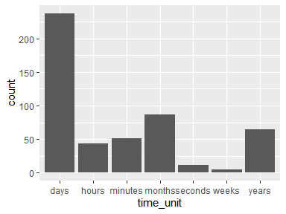

* Observed factor levels: "days", "hours", "minutes", "months", "seconds", "weeks", "years".

## offline_crack_sec

| Feature | Result |
| --- | --- |
| Variable type | numeric |
| Number of missing obs. | 0 (0 %) |
| Number of unique values | 16 |
| Median | 0 |
| 1st and 3rd quartiles | 0; 0.08 |
| Min. and max. | 0; 29.27 |

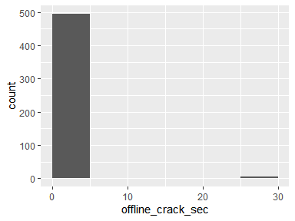

## strength

| Feature | Result |
| --- | --- |
| Variable type | integer |
| Number of missing obs. | 0 (0 %) |
| Number of unique values | 22 |
| Median | 7 |
| 1st and 3rd quartiles | 6; 8 |
| Min. and max. | 0; 48 |

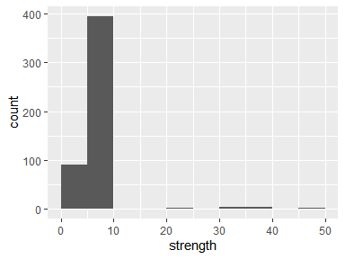

## font_size

| Feature | Result |
| --- | --- |
| Variable type | integer |
| Number of missing obs. | 0 (0 %) |
| Number of unique values | 19 |
| Median | 11 |
| 1st and 3rd quartiles | 10; 11 |
| Min. and max. | 0; 28 |

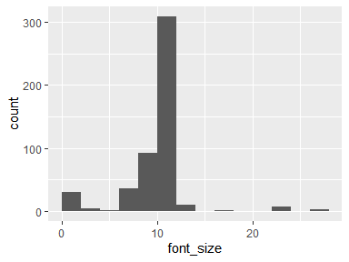

Report generation information:

* Created by: Kunning Shen (username: SKN).
* Report creation time: Wed Mar 20 2024 16:51:52
* Report was run from directory: C:/Users/SKN/Desktop/Courses/GLHLTH562/final
* dataReporter v1.0.2 [Pkg: 2021-11-11 from CRAN (R 4.3.3)]
* R version 4.3.2 (2023-10-31 ucrt).
* Platform: x86_64-w64-mingw32/x64 (64-bit)(Pacific/Easter).
* Function call: dataReporter::makeDataReport(data = password_data, mode = c("summarize", "visualize", "check"), smartNum = FALSE, file = "codebook_password_data.Rmd", replace = TRUE, checks = list(character = "showAllFactorLevels", factor = "showAllFactorLevels", labelled = "showAllFactorLevels", haven_labelled = "showAllFactorLevels", numeric = NULL, integer = NULL, logical = NULL, Date = NULL), listChecks = FALSE, maxProbVals = Inf, codebook = TRUE, reportTitle = "Codebook for password_data", output_dir = getwd(), report_title = "Data Report", open_report = FALSE)