Mean ,Median,Mode difference

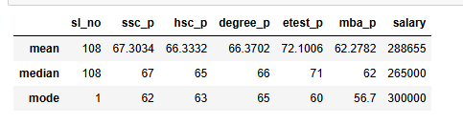

Key Findings
- SSC Percentage:
The average SSC score is 67.30%, while the median is 67%, showing that the data is relatively balanced.
- HSC Percentage:
The mean is 66.33% and median is 65%, indicating a small difference between the average and middle value.
- Degree Percentage:
The mean (66.37%) and median (66%) are very close, suggesting a relatively symmetrical distribution.
- Employability Test:
The etest_p mean is 72.10%, which is the highest average percentage among the academic/test variables shown.
- MBA Percentage:
The average MBA score is 62.28%, with a median of 62%, indicating that the typical MBA score is around 62%.
- Salary:
The average salary is ₹288,655, while the median salary is ₹265,000. Since the mean is higher than the median, some candidates with relatively high salaries are pulling the average upward.

Overall Summary
The dataset shows that candidates have an average academic performance of around 62–67%, while their average employability test score is approximately 72%. The salary has a mean of ₹288,655 and a median of ₹265,000, suggesting some higher salary values in the dataset. Overall, the academic variables have mean and median values that are fairly close, indicating relatively balanced
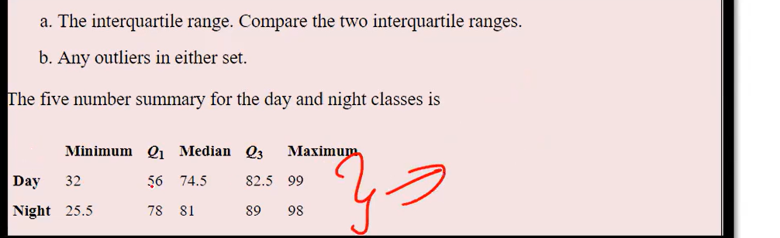

IQR=Q3-Q1
=82.5-56
=26.5

Lower range
Q1-1.5*IQR
=56-1.5*26.5
=56-39.75
=16.25

Day-32 in minimum- lower range is 16.25 so minimum days value is not lower than lower range so no outlier presrnt in the data.

Higher Range=Q3+1.5*IQR
=82.5+1.5*26.5
=82.5+39.75
=122.25

Maximum days 99 and higher range is 122.25 no maximum range is higher than higher range value so no outlier.

