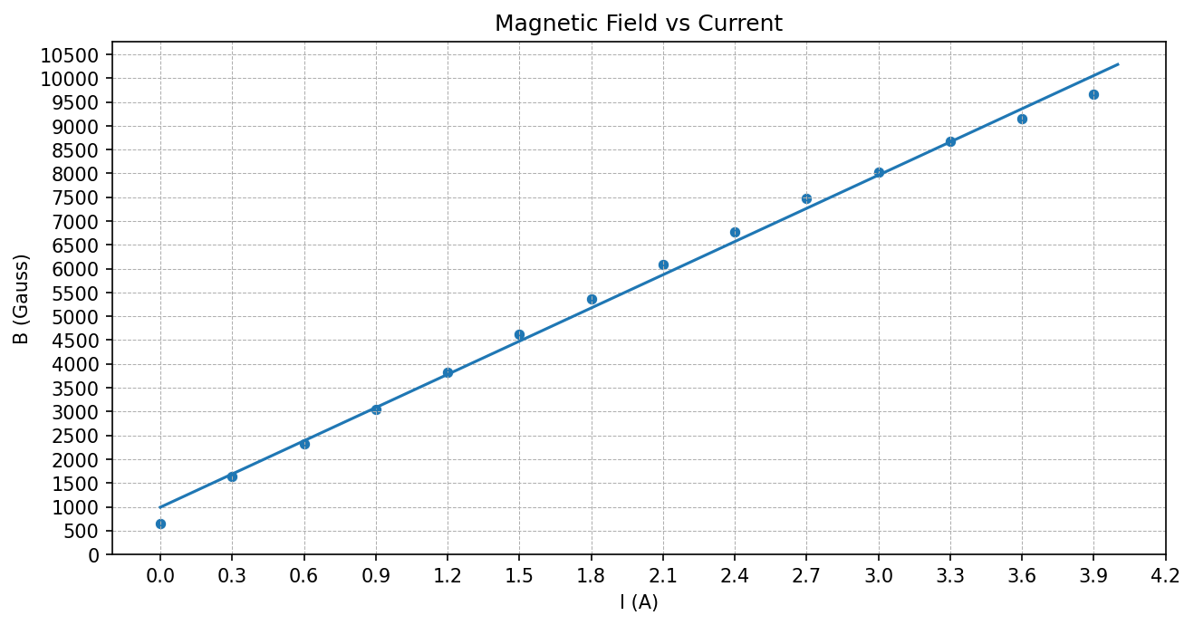
Current vs Magnetic Field-

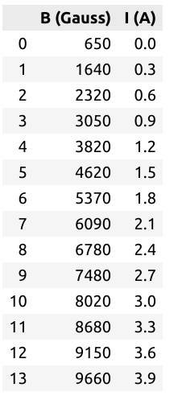

Without Splitting-

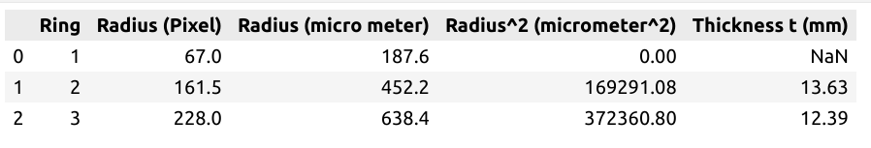

Average Thickness = 13.01 mm
Average Thickness = 0.013 m

With Splittng-
1.
I = 2A
B = 0.56 T
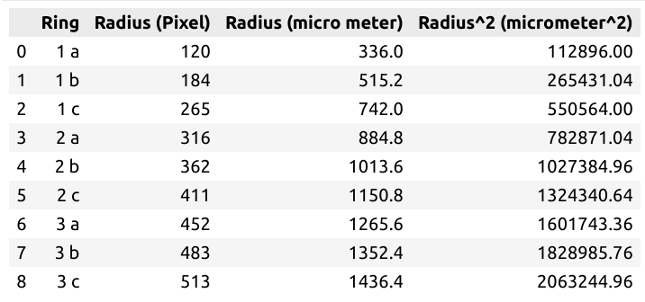
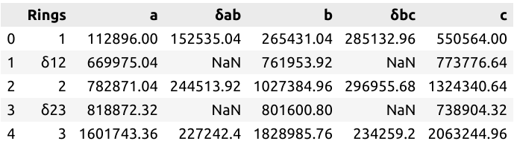
Average δab = 208097.11 micrometer^2
Average δbc = 272115.94 micrometer^2

Average δab = 2.08e-07 meter^2
Average δbc = 2.72e-07 meter^2

Average δ12 = 735235.19 micrometer^2
Average δ23 = 786459.14 micrometer^2

Average δ12 = 7.35e-07 meter^2
Average δ23 = 7.86e-07 meter^2

Average Δ = 7.60e-07 meter^2
Average Vab = 10.51meter^2
Average Vbc = 13.74 meter^2

u0/hc= 43.01
2.
I = 3A
B = 0.8 T

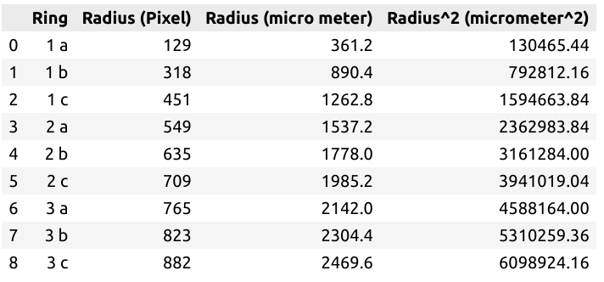

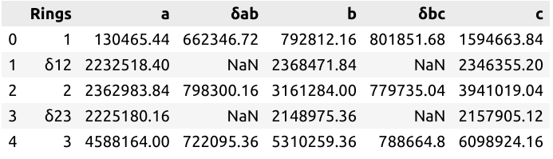
Average δab = 727580.74 micrometer^2
Average δbc = 790083.83 micrometer^2

Average δab = 7.27e-07 meter^2
Average δbc = 7.90e-07 meter^2

Average δ12 = 2315781.81 micrometer^2
Average δ23 = 2177353.54 micrometer^2

Average δ12 = 2.31e-06 meter^2
Average δ23 = 2.17e-06 meter^2

Average Δ = 2.24e-06 meter^2
Average Vab = 12.44 meter^2
Average Vbc = 13.51 meter^2
u0/hc= 32.59

3.
I = 3.76 A
B = 0.97 T

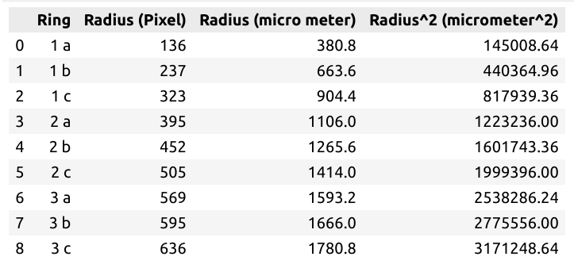
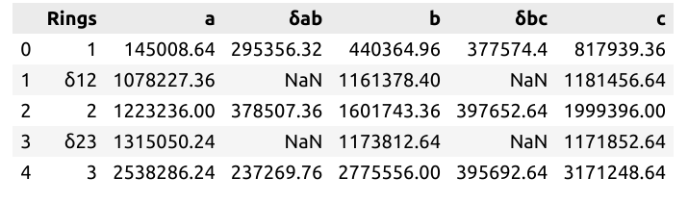
Average δab = 303711.14micrometer^2
Average δbc = 390306.56 micrometer^2

Average δab = 3.03e-07 meter^2
Average δbc = 3.90e-07 meter^2

Average δ12 = 1140354.13 micrometer^2
Average δ23 = 1220238.50 micrometer^2

Average δ12 = 1.14e-06 meter^2
Average δ23 = 1.2202385066666663e-06 meter^2

Average Δ = 1.18e-06 meter^2
Average Vab = 9.88 meter^2
Average Vbc = 12.70 meter^2

u0/hc= 23.22S

