Name- Shailja Kant Tiwari

Entry no.- 2021PHS7218

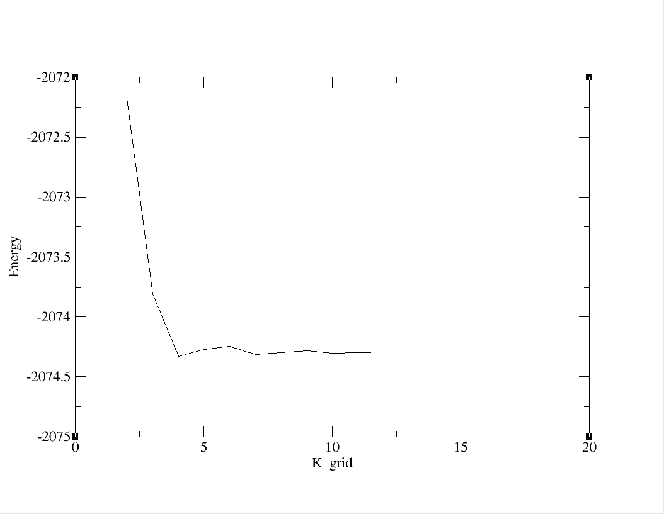

Here further calculation is done for k_grid **(6 6 1)** because in further increasing the k_grid we don’t achieve that much of accuracy while the computation cost will increase rapidly

After Trying for different values of **bin_size**  and **dos_kgrid_factor**

I found a good plot for

**bin_size = 0.1 and**

**dos_kgrid_factor = 15**

