Name- Shailja Kant Tiwari

Entry No. - 2021PHS217218

ASSIGNMENT-3

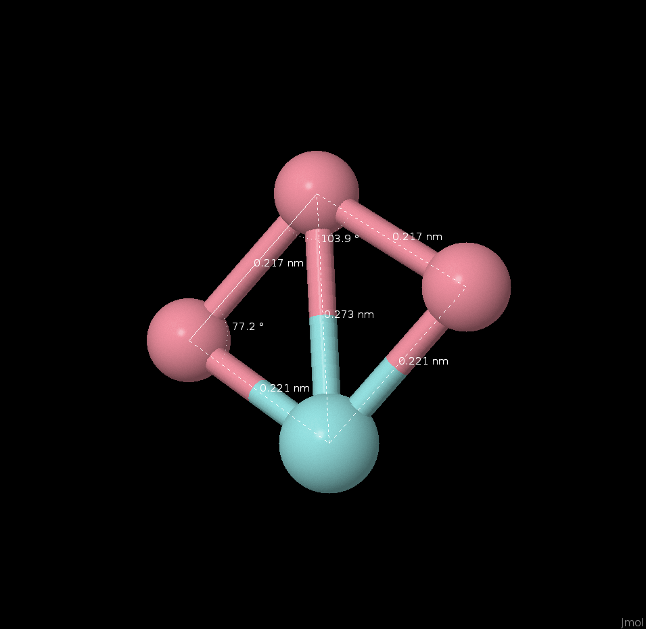**Structure-1**

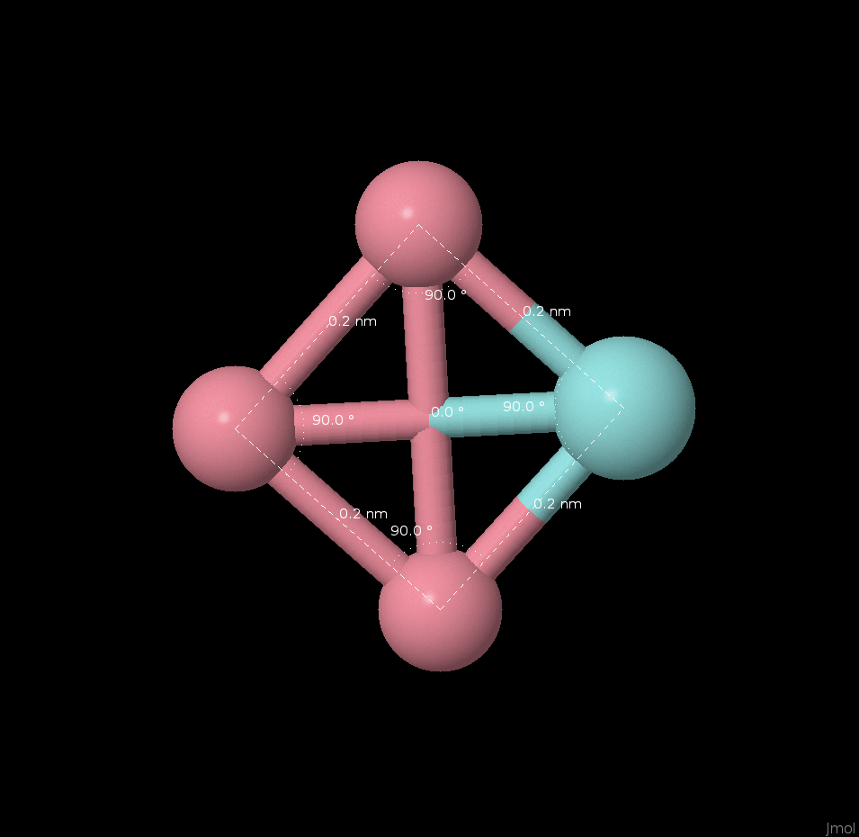

atom 0 0 0 Co

atom 0 2 0 Co

atom 2 0 0 Zr

atom 2 2 0 Co

atom -0.21922134 -0.20170934 0.00000000 Co

atom 0.04299373 1.95700628 -0.00000000 Co

atom 1.97451829 0.02548173 -0.00000000 Zr

atom 2.20170932 2.21922132 0.00000000 Co

Energy = **-212993.138496 eV**

**Structure-2**

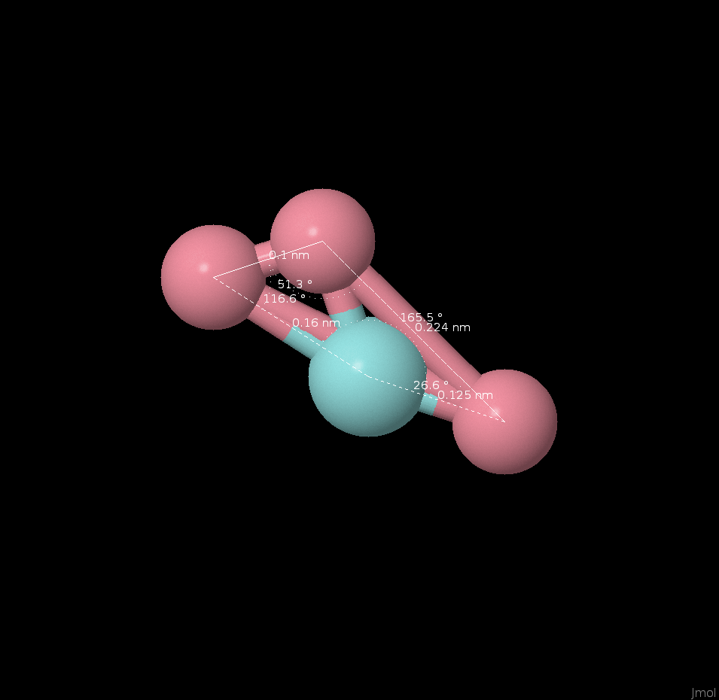 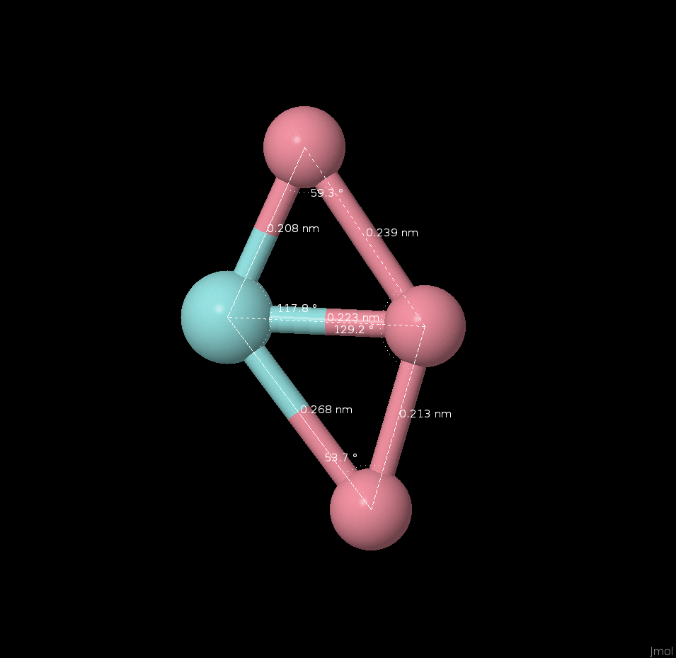

atom 0 0 0 Co

atom 1 0.75 0 Zr

atom 2 2 0 Co

atom 1 2 0 Co

atom 1.47485134 0.10028169 -0.00000000 Zr

atom 2.60957692 2.53365794 -0.00000000 Co

atom 0.51857539 2.11589245 0.00000000 Co

Energy = **-212992.883632 eV**

**Structure-3**

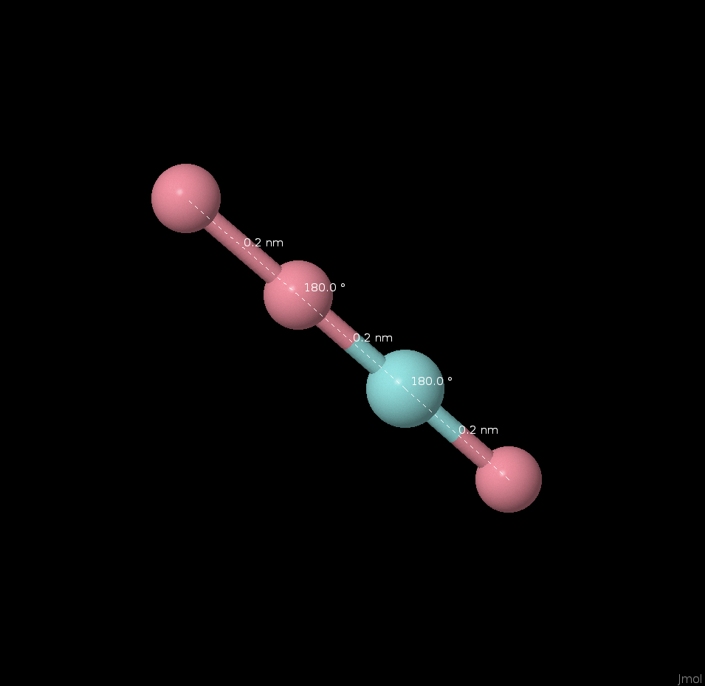 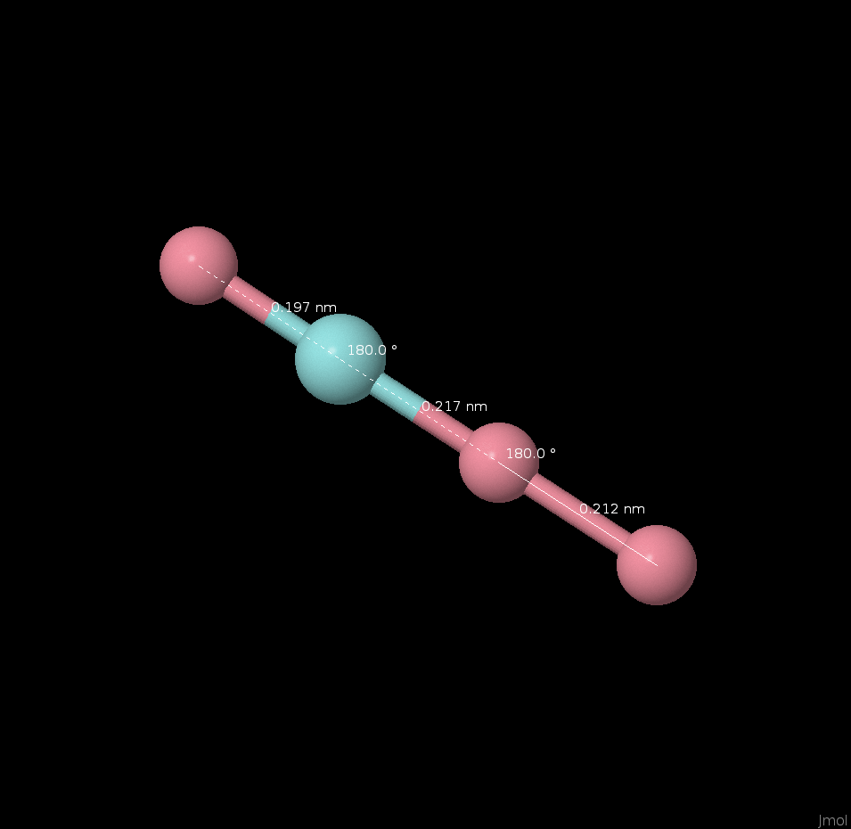

atom 0 0 0 Co

atom 0 0 2 Co

atom 0 0 4 Zr

atom 0 0 6 Co

atom 0.00000001 0.00000006 -0.16985270 Co

atom -0.00000000 -0.00000008 1.95214133 Co

atom -0.00000002 -0.00000002 4.12362648 Zr

atom 0.00000001 0.00000004 6.09408489 Co

Energy = **-212990.966254 eV**

**Structure-4**

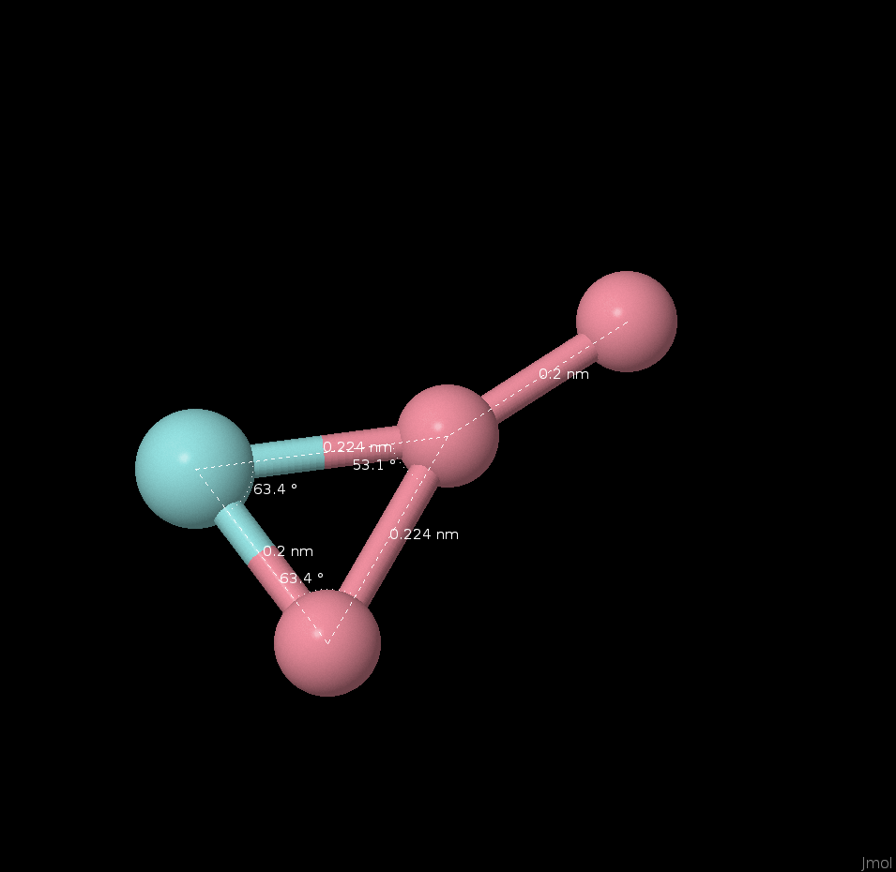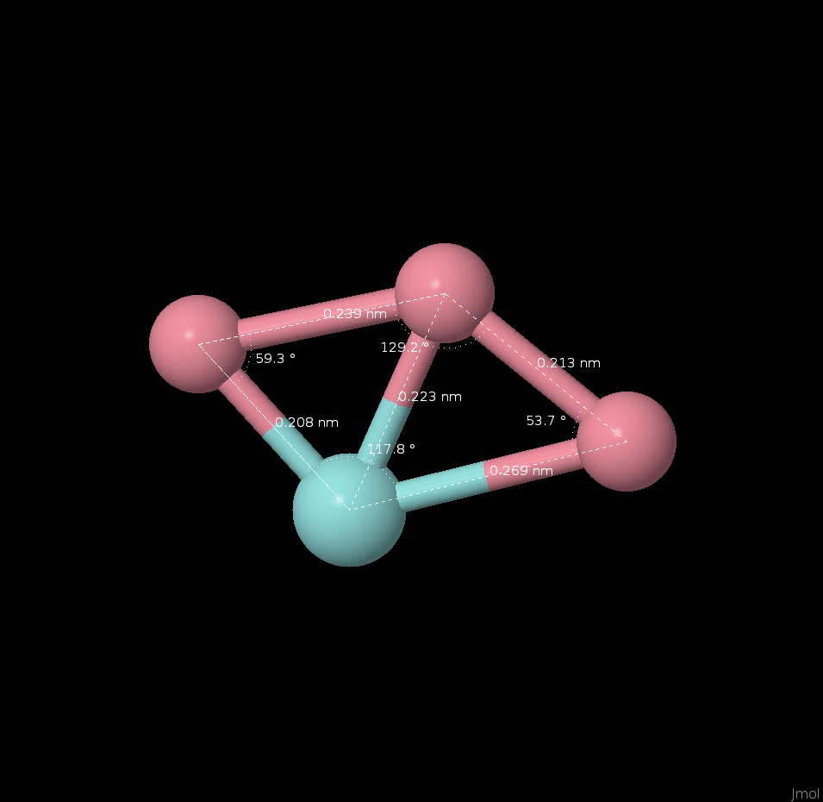

atom -1 0 0 Co

atom 1 0 0 Zr

atom 0 2 0 Co

atom 0 4 0 Co

atom -0.74633737 -0.35020863 -0.00003932 Co

atom 0.97285898 0.82114447 0.00002960 Zr

atom -0.89543623 2.03991114 0.00004292 Co

atom 0.66891462 3.48915302 -0.00003321 Co

Energy = **-212992.883826 eV**

**Structure-5**

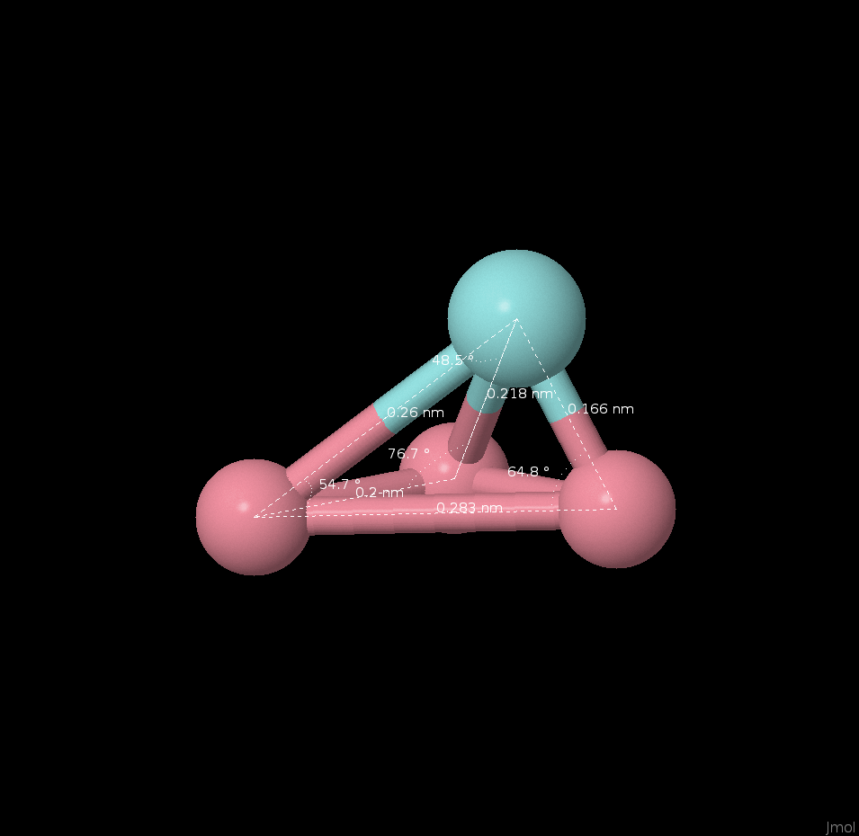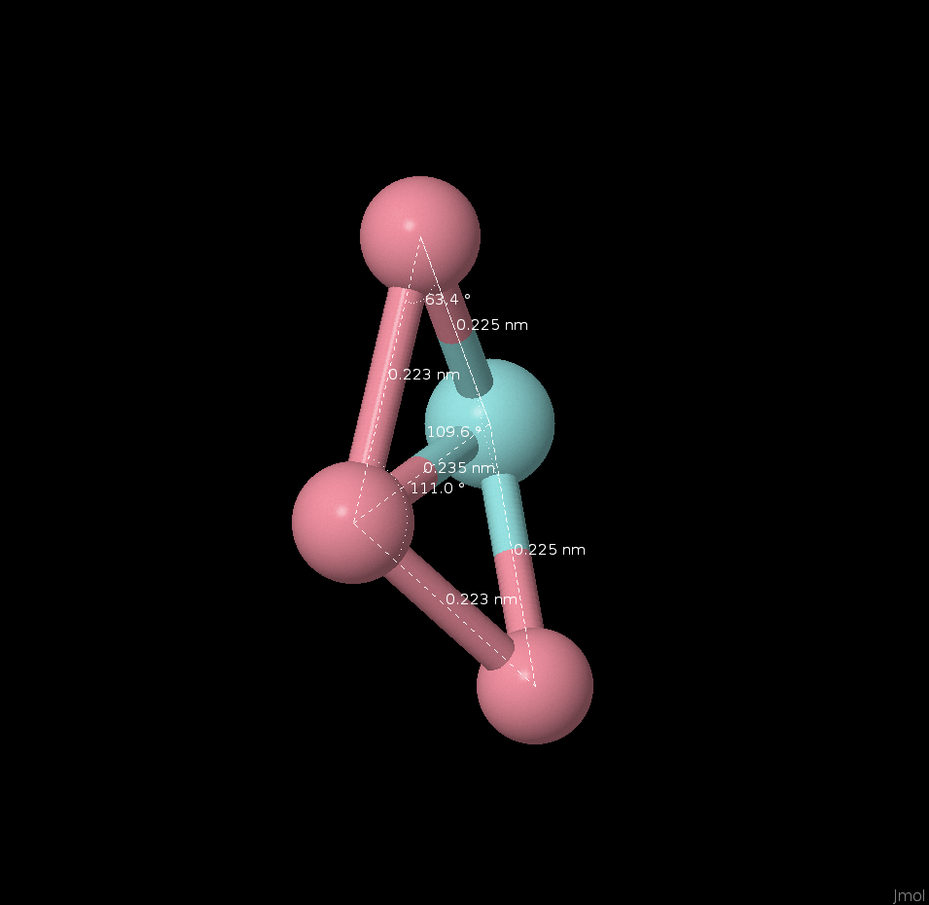

atom 0 0 0 Co

atom 0 0 2 Co

atom 0 2 2 Co

atom 1.5 1.5 1.5 Zr

atom 0.43493234 -0.26015163 -0.08954909 Co

atom -0.27884462 0.08996056 1.99363172 Co

atom -0.04521879 2.23124079 2.56730070 Co

atom 1.38913107 1.43895028 1.02861668 Zr

Energy = **212992.878588 eV**