A Global-Local Feature Fusion Network with Focal Loss for Imbalanced Breast BI-RADS Classification

1st Gia-Phat Nguyen
Artificial Intelligence Department FPT University
Ho Chi Minh city, Vietnam giaphat.astronyx@gmail.com Co-first Author

1st Giang-Nam Luu
Faculty of Information Technology Industrial University of Ho Chi Minh city Ho Chi Minh city, Vietnam luugiangnam@iuh.edu.vn
Co-first Author

3rd Long-Phuoc Toˆn*
Faculty of Information Technology Industrial University of Ho Chi Minh city Ho Chi Minh city, Vietnam tonlongphuoc@iuh.edu.vn
Corresponding Author

Abstract—Automated Breast Imaging Reporting and Data System (BI-RADS) assessment plays a crucial role in breast cancer screening. However, the development of reliable diagnostic models is severely hindered by the highly imbalanced nature of clinical mammography datasets, where higher-suspicion assess-ment categories (BI-RADS 3, 4, 5) represent a minimal fraction of the data. In this paper, we propose a deep learning frame-work to mitigate class imbalance in mammogram classification through a Global-Local Feature Fusion Network. To capture both macroscopic anatomical context and fine-grained lesion details, the model simultaneously processes full-context images via a global branch (EfficientNet-B0) and YOLOv8-extracted regions of interest (ROI) via a high-resolution local branch (EfficientNet-B3). The features from both branches are then concatenated to make the final diagnostic decision. Furthermore, label smoothing is applied during optimization to prevent model overconfidence and improve generalization on minority classes. Extensive experiments on the VinDr-Mammo dataset demon-strate that, compared to a standard baseline, our global-local architecture increases overall accuracy to 0.79 and the macro F1-score to 0.63 across the five-tier BI-RADS scale, outperforming all baselines. This demonstrates a substantial enhancement in reliable lesion identification, paving the way for more robust computer-aided diagnosis systems.
Index Terms—Mammography, ROIs, Global-Local Fusion, BI-RADS Classification, Deep Learning, Class Imbalance

- Introduction
Breast cancer remains one of the most prevalent ma-lignancies and a leading cause of cancer-related mortality among women globally [1] [2]. Early detection through regular screening mammography stands as the most effective strategy to improve survival rates and optimize therapeutic outcomes. To standardize breast imaging reporting and minimize ambi-guity in clinical practice, the American College of Radiology developed the Breast Imaging Reporting and Data System (BI-RADS) [3]. The BI-RADS assessment scales provide critical risk stratification, guiding clinicians from routine follow-ups (BI-RADS 1–2) to urgent biopsy recommendations (BI-RADS 3-4–5). However, manual interpretation of mammograms is highly challenging, time-consuming, and prone to intra- and inter-observer variability, even among experienced radiologists
[4] [5]. This subjectivity underscores the critical need for robust computer-aided diagnosis systems [6] [7] to support clinical workflows.
In recent years, Deep Convolutional Neural Networks (CNNs) have emerged as highly powerful tools for automated medical image analysis [8] [9]. Despite their success, standard monolithic CNN approaches encounter a severe performance bottleneck induced by the extreme clinical class imbalance of BI-RADS 1–2 cases compared to BI-RADS 3-4–5 instances. In population-wide screening datasets, the overwhelming ma-jority of records fall under completely negative or benign evaluations, meaning standard optimization objectives quickly become heavily biased toward learning common healthy tissue patterns. Conversely, critical actionable categories indicating higher radiologist-assessed suspicion receive insufficient opti-mization weight, leading to elevated false-negative rates.

Addressing this fundamental constraint, multi-scale and multi-view fusion strategies have gained significant trac-tion. Clinicians inherently use a multi-scale cognitive pro-cess—scanning the entire breast environment for general asymmetry or architectural distortions before zooming into specific focal densities. Translating this dual-perspective ap-proach into machine learning architectures remains an active area of research. Furthermore, popular benchmarks like the VinDr-Mammo dataset [10] have provided highly detailed annotations, including localized bounding boxes and overall breast-level BI-RADS scores, opening up opportunities to explicitly train networks that bridge the gap between global contextual knowledge and local lesion characteristics.

In this paper, we propose a novel multi-stream Global-Local Feature Fusion Network for automated five-tier BI-RADS classification using the VinDr-Mammo dataset. Our framework processes mammograms via two concurrent streams tailored to their respective spatial tasks: a global contextual stream utilizing an EfficientNet-B0 backbone [11] on a downscaled full image, and a localized fine-grained stream utilizing an EfficientNet-B3 backbone on a high-resolution regional crop extracted by YOLOv8. Features from both streams are fused and routed through a regularized classifier network. Given the severe class imbalance across the BI-RADS tiers, the entire network is trained using a Focal Loss function enhanced with label smoothing.

- Related Work
- Deep Learning for Mammography and BI-RADS Assess-ment
The application of deep learning to breast cancer screening has transformed computer-aided diagnosis from traditional handcrafted feature extraction to end-to-end representation learning. Early milestone studies, such as the work by McK-inney et al. [12], demonstrated that Convolutional Neural Networks (CNNs) could perform on par with or even exceed expert radiologists in binary classification tasks. Subsequent research has shifted towards predicting the exact BI-RADS categories to provide more granular clinical guidance. For instance, Shen et al. [13] proposed an interpretable classifier for high-resolution screening images using weakly supervised localization. Despite these advances, most existing architec-tures treat the BI-RADS classification as a standard multi-class problem on balanced benchmarks, often failing to maintain high sensitivity in real-world clinical settings where severe data skewness is prevalent. Our work builds upon CNN back-bones, EfficientNet, but explicitly re-engineers the pipeline to handle the inherent class imbalance and high-resolution spatial challenges of clinical BI-RADS distributions.
- Mitigating Class Imbalance in Medical Image Analysis
Class imbalance has always been a difficult challenge in the machine learning field, and it is particularly a pervasive challenge in medical image analysis, as pathological find-ings are inherently rare compared to healthy tissues. Buda et al. [14] provided a systematic evaluation of imbalance mitigation strategies in CNNs, broadly categorizing them into data-level and algorithm-level methods. More recently, several comprehensive surveys have consolidated progress in this area: Kumar et al. [15] present a detailed taxonomy of methods for handling class overlap in imbalanced datasets, comparing data-level, algorithm-level, ensemble, and hybrid solutions and highlighting how overlap compounds the difficulty of standard imbalance-handling techniques; Yang et al. [16] review over-sampling strategies specifically for multi-class imbalanced problems in medical informatics, noting a grow-ing trend toward hybrid resampling approaches that combine complementary techniques; and de Alvis and Seneviratne [17] survey deep long-tail classification methods under a unified mathematical framework, underscoring that even state-of-the-art approaches still struggle to close the performance gap on heavily skewed distributions. While data-level techniques like SMOTE are effective for tabular data, they often introduce noise or synthetic artifacts when applied to complex, high-dimensional medical images. Consequently, algorithm-level approaches have gained prominence. Lin et al. [18] introduced Focal Loss, which dynamically scales the cross-entropy loss based on prediction confidence, forcing the model to focus on hard-to-classify, minority examples. Furthermore, Mu¨ller et al.
[19] demonstrated that Label Smoothing acts as a powerful regularizer, preventing neural networks from becoming over-confident and improving generalization. In our framework, we
avoid synthetic oversampling in favor of integrating Focal Loss and Label Smoothing, ensuring that the model learns robust representations for the critical minority classes (BI-RADS 3-4-5) without overfitting.
- Proposed Methodology
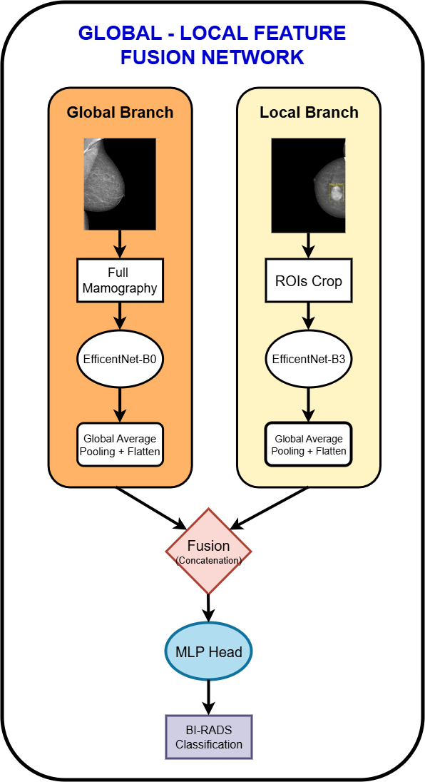

Fig. 1. The overall architecture of the proposed Global-Local Feature Fusion Network for multi-scale mammographic image classification.

- Clinical Significance of Regions of Interest (ROIs)
In medical image analysis, a Region of Interest (ROI) denotes a targeted sub-region containing pathological features critical for diagnosis. Since abnormalities such as micro-calcifications or masses occupy only a small fraction of a mammogram, training solely on full-field images forces the

network to search a massive spatial space, often causing missed detections or false positives from dense, overlapping tissue.
The proposed architecture leverages the VinDr-Mammo dataset’s expert-annotated bounding boxes [x_{min}, y_{min}, x_{max}, y_{max}], provided primarily for BI-RADS 3-4–5 cases, to mitigate this spatial dilution. These categories mark the core clinical threshold where biopsy or accelerated surveillance is warranted.
To operationalize this into a deployment-ready pipeline, a two-stage procedure is used: first, the ground-truth boxes train a dedicated YOLOv8 lesion detector; second, this trained de-tector—not the ground-truth annotations—generates the ROI crops used across the training and test splits of the clas-sification framework. This ensures the network is evaluated under realistic inference conditions, where localization is fully automated, while still letting the detector benefit from full radiologist supervision during its own training.
Unlike pipelines that copy static ground-truth crops directly into classification, this design forms a genuine detection-then-classification cascade: the YOLOv8-predicted ROIs are propagated forward as the local branch’s input, bypassing
the higher resolution demands of fine-grained lesion regions without destabilizing gradient propagation.
- Global and Local Feature Extractors
The core of the proposed Global-Local Feature Fusion Net-work, whose overall architecture is illustrated in Fig. 1, relies on two distinct deep convolutional neural network (CNN) backbones, acting as asymmetric feature extractors to capture multi-scale clinical indicators from mammographic images.
  - Global Context Branch: The global pathway is designed to model the holistic structural topology of the breast, such as overall breast density patterns and pectoral muscle symmetry.
Let X_{global} ∈ R^{3×H}g×Wg represent the input global image resized to dimensions H_{g} = W_{g} = 768. We employ a pre-
trained EfficientNet-B0 architecture as the backbone, stripped of its original fully connected classification layer.
The image passes through successive mobile inverted bot-tleneck convolution blocks to extract high-level semantic fea-ture maps. The final convolutional feature tensor is spatially aggregated using Global Average Pooling (GAP) [22] to collapse spatial dimensions, followed by a flattening operation to generate a low-dimensional global context vector f_{g}:

irrelevant background and focusing the network on regions flagged as higher-suspicion (BI-RADS 3-4–5) findings. This
f_{g} = Flatten GAP F_{B0}
(Xglobal
; Θ_{g}) (1)

functions as an explicit hard spatial prior, restricting the local branch’s receptive field to detector-flagged regions and thereby optimizing it for fine-grained lesion morphology under realis-tic, detector-driven conditions, which boosts overall diagnostic discriminative power.
Critically, the YOLOv8 detector was trained exclusively on ground-truth bounding boxes from the training partition. No bounding-box annotation from the test partitions was used dur-ing detector training or hyperparameter tuning. The detector is subsequently applied in inference-only mode to generate ROI crops for the training and test splits alike, ensuring the classification framework is evaluated under realistic, fully automated localization conditions without any information leakage from held-out data.

- EfficientNet Backbone
In order to extract robust features without prohibitive computational overhead, we employ the EfficientNet archi-tecture family, which relies on mobile inverted bottleneck convolutions (MBConv) augmented [20] with squeeze-and-excitation blocks [21]. The core innovation of EfficientNet is its unified compound scaling method, which systematically scales network depth, width, and input resolution simulta-neously using a fixed, principled compound coefficient to maximize representational capacity. We exploit this property within our dual-branch framework by assigning asymmetric variants tailored to our distinct input scales. Specifically, the lightweight EfficientNet-B0 serves as our global baseline to process broad macro-structural context. Conversely, the deeper and wider EfficientNet-B3 is utilized for the local pathway, scaling up the network’s receptive field uniformly to match
where F_{B0} denotes the functional mapping of the EfficientNet-B0 backbone parameterized by weights Θ_{g}.
  - Local Region-of-Interest (ROI) Branch: Concurrently, the local pathway focuses on high-resolution micro-calcifications, mass margins, and fine architectural distortions (extracting high-resolution ROIs via YOLOv8). Let X_{local} ∈
R^{3×H}l×Wl represent the dynamic ROI crop scaled via bicubic
interpolation to a higher resolution of H_{l} = W_{l} = 1024. To accommodate this higher resolution and capture more granular feature hierarchies, a larger pretrained EfficientNet-B3 architecture is leveraged. Similar to the global branch, the final spatial features are pooled and projected into a localized anomaly feature vector.
  - Feature Fusion and Joint Representation: To construct a unified clinical representation that merges structural context with targeted pathology details, the output embeddings from both asymmetric branches are integrated. The global and local feature vectors are combined using a vector concatenation operation along the channel dimension:

ffused = fg fl (2)
where denotes the concatenation operator. This fused vector f_{fused} serves as the complete input representation passed downstream to the Multi-Layer Perceptron (MLP) classification head for ultimate BI-RADS category assignment.
- Imbalance Mitigation via Focal Loss
The severe majority-class bias induced by the predominance of BI-RADS 1 and BI-RADS 2 screening samples is addressed by replacing the standard multi-class Cross-Entropy (CE) loss with a regularized variant of Focal Loss. Standard CE

optimization evaluates all misclassifications uniformly, which permits a massive volume of easily classified negative samples to collectively dominate the gradient updates, drowning out the critical learning signals from rare positive pathologies (BI-RADS 3, 4, and 5).
For a C-class problem (C = 5 in our BI-RADS formula-tion), let y ∈ {1, . . . , C} denote the ground-truth class index of a sample, and let p_{c} ∈ [0, 1] be the softmax probability assigned by the network to class c, with ^{C} p_{c} = 1.
c=1
Σ
To mitigate overconfidence, the one-hot target is first re-placed by a label-smoothed distribution:
y^{smoothed} = y (1 − ϵ) + ϵ , ϵ = 0.05 (3)
k k
C
where k indexes the class. The smoothed target is then combined with Focal Loss’s modulating factor (1 − p_{c})^{γ} and the per-class weight α_{c}, giving the full training objective as a weighted sum over all C classes rather than a single scalar p_{t}:
L = − Σ α y^{smoothed} (1 − p )^{γ} log(p ) (4)
C
- represent a minimal fraction of merely 4.94%. Figure 2 visually demonstrates this severe long-tailed distribution.
This extreme data skewness introduces a catastrophic pitfall for standard deep learning models known as the accuracy paradox. A naive CNN optimizing for standard Cross-Entropy loss will inherently bias its predictions toward the majority classes to minimize its global error. Consequently, such a model could simply classify almost every image as BI-RADS 1 or 2 and achieve a deceptively high overall accuracy, while completely failing to identify actual malignancies.
In a clinical screening context, the impact of this algorithmic bias is asymmetrical and potentially fatal. A false positive (e.g., predicting BI-RADS 4 for a healthy patient) results in an unnecessary biopsy and temporary patient anxiety - a manageable clinical cost. However, a false negative (e.g., mis-classifying a BI-RADS 4 or 5 case (high suspicion warranting biopsy) as BI-RADS 1 or 2 delays the recommended diag-nostic workup, risking a delayed rather than missed diagnosis, delaying critical, life-saving interventions. Therefore, standard data distributions actively penalize the detection of the most

focal
c c
c=1
c c dangerous cases, making robust imbalance mitigation not just a technical optimization, but an absolute clinical necessity for

For a hard target (ϵ = 0), this reduces to the standard single-term formulation −α_{y}(1 − p_{y})^{γ} log(p_{y}) with p_{y} → 1 driving the modulating factor toward zero for easy, correctly
the proposed framework.

TABLE I

classified examples, and p_{y} → 0 preserving the loss for hard, under-represented ones. With label smoothing, all C terms contribute, weighted by how much probability mass ϵ/C (or 1 − ϵ for the true class) each class receives.
BI-RADS | Clinical Implication | No. Images | Percentage
BI-RADS 1 | Negative / Normal | 13406 | 67.03%
BI-RADS 2 | Benign | 4676 | 23.38%
BI-RADS 3 | Probably Benign (Suspicious) | 931 | 4.65%
BI-RADS 4 | Suspicious for Malignancy | 761 | 3.81%
BI-RADS 5 | Highly Suggestive of Malignancy | 226 | 1.13%
Total | - | 20000 | 100.00%

Class Distribution of the Evaluated Dataset

The per-class weight α_{c} is set inversely proportional to the
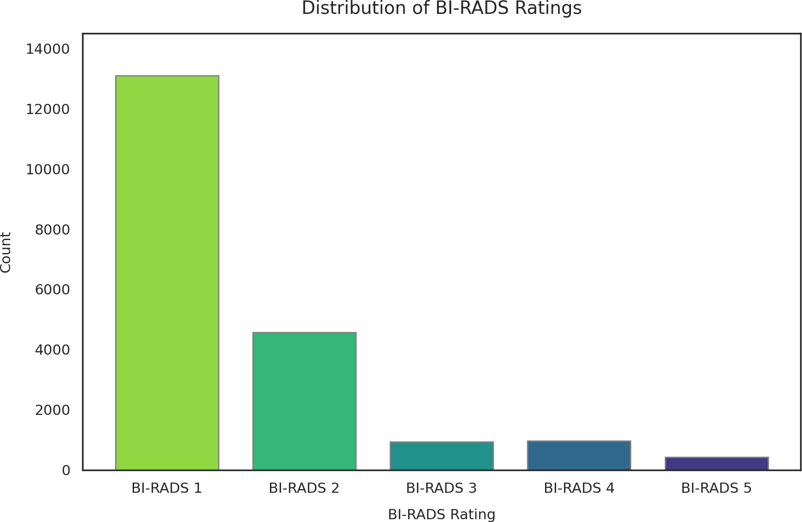
class frequency in the training set, computed from the training split support rather than the held-out test support to avoid data leakage, and the focusing parameter is fixed at γ = 2.0 throughout training. This combined objective encourages the network to prioritize learning signals from minority BI-RADS categories while remaining robust to annotation noise at class boundaries.
- Experiment
- Dataset

The empirical validation of our framework is executed using the VinDr-Mammo dataset, a large-scale, fully annotated digi-tal mammography cohort consisting of 20,000 mammography images, distributed across 5,000 cases. The dataset contains full-field digital mammogram (FFDM) images captured across distinct views (mediolateral oblique [MLO] and craniocaudal [CC]). Each image in the dataset is annotated by expert radiologists for both localized breast findings and overall breast-level Breast Imaging Reporting and Data System (BI-RADS) categories, ranging from BI-RADS 1 to 5.
A fundamental challenge of this clinical dataset is its extreme class imbalance. As detailed in Table I, standard or benign findings (BI-RADS 1 and 2) heavily dominate the data distribution, constituting approximately 90.41% of the dataset. Conversely, high-suspicion assessment categories (BI-RADS 4 and 5) - the primary targets of breast cancer screening

Fig. 2. Bar chart illustrating the severe long-tailed distribution of the VinDr-Mammo dataset. The extreme scarcity of BI-RADS 3, 4, and 5 categories inherently biases standard models toward false negatives.

For the purposes of this experiment, target labels are parsed directly from the clinical breast_birads metadata strings and mapped to a zero-indexed integer space (0 to 4). Missing or ambiguous records are discarded during preprocessing.

Models are optimized using the official training data partition specified within the repository metadata. This con-figuration yields a strict 80/20 division of the entire dataset at the patient level. Since a standard clinical mammography examination comprises four views—two per breast (Cranio-Caudal [CC] and Mediolateral Oblique [MLO] views for both left and right sides)—this division translates to a training sub-set of 4,000 unique clinical examinations (16,000 images) and an independent test set of 1,000 unique clinical examinations (4,000 total images)
- Devices Usage
Concurrent multi-scale image processing imposes substan-tial computational and memory demands, necessitating the use of high-performance GPU hardware for model training and evaluation. The primary training computational specifications are outlined below:
  - Graphics Processing Unit (GPU): Single NVIDIA RTX A6000 equipped with 32 GB of VRAM.
  - Data Pipeline Parallelism: Managed via PyTorch multi-processing with a multi-threaded data loader queue (Nworkers = 4).
- Hyperparameter Settings
The network is compiled using an empirical configuration optimized for stabilization across asymmetric multi-scale in-puts. The definitive hyperparameters utilized for the experi-mental execution are consolidated in Table II.
TABLE II
Global-Local Fusion Network Configuration
Hyperparameters

Hyperparameter Parameter Assigned Value / Setting
Global Input Footprint 768 × 768 × 3
Local Input Footprint 1024 × 1024 × 3
Training Horizon 100 Epochs
Batch Dimension 8 Samples Optimization Algorithm Adam Optimizer Base Learning Rate (η) 1 × 10⁻⁴
Loss Criteria Configuration Regularized Focal Loss (γ = 2.0)
Label Smoothing (ϵ) 0.05

The model is trained for a fixed number of epochs without intermediate checkpointing or early stopping, as no separate validation set was used. To evaluate robustness against the
long-tailed class distribution in the VinDr-Mammo dataset, the
conventional supervised training pipeline without any special-ized imbalance-mitigation strategies, serving as a straightfor-ward reference model for evaluating the effectiveness of the proposed architecture. Each mammogram is processed inde-pendently through a single EfficientNet-B0 backbone, and the extracted features are passed directly to the final classification layer for BI-RADS prediction.
The second baseline utilizes the same EfficientNet-B0 back-bone and input resolution, but incorporates two commonly adopted techniques for handling the severe class imbalance present in mammographic datasets: Weighted Random Sam-pling and Focal Loss. The Weighted Random Sampler dy-namically adjusts data-loading probabilities according to the inverse frequency of each BI-RADS category, increasing the likelihood that minority classes are observed during training. In parallel, Focal Loss reduces the contribution of well-classified majority-class samples and emphasizes difficult or misclassified examples, encouraging the network to focus on underrepresented and diagnostically challenging cases. Unlike the proposed dual-branch framework, this baseline still relies solely on a single full-field mammogram input and does not incorporate explicit global-local feature extraction or ROI-aware processing.
- Evaluation Metrics
To rigorously evaluate the performance of the proposed BI-RADS classification framework, we utilize a comprehensive set of evaluation metrics. Due to the aforementioned accuracy paradox in highly imbalanced medical datasets, relying solely on overall accuracy is fundamentally flawed. Therefore, we emphasize Precision, Recall, and the F1-score.
For a specific BI-RADS category c, let TP_{c} (True Positives) denote the number of correctly predicted instances of class c; FP_{c} (False Positives) denote the number of instances falsely classified as class c; FN_{c} (False Negatives) denote the number of instances of class c incorrectly assigned to another class; and TN_{c} (True Negatives) denote the number of correctly identified non-class c instances.
  - Accuracy: Accuracy measures the overall proportion of correct predictions across all categories. While it provides a general macro-level view, it is insufficient for assessing diagnostic safety.
N ΣC TP
Accuracy =
correct = c=1 c
(5)

final convergence profile and performance are assessed using N N
macro-averaged F1-scores and detailed class-wise classifica- where Ncorrect denotes the total number of correctly classified
c=1
Σ

tion metrics at the end of training.
- Baseline Architectures for Comparative Evaluation
The performance gains achieved by the proposed dual-branch Global-Local Fusion Network are evaluated against two baseline models designed with increasing levels of class-imbalance handling while maintaining a single-image classifi-cation paradigm.
The first baseline consists of a standard single-scale
samples, N = ^{C} (TP_{c} + FN_{c}) is the total number of samples in the test set, and C is the total number of BI-RADS categories (C = 5). Note that in a single-label multiclass setting, ^{C} TP_{c} directly equals N_{correct}, since each sample contributes to exactly one class’s true-positive count.
  - Precision (Positive Predictive Value): Precision mea-sures the proportion of positive identifications that were ac-tually correct for a given class. High precision indicates a low false alarm rate.
c=1
Σ

EfficientNet-B0 architecture trained on full-field digital mam-
mograms resized to 768 × 768 pixels. This baseline employs a
Precision_{c}
TP_{c}
=
TP_{c} + FP_{c}
(6)

  - Recall (Sensitivity or True Positive Rate): Recall mea-sures the proportion of actual positive cases that were correctly identified. In clinical diagnostics, Recall is the most critical safety metric for minority, malignant classes (BI-RADS 3, 4, 5). Maximizing recall ensures that the devastating clinical cost of a false negative (missed cancer) is minimized.
mammograms, achieves a Macro F1-Score of only (0.40). Although the model attains a reasonable overall accuracy, its performance on minority BI-RADS categories remains limited because of the class imbalance in the dataset. The substantial reduction in image resolution required for single-backbone processing causes many subtle lesion characteristics and fine-

Recall
TP_{c}
grained morphological patterns to be lost, leading to poor

^{c} = TP + FN
c
c
(7)
recall and F1-scores for BI-RADS 3 and BI-RADS 4 cases. Baseline 2 introduces Focal Loss and a Weighted Random

  - Class-wise F1-score: The F1-score provides a single
metric that balances the trade-off between Precision and Recall by calculating their harmonic mean.
Sampler to address the severe class imbalance present in the dataset. This modification increases the Macro Recall from
0.41 to 0.44 and improves the Macro F1-Score from 0.40

F1-score_{c}
Precision_{c} × Recall_{c}
= 2 × Precision + Recall
c c
(8)
to 0.45. The improvement indicates that emphasizing difficult samples and increasing the sampling frequency of minority

  - Macro F1-score: Because our primary objective is to overcome class imbalance, we designate the Macro F1-score as our principal evaluation metric. The Macro F1-score is computed by taking the unweighted arithmetic mean of the class-wise F1-scores across all C categories:
classes can partially mitigate the bias toward dominant BI-RADS categories. Nevertheless, the model continues to op-erate on a single resized mammogram and therefore remains constrained by the lack of explicit local lesion analysis.
In contrast, the proposed Global-Local Feature Fusion Net-work achieves the strongest overall performance, obtaining a

Macro F1 = 1 Σ F1-score
C
(9)
Macro Precision of 0.68, Macro Recall of 0.61, and a Macro

C c
c=1
Unlike the weighted or micro F1-score, the Macro F1-score treats all classes equally, regardless of their support size. Consequently, a high Macro F1-score can only be achieved if the model successfully learns the rare minority classes (BI-RADS 3, 4, and 5) rather than exploiting the normal major-ity, supporting the effectiveness of our imbalance mitigation strategies.
- Result
- Comparative Performance Analysis
The efficacy of the proposed multi-scale dual-branch frame-work is evaluated by comparing its classification perfor-mance against two EfficientNet-B0-based baselines. Baseline 1 consists of a standard EfficientNet-B0 trained on full-field mammograms, while Baseline 2 employs the same architecture augmented with Focal Loss and a Weighted Random Sampler to alleviate class imbalance. Table III summarizes the Macro Precision, Macro Recall, and Macro F1-Score achieved by all three approaches.

TABLE III
Comparative Classification Metrics Across Different Model
Architectures
F1-Score of 0.63. Compared with Baseline 1, the proposed framework improves the Macro F1-Score by approximately 23 percentage points over Baseline 1, and 18 points over Baseline
2. These results demonstrate the effectiveness of combining global breast context with high-resolution local ROI informa-tion. By simultaneously modeling large-scale anatomical struc-tures and fine lesion characteristics, the proposed dual-branch architecture learns a more discriminative feature representation for challenging multi-class BI-RADS classification. Figure 3 illustrates several prediction examples, where the local ROI view is shown on the left and the global mammogram view is shown on the right. Correct predictions are highlighted in green, whereas incorrect predictions are marked in red.
- Class-Wise Evaluation of the Proposed Model
Table IV outlines the comprehensive class-wise tracking metrics used to analyze the diagnostic behavior of our Global-Local network under clinical conditions on the test set.

TABLE IV
Class-Wise Performance Breakdown of the Proposed
Global-Local Feature Fusion Network

Model Architecture
Macro Precision
Macro Recall
Macro F1-Score

BI-RADS 5 0.71 0.54 0.62 46
Target Category  BI-RADS 1 | Precision Recall F1-Score  0.83 0.93 0.88 | Support  2682
BI-RADS 2 | 0.71 0.48 0.57 | 934
BI-RADS 3 | 0.62 0.67 0.64 | 186
BI-RADS 4 | 0.51 0.41 0.46 | 152

EfficientNet-B0 0.53 0.41 0.40
EfficientNet-B0 + Focal Loss 0.54 0.44 0.45
Global-Local Feature Fusion Network 0.68 0.61 0.63
The experimental results on the test set demonstrate that the proposed Global-Local Feature Fusion Network consis-tently outperforms both baseline models across all evaluation metrics. Baseline 1, which relies solely on a conventional EfficientNet-B0 architecture operating on resized full-field
Macro Average 0.68 0.61 0.63 4000
Weighted Average 0.77 0.79 0.78 4000

Class-wise performance reveals that BI-RADS 1 achieves the highest F1-Score (0.88) and recall (0.93). This result is likely influenced by the predominance of BI-RADS 1 samples in the dataset, which provides the model with substantially more training examples than the higher-risk categories. The corresponding error distribution, shown in Fig. 4, further

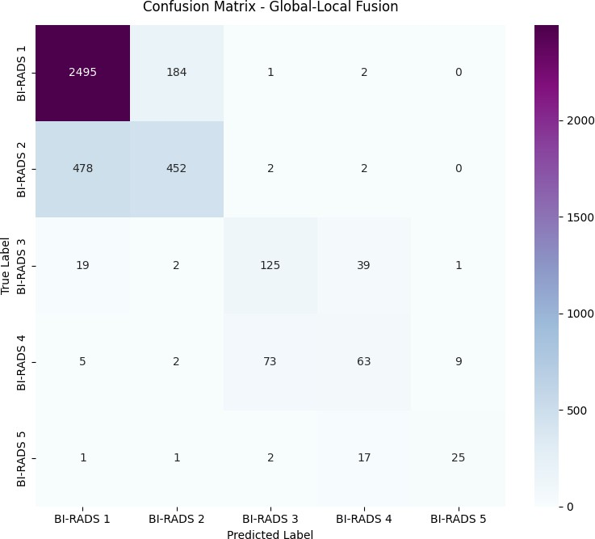

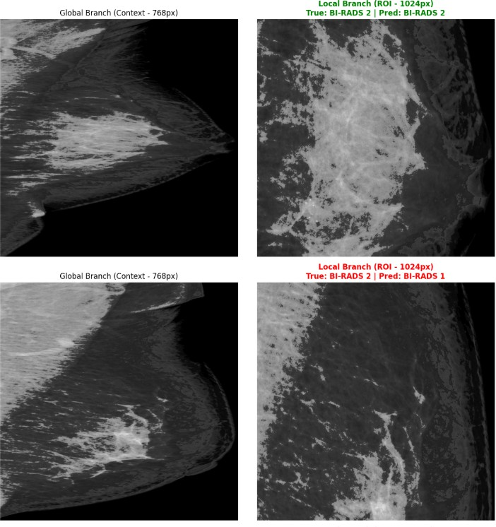
Fig. 3. Global-local branch visual comparison displaying successful (top) and misclassified (bottom) BI-RADS predictions.

illustrates the model’s tendency to correctly classify normal screening cases.
Crucially, for highly severe malignancies (BI-RADS 5), the model maintains high precision, achieving a precision score of
0.71 and an F1-Score of 0.62. The localized branch is associ-ated with improved performance in intermediate pathological states (BI-RADS 3 and BI-RADS 4), yielding F1-scores of
0.64 and 0.46, respectively. Because BI-RADS 3 and 4 rep-resent borderline configurations that suffer from considerable inter-observer variability even among human expert readers, the model’s capacity to maintain stable precision and recall profiles over these critical thresholds directly validates the integration of our ROI-guided training mechanism with Focal Loss regularization.
- Discussion
The empirical findings validate our multi-scale dual-branch framework, achieving a peak macro-averaged F₁-score of
0.63 and an accuracy of 0.79. Its primary strength lies in preserving ultra-high-resolution local tissue anomalies via the EfficientNet-B3 path, capturing subtle border traits in bor-derline tiers like BI-RADS 3 (F₁ = 0.64) and BI-RADS 4 (F₁ = 0.46) where standard downsampled baselines fail.
A key limitation is that the YOLOv8 detector is itself trained on ground-truth bounding boxes, so localization quality is upper-bounded by radiologist annotation availability. Despite the fully automated nature of classification inference based on YOLOv8 ROIs, upstream detection errors (e.g., missed BI-RADS 3 lesions) propagate to the local branch, thereby
Fig. 4. Confusion matrix on test set of the proposed architecture

threatening performance on key minority classes. Furthermore, channel-wise concatenation is a rigid approach to feature fu-sion, and evaluating mammographic views individually misses the opportunity to jointly leverage paired CC and MLO projections.
- Conclusion
In this work, we presented a Global-Local Feature Fusion Network optimized with regularized Focal Loss for five-tier BI-RADS classification on the imbalanced VinDr-Mammo dataset.
By pairing a global structural processing stream EfficientNet-B0 with an asymmetric, high-resolution regional pathway EfficientNet-B3 and integrating YOLOv8-guided ROI extraction with an optimized Focal Loss and Label Smoothing strategy, the network successfully mimics the multi-scale cognitive analytical workflow used by clinical radiologists. Our model significantly outperforms all baselines, establishing an accuracy of 0.79 and a macro-averaged F₁-score of 0.63. These results show that combining holistic breast topology with precise, fine-grained lesion characteristics provides a highly discriminative feature space capable of regularizing severe clinical class imbalances.
In the future, we will validate this spatial decomposition strategy across multi-center clinical registries to ensure cross-domain generalization. We also plan to explore self-supervised representation learning to further sharpen the decision bound-aries of intermediate BI-RADS categories without the need for dense expert annotations.
References
- D. R. Youlden, S. M. Cramb, N. A. Dunn, J. M. Muller, C. M. Pyke, and P. D. Baade, “The descriptive epidemiology of female breast cancer: An international comparison of screening, incidence,

survival and mortality,” Cancer Epidemiology, vol. 36, no. 3, pp. 237–248, 2012. [Online]. Available: https://www.sciencedirect.com/ science/article/pii/S187778211200029X
- S. Winters, C. Martin, D. Murphy, and N. K. Shokar, “Chapter one - breast cancer epidemiology, prevention, and screening,” in Approaches to Understanding Breast Cancer, ser. Progress in Molecular Biology and Translational Science, R. Lakshmanaswamy, Ed. Academic Press, 2017, vol. 151, pp. 1–32. [Online]. Available: https://www.sciencedirect.com/science/article/pii/S1877117317301126
- Y. Jiang, R. M. Nishikawa, R. A. Schmidt, A. Y. Toledano, and K. Doi, “Potential of computer-aided diagnosis to reduce variability in radiol-ogists’ interpretations of mammograms depicting microcalcifications,” Radiology, vol. 220, no. 3, pp. 787–794, 2001.
- D. A. Ragab, M. Sharkas, S. Marshall, and J. Ren, “Breast cancer detection using deep convolutional neural networks and support vector machines,” PeerJ, vol. 7, p. e6201, 2019.
- S. Ciurescu, S. Cerbu, C. N. Dima, V. Buciu, D. M. S¸ erban, D. G. Ilas¸, and I. Sas, “Stratifying breast lesion risk using bi-rads: A correlative study of imaging and histopathology,” Medicina, vol. 61, no. 7, p. 1245, 2025.
- D. Muduli, R. Dash, and B. Majhi, “Automated diagnosis of breast cancer using multi-modal datasets: A deep convolution neural network based approach,” Biomedical Signal Processing and Control, vol. 71, p. 102825, 2022. [Online]. Available: https:
//www.sciencedirect.com/science/article/pii/S1746809421004225
- L. Liberman and J. H. Menell, “Breast imaging reporting and data system (bi-rads),” Radiologic Clinics of North America, vol. 40, no. 3,
pp. 409–430, 2002. [Online]. Available: https://www.sciencedirect.com/ science/article/pii/S0033838901000173
- W. A. Berg, D. Gur, A. I. Bandos, B. Nair, T.-A. Gizienski, C. S. Tyma,
G. Abrams, K. M. Davis, A. S. Mehta, G. Rathfon, U. X. Waheed, and C. M. Hakim, “Impact of original and artificially improved artificial intelligence–based computer-aided diagnosis on breast us interpretation,” Journal of Breast Imaging, vol. 3, no. 3, pp. 301–311, 05 2021. [Online]. Available: https://doi.org/10.1093/jbi/wbab013
- N. Chouhan, A. Khan, J. Z. Shah, M. Hussnain, and M. W. Khan, “Deep convolutional neural network and emotional learning based breast cancer detection using digital mammography,” Computers in Biology and Medicine, vol. 132, p. 104318, 2021. [Online]. Available: https://www.sciencedirect.com/science/article/pii/S0010482521001128
- H. T. Nguyen, H. Q. Nguyen, H. H. Pham, K. Lam, L. T. Le, M. Dao, and
V. Vu, “VinDr-Mammo: A large-scale benchmark dataset for computer-aided diagnosis in full-field digital mammography,” Scientific Data, vol. 10, no. 1, p. 277, May 2023.
- M. Tan and Q. Le, “EfficientNet: Rethinking model scaling for convolutional neural networks,” in Proceedings of the 36th International Conference on Machine Learning, ser. Proceedings of Machine Learning Research, K. Chaudhuri and R. Salakhutdinov, Eds., vol. 97. Long Beach, California, USA: PMLR, 09–15 Jun 2019, pp. 6105–6114. [Online]. Available: https://proceedings.mlr.press/v97/tan19a.html
- S. M. McKinney, M. Sieniek, V. Godbole, N. Agarwal, C. Alentorn-Geli, E. Shelhamer, P. Back, D. Sanders, A. Darzi, S. Mozzi et al., “International evaluation of an ai system for breast cancer screening,” Nature, vol. 577, no. 7788, pp. 89–94, 2020.
- Y. Shen, N. Wu, J. Phang, J. Park, K. Liu, S. Tyagi, L. Heacock, S. G. Kim, L. Moy, K. Cho, and K. J. Geras, “An interpretable classifier for high-resolution breast cancer screening images utilizing weakly supervised localization,” Medical Image Analysis, vol. 68, p. 101908, February 2021.
- M. Buda, A. Maki, and M. A. Mazurowski, “A systematic study of the class imbalance problem in convolutional neural networks,” Neural Networks, vol. 106, pp. 249–259, October 2018.
- A. Kumar, D. Singh, and R. Shankar Yadav, “Class overlap handling methods in imbalanced domain: A comprehensive survey,” Multimedia Tools and Applications, vol. 83, no. 23, pp. 63 243–63 290, 2024. [Online]. Available: https://doi.org/10.1007/s11042-023-17864-8
- Y. Yang, H. A. Khorshidi, and U. Aickelin, “A review on over-sampling techniques in classification of multi-class imbalanced datasets: insights for medical problems,” Frontiers in Digital Health, vol. Volume 6
- 2024, 2024. [Online]. Available: https://www.frontiersin.org/journals/ digital-health/articles/10.3389/fdgth.2024.1430245
- C. de Alvis and S. Seneviratne, “A survey of deep long-tail classification advancements,” 2024. [Online]. Available: https:
//arxiv.org/abs/2404.15593
- T.-Y. Lin, P. Goyal, R. Girshick, K. He, and P. Dolla´r, “Focal loss for dense object detection,” IEEE Transactions on Pattern Analysis and Machine Intelligence, vol. 42, no. 2, pp. 318–327, 2020.
- R. Mu¨ller, S. Kornblith, and G. Hinton, “When does label smooth-ing help?” in Advances in Neural Information Processing Systems (NeurIPS), vol. 32, Vancouver, Canada, 2019, pp. 4694–4703.
- M. Sandler, A. Howard, M. Zhu, A. Zhmoginov, and L.-C. Chen, “Mo-bilenetv2: Inverted residuals and linear bottlenecks,” in 2018 IEEE/CVF Conference on Computer Vision and Pattern Recognition, Salt Lake City, UT, USA, 2018, pp. 4510–4520.
- J. Hu, L. Shen, and G. Sun, “Squeeze-and-excitation networks,” in 2018 IEEE/CVF Conference on Computer Vision and Pattern Recognition, Salt Lake City, UT, USA, 2018, pp. 7132–7141.
- M. Lin, Q. Chen, and S. Yan, “Network in network,” 2014. [Online]. Available: https://arxiv.org/abs/1312.4400

