

Capstone Project Report
Report 4 – Software Design Document

– FPT University, October 2026 –

Table of Contents
I. Record of Changes 3
II. Software Design Document 4
1. System Design 4
1.1 System Architecture 4
1.2 Package Diagram 4
2. Database Design 4
3. Detailed Design 5
3.1 <Feature/Function Name1> 5
3.2 <Feature/Function Name2> 6

I. Record of Changes
Date | A*  M, D | In charge | Change Description
26/10/2026 | M | Lê Nguyễn Quang Đức | Populate VISTA Review 2 content on original university template; code verification pending
*A - Added M - Modified D - Deleted

II. Software Design Document

1. System Design
Architecture separates browser, NestJS Education API (authorization/business logic), Supabase Auth/PostgreSQL, evidence storage, external AI/model service and local Python Robot Runtime. Drawings depict target boundaries; verify the current deployed state and API contracts before claiming integration.

1.1 System Architecture
Figure 01. Source: diagramall.drawio.xml page 1; proposed unless explicitly code-verified. Rendered repository counterpart: docs/review-2/04-diagrams/*/mermaid-reference/.
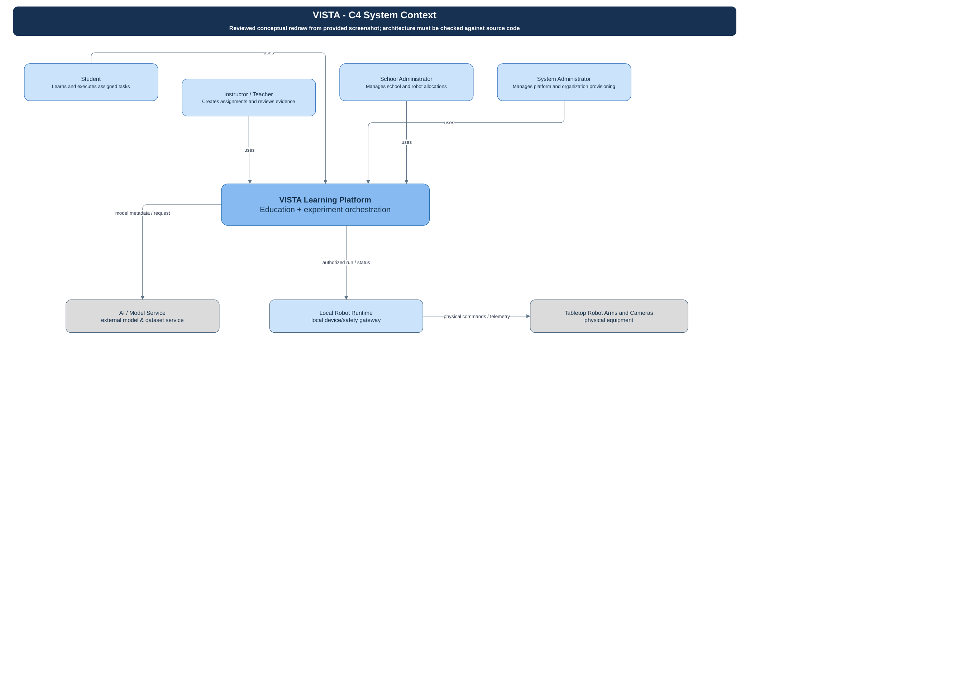
Figure 02. Source: diagramall.drawio.xml page 2; proposed unless explicitly code-verified. Rendered repository counterpart: docs/review-2/04-diagrams/*/mermaid-reference/.
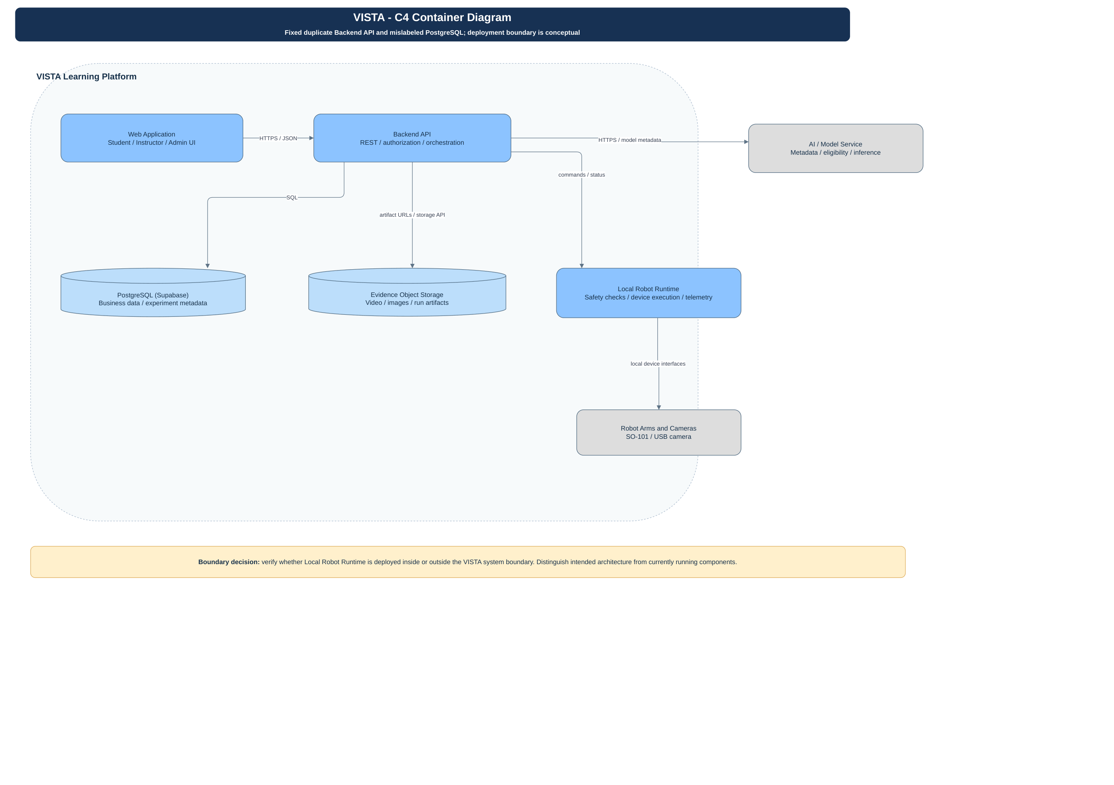
Figure 03. Source: diagramall.drawio.xml page 3; proposed unless explicitly code-verified. Rendered repository counterpart: docs/review-2/04-diagrams/*/mermaid-reference/.
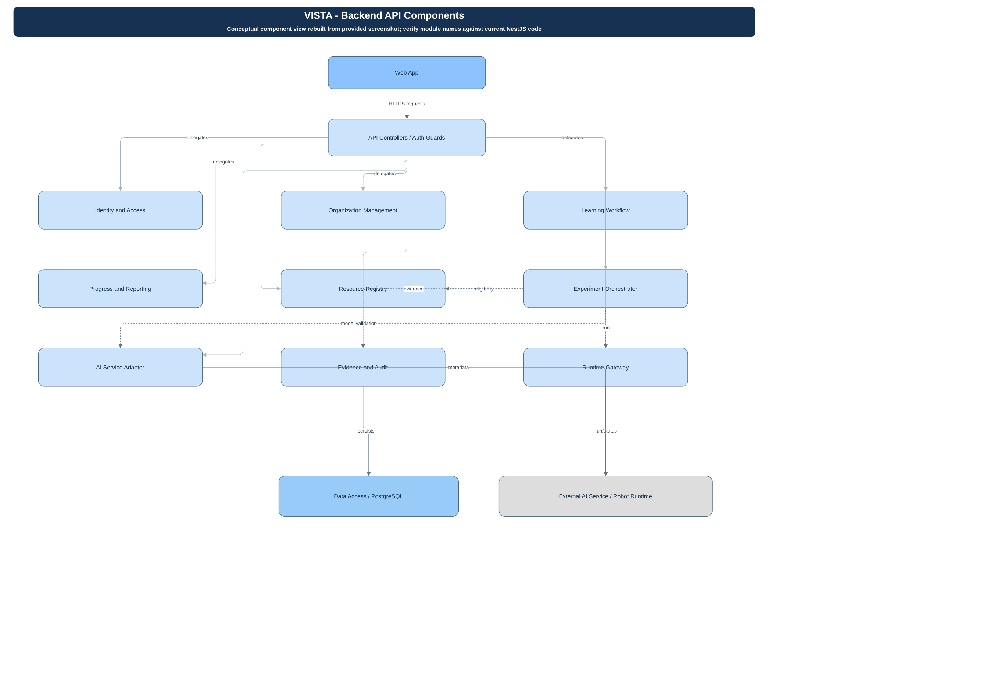
Source: diagramall.drawio.xml pages 1–3 and the matching repository Mermaid sources. Browser obtains JWT; NestJS guards validate membership and organization scope; Prisma persists records. Design components are mapped to implemented modules or explicitly marked planned.
C4 System Context: Student, Teacher, School/System Admin → VISTA Web → NestJS Education API → Supabase PostgreSQL/Auth; optional external AI/model service; Python Robot Runtime with fail-closed hardware safety. The submitted C4 drawings require verification against the repo before BM02.

1.2 Package Diagram
Mapped code roots: web/robot-edu (React/Vite); services/education-api (NestJS 11 and Prisma); services/ai-integration (AI interface); services/robot-runtime (Python); edge/raspberry-pi-agent (edge); services/backend requires independent inspection. Refer to embedded figures.
Logical packages: Identity/Access; Education Administration; Curriculum & Learning; Program Versioning; Experiment & Symbolic Evaluation; Assessment/Feedback; Robot Runtime Adapter; Persistence. These are design responsibilities, not necessarily separate deployed microservices.
Package Descriptions
No | Package | Description
1 | Education API / access | NestJS controllers, guards, DTOs; Prisma data access
2 | External integration | Python Robot Runtime and AI/model service; status unverified

2. Database Design
Figure 12. Source: diagramall.drawio.xml page 12; proposed unless explicitly code-verified. Rendered repository counterpart: docs/review-2/04-diagrams/*/mermaid-reference/.
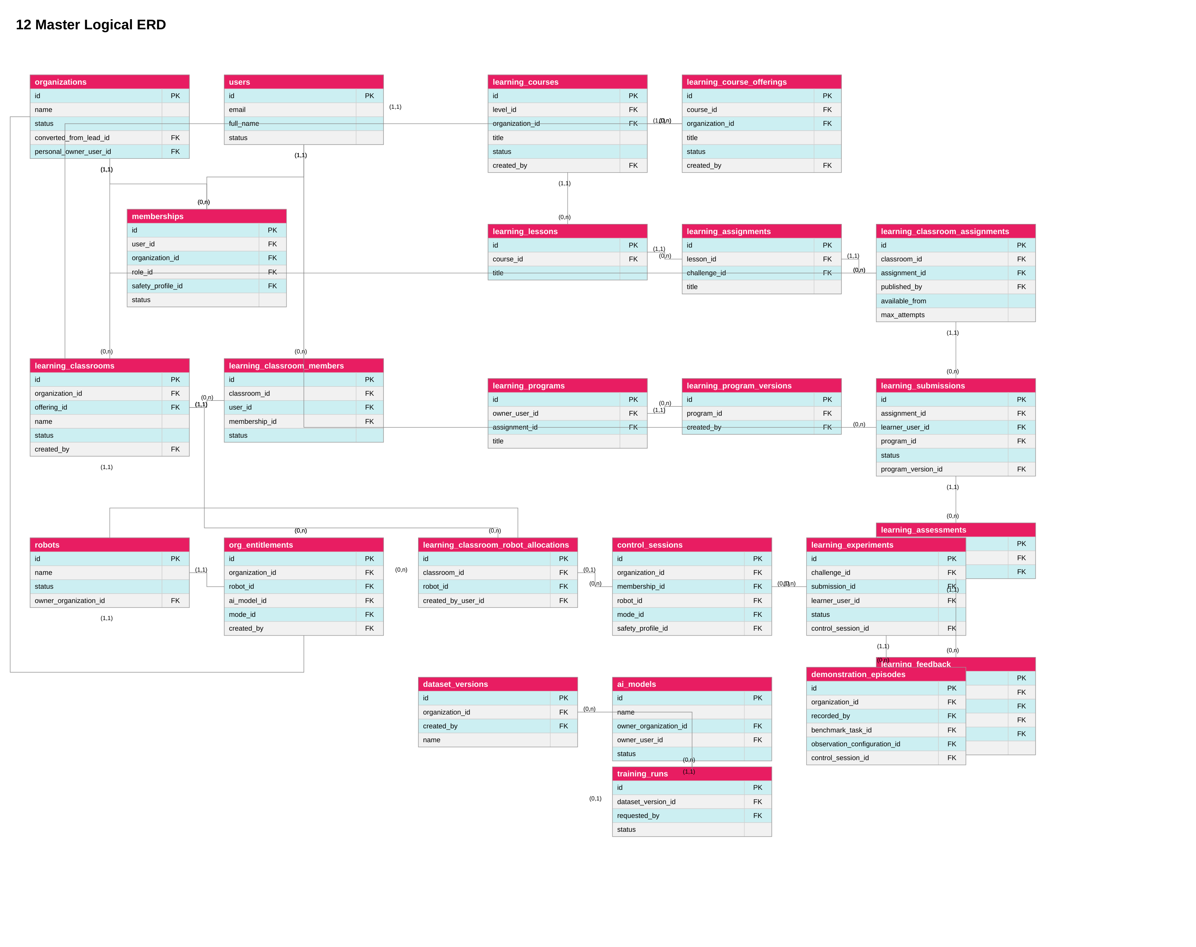
Figure 13. Source: diagramall.drawio.xml page 13; proposed unless explicitly code-verified. Rendered repository counterpart: docs/review-2/04-diagrams/*/mermaid-reference/.
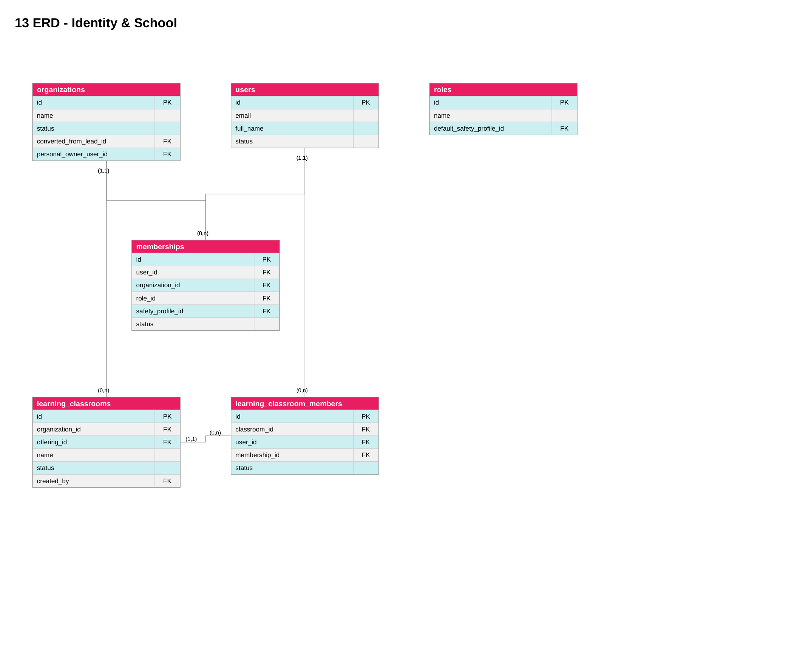
Figure 15. Source: diagramall.drawio.xml page 15; proposed unless explicitly code-verified. Rendered repository counterpart: docs/review-2/04-diagrams/*/mermaid-reference/.
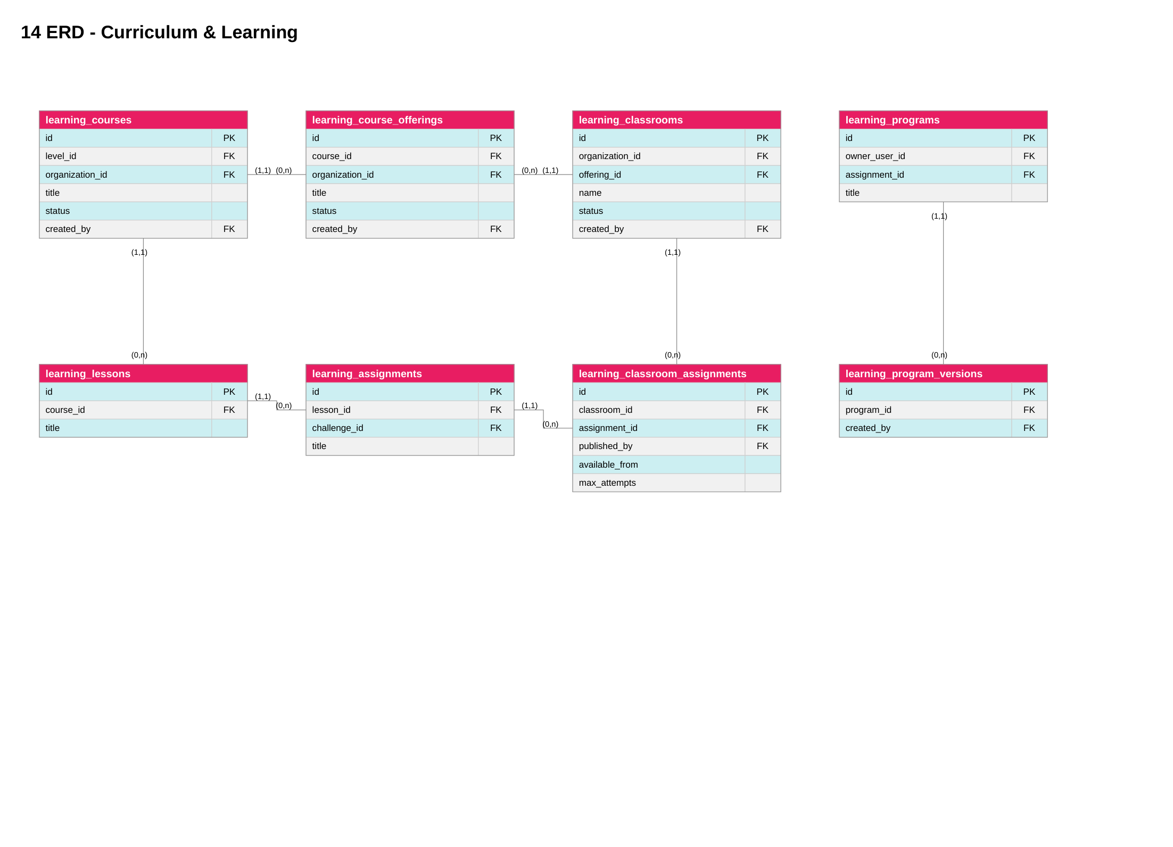
Figure 17. Source: diagramall.drawio.xml page 17; proposed unless explicitly code-verified. Rendered repository counterpart: docs/review-2/04-diagrams/*/mermaid-reference/.
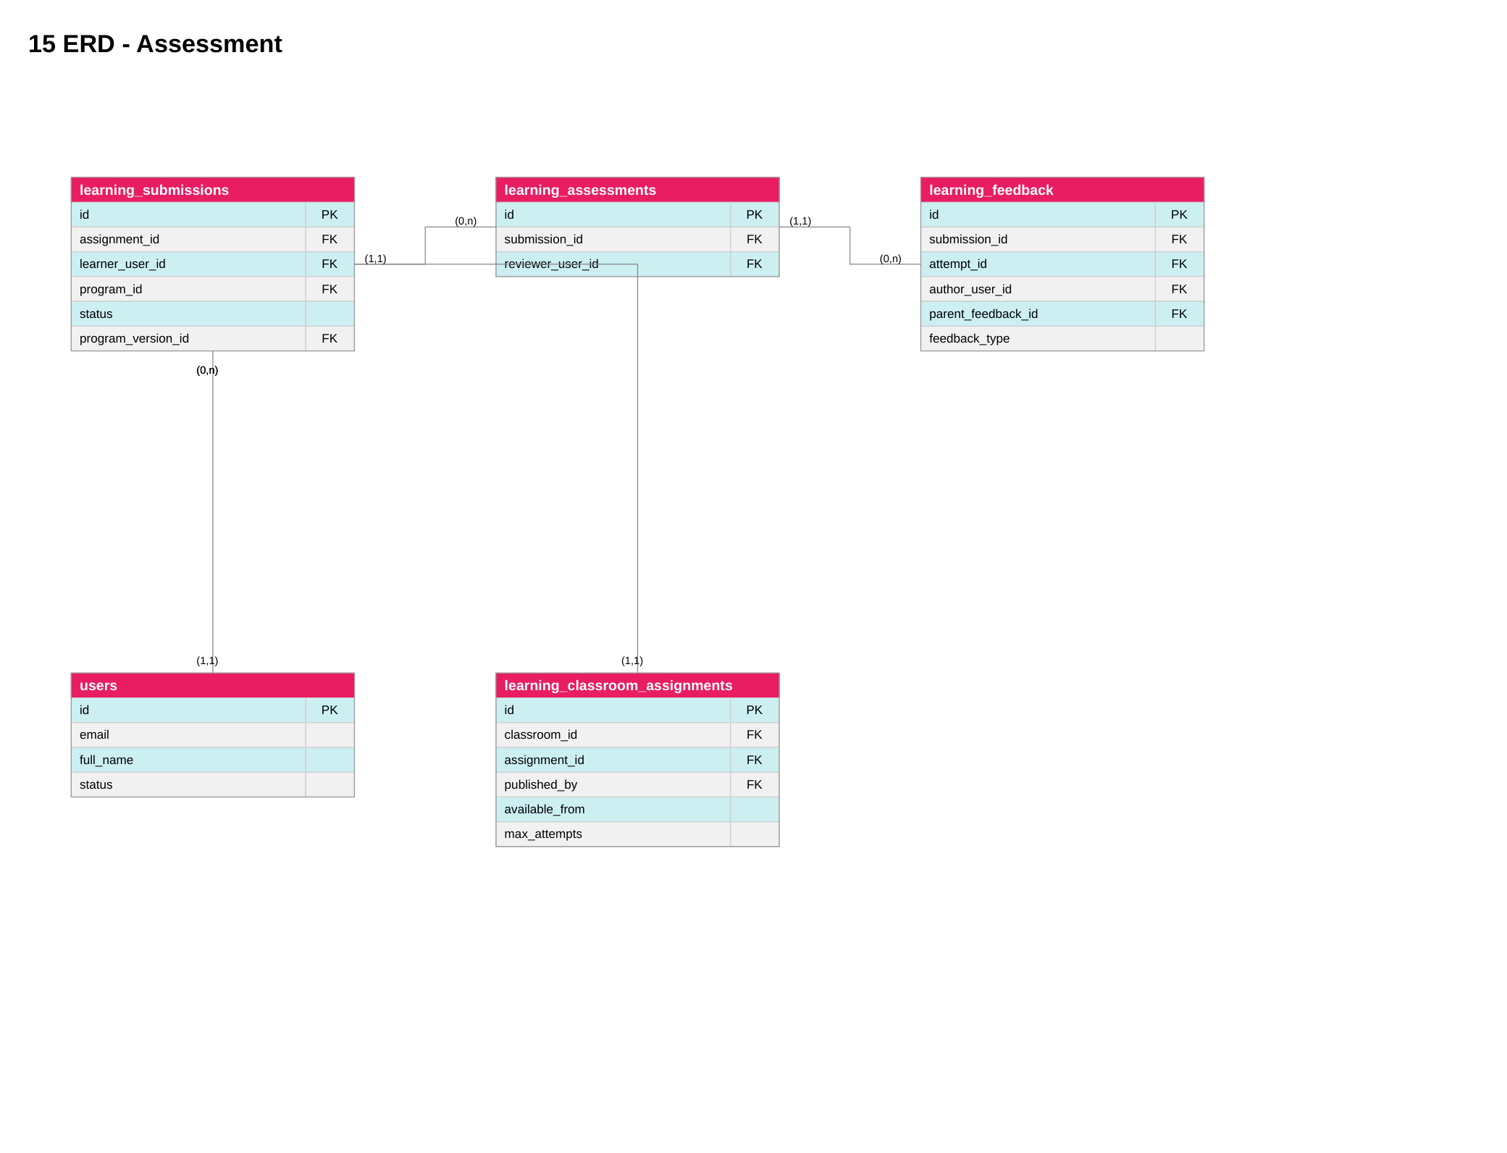
Figure 19. Source: diagramall.drawio.xml page 19; proposed unless explicitly code-verified. Rendered repository counterpart: docs/review-2/04-diagrams/*/mermaid-reference/.
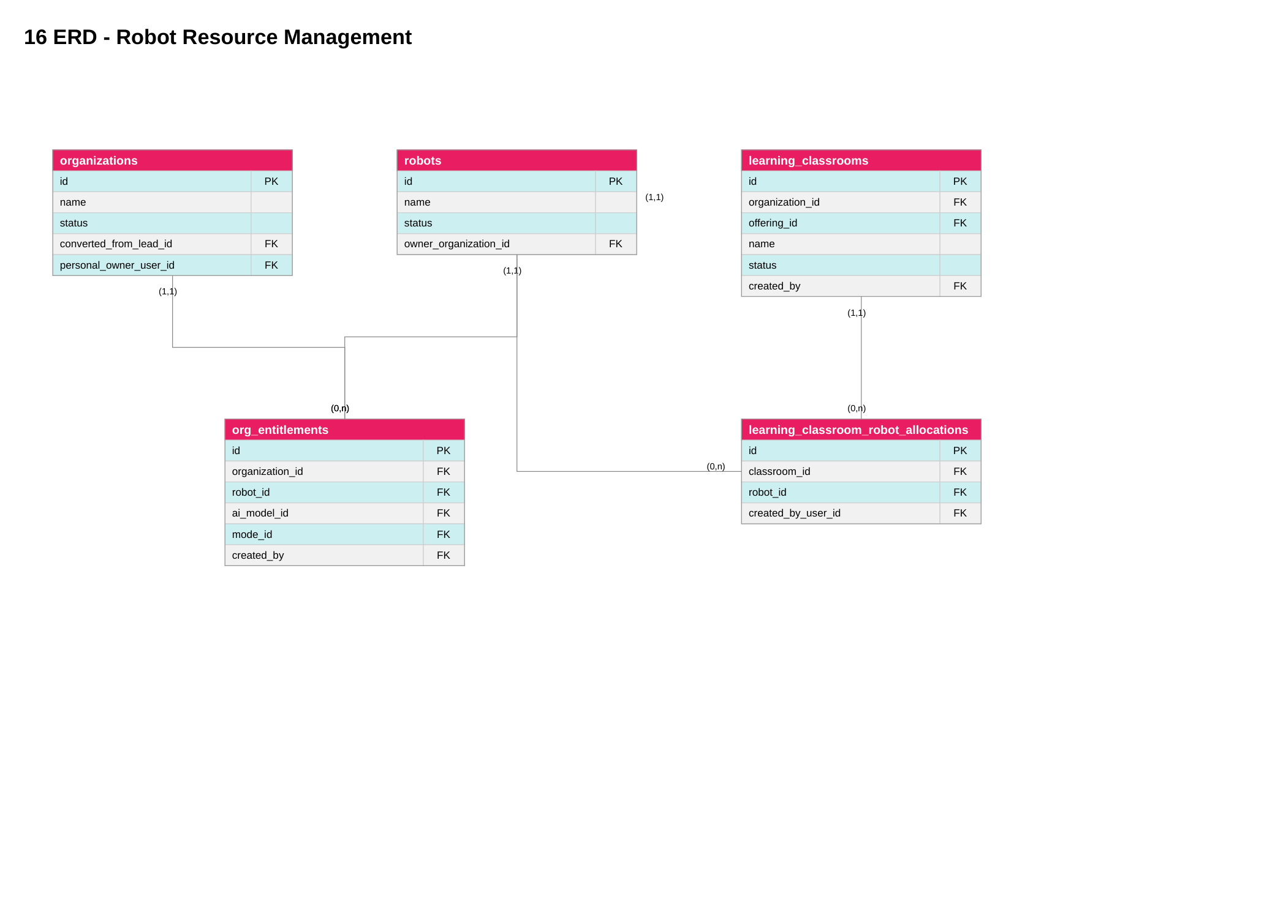
Figure 21. Source: diagramall.drawio.xml page 21; proposed unless explicitly code-verified. Rendered repository counterpart: docs/review-2/04-diagrams/*/mermaid-reference/.
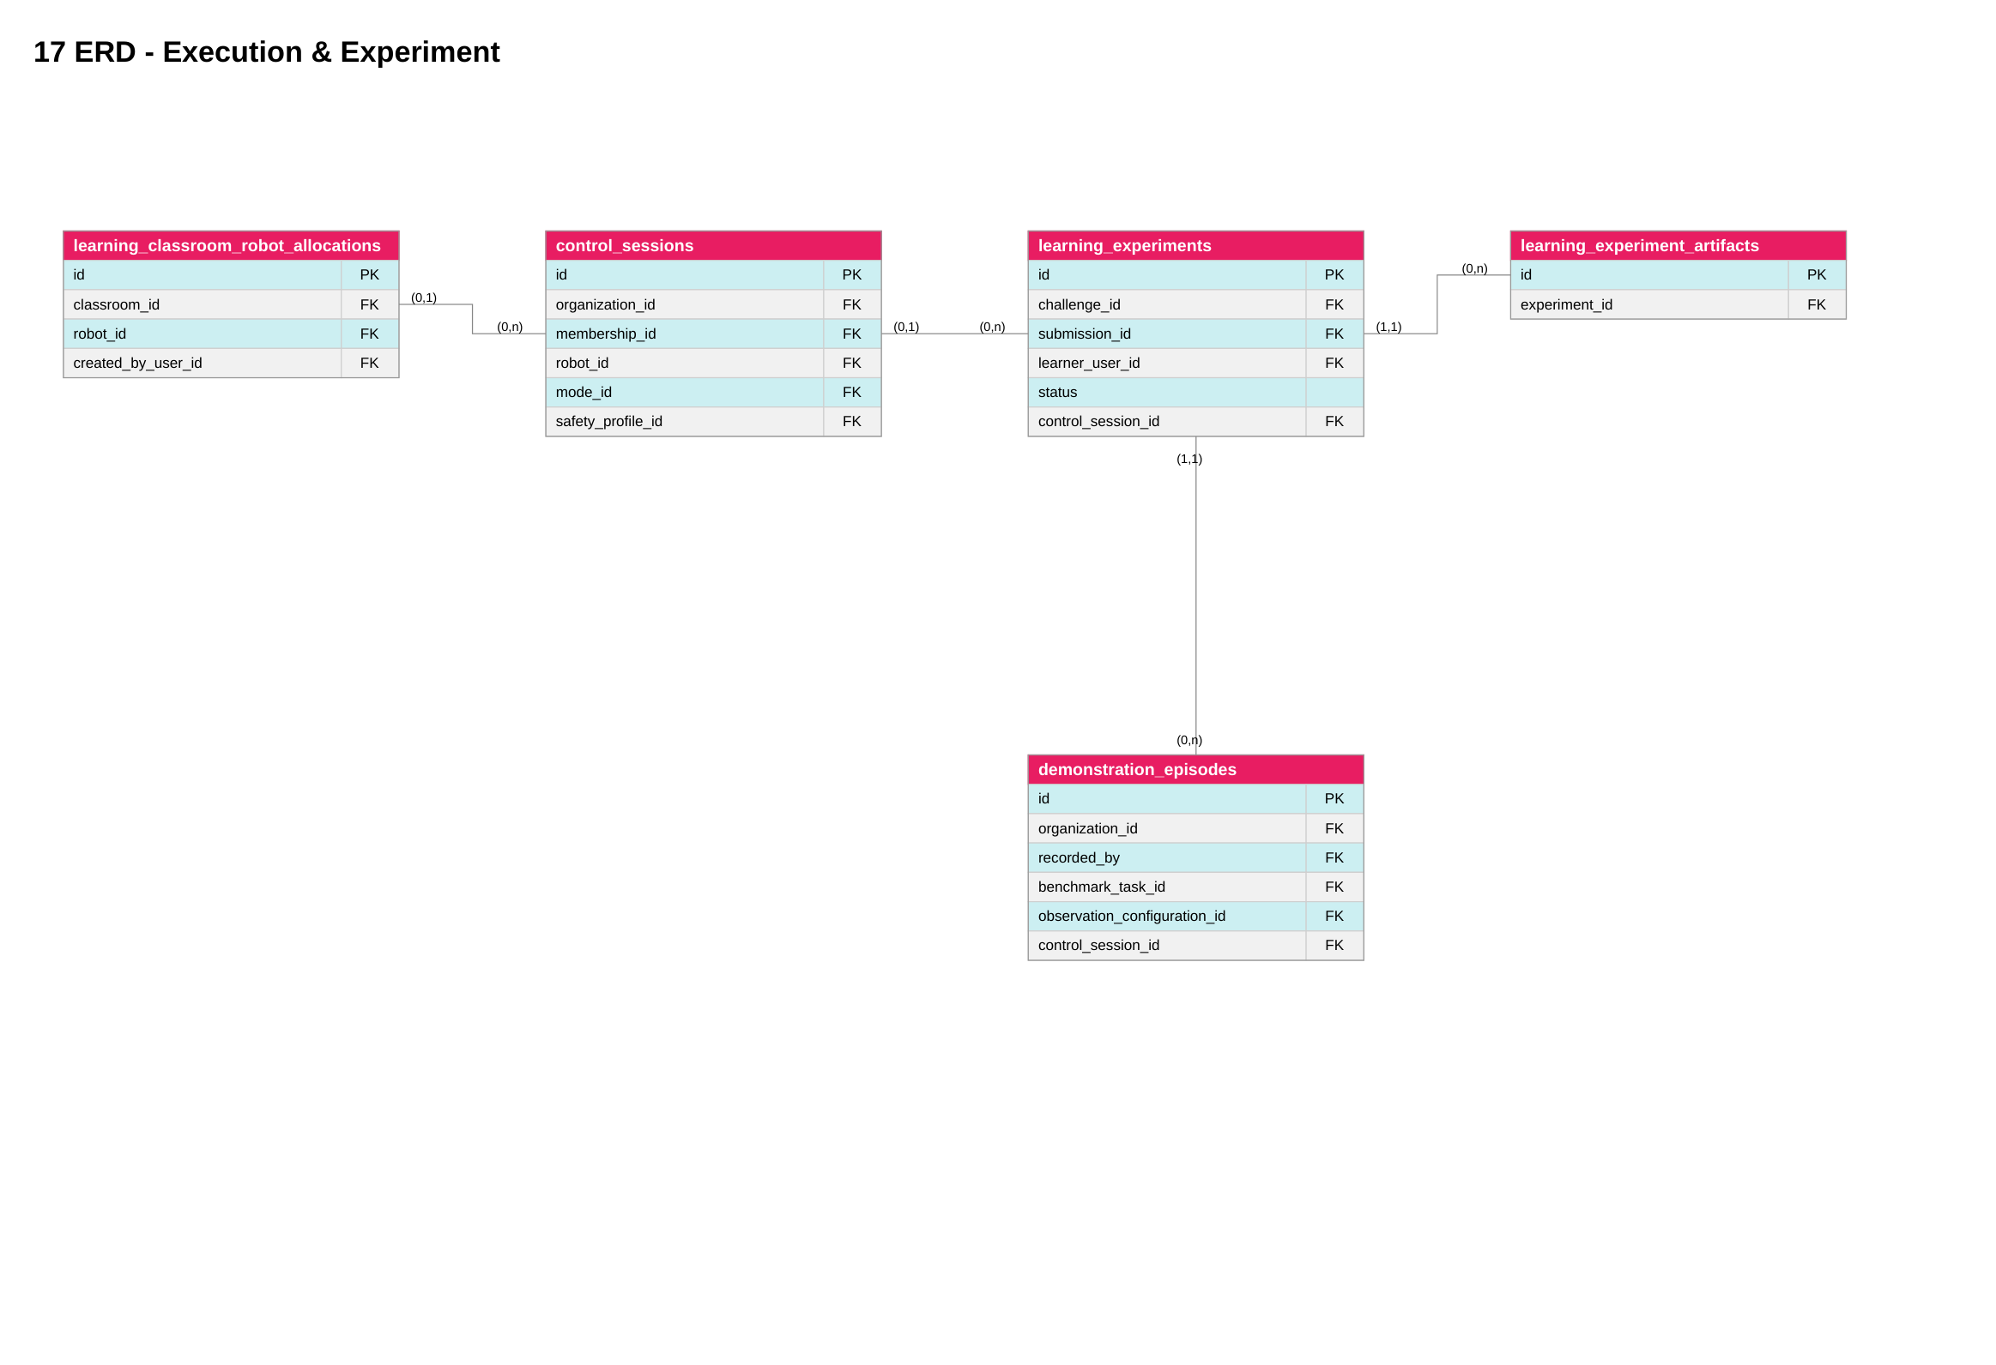
Figure 23. Source: diagramall.drawio.xml page 23; proposed unless explicitly code-verified. Rendered repository counterpart: docs/review-2/04-diagrams/*/mermaid-reference/.
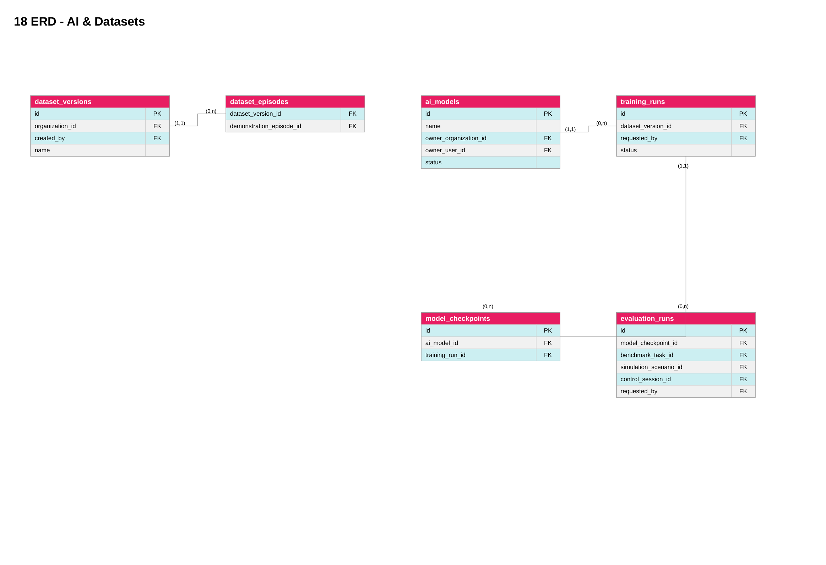
The complete ERD set is shown in the reconciled appendix: one conceptual, five logical and six physical views. Figure 16a (Programs & Assessment) and Figure 16b (AI & Datasets) remain separate. Exact constraints require verification against Prisma and migrations.
Database source of truth is applied PostgreSQL schema and migrations. Organization memberships, classroom membership, org_entitlements, classroom robot allocations, control_sessions, learning_experiments, submissions, program versions and assessments are distinct.
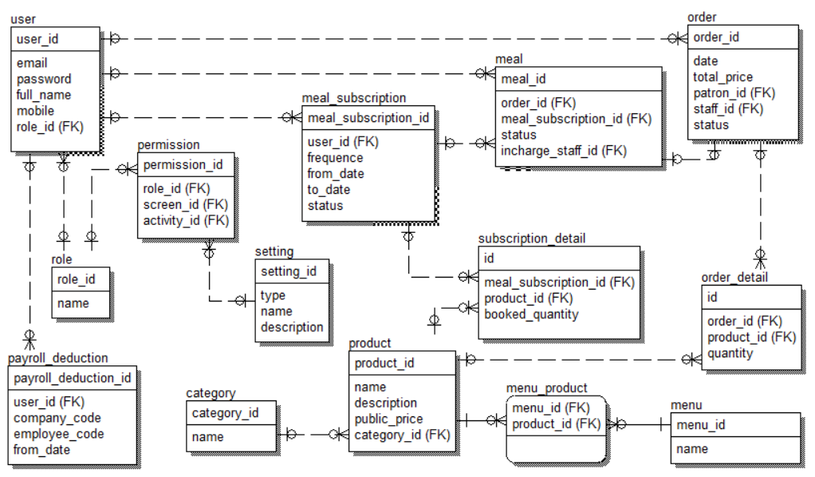
Table Descriptions
No | Table | Description
1 | learning_classroom_robot_allocations | Robot authorization at classroom level
2 | learning_experiments | Schematic experiment request/status; verify FK constraints

3. Detailed Design
Figure 04. Source: diagramall.drawio.xml page 4; proposed unless explicitly code-verified. Rendered repository counterpart: docs/review-2/04-diagrams/*/mermaid-reference/.
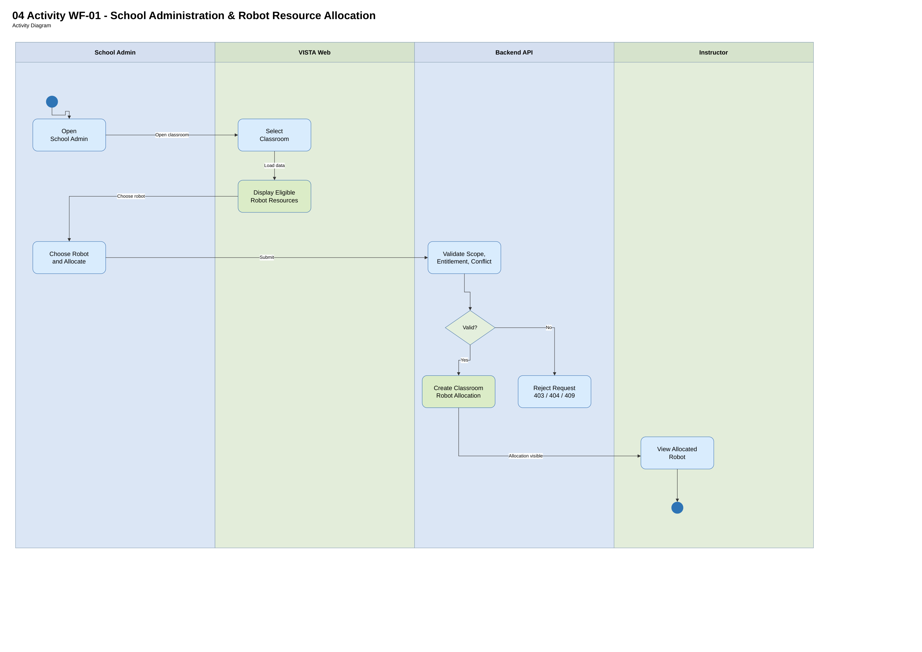
Figure 05. Source: diagramall.drawio.xml page 5; proposed unless explicitly code-verified. Rendered repository counterpart: docs/review-2/04-diagrams/*/mermaid-reference/.
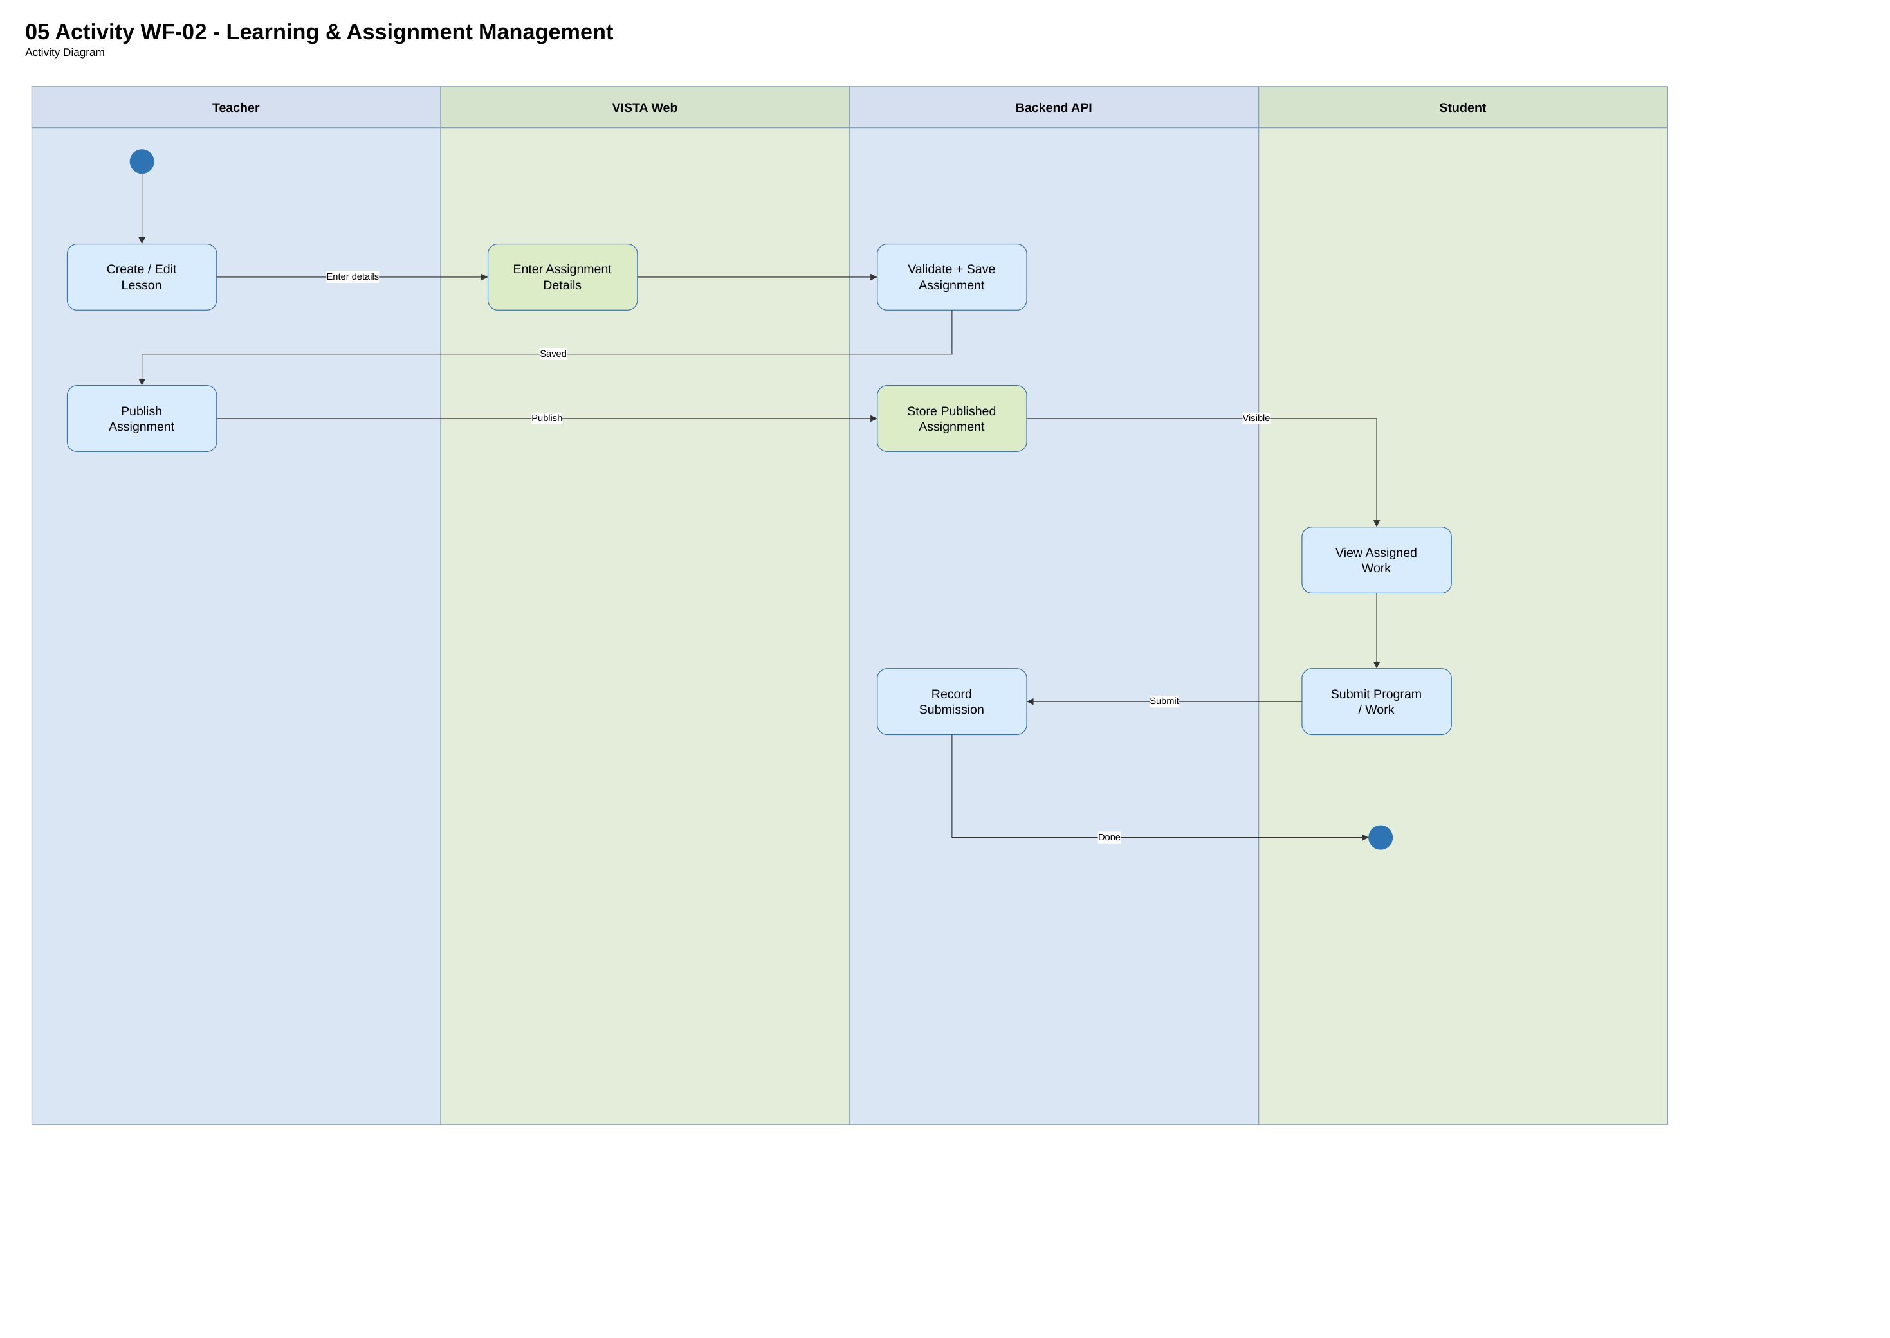
Figure 06. Source: diagramall.drawio.xml page 6; proposed unless explicitly code-verified. Rendered repository counterpart: docs/review-2/04-diagrams/*/mermaid-reference/.
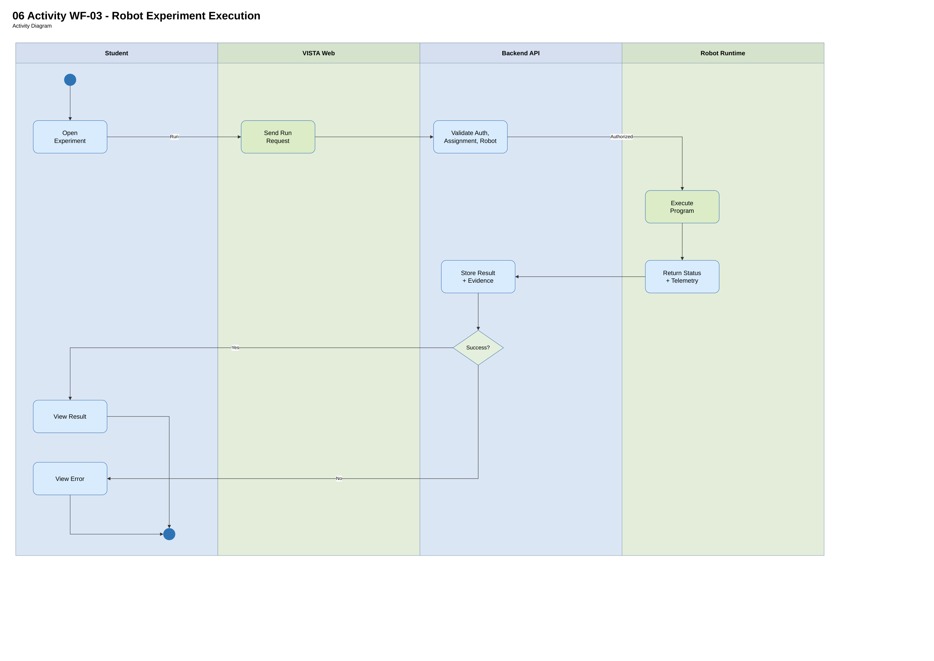
Figure 07. Source: diagramall.drawio.xml page 7; proposed unless explicitly code-verified. Rendered repository counterpart: docs/review-2/04-diagrams/*/mermaid-reference/.
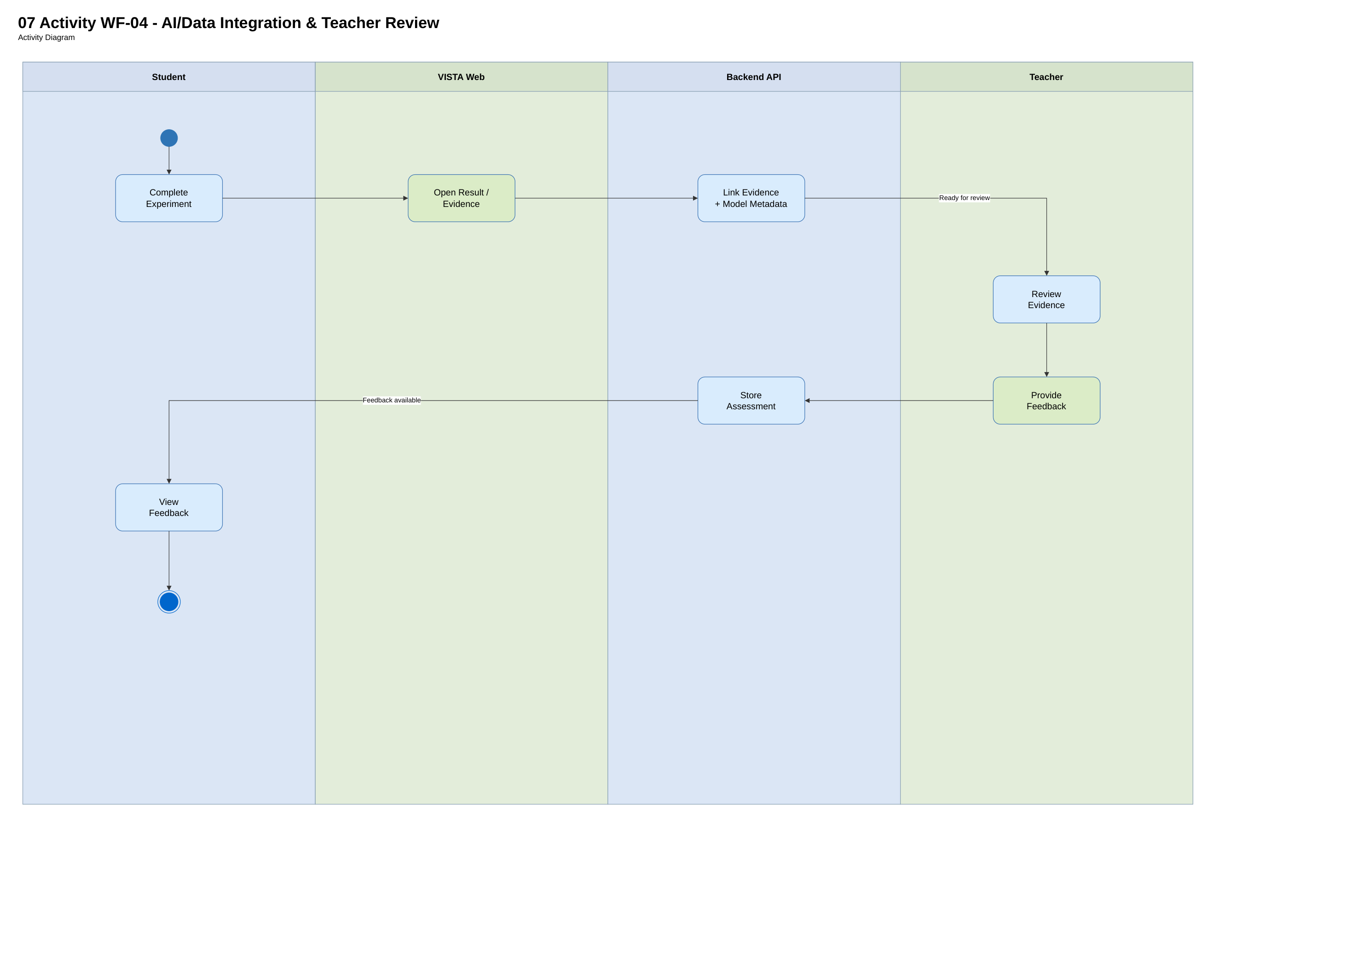
Figure 08. Source: diagramall.drawio.xml page 8; proposed unless explicitly code-verified. Rendered repository counterpart: docs/review-2/04-diagrams/*/mermaid-reference/.
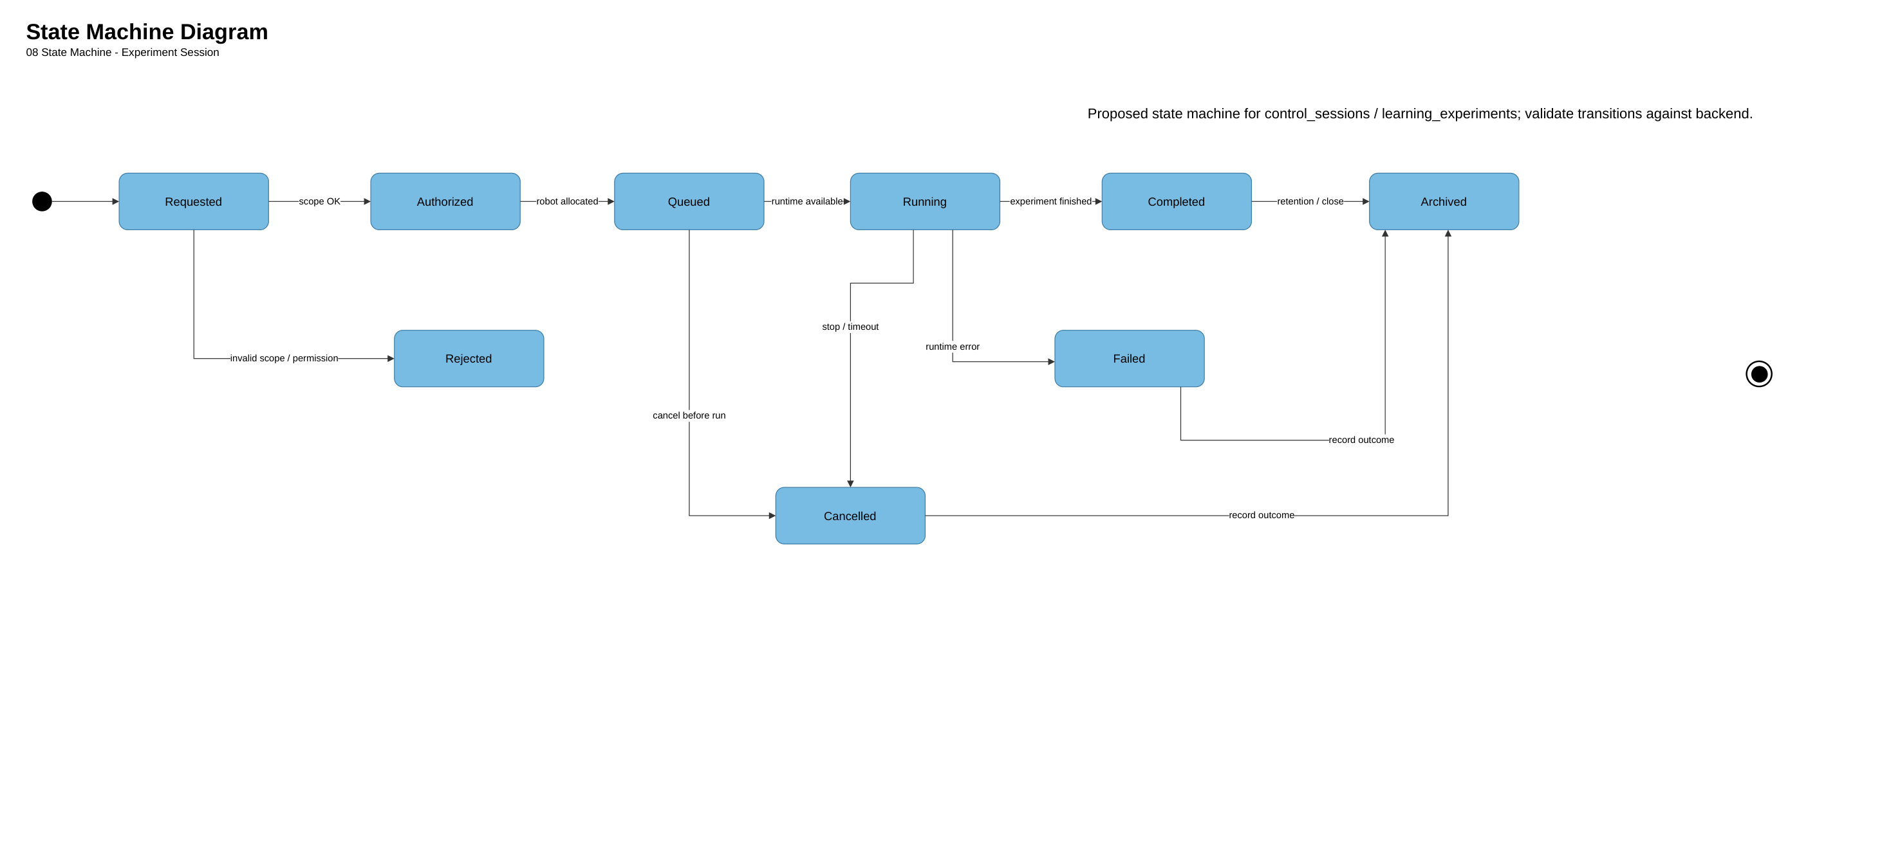
Figure 09. Source: diagramall.drawio.xml page 9; proposed unless explicitly code-verified. Rendered repository counterpart: docs/review-2/04-diagrams/*/mermaid-reference/.
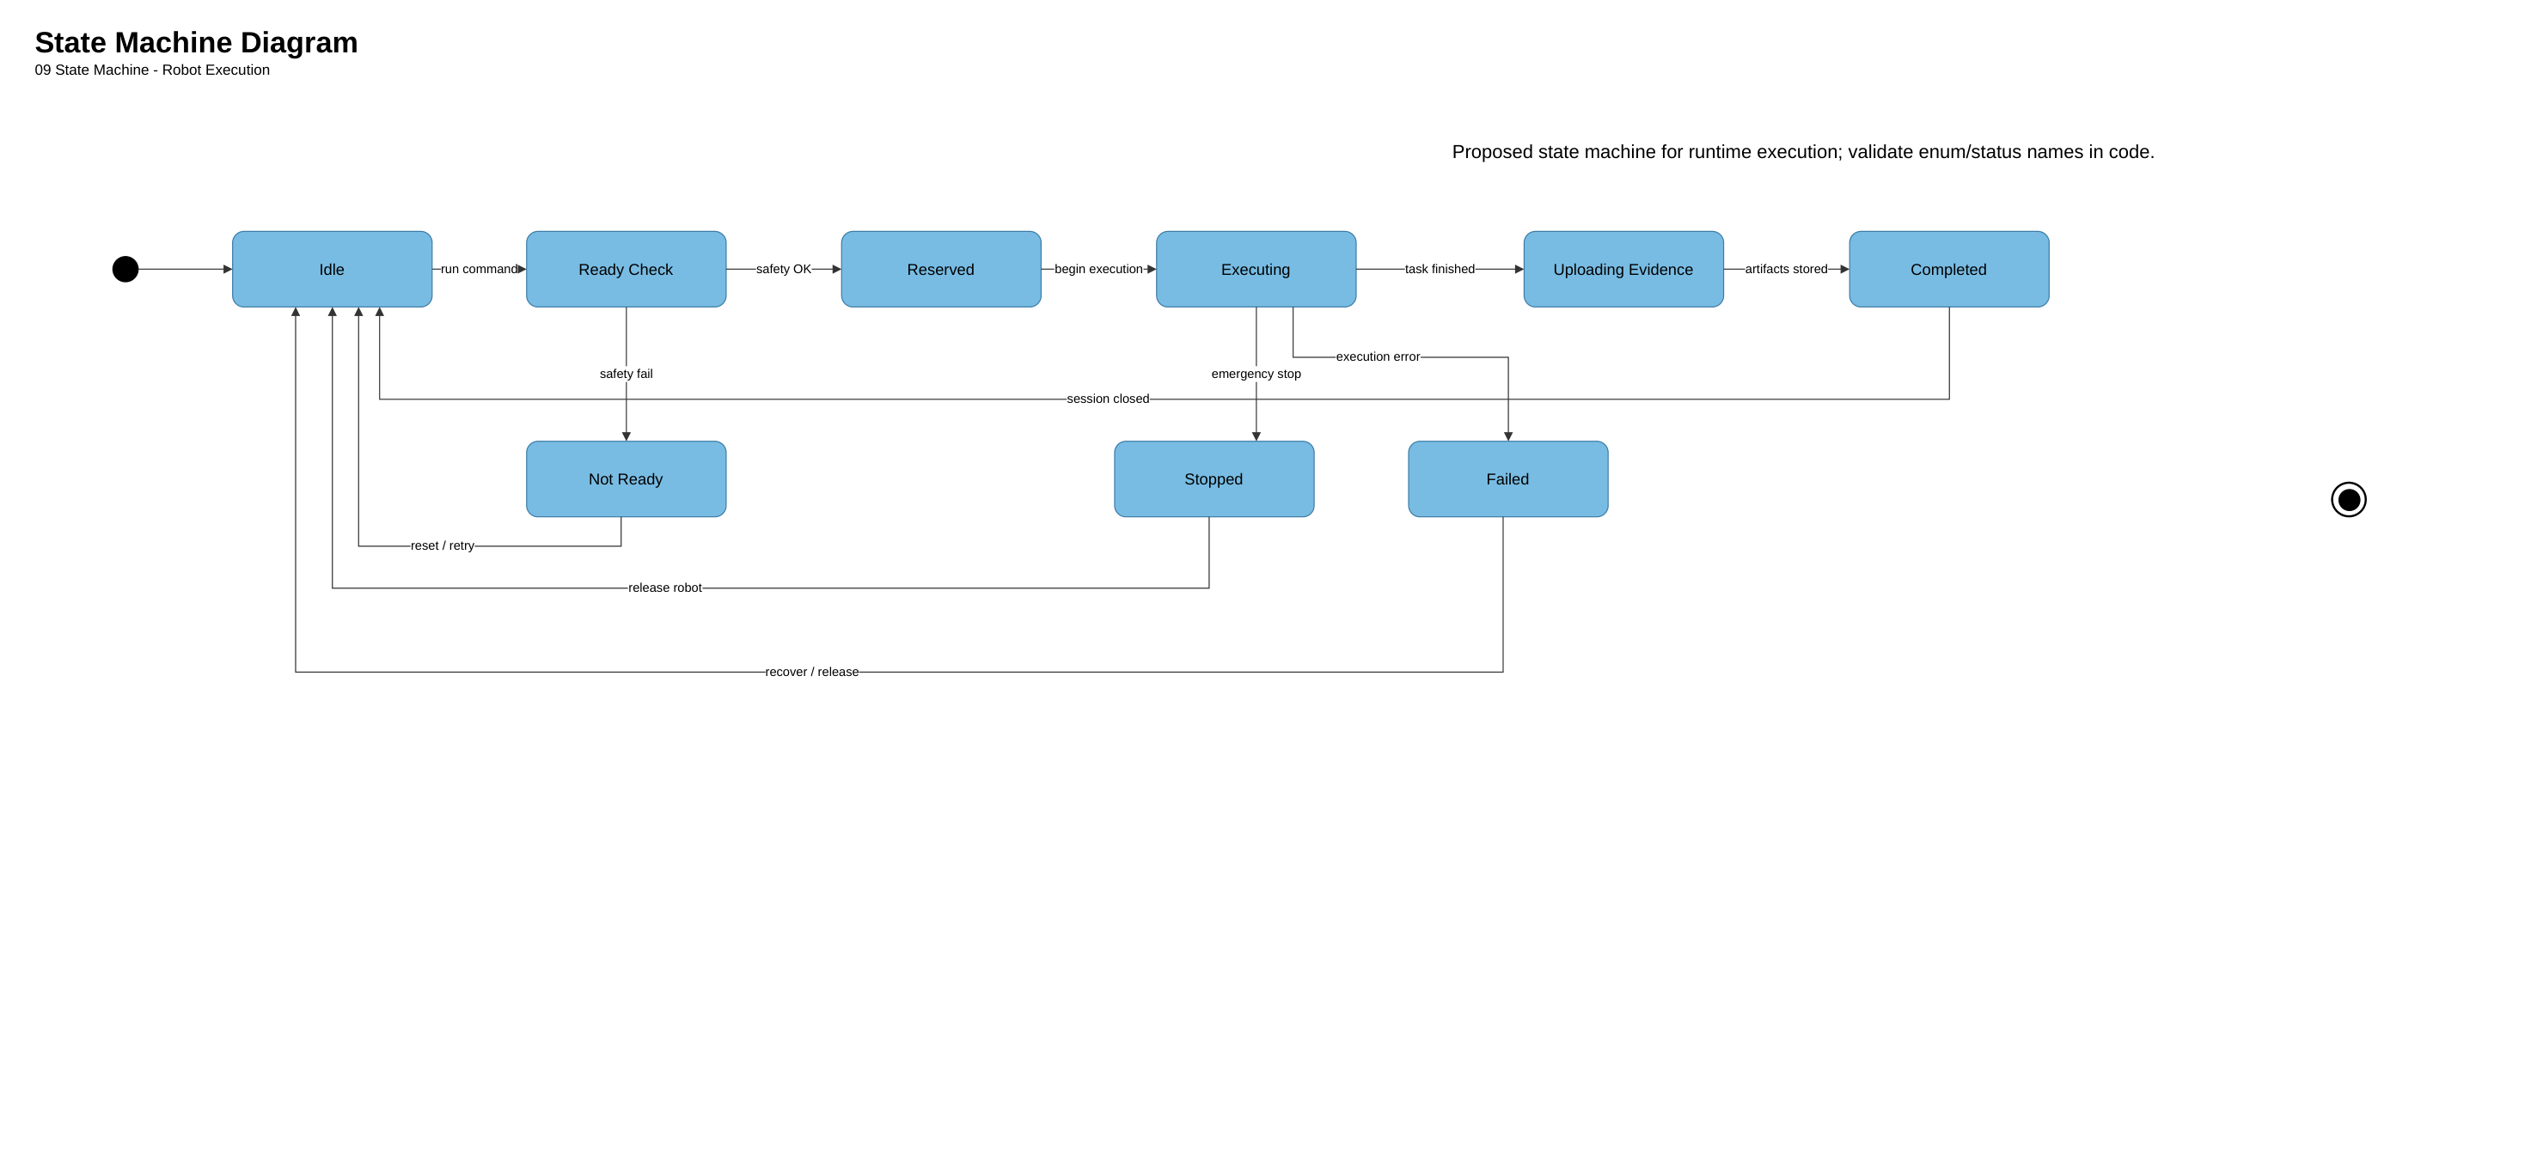
Figure 10. Source: diagramall.drawio.xml page 10; proposed unless explicitly code-verified. Rendered repository counterpart: docs/review-2/04-diagrams/*/mermaid-reference/.
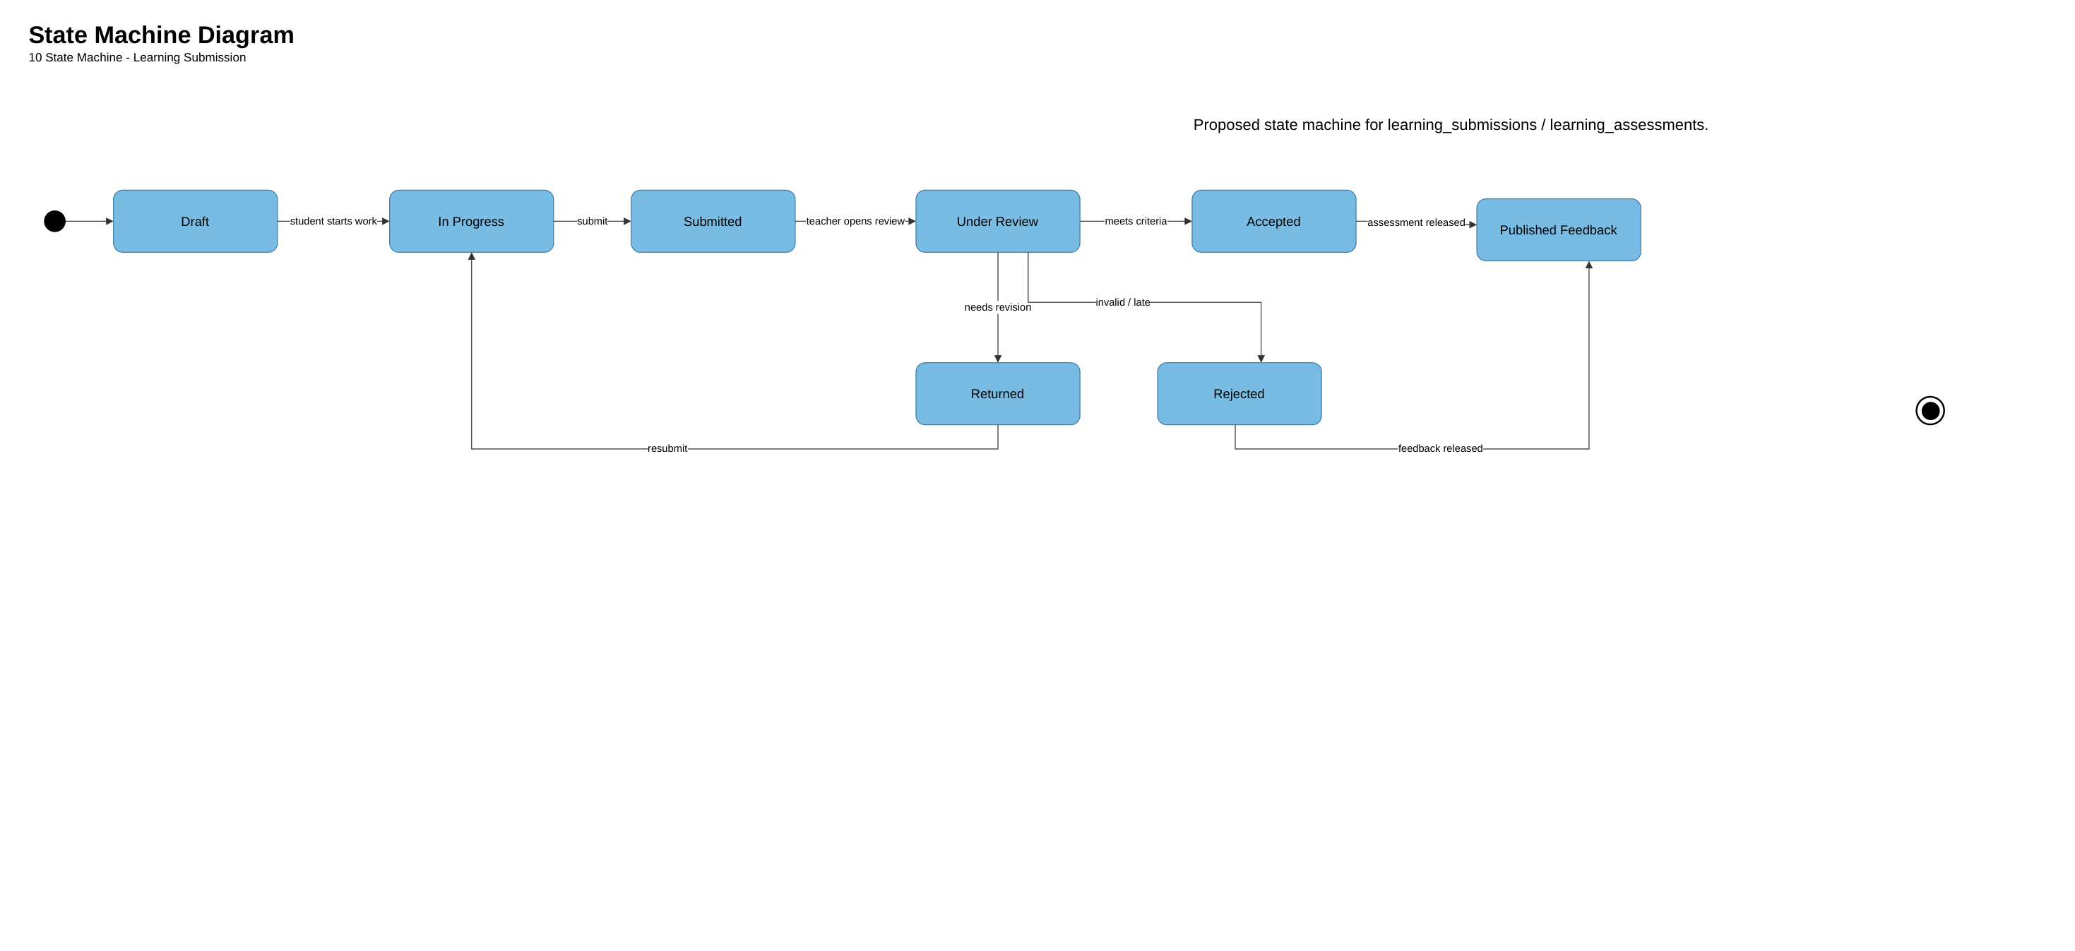
Figure 11. Source: diagramall.drawio.xml page 11; proposed unless explicitly code-verified. Rendered repository counterpart: docs/review-2/04-diagrams/*/mermaid-reference/.
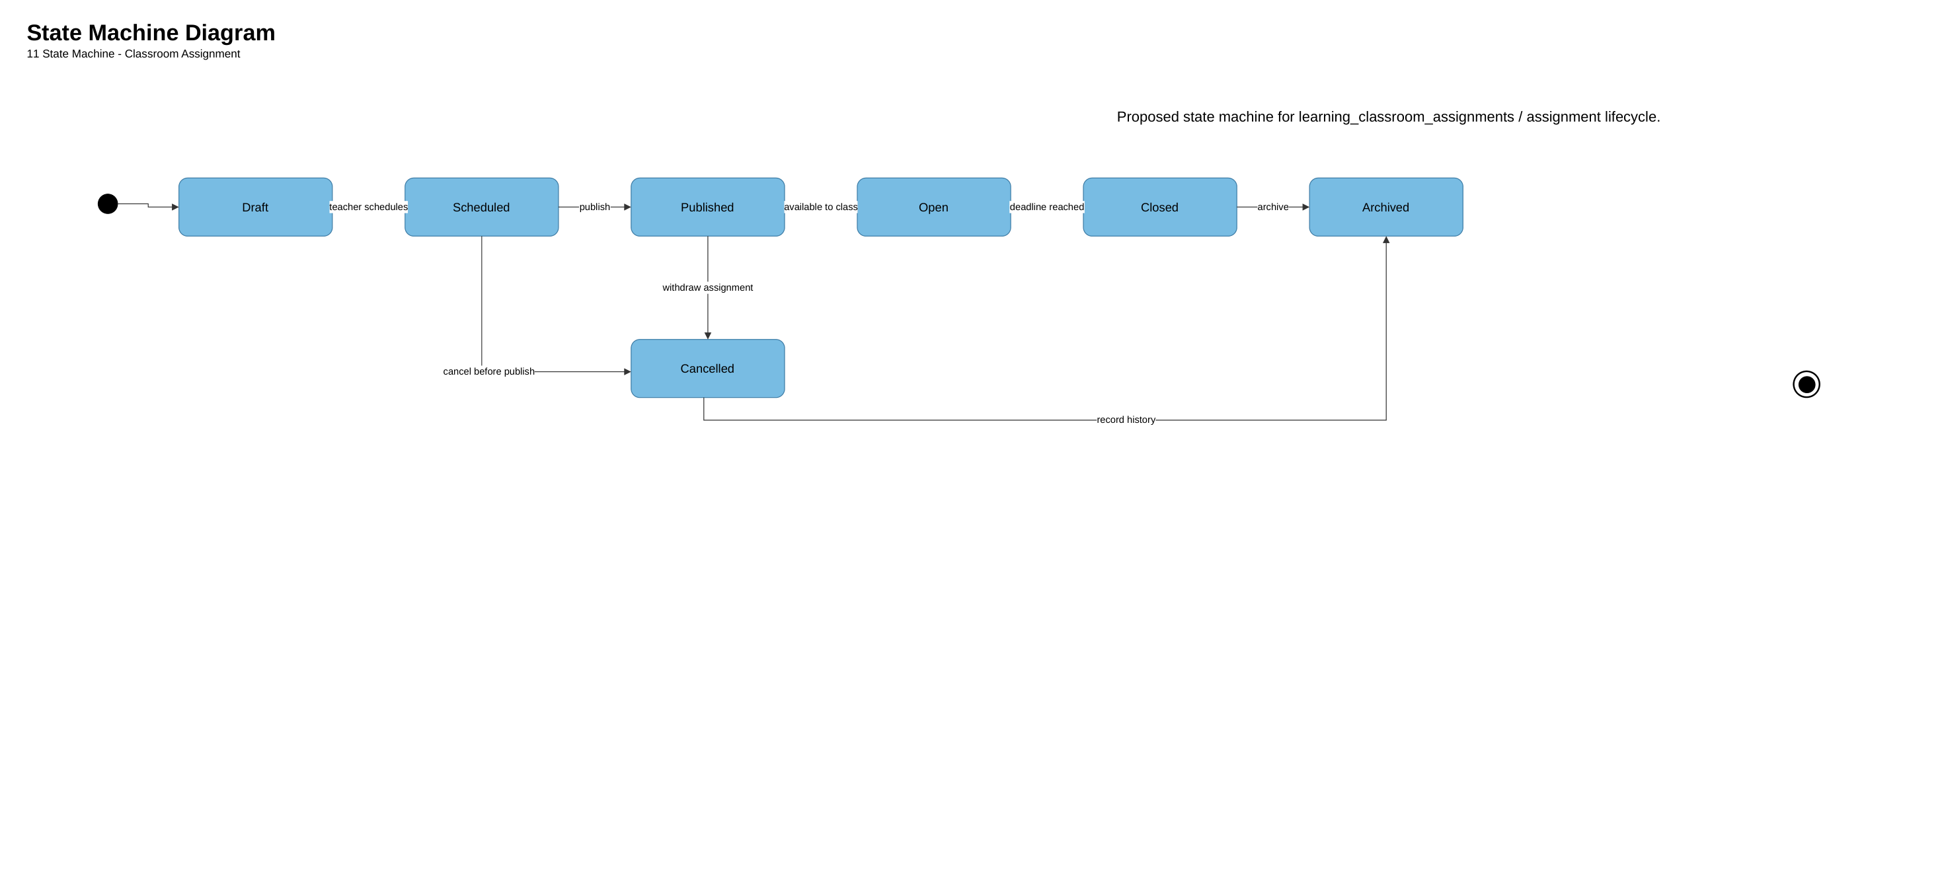
Four workflows: WF-01 scoped allocation, WF-02 assignment/submission, WF-03 schematic experiment with proposed physical integration, WF-04 assessment/AI evidence. Workflow figures are embedded in this report.

3.1 WF-01 School Administration and Robot Allocation
Validate Supabase JWT -> active membership -> classroom org scope -> robot entitlement -> atomic class allocation; no direct actuation or runtime reservation.
Controller: EducationAdminController; service: EducationAdminService. Guard maps Supabase JWT to VISTA user; scope checks active organization membership and entitlement; persistence updates one allocation per classroom atomically.

3.1.1 Class Diagram
Relevant data model in Master ERD and Robot Resource ERD (figures below). Direct UML class implementation diagram must be generated/verified separately if required by school.
Class diagram: use existing services, DTOs, Prisma repositories; avoid modeling a new RobotAllocationService or a physical robot executor without implementation.
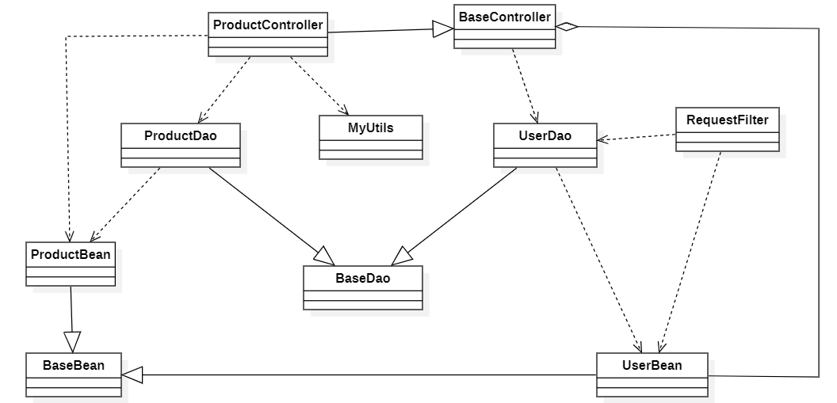
3.1.2 WF-01 Interaction Sequence
Sequence: School Admin → Web → EducationAdminController → scope checks → Prisma/DB → view allocation. Failure: deny inaccessible classroom/robot with no information leak.
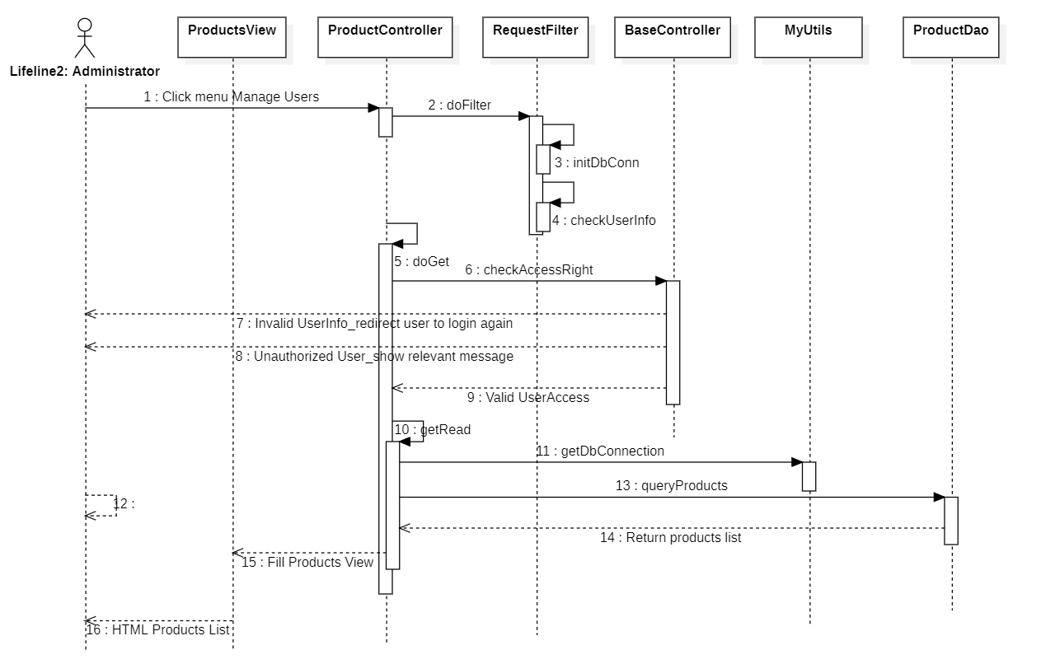

3.1.3 WF-02–WF-04 Sequence Sources
The 23-page visual source contains C4, activity, state and ERD views; it does not contain separate UML sequence pages. The interaction descriptions below are therefore code-aligned textual sequences and remain DRAFT until dedicated sequence diagrams are approved.

Teacher creates classroom assignment → student starts attempt → program/version → submission. Student schematic experiment creates pending record; run-schematic/evaluate-symbolic are separate endpoints. Teacher assessment/feedback and student reflection are persisted separately.

3.2 State Machines / ERD / Deployment
State machines on pages 8–11 of diagramall.drawio.xml are PROPOSED. Transition labels must be mapped to persisted code/database values before they become implementation claims. Development uses project scripts and Docker Compose where present. AWS is planned; deployment and rollback require actual staging evidence.
State machines must use code/database statuses, not visual filler. Master Logical ERD uses business FKs and junction entities. AWS architecture is a proposed staging design; not evidence of deployment.

Appendix — Reconciled ERD Set
Editable source: diagramall.drawio.xml (23 pages). This appendix contains all 12 ERD views: one conceptual, five logical (including separate 16a and 16b), and six physical. The PNGs are rendered from the matching repository Mermaid sources for review readability. The Draw.io XML remains the supplied editable visual source; keys, nullability, uniqueness and enum/state values must still be verified against Prisma schema and applied PostgreSQL migrations before final sign-off.

Figure 12 — Conceptual ERD
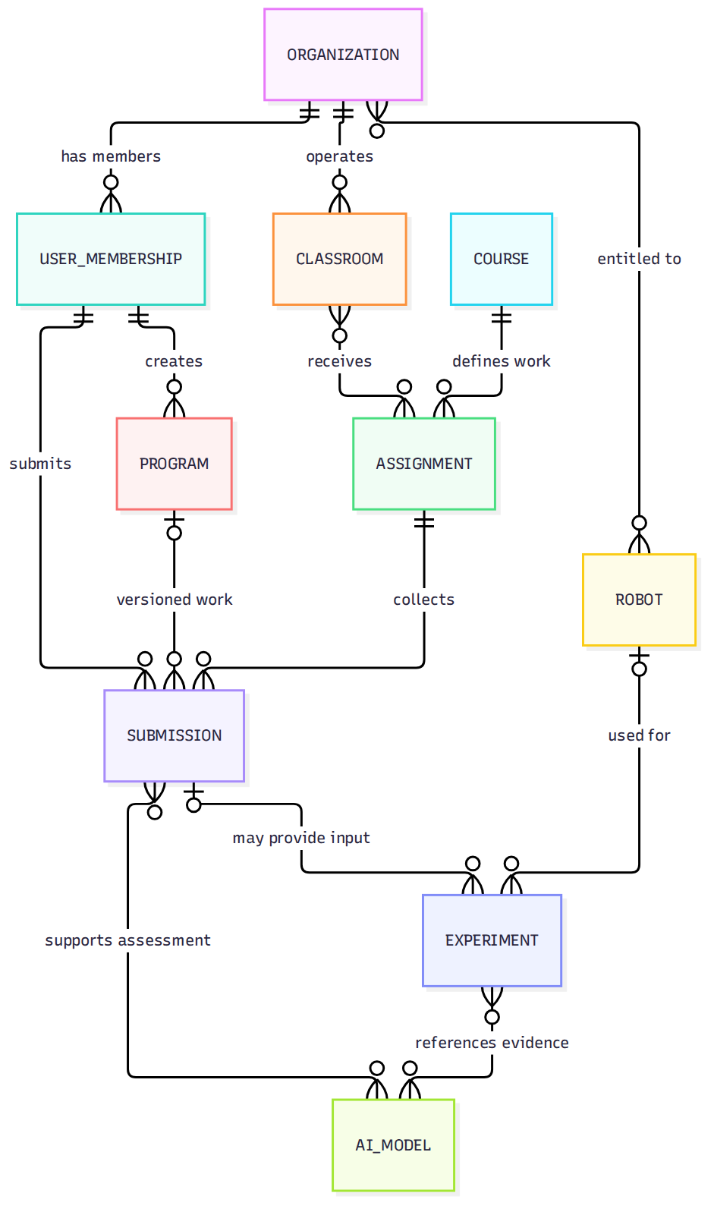
Repository-rendered reference; editable source page and exact mapping are recorded in docs/review-2/04-diagrams/manifest.md. Status: DRAFT pending schema/state verification.

Figure 13 — Logical ERD: School & Access
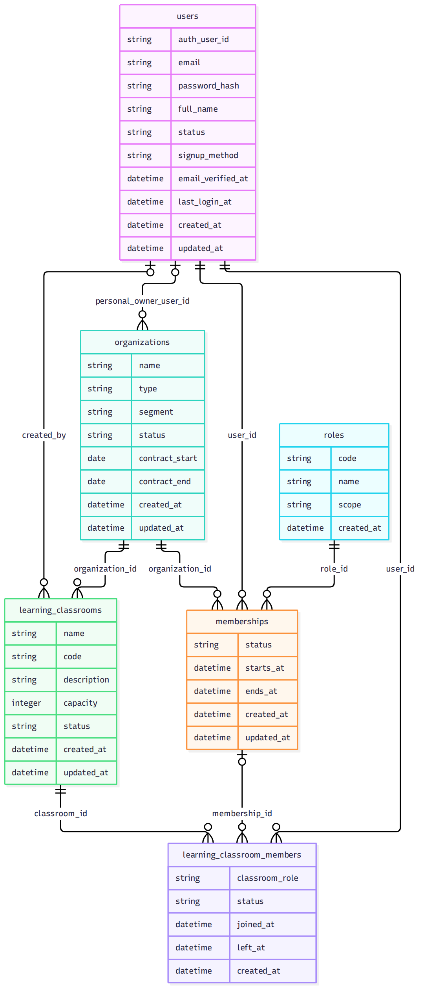
Repository-rendered reference; editable source page and exact mapping are recorded in docs/review-2/04-diagrams/manifest.md. Status: DRAFT pending schema/state verification.

Figure 14 — Logical ERD: Curriculum & Assessment
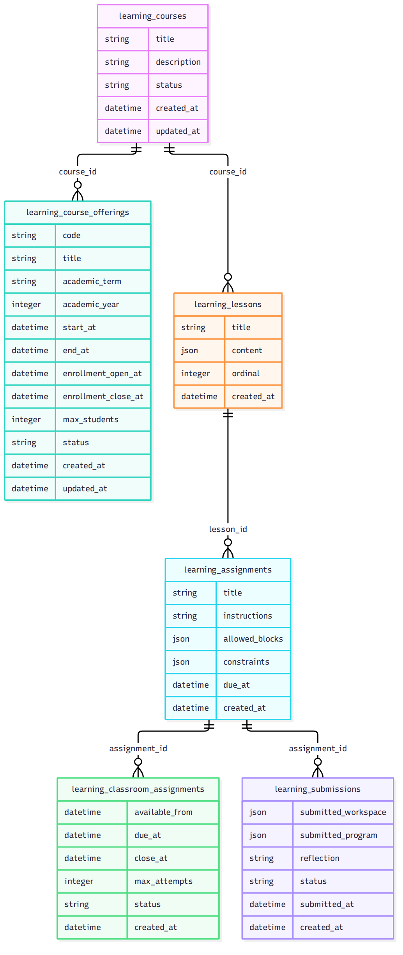
Repository-rendered reference; editable source page and exact mapping are recorded in docs/review-2/04-diagrams/manifest.md. Status: DRAFT pending schema/state verification.

Figure 15 — Logical ERD: Robots & Experiments
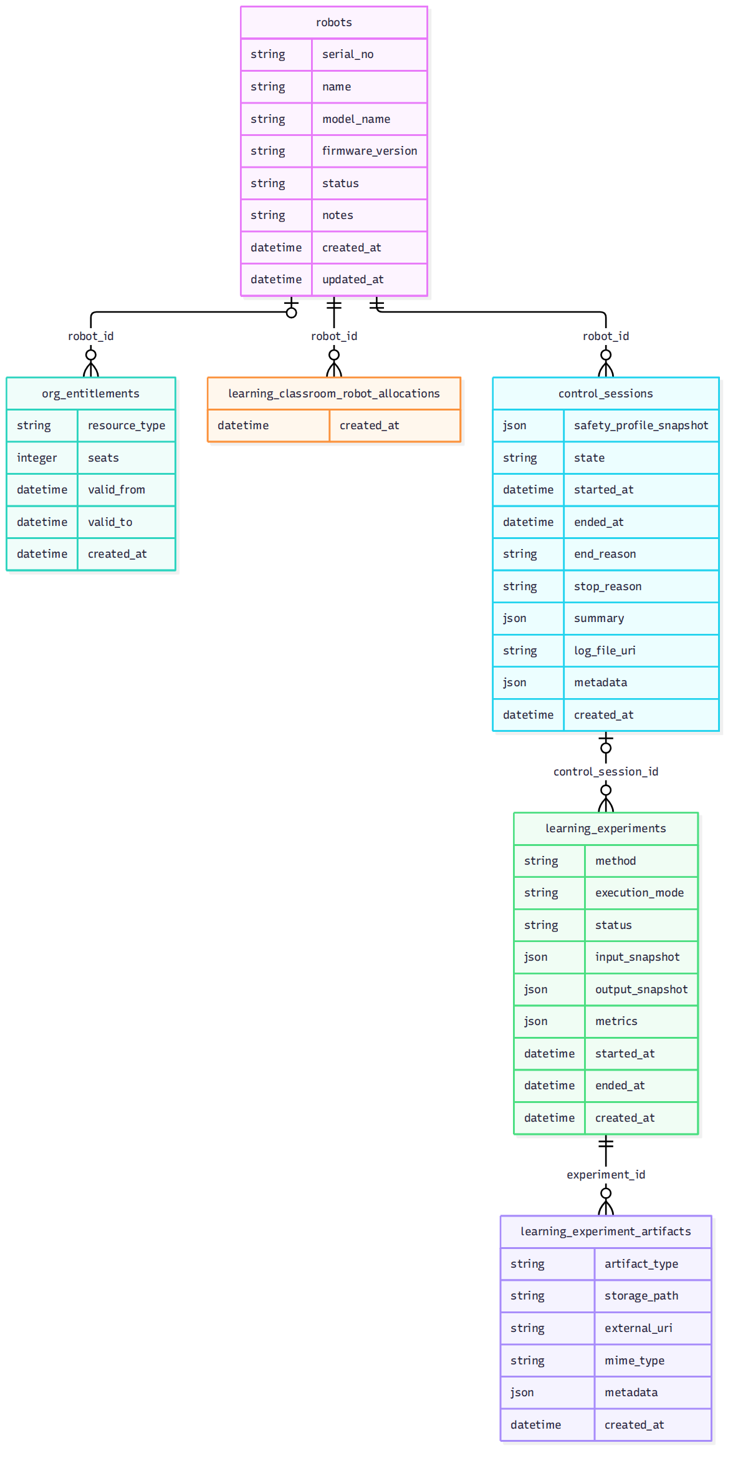
Repository-rendered reference; editable source page and exact mapping are recorded in docs/review-2/04-diagrams/manifest.md. Status: DRAFT pending schema/state verification.

Figure 16a — Logical ERD: Programs & Assessment
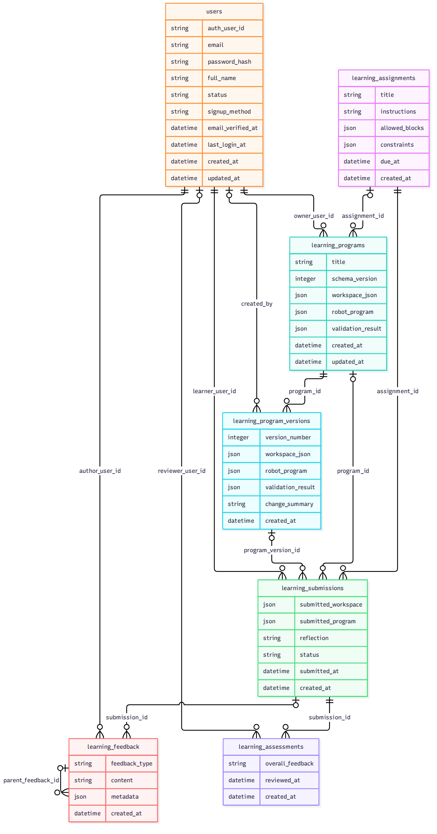
Repository-rendered reference; editable source page and exact mapping are recorded in docs/review-2/04-diagrams/manifest.md. Status: DRAFT pending schema/state verification.

Figure 16b — Logical ERD: AI & Datasets
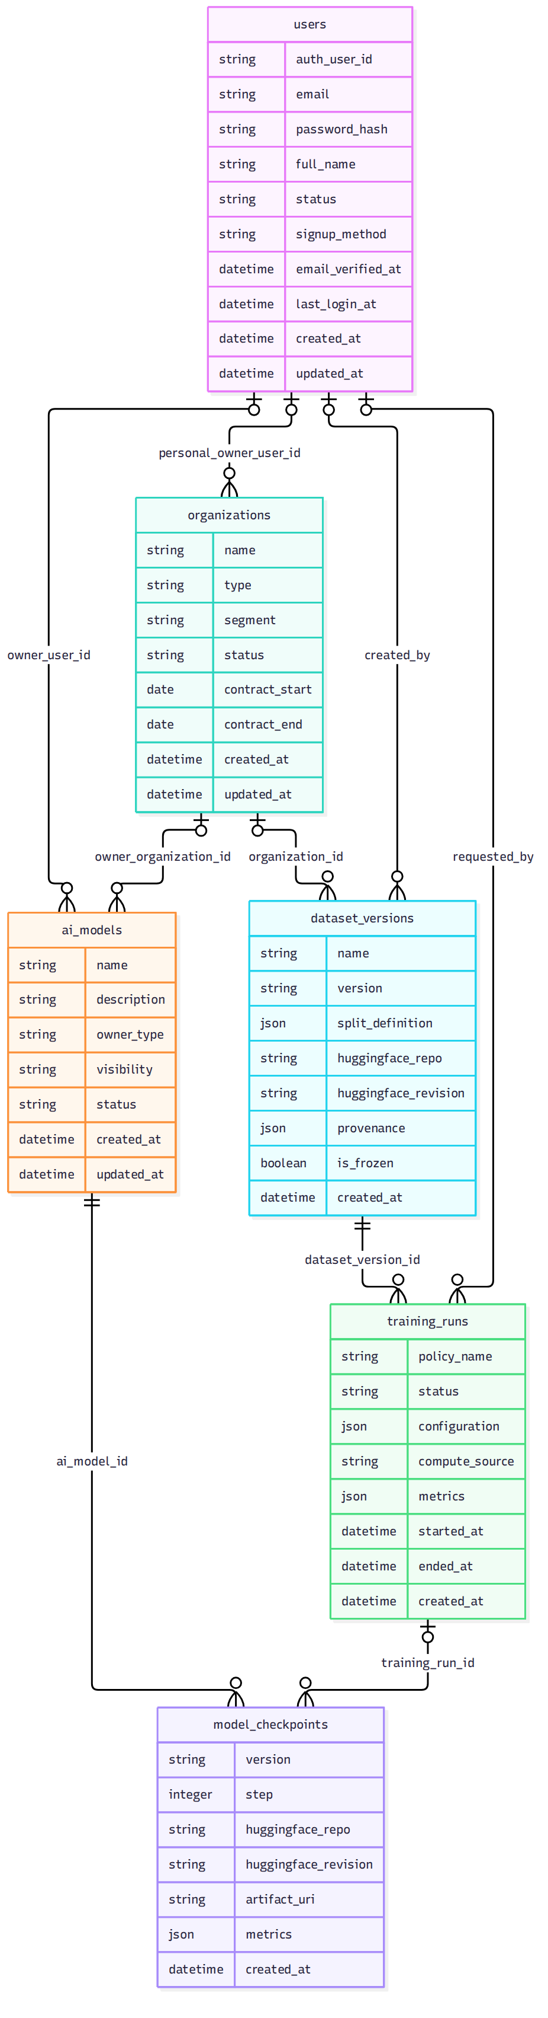
Repository-rendered reference; editable source page and exact mapping are recorded in docs/review-2/04-diagrams/manifest.md. Status: DRAFT pending schema/state verification.

Figure 17 — Physical ERD: Identity & School
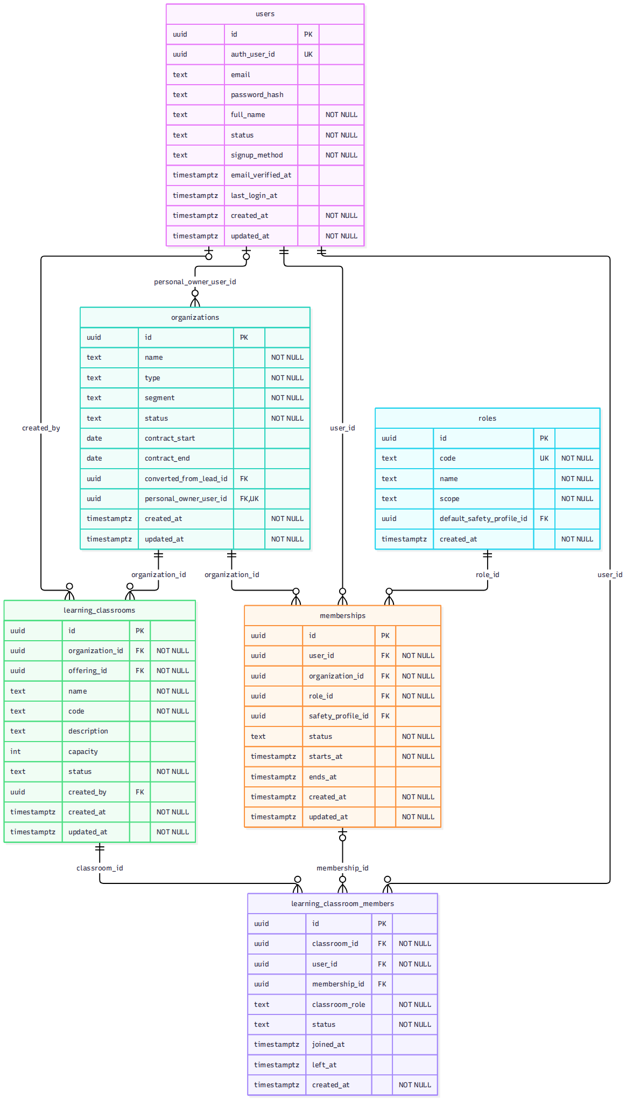
Repository-rendered reference; editable source page and exact mapping are recorded in docs/review-2/04-diagrams/manifest.md. Status: DRAFT pending schema/state verification.

Figure 18 — Physical ERD: Curriculum
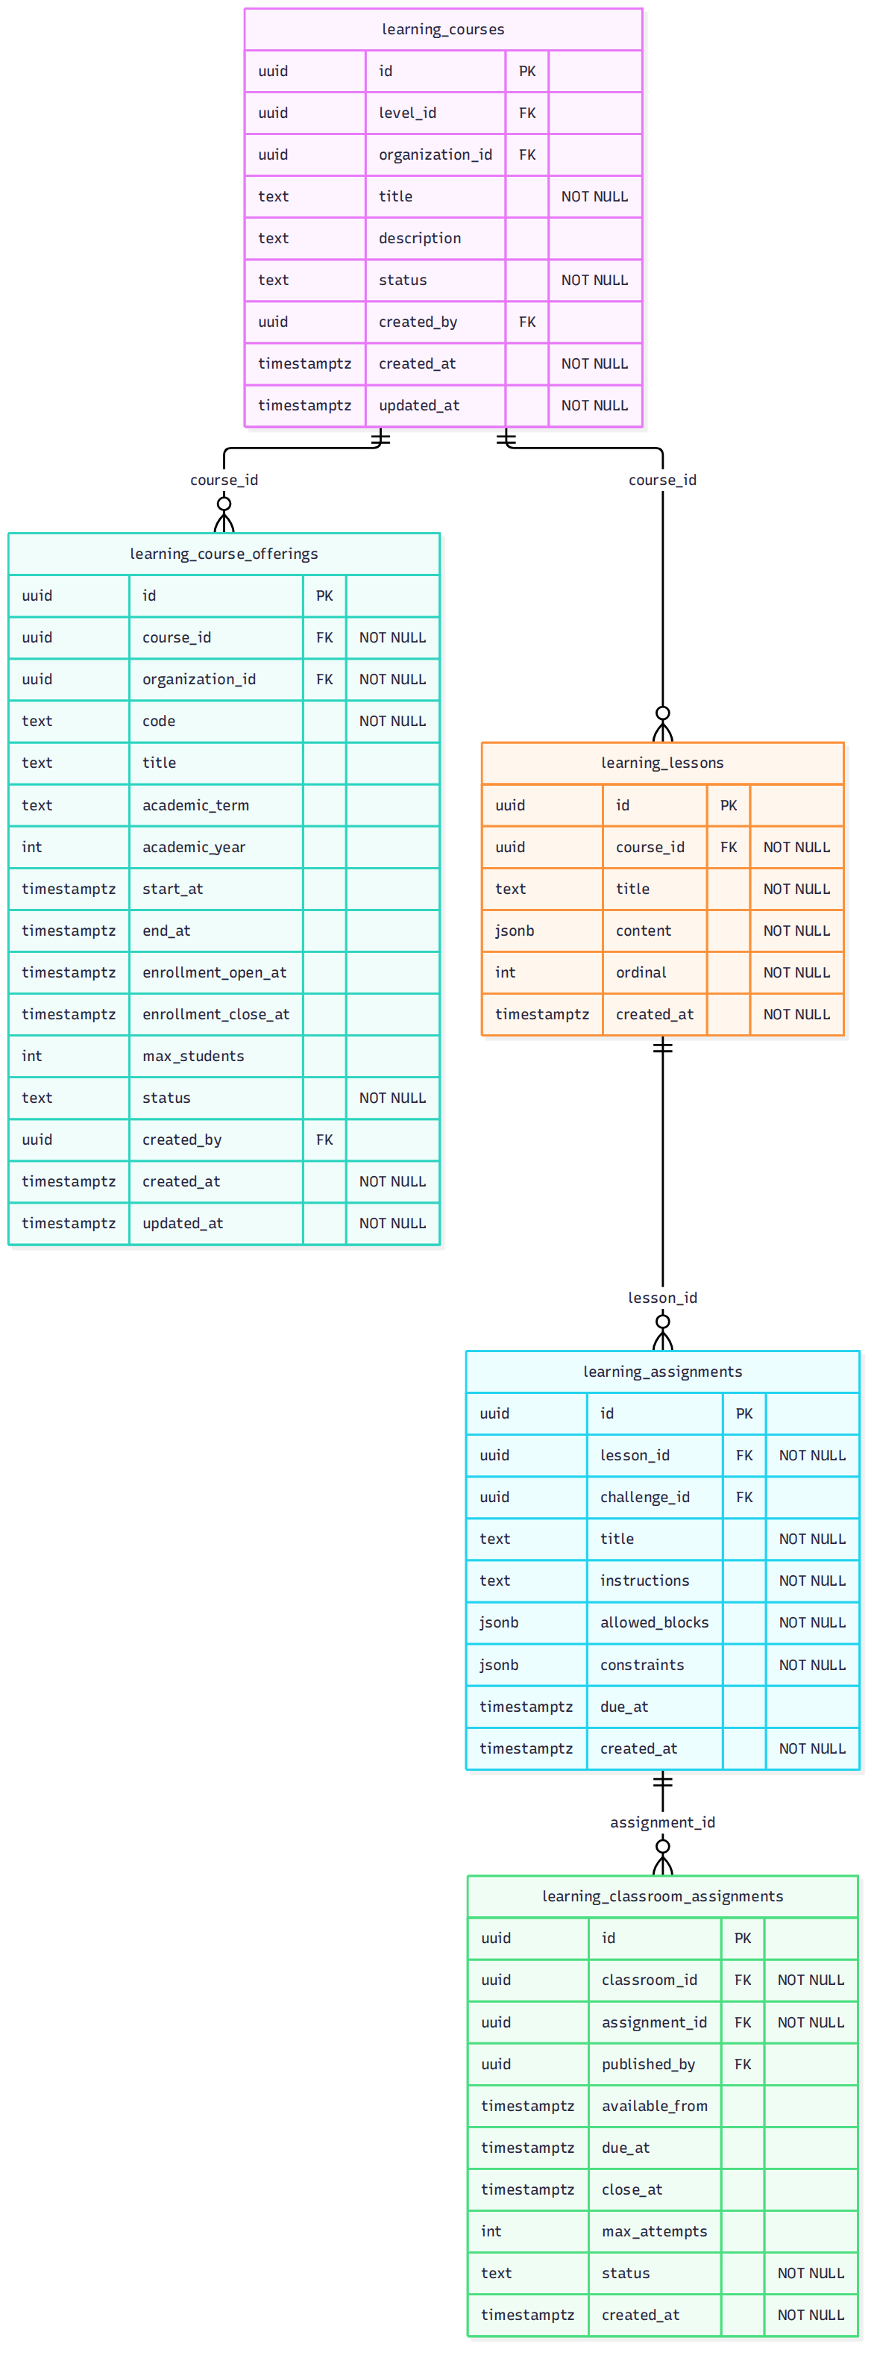
Repository-rendered reference; editable source page and exact mapping are recorded in docs/review-2/04-diagrams/manifest.md. Status: DRAFT pending schema/state verification.

Figure 19 — Physical ERD: Programs & Assessment
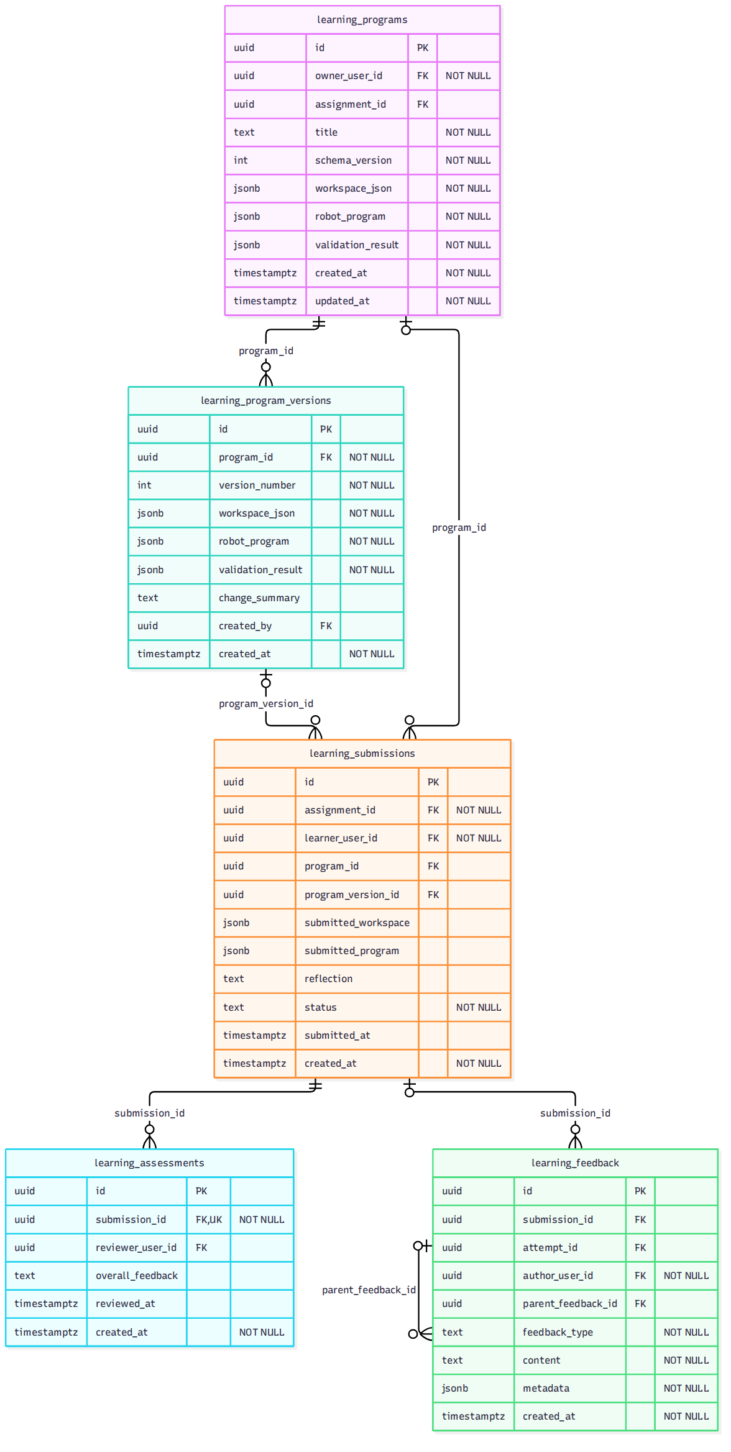
Repository-rendered reference; editable source page and exact mapping are recorded in docs/review-2/04-diagrams/manifest.md. Status: DRAFT pending schema/state verification.

Figure 20 — Physical ERD: Robot Resources
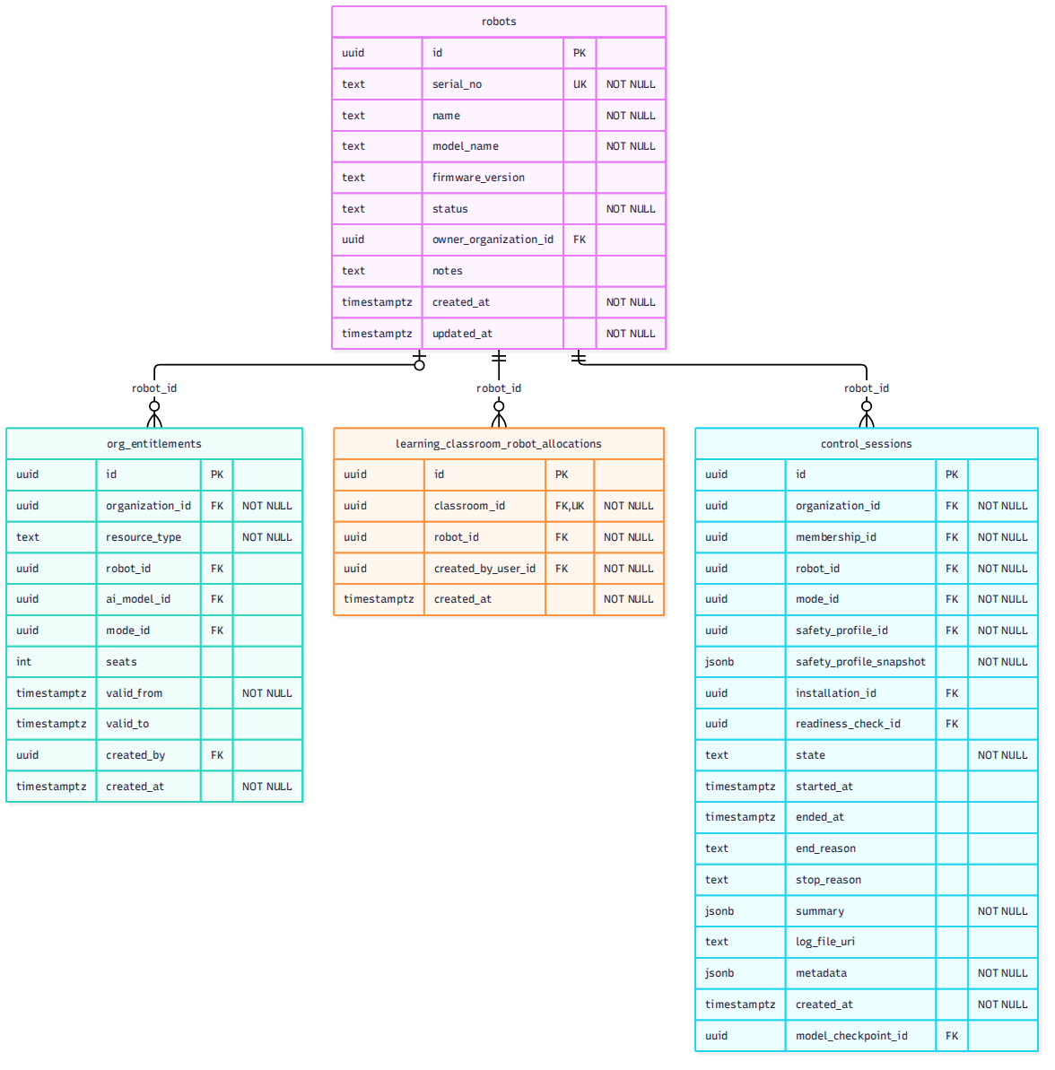
Repository-rendered reference; editable source page and exact mapping are recorded in docs/review-2/04-diagrams/manifest.md. Status: DRAFT pending schema/state verification.

Figure 21 — Physical ERD: Experiment
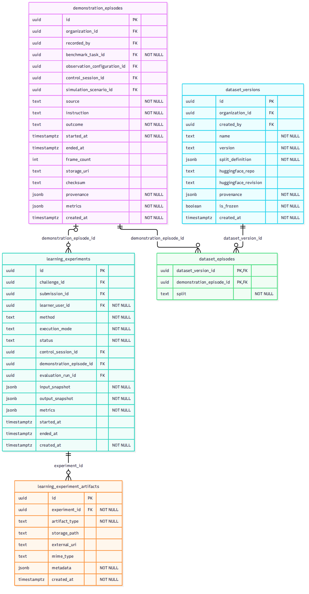
Repository-rendered reference; editable source page and exact mapping are recorded in docs/review-2/04-diagrams/manifest.md. Status: DRAFT pending schema/state verification.

Figure 22 — Physical ERD: AI & Model Lifecycle
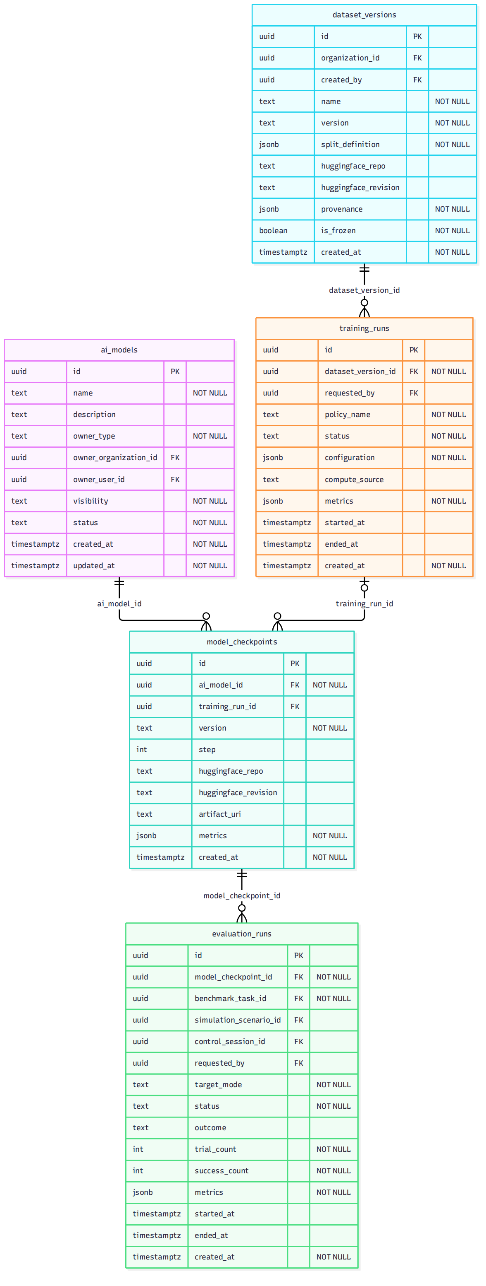
Repository-rendered reference; editable source page and exact mapping are recorded in docs/review-2/04-diagrams/manifest.md. Status: DRAFT pending schema/state verification.

