

Capstone Project Report
Report 3 – Software Requirement Specification

– FPT University, October 2026 –
Table of Contents
I. Project Report 3
1. Status Report 3
2. Team Involvements 3
3. Issues/Suggestions 3
II. Software Requirement Specification 4
1. Overall Description 4
1.1 Product Overview 4
1.2 Business Rules 5
2. User Requirements 6
2.1 System Actors 6
2.2 Use Cases 6
3. Functional Requirements 8
3.1 System Functional Overview 8
3.2 <<Feature Name 1>> 10
3.3 <<Feature Name 2>> 10
4. Non-Functional Requirements 11
4.1 External Interfaces 11
4.2 Quality Attributes 12
5. Other Requirements 14
5.1 Appendix1 - Messages List 14
5.2 Appendix2 - … 14
5.3 … 14

I. Record of Changes
Date | A*  M, D | In charge | Change Description
26/10/2026 | M | Lê Nguyễn Quang Đức | Populate VISTA Review 2 content on original university template; code verification pending
*A - Added M - Modified D - Deleted

II. Software Requirement Specification

1. Product Overview
VISTA is a multi-role education platform for schools, teachers and learners, linking authorized classroom robot allocation to learning assignment, versioned student work, schematic experiment requests and teacher feedback. Local Robot Runtime and AI integration remain separate trust boundaries; physical E2E must be verified before marking implemented.
VISTA is a role-governed robotics education platform. Roles: System Admin, School Admin, Instructor/Teacher and Student. External integrations are Supabase Auth/PostgreSQL, optional AI/model service and local safety-managed Robot Runtime. System Context is in the supplied C4 diagrams; only code-verified responsibilities are mandatory.
Learning loop: Learn → Predict → Build → Experiment → Reflect → Assess. Classroom resource allocation grants access; it does not create a live robot control session.
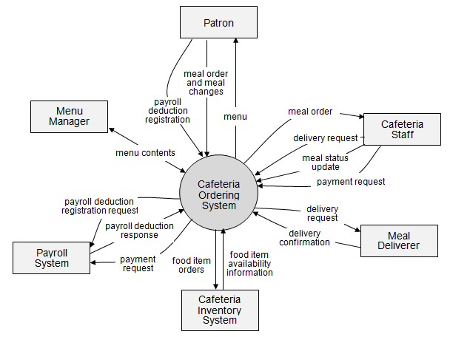

2. User Requirements
School Admin manages classroom and entitled robot allocation; Teacher publishes assignments and reviews student work; Student accesses own class, versions work and requests permitted experiments; system/external actors include AI/Model Service and Local Robot Runtime.

2.1 Actors
Authorization derives JWT subject → public users → active organization and classroom membership. Scope permission is required alongside active membership; out-of-scope resources may return 404.
- Students: their classes, authorized assignments, programs, experiments, feedback and reflections.
- Teachers: class delivery, assignments, review and assessments within teacher/TA classroom relationship.
- School administrators: school members, classrooms, entitled robots and classroom allocations.
System administrators: globally scoped role/organization administration only with authoritative permission.
# | Actor | Description
1 | System Administrator | Platform-scoped administration; verify code roles
2 | School Administrator | Own school classrooms and robot allocation
3 | Teacher | Publish classroom learning and review authorized work

2.2 Use Cases
UC-01 school admin allocates an entitled robot; UC-02 teacher publishes class assignment and student submits immutable program; UC-03 student runs schematic preview and symbolic evaluation; UC-04 teacher assesses student work and student reflects.

2.2.1 Diagram(s)
Relevant source diagrams supplied in VISTA_DIAGRAM.pdf: pages 1–7 for architecture and 4 workflow activities. This PDF is referenced here; rendered design figures are embedded in Report 4.
Use Case Diagram is an SRS illustration; linked C4 and activity diagrams should be updated from true route and schema. No completed physical robot execution claim.
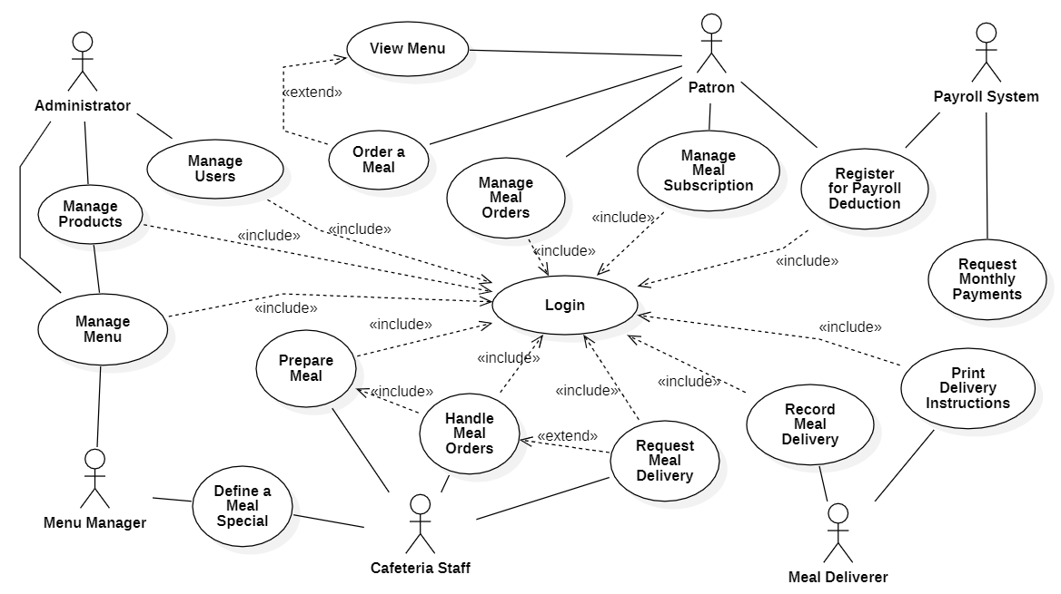

2.2.2 Descriptions
UC main/exception scenarios and owners are in BM01 Appendix A. Acceptance requires persisted entity state and scoped authorization checks.
ID | Use Case | Actors | Use Case Description
UC-01 | Authentication and role-scoped access | School Admin/Teacher/Student | Requests require valid user, membership, scoped authorization; cross-org access is denied
UC-02 | Classroom robot allocation | School Admin | Only entitled robot can be allocated to same-org classroom; replacement leaves one allocation
UC-03 | Course and lesson delivery | Teacher | Authorized teacher can assign published learning resources to assigned classroom

3. Functional Requirements

3.1 System Functional Overview
The functional baseline uses FR-01 to FR-06 and four workflows. Scope must remain consistent with Registration v1.2 and actual API authorization. Expected errors include unauthorized org/classroom scope, invalid entitlement, invalid submission ownership, and non-schematic experiment mode.
Functional requirements must be independently testable and mapped to implemented controllers/services. Examples below separate implemented API capabilities from planned physical execution.

3.1.1 Screens Flow
School Admin: organization/classroom -> eligible robot -> allocation; Teacher: lesson -> assignment -> publish -> review; Student: assigned content -> versioned program -> submit -> schematic experiment -> view feedback. UI routes require code-level confirmation.
Student → course/lesson → own assignment → own attempt → program version → experiment → submission and feedback. Teacher and school administration routes are independently permission-scoped.
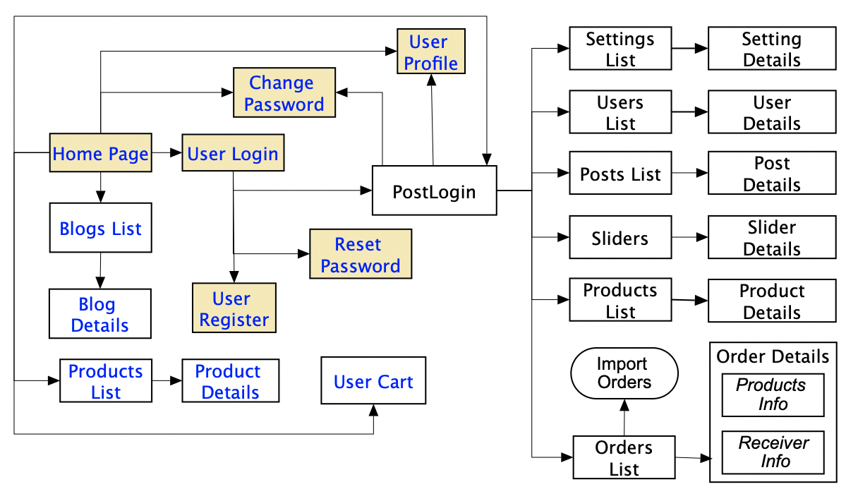

3.1.2 Screen Descriptions
Access, School/Classroom Management, Learning Content and Assignment, Student Program/Submission, Experiment Request/Result, Teacher Assessment/Feedback. Detailed routes and controls are to be verified against web/robot-edu; conceptual flow is not evidence of a working page.
Screens: Login, School Admin Classrooms/Robot Allocation, Teacher Course/Assignment, Student Program/Experiment, Instructor Assessment, Student Feedback/Reflection.
# | Feature | Screen | Description
2 | Authentication and role-scoped access | WF-01 concept | Requests require valid user, membership, scoped authorization; cross-org access is denied
3 | Classroom robot allocation | WF-02 concept | Only entitled robot can be allocated to same-org classroom; replacement leaves one allocation
4 | Course and lesson delivery | WF-03 concept | Authorized teacher can assign published learning resources to assigned classroom

3.1.3 Screen Authorization
System Admin (platform scope), School Admin (organization), Teacher (assigned classroom/course), Student (own membership and work). Backend must check Supabase JWT, public.users mapping, active membership and per-resource scope.
Student cannot enter another school’s classroom or assignment; teacher/TA requires active class relationship plus learning.delivery.manage; admin cannot authorize physical motion merely by allocating robot.
Screen | System Admin | School Admin | Teacher | Student
Login | Y | Y | Y | Y
School Resource Allocation | N | Y | N | N
Manage Assignments | N | N | Y | Read
Program Submission | N | N | Review | Y
Experiment Schematic | N | N | Review | Y
Assessment | N | N | Y | Read
Add New Data |  |  | X | X
Update All Data |  |  |  | X
Update Own Data |  |  |  | X
Update Managed Data |  |  |  | X
Delete Data
…

3.1.4 Non-Screen Functions
NestJS API handles authorization, resource entitlement checks, durable program versions/submissions, schematic experiment request persistence and teacher assessment; Python runtime device execution is an independent integration boundary.
Non-screen functions: JWT guard, scope service, Postgres advisory transaction locking for experiment deduplication, immutable ProgramVersion and safety-limited runtime adapter.
# | Feature | System Function | Description
1 | Authentication and role-scoped access | FR-01 | Requests require valid user, membership, scoped authorization; cross-org access is denied
2 | Classroom robot allocation | FR-02 | Only entitled robot can be allocated to same-org classroom; replacement leaves one allocation

3.1.5 Entity Relationship Diagram
Logical ERD reference: pages 12–23 of VISTA_DIAGRAM.pdf; diagrams contain proposed cardinalities and require verification against Prisma/migrations including PK, FK, nullable and unique constraints.
Master Logical ERD is a curated view from Supabase columns/FKs; compare all FK constraint groups with nullability/unique constraints; no arbitrary extra relationships.
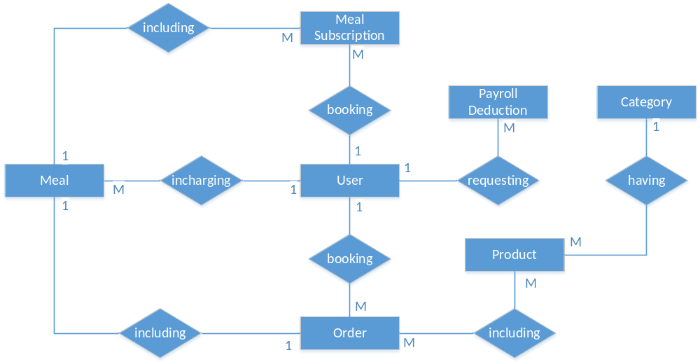
Entities Description
# | Entity | Description
1 | learning_classroom_robot_allocations | Scoped robot authorization
2 | learning_classroom_assignments | Published classroom task
3 | learning_submissions | Student work version link
4 | learning_experiments | Experiment request and status

3.2 WF-01 School Administration and Classroom Robot Allocation
FR-02: School Admin selects own classroom and a currently entitled robot. API verifies active role/organization/classroom membership and entitlement; it upserts allocation atomically. Postcondition is an authorization record, not a live robot control session. Reject cross-school/expired-entitlement requests.

3.2.1 School Admin Allocates Robot
Precondition: authorized school admin, existing classroom in organization, eligible robot. Main: list classroom and eligible robots; select and submit; guard validates scope; service records one classroom allocation; display current allocation. Exception: 403/404 unauthorized scope; conflict/validation failure returns without unauthorized change.
Trigger: School Admin selects an own classroom and an entitled robot.
- Validation: authenticated organization permission, active school membership, classroom ownership, entitlement and allocation conflict rules.
- Result: one classroom robot allocation; atomic replace. Allocation is not an execution lease.
- API: GET /api/v1/education-admin/classrooms/:classroomId/eligible-robots; PUT /api/v1/education-admin/classrooms/:classroomId/robot-allocation.
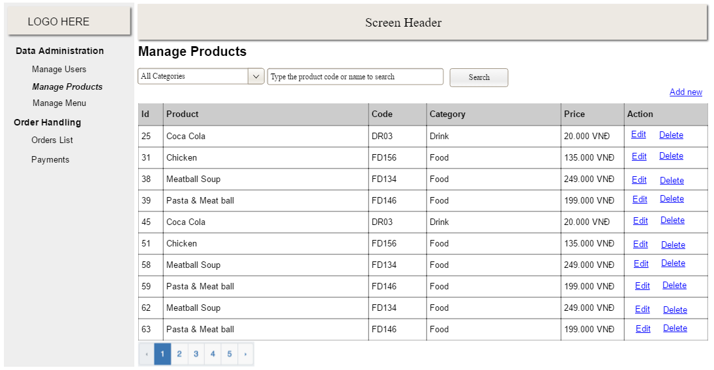
- Failure: inaccessible class, no entitlement and conflict are rejected without cross-school data leakage.

3.2.2 WF-02 Learning & Assignment; WF-03 Experiment; WF-04 Assessment
WF-02 FR-03/04: Teacher prepares/publishes classroom assignment, learner versions program and submits own work. WF-03 FR-05: create schematic experiment request; reject any unsupported executionMode; pending is NOT physical run completion. WF-04 FR-06: authorized teacher reviews submission and records assessment/feedback; integration of AI metadata is separately scoped.
WF-02: teacher delivers/publishes assignment, student creates attempt and versioned RobotProgram, then submits authorized immutable version.

WF-03: ExperimentService currently accepts schematic mode only; creation starts pending and separate schematic/symbolic evaluation actions exist. Do not present physical execution as implemented.

4. Non-Functional Requirements
NFR acceptance targets must be measurable. Cross-school authorization isolation: zero unauthorized successful responses in a seeded negative-case suite. Defense 1.1 targets (not current results): mandatory main scenarios 100%; exception scenarios at least 80%, total cases pass at least 90%, >=50% of test cases automated CI.

4.1 External Interfaces
Web app HTTPS JSON -> Education API, Supabase Auth JWT, Prisma/PostgreSQL and evidence storage. AI service and Python Robot Runtime integration are design interfaces; confirm routes and deployment before asserting live E2E.
External interfaces: Supabase Auth JWT, NestJS /api/v1 REST/JSON, Prisma/PostgreSQL, external AI/model adapter (verify configuration), private Python Robot Runtime.

4.2 Quality Attributes
NFRs are proposed and require owner-confirmed test threshold, measurement environment and reporting; do not invent performance measurements.

4.2.1 Usability
Usability: a teacher and student must complete approved main workflow using clear actionable error messages; measure by timed usability session in staging.

4.2.2 Reliability
Reliability: authorization and state checks fail closed on unavailable dependencies; verify with fault injection and negative tests.
Availability—specify the percentage of time available ( xx.xx%), hours of use, maintenance access, degraded mode operations, and so on.
Mean Time Between Failures (MTBF) — this is usually specified in hours, but it could also be specified in terms of days, months or years.
Mean Time To Repair (MTTR)—how long is the system allowed to be out of operation after it has failed?
Accuracy—specifies precision (resolution) and accuracy (by some known standard) that is required in the system’s output.
Maximum Bugs or Defect Rate—usually expressed in terms of bugs per thousand lines of code (bugs/KLOC) or bugs per function-point( bugs/function-point).
Bugs or Defect Rate—categorized in terms of minor, significant, and critical bugs: the requirement(s) must define what is meant by a “critical” bug; for example, complete loss of data or a complete inability to use certain parts of the system’s functionality.]

4.2.3 Performance
Performance: latency target and simultaneous user load to be signed off in BM01, measured with staged repeatable load test and recorded percentiles.
Response time for a transaction (average, maximum)
Throughput, for example, transactions per second
Capacity, for example, the number of customers or transactions the system can accommodate
Resource utilization, such as memory, disk, communications, and so forth.]

4.2.4 …
Additional: privacy/scope isolation and robot safety checks take priority over throughput.

5. Requirement Appendix
Appendix maps each FR to WF, owner and test IDs in the project test workbook; unverified state labels require correction against code.

5.1 Business Rules
BR-01 student sees only authorized classroom content and own attempts. BR-02 allocation conveys classroom authorization not active physical robot control. BR-03 physical control needs separate exclusive, safe runtime session. BR-04 experiment creation in observed Education API only supports schematic and creates pending record. BR-05 assessment changes require appropriate reviewer membership.
BR-01 Student reads only currently authorized classroom content and own attempts.
ID | Rule Definition
BR-01 | Cross-organization reads/writes forbidden
BR-02 | Classroom allocation is not runtime control
BR-03 | Schematic mode only on observed Education API
BR-04 | Program versions referenced by submission immutable
BR-05 | Physical execution requires separate safety gate
BR-12 | Order price is calculated as the sum of each food item price times the quantity of that food item ordered, plus applicable sales tax, plus a delivery charge if a meal is delivered outside the free delivery zone.
BR-24 | To verify
BR-33 | Network transmissions that involve financial information or personally identifiable information require 256-bit encryption.
BR-86 | Only regular employees can register for payroll deduction for any company purchase.
BR-88 | An employee can register for payroll deduction payment of cafeteria meals if no more than 40 percent of his gross pay is currently being deducted for other reasons.

5.2 Common Requirements
BR-02 Classroom robot allocation does not authorize physical motion; separate robot.control and safety checks are necessary.

5.3 Application Messages List
# | Message code | Message Type | Context | Content
1 | AUTH_SCOPE | Error | Role/scope or input | Request outside authorized organization/classroom
2 | ENTITLEMENT | Error | Role/scope or input | Robot not entitled to this organization
3 | EXPERIMENT_MODE | Error | Role/scope or input | Unsupported executionMode; only schematic allowed
4 | SUBMISSION_OWNER | Error | Role/scope or input | User cannot modify another learner submission
5 | MSG05 | Toast message | Confirming email of asset hand-over is sent successfully | A confirmation email has been sent to {email_address}.
6 | MSG06 | Toast message | Resetting asset information successfully | Return asset(s) successfully.
7 | MSG07 | Toast message | Deleting asset information successfully | Delete asset(s) successfully.
8 | MSG08 | In red, under the text box | Input value length > max length | Exceed max length of {max_length}.
9 | MSG09 | In line | Username or password is not correct when clicking sign-in | Incorrrect user name or password. Please check again.

All user-visible success states must correspond to authoritative persisted data and runtime evidence.

Requirement-to-design cross-reference — revised ERD
ERD baseline: aldia.xml, sheets 12–22. Conceptual captures business entities and relationships; Logical adds attributes and domain relationships; Physical provides PostgreSQL-oriented fields and keys. FR-WF01 references School/Access and Robot Resources; FR-WF02 references Curriculum and Programs; FR-WF03 references Experiments; FR-WF04 references Programs/Assessment and AI lifecycle. The drawing is a design source, not proof of completed runtime integration.

