

Capstone Project Report
Report 1 – Project Introduction

– FPT University, October 2026 –
Table of Contents
I. Record of Changes 3
II. Project Introduction 4
1. Overview 4
1.1 Project Information 4
1.2 Project Team 4
2. Product Background 4
3. Existing Systems 4
3.1 System name1 4
3.2 System name2 4
4. Business Opportunity 4
5. Software Product Vision 5
6. Project Scope & Limitations 5
6.1 Major Features 5
6.2 Limitations & Exclusions 6

I. Record of Changes
Date | A*  M, D | In charge | Change Description
27/10/2026 | M | Lê Nguyễn Quang Đức | Reconcile project title to approved identity, remove duplicate member row, and update diagram baseline to 23 pages (12 ERDs).
*A - Added M - Modified D - Deleted

II. Project Introduction

1. Overview

1.1 Project Information
- Project name: VISTA: Vision-Language-Action System for Tabletop Manipulation with Dual Robot Arms (Platform: VISTA — Robotics & AI Education Platform)
- Project code: FA26SE183
- Group name: GFA26SE94
- Software type: Web learning platform, NestJS API, PostgreSQL and local robot runtime

1.2 Project Team
Full Name | Role | Email | Mobile
Lê Nguyễn Quang Đức | Leader / WF-01 | quangducle.127@gmail.com | 0901430379
Trần Tiến Đạt | WF-02 | dattt1608@gmail.com | 0339537689
Vũ Anh Tuấn | WF-03 | tuanmeh123@gmail.com | 0375798222
Phạm Viết Lợi | WF-04 | loipvse181843@fpt.edu.vn | 0964568267

2. Product Background
VISTA addresses fragmented STEM learning and robotic practice: teachers need a traceable path from classroom assignment to learner program/version, scoped experiment and assessed evidence. Project objective is an education platform integrated with bounded SO-101 robot activities; physical end-to-end execution remains to be proven.
VISTA brings structured STEM education, classroom delivery, and authorized tabletop robotics practice together. Student programs and experiments are subject to organization and classroom authorization. The product loop is Learn → Predict → Build → Experiment → Reflect → Assess.
Target users are School Administrator, System Administrator, Instructor/Teacher, and Student. The platform connects course offerings, lessons, classroom assignments, immutable program versions, schematic experiments, teacher feedback and local robot hardware subject to safety controls.

3. Existing Systems
Generic LMS supports course delivery and grading, whereas standalone robot programming environments support hardware practice. VISTA combines school authorization, assignment/submission traceability and a separated experiment runtime interface. This is a gap analysis, not an assertion of competitive market dominance.
Relevant existing categories are learning management systems, block-based coding education tools and robotic lab interfaces. These inform UI/UX patterns; they do not replace VISTA’s entitlement-scoped robot resource management.

3.1 Learning Management Systems
Course, lesson, assignment and class membership workflows; conventional LMS tools generally do not couple class authorization with robot hardware safety.

3.2 Blockly / Robotics Learning Systems
Visual programming and robotics education tools provide valuable concepts; VISTA must keep Blockly representation distinct from verified, deterministic RobotProgram IR.

4. Business Opportunity
School-based STEM and robotics labs need supervised allocation of expensive shared devices and auditable experiment/assessment workflows. Intended customers/users are participating schools, teachers and learners; commercialization is not an Iteration 1 requirement.
The opportunity is to make practical robotics accessible while retaining auditable student work, teacher assessment, and safe, scoped access to limited lab resources.
A shared robotics facility needs controlled class access, immutable submitted programs and traceable experiments rather than treating robot operation as unrestricted web requests.

5. Software Product Vision
Provide a secure, scoped Robotics & AI learning platform that lets students learn, version programs, submit work and inspect evidence while teachers allocate resources and assess progress; the target system integrates AI/model services and local robot runtime with clear safety boundaries.
VISTA is a role-governed Robotics & AI learning platform connecting curricula, structured programming and bounded experiment evidence for students and teachers.
Learning and robot resource management are unified without conflating classroom allocation, runtime control session, and physical safety permissions.

6. Project Scope & Limitations
In scope: role-based education, classroom/course assignments, program/version/submission, robot resource entitlement/allocation, schematic experiment, assessment/feedback, planned bounded physical robot practice and AI service interface. Out of scope: standalone mobile, full commercial LMS, new VLA foundation-model training from scratch and unrestricted unsupervised internet hardware control.
Scope follows Registration v1.2 and confirmed repository business rules. Four tracked workflows: WF-01 School Administration & Resource Allocation; WF-02 Learning/Assignment/Submission; WF-03 schematic experiment and scoped future physical runtime integration; WF-04 Instructor Assessment/Feedback/Reflection.

6.1 Major Features
Each feature is mapped to a user role, API and test evidence in Report 3. Planned scope is distinguished from capabilities currently implemented.
Core feature candidates:
FE-01: School-scoped account, membership, classroom administration and robot entitlement/allocation.
FE-02: Courses, offerings, lessons, assignments and authorized classroom delivery.
FE-03: Student Blockly/RobotProgram draft, immutable versions, attempts and submissions.
FE-04: Bounded schematic experiments and symbolic evaluation; physical runtime integration remains separately gated.
FE-05: Teacher assessment, feedback, learner reflection and progress evidence.

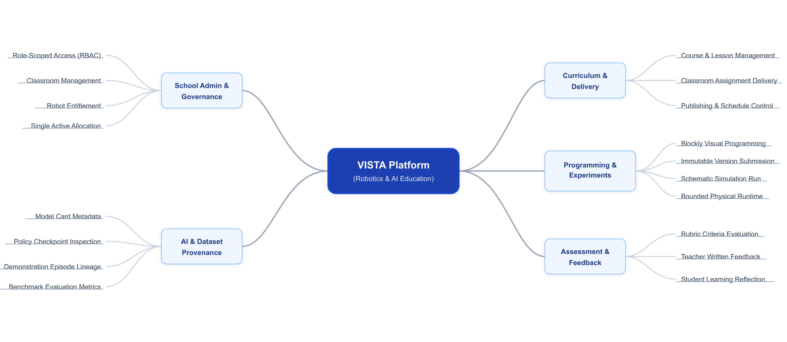
Figure 1. VISTA Platform — System Feature Decomposition Mindmap
See SRS acceptance criteria and BM01 mandatory feature list for testable detail.

6.2 Limitations & Exclusions
Excluded: unsafe unrestricted robot commands, arbitrary JavaScript execution from Blockly, autonomous training of foundation VLA models, or fabricated physics simulation and cloud production claims.
Limitations:
LI-01: Physical robot motion requires robot.control, safe/ready hardware and an authorized control session; schematic preview is not physical execution.
LI-02: AWS staging and AI external providers are proposed integrations until deployment and evidence confirm them.
LI-03: The system is built for scoped classroom robotics practice, not general-purpose industrial autonomy.
Design documentation update: the Review 2 database design is represented by a Conceptual ERD, five Logical domain ERDs and six Physical domain ERDs in the 23-page authoritative diagram set (including separate 16a and 16b ERD pages). Physical robot execution remains a stated target whose end-to-end status needs code and test verification.

