

Capstone Project Report
Report 3 – Software Requirement Specification

– FPT University, October 2026 –
Table of Contents
I. Project Report 3
1. Status Report 3
2. Team Involvements 3
3. Issues/Suggestions 3
II. Software Requirement Specification 4
1. Overall Description 4
1.1 Product Overview 4
1.2 Business Rules 5
2. User Requirements 6
2.1 System Actors 6
2.2 Use Cases 6
3. Functional Requirements 8
3.1 System Functional Overview 8
3.2 <<Feature Name 1>> 10
3.3 <<Feature Name 2>> 10
4. Non-Functional Requirements 11
4.1 External Interfaces 11
4.2 Quality Attributes 12
5. Other Requirements 14
5.1 Appendix1 - Messages List 14
5.2 Appendix2 - … 14
5.3 … 14

I. Record of Changes
Date | A*  M, D | In charge | Change Description
27/10/2026 | M | Lê Nguyễn Quang Đức | Expand use case and feature tables to all 8 mandatory FRs, remove NFR template placeholder text, and update ERD baseline reference to 23 pages (12 ERDs).
*A - Added M - Modified D - Deleted

II. Software Requirement Specification

1. Product Overview
VISTA is a multi-role education platform for schools, teachers and learners, linking authorized classroom robot allocation to learning assignment, versioned student work, schematic experiment requests and teacher feedback. Local Robot Runtime and AI integration remain separate trust boundaries; physical E2E must be verified before marking implemented.
VISTA is a role-governed robotics education platform. Roles: System Admin, School Admin, Instructor/Teacher and Student. External integrations are Supabase Auth/PostgreSQL, optional AI/model service and local safety-managed Robot Runtime. System Context is in the supplied C4 diagrams; only code-verified responsibilities are mandatory.
Learning loop: Learn → Predict → Build → Experiment → Reflect → Assess. Classroom resource allocation grants access; it does not create a live robot control session.
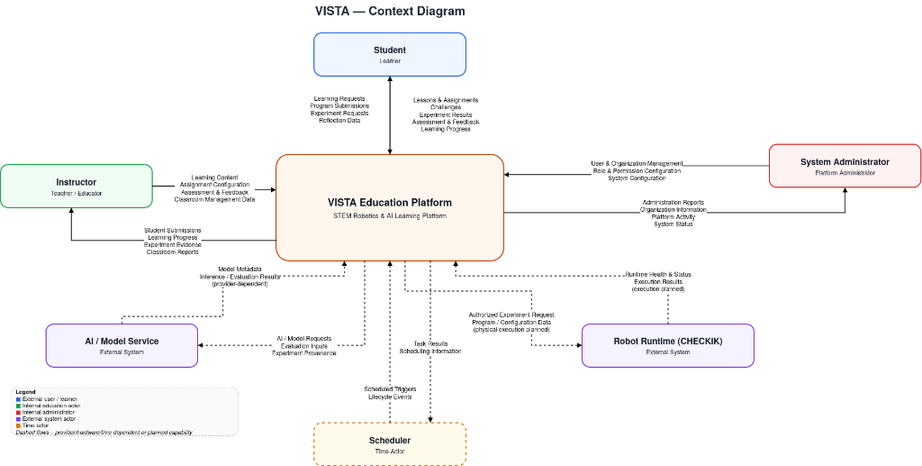
Figure 1. VISTA Platform — System Context Diagram

2. User Requirements
School Admin manages classroom and entitled robot allocation; Teacher publishes assignments and reviews student work; Student accesses own class, versions work and requests permitted experiments; system/external actors include AI/Model Service and Local Robot Runtime.

2.1 Actors
Authorization derives JWT subject → public users → active organization and classroom membership. Scope permission is required alongside active membership; out-of-scope resources may return 404.
- Students: their classes, authorized assignments, programs, experiments, feedback and reflections.
- Teachers: class delivery, assignments, review and assessments within teacher/TA classroom relationship.
- School administrators: school members, classrooms, entitled robots and classroom allocations.
System administrators: globally scoped role/organization administration only with authoritative permission.
# | Actor | Description
1 | System Administrator | Platform-scoped administration; verify code roles
2 | School Administrator | Own school classrooms and robot allocation
3 | Teacher | Publish classroom learning and review authorized work

2.2 Use Cases
UC-01 school admin allocates an entitled robot; UC-02 teacher publishes class assignment and student submits immutable program; UC-03 student runs schematic preview and symbolic evaluation; UC-04 teacher assesses student work and student reflects.

2.2.1 Diagram(s)
Relevant source diagrams supplied in VISTA_DIAGRAM.pdf: pages 1–7 for architecture and 4 workflow activities. This PDF is referenced here; rendered design figures are embedded in Report 4.
Use Case Diagram is an SRS illustration; linked C4 and activity diagrams should be updated from true route and schema. No completed physical robot execution claim.
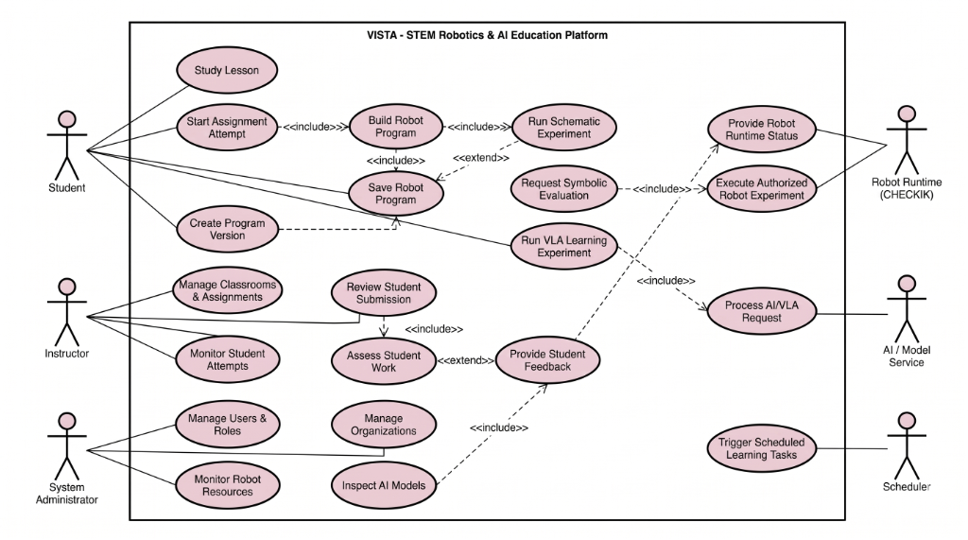
Figure 2. VISTA Platform — Use Case Diagram

2.2.2 Descriptions
UC main/exception scenarios and owners are in BM01 Appendix A. Acceptance requires persisted entity state and scoped authorization checks.
ID | Use Case | Actors | Use Case Description
UC-01 | Authentication and role-scoped access | System Admin / School Admin / Teacher / Student | Requests require valid user, active membership, and scoped authorization; cross-organization access is denied.
UC-02 | Classroom robot allocation and governance | School Admin | Only an entitled robot can be allocated to an owned classroom; conflicting active allocations are atomically rejected.
UC-03 | Lesson preparation and assignment publication | Teacher | Authorized teacher creates and publishes classroom assignments; unauthorized publish requests are rejected.
UC-04 | Immutable program versioning and submission | Student | Learner edits RobotProgram drafts, generates immutable versions, and submits an eligible version for an active attempt.
UC-05 | Schematic experiment execution and symbolic evaluation | Student | Student requests a schematic experiment run; backend validates eligibility and persists truthful execution state and evidence.
UC-06 | Bounded physical robot execution through local runtime | Student, Robot Runtime | Physical execution requires active reservation, hardware readiness, and safety checks; failure or stop fails closed.
UC-07 | Teacher assessment, feedback, and student reflection | Teacher, Student | Teacher reviews submission evidence and records rubric assessment; student inspects feedback and records reflection.
UC-08 | AI model and dataset provenance metadata inspection | Student / Teacher / System Admin | Users view traceable model versions, training datasets, and evaluation metrics; external writes fail gracefully.

3. Functional Requirements

3.1 System Functional Overview
The functional baseline uses FR-01 to FR-06 and four workflows. Scope must remain consistent with Registration v1.2 and actual API authorization. Expected errors include unauthorized org/classroom scope, invalid entitlement, invalid submission ownership, and non-schematic experiment mode.
Functional requirements must be independently testable and mapped to implemented controllers/services. Examples below separate implemented API capabilities from planned physical execution.

3.1.1 Screens Flow
School Admin: organization/classroom -> eligible robot -> allocation; Teacher: lesson -> assignment -> publish -> review; Student: assigned content -> versioned program -> submit -> schematic experiment -> view feedback. UI routes require code-level confirmation.
Student → course/lesson → own assignment → own attempt → program version → experiment → submission and feedback. Teacher and school administration routes are independently permission-scoped.
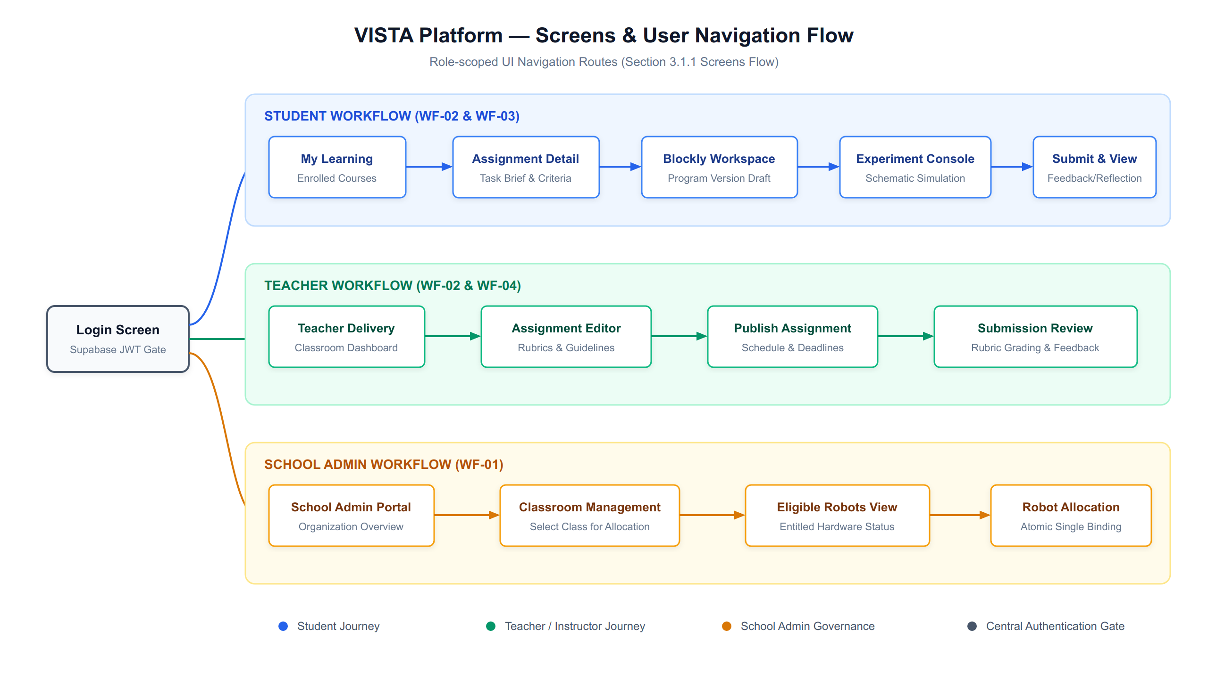
Figure 3. VISTA Platform — Screens & User Navigation Flow

3.1.2 Screen Descriptions
Access, School/Classroom Management, Learning Content and Assignment, Student Program/Submission, Experiment Request/Result, Teacher Assessment/Feedback. Detailed routes and controls are to be verified against web/robot-edu; conceptual flow is not evidence of a working page.
Screens: Login, School Admin Classrooms/Robot Allocation, Teacher Course/Assignment, Student Program/Experiment, Instructor Assessment, Student Feedback/Reflection.
# | Feature | Screen | Description
1 | Role-governed access & identity gate | Login & Access Gate | JWT authentication, organization context selection, and scope validation.
2 | Classroom robot allocation & governance | School Admin Dashboard | School-scoped classroom management and atomic robot allocation.
3 | Assignment creation & delivery | Teacher Course / Delivery View | Classroom assignment authoring, scheduling, and publication.
4 | Visual programming & version submission | Student Workspace / Blockly | Block-based coding, canonical AST compile, immutable versioning, and submission.
5 | Schematic experiment & symbolic evaluation | Experiment Console | Schematic execution simulation, trajectory verification, and artifact persistence.
6 | Bounded physical robot execution | Hardware Telemetry Monitor | Local device gateway status, readiness check, and supervised run dispatch.
7 | Teacher assessment & student reflection | Assessment & Feedback Portal | Rubric grading, feedback delivery, and student reflection records.
8 | AI model & dataset metadata inspection | Model / Dataset Registry | Traceable AI model cards, dataset versions, and benchmark evaluation metrics.

3.1.3 Screen Authorization
System Admin (platform scope), School Admin (organization), Teacher (assigned classroom/course), Student (own membership and work). Backend must check Supabase JWT, public.users mapping, active membership and per-resource scope.
Student cannot enter another school’s classroom or assignment; teacher/TA requires active class relationship plus learning.delivery.manage; admin cannot authorize physical motion merely by allocating robot.
Screen | System Admin | School Admin | Teacher | Student
Login | Y | Y | Y | Y
School Resource Allocation | N | Y | N | N
Manage Assignments | N | N | Y | Read
Program Submission | N | N | Review | Y
Experiment Schematic | N | N | Review | Y
Assessment | N | N | Y | Read
Add New Data |  |  | X | X
Update All Data |  |  |  | X
Update Own Data |  |  |  | X
Update Managed Data |  |  |  | X
Delete Data
…

3.1.4 Non-Screen Functions
NestJS API handles authorization, resource entitlement checks, durable program versions/submissions, schematic experiment request persistence and teacher assessment; Python runtime device execution is an independent integration boundary.
Non-screen functions: JWT guard, scope service, Postgres advisory transaction locking for experiment deduplication, immutable ProgramVersion and safety-limited runtime adapter.
# | Feature | System Function | Description
1 | Authentication & Access Control | FR-01 | System verifies Supabase JWT and enforces strict organization and classroom scope guards on all endpoints.
2 | Classroom Robot Allocation | FR-02 | School Admin allocates an entitled robot to an owned classroom; atomic replacement prevents dual active allocations.
3 | Assignment Publication | FR-03 | Teacher publishes classroom work; unauthorized actors or foreign teachers cannot publish or alter assignments.
4 | Versioned Program Submission | FR-04 | Student creates immutable program versions and submits an attempt; other students cannot submit or alter work.
5 | Schematic Experiment Execution | FR-05 | Student runs schematic simulation; backend persists deterministic execution logs, status, and evaluation results.
6 | Physical Execution Boundary | FR-06 | System dispatches physical commands only to ready, reserved hardware; duplicate or unsafe commands fail closed.
7 | Assessment & Feedback Delivery | FR-07 | Teacher submits score and feedback for student submission; student receives feedback and submits reflection.
8 | AI / Model Metadata Management | FR-08 | Platform serves read-only metadata for AI model cards, dataset lineage, and evaluation metrics with zero false claims.

3.1.5 Entity Relationship Diagram
Logical ERD reference: pages 12–23 of VISTA_DIAGRAM.pdf; diagrams contain proposed cardinalities and require verification against Prisma/migrations including PK, FK, nullable and unique constraints.
Master Logical ERD is a curated view from Supabase columns/FKs; compare all FK constraint groups with nullability/unique constraints; no arbitrary extra relationships.
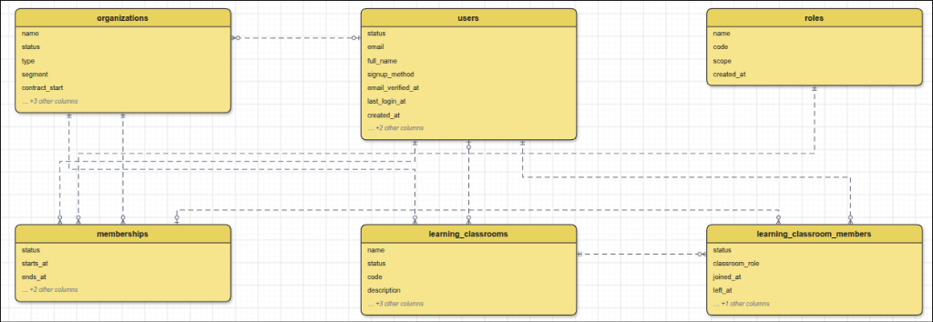
Figure 4. VISTA Platform — Logical ERD (School & Access Scope)
Entities Description
# | Entity | Description
1 | learning_classroom_robot_allocations | Scoped robot authorization
2 | learning_classroom_assignments | Published classroom task
3 | learning_submissions | Student work version link
4 | learning_experiments | Experiment request and status

3.2 WF-01 School Administration and Classroom Robot Allocation
FR-02: School Admin selects own classroom and a currently entitled robot. API verifies active role/organization/classroom membership and entitlement; it upserts allocation atomically. Postcondition is an authorization record, not a live robot control session. Reject cross-school/expired-entitlement requests.

3.2.1 School Admin Allocates Robot
Precondition: authorized school admin, existing classroom in organization, eligible robot. Main: list classroom and eligible robots; select and submit; guard validates scope; service records one classroom allocation; display current allocation. Exception: 403/404 unauthorized scope; conflict/validation failure returns without unauthorized change.
Trigger: School Admin selects an own classroom and an entitled robot.
- Validation: authenticated organization permission, active school membership, classroom ownership, entitlement and allocation conflict rules.
- Result: one classroom robot allocation; atomic replace. Allocation is not an execution lease.
- API: GET /api/v1/education-admin/classrooms/:classroomId/eligible-robots; PUT /api/v1/education-admin/classrooms/:classroomId/robot-allocation.
- Failure: inaccessible class, no entitlement and conflict are rejected without cross-school data leakage.

3.2.2 WF-02 Learning & Assignment; WF-03 Experiment; WF-04 Assessment
WF-02 FR-03/04: Teacher prepares/publishes classroom assignment, learner versions program and submits own work. WF-03 FR-05: create schematic experiment request; reject any unsupported executionMode; pending is NOT physical run completion. WF-04 FR-06: authorized teacher reviews submission and records assessment/feedback; integration of AI metadata is separately scoped.
WF-02: teacher delivers/publishes assignment, student creates attempt and versioned RobotProgram, then submits authorized immutable version.

WF-03: ExperimentService currently accepts schematic mode only; creation starts pending and separate schematic/symbolic evaluation actions exist. Do not present physical execution as implemented.

4. Non-Functional Requirements
NFR acceptance targets must be measurable. Cross-school authorization isolation: zero unauthorized successful responses in a seeded negative-case suite. Defense 1.1 targets (not current results): mandatory main scenarios 100%; exception scenarios at least 80%, total cases pass at least 90%, >=50% of test cases automated CI.

4.1 External Interfaces
Web app HTTPS JSON -> Education API, Supabase Auth JWT, Prisma/PostgreSQL and evidence storage. AI service and Python Robot Runtime integration are design interfaces; confirm routes and deployment before asserting live E2E.
External interfaces: Supabase Auth JWT, NestJS /api/v1 REST/JSON, Prisma/PostgreSQL, external AI/model adapter (verify configuration), private Python Robot Runtime.

4.2 Quality Attributes
NFRs are proposed and require owner-confirmed test threshold, measurement environment and reporting; do not invent performance measurements.

4.2.1 Usability
Usability: a teacher and student must complete approved main workflow using clear actionable error messages; measure by timed usability session in staging.

4.2.2 Reliability
Reliability: authorization and state checks fail closed on unavailable dependencies; verify with fault injection and negative tests.
Availability: The VISTA Learning Platform targets ≥99.0% service availability during scheduled school instructional hours (07:00–18:00 UTC+7).
Mean Time Between Failures (MTBF): Targeted MTBF is ≥300 operating hours between unscheduled API or database service interruptions.
Mean Time To Repair (MTTR): Targeted MTTR is ≤2 hours for containerized API services in local and staging environments.
Accuracy: Robot program AST compilation and schematic trajectory evaluations are deterministic (100% precision with identical inputs).
Maximum Bugs or Defect Rate: Zero critical defects (data loss, privilege escalation, or unauthorized physical motion) permitted in release baselines.
Defect Severity Thresholds: Critical defects must be resolved within 24 hours; major defects within 5 business days; minor defects scheduled by sprint.

4.2.3 Performance
Performance: latency target and simultaneous user load to be signed off in BM01, measured with staged repeatable load test and recorded percentiles.
Response Time: Ordinary authenticated REST API operations return within P95 ≤3.0 seconds under nominal classroom concurrency (30 concurrent users).
Throughput: Education API handles a minimum of 50 requests per second across typical reading, submitting, and evaluation workloads.
Capacity: The database and API scale to support at least 1,000 active students and 10,000 immutable program versions per registered school.
Resource Utilization: API container memory utilization remains below 70% under standard instructional loads (512 MB memory limit).

4.2.4 Security & Safety
Additional: privacy/scope isolation and robot safety checks take priority over throughput.

5. Requirement Appendix
Appendix maps each FR to WF, owner and test IDs in the project test workbook; unverified state labels require correction against code.

5.1 Business Rules
BR-01 student sees only authorized classroom content and own attempts. BR-02 allocation conveys classroom authorization not active physical robot control. BR-03 physical control needs separate exclusive, safe runtime session. BR-04 experiment creation in observed Education API only supports schematic and creates pending record. BR-05 assessment changes require appropriate reviewer membership.
BR-01 Student reads only currently authorized classroom content and own attempts.
ID | Rule Definition
BR-01 | Cross-organization reads/writes forbidden
BR-02 | Classroom allocation is not runtime control
BR-03 | Schematic mode only on observed Education API
BR-04 | Program versions referenced by submission immutable
BR-05 | Physical execution requires separate safety gate
BR-12 | Order price is calculated as the sum of each food item price times the quantity of that food item ordered, plus applicable sales tax, plus a delivery charge if a meal is delivered outside the free delivery zone.
BR-24 | To verify
BR-33 | Network transmissions that involve financial information or personally identifiable information require 256-bit encryption.
BR-86 | Only regular employees can register for payroll deduction for any company purchase.
BR-88 | An employee can register for payroll deduction payment of cafeteria meals if no more than 40 percent of his gross pay is currently being deducted for other reasons.

5.2 Common Requirements
BR-02 Classroom robot allocation does not authorize physical motion; separate robot.control and safety checks are necessary.

5.3 Application Messages List
# | Message code | Message Type | Context | Content
1 | AUTH_SCOPE | Error | Role/scope or input | Request outside authorized organization/classroom
2 | ENTITLEMENT | Error | Role/scope or input | Robot not entitled to this organization
3 | EXPERIMENT_MODE | Error | Role/scope or input | Unsupported executionMode; only schematic allowed
4 | SUBMISSION_OWNER | Error | Role/scope or input | User cannot modify another learner submission
5 | MSG05 | Toast message | Confirming email of asset hand-over is sent successfully | A confirmation email has been sent to {email_address}.
6 | MSG06 | Toast message | Resetting asset information successfully | Return asset(s) successfully.
7 | MSG07 | Toast message | Deleting asset information successfully | Delete asset(s) successfully.
8 | MSG08 | In red, under the text box | Input value length > max length | Exceed max length of {max_length}.
9 | MSG09 | In line | Username or password is not correct when clicking sign-in | Incorrrect user name or password. Please check again.

All user-visible success states must correspond to authoritative persisted data and runtime evidence.

Requirement-to-design cross-reference — revised ERD
ERD baseline: diagramall.drawio.xml, 23 pages containing 12 ERDs. Conceptual ERD (page 12) outlines core business entities; five Logical ERDs (pages 13–16b, including separate 16a Programs & Assessment and 16b AI & Datasets) define normalized attributes and foreign keys; six Physical ERDs (pages 17–22) establish PostgreSQL data types, primary/foreign key constraints, and unique indexes.

