**Practical-1:**

1. JavaScript code embedded within the HTML file
2. Install Node.js: Download and install Node.js from nodejs.org.
3. create a “script.js” file to print “Hello world” on the server side
4. create an “app.js” file to create and store JSON Object in the File

To execute JavaScript code within an HTML file, you can use the **<script>** tag. Here's a simple example of embedding JavaScript within an HTML document:

**File Name:** index.html

<!DOCTYPE html>

<html lang="en">

<head>

<title>JavaScript in HTML Example</title>

</head>

<body>

<!-- JavaScript code embedded within the HTML file -->

**<script>**

// You can also define functions

function greet(name) {

alert("Hello, " + name + "!");

}

// Call the function

greet("Devendra Vashi");

**</script>**

</body>

</html>

**To run JavaScript on the server side, Follow these steps:**

Install Node.js: Download and install Node.js from nodejs.org.

Open a Terminal or Command Prompt. **(PowerShell)**

Navigate to the directory containing your JavaScript file.

Run your JavaScript file using the following command:

**File Name:** script.js

console.log("Hello, World!");

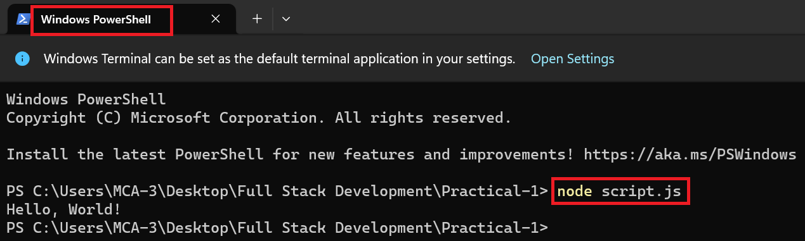

**File Name:** app.js

// app.js

const fs = require('fs');

// Create a JSON object

const jsonObject = {

name: 'John Doe',

age: 25,

city: 'Example City',

};

// Convert JSON object to a string

const jsonString = JSON.stringify(jsonObject, null, 2);

// Specify the file path

const filePath = 'output.json';

// Write JSON string to a file

fs.writeFile(filePath, jsonString, 'utf-8', (err) => {

if (err) {

console.error('Error writing to file:', err);

} else {

console.log('JSON object has been stored in', filePath);

}

});

**Notes:**

This example uses the Node.js **fs** (File System) module to write to a file.

The **JSON.stringify** method is used to convert the JavaScript object into a JSON-formatted string.

The **writeFile** method is asynchronous, and it takes a callback function that will be called after the file is written.

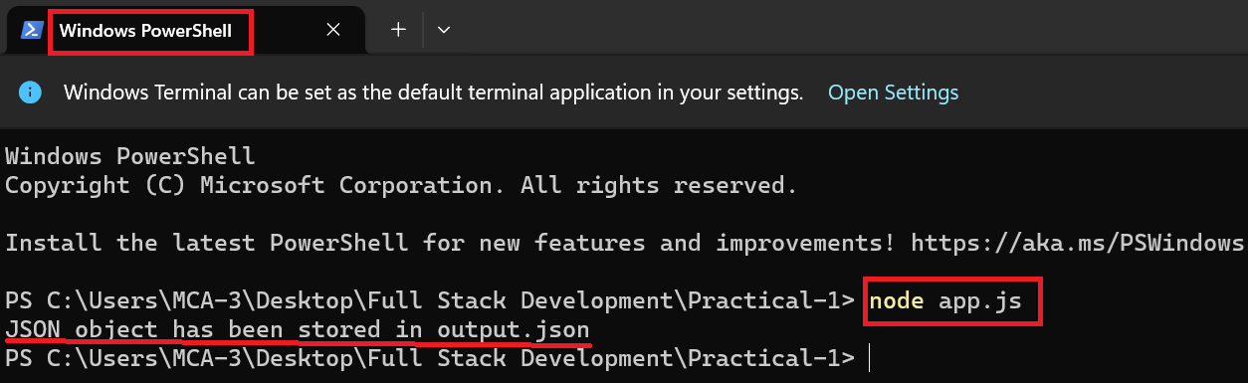

The above screenshots show the **execution of JavaScript code** on the **server side**.