E-commerce system

**Project Overview**

The E-Commerce Management System is a console-based application developed to facilitate online shopping by allowing users to register, browse products, add items to their cart, and make purchases. The system also includes an admin panel for managing products and users. It provides a seamless shopping experience with essential functionalities such as authentication, product management, cart management, and order checkout.

**Objectives**

* To develop a simple and effective e-commerce system.
* To implement user authentication and role-based access.
* To provide an intuitive interface for product management.
* To enable seamless cart and checkout functionality.
* To ensure secure storage and retrieval of data.

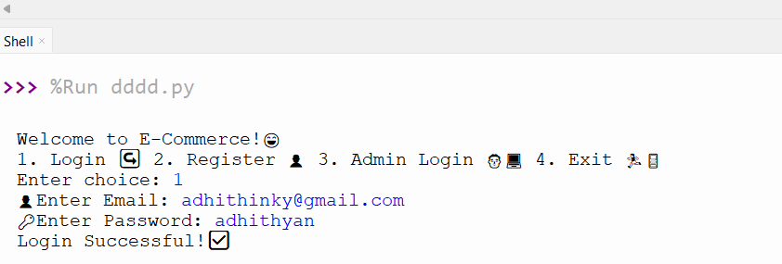

**Software requirements specifications(SRS)**

Programming Language: Python

Database: JSON file-based storage

Libraries Used:

json (for data handling)

os (for file operations)

random (for product ID generation)

tabulate (for tabular representation of data)

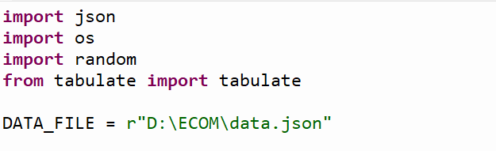

**System Architecture & Features**

**User Module**

User Registration: Users can sign up by providing their name, email, and password.

User Login: Validates user credentials before granting access.

Cart Management: Users can add products to their cart and view them.

Checkout Process: Users can make payments via available payment methods.

**Admin Module**

Admin Login: A designated admin can log in using predefined credentials.

Product Management: Admins can add, edit, and delete products.

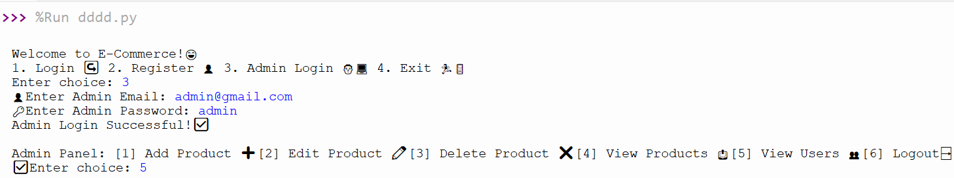

User Management: Admins can view registered users. 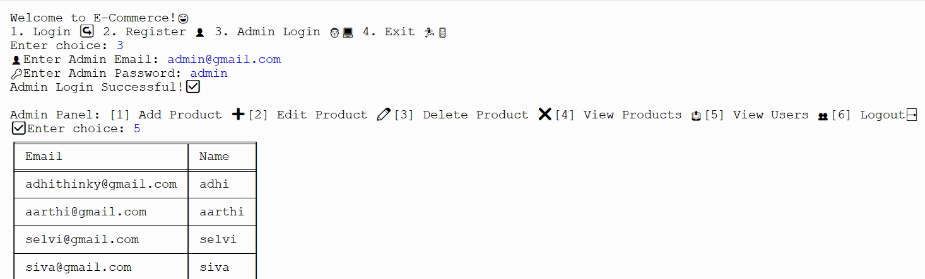

**Product Management**

Add Product: Products are assigned a unique ID and stored in the database.

Edit Product: Allows modification of product details.

Delete Product: Removes products from the system.

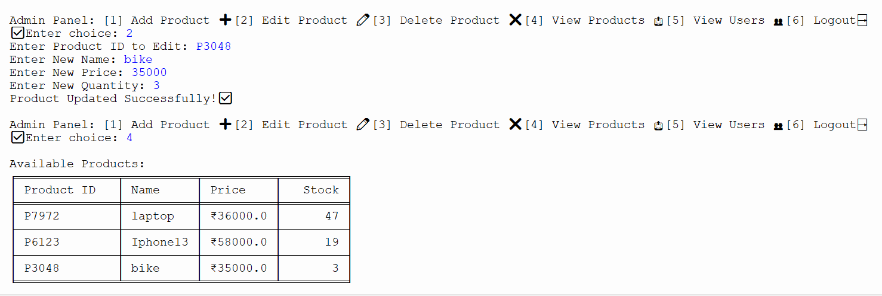

View Products: Displays available products in a tabular format. 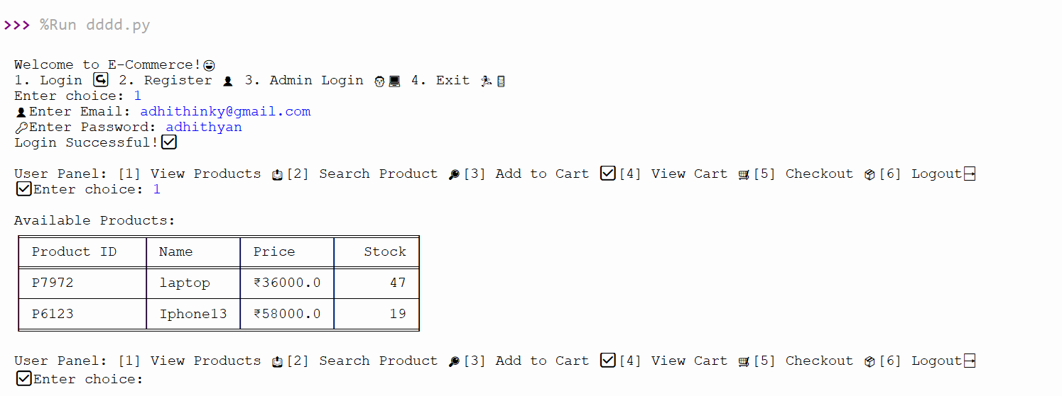

Search Product: Allows users to search for products by name.

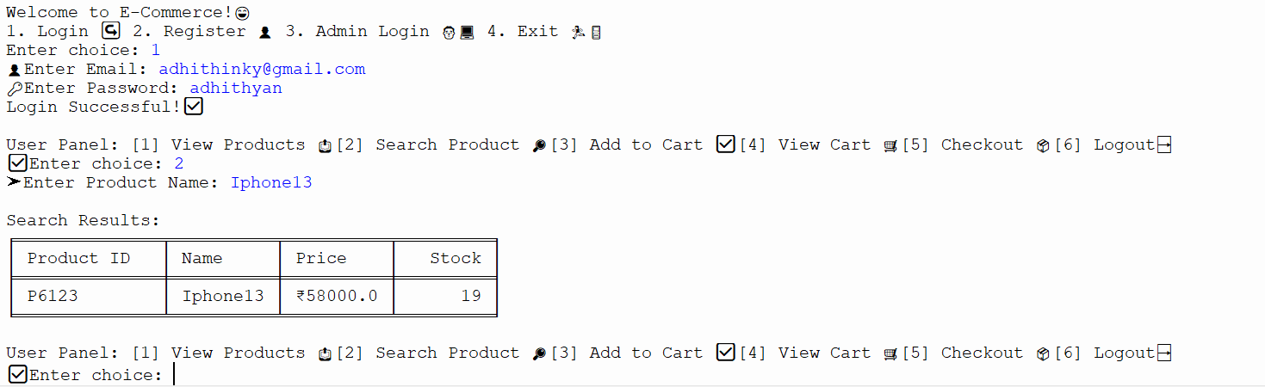

**Cart & Checkout System**

Add to Cart: Users can add products to their shopping cart.

View Cart: Displays selected products with their total price.

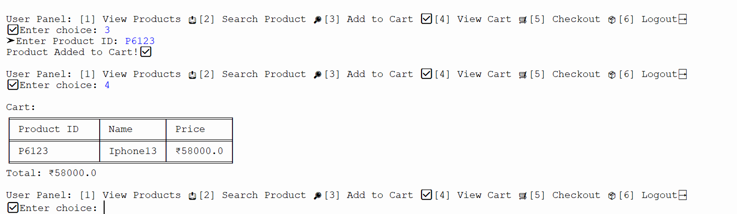

Checkout: Deducts product quantity and processes payments.

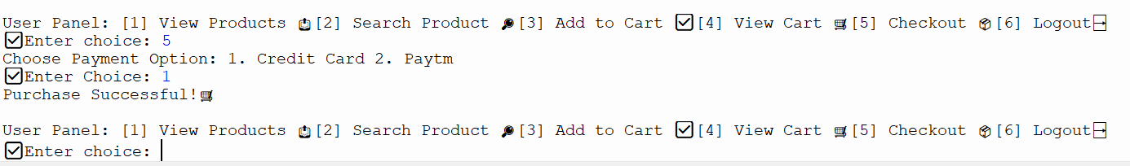

**Business rules**

The system follows these key business rules:

A **user must register** before making a purchase.

**Admins can manage products** but not customer accounts.

A product **must have a unique ID, name, price, and stock quantity**.

Users **cannot checkout with an empty cart**.

Payment is simulated via **credit card or Paytm**. 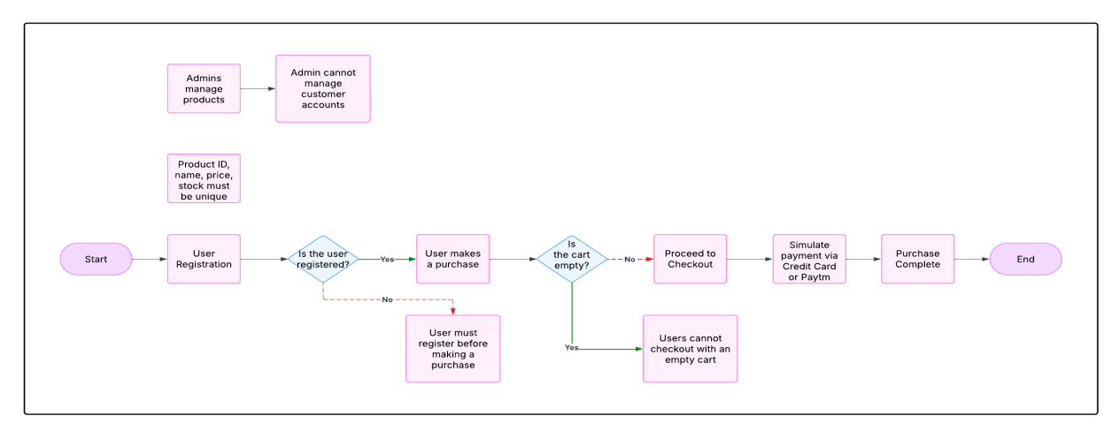

**Conclusion**

This **E-Commerce System** successfully implements an online shopping workflow using Python and OOP principles. Future enhancements could include a **web-based UI**, integration with **payment gateways**, and **database migration** for scalability.

**Use Case Diagram**

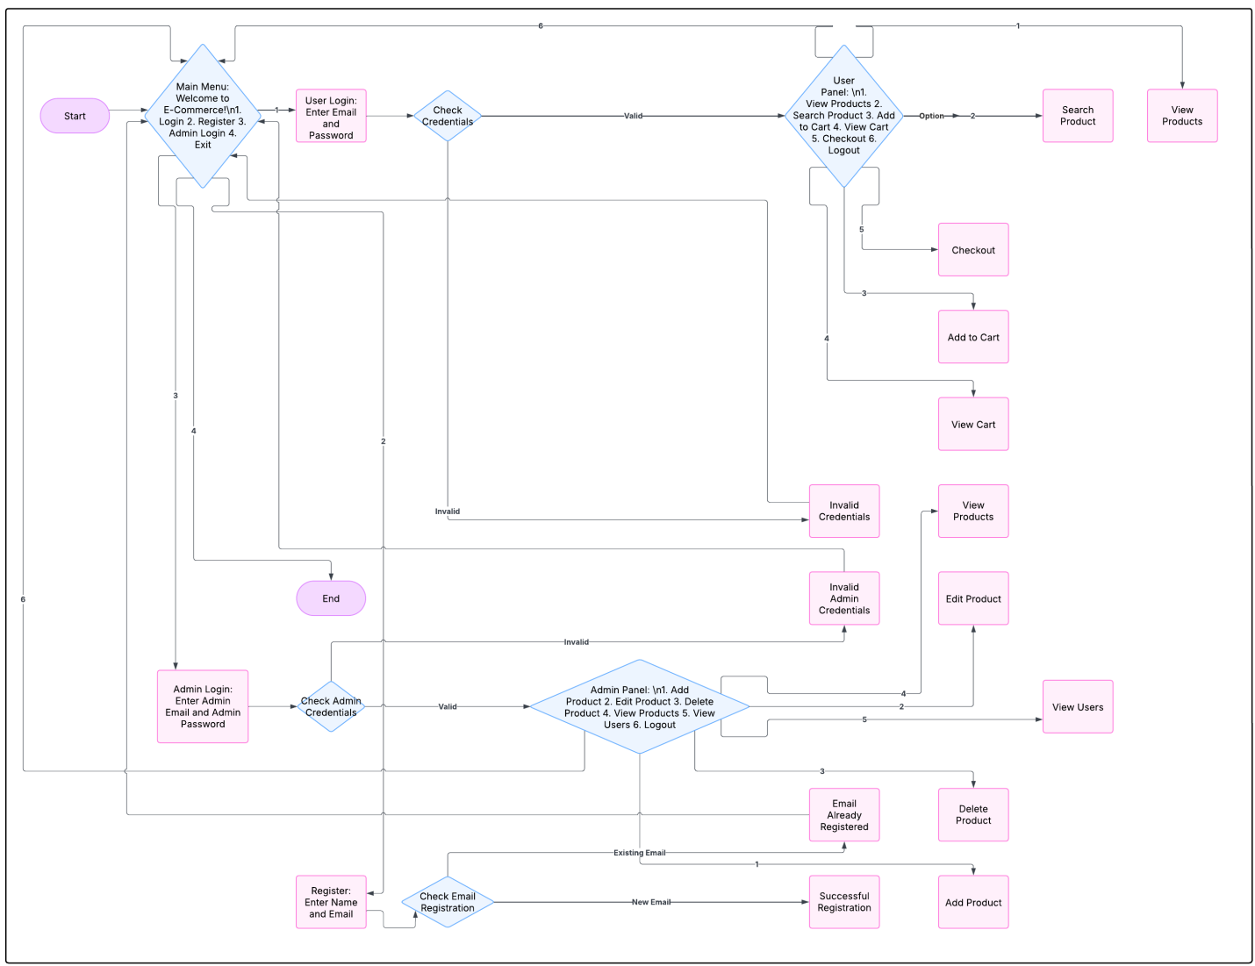

**JSON Based Data Storage**

