Universal Tournament Management System
  - By Souravjyoti Kalita
24BCE1817

Introduction
The Universal Tournament System (UTS) is a tournament management application developed to simplify the organization and administration of sports competitions. Managing tournaments manually often involves maintaining multiple spreadsheets, paper records, and schedules, which can lead to errors, duplication of work, and difficulty in tracking tournament progress.
The purpose of this project is to provide a centralized platform where tournament organizers can efficiently manage players, teams, tournaments, and matches. The system automates many administrative tasks, including participant registration, fixture generation, score tracking, and tournament monitoring.
The application follows a client-server architecture. A FastAPI backend handles business logic and communication with the database, while a Textual-based Terminal User Interface (TUI) allows users to interact with the system through an intuitive and organized interface. MongoDB is used as the database to store all tournament-related information.
By integrating modern software development technologies, the Universal Tournament System provides a reliable and scalable solution for managing sports events of different sizes and formats.
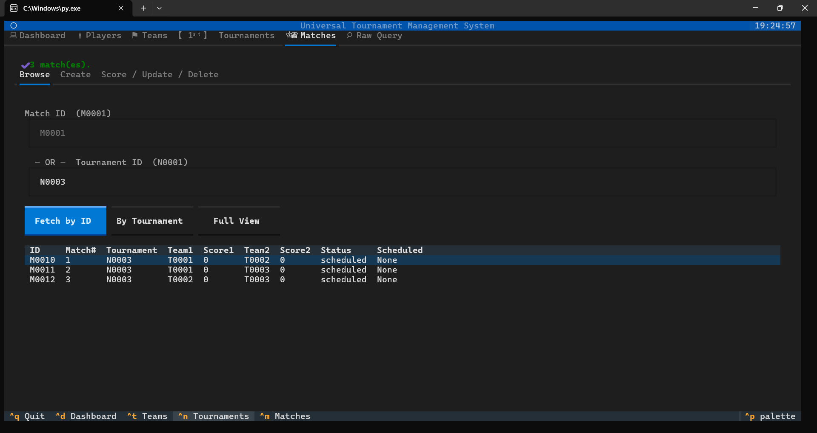

Objectives
The primary objectives of the Universal Tournament System are:
- To develop a centralized platform for tournament management.
- To simplify the process of managing players, teams, matches, and tournaments.
- To reduce manual effort involved in tournament administration.
- To automate fixture generation and match scheduling.
- To maintain accurate tournament records in a database.
- To provide efficient search, update, and reporting capabilities.
- To improve data consistency through validation and structured storage.
- To create a scalable system that can be extended with additional features in the future.

Tools and Technologies used
The project utilizes several modern technologies for frontend development, backend services, and database management.

Programming Language

Python
Python was selected as the primary programming language because of its simplicity, readability, and extensive ecosystem of libraries.

Backend Framework

FastAPI
FastAPI is used to build the backend REST API that handles all business operations and database interactions.
Features of FastAPI:
- High performance
- Automatic API documentation
- Easy request validation
- Support for asynchronous programming
- Clean and maintainable code structure

Database

MongoDB
MongoDB is a NoSQL database used to store tournament-related data.
Collections used in the project:
- Players
- Teams
- Matches
- Tournaments
Advantages:
- Flexible schema design
- Fast data retrieval
- Easy scalability
- Efficient handling of nested documents

Database Connectivity

PyMongo
PyMongo is used to establish communication between the FastAPI backend and MongoDB.
Functions performed by PyMongo:
- Database connection
- CRUD operations
- Aggregation queries
- Data retrieval and updates

Frontend Framework

Textual
Textual is a Python framework used for creating Terminal User Interfaces. That is the user interface runs wholly on the command line itself, so no additional pop up windows
Features used in the project:
- Interactive forms
- Tables
- Tabs and navigation panels
- Dialog windows
- Dashboard views

3.6 Additional Libraries

Pydantic
Used for validating incoming data and ensuring consistency.

HTTPX
Used by the frontend to communicate with the FastAPI backend.

AsyncIO
Provides asynchronous execution capabilities.

Datetime
Handles dates, scheduling, and age calculations.

Logging
Records system events and errors.

JSON
Processes structured data exchanged between frontend and backend.

Database Design

The initial Design of the project using ER diagram is a follows
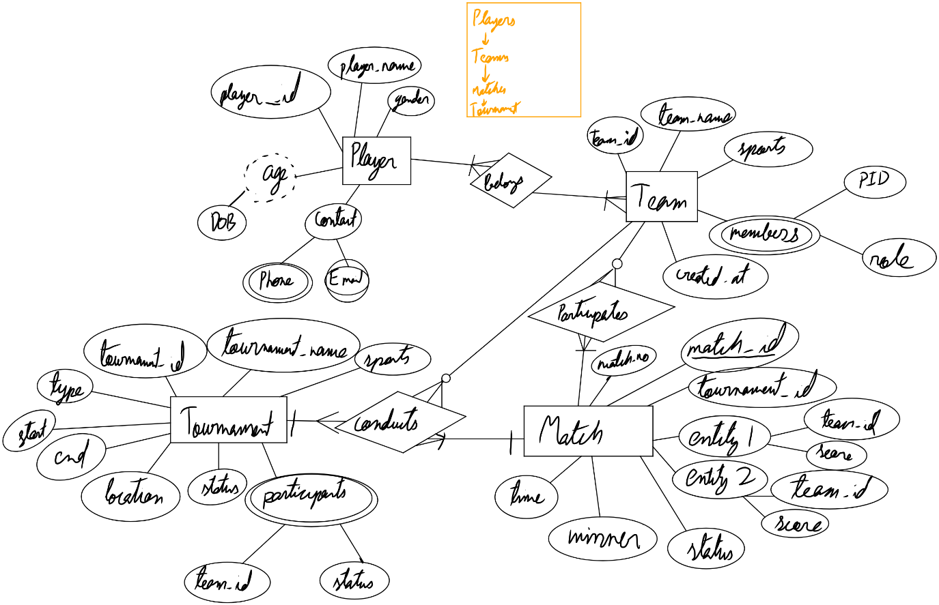
The schema of the database is as follows:

Player
{
"player_name": str,
"gender":str,
"contact":{},
"age": int
"dob": date
}
Team
{
"team_name": str,
"sport": str,
"members": [{"player_id": str, "role":str}, ...]
}
Match
{
"match_no": int,
"tournament_id": str,
"entity1": {"team_id": str, "score":int},
"entity2": {"team_id": str, "score":int},
"scheduled_at": datetime,
"status": str # (not recommended to fill manually)"scheduled" | "ongoing" | "completed"
"winner": int | none
}
Tournament
{
"tournament_name": str,
"sports": str
"start_date": datetime,
"end_date": datetime,
"location": str | dict
"participants": [{"team_id": str, "playing": bool}, ...],
"status": str # "upcoming" | "ongoing" | "completed"
"type": "knockout" | "cyclic"
}

API endpoints
The Universal Tournament System uses a RESTful API built with FastAPI. The API acts as a communication layer between the Textual frontend and the MongoDB database. Each endpoint performs a specific operation related to players, teams, matches, or tournaments.

Player Endpoints
POST /player
Creates a new player record in the database. The endpoint receives player information such as name, gender, date of birth, and contact details. A unique player ID is generated automatically.
GET /player/all
Retrieves all player records stored in the database.
GET /player/search
Searches for players using a full or partial player name. The search is case-insensitive, making it easier to locate records.
GET /player/{id}
Retrieves the complete information of a specific player using the player's unique ID.
PATCH /player/{id}
Updates one or more fields of an existing player record without modifying the entire document.
DELETE /player/{id}
Removes a player record from the database.
POST /player/query
Executes a custom MongoDB query on the player collection. This endpoint is mainly used by the Raw Query feature of the application
Team Endpoints.
POST /team
Creates a new team and stores team information including team name, sport, and members.
GET /team/all
Retrieves all team records.
GET /team/search
Searches teams by full or partial team name.
GET /team/{id}
Returns complete details of a specific team.
PATCH /team/{id}
Updates team information such as team name, sport, or members.
DELETE /team/{id}
Deletes a team record from the database.
POST /team/query
Performs custom MongoDB queries on the team collection.

Match Endpoint
POST /match
Creates a new match record containing participating teams, tournament information, schedule, and scores.
GET /match/{id}
Retrieves information about a specific match.
PATCH /match/{id}
Updates match details such as schedule, status, or scores.
DELETE /match/{id}
Deletes a match from the database.
POST /match/query
Allows custom MongoDB queries on the match collection.
GET /match/tournament/{tournament_id}
Returns all matches associated with a particular tournament.
POST /match/{id}/score
Updates the score of a match. The endpoint receives the team number and score increment value, then updates the corresponding score automatically.
GET /match/{id}/full
Returns a detailed match view that includes information from both the match and the participating teams.
GET /match/tournament/{tournament_id}/completed
Retrieves all completed matches within a tournament.
GET /match/tournament/{tournament_id}/current
Returns ongoing matches or both ongoing and scheduled matches, depending on the filter selected.
GET /match/tournament/{tournament_id}/next
Retrieves the next upcoming match in a tournament.
POST /match/{id}/start_end
Changes the status of a match. If the match is scheduled, it becomes ongoing. If it is already ongoing, it is marked as completed.

Tournament Endpoints
Tournament Endpoints
POST /tournament
Creates a new tournament record including tournament details, participants, dates, and tournament type.
GET /tournament/all
Retrieves all tournaments stored in the database.
GET /tournament/search
Searches tournaments using full or partial tournament names.
GET /tournament/{id}
Returns complete information about a specific tournament.
PATCH /tournament/{id}
Updates tournament information such as dates, participants, location, or status.
DELETE /tournament/{id}
Deletes a tournament record.
DELETE /tournament/{id}/cascade
Deletes a tournament together with all matches belonging to that tournament. This helps maintain database consistency.
POST /tournament/query
Executes custom MongoDB queries on the tournament collection.
GET /tournament/{id}/teams
Returns all teams participating in a tournament. Additional filters can be used to display only currently playing teams or search for a specific team.
GET /tournament/{id}/generate
Automatically generates tournament fixtures and creates match records based on the participating teams and tournament type.

Functioning of the Project

Player Management Module
This module manages all player-related information.
Stored Information:
- Player ID
- Player Name
- Gender
- Date of Birth
- Age
- Contact Information
Functions:
- Add new player
- Search player
- View player details
- Update player information
- Delete player records
The system automatically calculates the player's age from the date of birth. 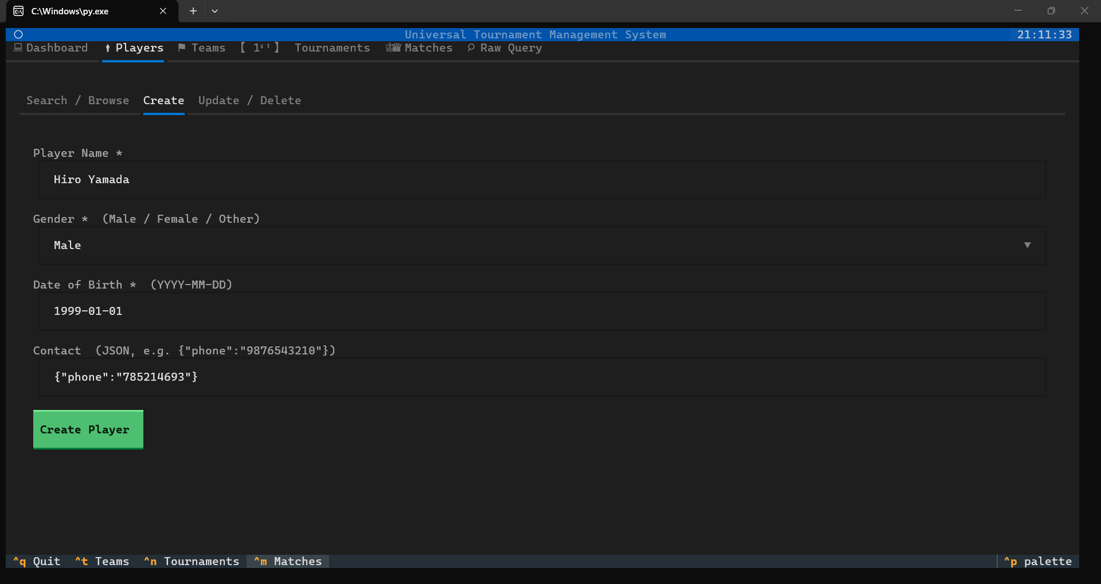

Team Management Module
This module manages sports teams participating in tournaments.
Stored Information:
- Team ID
- Team Name
- Sport Type
- Team Members
Functions:
- Create team
- View team details
- Update team information
- Delete team
- Search teams
A team contains references to player records, allowing easy retrieval of member information. 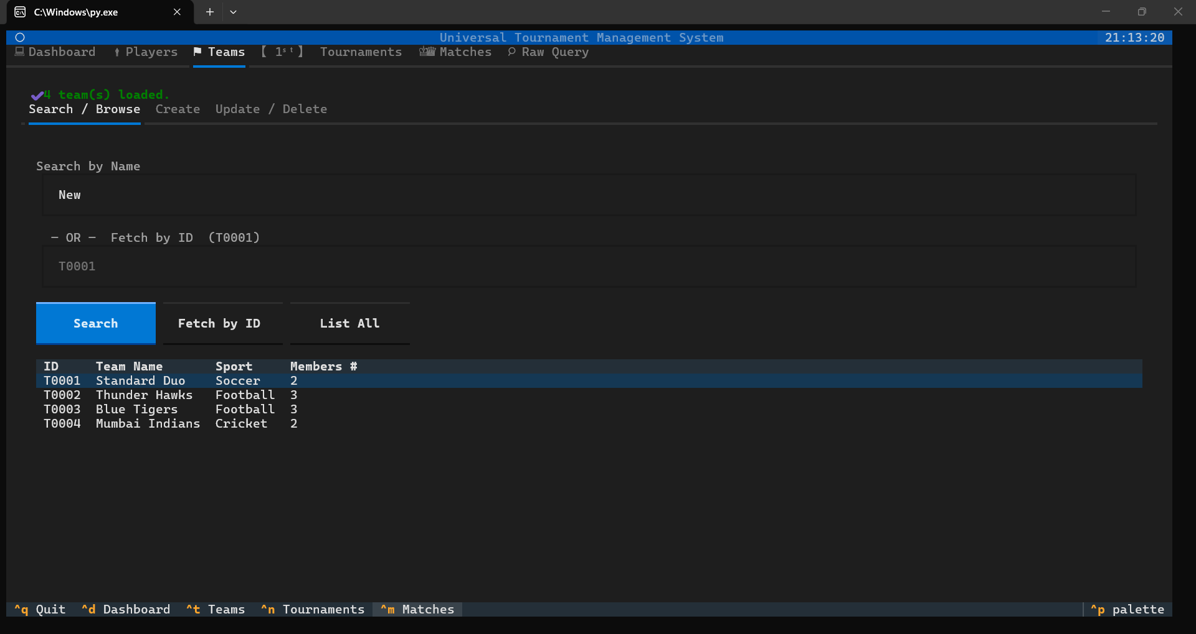

Tournament Management Module
This module manages tournament information.
Stored Information:
- Tournament ID
- Tournament Name
- Sport
- Start Date
- End Date
- Venue
- Participating Teams
- Tournament Type
Functions:
- Create tournament
- Update tournament details
- Delete tournament
- View participating teams
- Generate tournament fixtures

The fixture generation feature helps organizers automatically schedule matches. 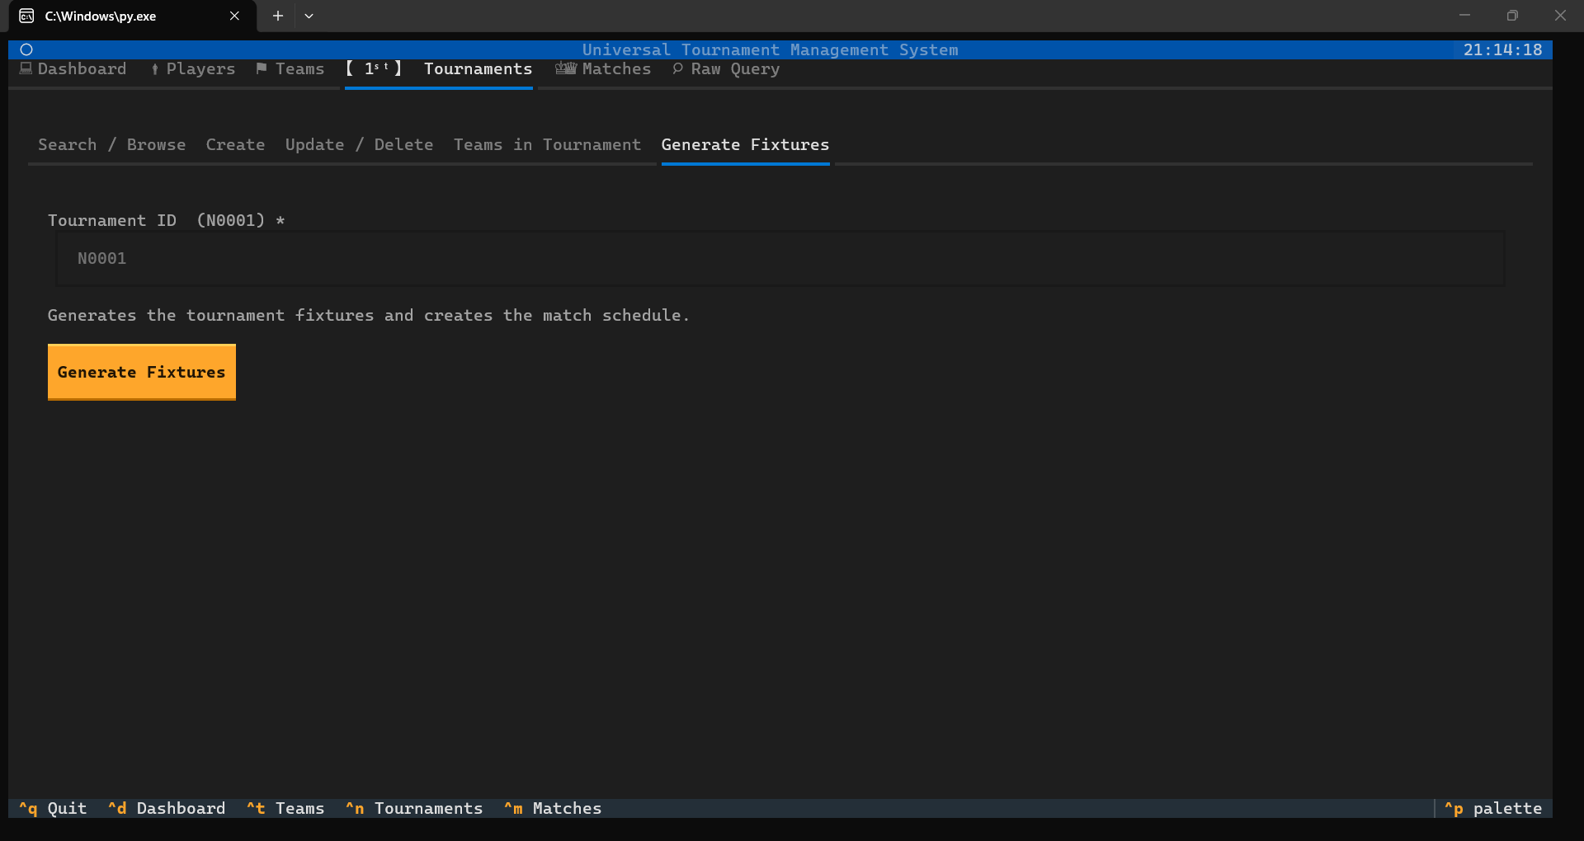

Match Management Module
This module handles all match-related operations.
Stored Information:
- Match Number
- Tournament ID
- Participating Teams
- Match Schedule
- Match Scores
- Match Status
Functions:
- Create match
- Update score
- Start match
- End match
- Delete match
- View match details
Match statuses include:
- Scheduled
- Ongoing
- Completed
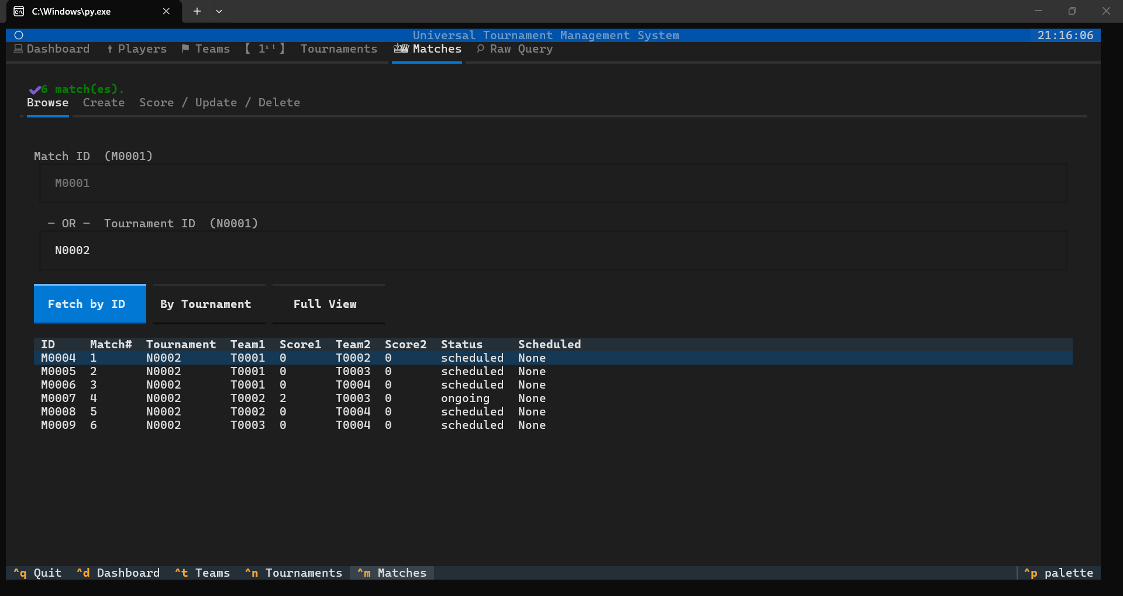

KEY FEATURES OF THE SYSTEM
The Universal Tournament System provides several useful features:
- Complete CRUD operations
- Centralized tournament management
- Player and team registration
- Match scheduling
- Fixture generation
- Score tracking
- Search functionality
- Data validation
- MongoDB integration
- Interactive Terminal User Interface
- REST API architecture
- Real-time record updates
These features help tournament organizers efficiently manage competitions from registration to completion.

OUTCOME OF THE PROJECT
The project successfully achieved its intended goals by providing a fully functional tournament management system.

Results Achieved
- Successful implementation of CRUD operations for all entities.
- Reliable storage and retrieval of tournament data.
- Efficient management of players and teams.
- Automated fixture generation.
- Accurate score tracking and match management.
- Improved organization of tournament information.

Testing Results
The application was tested using sample datasets consisting of players, teams, tournaments, and matches. All major functionalities performed as expected, including data creation, retrieval, updates, deletions, and fixture generation.
The frontend and backend communicated successfully through REST APIs, and all database operations were completed correctly.
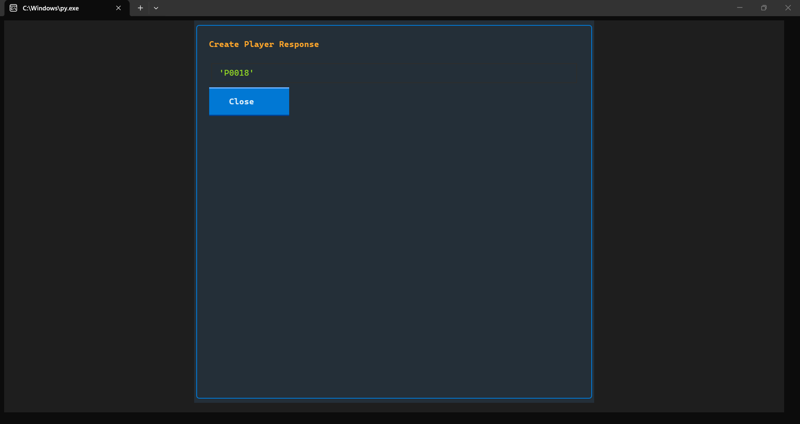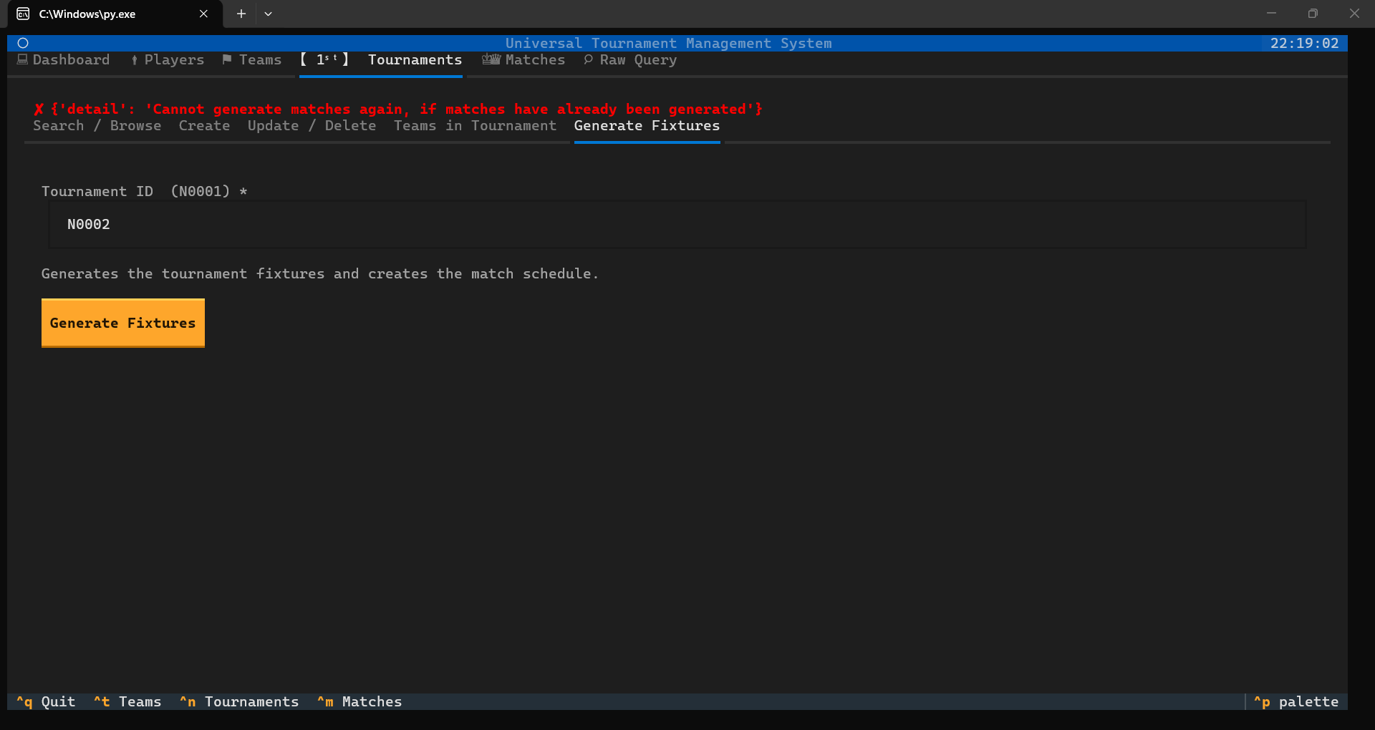
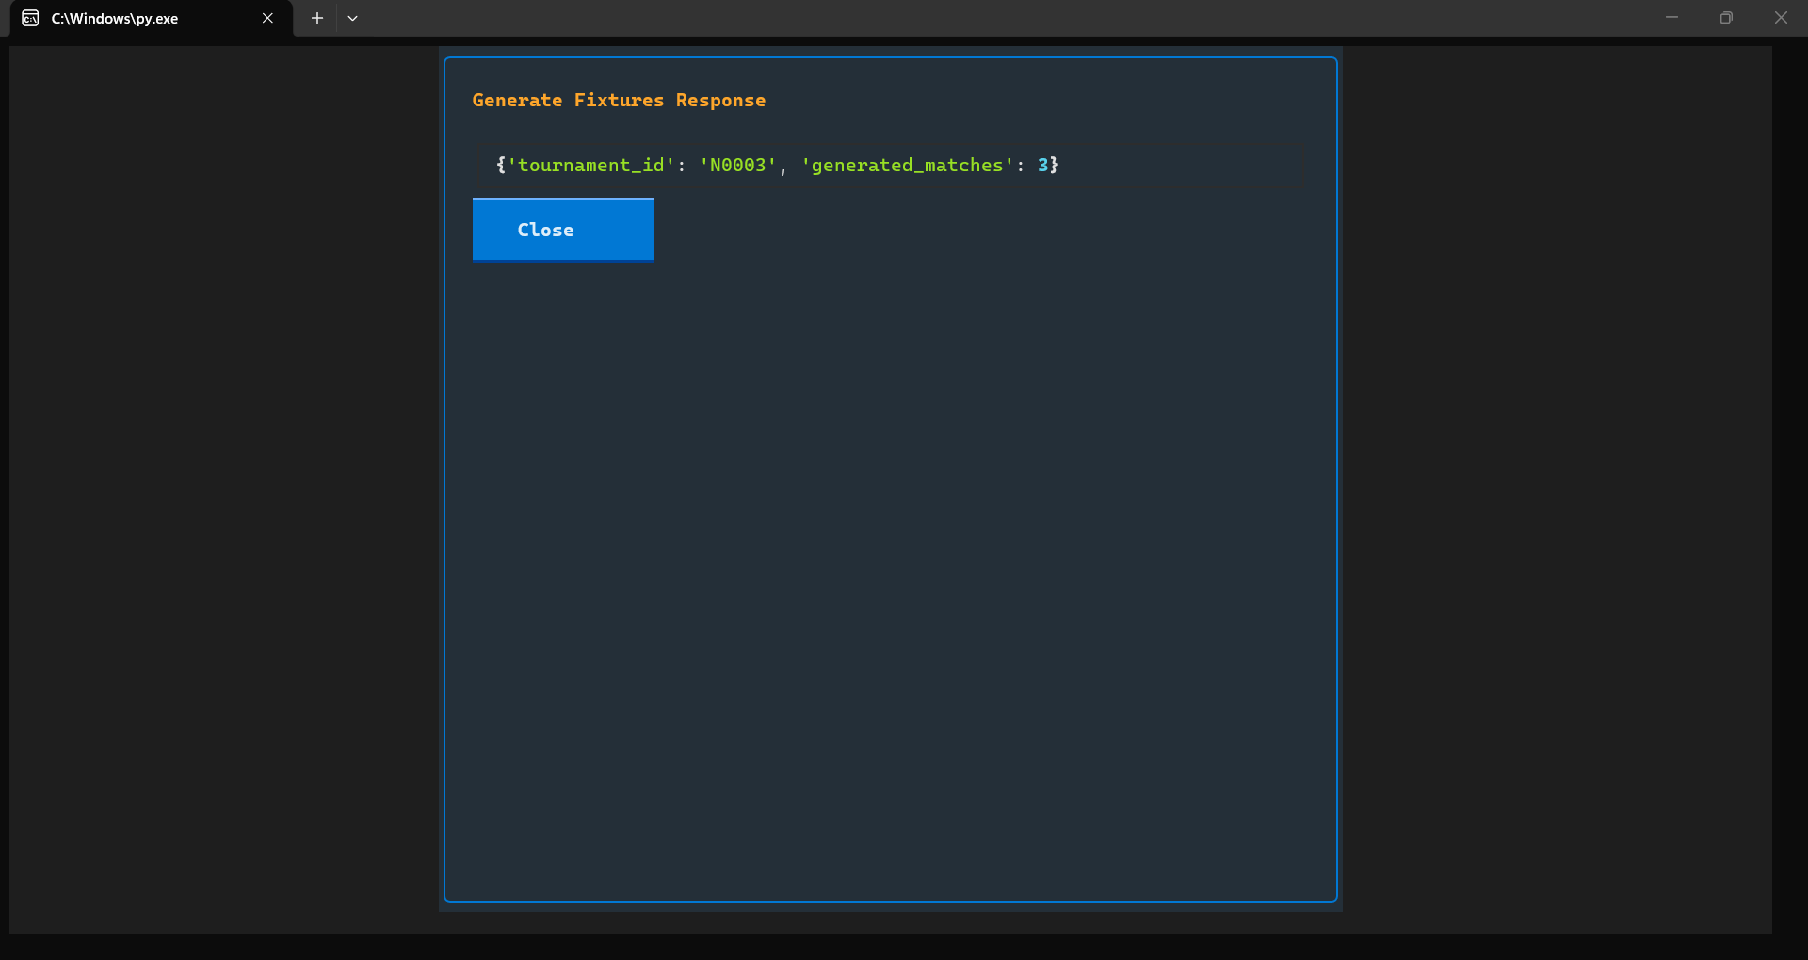
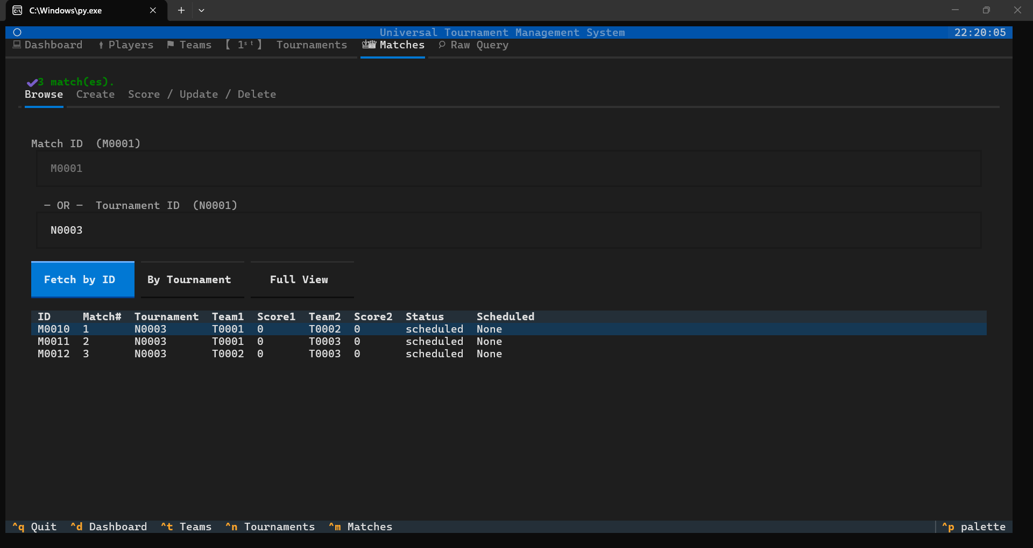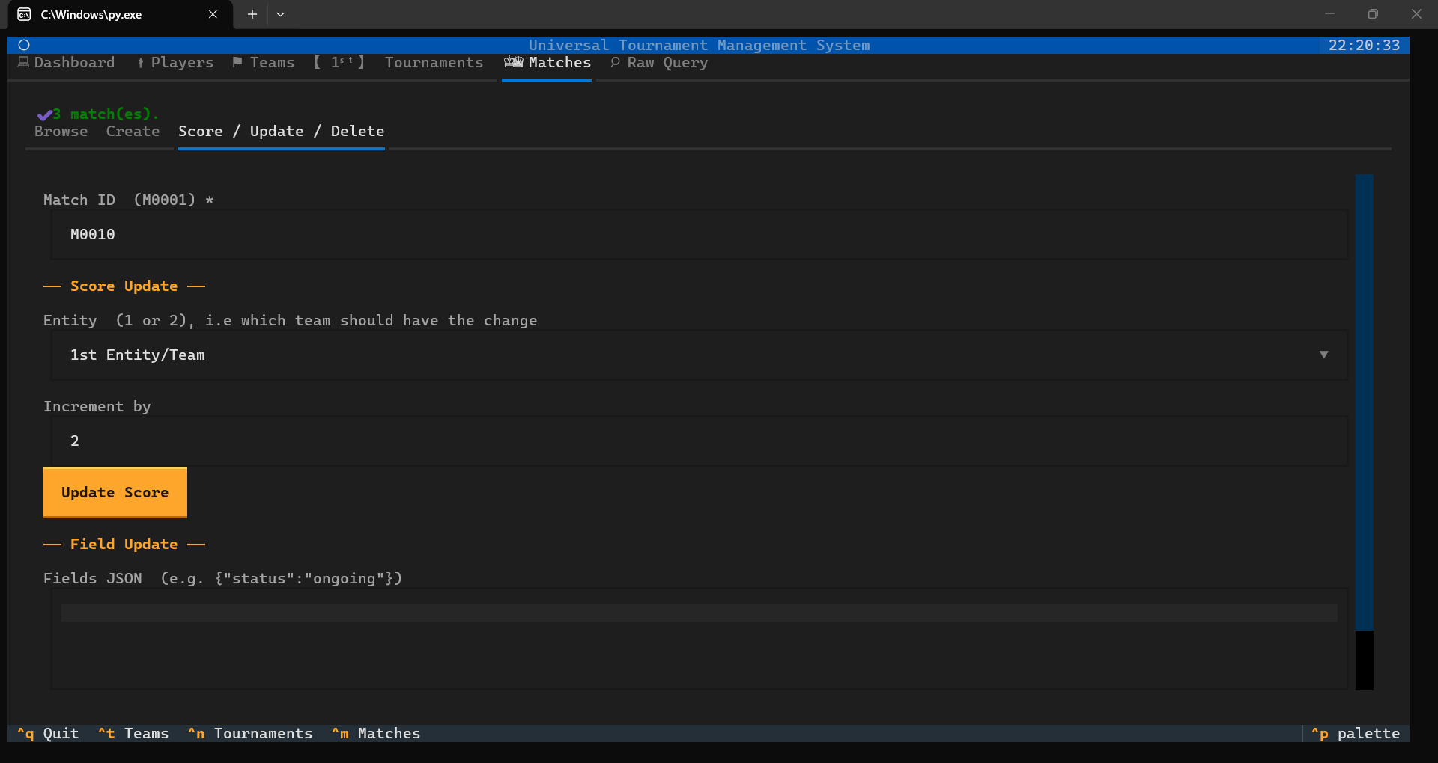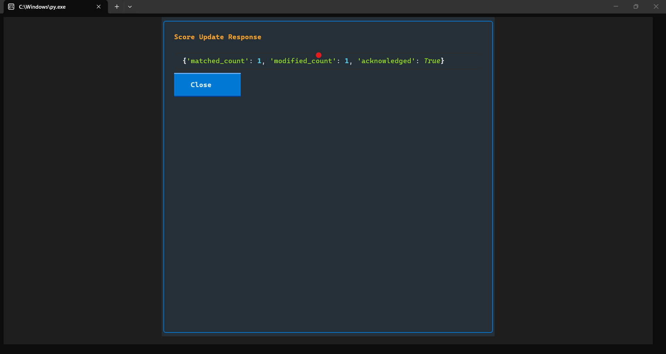

CONCLUSION
The Universal Tournament System (UTS) is a comprehensive software solution developed to simplify tournament administration and management. The project successfully integrates FastAPI, MongoDB, PyMongo, and Textual to provide a complete platform for managing players, teams, matches, and tournaments.
The system automates several administrative tasks that are traditionally performed manually, thereby reducing effort, minimizing errors, and improving efficiency. Through its modular architecture and database-driven design, the application demonstrates practical implementation of modern software development principles.
The project successfully fulfills its objectives and provides a strong foundation for future enhancements. It can be effectively used by educational institutions, sports clubs, community organizations, and event coordinators to manage tournaments in an organized and efficient manner.

