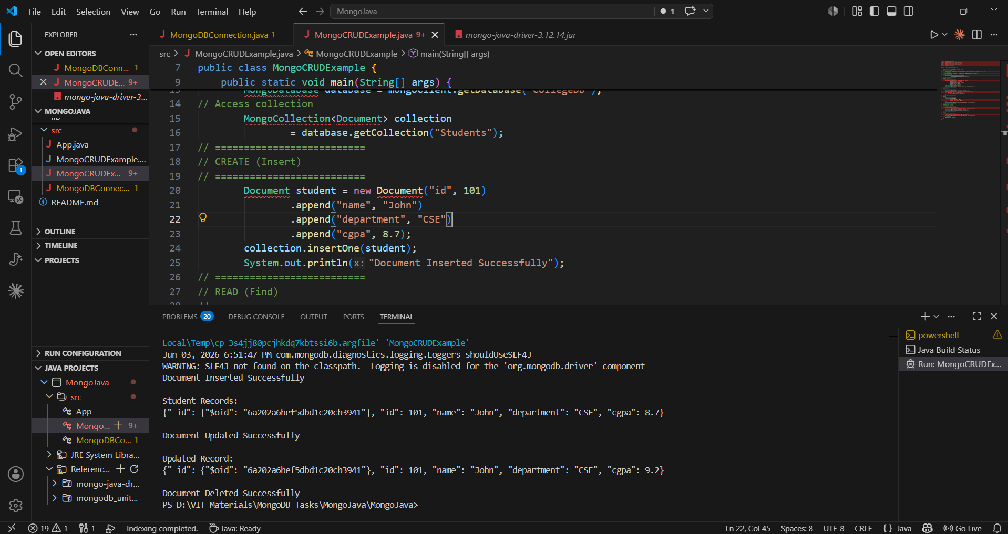
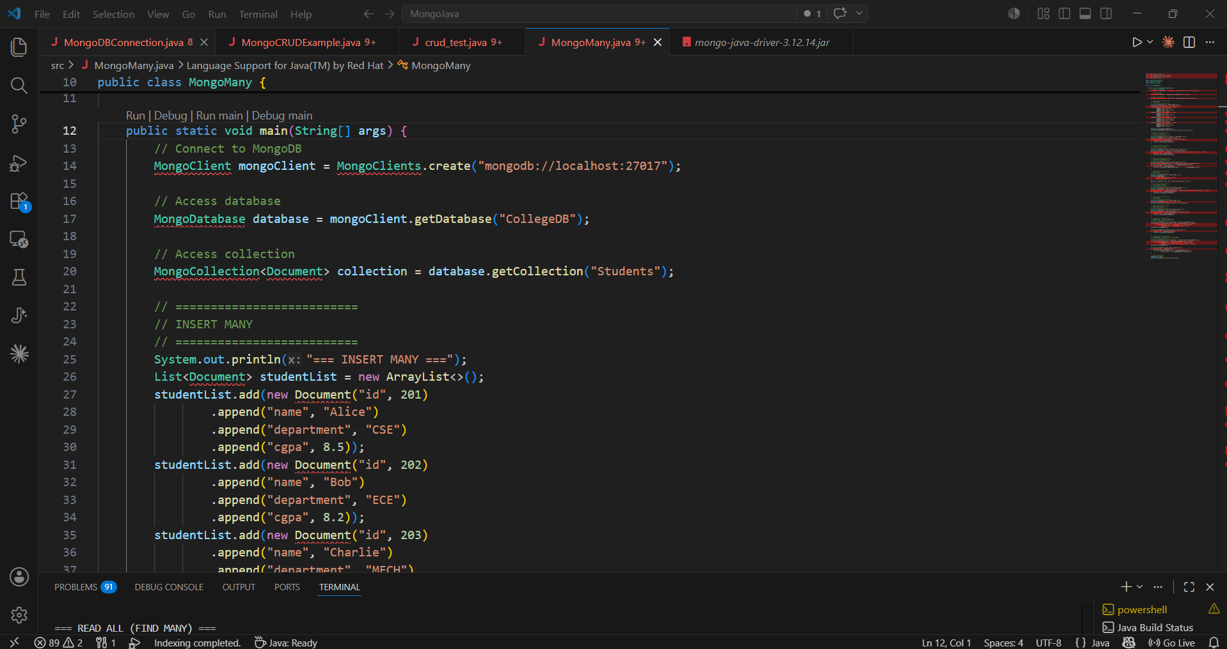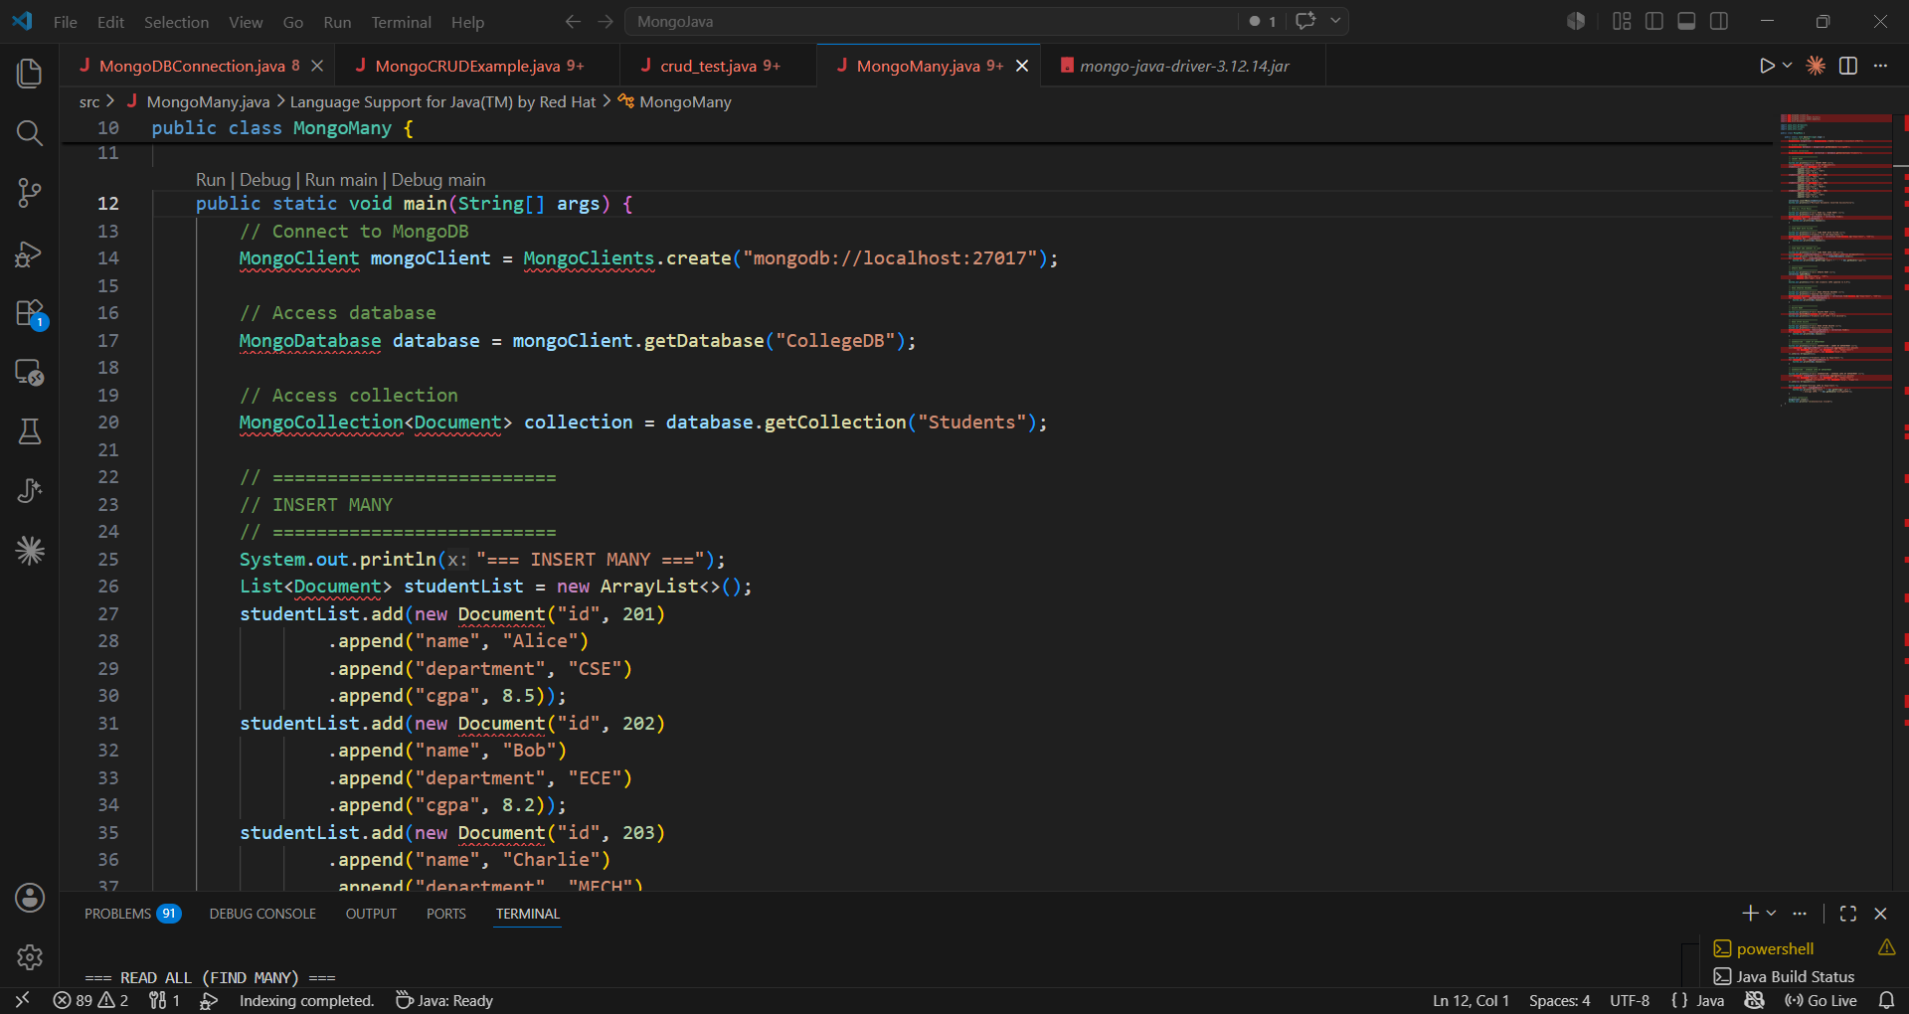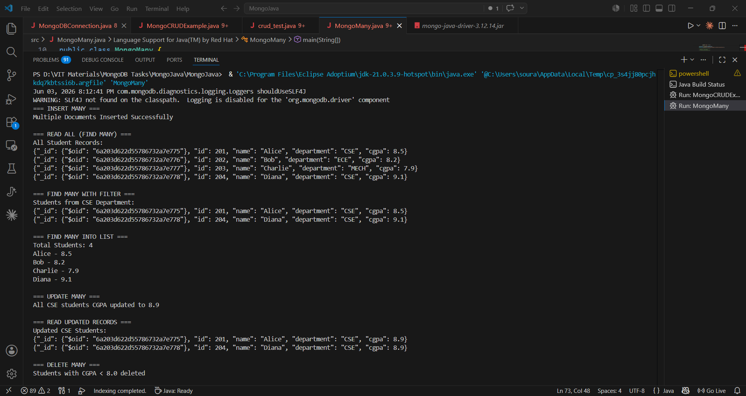
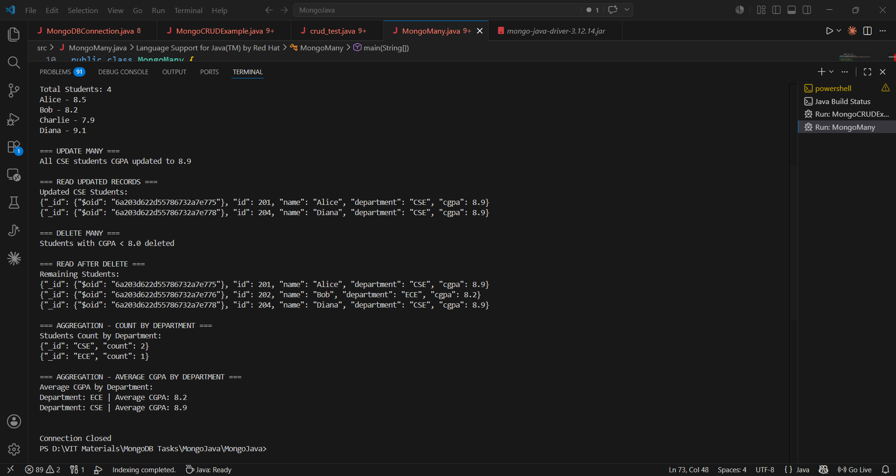
import com.mongodb.client.*;
import com.mongodb.client.model.Filters;
import com.mongodb.client.model.Updates;
import org.bson.Document;

import java.util.ArrayList;
import java.util.Arrays;
import java.util.List;

public class MongoMany {

public static void main(String[] args) {
// Connect to MongoDB
MongoClient mongoClient = MongoClients.create("mongodb://localhost:27017");

// Access database
MongoDatabase database = mongoClient.getDatabase("CollegeDB");

// Access collection
MongoCollection<Document> collection = database.getCollection("Students");

// ==========================
// INSERT MANY
// ==========================
System.out.println("=== INSERT MANY ===");
List<Document> studentList = new ArrayList<>();
studentList.add(new Document("id", 201)
.append("name", "Alice")
.append("department", "CSE")
.append("cgpa", 8.5));
studentList.add(new Document("id", 202)
.append("name", "Bob")
.append("department", "ECE")
.append("cgpa", 8.2));
studentList.add(new Document("id", 203)
.append("name", "Charlie")
.append("department", "MECH")
.append("cgpa", 7.9));
studentList.add(new Document("id", 204)
.append("name", "Diana")
.append("department", "CSE")
.append("cgpa", 9.1));

collection.insertMany(studentList);
System.out.println("Multiple Documents Inserted Successfully");

// ==========================
// READ ALL (Find Many)
// ==========================
System.out.println("\n=== READ ALL (FIND MANY) ===");
System.out.println("All Student Records:");
FindIterable<Document> allStudents = collection.find();
for (Document doc : allStudents) {
System.out.println(doc.toJson());
}

// ==========================
// FIND MANY WITH FILTER
// ==========================
System.out.println("\n=== FIND MANY WITH FILTER ===");
System.out.println("Students from CSE Department:");
FindIterable<Document> cseStudents = collection.find(Filters.eq("department", "CSE"));
for (Document doc : cseStudents) {
System.out.println(doc.toJson());
}

// ==========================
// FIND MANY AND CONVERT TO LIST
// ==========================
System.out.println("\n=== FIND MANY INTO LIST ===");
List<Document> studentDocuments = collection.find().into(new ArrayList<>());
System.out.println("Total Students: " + studentDocuments.size());
for (Document doc : studentDocuments) {
System.out.println(doc.getString("name") + " - " + doc.getDouble("cgpa"));
}

// ==========================
// UPDATE MANY
// ==========================
System.out.println("\n=== UPDATE MANY ===");
collection.updateMany(
Filters.eq("department", "CSE"),
Updates.set("cgpa", 8.9)
);
System.out.println("All CSE students CGPA updated to 8.9");

// ==========================
// READ UPDATED RECORDS
// ==========================
System.out.println("\n=== READ UPDATED RECORDS ===");
System.out.println("Updated CSE Students:");
FindIterable<Document> updatedCseStudents = collection.find(Filters.eq("department", "CSE"));
for (Document doc : updatedCseStudents) {
System.out.println(doc.toJson());
}

// ==========================
// DELETE MANY
// ==========================
System.out.println("\n=== DELETE MANY ===");
collection.deleteMany(Filters.lt("cgpa", 8.0));
System.out.println("Students with CGPA < 8.0 deleted");

// ==========================
// READ AFTER DELETE
// ==========================
System.out.println("\n=== READ AFTER DELETE ===");
System.out.println("Remaining Students:");
FindIterable<Document> remainingStudents = collection.find();
for (Document doc : remainingStudents) {
System.out.println(doc.toJson());
}

// ==========================
// AGGREGATION - COUNT BY DEPARTMENT
// ==========================
System.out.println("\n=== AGGREGATION - COUNT BY DEPARTMENT ===");
List<Document> aggregationResult = collection.aggregate(Arrays.asList(
new Document("$group", new Document("_id", "$department")
.append("count", new Document("$sum", 1)))
)).into(new ArrayList<>());

System.out.println("Students Count by Department:");
for (Document doc : aggregationResult) {
System.out.println(doc.toJson());
}

// ==========================
// AGGREGATION - AVERAGE CGPA BY DEPARTMENT
// ==========================
System.out.println("\n=== AGGREGATION - AVERAGE CGPA BY DEPARTMENT ===");
List<Document> avgCgpaResult = collection.aggregate(Arrays.asList(
new Document("$group", new Document("_id", "$department")
.append("averageCGPA", new Document("$avg", "$cgpa")))
)).into(new ArrayList<>());

System.out.println("Average CGPA by Department:");
for (Document doc : avgCgpaResult) {
System.out.println("Department: " + doc.getString("_id") +
" | Average CGPA: " + doc.getDouble("averageCGPA"));
}

// Close connection
mongoClient.close();
System.out.println("\n\nConnection Closed");
}
}

