ASIA PACIFIC INSTITUTE OF INFORMATION TECHNOLOGY
in collaboration with UNIVERSITY OF STAFFORDSHIRE
DipSEER
Integrating Laptop Camera Data with Wearable Sensors to Identify Zoning Out in Students
A real-time multimodal cognitive focus detection system using SVD-based visual analysis, multiresolution CNN-LSTM physiological inference and dynamic signal-quality adaptive fusion
Author Sarith Kariyawasam
Student ID CB013130
Programme BSc (Hons) Computer Science
Supervisor Mr. Abdul Baasith
Submission Final Year Project — Interim Report
August 2026

DECLARATION OF ORIGINALITY
I hereby declare that this report is my own work and has not been submitted previously for any academic award. Where the work of others has been used it has been acknowledged and referenced in accordance with the Harvard (Cite Them Right) referencing style.
Signature: ______________________________
Date: ______________________________

ACKNOWLEDGEMENT
I thank my supervisor, Mr. Abdul Baasith, for his guidance throughout this project, and the staff of the School of Computing at APIIT for their support. I am grateful to the authors of the DAiSEE and DIPSER corpora for making their data publicly available, without which the machine-learning components of this work could not have been attempted.

ABSTRACT
Mind wandering — the involuntary redirection of attention from a task towards self-generated thought — is a measurable cognitive state and a substantial impediment to learning in online education. Its defining property is that the learner does not notice it, so it cannot be corrected by intention and must be detected externally. Existing systems fail on three counts: they commit to one sensing modality and inherit its blind spot, webcam-based systems in particular being unable to distinguish attention from the fixed unfocused gaze that characterises zoning out; where they combine modalities they depend on research-grade instrumentation students do not own; and they analyse recordings after the fact, so detection cannot become intervention.
This project designed, developed and evaluated DipSEER, a real-time multimodal detection system built on hardware a student is likely already to possess: a laptop webcam and a Samsung Galaxy Watch 7. A visual module detects the face by cascaded Haar classifiers, partitions the ocular region into an 8×8 grid of intensity-energy blocks, maintains a 200-frame matrix of these energies and applies singular value decomposition each cycle, selecting the singular vector of greatest high-frequency amplitude before reducing it to 142 statistical and spectral descriptors for XGBoost classification — a streaming reformulation of a method previously demonstrated only offline. A physiological module reconciles the twenty-to-one sampling-rate mismatch through a two-branch multiresolution CNN-LSTM, each modality convolved at its native rate and pooled twice in parallel, by average and by maximum, before cross-branch fusion. A fusion engine recomputes modality weights every cycle from live signal-quality estimates, extending fixed weighted-fusion strategies into a continuously varying regime. Communication runs over TLS-encrypted WebSockets with zero-configuration UDP discovery, and intervention is delivered as a desktop notification and a wrist haptic pulse.
Evaluation produced a divided result this report states plainly. The architecture meets its requirements: weight adaptation was verified across four sensor-degradation scenarios, sessions re-established automatically across three Wi-Fi networks without configuration, and inference occupies about 100 ms of the one-second budget. Both learning components were found defective, and both defects were diagnosed and corrected before the figures reported here were obtained. The visual classifier initially attained 94.6% accuracy with balanced accuracy of exactly 0.500, assigning all 481 samples to "focused" after a 10% corpus sample left only 26 minority examples; the physiological network attained R² = 0.992, traced to target leakage in which three of four visual inputs were synthesised from the annotation (r ≥ 0.955) and to a validation split taken by array index rather than by participant. Re-extracted across every available minority clip, the visual classifier returns ROC AUC 0.500 ± 0.036 on 936 clips — the SVD descriptor set as implemented does not separate the classes. Supplied with genuine facial features from approximately 49,000 face frames alongside watch telemetry, the physiological network returns R² = −0.060 ± 0.029 under subject-wise cross-validation, negative in all five folds. The project concludes that on these corpora, under this processing, neither modality nor their fusion predicts attention for unseen participants, and offers that well-powered negative result, together with the diagnosis of both original defects, as its most useful evaluative contribution.
Keywords: mind wandering detection, multimodal fusion, singular value decomposition, CNN-LSTM, heart rate variability, wearable sensing, signal-quality adaptive fusion, target leakage.
ACM Subject Descriptors: Human-centred computing → Ubiquitous and mobile computing; Computing methodologies → Machine learning; Applied computing → Education.

TABLE OF CONTENTS
1 INTRODUCTION 1
1.1 Chapter Overview 1
1.2 Problem Background 1
1.2.1 Mind wandering in digital learning 1
1.2.2 Existing approaches 1
1.2.3 Why combine two sensors 1
1.3 Problem Definition 2
1.3.1 Problem statement 2
1.4 Research Motivation 2
1.5 Research Gap 2
1.5.1 Gap 1 — No consumer dual-sensor system for online learning 2
1.5.2 Gap 2 — Detection that cannot happen in real time 3
1.5.3 Gap 3 — SVD eye analysis has never been paired with smartwatch data 3
1.6 Contribution to the Body of Knowledge 3
1.6.1 Contribution to the Research Domain 3
1.6.2 Contribution to the Problem Domain 4
1.6.3 Novelty of the Problem 4
1.6.4 Novelty of the Solution 4
1.7 Research Challenges 4
1.8 Research Questions 5
1.9 Research Aim 5
1.10 Research Objectives 5
1.11 Chapter Summary 7
2 LITERATURE REVIEW 7
2.1 Chapter Overview 7
2.2 Concept Map 7
2.3 Attention Lapses in Self-Directed Digital Learning 8
2.4 Existing Work 9
2.4.1 Review Protocol 9
2.4.2 Vision-Based Detection 10
2.4.3 Physiological Detection 10
2.4.4 Multimodal Systems 11
2.4.5 Intervention Design 12
2.5 Technological Review 12
2.5.1 Signal Acquisition and Face Detection 12
2.5.2 Preprocessing and Signal Conditioning 12
2.5.3 Feature Extraction 13
2.5.4 Class Imbalance 13
2.5.5 Model Architectures 13
2.5.6 Hyperparameter Tuning 14
2.5.7 Fusion Strategies 14
2.6 Evaluation and Benchmarking 15
2.6.1 Metric Selection Under Class Imbalance 15
2.6.2 Validation Protocol and Data Leakage 15
2.6.3 Reported Performance in Comparable Systems 15
2.7 Chapter Summary 17
3 METHODOLOGY 17
3.1 Chapter Overview 17
3.2 Research Methodology 18
3.2.1 Research Philosophy 18
3.2.2 Research Approach 18
3.2.3 Research Strategy 19
3.2.4 Methodological Choice 19
3.2.5 Time Horizon 19
3.2.6 Techniques and Procedures 19
3.3 Development Methodology 20
3.4 Project Management Methodology 22
3.4.1 Gantt Chart 22
3.4.2 Deliverables and Dates 23
3.5 Resources 23
3.5.1 Hardware Resources 23
3.5.2 Software Resources 24
3.5.3 Technical Skills 25
3.5.4 Data Requirements 26
3.6 Risks and Mitigation 27
3.7 Chapter Summary 28
4 SOFTWARE REQUIREMENTS SPECIFICATION 28
4.1 Chapter Overview 28
4.2 Rich Picture Diagram 28
4.3 Stakeholder Analysis 29
4.3.1 Stakeholder Onion Model 29
4.3.2 Stakeholder Viewpoints 30
4.4 Selection of Requirement Elicitation Methodologies 30
4.5 Findings 31
4.5.1 Literature Review 31
4.5.2 Survey 31
4.5.3 Prototyping 32
4.6 Summary of Findings 32
4.7 Context Diagram 32
4.8 Use Case Diagram 33
4.9 Use Case Descriptions 33
4.10 Requirements 34
4.10.1 Functional Requirements 34
4.10.2 Non-Functional Requirements 35
4.11 Chapter Summary 36
5 DESIGN 36
5.1 Chapter Overview 36
5.2 Design Goals 37
5.3 System Architecture Design 38
5.3.1 Architecture Diagram 38
5.3.2 The Four Layers 38
5.4 Detailed Design 39
5.4.1 Choice of Design Paradigm 39
5.4.2 Choice of Programming Model 39
5.4.3 Component Diagram 40
5.4.4 Data Flow Diagram 40
5.4.5 Algorithm Design 41
5.4.6 User Interface Design 44
5.4.7 System Process Workflow 45
5.5 Chapter Summary 45
6 IMPLEMENTATION 46
6.1 Chapter Overview 46
6.2 Technology Selection 46
6.2.1 Technology Stack 46
6.2.2 Data Selection 46
6.2.3 Selection of Programming Language 47
6.2.4 Libraries 47
6.2.5 Frameworks 48
6.2.6 Integrated Development Environments 48
6.2.7 Summary of Technology Selection 48
6.3 Implementation of Core Functionality 49
6.3.1 Offline Training Pipelines 49
6.3.2 Module A — Visual Processing 50
6.3.3 Module B — Physiological Processing and the Watch Application 51
6.3.4 Module C — Quality-Aware Fusion 53
6.3.5 Traceability from Published Method to Implemented Artefact 54
6.3.6 System Evolution 55
6.3.7 Parameter Provenance 55
6.3.8 Deployment and Startup 59
6.4 User Interface 60
6.5 Chapter Summary 61
7 TESTING 61
7.1 Chapter Overview 61
7.2 Objectives and Goals of Testing 61
7.3 Testing Criteria 61
7.4 Model Testing 62
7.4.1 Evaluation Protocol and Metric Selection 62
7.4.2 Module A — Visual Classifier 62
7.4.3 Module B — Multiresolution CNN-LSTM 64
7.4.4 Confusion Matrix, Accuracy, Precision, Recall and F1 66
7.4.5 AUC and ROC Curve 67
7.4.6 A Second Distribution Mismatch in Module A 68
7.5 Benchmarking 68
7.6 Functional Testing 69
7.7 Module and Integration Testing 71
7.8 Non-Functional Testing 73
7.8.1 Accuracy Testing 73
7.8.2 Performance Testing 73
7.8.3 Load Balance and Scalability 74
7.8.4 Security Testing 75
7.9 Limitations of the Testing Process 76
7.10 Chapter Summary 77
8 CONCLUSION 77
8.1 Chapter Overview 77
8.2 Achievement of Research Aims and Objectives 77
8.3 Utilisation of Knowledge from the Course 79
8.4 Use of Existing Skills 79
8.5 Use of New Skills 79
8.6 Achievement of Learning Outcomes 80
8.7 Problems and Challenges Faced 81
8.8 Deviations 82
8.8.1 Scope Related Deviations 82
8.8.2 Schedule Related Deviations 82
8.8.3 Corrections to Attributed Sources 82
8.9 Limitations of the Research 83
8.10 Future Enhancements 83
8.11 Achievement of the Contribution to the Body of Knowledge 85
8.12 Concluding Remarks 85
REFERENCES I
APPENDIX A — SURVEY AND INTERVIEW INSTRUMENTS VI
A.1 Survey instrument VI
B.1 Visual classifier, hold-out protocol VI
B.2 Most influential TSFEL descriptors VI
B.3 Module B per-fold results VI
APPENDIX C — REMAINING USE CASE DESCRIPTIONS VII
C.1 Supporting use cases VIII

LIST OF FIGURES
Figure 2.1 — Concept map of the review, relating the problem domain to the sensing modalities, the…
Figure 3.1 — Project schedule across the seven development phases and the reporting milestones
Figure 4.1 — Rich picture of the DipSEER operating context, showing the two sensor streams converging on…
Figure 4.2 — Stakeholder onion model
Figure 4.3 — Context diagram showing DipSEER as a single process with its six external entities and the…
Figure 4.4 — Use case diagram
Figure 5.1 — Four-layer architecture
Figure 5.2 — The seven main software components and their connections
Figure 5.3 — Data flow from sensor input through seven processes and five stores to the classified state…
Figure 5.4 — Layer structure of the two-branch multiresolution network
Figure 5.5 — Low-fidelity wireframes for the dashboard and the watch face, showing the layout decisions…
Figure 5.6 — One inference cycle, showing the three points where the system adapts to sensor conditions…
Figure 6.1 — The two-branch network definition in train_multiresolution_cnn_lstm.py, showing the…
Figure 6.2 — The streaming SVD inference step in svd_inference.py, which decomposes the 200×64 energy…
Figure 6.3 — The multi-interface UDP beacon in discovery.py, which enumerates every active network…
Figure 6.4 — The quality-adaptive weighting in meta_classifier.py, where the base weights are scaled by…
Figure 6.5 — Behaviour of the weighting
Figure 6.6 — Web dashboard
Figure 6.7 — Watch interface: three elements, one action, no numbers
Figure 7.1 — Visual classifier evaluation
Figure 7.2 — Per-fold coefficient of determination for Module B under subject-wise cross-validation
Figure 7.3 — Branch ablation
Figure 7.4 — Confusion matrix of the first, degenerate evaluation alongside the ROC curve of the…

LIST OF TABLES
Table 1.1 — Mapping of research objectives to research questions and module learning outcomes, showing…
Table 2.1 — Protocol followed in conducting the literature review
Table 2.2 — Reported performance across the comparable systems retained by the review, with modality,…
Table 3.1 — Selection made at each layer of the research onion, with the reason each was preferred to…
Table 3.2 — The seven development phases, with the working increment each delivered and the defect or…
Table 3.3 — Project deliverables with their scope and submission points, the dates to be confirmed…
Table 3.4 — Hardware used, with the role each device plays in development or in the deployed system
Table 3.5 — Software components across the three deployed artefacts and the development toolchain, with…
Table 3.6 — Project risks with likelihood, impact and mitigation
Table 4.1 — Use case description for UC-01, Start Monitoring Session
Table 4.2 — Functional requirements, prioritised under MoSCoW and traced to the elicitation method that…
Table 4.3 — Non-functional requirements by quality category, prioritised under MoSCoW and traced to the…
Table 5.1 — Layer-by-layer design of the two-branch multiresolution network, with the rationale for…
Table 6.1 — Technology occupying each architectural tier across the three deployed artefacts
Table 6.2 — Python libraries on which the backend depends, with the version developed against and the…
Table 6.3 — Frameworks used across the three artefacts, with the version developed against and the role…
Table 6.4 — Summary of technology selection, with the alternative considered and the factor that…
Table 6.5 — Traceability from published method to implemented artefact, showing where each borrowed…
Table 6.6 — Provenance of every constant in the system
Table 7.1 — Pass conditions by test class
Table 7.2 — Visual classifier under stratified five-fold cross-validation over the re-extracted…
Table 7.3 — Correlation of each network input with the target under the original construction,…
Table 7.4 — Module B under subject-wise five-fold cross-validation with genuine facial features and…
Table 7.5 — Branch ablation under subject-wise five-fold cross-validation
Table 7.6 — Confusion matrix of the first Module A evaluation, over the 481 rows extracted from the ten…
Table 7.7 — This project’s measured figures against three published systems
Table 7.8 — Functional test cases, one per requirement in Table 4.2
Table 7.9 — Fusion engine verification
Table 7.10 — Designed module-boundary and integration tests
Table 7.11 — Inference latency on the deployment CPU, by stage
Table 7.12 — Face-detection cost on the deployment CPU over 100 frames at 640 × 480
Table 7.13 — Designed load and scalability tests
Table 7.14 — Designed security tests
Table 8.1 — Each research objective of Section 1.10 against the evidence produced for it and its status
Table 8.2 — Module learning outcomes against the work demonstrating them
Table C.1 — Use case description for UC-04, Detect Mind Wandering.
Table C.2 — Use case description for UC-06, Trigger Intervention Alert.

LIST OF ABBREVIATIONS
Abbreviation | Definition
AUC | Area Under the Curve
ADB | Android Debug Bridge
BLE | Bluetooth Low Energy
CNN | Convolutional Neural Network
CPU | Central Processing Unit
CV | Cross-Validation
DAiSEE | Dataset for Affective States in E-Environments
DFD | Data Flow Diagram
DIPSER | Dataset for In-Person Student Engagement Recognition
EDA | Electrodermal Activity
EEG | Electroencephalography
FFT | Fast Fourier Transform
fNIRS | Functional Near-Infrared Spectroscopy
FR | Functional Requirement
GDPR | General Data Protection Regulation
GPU | Graphics Processing Unit
HR | Heart Rate
HRV | Heart Rate Variability
HCI | Human-Computer Interaction
IMU | Inertial Measurement Unit
LSTM | Long Short-Term Memory
MAE | Mean Absolute Error
MM-SART | Multimodal Sustained Attention to Response Task (dataset)
MoSCoW | Must have, Should have, Could have, Will not have
NFR | Non-Functional Requirement
PPG | Photoplethysmography
PR AUC | Precision–Recall Area Under the Curve
RMSSD | Root Mean Square of Successive Differences
RMSE | Root Mean Square Error
ROC | Receiver Operating Characteristic
ROI | Region of Interest
R-R | Interval between successive heartbeats
SDNN | Standard Deviation of Normal-to-Normal intervals
SRS | Software Requirements Specification
SVD | Singular Value Decomposition
TLS | Transport Layer Security
TSFEL | Time Series Feature Extraction Library
UDP | User Datagram Protocol
UML | Unified Modeling Language
WSS | WebSocket Secure

1 INTRODUCTION

1.1 Chapter Overview
This chapter sets out the problem of mind wandering in online learning, the aim and six objectives, the novelty, the research gap, the contribution and the main engineering challenges.

1.2 Problem Background

1.2.1 Mind wandering in digital learning
Mind wandering — attention shifting from a task to unrelated thought — is a measurable cognitive state with consistent neural markers, not a lack of effort (Kam et al., 2022). Its educational cost is direct: attention lost in a lecture reduces understanding and recall, and the effect builds across a session (Tang and Li, 2024).
Online delivery makes this worse: the lecturer’s read of posture and expression is gone and distractions multiply. Buono et al. (2023) found, across thirty undergraduates in online lectures, that estimated engagement matched self-report at only ρ = 0.39. A mind-wandering learner does not notice at the time and cannot fix it by choosing to concentrate harder, so the prompt must come from outside.

1.2.2 Existing approaches
Three sensing approaches dominate. Brain activity is most direct: Chen et al. (2022) detect mind wandering from EEG on the MM-SART database and Tang, Liang and Li (2023) during video lessons, but electrodes, gel and per-session calibration make EEG unusable for everyday study.
Eye behaviour is less intrusive. Hutt et al. (2024) predicted mind wandering and comprehension errors above chance across 278 participants with WebGazer, a browser-based tracker on an ordinary webcam, removing what they call a forty-thousand-dollar equipment barrier. Lee, H.-H. et al. (2021) separated focused from wandering states by gaze concentration or dispersion. Anh et al. (2024) skipped gaze estimation, applying singular value decomposition to eye-region signals and improving F1 on the non-focused class by seven per cent over an eye-aspect-ratio method. Third, wearables: Gedam and Paul (2021) identify heart rate variability as the most reliable body-based marker of mental load; Gomes et al. (2023) show consumer wrist devices give signals adequate for inferring mental state.

1.2.3 Why combine two sensors
Cameras fail in the case that matters most, a learner facing the screen with open eyes and a wandering mind, and degrade in poor light or at an angle (Li, W. et al., 2021). Body sensors detect arousal but not its cause: a raised heart rate fits concentration, anxiety or a flight of stairs equally well (Gomes et al., 2023). Combining them covers both blind spots: Brishtel et al. (2020) improved F1 from 0.80 and 0.78 separately to 0.83 combined; Liu et al. (2025) reached 76.3% pairing facial analysis with smartwatch data, beating either alone; Asish et al. (2024) found the same in educational virtual reality.

1.3 Problem Definition
Three limitations recur across published systems.
One sensor only. A single channel inherits its blind spot: camera-only systems cannot tell sustained attention from the blank stare of mind wandering (Asish et al., 2024; Brishtel et al., 2020); EEG is accurate but needs hardware no student will wear for two hours (Chen et al., 2022); wearable-only systems watch the body, not the task (Gjoreski et al., 2021).
Laboratory equipment. Combined-sensor systems use laboratory instruments — tethered eye trackers, clinical sensors, research headsets — costing more than most students could justify (Asish et al., 2024; Hutt et al., 2024; Lee, T. et al., 2022).
Analysis after the fact. Most systems process recordings after the session: Brishtel et al. (2020) worked offline and said moment-by-moment detection remained difficult, and Anh et al. (2024) and Liu et al. (2025) used pre-recorded material.

1.3.1 Problem statement
No real-time, non-intrusive system currently combines ordinary webcam facial analysis with consumer wearable body signals to detect mind wandering during study, adjusts each sensor’s trust to its live signal quality, and responds with an immediate prompt.

1.4 Research Motivation
The motivation is partly personal. Studying remotely through a degree taught largely online, I noticed that the moment I lost the thread of a lecture was almost never the moment I realised I had lost it; by the time I noticed, several minutes had gone. Rewinding recovers the content but not the hour. What made this worth building rather than merely complaining about is that the two signals which might catch such a lapse were already sitting on the desk and on my wrist. A laptop has a camera. A smartwatch reports heart rate every second. Neither was bought for this purpose, and nothing else has to be.
The second motivation is that the existing answers are not available to the people who need them. Laboratory work on attention uses eye trackers, chest electrodes and research-grade wristbands, and reports accuracies that consumer hardware has never been asked to match. A method that works only on equipment a student will never own has not solved the student’s problem. Establishing what two ordinary consumer sensors can and cannot do is therefore useful whichever way the answer falls, and this project reports an answer that fell the less convenient way.

1.5 Research Gap
The review in Section 2.4 exposes three gaps.

1.5.1 Gap 1 — No consumer dual-sensor system for online learning
Multimodal attention research depends on equipment students cannot buy and would not wear (Lee, T. et al., 2022). Brishtel et al. (2020), the closest comparable study, reached F1 0.83 with two sensors against 0.80 and 0.78 for each alone, but used a Tobii eye tracker and an Empatica E4 research wristband costing more than the laptop they supplement. Asish et al. (2024) needed a virtual-reality headset with built-in eye tracking, and Hutt et al. (2024) describe their contribution as removing a forty-thousand-dollar hardware barrier.
The one study using consumer hardware, Liu et al. (2025), reached 76.3% accuracy pairing facial analysis with a smartwatch, but was built for the physical classroom, where one fixed camera watches many students and failure modes differ from a single learner at a laptop. No published system detects mind wandering during online lectures with a built-in webcam and a commercial smartwatch, the equipment most remote learners already own.

1.5.2 Gap 2 — Detection that cannot happen in real time
Almost all existing systems analyse a session after it ends, ruling out the only useful response: one delivered while attention is lapsing. Brishtel et al. (2020) worked offline and said moment-by-moment detection remained difficult; Anh et al. (2024) and Liu et al. (2025) used pre-recorded material; Bosch and D’Mello (2021) analysed recorded classroom video. Nor is this limited to small prototypes: Wettstein et al. (2024) ran monitoring on a consumer Apple Watch across 95 patients for at least twelve months each, integrated into hospital systems and tested in a randomised controlled trial, yet deliberately delayed feedback, a clinician reviewing the data and replying later — a loop closing in days rather than seconds, which suggests the gap is structural.
What is missing is a system that streams sensor data, infers a state and prompts during the lapse itself — hence the one-second cycle as a requirement and the prompt as part of the system rather than future work.

1.5.3 Gap 3 — SVD eye analysis has never been paired with smartwatch data
Anh et al. (2024) showed that singular value decomposition of eye-region signals predicts mind wandering well, improving F1 on the non-focused class by seven per cent and ROC AUC by two per cent over an eye-aspect-ratio baseline without gaze estimation or special hardware, which suits this project’s constraints. That work used video alone.
The wearable literature has developed heart rate variability into a reliable indicator of mental load and stress (Gedam and Paul, 2021; Gomes et al., 2023) and confirmed that consumer devices produce adequate signals (Hickey et al., 2021; Sheikh, Qassem and Kyriacou, 2021). No study has combined SVD eye features with smartwatch data, though they cover opposite weaknesses: SVD reads the eye but not the arousal behind a steady gaze, while wrist sensors read arousal but cannot separate concentration from anxiety. This research joins them.

1.6 Contribution to the Body of Knowledge

1.6.1 Contribution to the Research Domain
The research contributes a working implementation of quality-aware sensor fusion for cognitive state classification, and evidence that SVD eye analysis can run continuously on an ordinary processor. Its most substantial contribution is a well-evidenced negative result: Section 7.4 reports a ROC AUC of 0.500 — chance — for the SVD feature set on 936 DAiSEE clips containing every available minority example, and a two-branch network on real facial features and watch data failing to generalise to new participants in all five folds. Both emerged only after fixing the defects that hid them: a 94.6% majority from sampling the corpus too thinly, and target leakage feeding the answer back as an input. The lesson extends to engagement-recognition studies reporting accuracy alone on skewed data and splitting it without holding participants out.

1.6.2 Contribution to the Problem Domain
The project delivers a prototype that captures, combines and acts on two sensors in real time using only a webcam and a smartwatch, showing the sensing, transport and prompting pipeline is achievable on ordinary hardware. Chapter 5 shows its classifiers are not yet trained to a usable standard, so the contribution is a delivery mechanism rather than validated detection. Video is processed in memory and never saved or transmitted, avoiding the privacy objection Section 4.3.2 records as the dominant stakeholder concern.

1.6.3 Novelty of the Problem
Mind wandering has been studied through EEG (Chen et al., 2022; Tang and Li, 2024), facial video (Anh et al., 2024; Lee, T. et al., 2022) and wearables (Gedam and Paul, 2021), but no one has combined an ordinary laptop webcam with a consumer smartwatch in real time during self-directed study. The nearest study, Liu et al. (2025), works in physical classrooms and does not intervene.

1.6.4 Novelty of the Solution
Real-time SVD eye analysis on an ordinary processor. Anh et al. (2024) established the method as an alternative to image-based deep learning, but offline. This work rebuilds it as a continuous computation over a rolling 200-frame window, picking each cycle the singular vector with the highest high-frequency content, so it runs without a graphics card.
Dual pooling applied to cognitive state. The two-branch architecture of John et al. (2021), built for wearable activity sensing, is combined with parallel average and maximum pooling so each branch captures slow trends and sudden spikes.
Quality-aware fusion. Rather than fixing sensor trust during training, the engine recalculates it every cycle from live quality measures, extending Wei et al. (2018) to a continuously changing setting. When the wrist moves and heart-rate quality degrades, the camera gains authority; when the face is blocked, the watch does.

1.7 Research Challenges
Different sampling rates. The webcam produces features at 20 Hz, the watch heart rate at roughly 1 Hz and irregularly, since the sensor depends on skin contact. Resampling either discards visual detail or invents physiological detail, so each sensor keeps its own rate and the two are reconciled inside a two-branch network, following John et al. (2021).
Real-time inference without a graphics card. DirectML TensorFlow on Windows cannot run standard Keras LSTM operations on the GPU, forcing all deep learning onto the processor. With the one-second budget this ruled out the image-based EfficientNet-B0 pipeline originally planned, the change described in Section 8.8.
Imperfect consumer hardware. Laptop webcams are noisy and badly lit, and wrist heart-rate sensors far less precise than a chest strap. The system therefore measures each sensor’s quality rather than assuming clean input, and builds a baseline from the first thirty heart-rate samples — a window the literature supports only at rest and under one statistical criterion, as Section 6.3.3 explains.
Networking without setup. The watch must find and connect securely to the laptop with no configuration, across changing networks, using a UDP broadcast beacon, a stored last-known address, and a self-signed certificate regenerated for whichever network interfaces are active.

1.8 Research Questions
The project is defined by four questions. Answering them is the project; Chapter 7 reports how far each has been answered.
- RQ1 — Can ocular block-energy features derived by singular value decomposition, computed continuously over a rolling window rather than offline over recorded video, separate attentive from inattentive states in webcam footage captured under uncontrolled conditions?
- RQ2 — Does consumer smartwatch photoplethysmography, over the short calibration windows a live system can afford, carry information about attentional state that generalises to people the model has not seen?
- RQ3 — Does combining a visual and a physiological channel improve on either alone, and at which depth — within a single network, or at the decision level with weights that respond to how reliable each sensor currently is?
- RQ4 — Can the whole pipeline, from capture through fusion to intervention, run inside a one-second cycle on an ordinary laptop processor with no accelerator, no external sensor and no configuration by the user?
The four are ordered by dependence rather than by importance. RQ1 and RQ2 ask whether either channel carries a usable signal; RQ3 only becomes meaningful once they are answered, since fusing two uninformative channels cannot produce an informative one; and RQ4 is independent of all three, because a pipeline can meet its timing budget whatever its classifiers conclude. That independence is what allows this report to record an engineering success alongside two null results without contradiction.

1.9 Research Aim
The aim is to design, build and evaluate DipSEER, a real-time system combining webcam visual features with Samsung Galaxy Watch signals through a quality-aware fusion engine and prompting the learner on both devices. It must run on an ordinary laptop processor, complete a sense–decide–act cycle within one second, keep working with reduced confidence when a sensor fails, and process video locally without saving it.

1.10 Research Objectives
The aim breaks into six measurable objectives.
- RO1 — Problem identification. Analyse thirty-five peer-reviewed publications to characterise the shortcomings of existing systems and derive requirements; completed and reported in Sections 1.5 and 2.4.
- RO2 — Visual module. Build a real-time pipeline (Module A) that finds the face, extracts an 8×8 energy grid from the eye region, applies singular value decomposition, derives TSFEL descriptors and classifies focus with XGBoost at 20 frames per second on the processor alone.
- RO3 — Physiological module. Train a two-branch CNN-LSTM (Module B) on the DIPSER dataset, handling the twenty-to-one difference between the 20 Hz visual and roughly 1 Hz heart-rate channels.
- RO4 — Fusion engine. Build a fusion engine (Module C) recalculating each sensor’s trust every cycle from live quality measures, following Wei et al. (2018), and verify it across four sensor-failure scenarios.
- RO5 — Communication and prompts. Build laptop–watch–dashboard communication with automatic network discovery, encrypted transport and native prompts on both devices, connecting with no manual setup across changing networks.
- RO6 — Evaluation. Evaluate the visual model with stratified cross-validation and the physiological model with participants held out, verify the fusion engine under controlled sensor degradation, and measure cycle time against the one-second budget.
Table 1.1 maps each objective to the question it serves and to the module learning outcome it evidences. The learning outcome column is to be completed from the module proforma.
Table 1.1 — Mapping of research objectives to research questions and module learning outcomes, showing which question each objective is designed to answer.
Objective | Serves | Learning outcome | Where evidenced
RO1 — Problem identification | RQ1–RQ4 | [LO1] | Chapter 2; Sections 1.6 and 4.5.1
RO2 — Visual module | RQ1, RQ4 | [LO2] | Sections 5.4.5 and 6.3.2; evaluated in Section 7.4.2
RO3 — Physiological module | RQ2, RQ4 | [LO2] | Sections 5.4.5 and 6.3.3; evaluated in Section 7.4.3
RO4 — Fusion engine | RQ3 | [LO3] | Sections 5.4.5 and 6.3.4; verified in Section 7.7
RO5 — Communication and prompts | RQ4 | [LO3] | Sections 5.3.2 and 6.3.3; tested in Section 7.6
RO6 — Evaluation | RQ1–RQ4 | [LO4], [LO5] | Chapter 7 in full

1.11 Chapter Summary
This chapter established mind wandering as a measurable, costly obstacle to learning and identified three limitations in existing work: one sensor, laboratory equipment, and analysis after the fact. From these came a problem statement, an aim and six objectives, and the novelty of a processor-only streaming SVD pipeline, a dual-pooling two-branch network and a quality-tracking fusion engine. Chapter 2 reviews the literature the project builds on, and Chapter 4 turns this into specified requirements.

2 LITERATURE REVIEW

2.1 Chapter Overview
This chapter examines the evidence behind the claims Chapter 1 stated in outline: the work establishing attention lapse as a measurable and costly state, the published detection systems grouped by sensing modality, the technologies from which a detection pipeline is assembled stage by stage, and the evaluation practices by which such systems are judged.

2.2 Concept Map
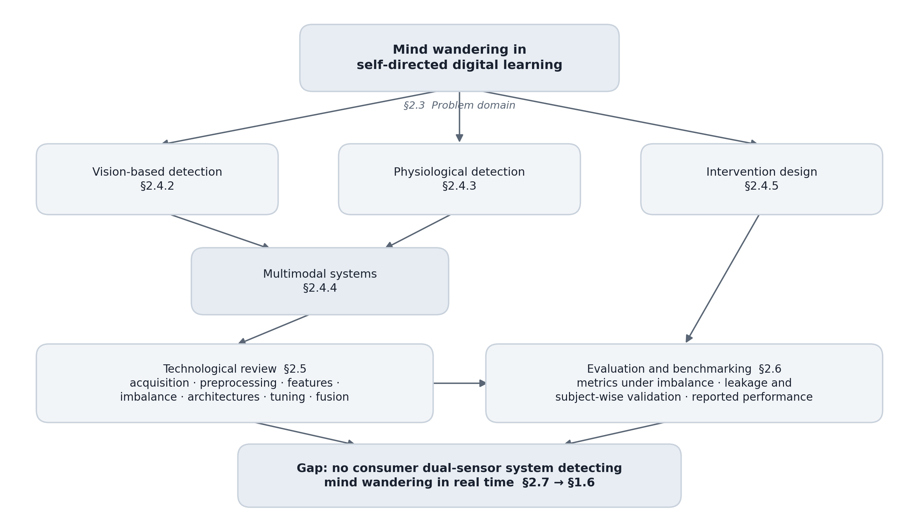
Figure 2.1 — Concept map of the review, relating the problem domain to the sensing modalities, the modelling approaches and the evaluation practices surveyed.
The map places the problem domain at the centre — sustained attention and its lapse during self-directed digital study — and radiates along three branches. The sensing branch divides the surveyed instrumentation into neural, ocular and facial, and peripheral physiological channels, each annotated with what it measures and the hardware it demands, and terminates in the multimodal systems that combine them. The modelling branch follows a signal from acquisition through conditioning, feature construction, class balancing, classification and fusion. The evaluation branch carries metric choice, validation protocol and reported performance, drawn touching every node on the modelling branch rather than hanging off its end. Cross-branch edges record three dependencies: a face detector cheap enough to run continuously, a variability estimate bounded by window length, and a per-channel reliability estimate for any fusion rule.

2.3 Attention Lapses in Self-Directed Digital Learning
Mind wandering is a decoupling, not a deficit: attention is redirected from an external task towards self-generated thought while the task continues, separable from fatigue, from low motivation and from difficulty. Its defining engineering property is that the learner remains physically engaged — seated, facing the screen, eyes open — while attention is elsewhere, so it is invisible to any observer relying on posture. Kam et al. (2022), reviewing the electrophysiological literature systematically, establish that the state carries markers consistent enough across independent experiments to be identified without asking the participant.
Rosenberg (2026) describes sustained attention as varying across a hierarchy of timescales, moment-to-moment shifts on the order of seconds nesting inside slower drifts across a session. Temporal smoothing is therefore a requirement of the interaction rather than a convenience of the model (Section 6.3.4).
The learner cannot supply the label, since one who noticed the lapse as it began would have ended it. Buono et al. (2023) find automatically estimated engagement matched self-report at only ρ = 0.39 across thirty undergraduates. Detection must therefore be external and continuous, and the same unreliability contaminates the training label; Marquez-Carpintero et al. (2025) respond by collecting independent rater annotations, which bounds the noise without removing it.
The cost is cumulative. Tang and Li (2024) quantify it during video-based learning, where attention lost is not recoverable within the session: the material continues whether or not it is processed, and later content depends on earlier content never encoded.
Self-directed online study is the hardest case. No agent external to the learner monitors attention, and the classroom systems — Liu et al. (2025) is the closest — assume one fixed camera observing many students at a consistent angle and distance, a geometry a learner alone at a laptop does not have. The device delivering the material is also the largest source of competing tasks, so a lapse frequently becomes an overt task switch that removes the learner from frame. And there is no probe schedule at deployment, so a system must be trained on corpora collected elsewhere and run unlabelled.
The target state has no distinctive appearance. Bosch and D’Mello (2021) report markers that are reductions in the variability of behaviour — less gaze variation, less head movement, less expression — rather than the presence of any behaviour, so a detector must work on second-order statistics over a window rather than on the content of a frame.
A reduction in eye movement is ambiguous evidence. Palmieri, Fernández and Carrasco (2023) found microsaccade rate falls from a steady 1.8 Hz to roughly 0.3 Hz when a participant expects a cued target, suppression accompanying heightened attention rather than its loss. The two separate by timescale: that suppression lasts a few hundred milliseconds, whereas disengagement produces sustained reduction across seconds with no anticipated event to explain it (Sections 6.3.2 and 8.10).
Individual variation bounds what a population model can achieve, the most consistent finding across every modality surveyed. Tang and Li (2024) report a mean AUC of 0.639 with only about a third of participants above 0.70; Gjoreski et al. (2021) found substantial between-person variation in a wrist-based cognitive-load challenge; Varandas et al. (2022) reached 70.9 ± 13.7% for mental fatigue and required individual tuning. The literature supports a per-participant baseline, which is why Module B normalises heart rate and RMSSD against a personal median (Section 6.3.3).
Peripheral physiology is underdetermined with respect to cognitive state. Gomes et al. (2023) survey what consumer wearables support, and the limit is structural: autonomic arousal is close to a scalar while the states producing it are not, so an elevated heart rate is equally consistent with concentration, anxiety and a flight of stairs. Sheikh, Qassem and Kyriacou (2021) caution that the sensor-to-state mapping is neither simple nor uniform across people.
The base rate works against the classifier. Attentive periods dominate any realistic recording, so the state of interest is the minority class in every corpus; Gupta et al. (2016) illustrate the scale in DAiSEE, where the low-engagement levels are a small fraction of 9,068 clips. A classifier optimising overall accuracy can score well by never predicting the minority class, which makes metric selection substantive (Section 2.6.1) and rebalancing necessary before training (Section 2.5.4).

2.4 Existing Work

2.4.1 Review Protocol
Under the protocol in Table 2.1, thirty-five publications were analysed, drawn from IEEE Transactions on Affective Computing, IEEE Journal of Biomedical and Health Informatics, Behavior Research Methods, NeuroImage, Sensors, IEEE Access and related venues.
Table 2.1 — Protocol followed in conducting the literature review.
Element | Specification
Research question | Which sensing modalities, feature families and fusion strategies have been shown to detect mind wandering or cognitive disengagement, and under what hardware constraints?
Sources | IEEE Xplore, ScienceDirect, MDPI, SpringerLink, PubMed Central and arXiv, supplemented by backward citation chaining from the papers retained.
Search terms | Combinations of “mind wandering”, “attention detection”, “student engagement”, “cognitive load” with “EEG”, “eye tracking”, “facial video”, “wearable”, “heart rate variability”, “multimodal fusion”.
Inclusion criteria | Peer-reviewed; reports an automated detection or estimation method, a dataset, or a systematic review of these; sensing modality relevant to webcam or wrist-worn hardware.
Exclusion criteria | Purely psychological studies with no computational component; systems requiring implanted or clinical-only instrumentation; work not available in English.
Date range | 2016 to 2025, extended backwards where a work is the standard reference for a technique still in use.
Retained | 35 publications, analysed thematically under the eight headings below.

Screening was performed by a single reviewer, so inter-rater reliability could not be assessed.
The thematic grouping followed the familiarisation-and-coding procedure of Braun and Clarke (2006): each publication was read in full and coded for sensing modality, feature family, model class, corpus and validation protocol, and the codes collapsed into the eight headings of Sections 2.4.2 to 2.6. Further sources are cited below without having entered the thematic set.

2.4.2 Vision-Based Detection
Eye behaviour is the best-validated non-invasive signal. Hutt et al. (2024) predicted mind wandering and comprehension errors above chance from webcam eye tracking across 278 participants, removing a forty-thousand-dollar hardware barrier, but report lower performance for participants identifying as Black or African American. Lee, H.-H. et al. (2021) separated concentrated from spread-out looking as a marker of focus. DuTell et al. (2024) mark the modality’s upper limit, synchronising ten cameras at over 700 MB/s for 0.25° accuracy.
Anh et al. (2024) provide the method this project builds on: rather than estimating gaze, they decompose eye-region variation with singular value decomposition and classify the resulting descriptors, improving F1 on the non-focused class by seven per cent and AUROC by two per cent over an eye-aspect-ratio baseline, without special hardware and offline on recorded video.
Bosch and D’Mello (2021) established detection from facial video in laboratory and classroom conditions, the basis for the measures of Section 6.3.2; Lee, T. et al. (2022) improved detection during online lectures; Buono et al. (2023) split facial behaviour into gaze direction, head pose and seventeen facial actions, each through its own network, reporting MSE 0.077; and Sukumaran and Manoharan (2024) recognise engagement from compact facial descriptors, the idea behind the four-element vector passed between Modules A and B.
Li, W. et al. (2021) enumerate the conditions under which appearance-based vision degrades — changing light, blocked view, awkward angle — all recurring for a learner at a laptop, and Hasan et al. (2024) show behaviour-interpreting models outperform appearance matching.

2.4.3 Physiological Detection
Brain activity remains the most direct route and the least deployable. Chen et al. (2022) built an entropy-assisted detector on the MM-SART database; Tang, Liang and Li (2023) detect the state during video lessons from scalp recordings; and Tang and Li (2024) show one entropy measure matching band-power features without eye-artefact removal, at mean AUC 0.639. Electrodes, gel and per-session calibration place EEG outside everyday study.
Gedam and Paul (2021) identify heart rate variability and skin conductance as the most reliable body-based markers of stress, engineered features outperforming learned representations because the response to mental load is subtle. Gomes et al. (2023) confirm consumer devices support mental-state classification with stress accuracies often above ninety per cent. Hickey et al. (2021) and Sheikh, Qassem and Kyriacou (2021) survey smart devices, environmental and smartphone sensing for mental-health monitoring, both cautioning that the sensor-to-state link is neither simple nor uniform.
Against cognitive rather than affective targets, wrist sensing performs modestly. Gjoreski et al. (2021), across twenty-three participants, report the best entries near 69% accuracy with substantial between-person variation, and Varandas et al. (2022) detected mental fatigue with a wearable optical sensor, requiring individual tuning. Rykov et al. (2024) predicted cognitive test scores from wearable features in a clinical trial, and Li, A. et al. (2023) reached 88.9% by combining wearable data with digital cognitive tests, an active task supplying information no passive sensor has.
Kargarandehkordi et al. (2025) analyse forty-eight studies fusing wearable biosensors with machine learning and identify limited real-world validity, mixed data, small samples and battery drain as recurring obstacles; Shajari et al. (2023) note machine learning is increasingly needed to correct interference in the raw signal. Adherence is not among the obstacles: Wettstein et al. (2024) report an Apple Watch across 95 patients in a randomised controlled trial producing sensor data on 78% of days over roughly thirteen months, with a usability score of 78 and 87% reporting daily-routine fit.

2.4.4 Multimodal Systems
Wei et al. (2018) provide this project’s foundation, each channel contributing in proportion to its reliability, with weights computed offline. John et al. (2021) process sensors sampled at different rates in separate branches at their native rates, the structure adopted for Module B. Najafi et al. (2023) found combining processed features beat combining raw signals for driver engagement, 82.0% against 74.0%, and Woo et al. (2018) supply the ablation justifying parallel average and maximum pooling.
Outside the cognitive domain, camera-and-wearable fusion is mature: Wei, H., Jafari and Kehtarnavaz (2019) combined video with inertial sensing for action recognition; Bijalwan, Semwal and Mandal (2021) a depth camera with a motion unit for gait analysis; and Park et al. (2025) released a dataset pairing infrared imaging with wearable armband sensors, motivated by privacy.
Applied to attention, fusion beats its components by margins that are real but small. Brishtel et al. (2020) combined eye tracking with a skin-conductance sensor during reading, improving F1 from 0.80 and 0.78 separately to 0.83 together. Asish et al. (2024) classified internal against external distraction in educational virtual reality, and Liu et al. (2025) reached 76.3% accuracy on individual attention by combining facial analysis with smartwatch data, in a physical classroom and after the fact. No study in the retained set closes the loop from detection to intervention in real time.
Gupta et al. (2016) introduced DAiSEE: 9,068 clips from 112 subjects rated for boredom, engagement, confusion and frustration under uncontrolled conditions, mapped to two classes in Section 6.2.2. Marquez-Carpintero et al. (2025) released DIPSER, capturing in-person engagement with synchronised smartwatch data, several camera angles and independent rater annotations; it is the only public corpus pairing engagement annotation with Samsung watch telemetry, and supplies Module B’s training data.

2.4.5 Intervention Design
Detection is the studied half of the problem and intervention the neglected one: almost every system in the retained set terminates at a classification, and in Wettstein et al. (2024) feedback is routed through a clinician who replies later, so the loop closes in days.
Remache-Vinueza, Trujillo-León and Vidal-Verdú (2025) place the duration at which a vibrotactile stimulus stops being felt as a discrete pulse and becomes continuous vibration near 30 ms, roughly constant from 40 to 590 Hz. Kargarandehkordi et al. (2025) identify battery drain as a recurring obstacle, limiting how often a device may be woken, and Park et al. (2025) show privacy is a first-order design driver.
Neither Wettstein et al. (2024) nor Hickey et al. (2021), surveying consumer smart devices, addresses the tolerability of an unsolicited interruption, and no study in the retained set reports a tolerable alert frequency for attention prompting; the cooldowns in Section 6.3.4 are therefore set by judgement and Appendix A.1 asks respondents for one directly.

2.5 Technological Review

2.5.1 Signal Acquisition and Face Detection
The face detector is the largest continuous cost in the pipeline, running on every frame while inference runs once per second. Cascaded Haar classifiers cost a small fixed amount per frame with no accelerator and are weakest under head rotation; MediaPipe-style landmark pipelines return a dense face mesh at substantially higher cost; neural detectors are the most robust to pose, occlusion and illumination and the most expensive, the vision-language models Hasan et al. (2024) apply to driver behaviour sitting at the far end of that scale.
The trade is decided by duty cycle. At 20 frames per second a detector costing 30 ms per frame consumes roughly 60% of one core continuously, which is what Section 7.8.2 measures for the cascade used here. Cascading frontal, profile and flipped detection recovers the learner turned towards a second monitor, and caching the previous detection exploits the slow movement of a seated face.

2.5.2 Preprocessing and Signal Conditioning
Anh et al. (2024) crop the eye region and partition it into an 8×8 grid, summing squared intensity within each block to give a 64-element vector per frame, invariant to multiplicative illumination change once normalised and of a length fixed by the grid rather than the crop. The region may be defined by an eye-detector cascade, as in the source method, or by a cheaper fixed geometric band proportional to the face box; Section 7.4.6 examines that divergence. Palmieri, Fernández and Carrasco (2023) measure a microsaccade rate near 1.8 Hz, placing the Nyquist limit at about 4 Hz and making 20 frames per second a fivefold margin.
Standard practice computes heart rate variability over five minutes. Kim, Seok and Shin (2021) test how far the window can shorten before each metric stops matching a 300-second reference: under a 50% limits-of-agreement test at rest, SDNN holds from 30 seconds and RMSSD from 10; under the stricter Cohen’s d test the same data give 60 and 240 seconds; under exercise the requirement for RMSSD lengthens to 240 seconds. Taoum et al. (2022) add the sensor-type dimension: of 48 measures, 37 agreed over five and a half minutes but only 16 remained valid at 90 seconds, and SDNN survived where RMSSD did not.
Kazijevs and Samad (2023), benchmarking deep imputation for missing values in health time series, document how filling a gap with a constant distorts what follows, since the model cannot distinguish an imputed value from an observed one; Section 6.3.3 records that this system imputes a median vector and that its masking layer is inert.

2.5.3 Feature Extraction
Singular value decomposition factors a window of frames into components ordered by the variation each explains, and the interesting component here is not the largest. Anh et al. (2024) stack per-frame ocular energy vectors into a matrix, decompose it, and select among the resulting vectors by high-frequency content rather than by singular value, slow components carrying posture drift and illumination change while the fast component carries eye movement. A 200×64 matrix decomposes in the 5.3 ms Section 6.3.4 measures.
The selected vector is a one-dimensional series, which automated descriptor libraries describe exhaustively — wavelet energies, spectrogram coefficients, linear predictive coding coefficients, distribution moments. Anh et al. (2024) use exactly this construction, and this project adopts the same library and descriptor groups so that the comparison is meaningful rather than approximate.
Sukumaran and Manoharan (2024) instead compress an image into a handful of interpretable scalars, which is what makes a visual signal cheap enough to pass into a second model; this project reduces Module A’s state to four scalars.

2.5.4 Class Imbalance
The minority class is small because the phenomenon is rare, so the imbalance cannot be collected away. Wongvorachan, He and Bulut (2023) compare undersampling, oversampling and SMOTE on educational data mining tasks and report oversampling outperforming undersampling at comparable imbalance — direct evidence against the strategy used here, Section 6.2.2 retaining all 234 minority clips and drawing three times that number of majority clips from a 9,068-clip corpus. Section 8.10 records the 1:3 ratio as a value fixed without a sweep.
Thölke et al. (2023) show for brain-decoding tasks that classifier choice and metric choice jointly determine whether an imbalanced result is interpretable at all: rebalancing the data changes what the model learns, while changing the metric changes only what is reported.

2.5.5 Model Architectures
Gradient-boosted trees suit a wide, correlated, engineered feature set: hundreds of descriptors correlated by construction, a condition under which boosted trees need no prior feature selection. Shwartz-Ziv and Armon (2022) tested this class against several proposed deep architectures and found XGBoost outperformed them across the datasets, including the datasets used in the papers proposing those models, while requiring markedly less hyperparameter tuning — a property that matters for a project which performs no search. Gjoreski et al. (2021) report the strongest challenge entries used classical classifiers over engineered features, and Gedam and Paul (2021) attribute the same preference to the subtlety of the physiological response.
Physiological time series call for a different model class. Convolution along the time axis extracts local shape and a recurrent layer accumulates the result across the window, the combination Najafi et al. (2023) apply to multi-sensor driver engagement and John et al. (2021) to wearable sensing. John et al. contribute multiresolution branch separation: each modality is convolved at its own native rate in its own branch, the branches joining only after each is reduced to a fixed-length summary, since upsampling a 1 Hz heart-rate stream to 20 Hz invents detail never measured and downsampling a 20 Hz visual stream discards the eye dynamics the channel exists to capture.
Woo et al. (2018) apply average and maximum pooling in parallel within CBAM, reporting on ResNet-50 over ImageNet-1K that average alone gives 23.14% error, maximum alone 23.20% and both together 22.80%, against a 24.56% baseline. Later work does not settle the question. Nirthika et al. (2022), surveying pooling and testing a selected set empirically, conclude that the appropriate operation depends on the scale of class-specific features relative to the input and that no single choice is universally best, so the parallel arrangement is an engineering choice awaiting its own ablation rather than a borrowed result. The transfer is partial, CBAM pooling across spatial dimensions to generate attention weights where this network pools across time (Section 6.3.1).

2.5.6 Hyperparameter Tuning
What Kapoor and Narayanan (2023) document as a recurring cause of irreproducible results is not the choice between grid, random and adaptive search but tuning against the same data used to report performance. Thölke et al. (2023) add that under imbalance the objective the search optimises is itself a decision, and Wongvorachan, He and Bulut (2023) imply that the balancing strategy and its ratio belong inside the search.
This project performed no hyperparameter search: every value in both models is a library default or a conventional starting point, as Table 6.6 records, and Section 8.10 records a proper nested search as required work.

2.5.7 Fusion Strategies
Fusion happens at one of three depths: data-level concatenates raw signals before any processing; feature-level concatenates per-modality descriptors; decision-level runs a separate model per modality and combines their outputs, forfeiting cross-modal interaction but making each channel independently trainable, testable and disableable when its sensor fails. Najafi et al. (2023) report 82.0% for feature-level against 74.0% for data-level fusion. For a real-time system with intermittent sensors the argument for fusing late is structural: a decision-level architecture keeps operating at reduced confidence when the watch is removed or the face leaves frame.
Wei et al. (2018) weight each channel of a multichannel physiological emotion recogniser according to its assessed reliability, computed offline; that treats reliability as a property of the channel, whereas in a deployed system it is a property of the moment. Zhu et al. (2023) take the later position, regressing a confidence estimate for each modality and weighting the modalities by it rather than by a fixed prior, which is the arrangement this project adopts. Recomputing the weights each cycle requires every module to expose a quality index alongside its prediction. John et al. (2021) supply the complementary mechanism inside a single model, and the same general form appears in Wei, H., Jafari and Kehtarnavaz (2019), Bijalwan, Semwal and Mandal (2021) and Park et al. (2025).

2.6 Evaluation and Benchmarking

2.6.1 Metric Selection Under Class Imbalance
Accuracy is uninformative where one class dominates: on a set that is 94.6% majority, a model assigning every sample to the majority class scores 94.6%. Thölke et al. (2023) show for brain decoding that classifier and metric choice interact under imbalance, and recommend measures insensitive to the class ratio. Balanced accuracy — the mean of per-class recall — reduces to 0.500 for the degenerate majority classifier. ROC AUC is invariant to the class ratio and reports ranking quality independently of any threshold; precision–recall AUC is not, its baseline being the minority prevalence rather than 0.5.
A model may rank correctly while producing scores concentrated near the extremes, which matters because the fusion engine combines probabilities numerically rather than combining ranks. Ojeda et al. (2023) compare calibration methods for probability estimation across machine-learning approaches; any such method must be fitted on held-out data.

2.6.2 Validation Protocol and Data Leakage
Kapoor and Narayanan (2023) survey machine-learning-based science across disciplines and find leakage — the contamination of evaluation by information unavailable at deployment — to be a systematic cause of irreproducible results. Three mechanisms bear on this project: target leakage, where a feature is derived from the label; train–test contamination, where the same information appears on both sides of a split through duplicated records, preprocessing fitted before the split, or hyperparameter selection against the test set; and illegitimate feature availability, where a feature could not be computed at prediction time.
In physiological and behavioural sensing the form contamination takes is subject leakage: consecutive samples from one participant are highly correlated, so a split drawn by row index or random shuffle places one participant’s samples on both sides and the model need only recognise the participant to predict the label. Subject-wise splitting is the only protocol measuring what a deployed system faces. Section 7.4.3 reports both defects in this project’s physiological model, and Appendix B.3 shows the signature — R² above 0.98 in every one of five folds.

2.6.3 Reported Performance in Comparable Systems
Table 2.2 collects what the surveyed systems report. The figures are not directly comparable and the table is not a ranking: the targets differ, mind wandering, engagement, cognitive load, mental fatigue and distraction being related but distinct constructs; the corpora differ in size by two orders of magnitude; and the class balance differs.
Table 2.2 — Reported performance across the comparable systems retained by the review, with modality, corpus and the validation basis recorded during screening. A dash marks a value this review did not record; it is not a statement that the source omitted it.
System | Modality | Corpus / participants | Reported figure | Validation basis recorded
Chen et al. (2022) | EEG | MM-SART database | Entropy-assisted detection of mind wandering | —
Tang and Li (2024) | EEG | Video-based learning | Mean AUC 0.639; about a third of participants above 0.70 | Per-participant; no eye-artefact removal required
Tang, Liang and Li (2023) | EEG | Video lessons | Detection of the state during video-based learning | —
Hutt et al. (2024) | Webcam eye tracking | 278 participants | Above chance for mind wandering and comprehension errors; lower for participants identifying as Black or African American | Reported by participant subgroup
Anh et al. (2024) | Facial video, SVD descriptors | Recorded online-learning video | +7% F1 on the non-focused class and +2% AUROC over an eye-aspect-ratio baseline | Offline batch processing of recordings
Buono et al. (2023) | Gaze, head pose, 17 facial actions | 30 undergraduates, online lectures | MSE 0.077; estimated engagement against self-report ρ = 0.39 | —
Bosch and D’Mello (2021) | Facial video | Laboratory and classroom | Detection established in both settings | Lab and classroom conditions compared
Gjoreski et al. (2021) | Wrist wearable | 23 participants | Best entries near 69% accuracy; substantial between-person variation | Machine-learning challenge protocol
Varandas et al. (2022) | Wearable optical (fNIRS) | Cognitive fatigue task | 70.9 ± 13.7% accuracy | Required individual tuning
Li, A. et al. (2023) | Wearable plus digital cognitive tests | Cognitive impairment screening | 88.9% | —
Brishtel et al. (2020) | Eye tracking plus EDA | Multimodal reading task | F1 0.83 combined against 0.80 and 0.78 separately | Offline; moment-by-moment detection reported as still difficult
Najafi et al. (2023) | Multi-sensor, driver | Driver mental engagement | 82.0% feature-level against 74.0% data-level fusion | Fusion levels compared on the same data
Liu et al. (2025) | Facial analysis plus smartwatch | Face-to-face classroom | 76.3% on individual attention | Offline, after the session
Wettstein et al. (2024) | Consumer smartwatch | 95 patients over ~13 months | Sensor data on 78% of days; usability 78; 87% reporting daily-routine fit | Randomised controlled trial

Three patterns emerge. Reported performance clusters between roughly 65% and 80% wherever the target is a cognitive state, the evidence comes from a passive sensor and participants are treated as a population; the figures above that band belong to systems using an active cognitive test or a task that is not attentional. Between-person variation is large wherever it is measured. And the validation column is the sparsest in the table: where a protocol was recorded it was frequently a single split or an unspecified cross-validation, so a figure reported without a stated subject-wise protocol cannot be assumed to describe generalisation to new people.

2.7 Chapter Summary
The review establishes five things. Mind wandering is a physically marked state detectable without asking the learner (Kam et al., 2022), fluctuating across a hierarchy of timescales whose fastest layer is measured in seconds (Rosenberg, 2026), and costing comprehension cumulatively (Tang and Li, 2024). Every modality performs only moderately and varies enormously between individuals (Gjoreski et al., 2021; Varandas et al., 2022), so a personal baseline is a requirement rather than a refinement. Combining two channels improves on either by small, consistent margins (Brishtel et al., 2020; Liu et al., 2025; Asish et al., 2024). Each pipeline stage has been solved somewhere — ocular decomposition by Anh et al. (2024), branch separation by John et al. (2021), parallel pooling by Woo et al. (2018), reliability-weighted combination by Wei et al. (2018) — but never assembled on hardware a student already owns. And reported figures are worth only as much as the protocol behind them (Kapoor and Narayanan, 2023; Thölke et al., 2023).
What is left open is a combination, not a technique: decomposition-based ocular features have never been paired with a consumer wrist device for this target, the fusion literature computes its reliability weights offline, and no system in the retained set delivers a prompt while the lapse is happening (Wettstein et al., 2024). The requirements that follow are automatic continuous detection (Buono et al., 2023), more than one sensor (Chen et al., 2022), personalisation, separate handling of the two sampling rates (John et al., 2021), validation with participants held out (Kapoor and Narayanan, 2023), and fusion weights that track signal reliability (Wei et al., 2018). Chapter 3 sets out the methodology.

3 METHODOLOGY

3.1 Chapter Overview
This chapter states how the project was conducted. It works through the research onion layer by layer, giving the selection made at each and the reason for it, and justifies incremental prototyping as the development methodology against the two alternatives seriously considered. It then sets out the project management approach, the schedule and the deliverables, and lists the hardware and software resources the work consumed alongside the technical skills it required. Finally it specifies the data the project needs and where each source comes from, and records the risks together with their mitigations, several of which were written after the risk had already materialised.

3.2 Research Methodology
The research onion structures methodological decisions as six nested layers, the outer layers constraining the inner. Each layer is treated below in turn, with the selection stated and defended against the alternatives it displaced; Table 3.1 collects the six selections.

3.2.1 Research Philosophy
Pragmatism was selected. The project is judged first by whether the artefact functions — whether a cycle of sensing, inference, decision and intervention completes inside one second on an ordinary processor — and only then by what the artefact reveals. That criterion is practical rather than epistemic, and pragmatism is the only philosophy that treats it as legitimate. It also permits the mixture the project requires: quantitative evaluation of the learning components, and qualitative elicitation from people who will never see a confusion matrix. Positivism was rejected because it treats the artefact as incidental to hypothesis testing, whereas four of this project’s requirements were discovered only by building, and could not have been deduced from any prior theory. Interpretivism was rejected in the opposite direction: it offers no means of adjudicating whether a ROC AUC of 0.500 on 936 clips means the descriptor set separates the classes, and that question has a determinate answer.

3.2.2 Research Approach
A combined deductive and inductive approach was adopted, each governing a different half of the work. The deductive half took published methods as hypotheses about transfer: that the singular-value decomposition of an ocular energy grid separates attentional states in facial video, demonstrated offline by Anh et al. (2024); that a two-branch multiresolution network reconciles a twenty-to-one sampling-rate mismatch, demonstrated on wearable sensing by John et al. (2021); and that fusion weights derived from live signal quality outperform fixed weights, demonstrated on physiological channels by Wei et al. (2018). Each was reimplemented and tested on the corpora available here, which is deduction: a general claim, an instance, a prediction, a test.
The inductive half was not planned. Both learning components returned null results, and the accounts of why — that a 10% corpus sample left twenty-six minority examples, and that three of four visual inputs to the physiological network had been synthesised from the annotation itself — were built upward from observation rather than derived from theory. The methodological claim the project ends with, that accuracy reported on skewed data and split without holding participants out is uninterpretable, is an inductive generalisation from two failures in one system.

3.2.3 Research Strategy
Experiment and case study were combined. The experimental strategy governs the evaluation of the learning components: subject-wise five-fold cross-validation with participants held out entirely, feature re-extraction across every available minority clip, and controlled degradation of each sensor in turn to test whether the fusion weights respond as designed. These are manipulations of a controlled variable with a measured outcome. The case-study strategy governs everything else: one developer, one laptop, one watch and one deployment, examined in depth across three Wi-Fi networks rather than sampled across many installations. A survey-only strategy was rejected because it cannot establish whether the system detects anything; action research was rejected because there is no organisational setting in which iterative intervention could be observed within the project window.

3.2.4 Methodological Choice
A multi-method quantitative design was selected. Three quantitative sources are combined: model evaluation metrics computed over the two secondary corpora, latency and resource measurements taken against the deployed build, and the closed Likert and ranking items of the survey. Each answers a question the others cannot. Cross-validation cannot establish whether a learner would accept a camera pointed at them for two hours; a survey cannot establish whether the descriptor set carries signal. A single-source design would have had to abandon one of the project’s two objectives. No qualitative strand is claimed: the survey instrument is entirely closed-item, so the design is multi-method within one paradigm rather than mixed methods, and the depth a qualitative strand would supply is recorded as a limitation in Section 8.9.

3.2.5 Time Horizon
The time horizon is cross-sectional. Each data source is captured once: the corpora as fixed published releases, the survey as a single administration, and the system measurements as one evaluation campaign against a frozen build. A longitudinal horizon would be preferable on one specific question — whether haptic and desktop interventions retain their effect after a learner has received several hundred of them, or whether habituation erodes it — but that requires repeated waves over months, which the single academic year does not allow. The limitation is recorded rather than concealed, and the habituation question is left to further work.

3.2.6 Techniques and Procedures
Data collection draws on two secondary corpora and one primary instrument. DAiSEE (Gupta et al., 2016) supplies 9,068 video clips from 112 subjects annotated on four-point ordinal scales, and is the sole training source for the visual module. DIPSER (Marquez-Carpintero et al., 2025) supplies synchronised Samsung smartwatch telemetry with multi-annotator attention ratings, and is the sole training source for the physiological module. Secondary corpora were preferred to primary collection for both because labelling mind wandering requires either thought-probe protocols or multiple trained annotators, neither of which is available to a single undergraduate within the schedule. The primary instrument — a twenty-two item survey, reproduced in Appendix A — collects what the corpora cannot: attitudes to being monitored, and the conditions under which monitoring would be accepted.
Table 3.1 — Selection made at each layer of the research onion, with the reason each was preferred to the alternatives available at that layer.
Layer | Selection | Justification
Philosophy | Pragmatism | The artefact is judged by whether it functions; the design mixes numerical model evaluation with qualitative elicitation, which positivism and interpretivism each exclude one half of.
Approach | Deductive and inductive combined | Deductive in testing whether three published methods transfer to these corpora and this hardware; inductive in the accounts of leakage and imbalance built upward from the null results.
Strategy | Experiment and case study | Experiment for the controlled evaluation of the learning components; case study for the single deployed instance examined in depth across three networks.
Choice | Multi-method quantitative | Model metrics answer whether it detects; closed survey items answer whether it would be adopted. The instrument carries no open items, so no qualitative strand is claimed.
Time horizon | Cross-sectional | Every source is captured once. A longitudinal design would be needed to measure habituation to the intervention, and is not feasible within one academic year.
Techniques | Secondary corpora, survey | DAiSEE and DIPSER supply labelled training data no solo project could collect; the survey supplies the user-facing requirements no corpus contains.

3.3 Development Methodology
Incremental prototyping was adopted. The implementation record documents seven distinct phases, each of which produced a system that ran end to end and was evaluated before the next phase began. This is not a retrospective label applied to unstructured work: each phase has an identifiable deliverable, and in each case the evaluation of that deliverable determined what the following phase addressed.
Twice the evaluation forced a redesign rather than an extension. The first was the visual pipeline. The original design fine-tuned EfficientNet-B0 on DAiSEE, but DirectML TensorFlow on Windows fails to register kernels for standard Keras recurrent operations on the graphics processor, so the visual and physiological models could not share the accelerator, and forcing both to the processor made frame-wise convolutional inference incompatible with the one-second budget. The whole visual module was replaced by the singular-value decomposition pipeline, which the layered architecture allowed without touching fusion, networking or the dashboard. The second was fusion. Fixed weights were adequate until prototyping exposed a case they cannot express: a learner reading with their chin resting on the wrist wearing the watch corrupts the photoplethysmographic signal through pressure and motion artefact while the face remains perfectly framed and lit. One sensor degrades to nothing while the other is at its best, and any fixed ratio is wrong in that moment. The adaptive engine of Phase 4 exists because of it.
Waterfall was rejected on exactly this evidence. Waterfall requires that requirements be fixed before design begins, and the requirement that drove the largest redesign — that all deep-learning inference execute on the processor without a discrete graphics card — was not knowable at specification time. It is a property of a vendor’s kernel registration table, discovered by running code. A specification written before Phase 1 would have committed the project to a visual architecture that cannot run, and Waterfall provides no sanctioned route back to the specification once implementation has begun.
Full Scrum was rejected for the opposite reason. Its mechanisms are coordination mechanisms: the sprint team distributes work, the daily stand-up surfaces blockers to people who can unblock them, and the product owner arbitrates priority between competing stakeholders. A single developer has none of these. Holding a stand-up with oneself surfaces nothing already unknown, and a velocity measured over one person has no comparison class. The ceremony would consume schedule and produce no coordination, because there is nothing to coordinate. What Scrum contributes that does survive the solo setting — short cycles, a working increment at the end of each, and evaluation before commitment to the next — is precisely what incremental prototyping retains.
Table 3.2 — The seven development phases, with the working increment each delivered and the defect or limitation its evaluation exposed, which set the agenda for the phase following.
Phase | Delivered | Exposed by evaluation
1 — Single-modality visual prototype | SVD feature extraction over the DAiSEE corpus, an XGBoost classifier on the extracted descriptors, and live webcam inference through a single frontal cascade. | Live output was pinned above 0.95 for essentially every frame regardless of observed state, the classifier having been trained on a distribution unlike live capture. A power transform was introduced as a compression measure.
2 — Physiological modality | A Wear OS foreground service registering heart rate and rotation vector, streaming to a receiver on the laptop; a threshold heuristic, then a single-branch recurrent model, then a unified model over a concatenated seven-element vector. | Concatenating features sampled at 20 frames per second with features sampled at roughly 1 Hz into one vector discards the temporal granularity of the faster stream.
3 — Multiresolution architecture | A two-branch network after John et al. (2021), each branch convolving its own stream at its native rate, with parallel average and maximum pooling before the recurrent stage. | Validation loss fell from 0.0012 to 0.000065. The magnitude of the improvement was not credible for the quantity of data available, and was later traced to target leakage.
4 — Dynamic fusion | Per-modality signal-quality indices from face size, head stability and wrist motion; a three-mode fusion engine recomputing weights each cycle; weight badges on the dashboard. | Fixed weights cannot represent the case where one sensor degrades to nothing while the other is at its best, which the chin-on-wrist posture produces routinely.
5 — Enriched visual features | A blank-stare fixation index over three-second windows, head-centroid velocity and jitter, and the four-element trait vector feeding the visual branch. | A zero trait vector returned when no face was detected drove the physiological branch to near-zero activation and produced false alerts. A neutral baseline vector replaced it.
6 — Intervention system | The alert engine with an audible cue, a native desktop notification raised without blocking the inference loop, the watch haptic waveform and the dismissible dashboard overlay. | Continuous alerting during a sustained episode produced notifications that were themselves the distraction. Independent cooldowns and a dismissal suppression window were added.
7 — Network robustness | Multi-interface UDP discovery, TLS certificates carrying every discovered address in the subject-alternative-name list, address persistence and fallback cycling on the watch, and the profile and flipped-profile cascades. | A single broadcast to the global address reaches only the default gateway interface, and Wear OS suspends Wi-Fi within two to three minutes, silently dropping the connection. A high-performance Wi-Fi lock and periodic pings were required.

3.4 Project Management Methodology
Work was managed as a lightweight Kanban flow with four columns — backlog, in progress, blocked and verified — and a work-in-progress limit of one. Kanban was preferred to a sprint-based method because the phases of Section 3.3 are not of equal length and cannot be made so: Phase 3 is a single architectural substitution, while Phase 7 is a sequence of small independent networking fixes. Forcing both into fixed-length iterations would either pad the short work or split the indivisible work.
The work-in-progress limit of one is the substantive constraint rather than a formality. The project spans four toolchains, and moving from the training pipeline to the watch application means changing language, editor, build system and target device, at a cost paid again on the return trip. A limit of one forces each item to be verified before another is started, which is why every phase in Table 3.2 ends in an evaluated increment rather than in partial work. The blocked column earns its place because blocking occurred: when the graphics-processor kernel failure halted live visual inference, that item moved to blocked and offline training continued, rather than the project stalling behind one obstruction.

3.4.1 Gantt Chart
Figure 3.1 sets the seven development phases against the reporting milestones.
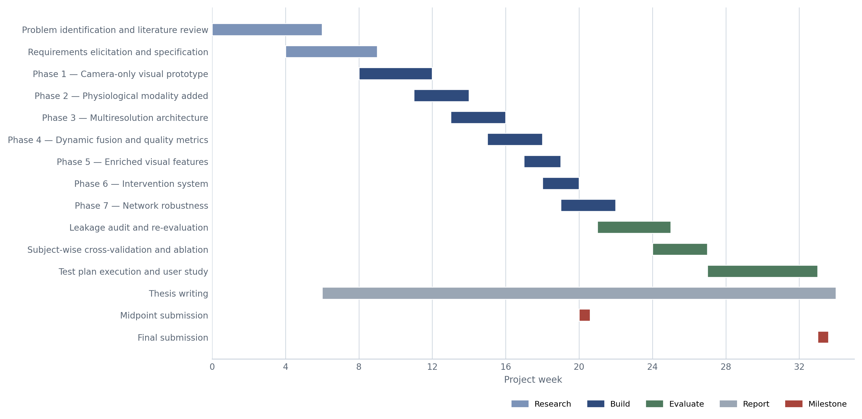
Figure 3.1 — Project schedule across the seven development phases and the reporting milestones.
Three features of the schedule are worth reading off the chart. The phases overlap only where the later one does not depend on the earlier one’s output, which is why Phases 6 and 7 run adjacent while Phases 2 and 3 do not. The literature review is a bar running the length of the project rather than a bounded early block, because three of the seven phases were initiated by a paper read after implementation had begun. The evaluation campaign sits after the final phase because its metrics are measured against one frozen build, not against seven successive ones.

3.4.2 Deliverables and Dates
Table 3.3 lists the deliverables. Every date is shown as a placeholder and is to be confirmed against the current module handbook before submission; the dates are set by the awarding institution and are not reproduced here from memory.
Table 3.3 — Project deliverables with their scope and submission points, the dates to be confirmed against the module handbook.
Deliverable | Description | Date
Project proposal | Problem statement, aim, objectives, scope and initial literature base; approval to proceed. | [date]
Ethics approval | Application covering the survey, including consent, withdrawal and anonymisation procedures. | [date]
Literature review | Systematic review of mind-wandering detection, wearable sensing and multimodal fusion, establishing the research gap. | [date]
Requirements specification | Elicitation findings, system models, and the prioritised functional and non-functional requirements. | [date]
Design documentation | Architecture, component, data-flow and activity models, and the interface designs. | [date]
Working prototype | The integrated system: backend, watch application and dashboard, running end to end at 1 Hz. | [date]
Interim demonstration | Live demonstration of the prototype to the supervisor, with the evaluation plan. | [date]
Evaluation results | Model evaluation under subject-wise cross-validation, system tests and resource measurements. | [date]
Draft thesis | Complete document submitted for supervisory comment before final revision. | [date]
Final thesis | Corrected and bound document with source code and appendices. | [date]
Viva voce | Oral examination and system demonstration. | [date]

3.5 Resources

3.5.1 Hardware Resources
The hardware requirement is the project’s central premise rather than an incidental list: the system was constrained to devices a student is likely already to own, which is why no research-grade sensor appears in Table 3.4.
Table 3.4 — Hardware used, with the role each device plays in development or in the deployed system.
Resource | Specification | Role
Development laptop | Windows, processor-only inference | Hosts the entire backend — the three inference modules, the WebSocket server and the discovery beacon — and ran all offline training. All deep-learning inference executes on the processor after the graphics-processor kernel failure of Section 3.3 removed acceleration as an option.
Samsung Galaxy Watch 7 | Wear OS 4, API level 33 or above; photoplethysmographic heart rate and rotation-vector inertial sensing | The physiological sensor and one of the three intervention channels. Streams heart rate and rotation vector to the backend, and executes the haptic waveform on command.
Integrated webcam | 640 × 480, decimated to 20 frames per second | The only visual sensor. An integrated camera was used deliberately rather than an external one, since a requirement to purchase hardware would defeat the premise.
Local wireless network | Standard consumer Wi-Fi, single subnet | Carries the encrypted WebSocket session and the discovery datagrams. Three separate networks were used during evaluation to test that the system re-establishes without configuration.

3.5.2 Software Resources
The software stack spans four languages across three deployed artefacts. Table 3.5 lists each component with the version the system was built against and the function it serves; the version constraints are minima rather than pinned releases.
Table 3.5 — Software components across the three deployed artefacts and the development toolchain, with versions and purpose.
Layer | Component | Version | Purpose
Backend | tensorflow | 2.15+ | Loading and running the two-branch CNN-LSTM
Backend | numpy | 1.24+ | Array handling and the singular-value decomposition
Backend | opencv-python | 4.8+ | Webcam capture, Haar-cascade face detection, image processing
Backend | websockets | 12.0+ | Asynchronous WebSocket Secure server for the watch and dashboard clients
Backend | tsfel | 0.1.6+ | Statistical and spectral descriptors from the selected singular vector
Backend | xgboost | 2.0+ | The visual classifier
Backend | pandas | 2.0+ | Corpus loading and temporal joining of telemetry to annotation
Backend | scikit-learn | 1.3+ | Cross-validation splitting and evaluation metrics
Backend | psutil | 5.9+ | Network interface enumeration for multi-subnet discovery
Backend | cryptography | 41.0+ | Self-signed TLS certificate generation with multi-address SAN entries
Watch | Kotlin | 1.9+ | Application language for the Wear OS client
Watch | Jetpack Compose for Wear OS | 1.3+ | Watch user interface
Watch | OkHttp3 | 4.12+ | WebSocket client
Watch | Samsung Health Sensor SDK | — | Photoplethysmographic heart-rate access
Dashboard | Vite | — | Build tool and development server
Dashboard | Vanilla JavaScript | ES2020 | Dashboard logic; no framework, as the page has one data source
Dashboard | CSS3 | — | Layout and the visual design system
Tooling | Visual Studio Code | — | Backend and dashboard development
Tooling | Android Studio | — | Watch application build, emulation and device deployment

3.5.3 Technical Skills
Seven technical competencies were acquired during the project, none of which was held at its start.
- Wear OS foreground services and sensor APIs. Registering for heart-rate and rotation-vector events, keeping a service alive against the platform’s power management, and holding a high-performance Wi-Fi lock and a multicast lock so that a socket survives the radio being suspended.
- Asyncio concurrency and lock-free buffer design. Structuring the inference cycle, the WebSocket server and the discovery beacon as cooperating tasks on one event loop, so that a buffer written by the network handler and read by the inference loop is never modified mid-read and needs no mutex.
- TLS certificate generation with multi-address SAN entries. Producing a self-signed certificate programmatically that enumerates every active interface address and writes each into the subject-alternative-name list, so one certificate validates on any subnet the laptop joins.
- UDP broadcast discovery across multiple network interfaces. Computing the per-interface subnet broadcast address rather than relying on the global address, which reaches only the default gateway interface and leaves a watch on any other subnet unreachable.
- Singular value decomposition applied to an image time series. Treating a rolling buffer of block-energy vectors as a matrix rather than a sequence, and selecting the singular vector carrying the greatest high-frequency amplitude as the ocular signal.
- The Keras functional API for multi-input branch networks. Expressing two named inputs, parallel average and maximum pooling paths, and a cross-branch join — a topology the sequential interface cannot represent — within a 17,905-parameter budget.
- Subject-wise cross-validation and data-leakage auditing. Splitting by participant rather than by array index, and correlating every input against the target before trusting any result, which is what exposed three of four visual inputs as functions of the annotation itself. Kapoor and Narayanan (2023) document leakage of this kind as a recurring cause of irreproducible machine-learning findings across disciplines.

3.5.4 Data Requirements
The project requires three kinds of data: labelled video for the visual model, labelled wearable telemetry for the physiological model, and attitudinal data from prospective users. No single source supplies more than one.
DAiSEE (Gupta et al., 2016) supplies the first: 9,068 clips from 112 subjects, annotated on four-point ordinal scales for boredom, engagement, confusion and frustration, and recorded under uncontrolled illumination, which matches the deployment condition rather than a laboratory one. The ordinal engagement label is collapsed to a binary target. The corpus is severely skewed at the low-engagement end, and the handling of that skew — retaining every available minority clip rather than sampling — is the correction that turned an apparent 94.6% accuracy into an honest chance-level result. Thölke et al. (2023) show that accuracy on imbalanced data is uninterpretable without a balanced-accuracy or area-under-curve companion, and Wongvorachan et al. (2023) compare resampling strategies for imbalanced educational data.
DIPSER (Marquez-Carpintero et al., 2025) supplies the second, and was selected as the only publicly available corpus pairing student attention annotation with synchronised Samsung smartwatch telemetry, which avoids a domain shift between the training sensor and the deployed one. Its multi-annotator attention ratings are mapped to a continuous target and joined to heart-rate samples within a bounded time tolerance.
Primary data comes from the instrument in Appendix A: a twenty-two item survey measuring self-reported mind-wandering frequency, willingness to be monitored under four separately stated data-handling conditions, and ranked intervention preferences.
Storage is entirely local. The two corpora, the extracted feature tables and the trained model files reside on the development laptop; nothing is uploaded, and no cloud service participates in training or inference. The privacy position at run time is stronger and is structural rather than procedural: no video frame is ever written to disk or transmitted beyond the process that captured it. Frames exist only in the capture thread and in the block-energy buffer derived from them, and what leaves the visual module is one probability and a four-element trait vector, from which no image can be reconstructed. There is no code path from a frame to a file, which is why the guarantee is absolute rather than a matter of configuration.
The planned user study raises the ordinary obligations and one specific one. Institutional ethics approval is to be obtained before any recruitment. Participants receive a plain-language information sheet stating what is sensed, that no video is recorded, and that withdrawal is available at any point without giving a reason; consent is written. Survey responses are anonymous and no identifying record is retained. The specific obligation concerns the demonstration: a false positive tells a learner who was concentrating that they were not, so the debrief states the measured accuracy plainly, and no participant leaves holding a belief about their own attention that the evidence does not support. The two secondary corpora are used within the terms of their published releases and are not redistributed.

3.6 Risks and Mitigation
Table 3.6 records the project risks. Four had already materialised by the time the table was written, and their mitigations are therefore reports of what was done rather than contingency plans; these are marked as such.
Table 3.6 — Project risks with likelihood, impact and mitigation. The four marked as materialised had already occurred, and their mitigations are the measures actually taken.
Risk | Likelihood | Impact | Mitigation
Hardware acceleration unavailable for the chosen model (materialised) | High | High | All inference moved to the processor and the visual architecture replaced with the singular-value decomposition pipeline, which fits the one-second budget without acceleration. The layered design confined the change to one module.
Corpus class imbalance too severe for the classifier to learn (materialised) | High | High | Every available minority clip retained rather than sampled, with majority clips drawn at a fixed ratio alongside; balanced accuracy and area under the curve reported instead of accuracy alone, following Thölke et al. (2023).
Label leakage invalidating reported results (materialised, caught in audit) | Medium | Severe | Every input correlated against the target before any result was accepted, which exposed three of four visual inputs as constructed from the annotation; validation split changed from array index to participant identity.
Watch connectivity dropping mid-session (materialised) | High | Medium | A high-performance Wi-Fi lock holds the radio awake, periodic pings keep the socket alive, and rediscovery by UDP beacon with address persistence and fallback cycling re-establishes the session without user action.
No corpus labelled directly for mind wandering | High | High | Engagement and attention annotations used as the nearest available proxy, with the substitution stated explicitly and its consequences for construct validity carried into the evaluation and the limitations.
Insufficient participant recruitment for the user study | Medium | Medium | Instruments designed to be completed in under fifteen minutes; recruitment from the immediate cohort; Any shortfall is reported rather than concealed, and the achieved sample stated alongside the target.
Scope creep beyond the deliverable | Medium | Medium | The work-in-progress limit of one blocks a new item until the current one is verified; educator analytics and session persistence were explicitly deferred to further work rather than started.
Loss or failure of the development hardware | Low | Severe | Source and trained models held in version control with an off-machine copy; the training pipelines are scripted end to end, so any model can be regenerated from the corpora on replacement hardware.

3.7 Chapter Summary
This chapter set out the six methodological selections — pragmatism, a combined deductive and inductive approach, experiment with case study, a multi-method quantitative choice, a cross-sectional horizon, and collection by secondary corpora with a survey — and defended each against the alternatives at its layer. It justified incremental prototyping on the documented evidence of seven evaluated increments and two evaluation-forced redesigns, rejecting Waterfall because the requirement behind the larger redesign was not knowable at specification time, and full Scrum because its mechanisms coordinate a team that does not exist here. It described a Kanban flow with a work-in-progress limit of one, presented the schedule and the deliverables with dates to be confirmed against the module handbook, listed the hardware and software the project consumed and the seven technical competencies it demanded, specified the three data sources with their storage, privacy and ethical conditions, and recorded eight risks of which four had already occurred. Chapter 4 applies this methodology to the elicitation and specification of requirements.

4 SOFTWARE REQUIREMENTS SPECIFICATION

4.1 Chapter Overview
This chapter documents the elicitation, analysis and specification of requirements: the sociotechnical situation, the stakeholders, and three elicitation methodologies with their findings, the literature review of Chapter 2 being the primary source of requirements for a research-driven project. It then models the system boundary and behaviour, and specifies the requirements.

4.2 Rich Picture Diagram
Figure 4.1 captures the situation in which the system operates, including the concerns people hold and the tensions it cannot fully resolve.
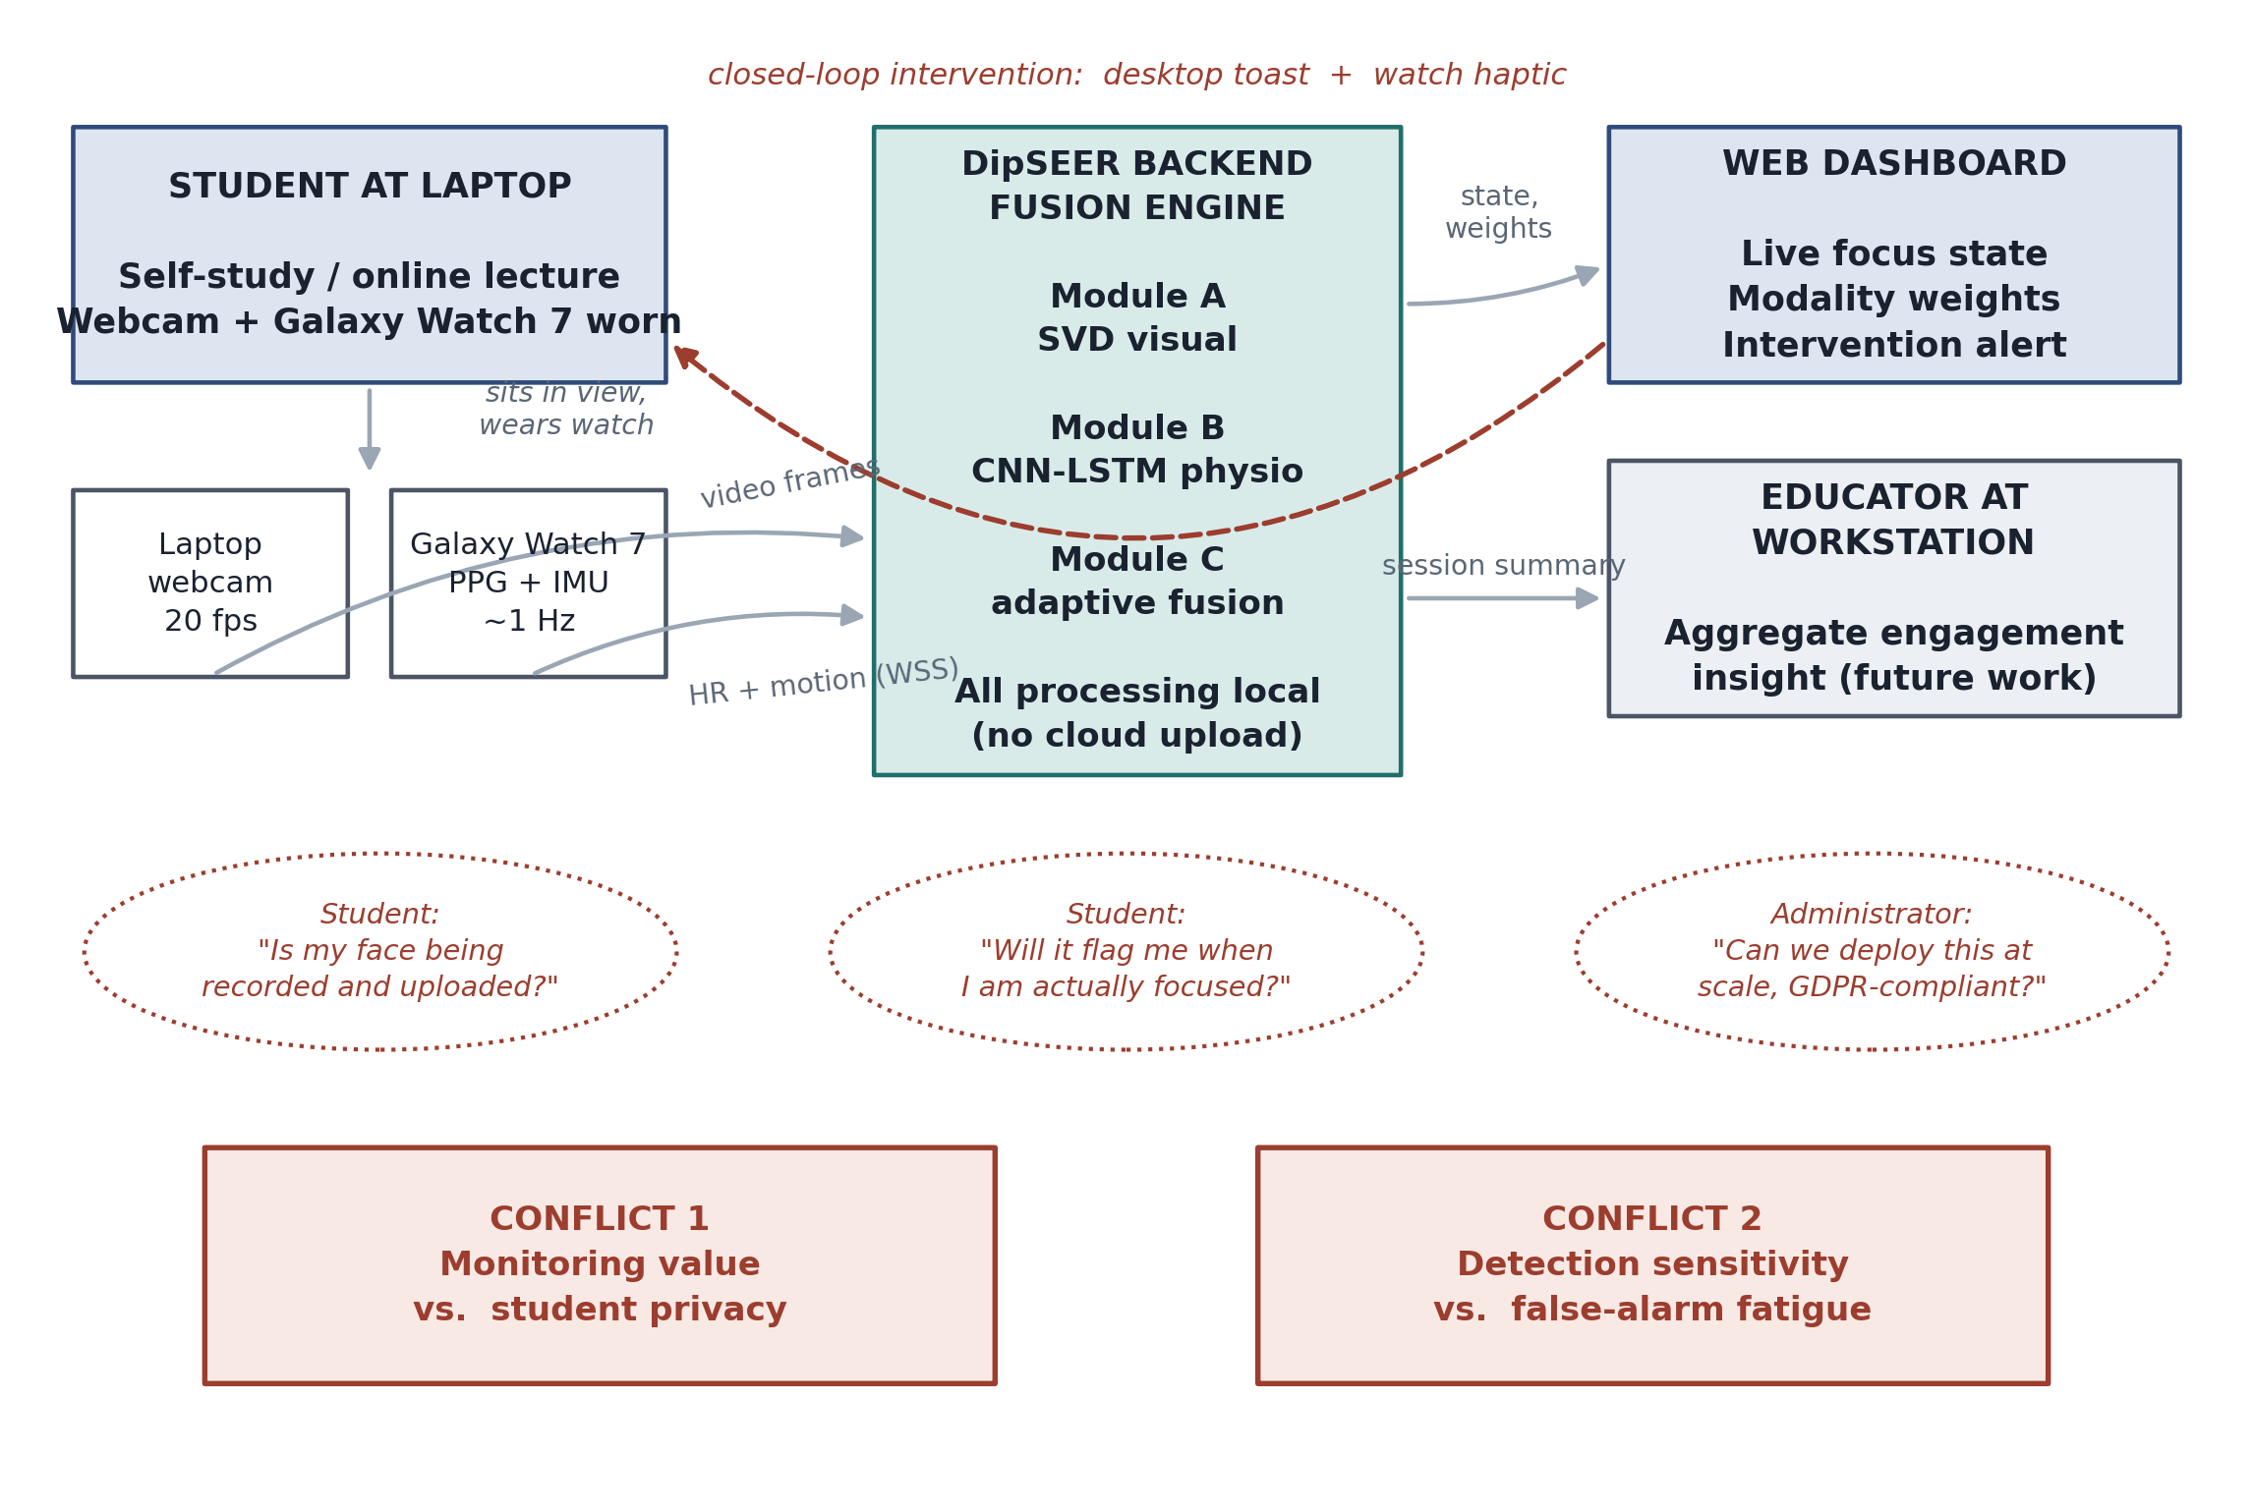
Figure 4.1 — Rich picture of the DipSEER operating context, showing the two sensor streams converging on the local fusion engine, the closed intervention loop back to the learner, and the two structural conflicts the design must negotiate.
A student in self-directed study sits at a laptop wearing a Samsung Galaxy Watch 7. Two streams originate: facial video from the built-in webcam at 20 frames per second, and heart rate with rotation-vector telemetry at roughly 1 Hz. Both converge on the backend fusion engine on the same laptop, which classifies the attentional state, returns it to a browser dashboard and, on a negative classification, drives a desktop notification and a wrist haptic pulse. The educator receives aggregate insight at the periphery, scoped as future work and not implemented.
The thought bubbles record concerns from stakeholder analysis: whether facial video is recorded and uploaded, whether the system will interrupt a learner who is concentrating, and whether the arrangement scales and satisfies data-protection obligations. Beneath them sit two ineliminable conflicts: monitoring against the learner’s privacy, and detection sensitivity against alert fatigue. The first is addressed by processing all video in volatile memory, never persisting or transmitting it; the second by alert cooldowns and a fusion decision band favouring precision over recall.

4.3 Stakeholder Analysis

4.3.1 Stakeholder Onion Model
Figure 4.2 arranges stakeholders by the directness of their interaction with the system.
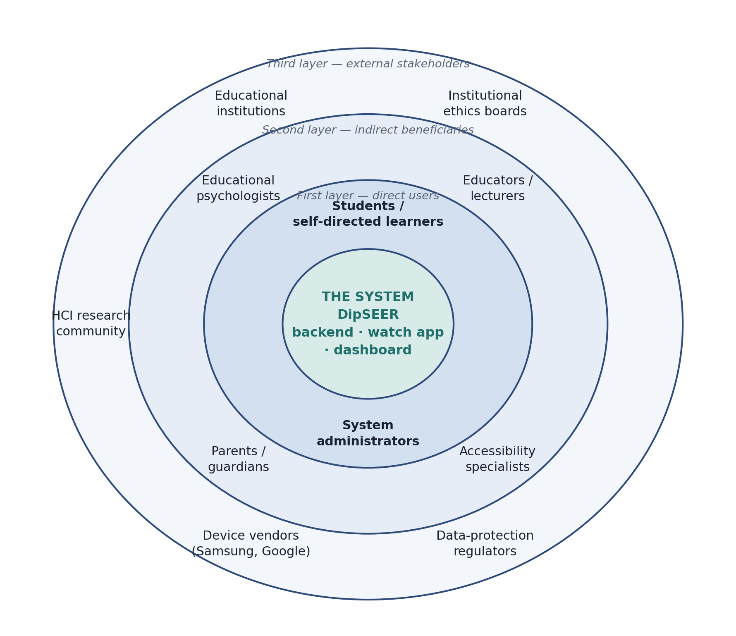
Figure 4.2 — Stakeholder onion model. Proximity to the centre denotes directness of interaction, not importance; the outermost ring exerts constraint rather than use.
The core is the system itself. The first layer operates it directly: students, who wear the watch and sit before the camera, and administrators, who install certificates and configure deployment. The second benefits from its output without operating it: educators, educational psychologists, parents of younger learners, and accessibility specialists who may adapt the intervention modality. The third constrains rather than uses it: institutional ethics boards, the institutions themselves, the HCI research community, device vendors and data-protection regulators.

4.3.2 Stakeholder Viewpoints
Students prioritise privacy and non-disruption above accuracy, the recurring concern being that facial video might be stored or transmitted; the requirement is absolute rather than probabilistic, captured as NFR-06. Until the survey is administered these viewpoints rest on stakeholder analysis, not data, though Wettstein et al. (2024) offer an external anchor: 71% of patients in a clinical monitoring deployment perceived a benefit and 87% integrated it into their routine. Educators require actionable output — a session-level summary of when attention declined, not a per-second probability — motivating the session-persistence and analytics requirements deferred to the final phase.
Institutions prioritise cost, scale and compliance; their constraint that deployment must not require per-student hardware purchase aligns with the project’s core premise. Administrators require modular, independently maintainable components, motivating NFR-05 and the design paradigm of Section 5.4.1. Researchers require transparency sufficient for replication, served by Chapters 4 and 5 and by reporting negative results.

4.4 Selection of Requirement Elicitation Methodologies
Three methodologies were selected, reflecting the project’s dual nature as research, whose requirements derive from the literature, and software, whose requirements derive from users.
Literature review was primary: the central requirements — which modalities to sense, which features carry signal, which fusion strategy to adopt — are empirical questions addressed by published work. Interviewing students about singular value decomposition would be unproductive; reading Anh et al. (2024) is not. Thirty-five publications were analysed. Its limitation is that it says nothing about this system’s users.
Survey was selected to quantify user attitudes at scale: mind-wandering frequency, willingness to be monitored, and preference between intervention modalities. It was chosen over a focus group because privacy questions attract social-desirability bias in groups.

Prototyping was selected because several requirements are not discoverable by asking. That DirectML would fail to register LSTM kernels on GPU, that a self-signed certificate would need regenerating on every subnet change, that XGBoost would return probabilities pinned near unity on live input — none could have been elicited from a stakeholder; they emerged from building.

4.5 Findings

4.5.1 Literature Review
The review itself is Chapter 2; what it yielded as requirements is recorded here. Three markers are established firmly enough to build on: reduced gaze variation and reduced head movement in facial video (Bosch and D’Mello, 2021), and heart-rate variability (Gedam and Paul, 2021). Those fixed the two sensing channels and their features — ocular decomposition on one side (Anh et al., 2024), SDNN and RMSSD against a personal baseline on the other (Gjoreski et al., 2021) — and with them FR-03 to FR-06, FR-08 to FR-10 and NFR-04.
The architecture followed from a gap rather than a result. No retained system pairs a webcam with a consumer wrist device and closes the loop while the lapse is happening: the nearest works offline after the session (Liu et al., 2025), the most complete consumer deployment in days (Wettstein et al., 2024). Where fusion depths were compared on the same data, fusing after per-modality processing beat fusing raw signals, 82.0% against 74.0% (Najafi et al., 2023), and combining late lets a channel drop out without malforming the input — FR-11, FR-12 and FR-19, with weights recomputed each cycle to extend Wei et al. (2018) from offline reliability to live.
Two timing requirements complete the set. Sustained attention fluctuates on the order of seconds (Rosenberg, 2026), so a cycle slower than roughly one second reports only the slow drift and cannot read as immediate — NFR-01. And no retained study states a tolerable alert frequency, so alert fatigue governs interruption design: FR-15, FR-16 and NFR-10 specify cooldowns rather than continuous prompting.

4.5.2 Survey
The survey comprises twenty-two items in four sections: demographics and device ownership; self-reported mind-wandering frequency on five-point Likert scales; willingness to be monitored under stated data-handling conditions; and forced-ranking of four intervention modalities. The third section varies the data-handling condition across items, so willingness is measured against privacy guarantee rather than in the abstract.
PLACEHOLDER — SURVEY DATA NOT YET COLLECTED. Insert here: sample size and composition; distribution of self-reported mind-wandering frequency; percentage willing to use monitoring under each data-handling condition; ranked intervention preferences. The requirements traced to Survey in Tables 4.2 and 4.3 (FR-16, FR-20, NFR-02) are provisional pending these data.

4.5.3 Prototyping
Prototyping surfaced four requirements, each discovered by failure. The first was architectural: the initial pipeline used EfficientNet-B0 fine-tuned on DAiSEE, but DirectML TensorFlow on Windows fails to register kernels for standard Keras LSTM operations on GPU, so the two models could not share the accelerator, and forcing both to CPU made frame-wise convolutional inference incompatible with the one-second cycle. The requirement that visual inference complete on CPU within budget drove the substitution of Section 8.8.
The second was networking: early builds hard-coded the laptop’s IP address in the watch application, so every change of Wi-Fi network broke the pairing, producing FR-17, FR-18 and the UDP discovery mechanism. The third concerned calibration: live XGBoost output clustered above 0.95 regardless of observed state, the classifier having been trained on a distribution unrepresentative of live capture, mitigated by a power transform and analysed in Section 7.4. The fourth concerned interruption: continuous alerting during a sustained episode produced notifications that were themselves distracting — the alert-fatigue conflict of the rich picture — leading to the cooldown intervals of Section 6.3.4.

4.6 Summary of Findings
The literature review established the modalities, feature families, multiresolution treatment of rate mismatch and reliability-weighted fusion; prototyping established the platform’s hard constraints: CPU-only inference, zero-configuration networking, output calibration and intervention pacing. The survey will contribute user-facing requirements once administered; those requirements are marked provisional below.

4.7 Context Diagram
Figure 4.3 fixes the system boundary and the external entities that cross it.
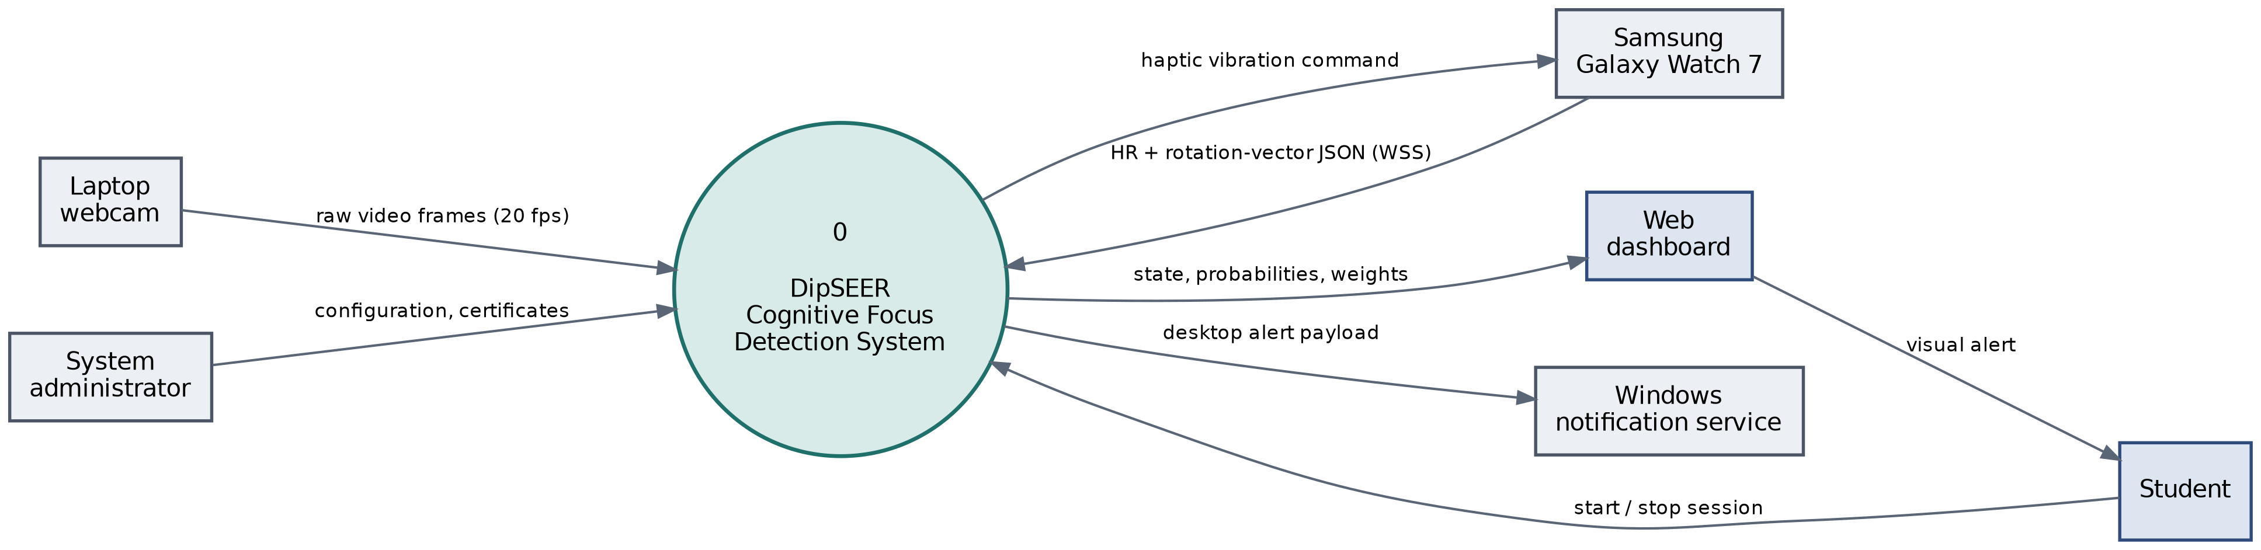
Figure 4.3 — Context diagram showing DipSEER as a single process with its six external entities and the data flowing across the system boundary in each direction.
Six entities cross the boundary. The webcam and Galaxy Watch supply sensor data inward, the student session control, the administrator configuration and TLS certificates. Outward go state, probabilities and modality weights to the dashboard, a vibration command to the watch, and an alert payload to the Windows notification service. No entity outside the laptop and paired watch receives facial data; the boundary encodes NFR-06.

4.8 Use Case Diagram
Figure 4.4 models the functional interactions between actors and system.
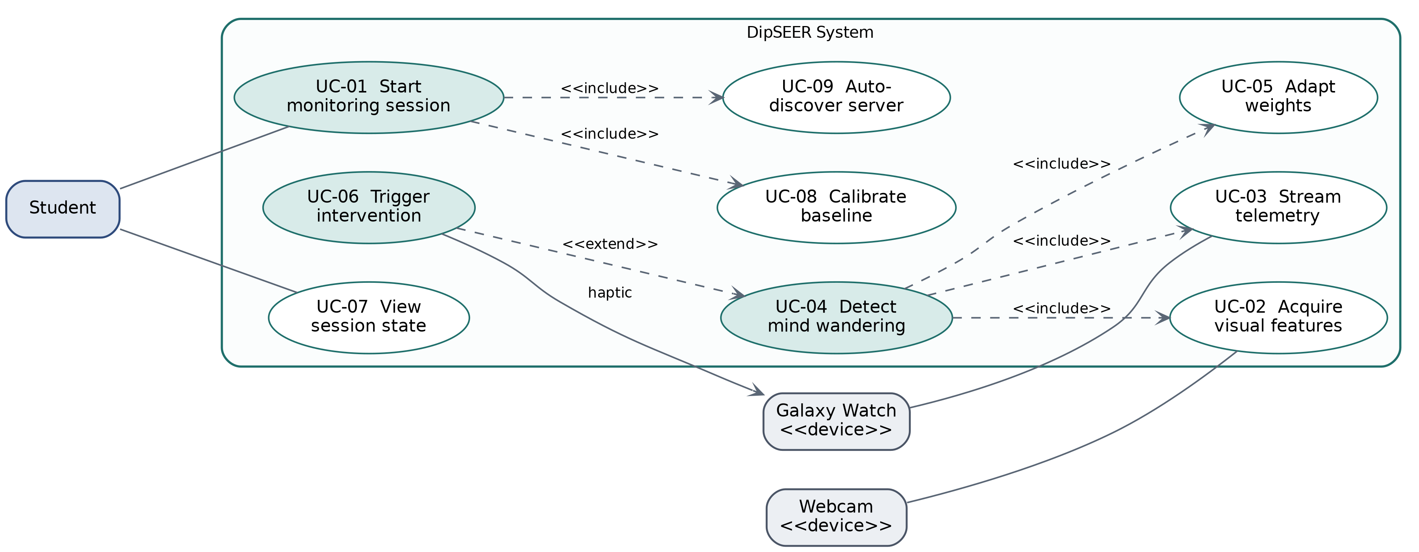
Figure 4.4 — Use case diagram. Shaded ellipses denote the three primary use cases described in Section 4.9; the remainder are included or extending behaviours.
Three actors participate: the student, and the webcam and watch as device actors. Detecting mind wandering (UC-04) includes visual acquisition, physiological streaming and weight adaptation, none optional. Triggering an intervention (UC-06) extends detection rather than being included by it, occurring only on a negative classification. Starting a session (UC-01) includes baseline calibration and server auto-discovery.

4.9 Use Case Descriptions
Each use case is specified with preconditions, main flow, alternative flows and postcondition. UC-01 is given in full below; UC-04, UC-06 and summaries of the remaining six appear in Appendix C.
Table 4.1 — Use case description for UC-01, Start Monitoring Session.
Field | UC-01 — Start Monitoring Session
Actor | Student (primary); Galaxy Watch, webcam (secondary)
Precondition | Backend running; watch application installed; both devices on the same subnet
Main flow | 1. Student launches the backend, which loads the XGBoost and CNN-LSTM models and opens the WSS server on port 8765. 2. The UDP discovery beacon begins broadcasting on port 8766. 3. Student opens the dashboard, which connects over WSS. 4. Student starts the watch application and presses Start. 5. The watch listens for a beacon, resolves the server address and opens a WSS connection. 6. The backend classifies the connection as a watch client on receipt of the first typed sensor payload. 7. Baseline calibration begins and continues for the first thirty heart-rate samples.
Alternative A1 | No beacon received within the two-second socket timeout: the watch falls back to the address persisted in SharedPreferences, and failing that to a static fallback list, cycling on each retry.
Alternative A2 | WSS handshake fails: the watch schedules reconnection after three seconds and updates its status text to “Reconnecting”.
Postcondition | Bidirectional session established; inference loop executing at 1 Hz

4.10 Requirements
Requirements are prioritised under MoSCoW and traced to the elicitation method that produced them; those traceable only to the survey are marked provisional pending data collection.

4.10.1 Functional Requirements
Table 4.2 — Functional requirements, prioritised under MoSCoW and traced to the elicitation method that produced each.
ID | Requirement | Priority | Source
FR-01 | Capture webcam video and retain frames only in volatile memory, discarding each after feature extraction. | Must | Lit. review; Prototyping
FR-02 | Detect the face using cascaded Haar classifiers, attempting frontal detection first and profile detection with horizontal flip as fallback. | Must | Prototyping
FR-03 | Compute an 8×8 block-energy matrix over the ocular region and maintain a 200-frame rolling buffer. | Must | Lit. review (Anh et al., 2024)
FR-04 | Apply singular value decomposition to the buffered matrix and select the singular vector of greatest high-frequency amplitude. | Must | Lit. review (Anh et al., 2024)
FR-05 | Derive statistical and spectral descriptors with TSFEL and classify focus with XGBoost. | Must | Lit. review
FR-06 | Derive head-pose velocity, jitter and a blank-stare index from the ocular and pose buffers. | Should | Lit. review (Bosch and D’Mello, 2021)
FR-07 | Receive heart rate and rotation-vector telemetry from the watch over WebSocket Secure. | Must | Prototyping
FR-08 | Compute SDNN and RMSSD from a rolling R-R interval buffer derived from instantaneous heart rate. | Must | Lit. review (Gedam and Paul, 2021)
FR-09 | Establish a personalised baseline over the first thirty heart-rate samples and normalise subsequent readings against it. | Should | Lit. review (Gjoreski et al., 2021)
FR-10 | Infer physiological focus using a two-branch multiresolution dual-pooling CNN-LSTM over a ten-step window. | Must | Lit. review (John et al., 2021)
FR-11 | Compute per-modality signal-quality indices each cycle from face size, head-pose stability, wrist motion and telemetry recency. | Must | Lit. review (Wei et al., 2018)
FR-12 | Fuse modality probabilities using weights recomputed each cycle from the quality indices. | Must | Lit. review (Wei et al., 2018)
FR-13 | Classify the fused score into "focused", "zoned out" or "user away". | Must | Lit. review; Prototyping
FR-14 | Broadcast a state, probability, weight and quality payload to all dashboard clients each cycle. | Must | Prototyping
FR-15 | Raise a native desktop notification with an audible cue on negative classification, subject to cooldown. | Must | Prototyping
FR-16 | Command a haptic pulse on the watch on negative classification, subject to an independent cooldown. | Must | Survey (provisional)
FR-17 | Broadcast a UDP discovery beacon on every active subnet so the watch requires no manual address configuration. | Should | Prototyping
FR-18 | Persist the last resolved server address on the watch and fall back to it when discovery fails. | Should | Prototyping
FR-19 | Fall back to visual-only operation when the watch is disconnected or detected as off-wrist. | Must | Prototyping
FR-20 | Allow the student to dismiss an on-screen alert, suppressing further alerts for a fixed interval. | Could | Survey (provisional)
EX-01 | Identify or re-identify an individual from captured video, or match a face against any enrolled identity. | Will not have | Stakeholder analysis

Priority follows necessity rather than value. A requirement is Must where its removal stops the system sensing, deciding or responding at all: capture and face location, the two inference paths, the quality-weighted fusion, the classification itself, the dashboard and intervention outputs, and the fallback that keeps the system running when the watch is lost. Should marks what makes the system usable without being load-bearing — personal calibration, the supplementary head-pose measures and zero-configuration discovery with its persisted fallback. Could marks convenience. EX-01 is a boundary, refused rather than deferred.

4.10.2 Non-Functional Requirements
Table 4.3 — Non-functional requirements by quality category, prioritised under MoSCoW and traced to the elicitation method that produced each.
ID | Requirement | Category | Priority | Source
NFR-01 | A complete sense–infer–decide–act cycle shall complete within one second. | Performance | Must | Lit. review (Rosenberg, 2026)
NFR-02 | The dashboard shall communicate state, contributing modality and confidence without accompanying explanation, and shall not convey any state by colour alone. | Usability | Should | Survey (provisional)
NFR-03 | The system shall recover automatically from watch disconnection without operator intervention. | Reliability | Must | Prototyping
NFR-04 | The system shall operate on an integrated laptop webcam without external camera hardware. | Compatibility | Must | Lit. review
NFR-05 | Modules shall be independently replaceable behind stable interfaces. | Maintainability | Should | Stakeholder analysis
NFR-06 | No facial image data shall be written to persistent storage or transmitted beyond the local process. | Privacy | Must | Stakeholder analysis
NFR-07 | All laptop–watch traffic shall be encrypted in transit using TLS. | Security | Must | Prototyping
NFR-08 | All deep-learning inference shall execute on CPU without requiring a discrete GPU. | Portability | Must | Prototyping
NFR-09 | The watch application shall sustain a monitoring session of at least two hours without battery exhaustion. | Performance | Should | Lit. review (Kargarandehkordi et al., 2025)
NFR-10 | Intervention alerts shall be rate-limited to avoid alert fatigue during sustained inattention. | Usability | Should | Prototyping
EX-02 | No biometric, facial or physiological data shall be stored in, or transmitted to, cloud infrastructure of any kind. | Privacy | Will not have | Stakeholder analysis

The same test applies to the quality attributes. Must covers the properties whose absence would make the system unfit rather than merely worse: the one-second cycle, on which the whole interaction rests; the privacy guarantee, which is absolute rather than graduated; encryption in transit; automatic recovery from sensor loss; and operation on integrated hardware with no discrete accelerator. Should covers what shapes the experience — dashboard legibility, modularity, battery endurance and alert pacing. EX-02 records a permanent exclusion; with EX-01 it fixes the scope boundary, and neither is an unimplemented requirement.

4.11 Chapter Summary
This chapter mapped the sociotechnical context of DipSEER, identified its stakeholders and their competing priorities, and justified four elicitation methodologies. The literature review supplied the design requirements — multimodality, personalisation, multiresolution treatment of rate mismatch and reliability-weighted fusion — while prototyping supplied the platform constraints no stakeholder could have articulated. Twenty functional and ten non-functional requirements were specified, prioritised and traced, those depending on uncollected data marked provisional. Chapter 5 converts this specification into an architecture.

5 DESIGN

5.1 Chapter Overview
This chapter turns the requirements of Chapter 4 into a design: the six goals shaping the architecture, the paradigm the decomposition follows, the system as four layers and as components, the data flow and decision sequence, the interfaces, the algorithms behind the three modules, and the requirement behind each choice.

5.2 Design Goals
Six goals shape the architecture, each describing its shape rather than a single behaviour.
Bounded response time. The one-second cycle in NFR-01 comes from the phenomenon, not from interface convention. Rosenberg (2026) describes three timescales of attention: the eye samples a scene three to eight times a second, attentional state shifts over seconds, alertness declines over minutes to hours. A system deciding more slowly than the state changes cannot follow it, setting an upper limit near one second; deciding faster gains nothing, since the fastest band is a brain process invisible to a 20 fps webcam and a once-a-second heart-rate sensor. Capture therefore runs on its own thread, prompts are launched without waiting, and no slow sensor holds up a fast one.
Useful behaviour when a sensor fails. The system must keep working, with lower and honestly reported confidence, when a sensor drops out. When the watch disconnects, it changes how much it trusts each remaining sensor and shows the change on screen. Failure handling is a normal part of Module C, not an error path.
Privacy built into the structure. NFR-06 is met by the architecture rather than by policy: no component has a path from video frames to disk or to the network. Frames exist only in the capture thread and the energy buffer derived from them; what leaves Module A is one number and a four-element vector, from which no image can be rebuilt.
Replaceable modules. Each module exposes only a small, fixed set of outputs — a probability, a quality score, a trait vector. This satisfies NFR-05, and it let the entire visual pipeline be replaced mid-project without touching the fusion engine, the network layer or the dashboard.
No setup, and ordinary hardware. Connecting securely across an unknown network without the user typing an address makes discovery, address storage and certificate generation architectural, not installation steps. NFR-04 and NFR-08 forbid any component from assuming a graphics card, an external camera or a research-grade sensor, which ruled out the original visual design and shaped what replaced it.

5.3 System Architecture Design

5.3.1 Architecture Diagram
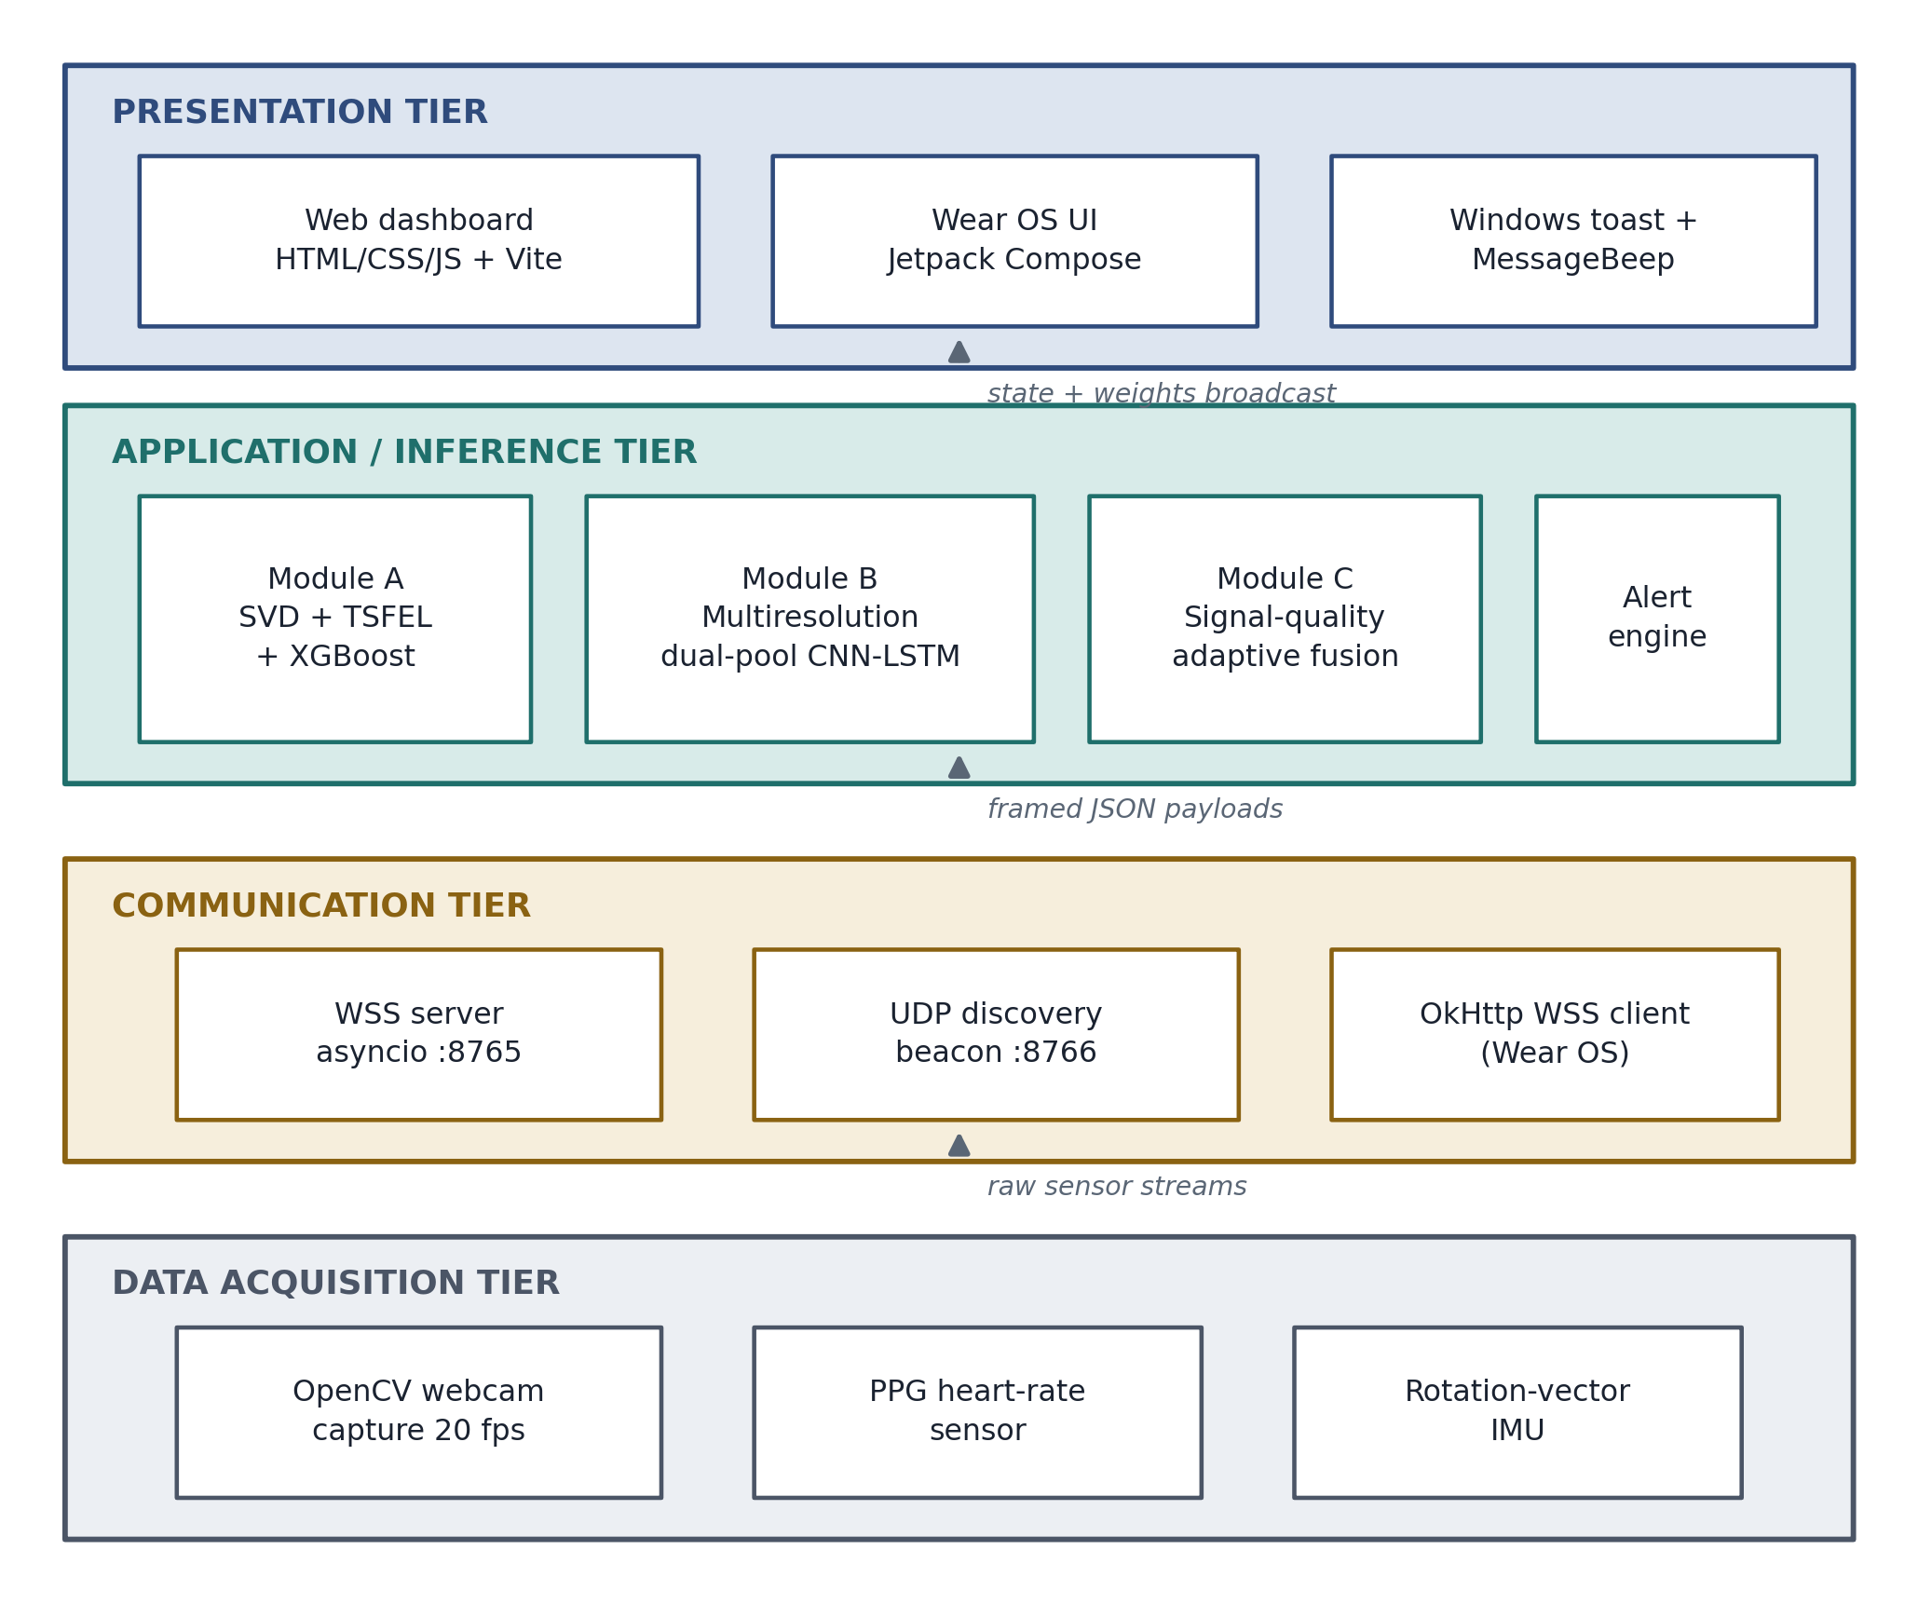
Figure 5.1 — Four-layer architecture. Each layer depends only on the one below it; the arrows name the form the data takes as it crosses each boundary.
A single combined program would have tied the visual and physiological paths so tightly that replacing one meant rebuilding both — and that replacement became necessary. Separate services would have added message-passing delay to a one-second budget for no gain, since everything runs on one machine. Layers give independence without that cost, and each depends only downward, so a change low down cannot ripple upward.

5.3.2 The Four Layers
Data capture. This layer owns the hardware and nothing else. On the laptop it manages the camera, reading on its own thread and reducing to 20 frames per second; on the watch it listens for heart-rate and motion readings. It interprets nothing, so a change of camera or watch model never reaches the layers above.
Communication. Data moves between the three devices over an encrypted WebSocket server on port 8765, a UDP discovery beacon on port 8766 broadcasting on every active network interface, and the client on the watch. Discovery belongs here, not in installation, so the laptop can change network without reconfiguration: the beacon announces the new address and the watch, listening before each attempt, follows.
Inference. The three modules each have a narrow output. Module A turns frames into a focus probability, a quality score and a four-element trait vector; Module B turns watch data and those traits into a probability and a quality score; Module C turns two probabilities and two quality scores into a state, a combined score and the weights that produced it; the alert engine turns a state into a prompt. The one exception is the trait channel from Module A to Module B, shown dashed in Figure 5.2, which would otherwise burden Module C with data it has no use for.
Presentation. Three surfaces do different jobs. The browser dashboard informs: it shows the classification with the sensor weights and quality scores behind it. The desktop notification and the watch vibration interrupt: they carry no detail and are used only when the system needs attention it does not have. The dashboard may update every second; the interruptions must not.

5.4 Detailed Design

5.4.1 Choice of Design Paradigm
The system is decomposed by object-oriented analysis and design. Each of the three inference modules is a class owning its model, its rolling buffers and its calibration state, exposing methods that return only numbers; the watch application is an Android foreground service holding sensor and connection state, with a Jetpack Compose interface observing that state rather than owning it.
Structured systems analysis and design was the alternative. It decomposes a system into functions and the data passing between them, which suits a system whose behaviour is determined by its current input. That is not this system. Its defining property is state that persists across cycles and changes what the same input means: the 200-frame energy buffer, the buffers holding the personal heart-rate baseline, and the hysteresis state that decides whether a score of 0.50 is a change or a continuation. An object holds that state together with the operations permitted to touch it, so the invariants — a fixed buffer length, a baseline existing only after thirty samples, a state changing only on a threshold crossing — are enforced in one place. A function-and-dataflow decomposition must instead thread all of it between processes or leave it in shared stores any process may write.
One structured notation is used anyway. The data flow diagram in Section 5.4.4 is retained because it is the clearest way to show what the system stores: it makes every store explicit and lets the reader confirm that none of the five can hold a video frame, which is how NFR-06 is enforced. The component diagram of Section 5.4.3 and the class-level decomposition described here are the object-oriented artefacts; the data flow diagram is a borrowed one, used for that single argument.

5.4.2 Choice of Programming Model
The backend uses Python’s asyncio: one event loop runs the inference cycle, the WebSocket server and the discovery beacon as cooperating tasks. Threads would contend for locks on the rolling buffers, which the network handler writes and the inference loop reads every cycle. Running everything in sequence would queue sensor data behind inference, so the system would fall behind real time. Asyncio avoids both: tasks yield only at chosen points, so a buffer is never modified halfway through being read and no lock is needed.
One exception remains: camera reads block at the operating-system level and cannot be made cooperative, so capture runs on its own thread writing into a fixed-length queue; since the reader only takes a snapshot, the overlap is harmless. Each module is a class holding its own model, buffers and calibration state, exposing methods that return only numbers. The watch application follows the Android pattern: a foreground service for sensors and networking, with a Jetpack Compose interface watching its state.

5.4.3 Component Diagram
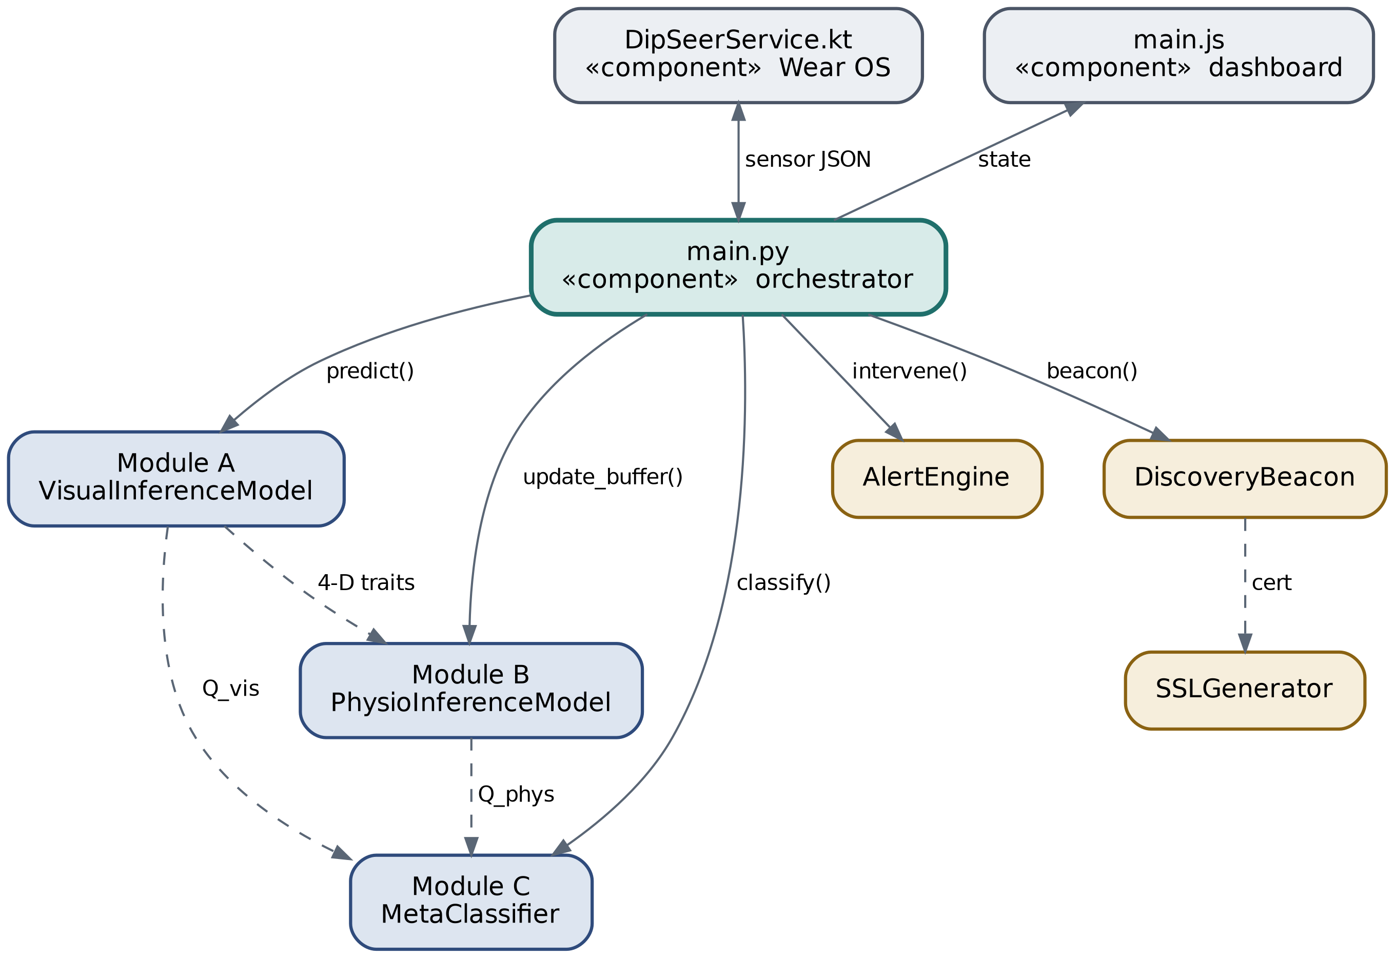
Figure 5.2 — The seven main software components and their connections. Solid arrows show one component calling another; dashed arrows show a data dependency.
The coordinating component, main.py, owns the event loop and calls the three modules in sequence each cycle. The sideways link from Module A to Module B carries the four-element trait vector; both modules expose quality scores that Module C reads. The discovery beacon checks with the certificate generator that a certificate exists before advertising, creating one if not. The watch application and the dashboard are external, communicating only over the WebSocket connection, so either could be replaced without changing the backend.

5.4.4 Data Flow Diagram
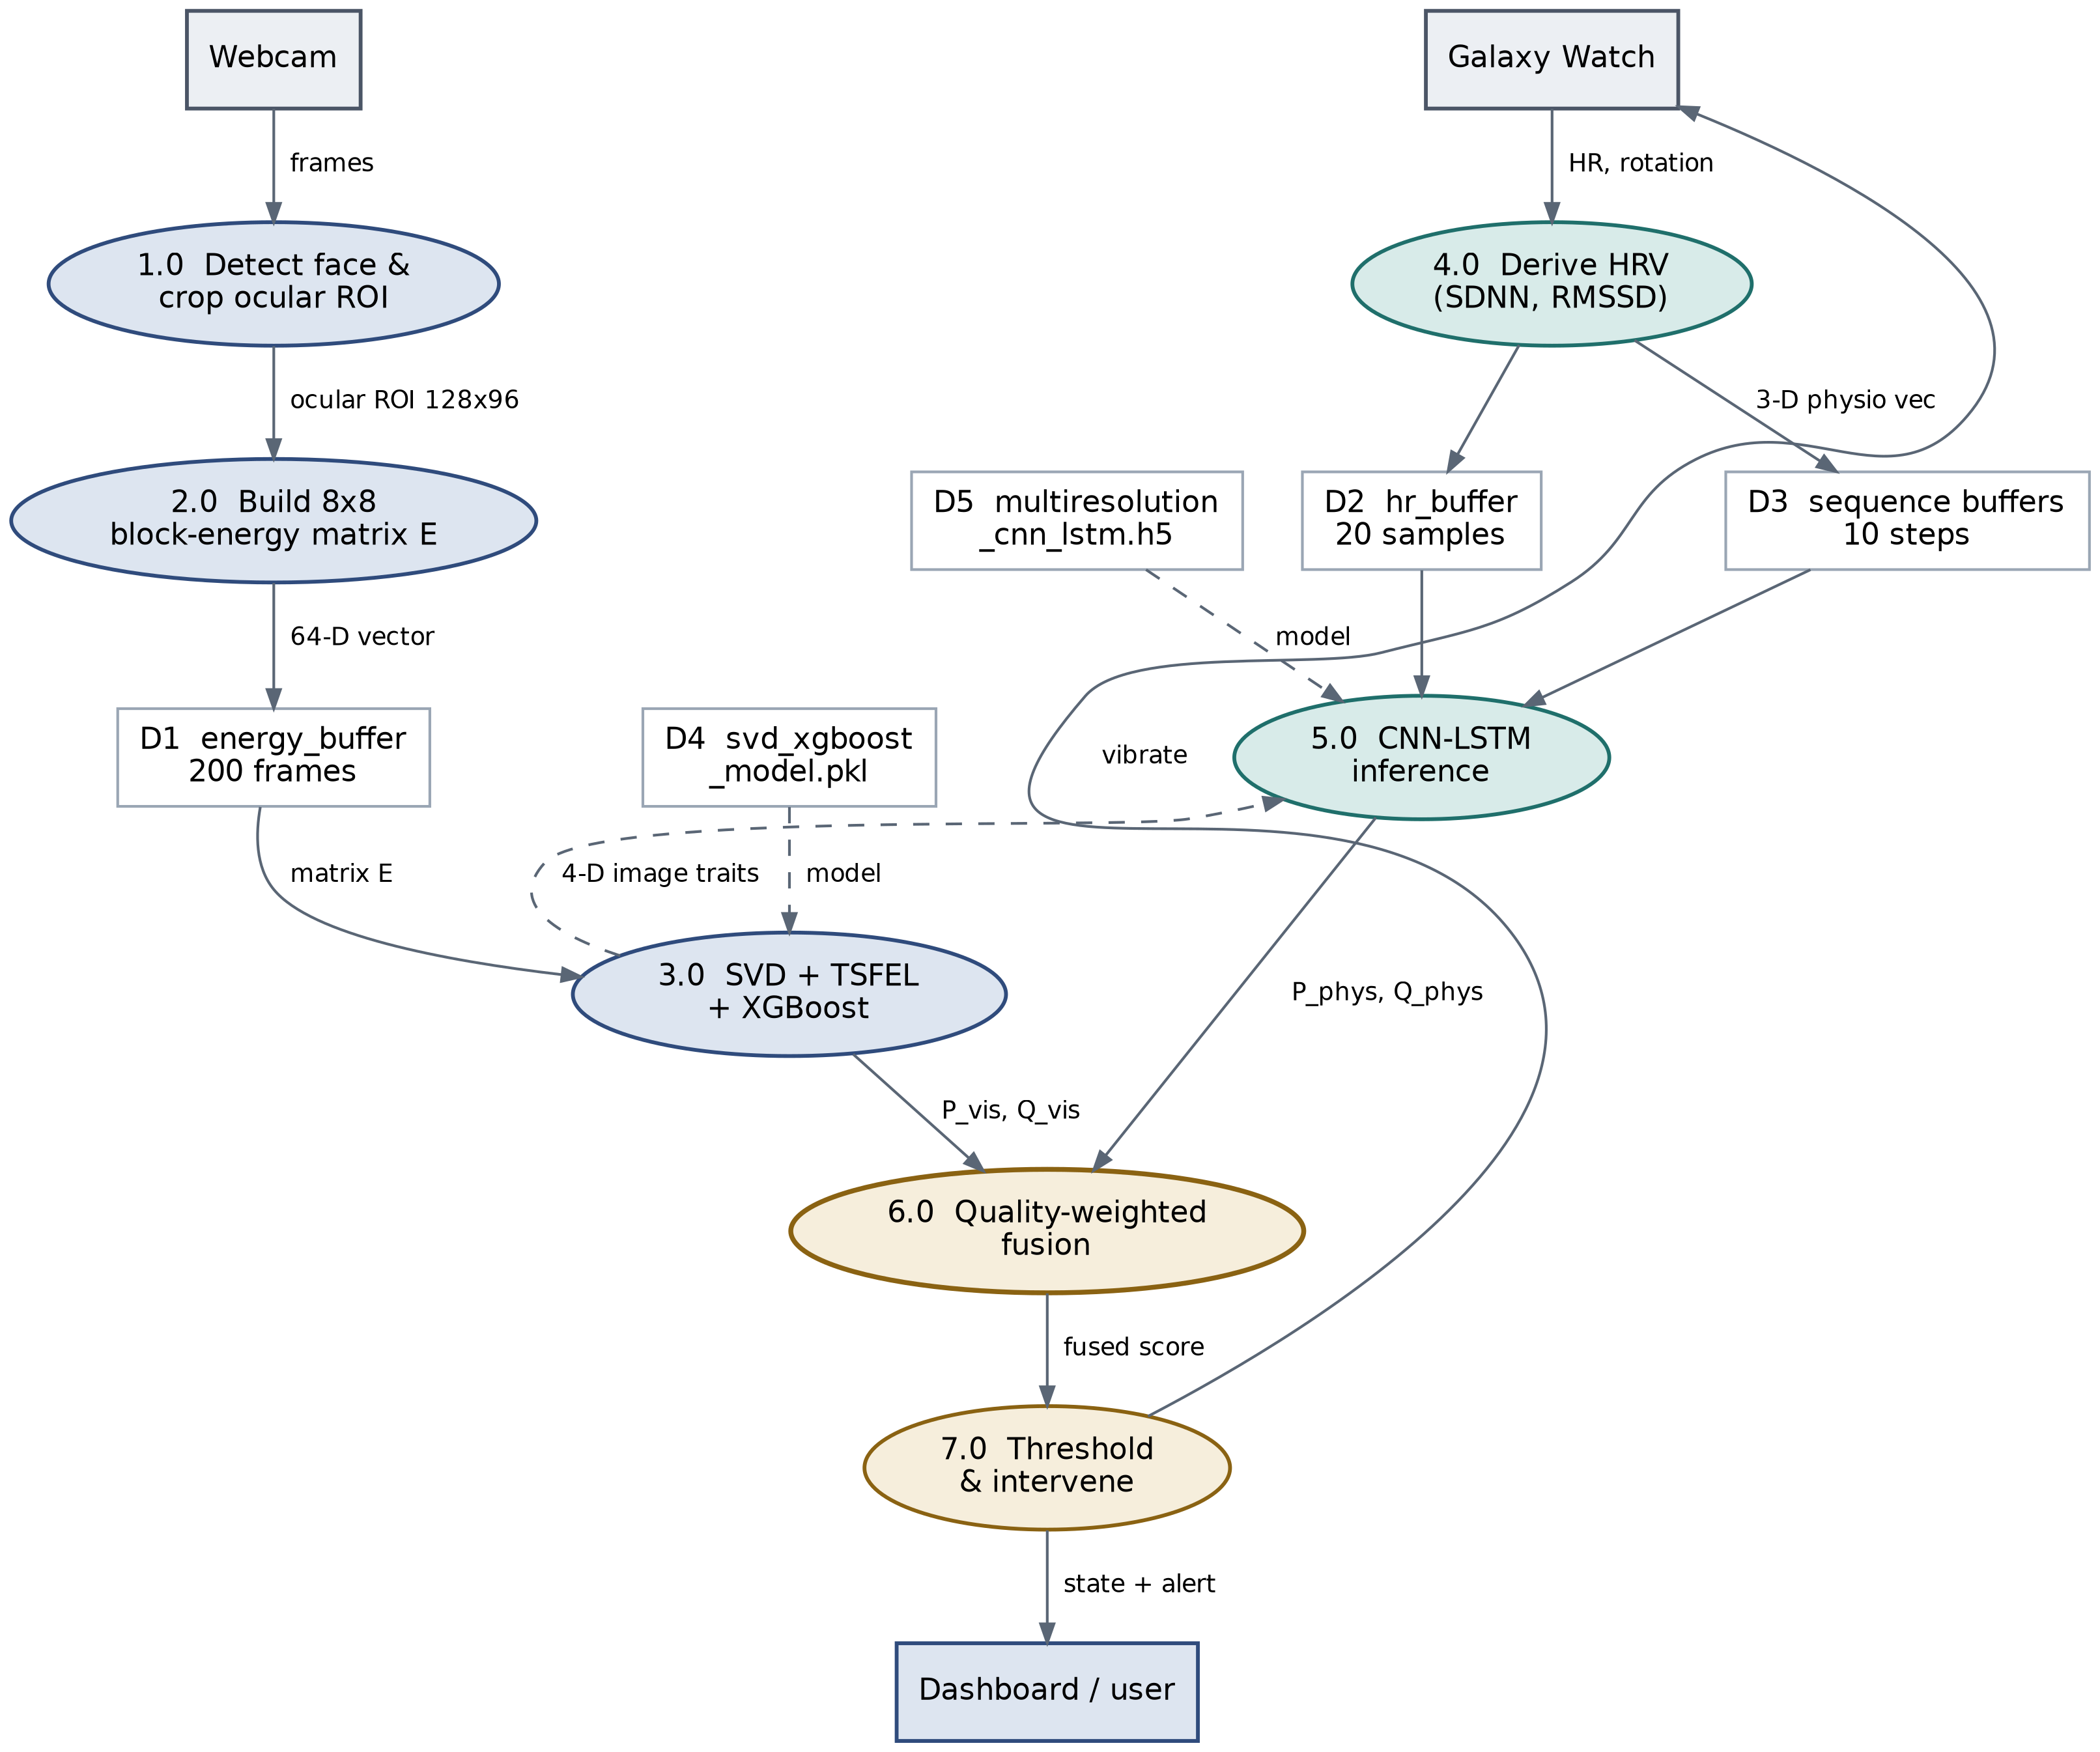
Figure 5.3 — Data flow from sensor input through seven processes and five stores to the classified state and the prompt.
The visual path is longer than the physiological one, four processes against two, so visual inference sets the cycle time. None of the five stores is permanent: D1 to D3 are fixed-length memory buffers, D4 and D5 model files loaded once at startup. There is nowhere a video frame could be written, which is how NFR-06 is enforced.

5.4.5 Algorithm Design
Three algorithms carry the system’s behaviour: the visual pipeline, the network reconciling two sampling rates, and the rule combining two probabilities into one state. This section gives the design; Section 6.3 records what was built.
Visual Pipeline. The source method is offline. Anh et al. (2024) read a complete recorded clip, stack its ocular energies, decompose the result once and emit one classification. A system deciding every second cannot wait for a clip to end, and the reformulation that makes the method real-time is a rolling buffer: the newest frame displaces the oldest, and the decomposition runs once per second over whatever the buffer holds. A per-frame decision was rejected in turn, since a single frame contains no eye movement — movement is a property of a sequence.
The window is 200 frames, ten seconds at 20 fps, and its length follows from the phenomenon. Palmieri, Fernández and Carrasco (2023) measure a steady microsaccade rate of 1.8 Hz, so ten seconds contains about eighteen movements, enough for spectral descriptors to measure a repeating structure rather than a few isolated events. A shorter window cannot distinguish a rhythm from noise; a longer one averages across attentional states that themselves change over seconds.
Each frame contributes 64 numbers: the ocular crop is resized to 128×96, divided into an 8×8 grid of 12×16-pixel blocks, and the squared brightness in each block summed. Crop and grid are taken from Anh et al. (2024), and the size relation they fix is the useful one — a block is large enough that a saccade of a few pixels changes which blocks are bright, small enough that the change stays local rather than averaging away across the crop. Stacking 200 such vectors gives a 200×64 matrix whose every column is one block’s brightness over time.
Singular value decomposition is the operation that matrix asks for. Eye movement is a small, fast, repeated variation sitting on a large, slow one caused by lighting drift and posture, and the decomposition orders components by how much of the variation each accounts for. The pipeline therefore does not take the leading singular vector, which describes the lighting rather than the learner; it takes the vector of greatest high-frequency amplitude under the Fourier transform, saccadic motion being the fastest thing in the window. TSFEL then reduces that vector to 142 descriptors.
Physiological Network. The two signals entering Module B arrive at different rates: the heart-rate features update about once a second, the visual traits twenty times a second. Resampling one to match the other either discards the faster signal or invents values for the slower. John et al. (2021) avoid the choice by giving each modality its own convolution at its own rate before the branches meet, and that separation is the organising decision of this network. The physiological branch uses 16 filters of width 2; the visual branch uses 32 filters of width 3, wider because that signal changes faster.
Each branch is then summarised twice in parallel. An average keeps slow drift and discards rare peaks; a maximum keeps peaks and loses the baseline. Woo et al. (2018) ablate both against either alone and find the pair superior, and both summaries are concatenated here for that reason, though Nirthika et al. (2022) report no universally best pooling operation, so the choice is declared rather than proven. The branches join only afterwards, so fusion occurs between summarised representations rather than raw sequences. Figure 5.4 shows the structure and Table 5.1 gives it layer by layer.
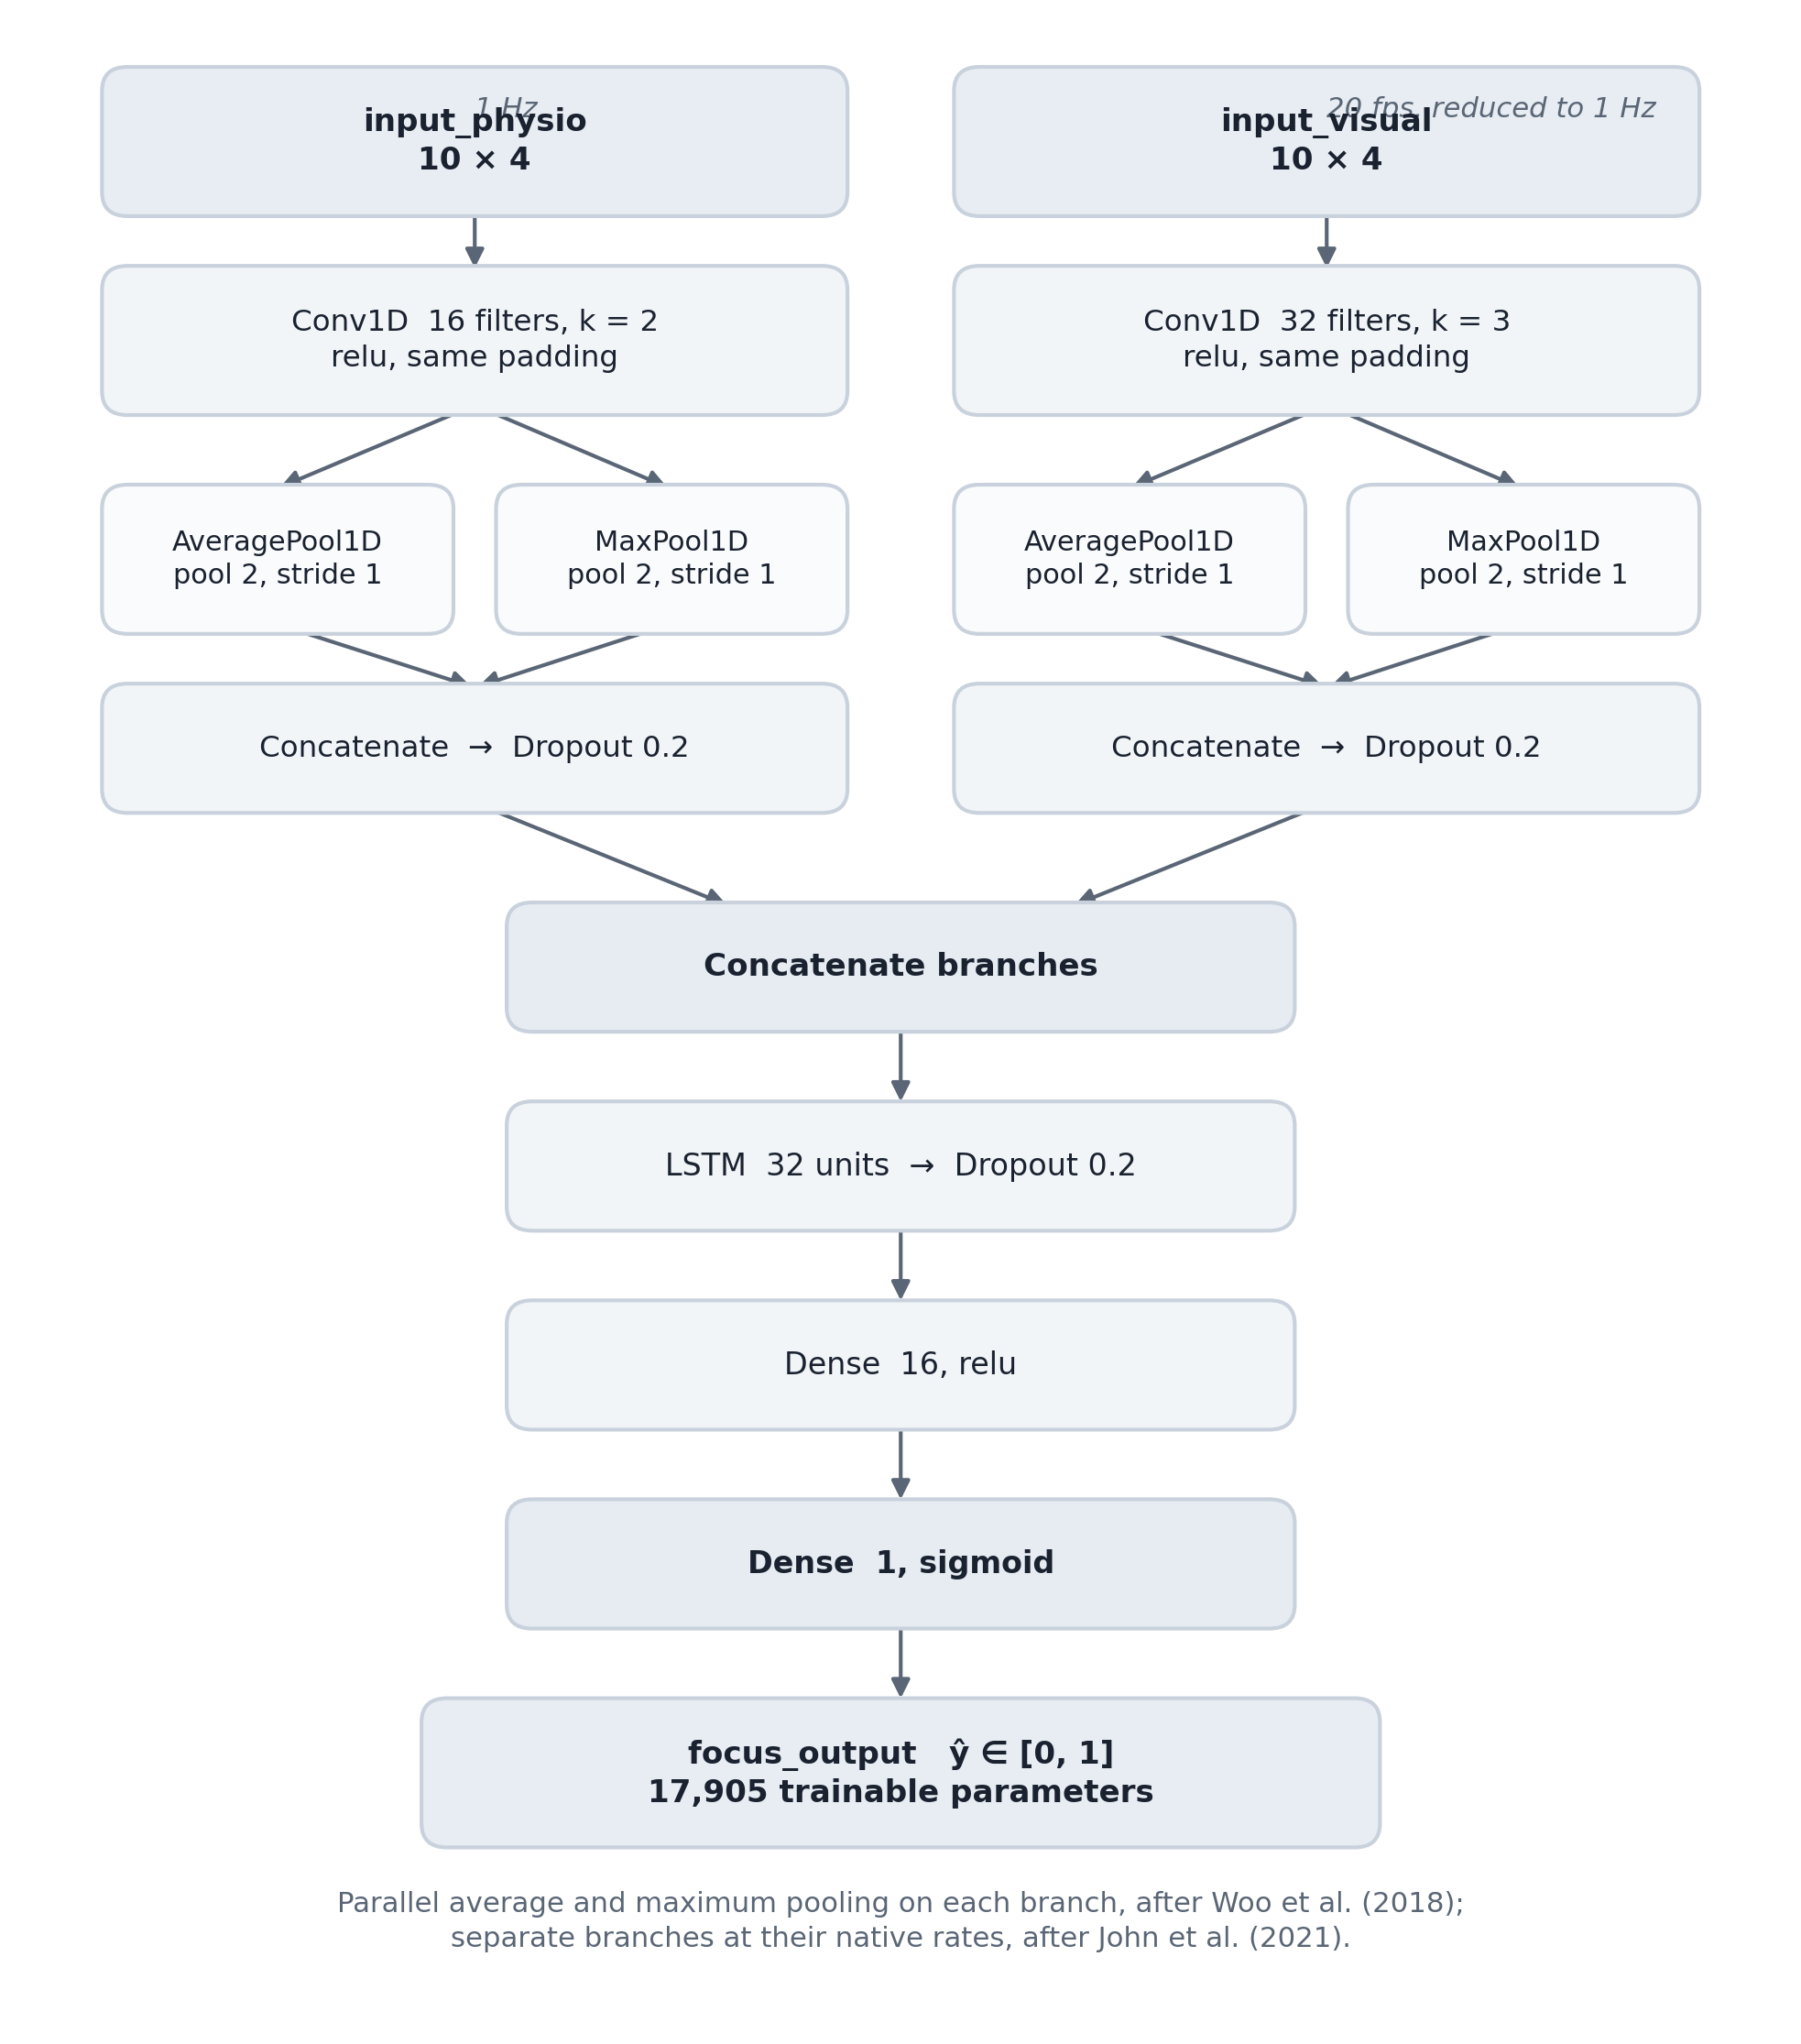
Figure 5.4 — Layer structure of the two-branch multiresolution network. Each branch is convolved at its own rate, summarised by parallel average and maximum pooling, and joined before the recurrent layer.
Table 5.1 — Layer-by-layer design of the two-branch multiresolution network, with the rationale for each choice.
Layer | Configuration | Output shape | Rationale
Input A — physiological | 10 timesteps × 4 features | (10, 4) | Baseline-normalised heart-rate and variability features at the watch’s ≈1 Hz reporting rate; ten steps matches the window length of John et al. (2021)
Conv1D — physiological | 16 filters, kernel 2 | (9, 16) | A narrow kernel spans two samples of a slow signal, the shortest span in which a direction of change exists; 16 filters suffice for a channel with few independent modes
AveragePooling1D and MaxPooling1D — physiological | pool 2, in parallel | (4, 16) each | Average retains slow drift, maximum retains transient peaks; Woo et al. (2018) ablate both against either alone and find the pair superior
Dropout — physiological | 0.20, after each pooling path | (4, 16) each | Nineteen participants supply the training sequences, few enough that the network can memorise individuals rather than learn the relation
Concatenate — physiological | feature axis | (4, 32) | Both summaries are carried forward; neither is chosen over the other
Input B — visual | 10 timesteps × 4 features | (10, 4) | The trait vector from Module A: gaze energy, blank-stare index, head stability and visual focus probability
Conv1D — visual | 32 filters, kernel 3 | (8, 32) | A wider kernel and twice the filters because the ocular signal changes faster and carries more independent structure than the cardiac one
AveragePooling1D and MaxPooling1D — visual | pool 2, in parallel | (4, 32) each | The same dual summary applied at this branch’s own resolution, which is the point of separating the branches
Dropout — visual | 0.20, after each pooling path | (4, 32) each | As above; the wider branch has more capacity to memorise and needs the regularisation more
Concatenate — visual | feature axis | (4, 64) | As above
Concatenate — branches | feature axis | (4, 96) | Fusion occurs only after each modality has been convolved and summarised at its own rate, following John et al. (2021)
LSTM | 32 units | (32) | One recurrent layer reads the joined sequence in order, so the model sees the direction of change and not only its magnitude
Dropout | 0.20 | (32) | The last regularisation before the output head, where overfitting is cheapest to prevent
Dense | 16 units | (16) | A narrow head: a wider one adds parameters without adding information, since 96 features already entered the recurrent layer
Dense | 1 unit, sigmoid | (1) | A single focus score bounded to the unit interval, which is the form Module C weights

The design totals 17,905 parameters. That size is a requirement rather than an outcome: NFR-04 forbids assuming a graphics card, so the whole forward pass must complete on a processor within a one-second cycle already largely consumed by capture.
Fusion Rule. Wei et al. (2018) weight each sensing channel in proportion to its assessed reliability, computed once from recorded data. This design keeps the principle and moves the computation into the cycle: the weight of a sensor is its base weight multiplied by its current quality score, the two products then divided by their sum so the pair adds to one. Both base weights are 0.50, asserting nothing about either sensor and leaving the quality terms to carry the whole adaptation.
Each quality term has a floor, so a degraded sensor is reduced rather than silenced: the watch score is held above 0.35, the camera score cannot fall below 0.32 while a face is visible, and a further floor inside the engine stops either weight reaching zero from a momentary drop. A sensor having a poor second loses influence in proportion and regains it as its quality recovers.
Two conditions override the calculation, being questions of kind rather than degree. A watch absent or detected off the wrist contributes nothing: the camera weight is forced to one, since a sensor reporting a stale value differs from one reporting a poor value. Before the baseline exists the normalised heart-rate features are undefined rather than noisy, so during calibration the weights are fixed at 0.90 camera and 0.10 watch.
The fused score becomes a state through two thresholds rather than one. From focused, a score below 0.45 declares inattention; from zoned out, a score above 0.55 declares recovery; between the two the current state persists. A single boundary would make the state depend only on the current cycle, so a score hovering near it would yield a new classification every second and an interface flickering between verdicts the learner cannot act on. Two thresholds require evidence of a definite size, which no run of small fluctuations can supply.

5.4.6 User Interface Design
Both interfaces were drawn at low fidelity before either was styled, and the wireframes in Figure 5.5 fixed three decisions the finished screens only dress. The first is the layout of the dashboard: two sensor cards above a full-width decision panel, so the eye reaches the evidence before the conclusion and the interface reads as an explanation rather than a verdict. The second is that state is carried by colour, text and shape together — the central indicator changes form as well as hue — so no classification depends on colour discrimination alone. The third is what the watch does not show: the watch wireframe has a title, a connection line and one switch, and no numeric field anywhere, a decision taken at the sketch stage rather than settled later by omission. Working at this fidelity kept the argument about layout separate from the argument about typography and colour, and settled the layout first.
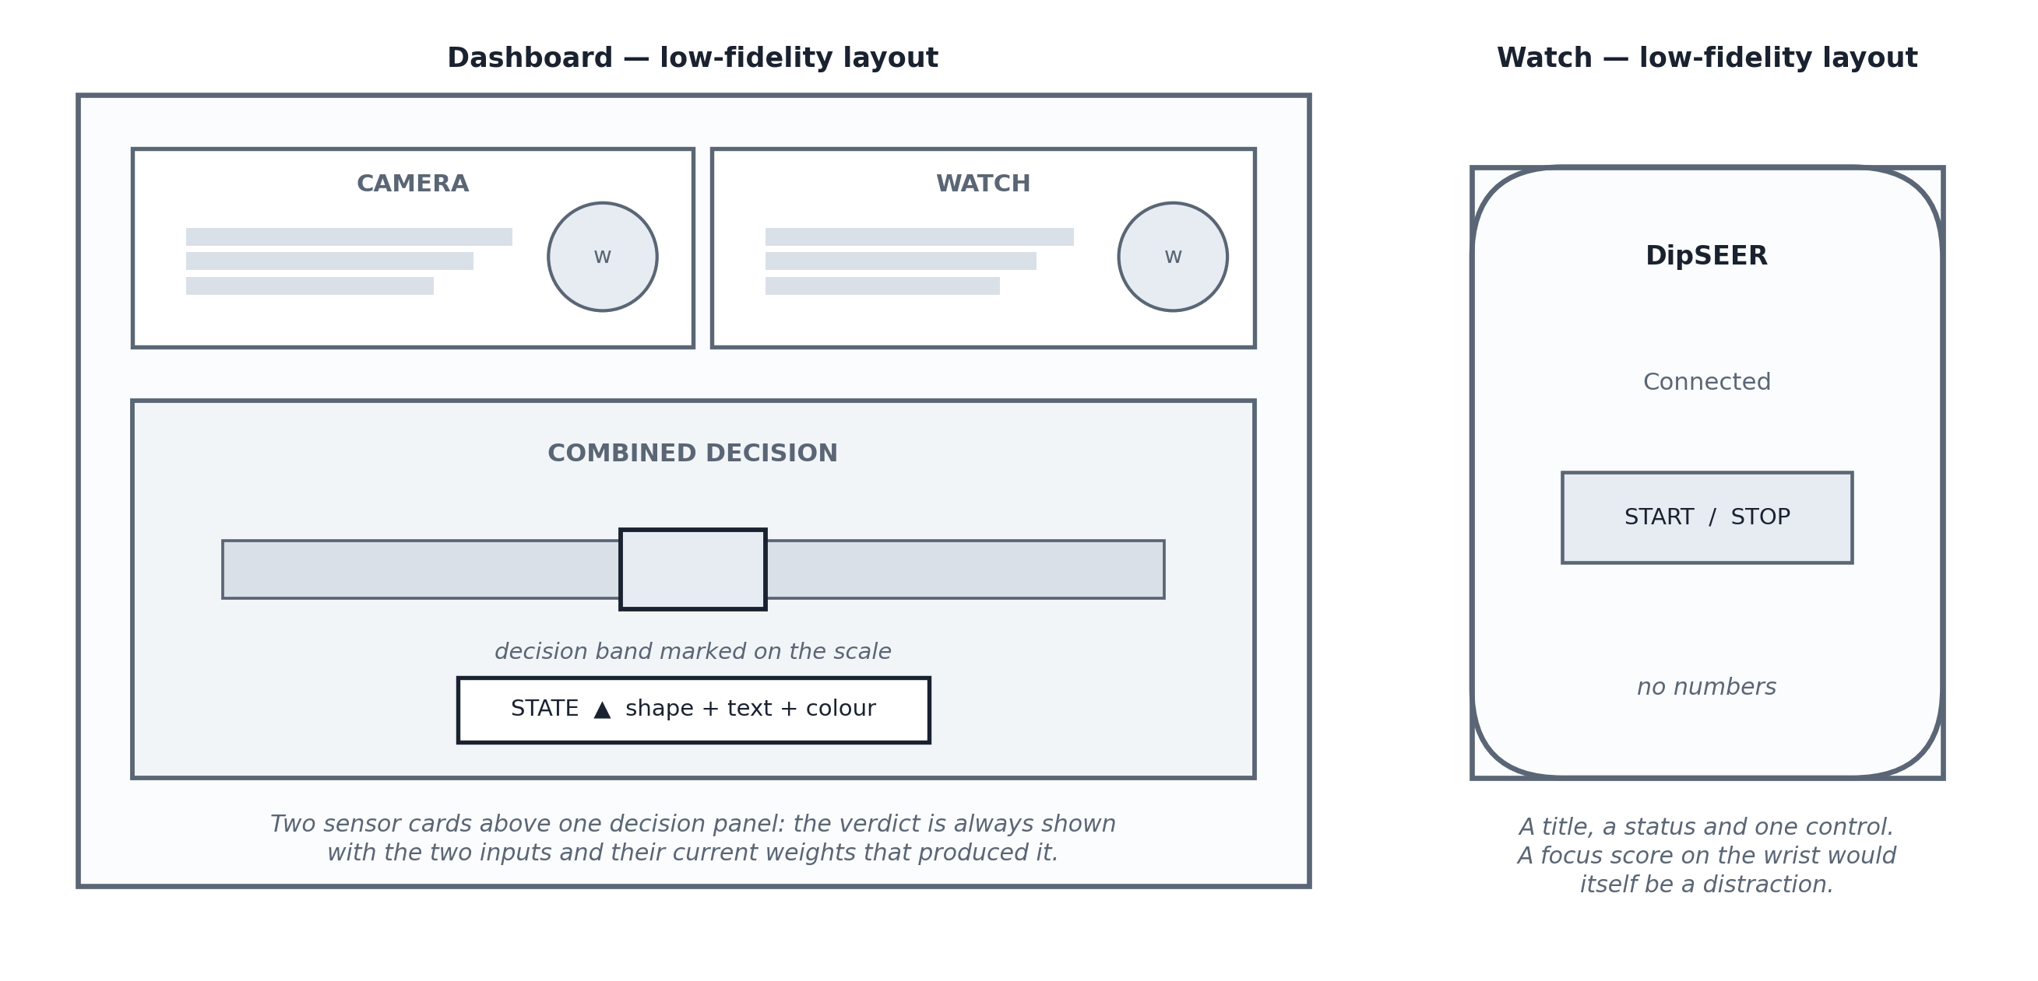
Figure 5.5 — Low-fidelity wireframes for the dashboard and the watch face, showing the layout decisions taken before visual design.

5.4.7 System Process Workflow
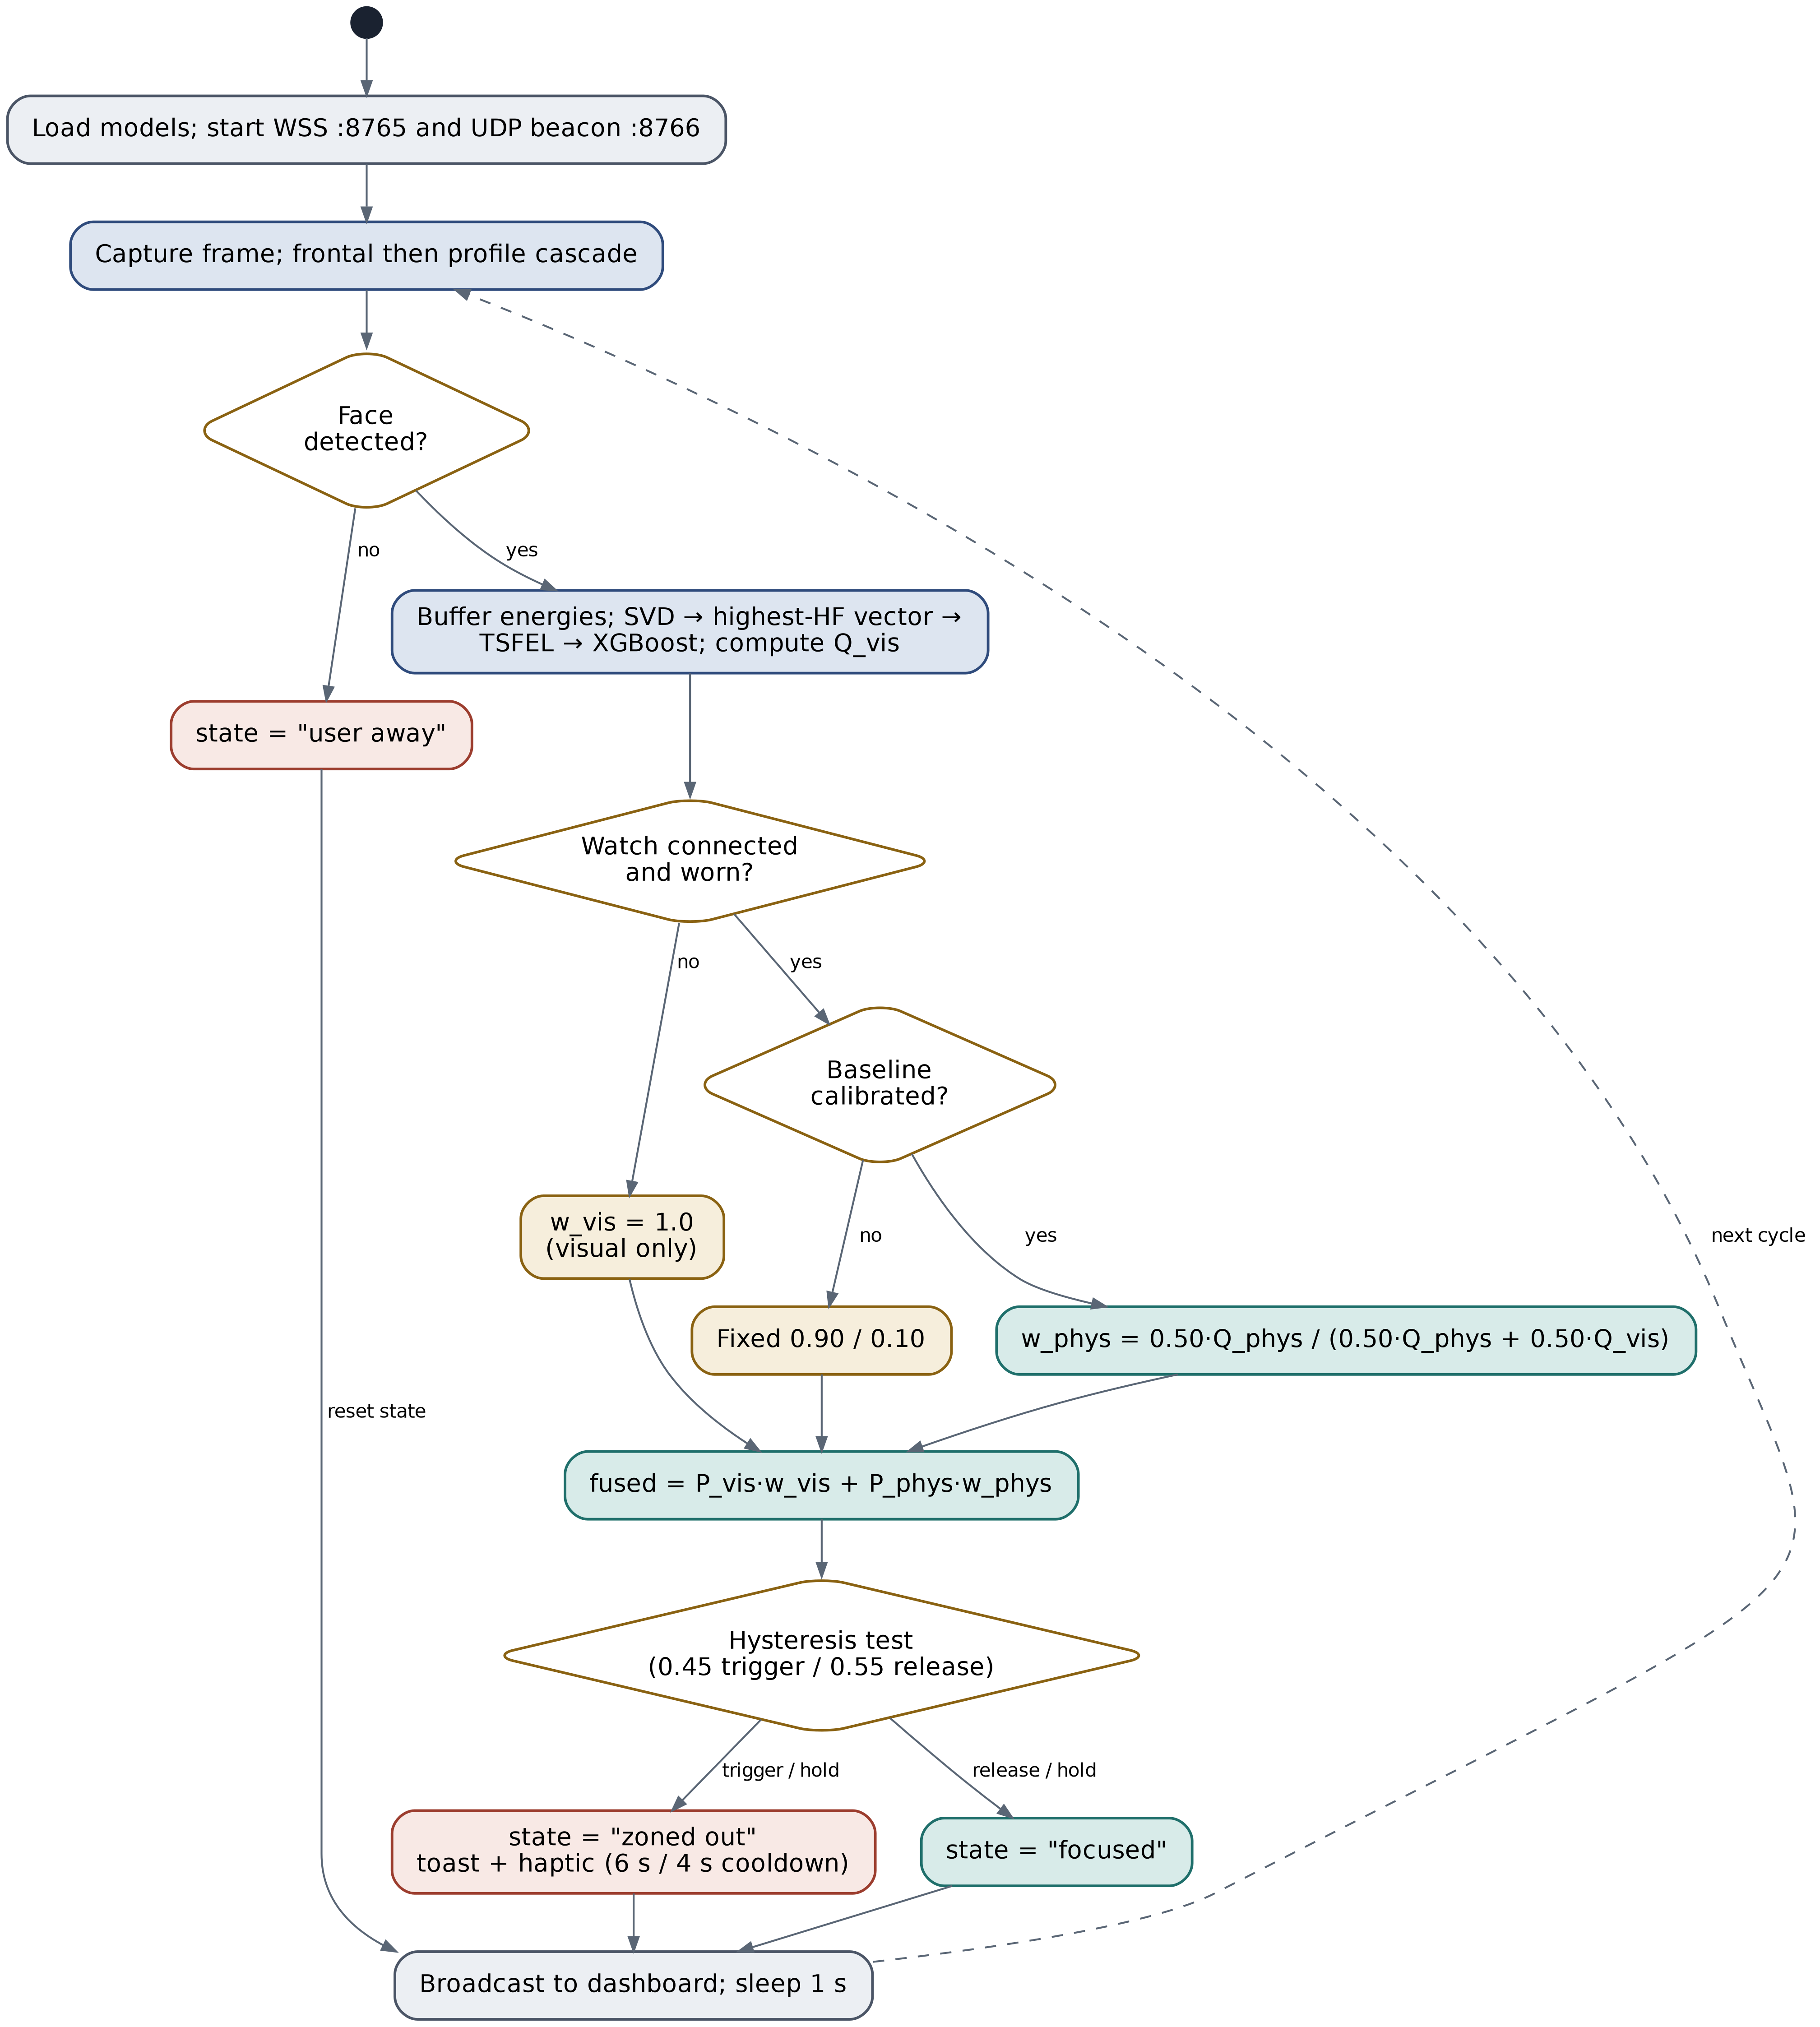
Figure 5.6 — One inference cycle, showing the three points where the system adapts to sensor conditions and the hysteresis test that turns the combined score into a reported state.
Three decisions govern how the system adapts. The first checks for a face: with no face there is no visual evidence, so the system reports "user away" and raises no alert. The second checks whether the watch is connected and worn, distinguishing disconnection from a watch lying on a table; both fall back to camera-only operation, but the dashboard shows which. The third checks calibration: until a personal baseline exists the normalised heart-rate features are meaningless, so weights are fixed at 0.90 camera and 0.10 watch rather than calculated from quality.
The last test is not a fallback but the point where a continuous score becomes a discrete state, and the only node reading the previous cycle as well as the current one, since thresholds depend on the current state. Section 6.3.4 explains the mechanism.

5.5 Chapter Summary
This chapter set out a four-layer architecture shaped by six goals, chiefly bounded response time and useful behaviour under sensor failure. Object-oriented decomposition was justified over structured analysis on the grounds that the system’s defining property is state persisting across cycles, with the data flow diagram retained as a borrowed notation for the single argument about storage that it makes best. An event-driven model was justified over threads and sequential execution on the grounds of buffer safety and real-time pace, with the exception blocking camera reads required. The component, data-flow and activity models show no permanent store for video and adaptation at three explicit decision points. Section 5.4.5 designed the three algorithms: a rolling-buffer reformulation of an offline visual method, a two-branch network convolving each modality at its own rate, and a fusion rule whose weights are recomputed every cycle and whose output is stabilised by two thresholds. Chapter 6 describes how this design was built.

6 IMPLEMENTATION

6.1 Chapter Overview
This chapter describes how the design was built. It justifies each technology choice against the alternative considered, then covers the training pipelines, the watch application, and the laptop backend that runs inference and fusion.

6.2 Technology Selection

6.2.1 Technology Stack
The system is a distributed application with three parts: a Python backend on the laptop, a Kotlin application on the watch, and a browser dashboard. Table 6.1 restates Figure 5.1 with the technology occupying each tier.
Table 6.1 — Technology occupying each architectural tier across the three deployed artefacts.
Tier | Laptop | Watch | Browser
Presentation | — | Jetpack Compose for Wear OS | HTML5, CSS3, vanilla JavaScript, Vite
Application / inference | Python 3.10, TensorFlow 2.14/Keras, XGBoost, TSFEL, scikit-learn | — | —
Communication | websockets (asyncio), Python ssl, socket, psutil | OkHttp 4 WebSocket, java.net.DatagramSocket | Browser WebSocket API
Data acquisition | OpenCV 4.8 (DirectShow backend) | Android SensorManager (TYPE_HEART_RATE, TYPE_ROTATION_VECTOR) | —

6.2.2 Data Selection
Two datasets were required because no single public dataset provides synchronised webcam video and consumer-smartwatch telemetry with attention labels.
DAiSEE (Gupta et al., 2016) was selected for the visual model — 9,068 clips from 112 subjects annotated for boredom, engagement, confusion and frustration on four-point ordinal scales — because its uncontrolled illumination matches deployment. The ordinal engagement label was mapped to a binary target, levels 0–1 as "zoned out" and 2–3 as "focused". Only 234 clips in the training split fall at levels 0 or 1; all were retained and majority clips sampled to three times that count, giving 936 clips at a 1:3 ratio (Sections 7.4.2 and 8.10).
DIPSER (Marquez-Carpintero et al., 2025) was selected for the physiological model as the only publicly available corpus pairing student engagement annotation with synchronised Samsung smartwatch telemetry. Nineteen subjects contributed usable sensor and label files. The corpus supplies one five-point attention rating per independent annotator at each timestamp; ratings at a timestamp are averaged into a consensus score and normalised to the unit interval by subtracting one and dividing by four, replacing an arbitrary interval scale from an earlier revision. Heart-rate samples are joined to the nearest label within a fifteen-second tolerance, tightened from an earlier forty-five seconds, to form ten-step sequences.

6.2.3 Selection of Programming Language
Python 3.10 was chosen for the backend because XGBoost, TSFEL, OpenCV and TensorFlow all have mature Python libraries, TSFEL having no equivalent elsewhere. C++ was rejected because Section 6.3.4 shows speed was never the limiting factor.
Kotlin was chosen for the watch for unmediated access to the Android SensorManager: Flutter and React Native sit between the app and the sensors, and Java lacks Kotlin’s null safety in asynchronous sensor callbacks.
Plain JavaScript was chosen for the dashboard over React or Vue: the page has one data source and about a dozen mutable elements, at which size neither framework’s state model earns its build cost.

6.2.4 Libraries
Table 6.2 lists the Python libraries the backend depends on with the version developed against. Three carried a choice. OpenCV 4.8 provides camera capture and Haar-cascade face detection, chosen over a neural detector or MediaPipe on processing cost, at the cost of weaker handling of head rotation (Sections 7.8.2 and 6.3.2). TSFEL supplies the descriptors because it implements exactly the set used by Anh et al. (2024); its temporal group is switched off, leaving 142 features. XGBoost was preferred to a support vector machine or random forest for handling a wide, correlated feature set without pre-selection; Shwartz-Ziv and Armon (2022) report that it also outperforms proposed deep architectures on tabular data and needs far less tuning to do so. The remaining five support: NumPy the decomposition and every buffer operation, pandas the dataset merges, scikit-learn the splitting and evaluation utilities, psutil the network-interface enumeration behind discovery, and cryptography the self-signed certificate.
Table 6.2 — Python libraries on which the backend depends, with the version developed against and the purpose each serves.
Library | Version | Purpose
OpenCV (opencv-python) | 4.8+ | Webcam capture, Haar-cascade face detection, ocular crop and resize
TSFEL | 0.1.6+ | The 142 statistical and spectral descriptors taken from the selected singular vector
XGBoost | 2.0+ | The gradient-boosted visual classifier trained over those descriptors
NumPy | 1.24+ | Block-energy arithmetic, the singular value decomposition, and all rolling-buffer operations
pandas | 2.0+ | Dataset loading and the tolerance-based temporal merge of labels to sensor samples
scikit-learn | 1.3+ | Cross-validation splitting and evaluation metrics in both training pipelines
psutil | 5.9+ | Enumeration of active network interfaces for the discovery beacon
cryptography | 41.0+ | Generation of the self-signed TLS certificate with multi-IP SAN entries

6.2.5 Frameworks
TensorFlow 2.14 with Keras was chosen for the two-branch network because its functional interface expresses two inputs, parallel pooling paths and a join between branches, which the sequential interface cannot; PyTorch was rejected on robust single-call model loading inside a long-lived asyncio process. Jetpack Compose for Wear OS renders the watch interface — four state indicators and one button — from the service state. OkHttp3 supplies the watch WebSocket client, handling TLS, reconnection and back-off. Vite serves and builds the dashboard. Table 6.3 lists each with its version.
Table 6.3 — Frameworks used across the three artefacts, with the version developed against and the role each plays.
Framework | Version | Role in the system
TensorFlow with Keras | 2.14 | Definition, training and single-call loading of the two-branch CNN-LSTM; the functional interface expresses the two inputs, the parallel pooling and the cross-branch join
Jetpack Compose for Wear OS | 1.3+ | Declarative watch interface, redrawn from the foreground-service state
OkHttp3 | 4.12+ | WebSocket client on the watch, including TLS negotiation and reconnection
Vite | — | Development server and production bundle for the browser dashboard

6.2.6 Integrated Development Environments
Visual Studio Code was used for the backend and the dashboard: one editor covers Python and JavaScript, its terminal runs the backend and the Vite server side by side, and its debugger attaches to the asyncio process without additional configuration. Android Studio was necessary for the watch application, the Wear OS Gradle build, the watch emulator, the Compose layout inspector and ADB deployment being unavailable elsewhere.

6.2.7 Summary of Technology Selection
Table 6.4 records the deciding factor for every choice made above, set against the alternative considered.
Table 6.4 — Summary of technology selection, with the alternative considered and the factor that decided each choice.
Category | Selected | Rejected alternative | Deciding factor
Backend language | Python 3.10 | C++ | TSFEL and XGBoost bindings; latency not the binding constraint
Wearable language | Kotlin | Java, Flutter | Native sensor access; null safety in async code
Frontend | Vanilla JS + Vite | React, Vue | One data source, twelve mutable nodes; framework unjustified
Deep-learning framework | TensorFlow 2.14 / Keras | PyTorch | Robust single-call model loading inside a long-lived asyncio process
Visual classifier | XGBoost | SVM, Random Forest | Handles 142 wide, correlated features without prior selection
Face detection | OpenCV Haar cascades | MediaPipe, DNN detector | Only option leaving CPU budget for the full cycle
Feature extraction | TSFEL (statistical + spectral) | Hand-written descriptors | Matches Anh et al. (2024) exactly, enabling comparison
Concurrency | asyncio | Threading, multiprocessing | Lock-free buffer safety; no serialisation cost
Transport | WebSocket Secure over Wi-Fi | Bluetooth Low Energy | BLE throughput and pairing reliability inadequate (Section 8.8)
Visual dataset | DAiSEE | Lab engagement corpora | Uncontrolled capture conditions match deployment
Physiological dataset | DIPSER | WESAD, SWELL | Only corpus with synchronised Samsung watch telemetry

6.3 Implementation of Core Functionality

6.3.1 Offline Training Pipelines
Three training pipelines were built; two were abandoned (Section 8.8). Section 6.3.5 traces every borrowed method to its source and its file.
The visual pipeline extracts features from DAiSEE at 20 frames per second, every third frame dropped — fivefold the roughly 4 Hz minimum implied by microsaccades at about two per second, measured at a steady 1.8 Hz by Palmieri, Fernández and Carrasco (2023). The eye region, found with the detector and geometric band the live system uses, is resized to 128×96 and divided into an 8×8 grid of 12×16 pixel blocks. Summing the squared brightness in each block gives a 64-element energy vector; stacking these across a fixed 200-frame window gives a 200×64 matrix, and shorter clips are discarded. Singular value decomposition selects the vector with the most high-frequency content, which TSFEL reduces to 142 descriptors. Extraction ran across eight parallel processes over the 936 selected clips; an earlier run on a 10% sample gave only 481 rows with 26 minority examples (Section 7.4.2).
The classifier is an XGBoost model; its settings and the network’s appear in Table 6.6 with the origin of each. None was obtained by search (Section 8.10). Training stopped early at 59 trees of a possible 1,000.
The physiological pipeline builds sequences from DIPSER. For each participant, a median heart rate and RMSSD baseline convert every sample into three numbers: change in heart rate, change in RMSSD, and scaled SDNN. A second vector of four numbers carries the visual traits, and ten consecutive steps form one sequence, targeted on the consensus mean of Section 6.2.2. The dataset provides no ready-made facial features, so Module A was run across the DIPSER face-camera recordings — about 49,000 frames — giving 5,199 sequences across nineteen participants (Section 7.4.3).
The network follows John et al. (2021) in giving each sensor its own branch at its own rate. The physiological branch uses 16 filters with a width of 2, the visual branch 32 filters with a width of 3. Each branch is summarised twice at once, by an average and a maximum, and the two are joined.
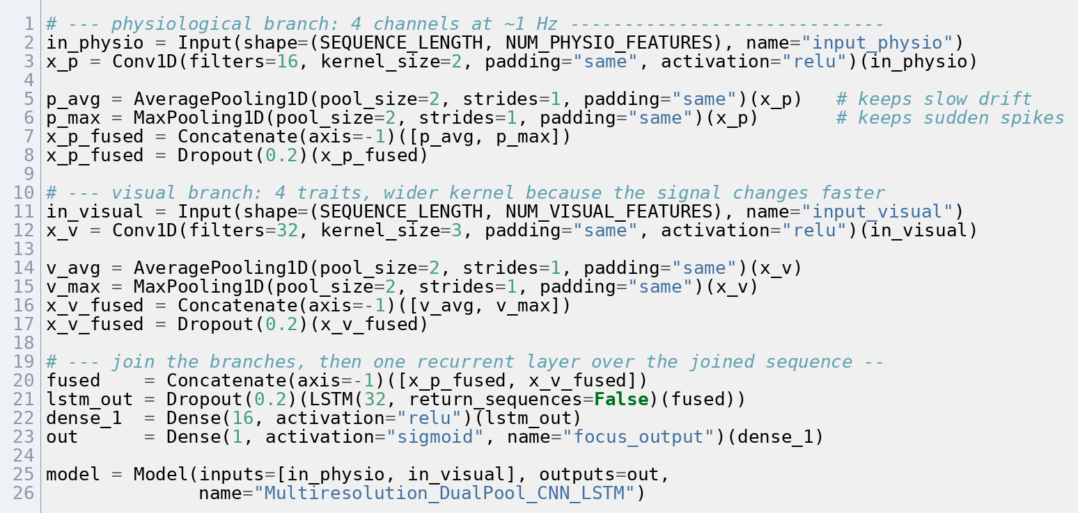
Figure 6.1 — The two-branch network definition in train_multiresolution_cnn_lstm.py, showing the parallel average and maximum pooling on each branch before the join.
Both branches apply the same three steps: a one-dimensional convolution at the branch’s own filter count and width, batch normalisation, then the two poolings on the same tensor, concatenated along the feature axis. The physiological input is ten steps of three values, the visual ten steps of four. Dropout follows each branch and the join.
Woo et al. (2018) use both poolings together in the CBAM module: on ResNet-50 over ImageNet-1K, average alone gives 23.14% error, maximum alone 23.20%, and both together 22.80%, against a 24.56% baseline; Nirthika et al. (2022) find no pooling operation universally best, so the arrangement is adopted as a design choice rather than an established result, against a 24.56% baseline. Table 6.5 records the departure from that use (Section 8.8.3).
The branches are joined and passed to a 32-unit LSTM, then a 16-unit layer and a single output. Training uses Adam at its default learning rate of 0.001 against mean squared error, for 15 passes at batch size 32, with 20% dropout after each pooling stage and before the final layer. The model has 17,905 parameters.

6.3.2 Module A — Visual Processing
Module A captures on its own thread and runs inference on the event loop. Capture is requested at 640 × 480, but a driver may substitute the nearest supported mode, so the actual resolution is read back and a scale factor formed from the ratio to 640, multiplying every pixel-based constant.
The capture thread tries frontal detection with the alt2 classifier, then profile detection, then a horizontal flip and retry. On detection the module records the face centre and size and takes the eye region as the band from 10% to 90% of face width across 15% to 55% of face height. Its energy vector joins a 200-frame buffer, a ten-second window holding about eighteen movements at the 1.8 Hz baseline of Palmieri, Fernández and Carrasco (2023); the thirty-frame minimum before inference spans about three.
Inference decomposes the buffered matrix, selects the highest-frequency vector, extracts TSFEL descriptors and produces a probability — the pipeline of Anh et al. (2024) rebuilt to run continuously rather than in batches. The probability is used directly; an earlier build raised it to the eighth power to spread output clustered near 1.0, a symptom of a classifier trained on a 94.6% majority; it was removed once the model was retrained. Ojeda et al. (2023) compare the calibration methods available.
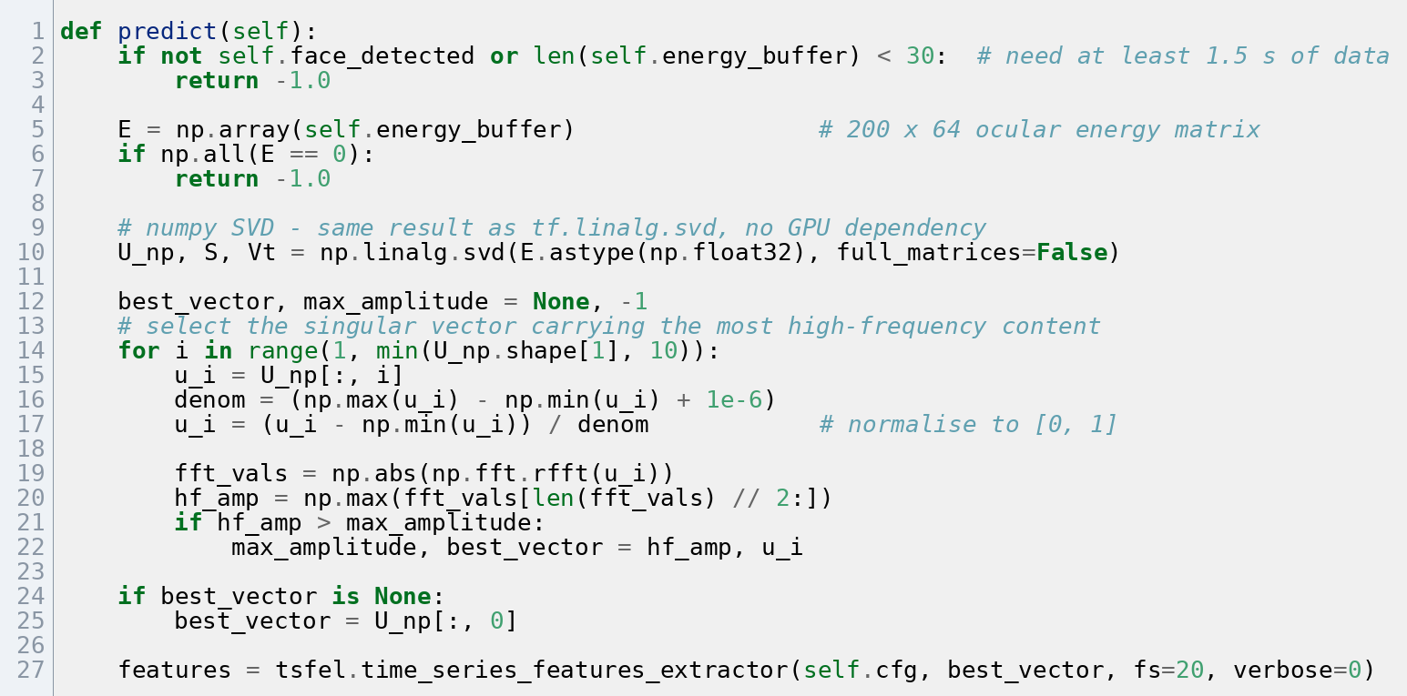
Figure 6.2 — The streaming SVD inference step in svd_inference.py, which decomposes the 200×64 energy buffer and selects the singular vector carrying the most high-frequency content.
The first ten singular vectors are examined rather than all sixty-four, the selected vector never having been seen beyond index four. Each is transformed to the frequency domain and the energy above the midpoint of its spectrum summed; the vector holding the largest share carries the fastest eye movement and is returned.
The module also derives three interpretable measures, implementing the markers of Bosch and D’Mello (2021): reduced gaze variation, less head movement and reduced expression distinguish mind wandering from attention. Head stability comes from how fast the face centre moves, in face-widths per second, removing the dependence on resolution and subject distance. Movement above 0.25 face-widths per second and stillness below 0.005 both count as disengagement.
The blank-stare measure looks at eye movement over the last three seconds, roughly five microsaccades at 1.8 Hz. Dividing the average variation in block energy over time by the average energy cancels any multiplicative change in scene brightness, leaving a lighting-independent ratio mapped to a score across the range 0.03 to 0.12. The upper bound, 0.120, is the 75th percentile of the ratio during active looking in the focused recordings; the lower, 0.030, is a floor below the observed 5th percentile of 0.046, no annotated zoned-out recordings being available.
Palmieri, Fernández and Carrasco (2023) found eye movement suppressed most strongly before a cued target, falling from 1.8 Hz to about 0.3 Hz; that effect lasts a few hundred milliseconds, whereas this measure looks for sustained reduction across three seconds with no cue (Section 8.10).
Visual quality combines face size and head stability in a 60/40 ratio, optimal at a face width of 160 pixels times the scale factor, where the eye crop is exactly 128 pixels wide and matches the training grid. The score never falls below 0.32 while a face is visible.

6.3.3 Module B — Physiological Processing and the Watch Application
The watch application runs as a foreground service holding a multicast lock and a high-performance Wi-Fi lock, without which the radio powers down and both discovery and the connection fail within minutes.
Connection begins with discovery. A background thread listens on UDP port 8766 with a two-second timeout for a beacon of the form DIPSEER_SERVER:address:port. On receipt the address is saved and an encrypted connection opened; on timeout the saved address is used, and failing that a fixed fallback list. The self-signed laptop certificate means the client accepts any certificate; Section 8.10 records certificate pinning as necessary before wider use.
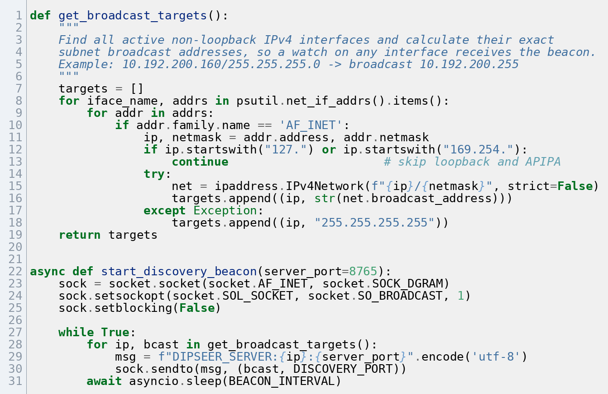
Figure 6.3 — The multi-interface UDP beacon in discovery.py, which enumerates every active network interface and computes its broadcast address.
Every interface is enumerated, each non-loopback IPv4 address paired with its netmask to compute the subnet broadcast address by setting the host bits; the global broadcast address is appended as a fallback and the datagram sent to each target every two seconds. A machine on both a wired and a wireless network advertises on both.
Sensor readings are sent as they arrive, tagged by type. On the laptop, heart-rate values are converted to beat-to-beat intervals, from which SDNN is their standard deviation and RMSSD the root mean square of the differences between consecutive ones. A rolling buffer keeps the median heart rate and median RMSSD as the personal baseline; until thirty samples have arrived the module reports itself calibrating and the fusion engine uses fixed weights.
Thirty samples is roughly thirty seconds, far shorter than the five minutes standard practice specifies. Kim, Seok and Shin (2021) and Taoum et al. (2022) support the shorter window only conditionally: it is defensible for a seated subject under the looser limits-of-agreement criterion, and not under the stricter tests or under movement.
Motion readings are reduced to a single movement figure and converted to a wrist-stability score, the physiological quality index. The watch counts as worn if a heart rate above 30 bpm arrived within the last five seconds.
When the camera loses the face the visual branch still expects an input, and zeros collapse the network state, so the module substitutes the median trait vector of the focused recordings, [0.48, 0.65, 0.95, 0.75]. This is a workaround — Kazijevs and Samad (2023) document how filling in a constant distorts what follows — and the masking layer at the head of the visual branch never fires, because Keras masking activates only when every value at a timestep is exactly zero (Section 8.10).

6.3.4 Module C — Quality-Aware Fusion
The fusion engine extends Wei et al. (2018), who had each sensing channel contribute in proportion to its reliability, with those proportions calculated offline, and follows Zhu et al. (2023) in treating that reliability as something estimated per modality at each moment rather than fixed in advance. Recalculating them every cycle from live quality measures is this project’s main technical contribution.
Both base weights, applied before quality, are set to 0.50. An earlier version gave the watch 0.65 against the camera’s 0.35, which the evidence supports from neither direction: Brishtel et al. (2020) found the eye channel slightly stronger at F1 0.80 against 0.78, while Gedam and Paul (2021) and Gjoreski et al. (2021) describe the body’s response to mental load as subtle and highly individual.
Those weights are multiplied by live quality and rescaled to sum to one. Each quality score has a floor so a briefly degraded sensor is reduced rather than silenced: the watch above 0.35, the camera above 0.32.
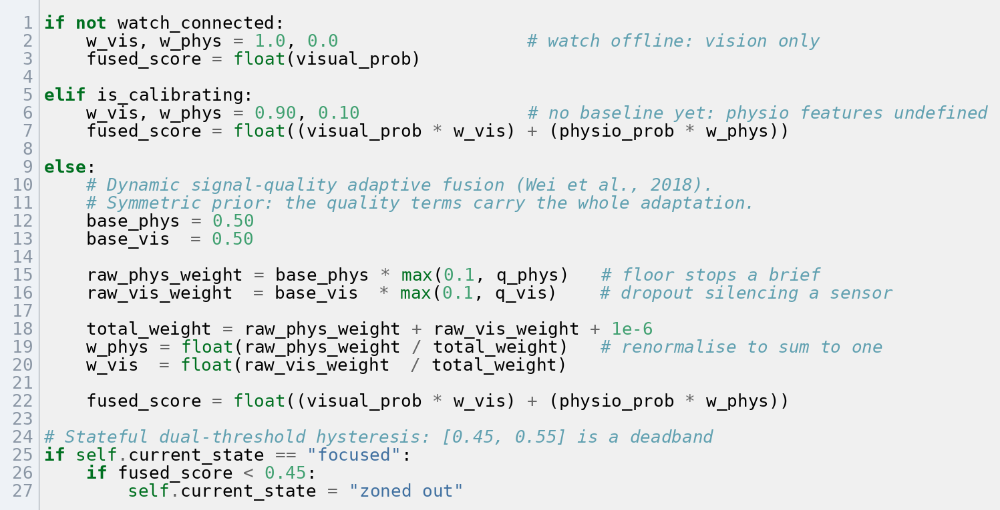
Figure 6.4 — The quality-adaptive weighting in meta_classifier.py, where the base weights are scaled by live quality and renormalised each cycle.
Each base weight is multiplied by its own quality index, floored beforehand so neither product can reach zero, and the two products divided by their sum. Nothing is carried between cycles, which separates this from the fixed offline weighting of Wei et al. (2018). The overrides are applied after normalisation and replace the computed pair outright.
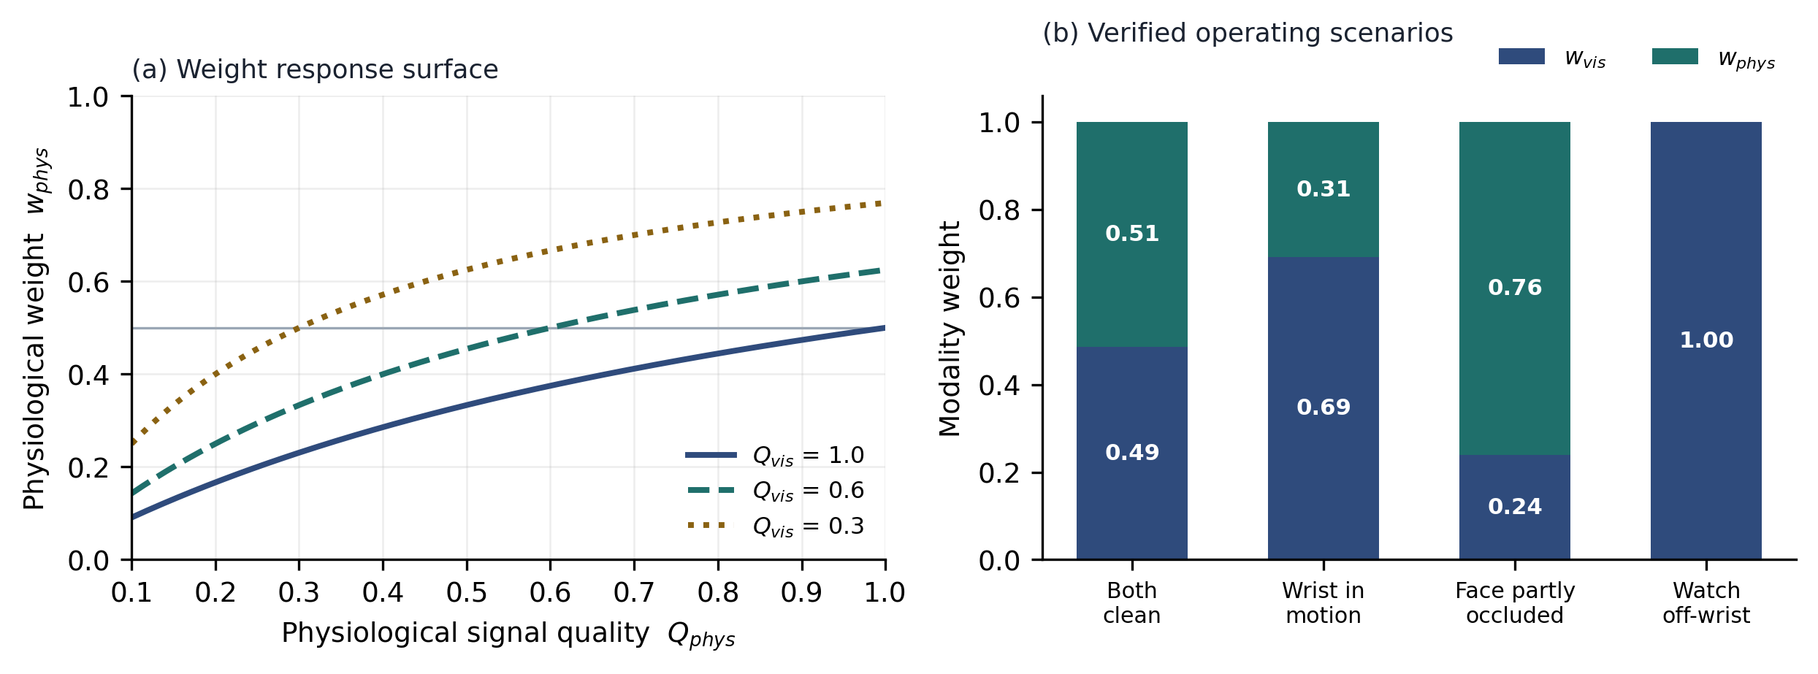
Figure 6.5 — Behaviour of the weighting. Panel (a) shows how the weights respond as watch quality varies at three fixed camera-quality levels; panel (b) shows the four scenarios verified in Section 7.4.
With no watch connected, or one off the wrist, the camera weight is forced to one and the watch excluded. During calibration the weights are fixed at 0.90 camera and 0.10 watch, the normalised heart-rate features meaning nothing before a baseline exists.
A single threshold would let a score near the decision point produce a new state every second, so the engine tracks the current state and applies two: from focused, a score below 0.45 declares inattention; from zoned out, a score above 0.55 declares recovery; between the two the current state persists. Both are judgement values, to be derived per Section 8.10.
On losing the face the system reports "user away", suppresses prompts and returns the state to focused.
The alert engine enforces a six-second cooldown, plays a sound and launches the desktop notification without blocking the event loop. The watch enforces its own four-second cooldown and gives two 300-millisecond pulses separated by 150 milliseconds, well above the ≈30 ms point at which Remache-Vinueza, Trujillo-León and Vidal-Verdú (2025) place the transition from tap to continuous vibration, roughly constant from 40 to 590 Hz.
Two costs must be kept separate. Inference runs once per second: Module A takes 37.4 ms on average (40.4 ms at the 95th percentile), made up of 5.3 ms for the decomposition, 24.9 ms for TSFEL and 7.2 ms for XGBoost, and Module B takes 63.3 ms (68.9 ms at the 95th percentile). Together that is roughly 100 ms of the one-second cycle, so NFR-01 is met with room to spare.
Capture runs continuously and dominates: face detection is measured in Section 7.8.2 at 28.66 ms per frame with the caching the module uses, so at 20 frames per second it consumes about 573 ms of every second, roughly two thirds of one processor core. The margin against NFR-01 concerns response time; the margin against the hardware is much narrower.

6.3.5 Traceability from Published Method to Implemented Artefact
Table 6.5 records what each of six directly implemented published methods contributed, the file in which it is realised, and how the implementation departs from its source.
Table 6.5 — Traceability from published method to implemented artefact, showing where each borrowed technique is realised in the codebase and how the implementation departs from its source.
Source | What was taken | Where it is implemented | Departure from the source
Anh et al. (2024) | 8×8 ocular block-energy grid; SVD factorisation; FFT-based selection of the highest high-frequency singular vector; TSFEL descriptors; XGBoost classification | extract_svd_features.py, train_svd_xgboost.py, module_a_visual/svd_inference.py | Reformulated from offline batch processing of recorded video to a streaming computation over a 200-frame rolling buffer, executed once per second on CPU
Bosch and D’Mello (2021) | Head-pose velocity and jitter, and prolonged gaze fixation, as behavioural markers of mind wandering | module_a_visual/svd_inference.py — _calculate_head_dynamics(), _calculate_blank_stare_index() | Markers are computed from ocular block-energy variance rather than facial action units, normalised by face width, and emitted as components of a four-element trait vector
John et al. (2021) | Multiresolution branch separation: each modality convolved at its native sampling rate before cross-branch fusion | train_multiresolution_cnn_lstm.py; module_b_receiver/physio_inference.py | Applied to cognitive focus estimation rather than the original IoT activity-sensing targets; branch widths set to 16 and 32 filters for the 1 Hz and 20 Hz channels
Woo et al. (2018) | Parallel average and maximum pooling, ablated as jointly superior to either alone | train_multiresolution_cnn_lstm.py — dual-pooling stage of both branches | Pooling is applied along the temporal axis of a 1-D convolution and used directly as enriched features, rather than across the spatial dimensions of a 2-D map to generate attention weights
Wei et al. (2018) | Reliability-weighted multichannel fusion, in which each channel contributes in proportion to its assessed signal quality | module_c_fusion/meta_classifier.py; get_visual_quality() and get_physio_quality() | Weights are recomputed every inference cycle from live quality indices rather than fixed offline; quality is estimated from face geometry and IMU-derived wrist motion
Sukumaran and Manoharan (2024) | The image-traits concept: compact computed descriptors of facial state in place of raw pixels | module_a_visual/svd_inference.py — get_image_traits(); consumed by Module B’s visual branch | Reduced to exactly four scalars — gaze energy, blank-stare index, head stability and calibrated visual probability — chosen for CPU-budget rather than accuracy reasons

Three further sources shaped decisions without contributing code. Gedam and Paul (2021) identified heart rate variability as the most reliable body-based marker of mental load, so SDNN and RMSSD rather than raw heart rate form the feature vector. Gjoreski et al. (2021) reported strong variation between individuals, motivating the personal baseline of Section 6.3.3. Najafi et al. (2023) found combining processed features beat combining raw signals (82.0% against 74.0%), so fusion happens at the decision level.

6.3.6 System Evolution
The system reached its present form over seven iterations. A camera-only prototype produced the first working SVD pipeline and revealed the overconfidence problem. The watch followed, its inference moving from a simple threshold through a single-branch network to a combined model, then to the two-branch architecture of John et al. (2021) with dual pooling; validation loss fell sharply, shown in Section 7.4.3 to have been a defect. Fixed weights gave way to the quality-aware engine of Wei et al. (2018), the trait vector followed Bosch and D’Mello (2021), then the prompt layer, then robustness to changing networks.

6.3.7 Parameter Provenance
Table 6.6 lists every fixed number in the system with its origin, separating values following from a published result, values derived from a property of the data or hardware, and values set by judgement. Every judgement value is carried into Section 8.10.
Table 6.6 — Provenance of every constant in the system. “Cited” means the value or its basis follows from the source given; “derived” means it follows from a property of the data or hardware stated in the same row; “judgement” means it was set during prototyping and has no external support; “needs source” marks a value defensible in principle but not yet supported by a citation.
Constant | Value | Where used | Provenance
Inference cycle period | 1 s | main.py inference loop | Derived — Rosenberg (2026) places moment-to-moment attentional state shifts on the order of seconds, so the cycle must be at or below one second to resolve them; the ~1 Hz photoplethysmographic stream caps the achievable rate at the same value
Frame decimation rate | 20 fps | Module A capture | Derived — Palmieri, Fernández and Carrasco (2023) report microsaccades at ≈2/s, so 20 fps samples the phenomenon ten times over and clears the Nyquist limit of 4 Hz fivefold
Capture resolution | 640 × 480 requested | Module A capture | Derived — read back from the device after negotiation; the measured width sets a scale factor applied to every pixel-denominated constant below
Ocular energy grid | 8 × 8 blocks | Module A feature extraction | Cited — Anh et al. (2024)
Ocular crop size | 128 × 96 px | Module A feature extraction | Cited — Anh et al. (2024)
Ocular band | 10–90% width, 15–55% height | Module A capture and extraction | Judgement — geometric approximation of the eye region, applied identically in training and inference; this diverges from the eye-cascade crop of Anh et al. (2024), a divergence Section 7.4.6 examines
Majority undersampling ratio | 1:3 (234 : 702 clips) | DAiSEE extraction selection | Judgement — all available minority clips retained, majority sampled to three times that count; ratio unswept, and Wongvorachan, He and Bulut (2023) report oversampling outperforming undersampling at comparable imbalance (Section 8.10)
Analysis buffer | 200 frames (10 s) | Module A energy buffer; extraction window | Derived — at the ≈1.8 Hz steady-state rate measured by Palmieri, Fernández and Carrasco (2023), a ten-second window contains on the order of eighteen microsaccades, sufficient for the spectral descriptors TSFEL computes
Minimum frames before inference | 30 | Module A predict() | Derived — 1.5 s spans ≈3 microsaccades at the Palmieri, Fernández and Carrasco (2023) baseline, the least that can carry any ocular dynamics; also guards against decomposing a near-empty matrix
Singular vectors searched | top 10 | Module A predict() | Judgement — truncation for cost; the selected vector was never observed beyond index 4
Head velocity ceiling | 0.25 face-widths/s | Module A head dynamics | Derived in form — normalising centroid displacement by detected face width makes the bound invariant to both resolution and subject distance; the numeric value is still judgement
Head stillness floor | 0.005 face-widths/s | Module A head dynamics | Judgement — direction supported by Bosch and D’Mello (2021), value unsupported
Blank-stare saturation bound | r_high = 0.120 | Module A blank-stare index | Derived — 75th percentile of relative saccadic variation during active gaze exploration in the focused recordings
Blank-stare plateau bound | r_low = 0.030 | Module A blank-stare index | Judgement — a one-sided floor below the observed 5th percentile of 0.046; no zoned-out distribution was available to estimate it directly
Blank-stare window | 3 s (60 frames) | Module A blank-stare index | Derived — three seconds spans ≈5 microsaccades at the 1.8 Hz baseline of Palmieri, Fernández and Carrasco (2023), the shortest window in which a sustained reduction is distinguishable from the gap between two ordinary events
Optimal face width | 160 px × scale | Module A quality index | Derived — the face width at which the 0.8w ocular crop is exactly 128 px, matching the training grid width one-to-one horizontally
Visual quality mix | 0.60 size / 0.40 stability | Module A quality index | Judgement — no sensitivity analysis performed
Visual quality range | [0.32, 1.0] with face present | Module A quality index | Derived — follows from the floors on the two component terms
Physiological quality clip | [0.35, 1.0] | Module B quality index | Judgement — the higher floor reflects that PPG degrades gracefully rather than failing outright
HRV metrics | SDNN, RMSSD | Module B feature vector | Cited — defined and evaluated by Kim, Seok and Shin (2021); the choice of variability metrics over raw heart rate follows Gedam and Paul (2021)
Calibration window | 30 samples (~30 s) | Module B baseline | Cited, conditionally — supported for SDNN (30 s) and RMSSD (10 s) at rest under the 50% limits-of-agreement criterion of Kim, Seok and Shin (2021); not supported under their stricter Cohen’s d criterion, nor under movement (Section 6.3.3)
Wear-detection floor | 30 bpm | Module B is_sensor_worn() | Judgement — a plausibility guard set well below any human resting rate to reject sensor noise, not a physiological boundary
Telemetry recency window | 5 s | Module B quality and wear detection | Derived — five reporting intervals at the watch’s ~1 Hz rate
Sequence length | 10 timesteps | Module B input | Cited — matches the window length of John et al. (2021)
Convolution filters | 16 physio / 32 visual | Module B branches | Judgement — declared as a departure from John et al. (2021) in Table 6.5; no width ablation performed
Kernel widths | 2 physio / 3 visual | Module B branches | Judgement — as above
Pooling | average and maximum, in parallel | Module B branches | Cited, contested — ablated as jointly superior by Woo et al. (2018) on a spatial axis; Nirthika et al. (2022) find no pooling operation universally best, so the temporal application is unproven
Fusion base weights | 0.50 physio / 0.50 visual | Module C classify() | Derived by exclusion — no measured or published basis supports an asymmetry in either direction, so the priors assert none and the quality terms carry the whole adaptation, as in the per-modality confidence weighting of Zhu et al. (2023) (Section 7.4.3)
Calibration-mode weights | 0.90 visual / 0.10 physio | Module C classify() | Judgement — reflects that normalised physiological features are undefined before a baseline exists
Hysteresis trigger threshold | 0.45 | Module C classify() | Judgement — direction justified by alert fatigue; value to be derived from a stated cost ratio per Section 8.10
Hysteresis release threshold | 0.55 | Module C classify() | Judgement — band width set to exceed observed cycle-to-cycle fluctuation; to be derived from the measured variance of the fused score
Alert cooldowns | 6 s desktop / 4 s haptic | Alert engine; watch service | Judgement — provisional; Appendix A.1 asks survey respondents for a tolerable alert frequency, from which these will be set
Dismissal suppression | 8 s | Dashboard overlay | Judgement — provisional, as above
Haptic waveform | 2 × 300 ms, 150 ms gap | Watch service | Cited in part — Remache-Vinueza et al. (2025) place the pulse-to-vibration perceptual transition near 30 ms, so 300 ms is comfortably suprathreshold; the choice of a sustained rather than a brief stimulus remains judgement, to be validated in the user study
Label join tolerance | 15 s | Module B dataset construction | Judgement — tightened from 45 s on the reasoning that attention states do not persist that long; the value itself is still unswept (Section 8.10)
Attention scale mapping | mean of annotator ratings, (r̄ − 1) / 4 | Module B target construction | Derived — the inter-annotator consensus mean the corpus supplies, normalised linearly; replaced the arbitrary interval scale of an earlier revision
Trait fallback vector | [0.48, 0.65, 0.95, 0.75] | Module B update_image_traits() | Derived as a value — the empirical median of the focused recordings — but judgement as a mechanism: a masking layer is present but inert while imputation supplies non-zero values (Section 6.3.3)
Network ports | 8765 WSS / 8766 UDP | Communication tier | Arbitrary — unregistered ports in the user range, no significance
Discovery timeouts | 2 s listen / 3 s retry / 2 s beacon | Discovery beacon; watch client | Arbitrary — engineering values; no external basis and none required
XGBoost configuration | 1000 rounds, lr 0.05, depth 6, subsample 0.8, colsample 0.8, early stop 50 | train_svd_xgboost.py | Judgement — library-typical starting values, no search performed; Shwartz-Ziv and Armon (2022) report XGBoost to be markedly less sensitive to tuning than the deep alternatives, which bounds the cost of that omission
CNN-LSTM training | Adam lr 0.001, MSE loss, 15 epochs, batch 32, dropout 0.2 | train_multiresolution_cnn_lstm.py | Judgement — 0.001 is the optimiser’s library default; the remainder were not searched

6.3.8 Deployment and Startup
First-time setup has four steps. generate_ssl.py discovers every local IP address and writes a certificate and key with a subject alternative name entry for each, so one certificate stays valid across networks. The Python libraries of Table 6.2 are installed. The CNN-LSTM weights and the pickled XGBoost classifier are placed in the training directory, the backend having no fallback if either is missing. The watch project is opened in Android Studio, built as a signed APK and installed over ADB.
Normal startup is three steps. The backend initialises the three modules, opens the webcam, loads both models, starts the secure WebSocket server on port 8765 and begins the discovery beacon on port 8766. Vite then serves the dashboard, which connects as it loads. The watch application is started last and streams telemetry once it discovers the backend from the beacon.
The backend prints one status line per second carrying the current state, the fused score, both module probabilities, both weights and the face and watch flags; the timing figures of Section 6.3.4 were read against it. Interrupting it releases the webcam and closes every open WebSocket connection.

6.4 User Interface
The design of both interfaces is given in Section 5.4.6; the implementation follows the wireframes without change.
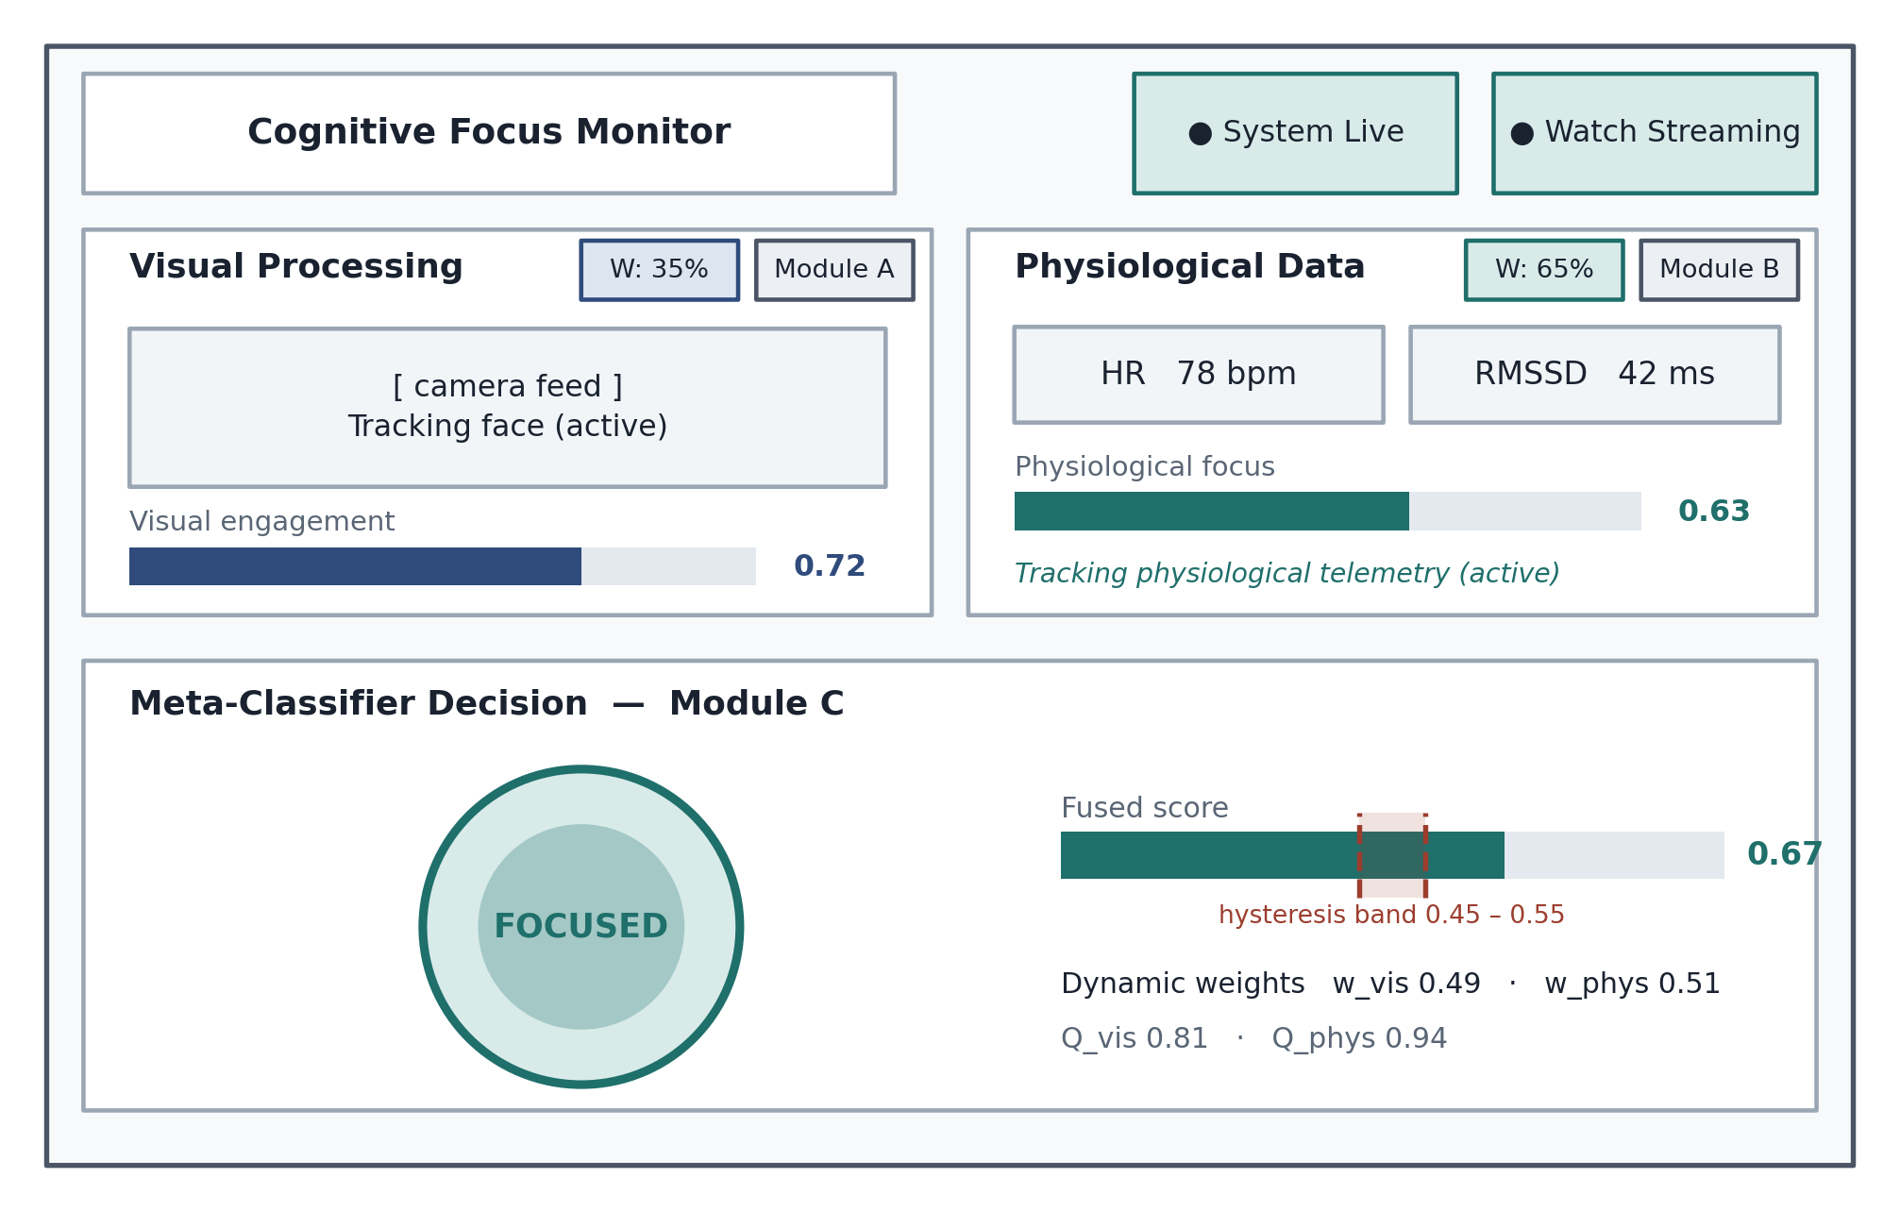
Figure 6.6 — Web dashboard. The two cards show each sensor separately with its current weight, so the combined decision below can be traced to its inputs.
The dashboard places two cards above a full-width decision panel. Each card shows one sensor — its probability, its current weight and its status — and the panel shows the combined result with the decision band marked, addressing the false-alarm concern of Section 4.2. State is shown by colour, text and the central indicator’s shape, not colour alone. The prompt overlay can be dismissed, suppressing further alerts for eight seconds.
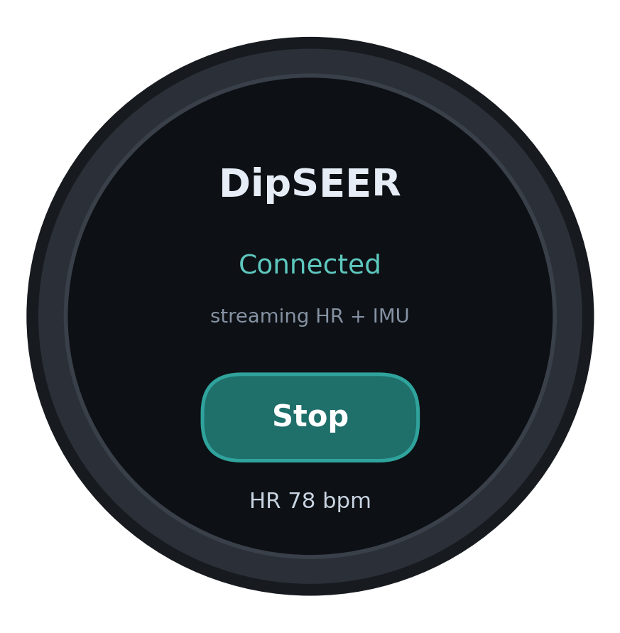
Figure 6.7 — Watch interface: three elements, one action, no numbers.
The watch shows a title, a connection status and one switch. Numbers are left off: a learner glancing at their watch to check their focus score has been distracted by the thing measuring their distraction.

6.5 Chapter Summary
This chapter justified each technology selection against its alternative and documented the three deployed artefacts. The offline pipelines produce an XGBoost visual classifier over SVD-derived TSFEL descriptors and a 17,905-parameter two-branch CNN-LSTM. The Wear OS service streams telemetry over a self-discovering encrypted connection, and the laptop backend fuses both modalities with weights recomputed each cycle from live quality. Chapter 7 evaluates what this implementation achieves.

7 TESTING

7.1 Chapter Overview
This chapter reports what was tested, what was found and what remains untested: both machine-learning components against stated baselines, the published systems the design draws on, the twenty functional requirements of Table 4.2, the module boundaries, and the non-functional thresholds of Table 4.3. The engineering results are positive and the model results are negative, and the chapter keeps the two apart. Every entry carries its status, and nothing designed is presented as though it had been run.

7.2 Objectives and Goals of Testing
A multimodal detection system poses two independent questions. The first is whether the software works: whether the watch discovers the laptop and streams, whether the fusion engine reweights the modalities as their quality changes, and whether the four intervention channels fire within the cycle budget. The second is whether the models predict anything. No amount of correct plumbing bears on the second: a system can deliver a probability every second, on time, over an encrypted socket, and the probability can be worthless.
The answers diverge, and that divergence is the principal finding of this chapter. Every mechanism the architecture specifies behaved as designed; both learned components sit at or below the baseline appropriate to their metric. The evaluation establishes a working delivery vehicle for a signal the project has not yet demonstrated exists.
A third objective was negative in kind: to find the defects that produced the project’s earlier, favourable results. A leaked label, an index-based validation split, a training corpus sampled at a tenth and a region mismatch between training and inference were all located by testing, and the numbers this chapter reports are those obtained after they were closed.

7.3 Testing Criteria
The pass conditions were fixed before the results were read, and they differ by test class. For the models, a metric is informative only against the baseline appropriate to it, since a skewed corpus makes some metrics rise on skew alone; for the regression component that baseline is the mean of the held-out group, the point at which the coefficient of determination is zero. For the software, each functional requirement must be demonstrably exercised against a stated expected result, and each non-functional requirement measured against the threshold Table 4.3 states for it.
Table 7.1 — Pass conditions by test class. The model baselines are those computed on the corpora described in Section 6.2.2; the software criteria are those stated in Tables 4.2 and 4.3.
Test class | Criterion | Baseline or threshold
Accuracy (Module A) | Exceed a constant predictor of the majority class | 0.750 on the 936-clip 1:3 set
Macro F1 (Module A) | Exceed a constant predictor of the majority class | 0.429
Balanced accuracy (Module A) | Exceed chance | 0.500
ROC AUC (Module A) | Exceed chance | 0.500
PR AUC (Module A) | Exceed the prevalence of the positive class | 0.750, "focused" class
Coefficient of determination (Module B) | Exceed the mean of the held-out participants | R² > 0
Functional requirement | Demonstrably exercised against a stated expected result | Each of FR-01 to FR-20
Non-functional requirement | Measured against the threshold stated for it | Each of NFR-01 to NFR-10

Two criteria are deliberately absent. No threshold is set for detection accuracy in absolute terms, because no requirement in Table 4.3 states one; Section 7.8.1 records the omission as a specification gap. No criterion is set for user acceptance, because the instruments that would measure it have not been administered.

7.4 Model Testing

7.4.1 Evaluation Protocol and Metric Selection
Three evaluations were performed: the visual classifier under stratified cross-validation, the physiological network under subject-wise cross-validation, and the fusion engine under controlled sensor degradation. Five-fold cross-validation was preferred to a single hold-out throughout, and the physiological evaluation groups by participant so no individual appears on both sides of a split. Reporting emphasises balanced accuracy, macro F1 and precision–recall AUC rather than accuracy, following Thölke et al. (2023), who found across systematically varied imbalance that accuracy rises with skew while balanced accuracy stays anchored to chance.

7.4.2 Module A — Visual Classifier
These are the second set of figures obtained. The first evaluation used a ten per cent sample of DAiSEE and produced a classifier that put all 481 rows in the majority class: accuracy 0.946, identical to always guessing "focused", balanced accuracy exactly 0.500, and a confusion matrix of [[0, 26], [0, 455]]. With twenty-six minority examples that result meant nothing.
Extraction was re-run. Every training clip labelled at engagement level 0 or 1 was kept, giving 234 minority clips, and three times as many majority clips were sampled alongside, giving 936 at a 1:3 ratio. Class weighting was applied on top.
Table 7.2 — Visual classifier under stratified five-fold cross-validation over the re-extracted 936-clip set, with the baseline appropriate to each metric. The baseline for accuracy and macro F1 is a constant predictor of the majority class; for balanced accuracy and ROC AUC it is chance; for precision–recall AUC it is the prevalence of the positive class.
Metric | XGBoost (5-fold CV) | Baseline | Verdict
Accuracy | 0.654 ± 0.025 | 0.750 | Below
Balanced accuracy | 0.492 ± 0.027 | 0.500 | Below
Macro F1 | 0.486 ± 0.030 | 0.429 | Marginally above
ROC AUC | 0.500 ± 0.036 | 0.500 | At chance
PR AUC, "focused" class | 0.775 ± 0.018 | 0.750 | Marginally above

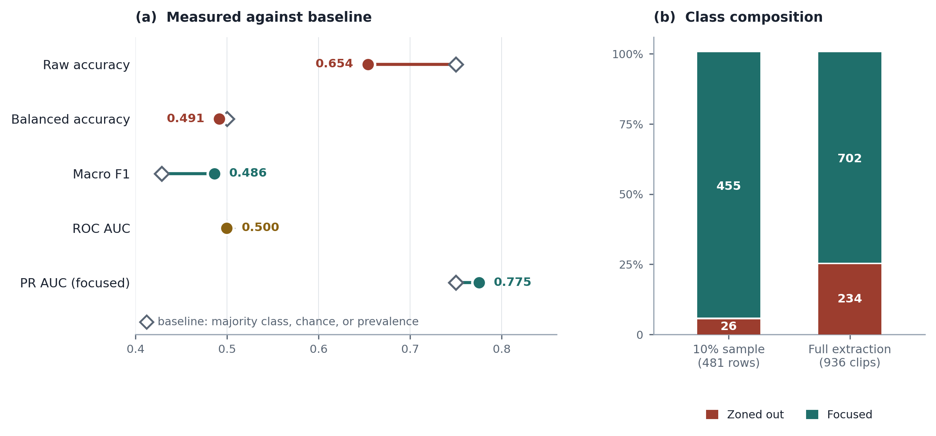
Figure 7.1 — Visual classifier evaluation. Panel (a) plots each measured metric against the baseline appropriate to it, the connector showing the gap; panel (b) shows the class composition before and after the full re-extraction.
The result is negative. Accuracy of 0.654 is worse than a constant predictor, the expected consequence of class weighting pushing the model off the majority, and balanced accuracy of 0.492 is below chance. Macro F1 and precision–recall AUC exceed their baselines by margins smaller than their own fold-to-fold standard deviations.
The decisive figure is the ROC AUC of 0.500 ± 0.036, which ignores the decision threshold and the class balance: it is the chance the model scores a randomly chosen zoned-out clip below a randomly chosen focused one. At 0.500 it cannot tell them apart, and no reweighting or calibration can extract an ordering from features that do not contain one. The first evaluation showed a classifier collapsing under extreme imbalance; this one shows the SVD features do not separate the classes at all.
Two hundred and thirty-four minority examples across five folds, with a standard deviation of 0.036, make this a stable estimate rather than an absence of evidence, and the earlier defence that fifty-two examples could not settle the question is no longer available.
Three explanations fit the finding and the project cannot yet separate them. First, the label: DAiSEE rates engagement over ten-second clips using external observers, whereas Anh et al. (2024) worked against mind-wandering labels, and a clip-level engagement rating may not mark the moments attention lapses. Second, the binary cut, placed between levels 1 and 2 of a four-point scale. Third, the eye region, discussed in Section 7.4.6.
One consequence follows immediately. The eighth-power transform that Section 6.3.2 previously described has been removed and the classifier now emits its probability directly: it existed to spread output clustered near unity, a symptom of the degenerate classifier, and with the model retrained there is no defensible reason to reshape output by an exponent chosen by inspection.

7.4.3 Module B — Multiresolution CNN-LSTM
The result reported here is the second one obtained, and the way the first failed is more instructive than the number it produced. The original dataset-construction routine synthesised three of the four elements of each step’s visual vector as affine functions of the attention label with a noise term added, so the model was handed the answer in the guise of an observation.
Table 7.3 — Correlation of each network input with the target under the original construction, separating the label-derived inputs from the measured ones. The three synthesised channels are the defect; the four measured channels are what the corrected pipeline retains.
Input feature | Origin under the original construction | Pearson r with target
ear_proxy | Synthesised from label | +0.996
gaze_energy | Synthesised from label | +0.981
calibrated_vis_prob | Synthesised from label | +0.955
head_stability | Measured (rotation vector) | −0.049
delta_HR | Measured (PPG) | +0.010
delta_RMSSD | Measured (PPG) | +0.006
SDNN_norm | Measured (PPG) | −0.028

A second defect compounded the first: the validation split was taken by array index, so sequences from a single participant fell on both sides of it. Both faults are named in the classification Kapoor and Narayanan (2023) built from a survey of reproducibility failures across seventeen fields — deriving an input from the answer is their category L2, illegitimate features; splitting so one participant falls on both sides is L3.2, non-independence.
Ablation confirmed it: the synthesised branch alone reached R² = 0.990 against the full model’s 0.992, while the measured physiological branch alone reached −0.053. All apparent performance originated in the leak.
Both defects were corrected and a third limitation removed: the label-derived channels were deleted, the position-based split replaced by holding participants out, and the join tolerance tightened from forty-five seconds to fifteen. An interim version computed the visual branch from the watch’s own motion readings, which removed the leak but supplied no visual evidence. Module A is now run across the DIPSER face-camera recordings, the four visual channels extracted from about 49,000 real face frames using the same detector, eye region and 128 × 96 grid the live system uses — the first evaluation in the project to test the two-sensor proposition rather than one sensor standing in for both.
Table 7.4 — Module B under subject-wise five-fold cross-validation with genuine facial features and watch telemetry, the held-out participants of each fold named. All nineteen participants appear in exactly one held-out fold.
Fold | Held-out participants | Sequences | MSE | MAE | R²
1 | subject_03, 11, 15, 21 | 1,081 | 0.01712 | 0.1261 | −0.0607
2 | subject_01, 17, 20 | 840 | 0.01704 | 0.1257 | −0.1002
3 | subject_06, 08, 10, 13 | 1,093 | 0.01969 | 0.1302 | −0.0743
4 | subject_02, 04, 09, 12 | 1,093 | 0.01878 | 0.1275 | −0.0529
5 | subject_07, 14, 16, 18 | 1,092 | 0.02157 | 0.1297 | −0.0104
Mean | — | 5,199 total | 0.0188 ± 0.0017 | 0.1278 ± 0.0018 | −0.060 ± 0.029

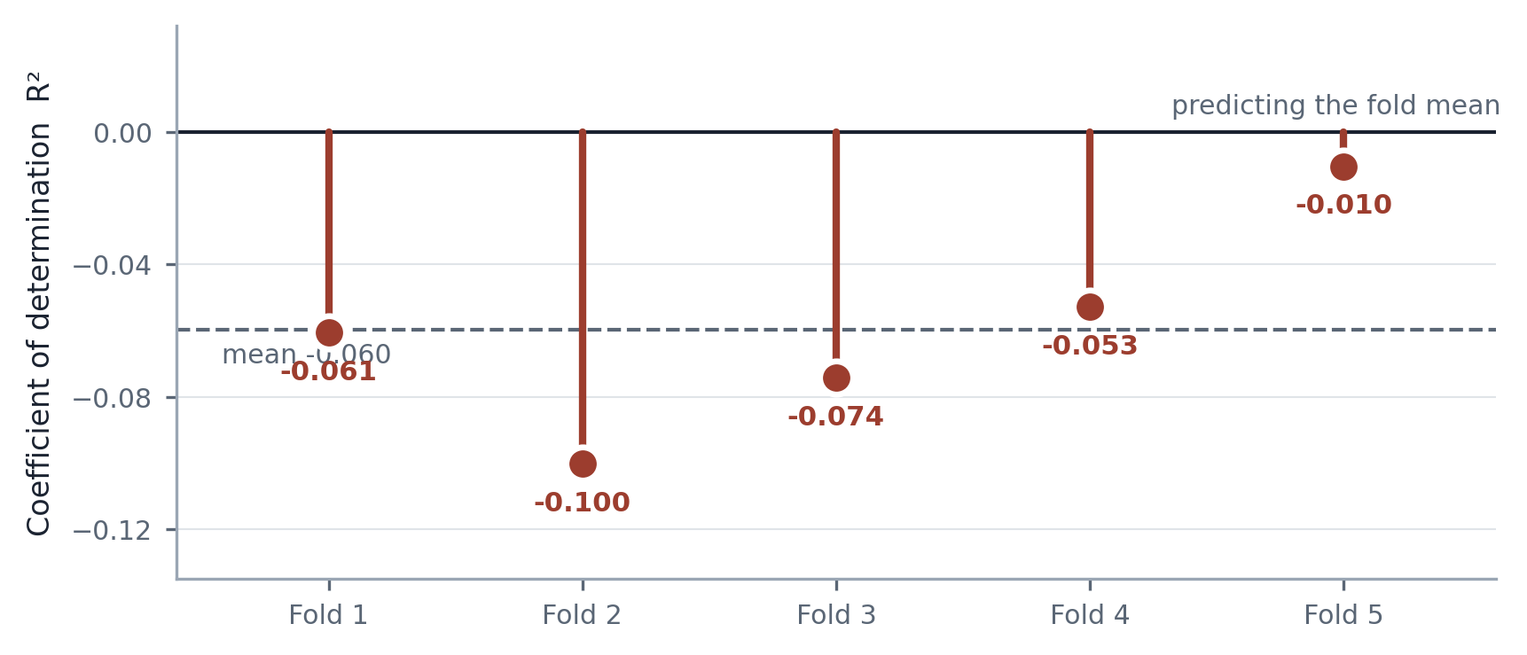
Figure 7.2 — Per-fold coefficient of determination for Module B under subject-wise cross-validation. Every fold falls below the line at which the model would merely be predicting the mean of its own held-out participants.
The corrected result is that the network does not generalise to new participants. An R² of −0.060 means its error is larger than simply predicting the average of the held-out group, and the root mean squared error of 0.137 sits above the target’s own spread of about 0.133. All five folds are negative, so this is not a model hovering around chance but one failing the same way each time.
With the visual branch computed from wrist motion the same procedure returned −0.067 ± 0.048; with real facial features it returns −0.060 ± 0.029. Real vision lifted no fold above zero, so the defensible claim is precise: on DIPSER, under the processing described in Chapter 6, neither smartwatch data nor webcam facial features nor their combination predicts the attention rating for unseen people.
A branch ablation was then run over the same GroupKFold partition and the same 5,199 sequences, training each branch alone and both concatenated in an otherwise identical architecture, so that the comparison isolates the modalities.
Table 7.5 — Branch ablation under subject-wise five-fold cross-validation. All three configurations were trained for twelve epochs on the same folds; the deployed model of Table 7.4 is trained for fifteen and is therefore not directly comparable with the third row.
Configuration | MSE | MAE | R²
Visual branch only | 0.01829 ± 0.00188 | 0.1265 ± 0.0027 | −0.0275 ± 0.0194
Physiological branch only | 0.01873 ± 0.00207 | 0.1275 ± 0.0027 | −0.0515 ± 0.0254
Both branches, concatenated | 0.01926 ± 0.00207 | 0.1276 ± 0.0027 | −0.0815 ± 0.0264

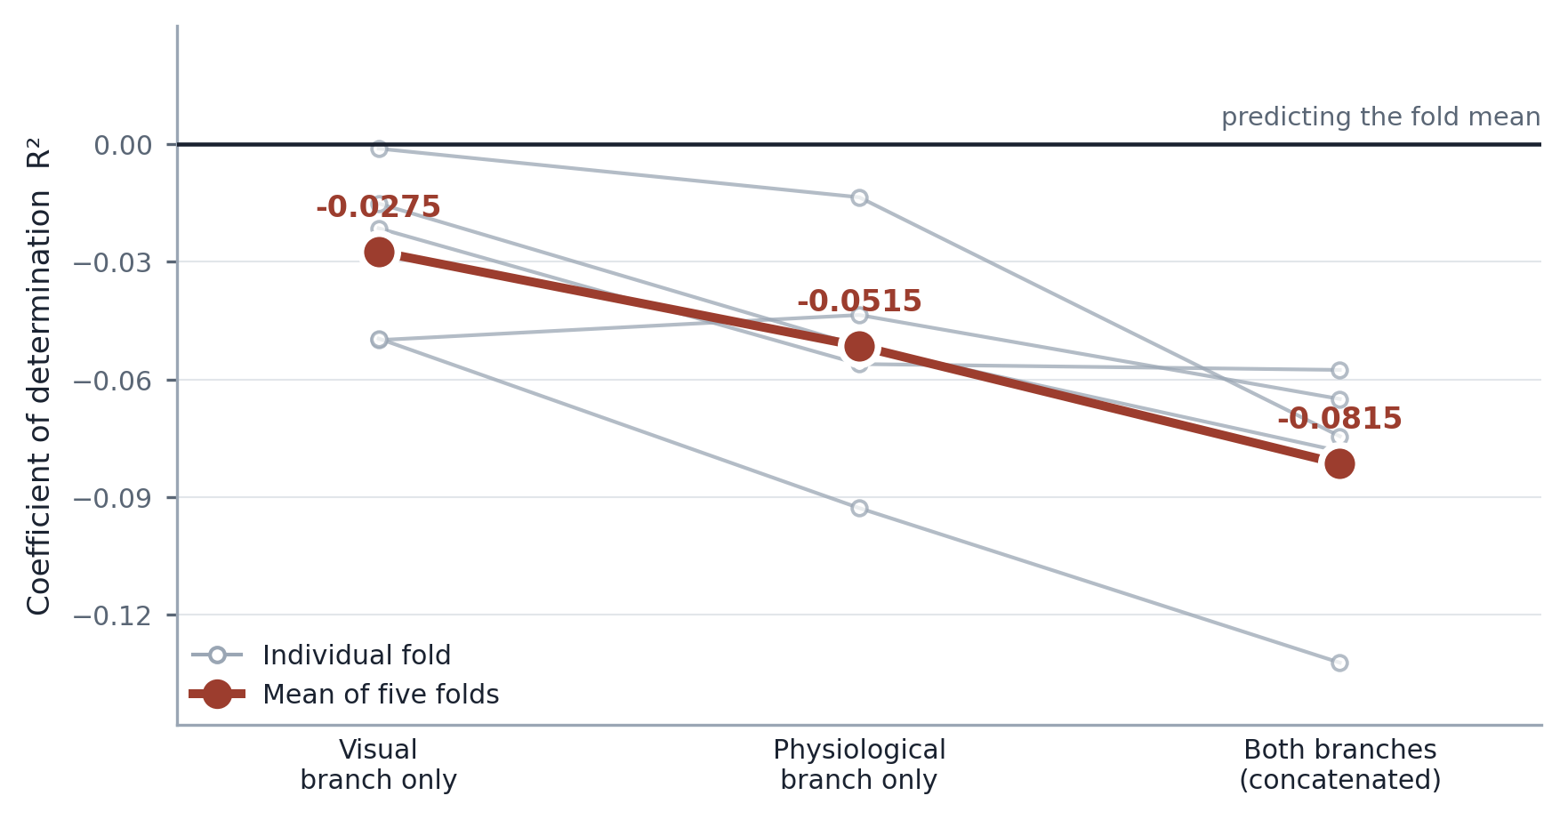
Figure 7.3 — Branch ablation. Each grey line traces one held-out fold across the three configurations; the heavy line is the mean. Concatenating the branches is worse than either branch alone in every fold.
Two findings follow, held with different confidence. Combining the branches makes generalisation worse: the joined model is behind both single branches in all five folds, a gap of 0.054 in mean R². Vision is the stronger of the two, ahead in four folds of five by an average of 0.024, an ordering that agrees with Brishtel et al. (2020) and supports abandoning the 0.65 physiological weight — though not replacing it with the opposite imbalance, since all three configurations remain below the baseline.
A weakness must be declared. No random seed is set anywhere in the training code, so each figure above is a single draw. The deployed configuration appears twice, at −0.060 in Table 7.4 and −0.082 in the ablation; the two differ in training length, but the gap of 0.022 is the same order as the 0.024 separating the branches. The visual-versus-physiological ordering is therefore suggestive rather than established; the visual-versus-combined gap is the more secure.
That joining the branches inside one network degrades generalisation is consistent with Module C’s decision-level approach, but Module C did not take part in this experiment, so the analogy is not a demonstration. The measurement that would settle it is cheap — score the two single-branch models’ per-fold predictions through Module C’s weighting on the same held-out participants — and until it is run the fusion strategy rests on Najafi et al. (2023) and on argument.
The finding fits the literature rather than contradicting it: Gedam and Paul (2021) describe the body’s response to mental load as subtle, Gjoreski et al. (2021) report strong variation between individuals, and Brishtel et al. (2020) obtained a real but modest gain using laboratory instruments. The fault may lie in the processing rather than the sensors, since a thirty-sample calibration window and a fifteen-second join tolerance each degrade the signal before the network sees it. What cannot be claimed is that either sensor, as processed here, carries usable information across people.

7.4.4 Confusion Matrix, Accuracy, Precision, Recall and F1
No confusion matrix, precision or recall was computed for the corrected five-fold run. One confusion matrix exists in the project record — that of the first evaluation of Module A, over the 481 rows from the ten per cent DAiSEE sample — and it is degenerate.
Table 7.6 — Confusion matrix of the first Module A evaluation, over the 481 rows extracted from the ten per cent DAiSEE sample. Rows are the true class and columns the predicted class. No row was assigned to the minority class.
Actual class | Predicted "zoned out" | Predicted "focused" | Row total
"Zoned out" (minority) | 0 | 26 | 26
"Focused" (majority) | 0 | 455 | 455
Column total | 0 | 481 | 481

Recall on the minority class is 0.000, and precision on it is undefined, the classifier having made no positive prediction from which a precision could be formed; scoring libraries report 0.000 by convention, and that convention rather than a measurement is what the figure represents. Precision on the majority class is 0.946, the prevalence of that class and therefore what a constant predictor would also achieve. The matrix has no diagonal structure at all, and its accuracy is an artefact of skew.
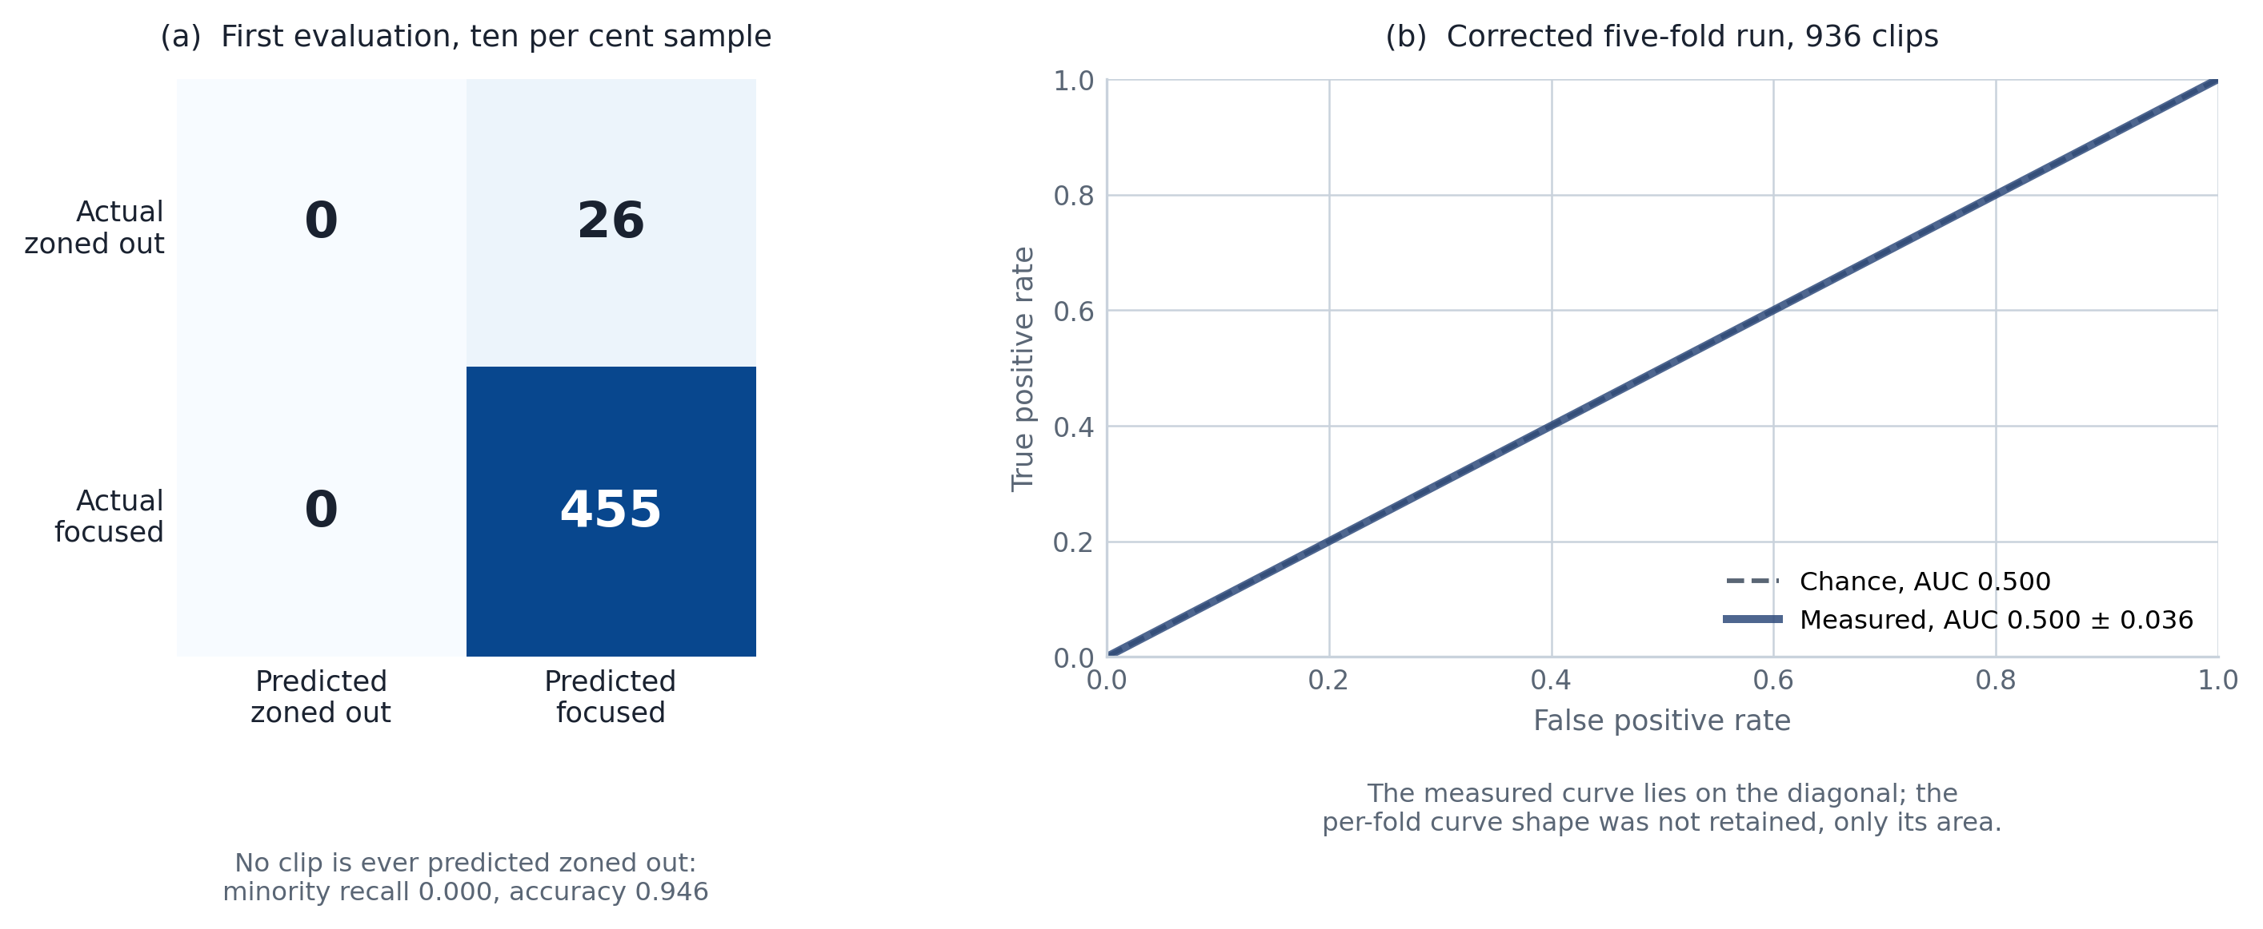
Figure 7.4 — Confusion matrix of the first, degenerate evaluation alongside the ROC curve of the corrected five-fold run, whose area of 0.500 places it on the diagonal.
That matrix belongs to the superseded evaluation. Obtaining the per-fold confusion matrices, precision and recall of the corrected run is outstanding, and Section 8.10 records it. No values are stated here because none were measured, and the aggregate metrics do not determine them: an accuracy of 0.654 with a ROC AUC of 0.500 is consistent with many distributions of the errors, and inferring one would be invention. What can be said without them is that a model whose ROC AUC is 0.500 has no threshold at which precision and recall trade against one another usefully, because it produces no ordering for a threshold to cut.

7.4.5 AUC and ROC Curve
The ROC area of 0.500 ± 0.036 is the metric this evaluation rests on, because it depends neither on where the decision threshold is placed nor on how skewed the classes are. A value of 0.500 means the model orders the two classes no better than a coin, so nothing applied afterwards can recover a separation the scores do not contain, and the standard deviation of 0.036 across folds makes the reading a finding rather than an absence of evidence.
The precision–recall area of 0.775 ± 0.018 for the focused class is reported alongside it because ROC area can flatter a classifier under heavy imbalance. It exceeds the positive-class prevalence by 0.025, a margin smaller than the fold-to-fold spread of the measurement itself, so it is not evidence of discrimination either. The two areas agree.

7.4.6 A Second Distribution Mismatch in Module A
Auditing for defects like the one found in Module B exposed a second problem in Module A: training and live use did not extract the same part of the face. In extraction the eye region was found by an OpenCV eye detector and cropped with 25% padding, while live inference ran no eye detector and took a fixed geometric band, so the 8×8 grid did not cover equivalent content. Training also stacked however many frames a clip provided, whereas inference always uses 200. Both have since been closed, and the figures in Section 7.4.2 are those of the corrected pipeline.
Closing the mismatch had an unintended consequence. Anh et al. (2024) locate the eye region with an eye detector and crop with padding, so matching training to inference moved the pipeline away from the source method rather than towards it. Internal consistency and fidelity to the published method are, on the present design, in competition: only running an eye detector at inference gives both, at a cost Section 7.8.2 shows is affordable. Until that is tested, the null result of Section 7.4.2 is a result about this implementation, not about the method as published.

7.5 Benchmarking
Three published systems in the reference list are close enough in aim to serve as external reference points: Brishtel et al. (2020) on mind wandering during reading from eye tracking and an electrodermal sensor, Gjoreski et al. (2021) on cognitive load from consumer wearable signals, and Najafi et al. (2023) on drivers’ mental engagement from multi-sensor fusion.
Table 7.7 — This project’s measured figures against three published systems. The comparison is indicative only: each row uses a different corpus, a different label definition and, in the case of Module B, a different task formulation.
System | Task and sensing | Reported figure | This project
Brishtel et al. (2020) | Mind wandering while reading; eye tracking plus electrodermal activity | F1 0.83 combined; 0.80 eye alone; 0.78 electrodermal alone | Module A macro F1 0.486 ± 0.030
Gjoreski et al. (2021) | Cognitive load; consumer wearable signals | Accuracy peaking near 69% | Module A accuracy 0.654 ± 0.025, below its own 0.750 majority baseline
Najafi et al. (2023) | Driver mental engagement; multi-sensor fusion | 82.0% feature-level fusion; 74.0% raw-signal fusion | No comparable fusion accuracy; Module B is a regression at R² −0.060 ± 0.029
This project, Module A | Engagement from webcam video (DAiSEE) | — | ROC AUC 0.500 ± 0.036, at chance
This project, Module B | Attention rating from facial traits plus watch telemetry (DIPSER) | — | R² −0.060 ± 0.029, negative in all five folds

This project’s models are below all three, and that statement needs no qualification: a ROC AUC of 0.500 is below any published system that reports better than chance, and an R² of −0.060 is below the mean predictor.
Reading the table as a ranking would nonetheless be wrong in three ways. The corpora differ: uncontrolled webcam video and in-person classroom recording against a controlled reading task, a challenge dataset and an instrumented driving study. The label definitions differ: mind wandering by probe, cognitive load induced by task difficulty, driver engagement and observer-rated engagement are four constructs, and Section 7.4.2 identifies the label as one candidate explanation for Module A’s null result. The instruments differ in kind: Brishtel et al. (2020) use a laboratory eye tracker and a dedicated electrodermal sensor, where this project attempts the same detection from an integrated webcam and a consumer smartwatch — a harder problem with weaker instruments.
What the table supports is a bound rather than a ranking. The published gains are real but modest — 0.03 in F1 for adding a second modality in Brishtel et al. (2020), accuracy near 69% in Gjoreski et al. (2021) — consistent with a signal that is present and weak. This project measures no signal at all.

7.6 Functional Testing
A test case was written for each of the twenty functional requirements of Table 4.2. Nine were executed as part of the end-to-end demonstration; the remaining eleven were designed but not executed.
The distinction matters more than the count. Several unexecuted cases cover code that unquestionably ran during the demonstration — the capture path, the extraction, the decomposition, the XGBoost call and the recurrent network all executed, since the dashboard displayed both modality probabilities each second. Running is not testing. None was exercised against a stated expected result, so none can be reported as passed.
Table 7.8 — Functional test cases, one per requirement in Table 4.2. Cases marked Passed were executed during the end-to-end demonstration; the remainder are specified but have not been run.
Test ID | Req. | Procedure | Expected result | Status
TC-F01 | FR-01 | Run a session with the working directory and system temporary directories under filesystem monitoring; inspect the lifetime of the frame buffer in the capture thread. | No image file is created anywhere on disk, and each frame is released once its features are extracted. | Designed, not executed
TC-F02 | FR-02 | Present frontal, three-quarter and full profile head positions in turn and record which cascade stage returns the bounding box. | The frontal cascade succeeds on frontal poses; the horizontally flipped profile cascade succeeds where the frontal stage fails. | Designed, not executed
TC-F03 | FR-03 | Instrument the extraction path; inspect the emitted matrix shape and the buffer length after 200 and after 400 frames. | An 8×8 block-energy matrix is emitted per frame and the buffer holds exactly 200, discarding the oldest. | Designed, not executed
TC-F04 | FR-04 | Feed a buffered matrix to the decomposition and record which singular vector is selected against the measured high-frequency amplitude of each. | The vector selected is the one of greatest high-frequency amplitude. | Designed, not executed
TC-F05 | FR-05 | Compare the descriptor vector and probability produced by the live path against the offline training path for one identical 200-frame buffer. | Identical descriptors and an identical probability to numerical tolerance. | Designed, not executed
TC-F06 | FR-06 | Record head-pose velocity, jitter and the blank-stare index under scripted stillness, nodding and rapid movement. | Each measure moves in the expected direction under its scripted condition. | Designed, not executed
TC-F07 | FR-07 | Start the watch application and observe the backend receiving typed heart-rate and rotation-vector payloads over the encrypted socket. | Both sensor types arrive at approximately 1 Hz and parse without error. | Passed
TC-F08 | FR-08 | Supply a recorded heart-rate sequence of known R-R composition and compare the computed SDNN and RMSSD against independently computed values. | Agreement to numerical tolerance. | Designed, not executed
TC-F09 | FR-09 | Start a session, record the baseline at the thirtieth heart-rate sample, and inspect how subsequent readings are expressed. | The baseline is fixed at the thirtieth sample and later readings are normalised against it. | Designed, not executed
TC-F10 | FR-10 | Present a ten-step window of known content to the live path and compare the network output against the offline model on the same window. | Identical output to numerical tolerance. | Designed, not executed
TC-F11 | FR-11 | Vary face size, head-pose stability, wrist motion and telemetry recency across the five scenarios of Table 7.9 and read both quality indices each cycle. | Both indices are recomputed every cycle and move with the degraded input. | Passed
TC-F12 | FR-12 | Observe the weight pair broadcast each cycle across the four degradation scenarios of Table 7.9. | Weights are recomputed each cycle and track the quality indices. | Passed
TC-F13 | FR-13 | Drive the fused score across the decision band in both directions, then leave the camera frame. | All three states are produced: "focused", "zoned out" and "user away". | Passed
TC-F14 | FR-14 | Open the dashboard and observe successive payloads over a sustained session. | State, probability, weight and quality fields update once per second in the connected client. | Passed
TC-F15 | FR-15 | Force a negative classification and observe the desktop channel. | A native notification is raised with an audible cue within the same cycle as the classification. | Passed
TC-F16 | FR-16 | Force a negative classification with the watch connected and observe the wrist. | A haptic pulse is delivered within the same cycle as the classification. | Passed
TC-F17 | FR-17 | Start the backend on three different Wi-Fi networks in turn and start the watch application with no address configured. | The watch resolves the server from the beacon and connects on each network with no manual entry. | Passed
TC-F18 | FR-18 | Suppress the beacon, then start the watch application on a network where the previously resolved address is still valid. | The watch connects using the address persisted in SharedPreferences. | Designed, not executed
TC-F19 | FR-19 | Remove the watch from the wrist mid-session and continue the session. | The physiological branch is excluded, the visual weight goes to 1.00 and the dashboard reports off-body operation. | Passed
TC-F20 | FR-20 | Dismiss the on-screen overlay, then force further negative classifications within the suppression interval. | No further overlay is shown for eight seconds regardless of state. | Designed, not executed

Nine of twenty is a weak coverage figure and is reported as such. The nine that passed are, however, the requirements that carry the system’s integration risk: discovery across networks, encrypted streaming, per-cycle broadcast, four-channel intervention and graceful degradation on sensor loss. The eleven outstanding cases are mostly unit-level checks on deterministic computations, with two exceptions. TC-F01 would evidence NFR-06, the project’s strongest privacy claim, and TC-F05 and TC-F10 would confirm that the live inference path reproduces the offline path — the assumption on which every figure in Section 7.4 is transferred to the deployed system.

7.7 Module and Integration Testing
The fusion engine was verified against four controlled sensor-degradation scenarios plus the face-absent condition. Unlike the model evaluations, this verification succeeded.
Table 7.9 — Fusion engine verification. The first four rows exercise weight adaptation and correspond to Figure 6.5(b); the fifth is the face-absent state, in which weighting is bypassed.
Scenario | Q_vis | Q_phys | w_vis | w_phys | Observed behaviour
Both sensors clean | 0.90 | 0.95 | 0.49 | 0.51 | Weights near the symmetric bases; state tracks fused score
Wrist in vigorous motion | 0.90 | 0.40 | 0.69 | 0.31 | Authority shifts to vision as PPG degrades
Face partly occluded | 0.30 | 0.95 | 0.24 | 0.76 | Authority shifts to physiology
Watch removed mid-session | 0.90 | 0.00 | 1.00 | 0.00 | Physiological branch excluded; dashboard reports off-body
Face absent | — | 0.95 | 0.00 | 1.00 | State forced to "user away"; no intervention raised

Each scenario was constructed by degrading a real input rather than injecting a value: the wrist-motion row by moving the arm, the occlusion row by covering part of the face. The fused score was driven clear of the [0.45, 0.55] band in each, so the state column reports genuine transitions under the hysteresis logic of Section 6.3.4 rather than marginal crossings, and the face-absent row exercises the state reset. All transitions occurred within a single cycle. The system recovered automatically from watch disconnection without operator action, satisfying NFR-03, and UDP discovery re-established the session across three different Wi-Fi networks without manual address entry, satisfying FR-17. This is integration testing rather than demonstration: it exercises the interface between the three modules at the system boundary, under conditions no module can produce for itself.
The system’s engineering is sound and its learning is not yet. The components that must supply the probabilities those mechanisms operate on do not yet supply informative ones — but the figures they now report are honest, which the earlier ones were not.
Four module boundaries remain untested, each one at which a failure would be silent: the system would go on producing plausible output while the underlying contract was violated. Table 7.10 specifies them.
Table 7.10 — Designed module-boundary and integration tests. None has been executed. Each targets a failure that would leave the system apparently functioning.
Test ID | Boundary | Procedure | Expected result | Status
TC-I01 | Module A output contract under face loss | Occlude the camera mid-session and inspect the value Module A returns, the state of its detection flag, and the trait vector passed to Module B on each subsequent cycle. | Module A returns −1.0 with the detection flag cleared, and the documented fallback trait vector is supplied rather than the last observed one. | Designed, not executed
TC-I02 | Module B behaviour on stale telemetry | Hold the watch socket open but suspend sensor events for 5, 15 and 60 seconds; inspect the ten-step sequence window, the telemetry-recency quality index and the emitted probability. | The recency index falls with the age of the last sample, and the stale steps are either excluded from the window or the branch is excluded by Module C, rather than the network inferring from an unchanged window. | Designed, not executed
TC-I03 | WebSocket reconnection path | Drop the watch connection at the network layer and restore it, repeating ten times, while the inference loop runs and the dashboard stays connected. | The watch reconnects within its three-second retry interval on every attempt, no duplicate client registration occurs, and the loop continues at 1 Hz throughout. | Designed, not executed
TC-I04 | Calibration to normal operation | Observe the weight pair, the baseline values and the broadcast payload on the cycles surrounding the thirtieth heart-rate sample. | The fixed 0.90/0.10 calibrating weights are replaced by quality-derived weights on the cycle after the thirtieth sample, with no discontinuity in the broadcast state. | Designed, not executed

TC-I01 and TC-I02 bear on Section 7.4. Both concern the substitution of a fallback value for a missing observation, which Section 6.3.3 records as a known weakness: the masking layer in Module B is inert while imputation supplies non-zero values. Until TC-I02 is run it is not established whether Module B, in live operation, distinguishes a resting wrist from a silent one.

7.8 Non-Functional Testing

7.8.1 Accuracy Testing
Accuracy testing is Section 7.4 in full. The criterion set in Section 7.3, that each metric exceed the baseline appropriate to it, is not met. Module A returns a ROC AUC of 0.500 ± 0.036, exactly chance, with accuracy and balanced accuracy below their baselines. Module B returns an R² of −0.060 ± 0.029, negative in all five folds. The branch ablation places all three configurations below the same line.
Table 4.3 states no numerical accuracy requirement, which is a gap in the specification rather than a pass; had one been stated it would have been failed. The requirement that should exist — a minimum ROC AUC at which the intervention is worth delivering — cannot be set until a cost ratio between a false interruption and a missed lapse is stated, recorded as outstanding in Section 8.10.

7.8.2 Performance Testing
NFR-01 requires a complete sense–infer–decide–act cycle within one second. Inference was timed on the deployment CPU stage by stage.
Table 7.11 — Inference latency on the deployment CPU, by stage. Module A is decomposed into its three constituent operations; Module B and the fusion step are timed end to end.
Stage | Mean | 95th percentile
Module A — SVD decomposition | 5.3 ms | 8.1 ms
Module A — TSFEL descriptor extraction | 24.9 ms | 26.8 ms
Module A — XGBoost classification | 7.2 ms | 10.1 ms
Module A — total | 37.4 ms | 40.4 ms
Module B — CNN-LSTM inference | 63.3 ms | 68.9 ms
Both modules plus fusion, per cycle | ≈100 ms | —

Inference consumes roughly a tenth of the cycle and NFR-01 is met with substantial margin. Descriptor extraction dominates Module A at 24.9 ms of its 37.4 ms, which is where any optimisation of the visual path should be directed.
Inference is not the expensive part of this system; capture is. Face detection runs at 20 frames per second throughout, so at 28.66 ms per frame it costs roughly 573 ms of every second against the 100 ms both models and fusion consume together. The continuous background load, not the one-second budget, is what would constrain running this alongside other work.
Section 6.2.4 selected Haar cascades on CPU-cost grounds, a preference earlier asserted rather than measured. Three configurations were timed over one hundred native 640 × 480 frames.
Table 7.12 — Face-detection cost on the deployment CPU over 100 frames at 640 × 480. The final column reports the fraction of one core consumed if the configuration ran at the 20 frames per second the analysis buffer requires.
Configuration | Per frame | Sustainable rate | Core load at 20 fps
Haar face detection on every frame | 91.09 ms | 11.0 fps | 182%
Haar face detection plus eye cascade | 92.08 ms | 10.9 fps | 184%
Cached Haar detection, re-detected every 15 frames | 28.66 ms | 34.9 fps | 57%

The measurement supports the choice of detector but changes the reason. Detecting on every frame would starve the buffer rather than merely load the processor; what makes the design work is caching, which sustains 34.9 frames per second at 57% of one core. The headroom belongs to the caching, not the detector, and the comparison against MediaPipe and a neural detector is still outstanding.
The result that matters most concerns Section 7.4.6. An eye detector restricted to the upper part of the face box costs 0.99 ms per frame. The region difference from Anh et al. (2024) was accepted on the assumption that an eye detector at inference would be unaffordable; that assumption is now measured and false, and restoring it would remove one of the three explanations for the null result. It was timed on top of per-frame rather than cached detection, so the combined figure would be an inference.
NFR-08 requires CPU-only inference and is satisfied by construction, the deployment running no GPU code, but no test confirms it. NFR-09 requires a two-hour watch session; none has been run.

7.8.3 Load Balance and Scalability
No load or scalability testing has been performed; every session run to date has used one dashboard client, one watch, and a duration of minutes. This is a real gap: the backend serves the watch and every dashboard client from a single WSS server on one asyncio loop, the rolling buffers have never been observed over hours, and nothing enforces the watch’s nominal 1 Hz send rate. Table 7.13 specifies the tests, none of which has been executed.
Table 7.13 — Designed load and scalability tests. None has been executed.
Test ID | Objective | Procedure | Pass condition | Status
TC-L01 | Concurrent dashboard clients | Connect 1, 5, 10 and 25 dashboard clients to the single WSS server while a session runs; measure the wall-clock duration of each broadcast and the interval between successive inference cycles. | The cycle interval stays within the one second NFR-01 requires at every client count tested, and the broadcast does not block the inference loop. | Designed, not executed
TC-L02 | Memory growth over a sustained session | Run a continuous session for at least the two hours NFR-09 requires, sampling the process resident set size and the length of the 200-frame visual buffer, the R-R interval buffer and the ten-step sequence window at fixed intervals. | No monotonic growth in resident set size; every rolling buffer stays at its stated bound. | Designed, not executed
TC-L03 | Telemetry arriving faster than 1 Hz | Drive the watch sensor stream at 2, 5 and 10 Hz; observe the receive queue depth, the age of the sample the inference loop consumes, and whether events are dropped or backlogged. | The queue stays bounded and the age of the consumed sample does not grow without limit; excess events are discarded rather than accumulated. | Designed, not executed

TC-L03 carries a known suspicion: nothing in the receive path limits how fast events may be enqueued, so a device delivering at 10 Hz would produce discarded samples in the best case and an unbounded queue in the worst. Which occurs is not established.

7.8.4 Security Testing
No security testing has been performed. Two requirements depend on it: NFR-07, that all laptop-to-watch traffic be encrypted in transit using TLS, and NFR-06, that no facial image data be written to persistent storage or transmitted beyond the local process. Both are satisfied by construction; neither has been verified by measurement. Table 7.14 specifies the tests.
Table 7.14 — Designed security tests. None has been executed. TC-S03 is expected to confirm a weakness rather than a strength.
Test ID | Objective | Procedure | Pass condition | Status
TC-S01 | TLS is actually negotiated and plaintext is refused | Attempt a plaintext ws:// connection to port 8765 from a scripted client; then complete a wss:// handshake and record the negotiated protocol version and cipher suite from the captured exchange. | The plaintext attempt is refused at the handshake; the encrypted attempt negotiates TLS, with the version and cipher recorded rather than assumed. | Designed, not executed
TC-S02 | Certificate covers every advertised interface | Enumerate the interfaces the discovery beacon advertises, then read the subjectAltName list of the generated self-signed certificate and compare the two sets. | Every address the beacon advertises appears in the certificate SAN list, so no advertised route produces a name mismatch. | Designed, not executed
TC-S03 | Permissive certificate handling on the watch | Present the watch client with a self-signed certificate other than the one the laptop generated, and with an expired certificate, and record whether either connection is established. | Both connections are established, confirming the documented weakness that the client accepts any certificate. | Designed, not executed
TC-S04 | NFR-06 enforcement | Run a full session with the filesystem under monitoring and all outbound traffic captured; search the captured traffic and the disk delta for image data. | No image file is written anywhere on disk, and no frame or frame-derived image payload appears in any outbound packet. | Designed, not executed

TC-S03 is designed to confirm a weakness, not to pass: because the laptop certificate is self-signed, the watch client accepts any certificate presented to it. TC-S04 would evidence the project’s strongest privacy claim; the absence of the code that would violate NFR-06 is a design argument, not a test result, and Section 4.3.2 records that students prioritise that guarantee above accuracy.

7.9 Limitations of the Testing Process
No random seed is set anywhere in the training code, so every model figure in this chapter is a single draw and the reported standard deviations measure variation across folds within one run. The run-to-run component can be estimated from the deployed Module B configuration appearing twice, at −0.060 in Table 7.4 and −0.082 in Table 7.5; the gap of 0.022 is the size of the 0.024 the ablation reports between the branches, so the branch ordering is unsupported until each configuration is repeated with fixed seeds. Both null results survive this: an R² of −0.060 with every fold negative, and a ROC AUC of exactly 0.500, are not artefacts of one draw.
There is no independent ground truth for mind wandering. Neither corpus was labelled by thought probes, so the project tests its features against a proxy, and a null result against a proxy cannot separate features that carry no information about attention from features whose information the proxy does not track.
The user study has not been run, so no result here speaks to whether the intervention helps or whether the detection is correct in deployment as opposed to on a corpus.
The survey instrument is designed but not administered, so FR-16, FR-20 and NFR-02, which are traced solely to them, remain provisional and the alert cooldowns and dismissal suppression are still judgement values.
Eleven of twenty functional test cases, all four integration tests, all three load tests and all four security tests are designed rather than executed: twenty-two designed against nine passed. That ratio is stated plainly because describing designed procedures in the past tense would misrepresent the work.

7.10 Chapter Summary
Testing returned opposite answers to the two questions this system poses. The engineering works: discovery, encrypted streaming, per-cycle dashboard update, four intervention channels and weight adaptation across four degradation scenarios all behaved as specified, satisfying NFR-01, NFR-03 and FR-17, with inference occupying about 100 ms of the one-second cycle.
The models do not predict. Module A returns a ROC AUC of 0.500 ± 0.036 over 936 clips, exactly chance; Module B returns an R² of −0.060 ± 0.029 with participants held out, negative in all five folds. Against the published systems of Table 7.7 the project sits below all three. Nine of twenty functional cases passed, the module-boundary, load and security tests are designed and unexecuted, and no seed was fixed in any training run. Chapter 8 sets these out in priority order.

8 CONCLUSION

8.1 Chapter Overview
This chapter measures the six objectives of Section 1.10 against the evidence, maps the learning outcomes to the work, sets out the eight engineering problems and the deviations from the plan, bounds what Chapter 7 supports, lists the sixteen improvements needed, and tests the contribution claimed in Section 1.6. The engineering objectives were met; those needing a classifier that discriminates were not.

8.2 Achievement of Research Aims and Objectives
The aim of Section 1.9 was a real-time system fusing webcam visual features with Samsung Galaxy Watch signals by live sensor quality, prompting on both devices within a one-second cycle on a laptop processor, degrading rather than failing when a sensor is lost, and processing video without storing it. Every clause is satisfied but the one that carries the purpose: the system detects nothing, because neither model discriminates.
Table 8.1 — Each research objective of Section 1.10 against the evidence produced for it and its status. Engineering objectives are met; the two objectives that require a discriminating model are met only in their construction and evaluation clauses.
Objective | Evidence | Status
RO1 — Problem identification. Analyse thirty-five peer-reviewed publications to characterise the shortcomings of existing systems and derive requirements. | Chapter 2 reviews the literature and Section 2.7 states the three gaps; Sections 1.3 and 1.5 derive the problem statement and the requirement set from them. | Achieved
RO2 — Visual module. Real-time pipeline finding the face, extracting an 8×8 energy grid from the eye region, applying SVD, deriving TSFEL descriptors and classifying focus with XGBoost at 20 frames per second on the processor alone. | The pipeline runs: SVD completes in 37 ms, and Table 7.12 shows cached Haar detection sustaining 34.9 frames per second at 57% of one core, above the 20 the buffer requires. Classification fails: Table 7.2 reports ROC AUC 0.500 ± 0.036 over 936 clips. | Partially achieved
RO3 — Physiological module. Train a two-branch CNN-LSTM on DIPSER, handling the twenty-to-one difference between the 20 Hz visual and roughly 1 Hz heart-rate channels. | The network is built and trained, the rate difference handled by separate branches at their native rates after John et al. (2021). Table 7.4 reports R² = −0.060 ± 0.029 with participants held out, negative in all five folds. | Partially achieved
RO4 — Fusion engine. Recalculate each sensor’s trust every cycle from live quality measures after Wei et al. (2018) and verify across four sensor-failure scenarios. | Table 7.9 records all four degradation scenarios plus the face-absent condition. Weights moved as specified, transitions completed within one cycle, and the dashboard badges tracked them. | Achieved
RO5 — Communication and prompts. Laptop–watch–dashboard communication with automatic discovery, encrypted transport and native prompts on both devices, connecting with no manual setup across changing networks. | UDP discovery re-established the session across three Wi-Fi networks without address entry, satisfying FR-17; the transport is WSS with certificates regenerated for the active interfaces; desktop notification, audible cue, dashboard overlay and wrist haptic are delivered together within one cycle. | Achieved
RO6 — Evaluation. Stratified cross-validation of the visual model, participant-held-out cross-validation of the physiological model, fusion verification under controlled degradation, and cycle time against the one-second budget. | All four were performed and are reported in Chapter 7. Inference occupies approximately 100 ms of the one-second budget, meeting NFR-01 with margin. No random seed is fixed, so each figure is a single draw. | Achieved

The evidence for RO4 and RO5 includes an end-to-end demonstration. The watch discovers the laptop with no configuration, the dashboard updates each second with both probabilities and the fused decision, a negative classification delivers all three prompts within one cycle, and removing the watch shifts the system to visual-only operation. It confirms integration, not detection.
The division is not accidental. RO1, RO4, RO5 and RO6 are objectives about building and measuring, each with evidence behind it. RO2 and RO3 split into a construction clause that succeeded and a discrimination clause that did not: the visual pipeline meets its specified rate but its classifier is at chance; the network resolves the twenty-to-one rate difference as John et al. (2021) prescribe but is worse on held-out participants than their mean.
Neither partial result is an incomplete measurement. Two hundred and thirty-four minority clips across five folds, at a standard deviation of 0.036, are enough to say the SVD feature set carries no ordering between the classes; five negative folds spread by 0.029 are enough to say the network does not transfer across people. Section 8.10 lists the measurements that would separate methods, corpora and processing. No seed is fixed, so every figure is a single draw: −0.060 against −0.082 puts run-to-run variation near 0.02 in R².

8.3 Utilisation of Knowledge from the Course

8.4 Use of Existing Skills
Software architecture and layering. Three tiers behind defined interfaces, so Table 7.9 verified the fusion engine while both models it consumes were defective.
Object-oriented design. Each module encapsulates its own buffers and calibration state, so the windows changed during Chapter 7 without touching the caller.
Concurrency. A background capture thread at 20 frames per second feeds once-per-second inference through a bounded buffer; the notification runs in a subprocess.
Networking and transport security. WSS with locally generated certificates, adopted after BLE failed; Section 8.10 records certificate pinning as the outstanding defect.
State management without a database. Video is processed in memory and never written; bounded buffers with defined eviction satisfy NFR-06 by construction.
Requirements engineering. Identifiers assigned before implementation and cited throughout the evaluation, with those resting on deferred instruments marked provisional.
Research methods. Participant-grouped cross-validation with baseline-anchored metrics follows Thölke et al. (2023); Appendix B.1 shows a single split returning 0.729 against 0.621 ± 0.102.

8.5 Use of New Skills
Wear OS foreground services and the Samsung Health Sensor SDK. Streaming needed a foreground service, tracker callbacks and a WifiLock in high-performance mode.
Asyncio event-loop design. One loop serves the dashboard, the watch, inference and alerting; a single print statement terminated it.
Singular value decomposition applied to an image time series. Selecting each cycle the singular vector richest in high frequencies makes Anh et al. (2024) a streaming procedure.
The Keras functional API for multi-input networks. A two-branch graph with parallel pooling and a shared recurrent head cannot be expressed sequentially.
TSFEL. Automated statistical, temporal and spectral descriptors replaced hand-designed features; Appendix B.2 puts the twelve highest-gain in the 1–6 Hz band.
Subject-wise cross-validation and data-leakage auditing, the most consequential skill acquired: R² = 0.992 came from label-derived channels and an index-based split, L2 and L3.2 in Kapoor and Narayanan (2023).
TLS certificate generation with multi-address SAN entries. Every discovered address enters the subject alternative name list, regenerated when interfaces change.
UDP broadcast discovery across interfaces. The global broadcast address reaches only the default gateway; enumerating each interface re-established the session across three networks.

8.6 Achievement of Learning Outcomes
The wording of the module learning outcomes is to be completed from the module proforma; the placeholders below mark where each belongs.
Table 8.2 — Module learning outcomes against the work demonstrating them. Outcome wording is to be inserted from the module proforma; the evidence stands independently of that wording.
Learning outcome | Where demonstrated | Evidence
[LO1] | Chapters 1 and 2; Sections 1.3, 1.6 and 2.5.1 | A review of thirty-five peer-reviewed publications yielding three stated gaps, a problem statement, an aim and six measurable objectives, with every bibliographic detail verified against publisher records and four misattributions corrected as recorded in Section 8.8.3.
[LO2] | Chapters 4 and 6; Tables 6.1 to 6.4 | A three-tier architecture across a Python backend, a Wear OS application and a browser dashboard, with the technology selection, the traceability from published method to implemented artefact, and the provenance of every constant in the system each tabulated.
[LO3] | Chapter 6; Sections 6.2 to 6.3.4 and Section 8.7 | A working prototype: streaming SVD ocular analysis at 37 ms, a two-branch CNN-LSTM, a quality-adaptive fusion engine, zero-configuration UDP discovery, WSS transport with regenerated certificates and three-channel intervention, together with the eight engineering problems overcome to reach it.
[LO4] | Chapter 7; Tables 7.1 to 7.6 and Appendix B | Stratified five-fold cross-validation of the visual classifier, subject-wise five-fold cross-validation of the physiological network, a branch ablation over the same folds, controlled sensor-degradation verification of the fusion engine, and timed detector configurations on the deployment CPU.
[LO5] | Sections 7.4, 8.2, 8.7 and 8.9; Appendix B.3 | Two null results reported rather than concealed, both defects that produced the earlier favourable figures named using an established leakage taxonomy, the limits of what the evaluation supports stated explicitly, and the contribution claim reduced to what the evidence carries.

8.7 Problems and Challenges Faced
Eight problems consumed a disproportionate share of development time.
The GPU could not run the recurrent layers. DirectML TensorFlow on Windows registered no kernel for the standard Keras LSTM operation, so the GPU was disabled at import and everything moved to the processor. CPU-bound frame-wise convolution could not then meet the one-second cycle, and EfficientNet-B0 gave way to the SVD pipeline of Section 8.8.1.
A single emoji crashed the event loop. A print statement in the alert engine raised a UnicodeEncodeError under the Windows cp1252 codec, and because it fired inside the asynchronous alert path it killed the loop rather than the statement. Print statements are now ASCII-safe.
UDP discovery reached only the default gateway interface, leaving a watch on another subnet with nothing. It now enumerates every active interface, computes each subnet’s broadcast address and transmits to each every two seconds.
Zero-valued visual features collapsed the physiological score. Four zeros returned on face loss drove the CNN-LSTM’s visual branch to near-zero activations and pulled the physiological probability from roughly 0.7 to 0.2, raising false zoned-out alerts. A neutral baseline vector is returned instead; because that substitutes rather than excludes, the masking layer remains in Section 8.10.
Wear OS put the Wi-Fi radio to sleep and dropped the WebSocket after two to three minutes, silently at both ends. A WifiLock in full high-performance mode, socket address reuse, a five-second ping and cancellation of any existing socket before reconnection resolved it.
XGBoost was overconfident on live data, returning probabilities above 0.95 for essentially every frame, so the system reported "focused" continuously and the fix at the time raised the probability to the eighth power. That transform is gone: the overconfidence came of training on a corpus sampled at ten per cent, leaving a 94.6% majority the model predicted unconditionally. With every available minority clip re-extracted the classifier emits its probability directly, and calibration belongs on held-out data (Ojeda et al., 2023).
The two sensors report at rates twenty times apart: visual features at 20 frames per second, heart rate at roughly 1 Hz and irregularly, so concatenation discards visual detail or invents physiological detail. The architecture of John et al. (2021) resolves it, each modality consumed by its own convolutional branch at its own rate, aligned by the trait-update call rather than resampled.
The laptop’s address changed between sessions and the watch, holding one hard-coded address, could not reconnect. The beacon now broadcasts every active interface address every two seconds, the watch persists the last working address, the certificate lists every discovered address in its SAN entries, and a fallback list cycles through previous ones.

8.8 Deviations

8.8.1 Scope Related Deviations
Visual architecture: EfficientNet-B0 replaced by SVD with XGBoost. DirectML could not register LSTM kernels on GPU, so both models ran on CPU, where frame-wise convolution on DAiSEE could not meet the one-second cycle. The SVD pipeline of Anh et al. (2024) replaced it at 37 ms and gave the streaming reformulation behind the novelty claim.
Communication: Bluetooth Low Energy replaced by WebSocket Secure over Wi-Fi. BLE pairing was unreliable across reconnection cycles and its throughput marginal for continuous dual-sensor streaming. WSS gives higher throughput, standard TLS and the bidirectional messaging the haptic requires, at the cost of a same-subnet dependency UDP discovery manages.
Scope additions: adaptive fusion and TLS. The fixed 60/40 weighting fails where it matters: with the learner’s chin on the watch hand, physiological quality collapses while the weight still grants it 60% authority. The adaptive engine of Section 6.3.4 replaced it. The prototype’s unencrypted ws:// became wss:// with locally generated certificates, the interface-tracking regeneration following from that.

8.8.2 Schedule Related Deviations
Moving all deep-learning inference to CPU cost roughly two weeks investigating the DirectML kernel failure. Visual feature extraction initially ran on a 10% sample of DAiSEE to preserve schedule — the most costly decision of the project, corrected by re-extraction across every available minority clip at the cost of the time saved. The survey was deferred: the instrument is designed in Section 4.5.2 but was not administered, so requirements traceable solely to them remain provisional.

8.8.3 Corrections to Attributed Sources
Four attributions required correction against the published record. The SVD ocular pipeline had been credited to an author list and venue that do not describe the method, and is correctly Anh et al. (2024); the fusion finding justifying decision-level combination is correctly Najafi et al. (2023); the image-traits concept behind the four-element visual vector is correctly Sukumaran and Manoharan (2024).
The fourth is more instructive. The dual-pooling arrangement had been credited to a paper on multi-scale one-dimensional convolution with dual temporal pooling that could not be located, its article slot belonging to an unrelated work. The principle traces instead to Woo et al. (2018), who ablate parallel average and maximum pooling in CBAM at 22.80% top-1 error against 23.14% and 23.20% alone; Section 6.3.1 applies it on a temporal rather than spatial axis.

8.9 Limitations of the Research
Neither corpus is labelled for mind wandering. DAiSEE (Gupta et al., 2016) is annotated for engagement and DIPSER (Marquez-Carpintero et al., 2025) for classroom attention, while Anh et al. (2024) obtained their result against mind-wandering labels. Every figure in Sections 7.4.2 and 7.4.3 measures a proxy.
DAiSEE engagement is rated by external observers over ten-second clips, so a clip in which attention lapsed for two seconds can carry the label of one in which it did not, and the binary cut between levels 1 and 2 was never swept. Both are candidate explanations for the ROC AUC of 0.500 ± 0.036 in Table 7.2.
Nineteen participants is a small basis for subject-wise generalisation. Table 7.4 holds out three or four per fold, and nineteen individuals cannot characterise the between-person variation Gjoreski et al. (2021) report as substantial.
No random seed is fixed, so every figure is a single draw. The deployed configuration appears at −0.060 and −0.082, a gap comparable to the 0.024 separating the branches in Table 7.5: the visual-versus-combined gap of 0.054 survives it, the branch ordering does not. No comparative claim smaller than about 0.03 in R² is settled.
The system has never been evaluated against thought probes on live users. Table 7.9 and the demonstration establish that the pipeline runs, adapts and intervenes, not that it intervenes at the right moment. The instruments of Appendix A are designed but not administered, so prompt timing, cooldown and suppression rest on prototyping judgement.
The null results are results about this implementation. Closing the region mismatch moved the visual pipeline away from the eye-detector-with-padding definition of Anh et al. (2024) rather than towards it (Section 7.4.6), and restoring that detector would cost 0.99 ms per frame (Section 7.8.2); the physiological channel passes through a thirty-sample calibration window and a fifteen-second join tolerance, neither varied. Chapter 7 establishes that under the processing of Chapter 6 neither modality nor their fusion predicts attention for unseen people; it does not establish that the published methods fail.

8.10 Future Enhancements
The evaluation and the parameter audit of Table 6.6 dictate the priority order. Seven items from earlier revisions are closed, among them the target leakage and index-based split of Module B, the region and window mismatches of Module A, and the ten per cent sampling constraint. What follows is ordered by consequence.
- Fix a random seed and repeat every run three to five times. Run-to-run variation of roughly 0.02 in R² is the size of the gap the ablation reports between branches, and nothing else here is worth reporting first.
- Test decision-level fusion against the ablation folds, combining the two single-branch models through Module C’s weighting and scoring them on the same held-out participants.
- Reinstate the eye detector and re-extract. At the 0.99 ms per frame of Section 7.8.2, restoring the region definition of Anh et al. (2024) is nearly free and removes one explanation for the null result in Section 7.4.2.
- Test whether the physiological channel is uninformative or mishandled. Varying the calibration window — the most suspect choice, for the reasons Section 6.3.3 takes from Kim, Seok and Shin (2021) — then the join tolerance and the annotator aggregation separates a weak channel from a mistreated one.
- Re-examine the label definition. The target is now the inter-annotator consensus mean (Section 6.2.2); untested is whether averaging disagreeing annotators is right, since a timestamp scored 1 and 5 is indistinguishable from one scored 3 twice.
- Derive the decision band. Both thresholds are asserted: a cost ratio between a false interruption and a missed lapse gives the centre, the measured cycle-to-cycle variation the width.
- Make the masking layer work. Sending zeros on face loss and routing the mask to the recurrent layer without an intervening convolution would let Module B exclude a missing sensor as Module C does (Section 6.3.3).
- Run a hyperparameter search. No setting in Table 6.6 came from one, and a panel presented with two null results will ask whether the models were tuned.
- Test the blank-stare measure against anticipation. Section 6.3.2 argues from Palmieri, Fernández and Carrasco (2023) that anticipatory and disengaged stillness separate by timescale without demonstrating it; recording both conditions would settle it.
- Re-check the head-movement bounds on live video. Measuring in face-widths per second removed the last environmental dependency and corrected a units error, so both bounds now act at magnitudes they did not before; the lower blank-stare bound stays one-sided.
- Sweep the join tolerance and reconsider the resampling. Forty-five seconds to fifteen replaced one unsupported value with another, and Wongvorachan, He and Bulut (2023) report oversampling beating the chosen 1:3 undersampling at comparable imbalance.
- Lengthen the calibration window or measure the cost of keeping it. Section 6.3.3 supports thirty seconds only conditionally: extend towards sixty and measure the usability cost, or build the baseline only from periods when the wrist is still.
- Complete the detector comparison. MediaPipe and a neural detector should be timed under the same caching, since Section 7.8.2 shows the chosen setup is workable rather than best.
- Run the survey and set the prompt timing from it, confirming or revising the provisional requirements FR-16, FR-20 and NFR-02 and replacing the cooldown and suppression intervals with tolerable values.
- Run a user study with thought probes. It is the only independent measure of whether the system detects mind wandering, the setting in which to validate the vibration pattern, and the source of the zoned-out recordings the blank-stare calibration needs.
- Replace the permissive certificate handling with pinning, and add aggregate-only session logging so the educator requirements of Section 4.3.2 can be met without breaking NFR-06.

8.11 Achievement of the Contribution to the Body of Knowledge
Section 1.6 claimed contributions to the problem and research domains. Four are delivered and one is not, along the division that separates Table 8.1.
Delivered: the streaming reformulation of the SVD ocular pipeline. Anh et al. (2024) applied it offline; this work runs it over a rolling 200-frame window in 37 ms on an ordinary processor, with Table 7.12 showing detection at 34.9 frames per second and 57% of one core.
Delivered: the quality-adaptive fusion engine, the principal technical contribution. Wei et al. (2018) fix the channel weights during training; this engine recomputes them every cycle from live quality indices, and Table 7.9 shows authority moving to vision as wrist motion degrades the PPG and the physiological branch excluded when the watch is removed.
Delivered: audited parameter provenance. Table 6.6 records every constant with its source, classified as cited, derived, judgement or needing a source, which is what makes Section 8.10 actionable.
Delivered: a documented leakage taxonomy applied to a working system. Appendix B.3 shows R² = 0.992 across subject-held-out folds — an artefact present identically in every subject’s data — named using Kapoor and Narayanan (2023), quantified by ablation and corrected.
Not delivered: any claim of detection accuracy. Module A returns a ROC AUC of 0.500 ± 0.036 over 936 clips containing every available minority example; Module B, given real facial features from about 49,000 frames alongside watch telemetry, returns an R² of −0.060 ± 0.029 with participants held out, negative in all five folds, and the ablation adds that concatenating the modalities is worse than either alone in every fold. The project offers no evidence that webcam and smartwatch signals, as processed here, detect mind wandering.
What it establishes is narrower: on DAiSEE and DIPSER, under the processing of Chapter 6, neither modality nor their fusion predicts attention for unseen people, over 936 clips and 5,199 subject-held-out sequences, after the defects behind the earlier favourable figures were removed. The third gap of Section 1.5.3 is closed in the only direction the evidence allows.

8.12 Concluding Remarks
DipSEER works as a system and fails as a detector. The transport, discovery, certificate handling, degradation logic, weight adaptation, three-channel intervention and one-second cycle all do what Chapter 4 specified, verified rather than asserted: a watch found a laptop across three networks with no configuration, a chin resting on a wrist moved authority to the camera within one cycle, and inference occupies a tenth of its budget.
The learning did not succeed. The visual classifier sits at chance, the physiological network is worse than the mean of people it has not seen, and no reweighting recovers an ordering from features that do not contain one. At the midpoint the same models reported 94.6% accuracy and an R² of 0.992, both artefacts — one of a corpus sampled at a tenth, the other of inputs derived from the answer and a split that put the same person on both sides. Finding them was the most valuable work the project did.

REFERENCES
Anh, N.T.L., Bach, N.G., Tu, N.T.T., Kamioka, E. and Tan, P.X. (2024) ‘SVD-based mind-wandering prediction from facial videos in online learning’, Journal of Imaging, 10(5), p. 97. doi:10.3390/jimaging10050097.
Asish, S.M., Kulshreshth, A.K., Borst, C.W. and Sutradhar, S. (2024) ‘Classification of internal and external distractions in an educational VR environment using multimodal features’, IEEE Transactions on Visualization and Computer Graphics, 30(11), pp. 7332–7342. doi:10.1109/TVCG.2024.3456207.
Bijalwan, V., Semwal, V.B. and Mandal, T.K. (2021) ‘Fusion of multi-sensor-based biomechanical gait analysis using vision and wearable sensor’, IEEE Sensors Journal, 21(13), pp. 14213–14220. doi:10.1109/JSEN.2021.3066473.
Bosch, N. and D’Mello, S.K. (2021) ‘Automatic detection of mind wandering from video in the lab and in the classroom’, IEEE Transactions on Affective Computing, 12(4), pp. 974–988. doi:10.1109/TAFFC.2019.2908837.
Braun, V. and Clarke, V. (2006) ‘Using thematic analysis in psychology’, Qualitative Research in Psychology, 3(2), pp. 77–101. doi:10.1191/1478088706qp063oa.
Brishtel, I., Khan, A.A., Schmidt, T., Dingler, T., Ishimaru, S. and Dengel, A. (2020) ‘Mind wandering in a multimodal reading setting: behavior analysis and automatic detection using eye-tracking and an EDA sensor’, Sensors, 20(9), p. 2546. doi:10.3390/s20092546.
Buono, P., De Carolis, B., D’Errico, F., Macchiarulo, N. and Palestra, G. (2023) ‘Assessing student engagement from facial behavior in on-line learning’, Multimedia Tools and Applications, 82(9), pp. 12859–12877. doi:10.1007/s11042-022-14048-8.
Chen, Y.-T., Lee, H.-H., Shih, C.-Y., Chen, Z.-L., Beh, W.-K., Yeh, S.-L. and Wu, A.-Y. (2022) ‘An effective entropy-assisted mind-wandering detection system using EEG signals of MM-SART database’, IEEE Journal of Biomedical and Health Informatics, 26(8), pp. 3649–3660. doi:10.1109/JBHI.2022.3187346.
DuTell, V., Gibaldi, A., Focarelli, G., Olshausen, B.A. and Banks, M.S. (2024) ‘High-fidelity eye, head, body, and world tracking with a wearable device’, Behavior Research Methods, 56(1), pp. 32–42. doi:10.3758/s13428-022-01888-3.
Gedam, S. and Paul, S. (2021) ‘A review on mental stress detection using wearable sensors and machine learning techniques’, IEEE Access, 9, pp. 84045–84066. doi:10.1109/ACCESS.2021.3085502.
Gjoreski, M., Mahesh, B., Kolenik, T., Uwe-Garbas, J., Seuss, D., Gjoreski, H., Luštrek, M., Gams, M. and Pejović, V. (2021) ‘Cognitive load monitoring with wearables – lessons learned from a machine learning challenge’, IEEE Access, 9, pp. 103325–103336. doi:10.1109/ACCESS.2021.3093216.
Gomes, N., Pato, M., Lourenço, A.R. and Datia, N. (2023) ‘A survey on wearable sensors for mental health monitoring’, Sensors, 23(3), p. 1330. doi:10.3390/s23031330.
Gupta, A., D’Cunha, A., Awasthi, K. and Balasubramanian, V. (2016) ‘DAiSEE: towards user engagement recognition in the wild’, arXiv. Available at: https://arxiv.org/abs/1609.01885 (Accessed: 26 August 2026).
Hasan, M.Z., Chen, J., Wang, J., Rahman, M.S., Joshi, A., Velipasalar, S., Hegde, C., Sharma, A. and Sarkar, S. (2024) ‘Vision-language models can identify distracted driver behavior from naturalistic videos’, IEEE Transactions on Intelligent Transportation Systems, 25(9), pp. 11602–11616. doi:10.1109/TITS.2024.3381175.
Hickey, B.A., Chalmers, T., Newton, P., Lin, C.-T., Sibbritt, D., McLachlan, C.S., Clifton-Bligh, R., Morley, J. and Lal, S. (2021) ‘Smart devices and wearable technologies to detect and monitor mental health conditions and stress: a systematic review’, Sensors, 21(10), p. 3461. doi:10.3390/s21103461.
Hutt, S., Wong, A., Papoutsaki, A., Baker, R.S., Gold, J.I. and Mills, C. (2024) ‘Webcam-based eye tracking to detect mind wandering and comprehension errors’, Behavior Research Methods, 56(1), pp. 1–17. doi:10.3758/s13428-022-02040-x.
John, A., Nundy, K.K., Cardiff, B. and John, D. (2021) ‘Multimodal multiresolution data fusion using convolutional neural networks for IoT wearable sensing’, IEEE Transactions on Biomedical Circuits and Systems, 15(6), pp. 1161–1173. doi:10.1109/TBCAS.2021.3134043.
Kam, J.W.Y., Rahnuma, T., Park, Y.E. and Hart, C.M. (2022) ‘Electrophysiological markers of mind wandering: a systematic review’, NeuroImage, 258, p. 119372. doi:10.1016/j.neuroimage.2022.119372.
Kapoor, S. and Narayanan, A. (2023) ‘Leakage and the reproducibility crisis in machine-learning-based science’, Patterns, 4(9), article 100804. doi:10.1016/j.patter.2023.100804.
Kargarandehkordi, A., Li, S., Lin, K., Phillips, K.T., Benzo, R.M. and Washington, P. (2025) ‘Fusing wearable biosensors with artificial intelligence for mental health monitoring: a systematic review’, Biosensors, 15(4), p. 202. doi:10.3390/bios15040202.
Kazijevs, M. and Samad, M.D. (2023) ‘Deep imputation of missing values in time series health data: a review with benchmarking’, Journal of Biomedical Informatics, 144, article 104440. doi:10.1016/j.jbi.2023.104440.
Kim, J.W., Seok, H.S. and Shin, H. (2021) ‘Is ultra-short-term heart rate variability valid in non-static conditions?’, Frontiers in Physiology, 12, article 596060. doi:10.3389/fphys.2021.596060.
Lee, H.-H., Chen, Z.-L., Yeh, S.-L., Hsiao, J.H. and Wu, A.-Y. (2021) ‘When eyes wander around: mind-wandering as revealed by eye movement analysis with hidden Markov models’, Sensors, 21(22), p. 7569. doi:10.3390/s21227569.
Lee, T., Kim, D., Park, S., Kim, D. and Lee, S.-J. (2022) ‘Predicting mind-wandering with facial videos in online lectures’, in Proceedings of the IEEE/CVF Conference on Computer Vision and Pattern Recognition Workshops (CVPRW). Piscataway: IEEE, pp. 2104–2113. doi:10.1109/CVPRW56347.2022.00228.
Li, A., Li, J., Zhang, D., Wu, W., Zhao, J. and Qiang, Y. (2023) ‘Synergy through integration of digital cognitive tests and wearable devices for mild cognitive impairment screening’, Frontiers in Human Neuroscience, 17, p. 1183457. doi:10.3389/fnhum.2023.1183457.
Li, W., Huang, J., Xie, G., Karray, F. and Li, R. (2021) ‘A survey on vision-based driver distraction analysis’, Journal of Systems Architecture, 121, p. 102319. doi:10.1016/j.sysarc.2021.102319.
Liu, J., Ng, K.K., Chui, K.T., Paoprasert, N., Lee, L.-K. and Zhao, M. (2025) ‘Individual student attention detection in face-to-face classrooms using multimodal facial and wearable data’, in 2024 International Symposium on Educational Technology (ISET). Piscataway: IEEE. doi:10.1109/ISET65607.2025.00017.
Marquez-Carpintero, L., Suescun-Ferrandiz, S., Gomez-Donoso, F. and Cazorla, M. (2025) ‘DIPSER: a dataset for in-person student engagement recognition in the wild’, arXiv. Available at: https://arxiv.org/abs/2502.20209 (Accessed: 26 August 2026).
Najafi, T.A., Affanni, A., Rinaldo, R. and Zontone, P. (2023) ‘Drivers’ mental engagement analysis using multi-sensor fusion approaches based on deep convolutional neural networks’, Sensors, 23(17), p. 7346. doi:10.3390/s23177346.
Nirthika, R., Manivannan, S., Ramanan, A. and Wang, R. (2022) ‘Pooling in convolutional neural networks for medical image analysis: a survey and an empirical study’, Neural Computing and Applications, 34(7), pp. 5321–5347. doi:10.1007/s00521-022-06953-8.
Ojeda, F.M., Jansen, M.L., Thiéry, A., Blankenberg, S., Weimar, C., Schmid, M. and Ziegler, A. (2023) ‘Calibrating machine learning approaches for probability estimation: a comprehensive comparison’, Statistics in Medicine, 42(29), pp. 5451–5478. doi:10.1002/sim.9921.
Palmieri, H., Fernández, A. and Carrasco, M. (2023) ‘Microsaccades and temporal attention at different locations of the visual field’, Journal of Vision, 23(5):6, pp. 1–17. doi:10.1167/jov.23.5.6.
Park, J., Yang, K.O., Park, S. and Choi, J.W. (2025) ‘Human Daily Indoor Action (HDIA) dataset: privacy-preserving human action recognition using infrared camera and wearable armband sensors’, IEEE Access, 13, pp. 60822–60832. doi:10.1109/ACCESS.2025.3556001.
Remache-Vinueza, B., Trujillo-León, A. and Vidal-Verdú, F. (2025) ‘Vibrotactile stimulus duration threshold for perception of pulse to vibration transition’, Scientific Reports, 15, article 5057. doi:10.1038/s41598-025-85778-6.
Rosenberg, M.D. (2026) ‘A temporal hierarchy of sustained attention dynamics’, Current Directions in Psychological Science, 35(1), pp. 3–9. doi:10.1177/09637214251342976.
Rykov, Y.G., Patterson, M.D., Gangwar, B.A., Jabar, S.B., Leonardo, J., Ng, K.P. and Kandiah, N. (2024) ‘Predicting cognitive scores from wearable-based digital physiological features using machine learning: data from a clinical trial in mild cognitive impairment’, BMC Medicine, 22, p. 36. doi:10.1186/s12916-024-03252-y.
Shajari, S., Kuruvinashetti, K., Komeili, A. and Sundararaj, U. (2023) ‘The emergence of AI-based wearable sensors for digital health technology: a review’, Sensors, 23(23), p. 9498. doi:10.3390/s23239498.
Sheikh, M., Qassem, M. and Kyriacou, P.A. (2021) ‘Wearable, environmental, and smartphone-based passive sensing for mental health monitoring’, Frontiers in Digital Health, 3, p. 662811. doi:10.3389/fdgth.2021.662811.
Shwartz-Ziv, R. and Armon, A. (2022) ‘Tabular data: deep learning is not all you need’, Information Fusion, 81, pp. 84–90. doi:10.1016/j.inffus.2021.11.011.
Sukumaran, A. and Manoharan, A. (2024) ‘Multimodal engagement recognition from image traits using deep learning techniques’, IEEE Access, 12, pp. 25228–25244. doi:10.1109/ACCESS.2024.3353053.
Tang, S. and Li, Z. (2024) ‘EEG complexity measures for detecting mind wandering during video-based learning’, Scientific Reports, 14, p. 8209. doi:10.1038/s41598-024-58889-9.
Tang, S., Liang, Y. and Li, Z. (2023) ‘Mind wandering state detection during video-based learning via EEG’, Frontiers in Human Neuroscience, 17, p. 1182319. doi:10.3389/fnhum.2023.1182319.
Taoum, A., Bisiaux, A., Tilquin, F., Le Guillou, Y. and Carrault, G. (2022) ‘Validity of ultra-short-term HRV analysis using PPG — a preliminary study’, Sensors, 22(20), article 7995. doi:10.3390/s22207995.
Thölke, P., Mantilla-Ramos, Y.-J., Abdelhedi, H., Maschke, C., Dehgan, A., Harel, Y., Kemtur, A., Mekki Berrada, L., Sahraoui, M., Young, T., Bellemare Pépin, A., El Khantour, C., Landry, M., Pascarella, A., Hadid, V., Combrisson, E., O’Byrne, J. and Jerbi, K. (2023) ‘Class imbalance should not throw you off balance: choosing the right classifiers and performance metrics for brain decoding with imbalanced data’, NeuroImage, 277, article 120253. doi:10.1016/j.neuroimage.2023.120253.
Varandas, R., Lima, R., Bermúdez i Badia, S., Silva, H. and Gamboa, H. (2022) ‘Automatic cognitive fatigue detection using wearable fNIRS and machine learning’, Sensors, 22(11), p. 4010. doi:10.3390/s22114010.
Wei, H., Jafari, R. and Kehtarnavaz, N. (2019) ‘Fusion of video and inertial sensing for deep learning-based human action recognition’, Sensors, 19(17), p. 3680. doi:10.3390/s19173680.
Wei, W., Jia, Q., Feng, Y. and Chen, G. (2018) ‘Emotion recognition based on weighted fusion strategy of multichannel physiological signals’, Computational Intelligence and Neuroscience, 2018, article 5296523. doi:10.1155/2018/5296523.
Wettstein, R., Sedaghat-Hamedani, F., Heinze, O., Amr, A., Reich, C., Betz, T., Kayvanpour, E., Merzweiler, A., Büsch, C., Mohr, I., Friedmann-Bette, B., Frey, N., Dugas, M. and Meder, B. (2024) ‘A remote patient monitoring system with feedback mechanisms using a smartwatch: concept, implementation, and evaluation based on the activeDCM randomized controlled trial’, JMIR mHealth and uHealth, 12, e58441. doi:10.2196/58441.
Wongvorachan, T., He, S. and Bulut, O. (2023) ‘A comparison of undersampling, oversampling, and SMOTE methods for dealing with imbalanced classification in educational data mining’, Information, 14(1), article 54. doi:10.3390/info14010054.
Woo, S., Park, J., Lee, J.-Y. and Kweon, I.S. (2018) ‘CBAM: convolutional block attention module’, in Computer Vision – ECCV 2018, Lecture Notes in Computer Science 11211. Cham: Springer, pp. 3–19. doi:10.1007/978-3-030-01234-2_1.
Zhu, Q., Zheng, C., Zhang, Z., Shao, W. and Zhang, D. (2023) ‘Dynamic confidence-aware multi-modal emotion recognition’, IEEE Transactions on Affective Computing, 15(3), pp. 1358–1370. doi:10.1109/TAFFC.2023.3340924.

APPENDIX A — SURVEY AND INTERVIEW INSTRUMENTS

A.1 Survey instrument
Twenty-two items across four sections. Section 1 (items 1–5) records age band, programme, study mode and current ownership of a smartwatch or fitness tracker. Section 2 (items 6–11) measures self-reported mind-wandering frequency during lectures and during self-study on five-point Likert scales, together with self-assessed awareness of the transition. Section 3 (items 12–18) measures willingness to use attention monitoring, with the data-handling condition varied item by item — no data leaves the device; no video is stored; aggregate data shared with the lecturer; data retained by the institution — so that willingness can be modelled as a function of the guarantee offered rather than measured in the abstract. Section 4 (items 19–22) asks respondents to rank four intervention modalities and to state a tolerable maximum alert frequency.

B.1 Visual classifier, hold-out protocol
Under the original 80/20 stratified hold-out (n = 97 test, of which 5 minority), the classifier produced a confusion matrix of [[0, 5], [0, 92]]: accuracy 0.949, balanced accuracy 0.500, precision and recall on the minority class both 0.000, macro F1 0.487, ROC AUC 0.729, PR AUC on the minority class 0.115. The single-split ROC AUC of 0.729 is notably higher than the five-fold mean of 0.621 ± 0.102, which illustrates why a single split is unreliable at this sample size and minority count.

B.2 Most influential TSFEL descriptors
By gain importance, the twelve highest-ranked descriptors were: wavelet energy at 2.5 Hz (0.069), LPCC coefficient 10 (0.030), wavelet absolute mean at 2.5 Hz (0.026), spectrogram mean coefficient at 5.32 Hz (0.025), wavelet energy at 1.25 Hz (0.024), spectrogram mean coefficient at 3.87 Hz (0.023), LPCC coefficient 2 (0.020), spectrogram mean coefficient at 13.06 Hz (0.019), spectrogram mean coefficient at 10.16 Hz (0.018), wavelet energy at 1.5 Hz (0.017), spectrogram mean coefficient at 6.29 Hz (0.016) and spectral variation (0.016). The concentration in the 1–6 Hz band is consistent with micro-saccadic and blink dynamics, which suggests the feature construction is capturing the intended phenomenon even though the classifier trained on it is degenerate. This should be read as provisional given the model’s behaviour.

B.3 Module B per-fold results
Subject-wise five-fold cross-validation of the two-branch model gave, by fold: MAE 0.0093 / RMSE 0.0133 / R² 0.9931; MAE 0.0126 / 0.0168 / 0.9889; MAE 0.0098 / 0.0195 / 0.9869; MAE 0.0086 / 0.0132 / 0.9935; MAE 0.0057 / 0.0103 / 0.9961. The consistency across folds, with subjects fully held out, initially appeared to indicate strong generalisation; it in fact indicates that the leaked relationship is present identically in every subject’s data, which is the expected signature of a construction artefact rather than a learned relationship.

APPENDIX C — REMAINING USE CASE DESCRIPTIONS
The two remaining primary use cases are specified in full below; the six supporting use cases are summarised after them.
Table C.1 — Use case description for UC-04, Detect Mind Wandering.
Field | UC-04 — Detect Mind Wandering
Actor | System (automated); no human initiation
Precondition | Session established; at least thirty frames buffered
Main flow | 1. Module A returns a focus probability and a four-dimensional trait vector. 2. The trait vector is pushed to Module B’s visual buffer. 3. Module B returns a physiological focus probability from the two-branch network. 4. Both modules return signal-quality indices. 5. Module C computes dynamic weights and the fused score. 6. The score is applied to the retained state through the hysteresis test, a score below 0.45 declaring "zoned out" from the focused state and a score above 0.55 declaring "focused" from the zoned-out state, with the state otherwise persisting.
Alternative A1 | No face detected: Module A returns −1.0, the state is set to "user away", the hysteresis state is reset to focused, and no intervention is raised.
Alternative A2 | Watch disconnected or off-wrist: visual weight is forced to 1.0 and the physiological branch is excluded.
Alternative A3 | Baseline calibration incomplete: fixed weights of 0.90 visual and 0.10 physiological are applied.
Postcondition | A classified state is broadcast to all dashboard clients

Table C.2 — Use case description for UC-06, Trigger Intervention Alert.
Field | UC-06 — Trigger Intervention Alert
Actor | System (automated), extending UC-04
Precondition | State classified as "zoned out"
Main flow | 1. The alert engine checks its six-second cooldown. 2. A system sound is played. 3. A PowerShell subprocess raises a native Windows notification without blocking the inference loop. 4. If a watch client is connected, a vibration command is broadcast. 5. The watch applies its own four-second cooldown and emits a two-pulse waveform at full amplitude. 6. The dashboard displays a dismissible full-screen overlay.
Alternative A1 | Cooldown active: the alert is suppressed and the cycle continues.
Alternative A2 | Overlay dismissed by the student: it is suppressed for eight seconds regardless of state.
Postcondition | Intervention delivered on all available channels; cooldown timers reset

C.1 Supporting use cases
UC-02 Acquire visual features: the capture thread reads a frame, decimates to 20 fps, attempts the three-stage face cascade, extracts the ocular band, computes the 64-element block-energy vector and appends it to the rolling buffer. Alternative flow: no face detected in any cascade stage, in which case a zero vector is appended and the detection flag is cleared.
UC-03 Stream physiological telemetry: the Wear OS service receives a sensor event, serialises it with a type tag and timestamp, and transmits it over the open WebSocket. Alternative flow: the socket is closed, in which case the event is discarded and reconnection is scheduled.
UC-05 Adapt modality weights: Module C reads both quality indices, floors each at 0.1, computes the base-weighted product for each modality, normalises and returns the pair. Alternative flows cover the watch-absent and calibrating conditions described in Section 6.3.4.
UC-07 View live session state: the dashboard receives a payload each cycle and updates both module cards, the weight badges, the heart-rate and RMSSD readouts, and the central state orb. Alternative flow: the WebSocket closes, in which case the status pill reports the system offline and reconnection is attempted every three seconds.
UC-08 Calibrate personal baseline: on each heart-rate sample during the first thirty, the module appends to the calibration buffers and recomputes the median heart rate and median RMSSD. Alternative flow: fewer than three samples received, in which case RMSSD is reported as zero and the default baseline is retained.
UC-09 Auto-discover server: the discovery beacon enumerates every active non-loopback IPv4 interface, computes each subnet broadcast address, and transmits an identification datagram to each, plus the global broadcast address, every two seconds. Alternative flow: interface enumeration fails, in which case the global broadcast address alone is used.

