Table of Contents

Overview of Application 1

Underserved population persona 2

Mainstream population persona 3

Design Decisions 4

Financial Attentiveness 4

Device Age 4

Device Access 4

Technological Experience 4

Walkthrough and Justifications: 4

Account Selection 5

Log-In 6

Product List 7

Product Page 8

Apply Discounts 9

Review Order 10

Complete Order 11

Checkout Page 12

Confirmation Page 13

# **Overview of Application**

As my final project in my Inclusive Design course (CS 468/568), my group and I created a high fidelity prototype of a hypothetical Amazon coupons application geared towards low-income, older users. We developed two personas – an underserved (marginalized) persona (“Jeff”) and a mainstream persona (“Elena”).

We developed these two personas through extensive research where we developed the personas through the birth and gestation stage all the way to maturity. All design decisions we made for our product ultimately came about because we decided it was the best possible decision for those personas. In an effort to create an inclusive application, we made sure it would be usable by both Jeff and Elena.

A step by step of the application alongside pictures of the prototype are part of “Walkthrough and Justifications” starting on page 5.

# **Underserved population persona**

Male age 41, Jeff

**Background**

Jeff is a 41-year-old male and a father of two. Only holding a high school diploma, he has mostly worked low-level management and labor jobs since graduating. He has completed trade classes and non-degree certificate programs, but has no formal degrees beyond his high school diploma. He did not grow up around computers, but he does use a computer for some of his work. He shares a few pieces of technology with his family, such as a communal laptop and an older Android cell phone.

**Financial Attentiveness**

* Maintains a strict budget[1]
* Keeps all receipts[2]
* Actively prioritizes essential expenses[3]

**Device Age**

* Owns a used Android phone that is 4 years old (Studies have shown lower-income Americans tend to buy cheaper Android devices)[4]
  + In 2016, one-fifth of adults living in households earning less than $30,000 a year were “smartphone-only” internet users – meaning they owned a smartphone but did not have broadband internet at home.
* Shares a 7 year old Windows laptop with his children (Nearly half don’t have home broadband services or a traditional computer. And a majority of lower-income Americans are not tablet owners.)[5]

**Device Access**

* Shares a laptop with his children[6].
* Shares a phone with his children[7].

**Technological Experience**

* Only a basic user of technological devices such as a smartphone or laptop[8].
  + a low income user “performs the majority of his banking routines on his personal laptop in his room where he feels nobody else can see it”
* Not necessarily willing to spend time online to fix problems[9].
  + “Poor households have less access to learning materials and experiences, including books and computers”

# Mainstream population persona

Female age 35, Elena

**Background**

* Works part-time as a teller for a bank
* Married to a salesman at a local car dealership, supports one child on their two incomes

**Financial Attentiveness**

* Makes small purchases without worry using cash or debit
* Uses a credit card for large purchases and pays a consistent fee at the end of the month

**Device Age**

* Purchases new devices as they come out, always has the latest updates

**Device Access**

* Has a personal laptop and cellphone, shares a desktop computer with her husband
* Usually purchases iOS devices

**Technological Experience**

* Uses computers extensively in her work

**Underserved persona summary**: Jeff is a 41 year old dad of two who works at a fast food restaurant. He doesn’t consider himself technologically proficient and he’s generally busy with a limited amount of time to spare. He would like to be able to shop for cheap and quickly.

**Wireframe/Prototyping Tools Used**: We used Balsamiq to create our prototypes and screen transition diagrams. Balsamiq gave us basic mockups we could improve upon which easily allowed us to represent how this Amazon Coupons application would look like on a smartphone screen.

# Design Decisions

## Financial Attentiveness

Underserved:

The underserved persona needs to maintain a strict budget and keeps all receipts. As he actively prioritises his essential expenses anything that helps him with the math and keeping a record of what he bought is something he appreciates and needs.

Mainstreamer: Our mainstreamer doesn’t keep a very strict budget and often doesn’t know exactly how much money they have. However, they do appreciate the added convenience of the coupons automatically being deducted from their order summary and cart so they know how much to pay.

## Device Age

Underserved:

The underserved persona owns an old Android phone that is four years old. In addition, he shares this phone with his family. He would like to be able to maintain multiple accounts on the same device.

Mainstreamer: Our mainstreamer has a fairly new iPhone and in fact usually gets the latest updates. They have their own device.

## Device Access

Underserved:

The underserved persona shares his mobile phone with his children, and would like to be able to maintain some privacy despite this.

Mainstreamer: Our mainstreamer has their own device, as does everyone in their own family.

## Technological Experience

Underserved:

A basic user of smartphones and laptops. He does not feel confident in his abilities to handle different problems or confusing prompts.

Mainstreamer: Our mainstreamer feels pretty confident in their ability to use technology.

# 

# Walkthrough and Justifications:

## Account Selection

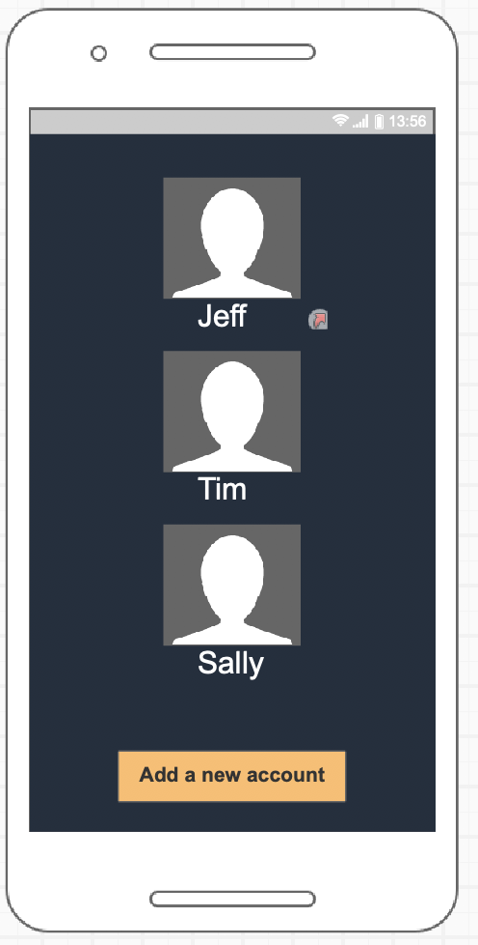

Underserved persona use case: Our persona Jeff shares a mobile device with other members of his family, such as his children Tim and Sally. Jeff clicks on his name and is taken to a screen where he can then verify his identity by entering a password.

## Log-In

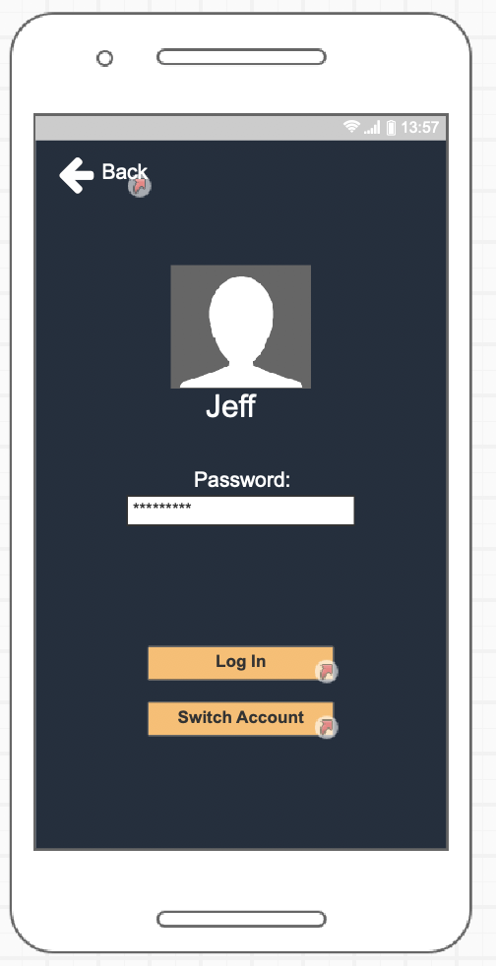

Underserved use case: After Jeff verifies his identity, he can then log into the website. Alternatively, if the user had actually been Sally or Tim and they had clicked on Jeff’s name by mistake and actually intended to log into their respective accounts, they can click on the “Switch Account” button.

## Product List

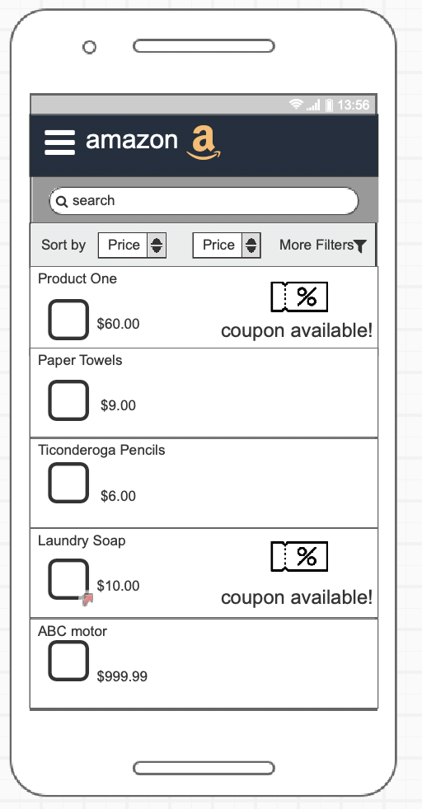

Underserved use case: After Jeff has logged in he can start easily searching products. Jeff will clearly see all the related results that Amazon’s algorithm has deemed he may be interested in. Most importantly, the coupon information will be easy for Jeff to find.

## Product Page

Underserved use case: Once Jeff has chosen the product, he is redirected to the product page. Here, Jeff can find more information about the product such as ratings, photos, instructions and so on. He can also choose all relevant coupons on the down-slider, though there is another page where he can go to see all relevant coupons. Once Jeff has made his decision, he can click “Add to cart” to be redirected to the review order page.

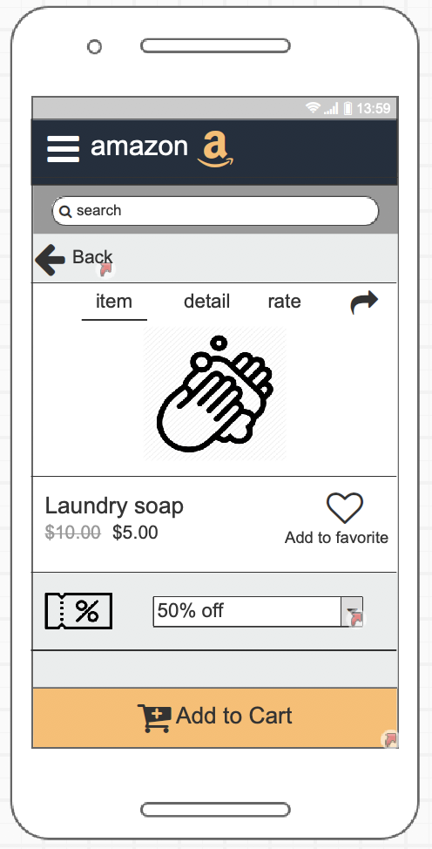

## Apply Discounts

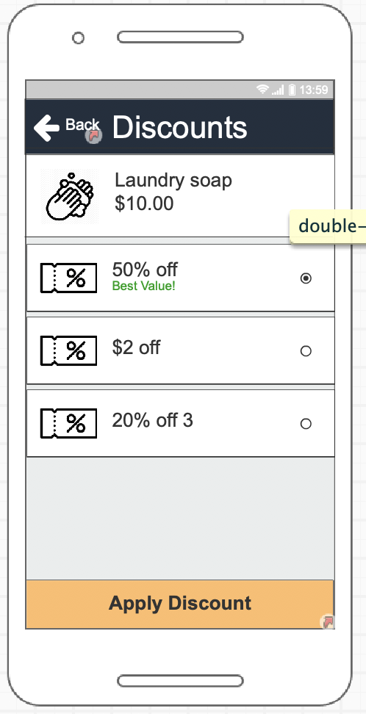

Underserved use case: Jeff wants to know about all the ways he could potentially save money on his purchase. He wants to know any terms or conditions that coupons come with and the raw savings he can have that cuts through confusing language that is often present in bulk or percentage based discounts.

## Review Order

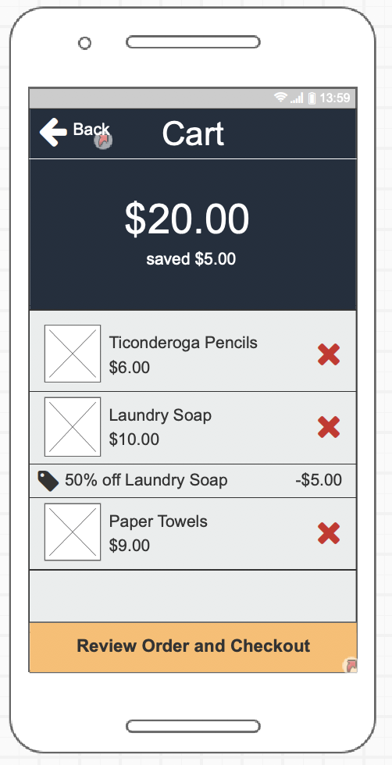

Underserved use case: If Jeff needs to see what coupons have been applied in his cart, the calculations are automatically done for him. Jeff isn’t a huge fan of doing math so he appreciates having it cleanly laid out for him how much money he’s spending and how much he’s saving.

## Complete Order

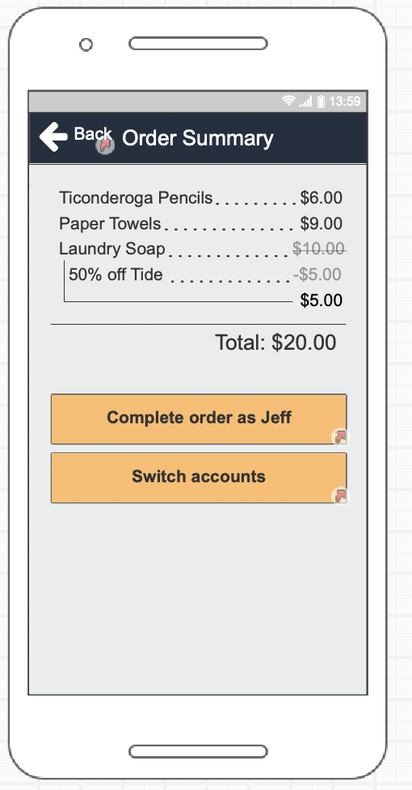

Underserved use case: After Jeff completes his order, he is taken to a page where he can verify his order or switch his account. The order summary gives him a clearly labelled explanation of everything he bought and how much he saved.

## Checkout Page

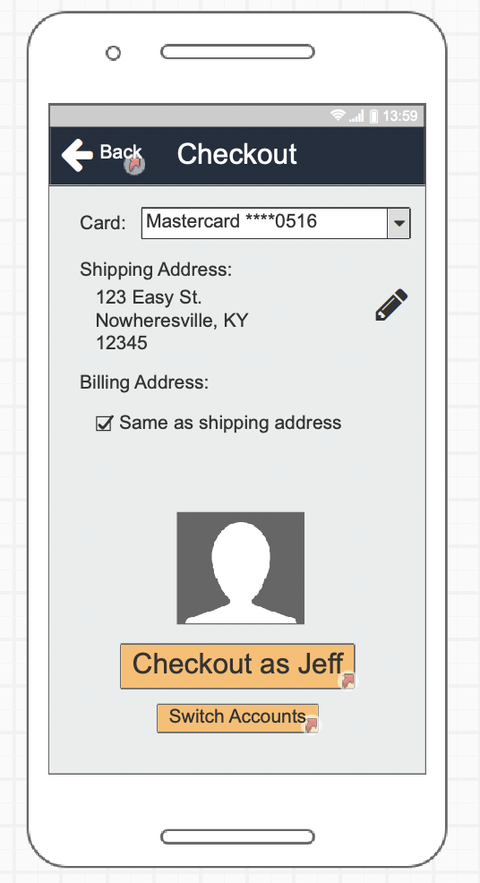

Underserved use case: After all of this, Jeff is made sure of what he ordered and how much it cost. Feeling satisfied, he can arrive to the Checkout page and choose to complete his order by clicking on “Checkout as Jeff”.

## Confirmation Page

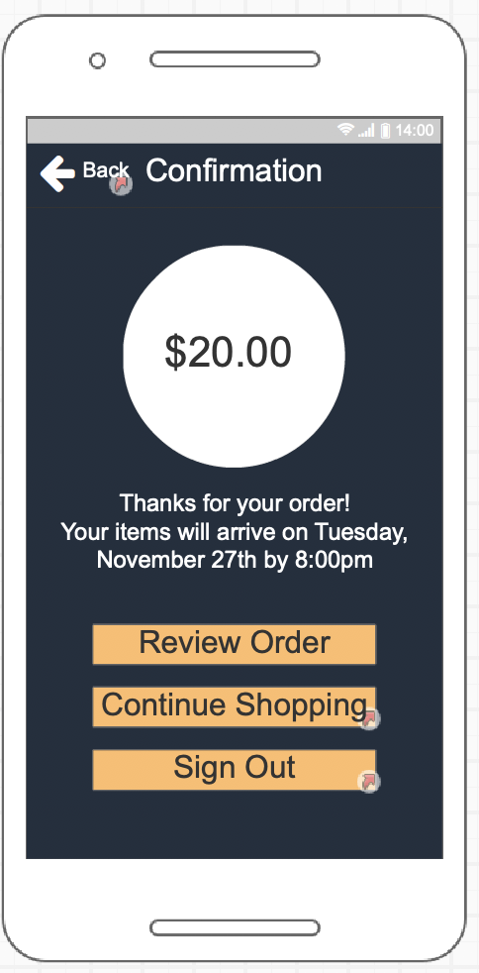

Underserved use case: Jeff has made his order but was unsure when it would arrive. This worry is assuaged however - he sees exactly when his order will arrive and how much it had cost him. But perhaps he’s feeling like he wants to go shopping more and add some amazing coupons to his next order. If so, he can continue shopping. Alternatively, he can review his order to see exactly what items he purchased and what coupons had been applied to that.

1. [‘Who Shops Where for Groceries—A Look at US Grocery Store Demographics’, *Coresight Research*](https://www.zotero.org/google-docs/?kf2A4v) 
2. [‘Topic: Food Shopping Behavior’, *Www.Statista.Com*](https://www.zotero.org/google-docs/?qUiTIR) 
3. [‘USDA ERS - FoodAPS National Household Food Acquisition and Purchase Survey’](https://www.zotero.org/google-docs/?9DQ4Bu) 
4. [Amit Chowdhry, ‘Lower-Income Americans Are Becoming Increasingly Dependent On Smartphones, Says Study’, *Forbes*](https://www.zotero.org/google-docs/?pqAT1p)
5. [‘Lower-Income Americans Still Lag in Tech Adoption’, *Pew Research Center*, p.](https://www.zotero.org/google-docs/?49vAP8)
6. [Parisa Khanipour Roshan and others, ‘Exploring How Parents in Economically Depressed Communities Access Learning Resources’, in *Proceedings of the 18th International Conference on Supporting Group Work*, GROUP ’14 (New York, NY, USA: ACM, 2014), pp. 131–141](https://www.zotero.org/google-docs/?vCO4jE)
7. [Sarita Yardi and Amy Bruckman, ‘Income, Race, and Class: Exploring Socioeconomic Differences in Family Technology Use’, in *Proceedings of the SIGCHI Conference on Human Factors in Computing Systems*, CHI ’12 (New York, NY, USA: ACM, 2012), pp. 3041–3050](https://www.zotero.org/google-docs/?cC3c88)
8. [John Vines, Paul Dunphy, and Andrew Monk, ‘Pay or Delay: The Role of Technology When Managing a Low Income’, in *Proceedings of the SIGCHI Conference on Human Factors in Computing Systems*, CHI ’14 (New York, NY, USA: ACM, 2014), pp. 501–510](https://www.zotero.org/google-docs/?1svuec)
9. [‘Education and Socioeconomic Status Factsheet’, *Http://Www.Apa.Org*](https://www.zotero.org/google-docs/?3PJoUN)