class4.R

sabrinakoldinger

2024-01-23

#First R script  
  
x=1:50  
plot(x, sin(x))

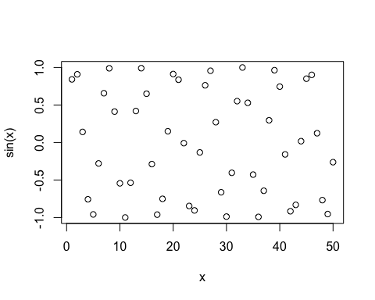

plot(x,sin(x), typ="l")

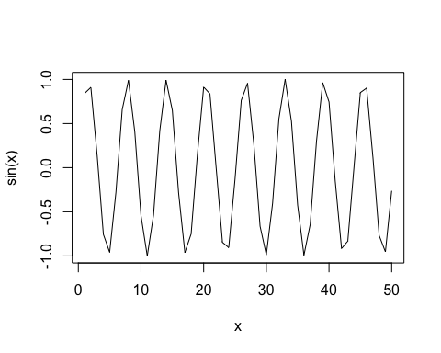

plot(x,sin(x), typ="l", col="blue")

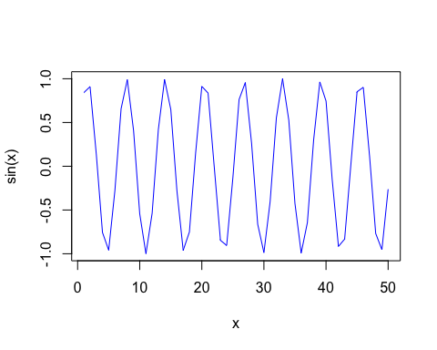

plot(x,sin(x), typ="l", col="blue", lwd=2)

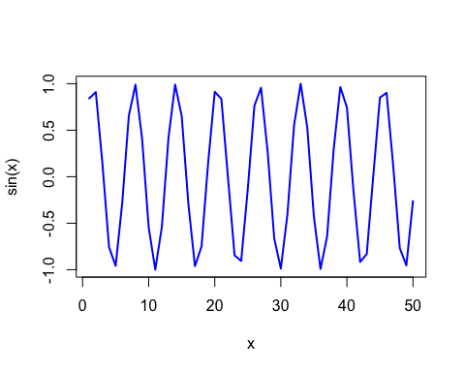

plot(x,sin(x), typ="l", col="red", lwd=2, xlab="hello")

