**NAAN MUDHALVAN**

**PROJECT REPORT ON**

A Demonstration of Text Input and Validation with Android Compose

**TEAM ID:** NM2023TMID13897

**SUBMITTED BY**

**TEAM LEADER**

**A KAMESH**

**AND MEMBERS:**

**Naveen Balaji SK KABILLAN KABILESHWARAN**

1 INTRODUCTION

* A Demonstration of Text Input and Validation with Android Compose is   
  The app is a sample project that demonstrates how to use the Android Compose UI toolkit to build a survey app. The app allows the user to answer a series of questions. It showcases some of the key features of the Compose UI toolkit, data management, and user interactions.

1.1 Overview

* Validation means checking if the user inputs are sufficient for a task to start or call a function. Generally, validation takes place in forms where the user is required to give mandatory inputs (fields marked with an asterisk). The most common examples of such forms are registration or sign-up forms and login forms.

1.2 Purpose

* Validating text fields when using jetpack compose can sometimes be challenging and verbose.
* Validable is an extensible library that allows you to validate your text fields in a simpler way while having a reusable code.

2 Problem Definition & Design Thinking

* To design and develop a user-friendly Android application that helps users study material design concepts effectively. The app should provide easy access to material design guidelines, components, and best practices, as well as offer interactive exercises and quizzes to help users reinforce their understanding. The app should also be visually appealing and follow the material design principles and guidelines, providing a seamless user experience. The target audience for the app could be beginner or intermediate-level designers, developers, or anyone interested in learning about material design principles and best practices. The app should be scalable, easily maintainable, and compatible with different screen sizes and versions of Android.
* Design thinking for the material design study app involves a user-centered approach that focuses on the needs of the users and their interactions with the app.

3 Architecture

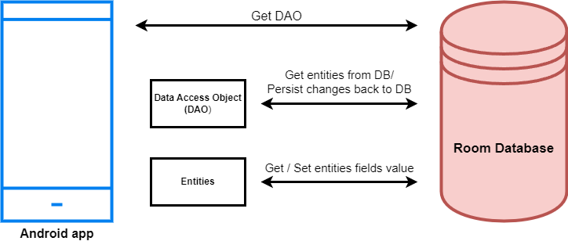

4 APPLICATIONS

* validation is an essential part of any data handling task whether you're in the field collecting information, analyzing data, or preparing to present data to stakeholders.
* Check that their email address is using the correct format. (i.e. contains an '@' symbol and follows email address syntax rules). Check that the email address belongs to a valid domain name. Check that the passwords are longer than 8 characters (or more).

5 Output

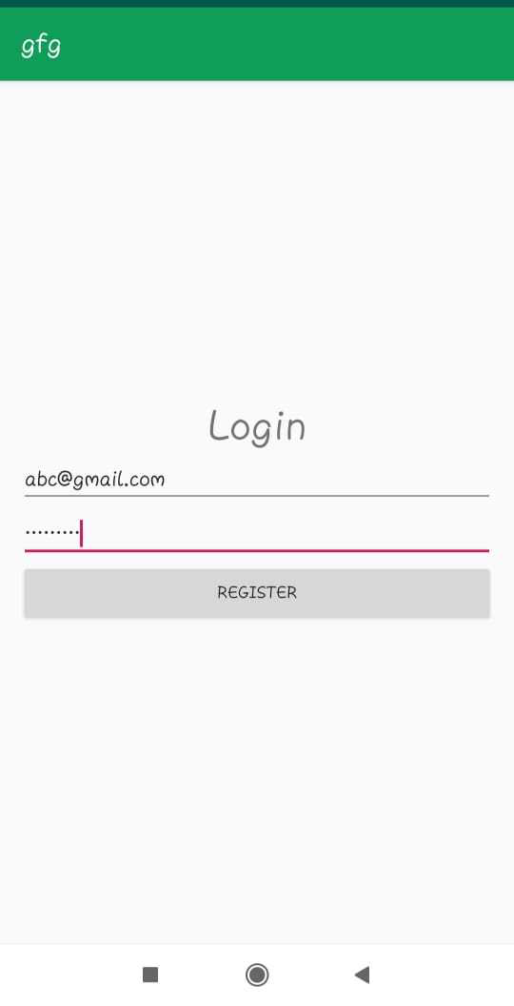

6 CONCLUSION

* A Demonstration of Text Input and Validation with Android Compose , this project shows the validation is important in very application. It Validates the data from the user. It’s a basic method used in every login page and forms.