Coursework Theme:
Transition from ancient mars with atmosphere, rain, lightning and water to current mars without atmosphere, rain, lightning and water and different surface textures.
Resubmitting because I wasn’t able to record a video on the lab PC for some reason so the previous submission didn’t have a video link.

YouTube Link: https://youtu.be/CCkT28HZl3M
List of Key Presses:
T – To transition from one scene to the other showing two different time periods
F – To toggle between automatic camera and free camera
V – To toggle multiple viewpoints with the first viewpoint camera being static and the second camera being free to move.
H – To toggle HDR
B – To toggle Bloom (Bloom is only activated once HDR is activated, so make sure to press H before B to see the bloom effects)
Left Key – To reduce the exposure for HDR/Bloom
Right Key – To increase the exposure for HDR/Bloom

- Scene showing ancient mars night time with rain, lightning and cube robot (for scene graph implementation)
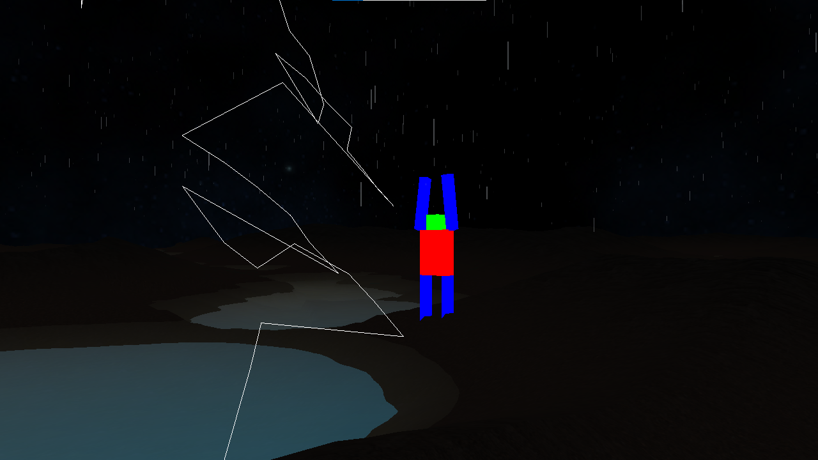

- Scene showing ancient mars daytime terrain, water and shadows on terrain.
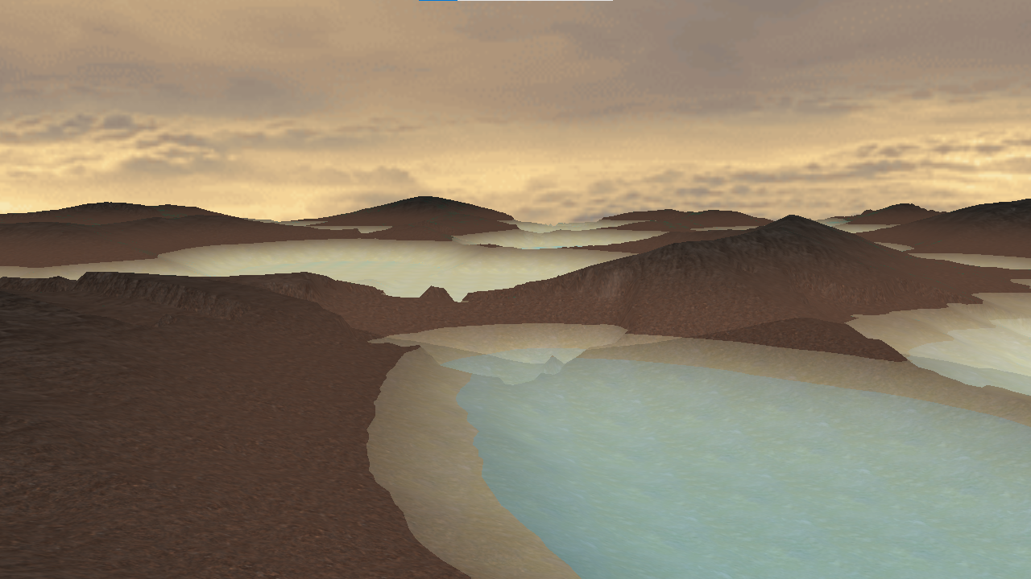

- Scene showing after showing current mars after transition without water and atmosphere and weather effects (different skybox)
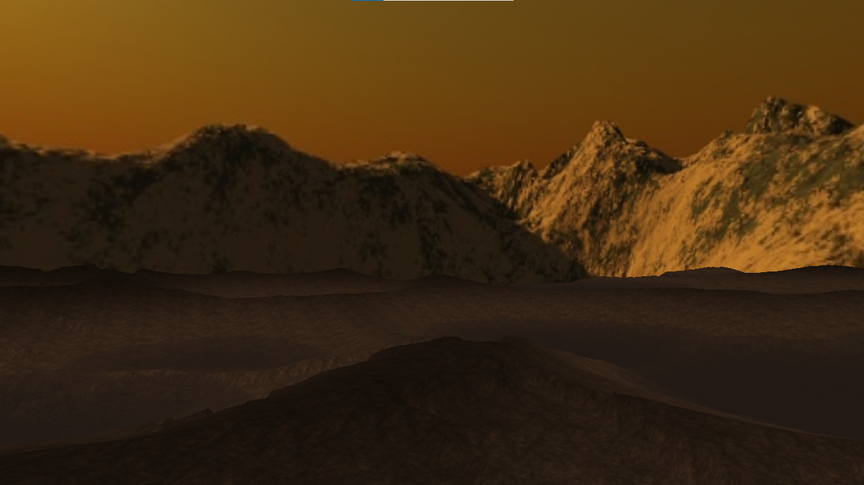

- Scene showing current mars with shadows appearing with changing sun’s position.
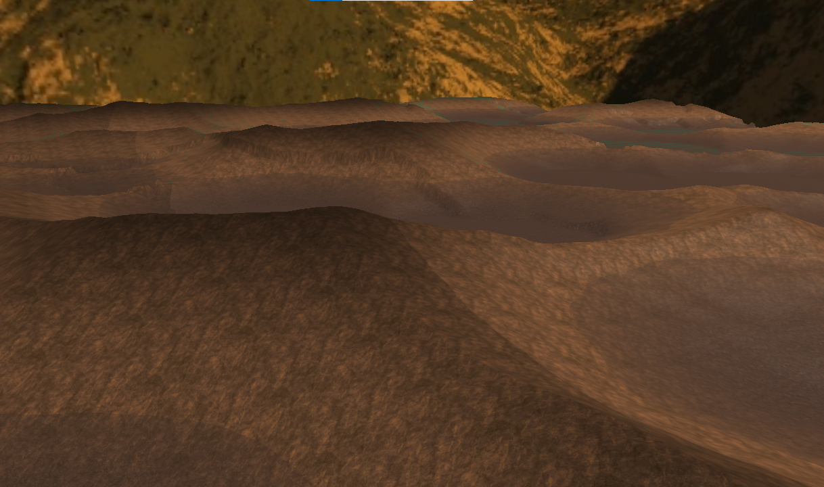

- Multiple viewpoints implementation.
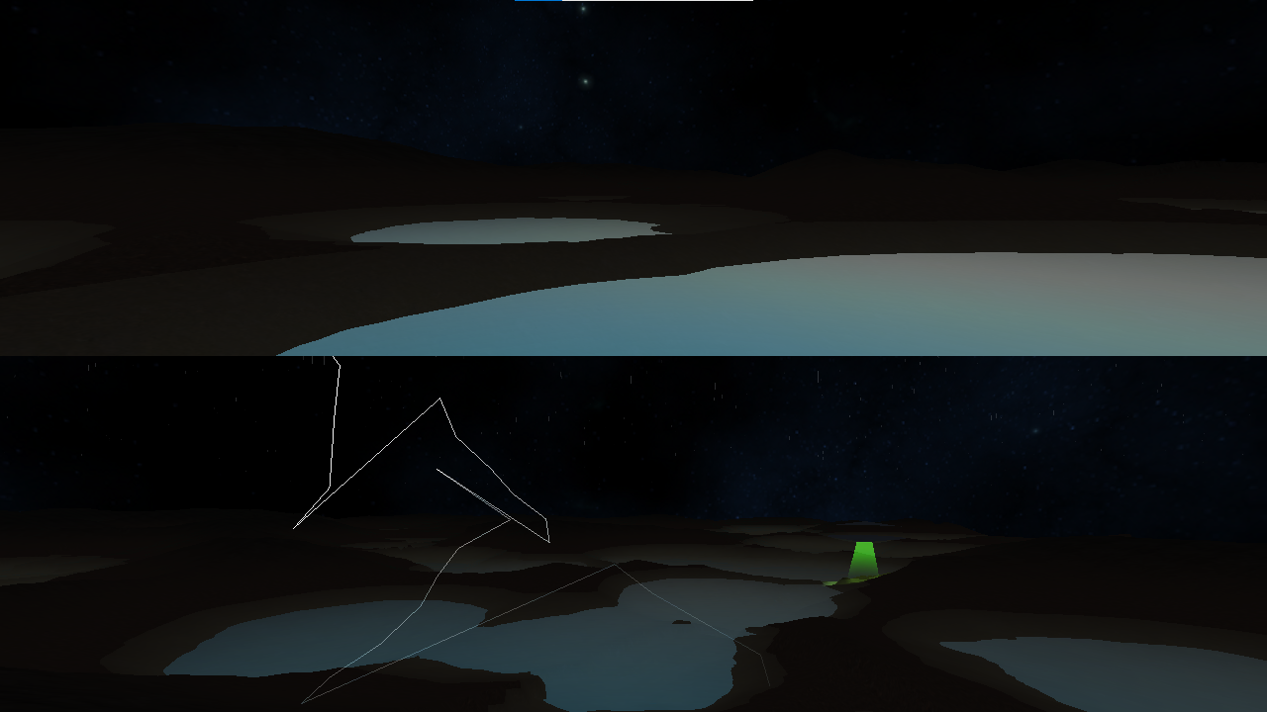

- UFO beam casting a light onto the terrain
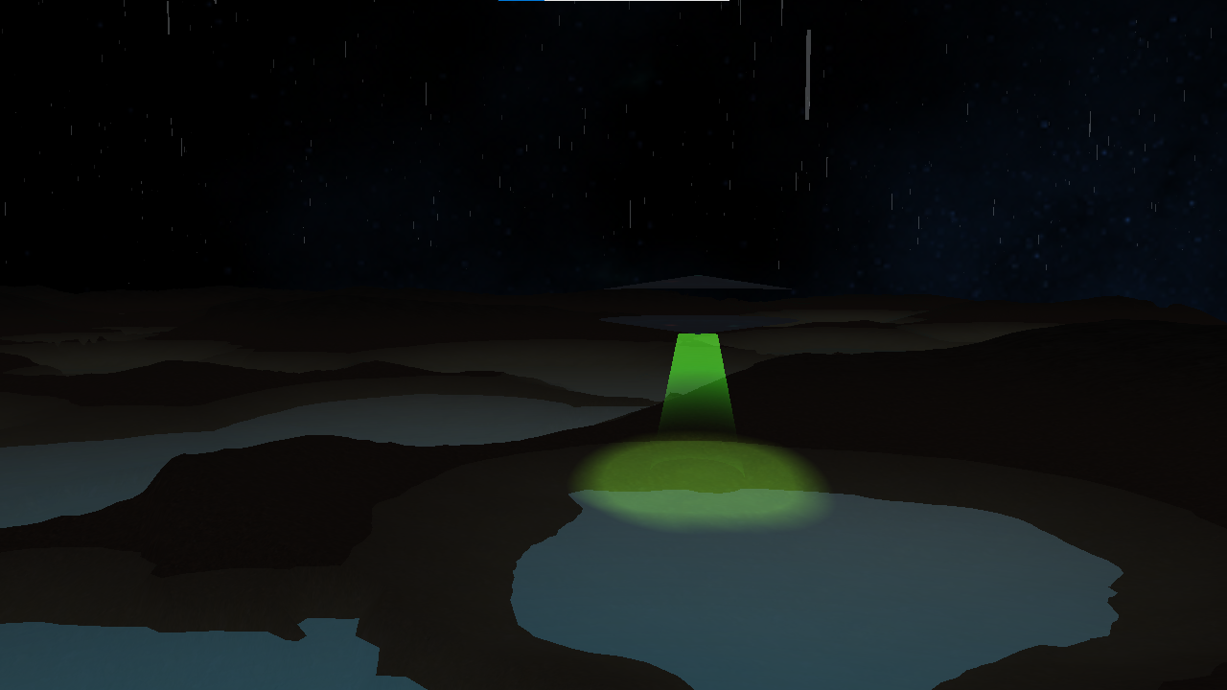

- HDR effect
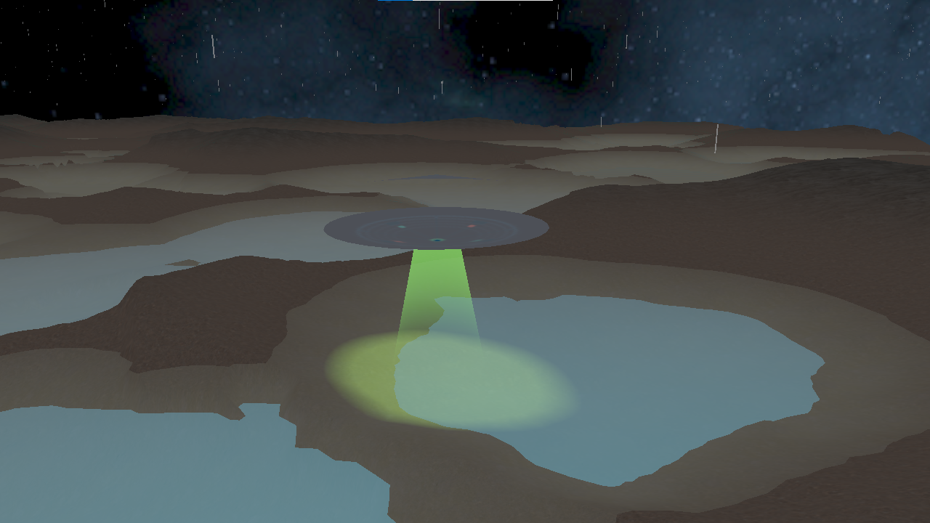

- Bloom effect
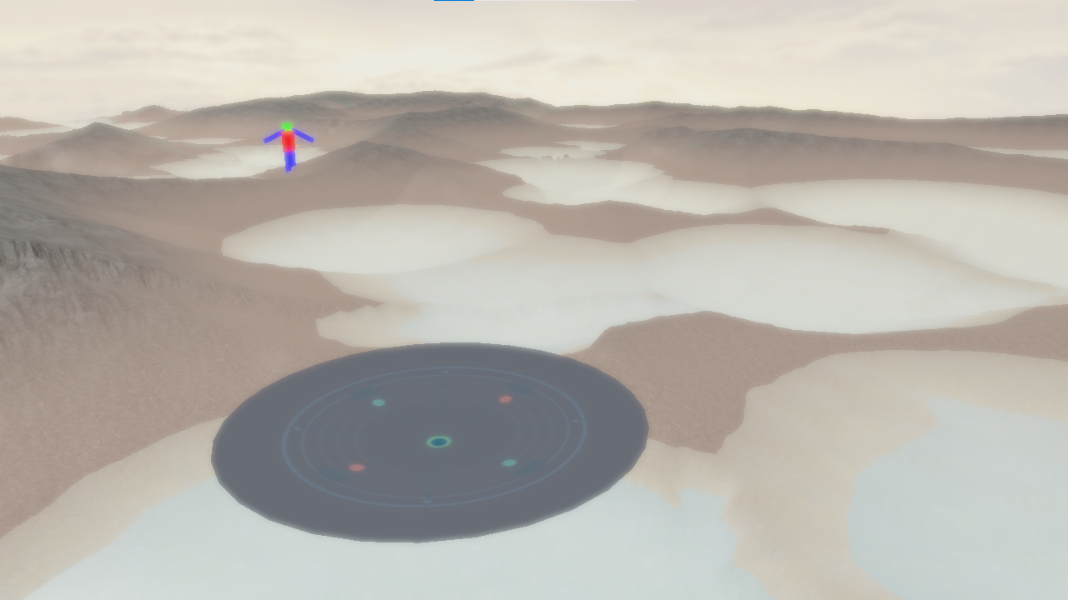

- FPS counter in console
