Web Design and Development

4COSC011C.3

Report

Isira Herath:

20223184/W1986703:

Group 16:

Student 2:

URL: <https://sl-pirate.github.io/weeb-dev-sem2-assignment/>

1. Introduction 2

2. Technical Discussion 3

• Task 1 3

• Task 2 3

• Task 3 3

• Task 4 3

• Task 5. 3

• Task 6. 3

3. Webpage Validation Statement 4

4. Janet 4

References 4

Appendices 4

Appendix A: Code 4

Appendix B: Screenshots 4

Appendix C: Screenshots - Webpage Validation Evidence 4

Appendix D: Individual Statement 5

Appendix E: Task Completion Checklist 6

# Introduction

Section guidelines:

1. List of the team members, allocation of tasks (student 1 to 4), and topic of the website.
2. Include the summary table of your contributions to the group meetings.

| **Group Coursework Meetings** (minimum 5 meetings, e.g., one per week) | | |
| --- | --- | --- |
| **1** | **Date & Time** | **24th June 2023** |
| **Objective:** | **Initiate project** |
| **Attended:** | **yes** |
| **Your Contribution:** | **Selected roles and talked about theme, topic and future planning** |
| **2** | **Date & Time:** | **1st June 2023** |
| **Objective:** | **To talk about progress** |
| **Attended:** | **Yes** |
| **Your Contribution:** | **Created git repo and collected code from everyone and merged** |
| **3** | **Date & Time:** | **8th June 2023** |
| **Objective:** | **To decide user content** |
| **Attended:** | **Yes** |
| **Your Contribution:** | **Picked Anuradhapua as my topic** |

| **4** | **Date & Time:** | **15th June 2023** |
| --- | --- | --- |
| **Objective:** | **To talk about progress** |
| **Attended:** | **No** |
| **Your Contribution:** | **Elaborated my current progress** |

| **5** | **Date & Time:** | **22nd June 2023** |
| --- | --- | --- |
| **Objective:** | **To finalize the project** |
| **Attended:** | **Yes** |
| **Your Contribution:** | **Finalized the project** |

# Technical Discussion

*1000 words (guidelines)*

Section guidelines

* **For each of your tasks** you will need to explain your choices regarding the page, your approach and defend your decisions regarding which elements and what HTML, CSS or JavaScript techniques you used.
* Explain what problems you faced, how you solved them and what you learnt by completing this task.
* Make references to resources used, whether these are lecture notes or external sources.
* Illustrate your explanation with code snippets and screen shots where appropriate.
* **Discuss only the tasks that you were allocated.**

Student 1 Tasks:

## Presentation Page

## Buy products

## Page Editor Page

## Extra content page relevant to topic

## Use of provided navigation bar (adapted).

## Addition CSS.

## Student 2 Tasks:

1. Main (home) page
2. Site navigation bar
3. External style sheet for website (with style guide)
4. Comments Form
5. Page Editor Page
6. Extra content page relevant to topic

Student 3 Tasks:

## Quiz

1. Student details
2. Page Editor Page
3. Extra content page relevant to topic

## Use of provided navigation bar (adapted).

## Addition CSS.

Student 4 Tasks:

1. Diagram (SVG)
2. Thumbnail Images
3. Page Editor Page
4. Extra content page relevant to topic

## Use of provided navigation bar (adapted).

## Addition CSS.

# Webpage Validation Statement

Validation for Comments page:

All validations were done using HTML itself with require fields and type fields as required

# Janet

Used Janet regulation to decide on theming to increase contrast so pages look more readable.

# References

# Appendices

## Appendix A: Code

* Comments.html
* <!DOCTYPE html>

<html lang="en">

<head>

<meta charset="UTF-8">

<meta name="viewport" content="width=device-width, initial-scale=1.0">

<link rel="icon" href="../gfx/favicon.png">

<title>Comments</title>

<link rel="stylesheet" href="../styles/global.css">

<link rel="stylesheet" href="../styles/comments.css">

<script src="../scripts/comments.js"></script>

</head>

<body>

<iframe src="global_navbar.html?page=comments" width="100%" height="100px" style="border:none;"></iframe>

<form>

<div id="satisfaction-range-outer-div">

<label>How satisfied are you with our webstie? Choose from 1 to 10 where 1 is dissatisfied and 10 is highly satisfied</label>

<label id="rate-required">This field is required</label>

<div id="satisfaction-range-inner-div">

<div class="satisfaction-range">

<label>1</label>

<input type="radio" name="satisfaction-value" value="1">

</div>

<div class="satisfaction-range">

<label>2</label>

<input type="radio" name="satisfaction-value" value="2">

</div>

<div class="satisfaction-range">

<label>3</label>

<input type="radio" name="satisfaction-value" value="3">

</div>

<div class="satisfaction-range">

<label>4</label>

<input type="radio" name="satisfaction-value" value="4">

</div>

<div class="satisfaction-range">

<label>5</label>

<input type="radio" name="satisfaction-value" value="5">

</div>

<div class="satisfaction-range">

<label>6</label>

<input type="radio" name="satisfaction-value" value="6">

</div>

<div class="satisfaction-range">

<label>7</label>

<input type="radio" name="satisfaction-value" value="7">

</div>

<div class="satisfaction-range">

<label>8</label>

<input type="radio" name="satisfaction-value" value="8">

</div>

<div class="satisfaction-range">

<label>9</label>

<input type="radio" name="satisfaction-value" value="9">

</div>

<div class="satisfaction-range">

<label>10</label>

<input type="radio" name="satisfaction-value" value="10">

</div>

</div>

</div>

<div id="tell-more">

<label>Please tell us more</label>

<label id="tellmore-required">This field is required</label>

<textarea id="tellmore-text"></textarea>

</div>

<div class="how-dropdown">

<label>How did you want to complete this task today? (Optional)</label>

<select id="task-today">

<option value="none">-- Please Select --</option>

<option value="phone">Phone</option>

<option value="webstite">WebSite</option>

<option value="webchat">WebChat</option>

<option value="social-media">Social Media</option>

<option value="email">Email</option>

</select>

</div>

<div class="how-dropdown">

<label>If you had to complete this task again, how would you prefer to do it? (Optional)</label>

<select id="task-again">

<option value="none">-- Please Select --</option>

<option value="phone">Phone</option>

<option value="webstite">WebSite</option>

<option value="webchat">WebChat</option>

<option value="social-media">Social Media</option>

<option value="email">Email</option>

</select>

</div>

<div id="submit">

<input type="button" name="submit" value="Submit" onclick="sendMail(null, null, null, null)">

</div>

</form>

<a href="page_editor_student2.html" style="margin: 50px;">Go to page editor</a>

</body>

</html>

* global_navbar.html
* <!DOCTYPE html>

<html lang="en">

<head>

<meta charset="UTF-8">

<meta name="viewport" content="width=device-width, initial-scale=1.0">

<title>Home</title>

<link rel="stylesheet" href="../styles/global.css">

<link href="../styles/global_navbar.css" rel="stylesheet">

<!-- Making te iframe open links in the parent window. Reference: https://stackoverflow.com/questions/1037839/how-to-force-link-from-iframe-to-be-opened-in-the-parent-window-->

<base target="_parent">

</head>

<body>

<!-- Navbar -->

<nav id="global-navbar">

<ul>

<a id="home" href="home.html" onmouseenter="highlightLink('home')" onmouseleave="resetHighlighting('home')">

<li><strong>Home</strong></li>

</a>

<a href="comments.html" id="comments" onmouseenter="highlightLink('comments')" onmouseleave="resetHighlighting('comments')">

<li><strong>Comments</strong></li>

</a>

<a href="shop.html" id="shop" onmouseenter="highlightLink('shop')" onmouseleave="resetHighlighting('shop')">

<li><strong>Shop</strong></li>

</a>

<a href="#" id="quiz" onmouseenter="highlightLink('quiz')" onmouseleave="resetHighlighting('quiz')">

<li><strong>Quiz</strong></li>

</a>

<a href="#" id="gallery" onmouseenter="highlightLink('gallery')" onmouseleave="resetHighlighting('gallery')">

<li><strong>Gallery</strong></li>

</a>

<a href="sitemap.html" id="sitemap" onmouseenter="highlightLink('sitemap')" onmouseleave="resetHighlighting('sitemap')">

<li><strong>Site Map</strong></li>

</a>

<a href="about-us.html" id="about-us" onmouseenter="highlightLink('about-us')" onmouseleave="resetHighlighting('about-us')">

<li><strong>About us</strong></li>

</a>

</ul>

</nav>

<script src="../scripts/global_navbar.js"></script>

</body>

</html>

* home.html
* <!DOCTYPE html>

<html lang="en">

<head>

<meta charset="UTF-8">

<meta name="viewport" content="width=device-width, initial-scale=1.0">

<title>Home</title>

<link rel="icon" href="../gfx/favicon.png">

<link rel="stylesheet" href="https://fonts.googleapis.com/css2?family=Bangers">

<link rel="stylesheet" href="../styles/home.css">

<link rel="stylesheet" href="../styles/global.css">

</head>

<body>

<iframe src="global_navbar.html?page=home" width="100%" height="100px" style="border:none;"></iframe>

<div class="title">

<h1>Travel Sri Lanka</h1>

<img src="../gfx/map.jpg" alt="Sri Lankan Tourist map">

</div>

<div class="topics">

<div id="student1_topic" onclick="navigate('student1_topic')">

<img src="../gfx/galle_2.jpg" alt="Galle">

<h5>Galle</h5>

</div>

<div onclick="navigate('student2_topic')">

<img src="../gfx/student2_topic.jpg" alt="Anuradhapura">

<h5>Anuradhapura</h5>

</div>

<div onclick="navigate('student3_topic')">

<img src="../gfx/student3_topic.jpg" alt="student3_topic">

<h5>student3_topic</h5>

</div>

<div onclick="navigate('student4_topic')">

<img src="../gfx/student4_topic.jpg" alt="student4_topic">

<h5>student4_topic</h5>

</div>

</div>

<a href="page_editor_student2.html" style="margin: 50px;">Go to page editor</a>

<script src="../scripts/home.js"></script>

</body>

</html>

* page_editor_student2.html
* <!DOCTYPE html>

<html lang="en">

<head>

<meta charset="UTF-8">

<meta name="viewport" content="width=device-width, initial-scale=1.0">

<title>Page editor</title>

<link rel="icon" href="../gfx/favicon.png">

<link rel="stylesheet" href="../styles/global.css">

<link rel="stylesheet" href="../styles/page_editor_student2.css">

</head>

<body>

<iframe src="global_navbar.html?page=about-us" width="100%" height="100px" style="border:none;"></iframe>

<div id="outer-div">

<h1>Page Editor</h1>

<hr>

<p>Name: Isira Herath</p>

<p>Role: Student 2</p>

<p>The following pages were edited by me!</p>

<hr>

<div class="entry">

<h3>Global navbar</h3>

<p>I created the global navbar as a seperated html page linked it to all pages using iframes</p>

<a href="global_navbar.html">view standalone navbar</a>

</div>

<div class="entry">

<h3>Home page</h3>

<p>Home page was created by me using plain html, css and js</p>

<a href="home.html">Go Home</a>

</div>

<div class="entry">

<h3>Comments section</h3>

<p>I created the Comments page using plain html, css and javascript, including the thanking page that is shown after a comment is submitted.</p>

<a href="comments.html">Go to Comments section</a>

</div>

<div class="entry">

<h3>Blog about Anuradhapura</h3>

<p>I created the blog post about Anuradhapuraya and styled it using HTML, CSS and Javascript</p>

<a href="student2_topic.html">Read the blog post about Anuradhapura</a>

</div>

</div>

</body>

</html>

* student2_topic.html
* <!DOCTYPE html>

<html lang="en">

<head>

<meta charset="UTF-8">

<meta name="viewport" content="width=device-width, initial-scale=1.0">

<title>Anuradhapura</title>

<link rel="icon" href="../gfx/favicon.png">

<link rel="stylesheet" href="../styles/global.css">

<link rel="stylesheet" href="../styles/student2_topic.css">

<link rel="preconnect" href="https://fonts.googleapis.com">

<link rel="preconnect" href="https://fonts.gstatic.com" crossorigin>

<link href="https://fonts.googleapis.com/css2?family=Lumanosimo&family=Manrope:wght@500&display=swap" rel="stylesheet">

</head>

<body>

<iframe src="global_navbar.html?page=home" width="100%" height="100px" style="border:none;"></iframe>

<div class="blog">

<div class="blog-title">

<h1>Anuradhapura</h1>

<h2>Exploring Sri Lanka's Ancient Sacred City</h2>

</div>

<ol>

<li><a href="#introduction">Introduction</a></li>

<li><a href="#historical_significance">Historical significance</a></li>

<li><a href="#sacred_sites">Sacred Buddhist sites</a></li>

<li><a href="#ruins">Magnificient Ruins</a></li>

<li><a href="#surrounding">Serene Surroundings</a></li>

<li><a href="#events">Cultural Festivals and Events</a></li>

<li><a href="#excursions">Accessible Excursions</a></li>

<li><a href="#conclusion">Conclusion</a></li>

</ol>

<div class="title-img">

<img src="../gfx/student2_topic.jpg" alt="Ruwanwelisaya">

</div>

<div class="description" id="introduction">

<h3>Introduction</h3>

<p>Sri Lanka, a tropical paradise in the heart of the Indian Ocean, is known for its rich history and cultural heritage. Among its many gems, Anuradhapura stands tall as an ancient sacred city that showcases the country's glorious past. This UNESCO World Heritage site offers a captivating journey back in time, with its majestic ruins, sacred temples, and serene surroundings. In this blog, we will delve into the wonders of Anuradhapura and highlight its significance in the realm of travel and tourism.</p>

</div>

<div class="description" id="historical_significance">

<h3>Historical significance</h3>

<p>Anuradhapura served as the capital of Sri Lanka for over a thousand years, from the 4th century BC to the 11th century AD. As the center of Theravada Buddhism, it boasts a remarkable collection of historical sites and monuments that reflect the country's religious and cultural heritage. The city is home to numerous stupas, monastic complexes, palaces, and intricate stone carvings, all of which offer a glimpse into the ancient civilization that thrived here.</p>

</div>

<div class="description" id="sacred_sites">

<div class="img">

<img src="../gfx/student2_topic_img1.jpg" class="subtopic" alt="buddha statue">

</div>

<div class="details">

<h3>Sacred Buddhist Sites</h3>

<p>For Buddhist pilgrims and enthusiasts, Anuradhapura is a spiritual sanctuary. The city is home to the Sacred Bodhi Tree, believed to be the oldest recorded tree in the world, with a history spanning over 2,000 years. This sacred tree is revered as the place where Lord Buddha attained enlightenment. Devotees flock to the site to offer prayers and experience the profound sense of tranquility that envelops the surroundings.</p>

</div>

</div>

<div class="description" id="ruins">

<div class="details">

<h3>Magnificient Ruins</h3>

<p>Exploring Anuradhapura is like stepping into a time capsule. The ruins of ancient palaces, monasteries, and dagobas (stupas) provide a glimpse into the architectural marvels of a bygone era. The Abhayagiri Dagoba, Jetavanaramaya, and Ruwanwelisaya are among the most iconic structures in Anuradhapura, with their sheer size and intricate craftsmanship leaving visitors in awe. Walking amidst these ruins is a humbling experience, allowing one to appreciate the craftsmanship and ingenuity of ancient Sri Lankan civilization.</p>

</div>

<div class="img">

<img src="../gfx/student2_topic_img2.webp" class="subtopic" alt="isurumuniya">

</div>

</div>

<div class="description" id="surrounding">

<h3>Serene Surroundings</h3>

<p>Apart from its historical significance, Anuradhapura also offers a serene and tranquil atmosphere. The city is dotted with picturesque lakes, lush green parks, and peaceful monastic complexes, making it an ideal destination for those seeking inner peace and tranquility. The shimmering waters of Tissa Wewa and Nuwara Wewa provide a perfect backdrop for leisurely strolls or picnics, allowing visitors to immerse themselves in the natural beauty that surrounds the ancient city.</p>

</div>

<div class="description" id="events">

<h3>Cultural Festivals and Events</h3>

<p>Anuradhapura comes alive during cultural festivals and events, offering visitors a chance to witness vibrant traditions and rituals. The Poson Poya Festival, commemorating the introduction of Buddhism to Sri Lanka, is celebrated with great fervor, attracting both locals and tourists alike. The city is adorned with colorful decorations, and devotees engage in religious observances, illuminating the ancient ruins with lanterns and lights, creating a mesmerizing spectacle.</p>

</div>

<div class="description" id="excursions">

<h3>Accessible Excursions</h3>

<p>Anuradhapura's central location makes it an ideal base for exploring other nearby attractions. Just a short drive away, you can visit the stunning rock fortress of Sigiriya, the ancient city of Polonnaruwa, or the serene shores of the Ritigala Forest Reserve. These excursions offer a well-rounded experience, allowing you to witness the diverse landscapes and historical wonders that Sri Lanka has to offer.</p>

</div>

<div class="description" id="conclusion">

<h3>Conclusion</h3>

<p>Anuradhapura, with its ancient ruins, sacred sites, and cultural significance, stands as a testament to Sri Lanka's glorious past. As a traveler, exploring this ancient sacred city is a captivating journey that not only provides insight into the country's history but also offers a spiritual and serene experience. Whether you are an architecture enthusiast, a history buff, or a seeker of tranquility, Anuradhapura has something extraordinary to offer. Plan your visit to this UNESCO World Heritage site and immerse yourself in the magnificence of Sri Lanka's ancient civilization.</p>

</div>

</div>

<a id="page_editor" href="#" style="margin: 50px;">Back to top</a>

<a id="page_editor" href="page_editor_student2.html" style="margin: 50px;">Go to page editor</a>

</body>

</html>

* thankyou_comments.html
* <!DOCTYPE html>

<html lang="en">

<head>

<meta charset="UTF-8">

<meta name="viewport" content="width=device-width, initial-scale=1.0">

<title>Thank You!</title>

<link rel="icon" href="../gfx/favicon.png">

<link rel="stylesheet" href="../styles/global.css">

<link rel="stylesheet" href="../styles/comments.css">

</head>

<body>

<iframe src="global_navbar.html?page=comments" width="100%" height="100px" style="border:none;"></iframe>

<div id="thanking">

<h1>Thank you for sparing your time to provide feedback!</h1>

<a href="home.html"><button>Go Home</button></a>

</div>

<a href="page_editor_student2.html" style="margin: 50px;">Go to page editor</a>

</body>

</html>

* comments.js
* function validateNotNull(value, id) {

if (value == null) {

document.getElementById(id).style.display = "block";

return false;

}

document.getElementById(id).style.display = "none";

return true;

}

function getRating () {

let val = null;

const elements = document.getElementsByName("satisfaction-value");

elements.forEach(element => {

if (element.checked) {

val = element.value;

}

});

console.log(val);

return val;

}

function getMoreDetails () {

const moreDetails = document.getElementById("tellmore-text").value;

if (moreDetails == '') {

return null;

}

return moreDetails;

}

function getTaskValueById(id) {

const value = document.getElementById(id).value;

if (value == "none") {

return null;

}

return value;

}

function sendMail () {

const rating = getRating();

const moreDetails = getMoreDetails();

const taskToday = getTaskValueById("task-today");

const taskAgain = getTaskValueById("task-again");

const newLine = "%0D%0A";

if (validateNotNull(rating, "rate-required")

& validateNotNull(moreDetails, "tellmore-required")) {

const emailAddr = "isira.20223184@iit.ac.lk";

const subject = "Feedback for Travel Sri Lanka website";

let body =

"Hello Isira," +

newLine +

newLine +

"I rate my experience with your site " +

rating +

"/10." +

newLine +

moreDetails +

"." +

newLine;

if (taskToday != null) {

body += "I used " +

taskToday +

" to complete this task." +

newLine;

}

if (taskAgain != null) {

body += "I will be using " +

taskAgain +

" to complete this task when I do again." +

newLine;

}

body += "Thank you for creating and maintaining this site!";

let email = "mailto:" + emailAddr + "?subject=" + subject + "&body=" + body;

console.log(email);

window.open(email, '_blank');

window.open("thankyou_comments.html", '_parent');

}

}

* global_navbar.js
* var currnetPage = "home";

setPage = page => {

currnetPage = page;

document.getElementById(page).style.setProperty("background-color", "#bff000");

document.getElementById(page).style.setProperty("color", "black");

}

highlightLink = page => {

if (currnetPage != page) {

document.getElementById(page).style.setProperty("background-color", "red");

}

}

resetHighlighting = page => {

if (currnetPage != page) {

document.getElementById(page).style.setProperty("background-color", "black");

}

}

setPage(new URLSearchParams(window.location.search).get("page"));

* home.js
* function navigate(page) {

window.open(page + ".html", '_parent');

}

* comments.css
* #satisfaction-range-outer-div {

margin: 25px;

margin-bottom: 50px;

}

#satisfaction-range-inner-div {

padding: 25px;

background-color: aqua;

display: flex;

justify-content: space-around;

margin-top: 25px;

border-radius: 25px;

}

.satisfaction-range {

display: flex;

flex-direction: column;

}

.satisfaction-range label {

text-align: center;

}

#tell-more {

display: flex;

flex-direction: column;

margin: 25px;

margin-bottom: 50px;

}

#tellmore-text {

margin-top: 10px;

width: 100%;

height: 100px;

resize: none;

}

.how-dropdown {

margin: 25px;

margin-bottom: 50px;

display: flex;

flex-direction: column;

}

.how-dropdown select {

margin-top: 10px;

width: 100%;

height: 40px;

padding-left: 10px;

}

#submit {

display: flex;

justify-content: center;

margin-bottom: 25px;

}

#submit input {

width: 100px;

padding: 15px;

background: #bfff00;

border: none;

font-weight: bold;

cursor: pointer;

margin-bottom: 20px;

border-radius: 5px;

}

#rate-required, #tellmore-required {

display: none;

color: red;

width:fit-content;

position: absolute;

right: 0px;

padding-right: 25px

}

#thanking {

display: flex;

justify-content: center;

align-items: center;

flex-direction: column;

}

#thanking h1 {

text-align: center;

font-size: 48pt;

font-weight: bold;

}

#thanking button {

width: 100px;

padding: 15px;

background: #bfff00;

border: none;

font-weight: bold;

cursor: pointer;

margin-bottom: 20px;

border-radius: 5px;

}

* global_navbar.css
* /* Styling for the global navigation bar */

#global-navbar {

background-color: black;

width:auto;

}

#global-navbar ul {

list-style: none;

display: flex;

justify-content: space-between;

padding-left: 0%;

padding-right: 0%;

margin-top: 0px;

}

#global-navbar ul a {

padding-top: 25px;

padding-bottom: 25px;

color: white;

font-size: large;

text-decoration: none;

width: 16.66%;

justify-content: center;

display: flex;

}

#global-navbar ul a li {

overflow:hidden;

text-overflow: ellipsis;

}

* global.css
* body, html{

margin: 0px;

margin-bottom: 10px;

}

html {

font-family: Arial, Helvetica, sans-serif;

}

* home.css
* .title {

display: flex;

flex-wrap: wrap;

margin-left: 5%;

margin-right: 5%;

font-family: "Bangers";

letter-spacing: 5px;

font-size: 48pt;

justify-content: space-evenly;

margin-bottom: 100px;

}

.title img {

width: 500px;

}

.title h1 {

width: 50%;

text-align: center;

cursor: default;

position: relative;

bottom: 50%;

}

.topics {

display: flex;

flex-wrap: wrap;

justify-content: space-evenly;

justify-content: space-around;

}

.topics div {

display: flex;

flex-direction: column;

width: 500px;

padding: 2.5%;

padding-bottom: 0px;

margin-bottom: 2%;

justify-content: space-between;

background-color: cyan;

border-radius: 50px;

cursor: pointer;

}

.topics div img {

width: 100%;

height: auto;

border-radius: 50px;

}

.topics h5 {

height: min-content;

position: relative;

bottom: 0px;

text-align: center;

}

* page_editor_student2.css
* #outer-div {

margin: 50px;

text-align: center;

}

.entry {

margin-bottom: 50px;

border-style: solid;

}

.entry a {

margin-bottom: 50px;

}

* student2_topic.css
* *{

scroll-behavior: smooth;

}

.blog{

display: flex;

flex-direction: column;

justify-content: center;

text-align: center;

margin-left: 50px;

margin-right: 50px;

}

.blog-title{

font-family: 'Lumanosimo', 'cursive';

padding: 80px 0px;

}

.blog-title h1{

font-size: 100px;

}

/*--------------------- anchores -------------------*/

.blog ol {

display: flex;

flex-wrap: wrap;

justify-content: center;

align-items: center;

gap:5px;

list-style-type: none;

}

.blog ol a{

color: aliceblue;

text-decoration: none;

}

.blog ol li{

flex: 15%;

font-size: larger;

border-radius: 10px;

padding: 5px 10px;

background-color: rgb(44, 44, 44);

transition: all 0.3s;

}

.blog ol li:hover{

padding: 5px 20px;

}

/*---------------------------------------------------*/

.title-img{

filter: drop-shadow(0px 0px 4px #000000a9);

display: flex;

justify-content: center;

align-items: center;

width: 100%;

height: 100%;

margin: 50px 0;

overflow: hidden;

}

.title-img img{

border-radius: 20px;

width: auto;

height: 100%;

}

.description{

font-family: 'Manrope', sans-serif;

font-size: 20px;

padding: 5% 5%;

}

.description h3{

font-size: 30px;

}

#introduction , #sacred_sites ,#surrounding,#excursions{

background-color: rgb(44, 44, 44);

color: aliceblue;

}

/* ---------------- description with images ------------*/

#ruins , #sacred_sites{

display: flex;

justify-content: space-around;

}

.description .img{

width: 50%;

margin: 0 50px;

}

.description .img img{

filter: drop-shadow(0px 0px 4px #000000a9);

border-radius: 20px;

width: 100%;

}

.description .details{

width: 50%;

}

/*------------------------------------------------*/

/*-------------- Page Editor Link -------------*/

#page_editor{

font-weight: 600;

text-decoration: none;

color: aliceblue;

border: 2px solid rgb(44, 44, 44);

background-color: rgb(44, 44, 44);

padding: 10px 20px;

}

#page_editor:hover{

background-color: aliceblue;

border: 2px solid rgb(44, 44, 44);

color: rgb(44, 44, 44);

}

## Appendix B: Screenshots

Provide a screenshot of all your web pages, in the following format:

* home.jpeg
* 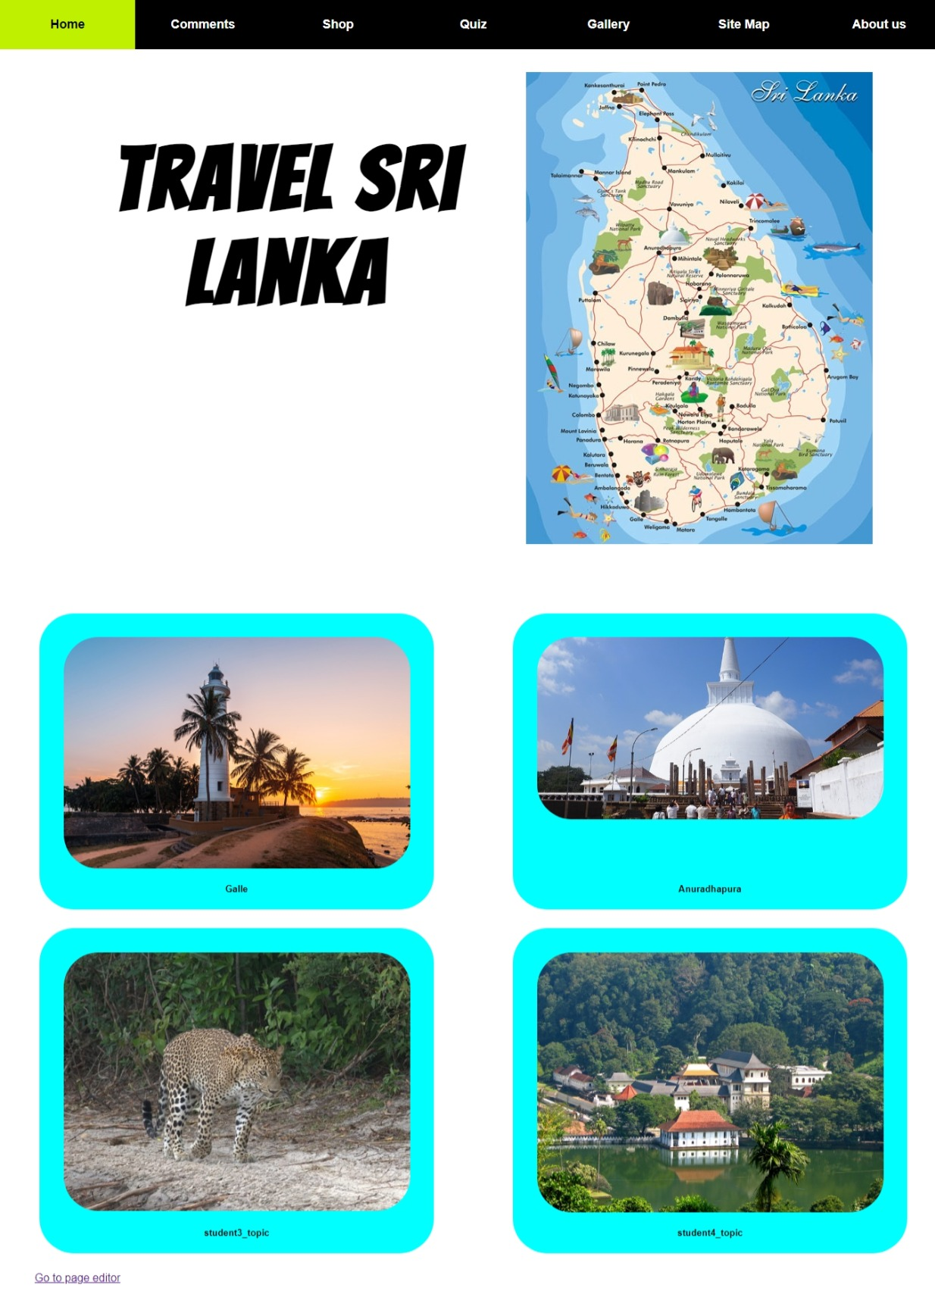 comments.jpeg
* 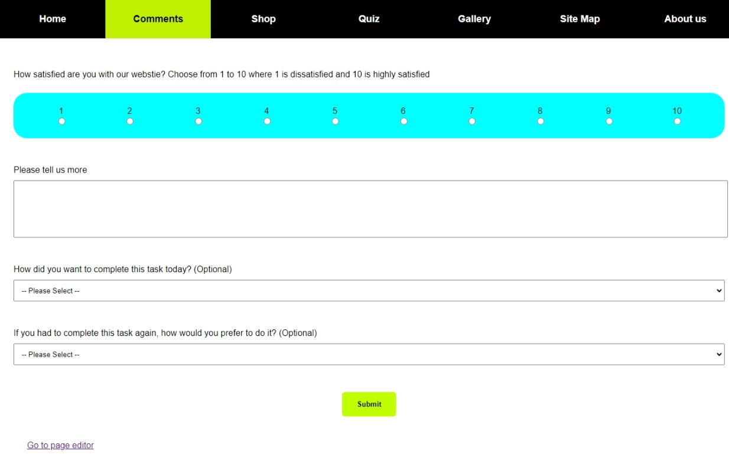thanking.jpeg

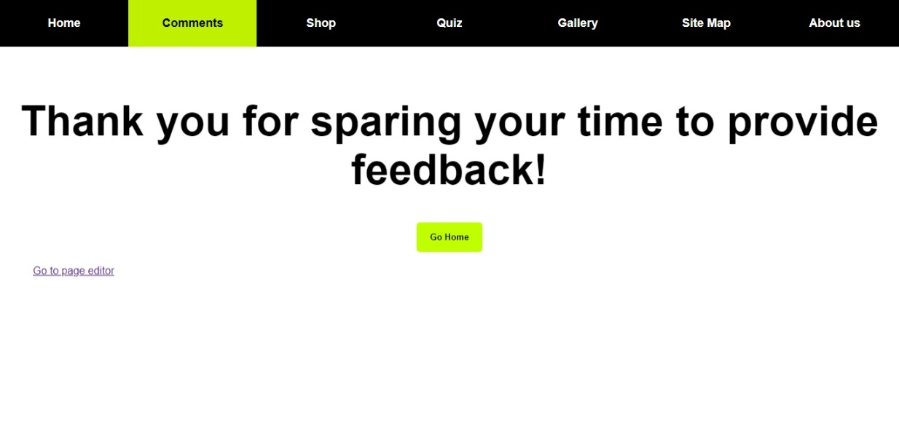

* anuradh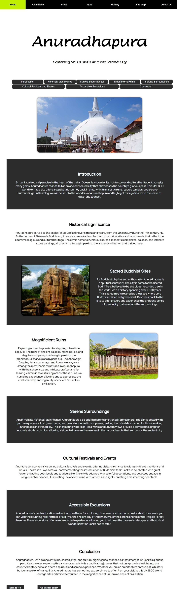apura.jpeg
* page_editor.jpeg

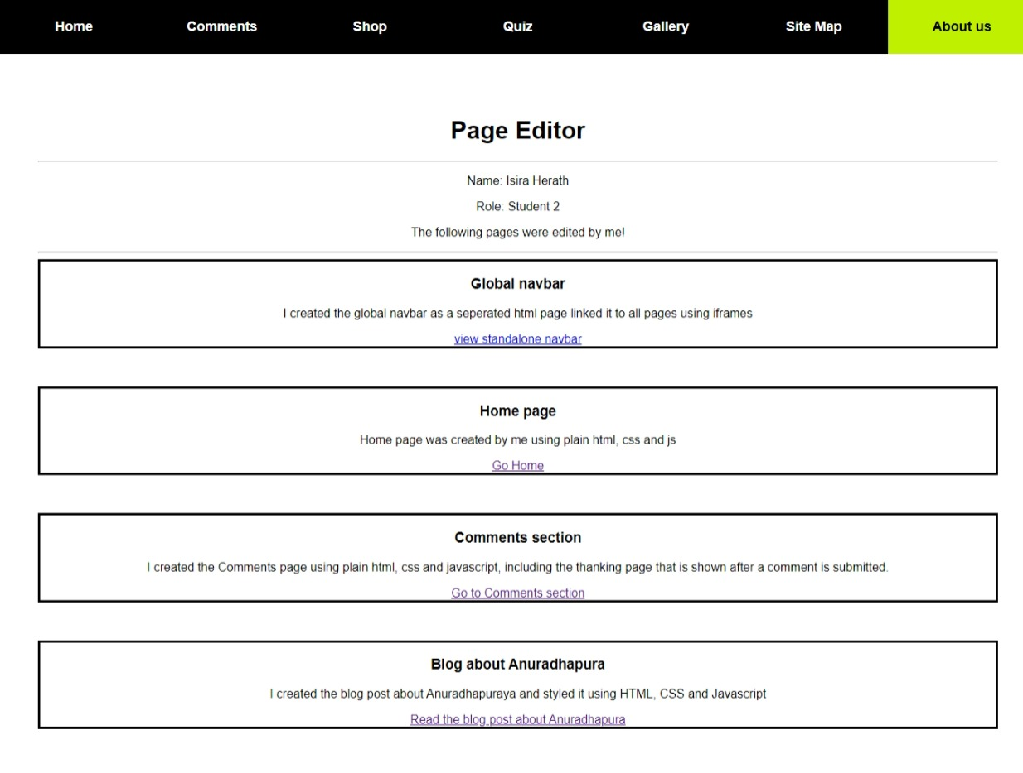

## Appendix C: Screenshots - Webpage Validation Evidence

* comments_validation.jpeg
* 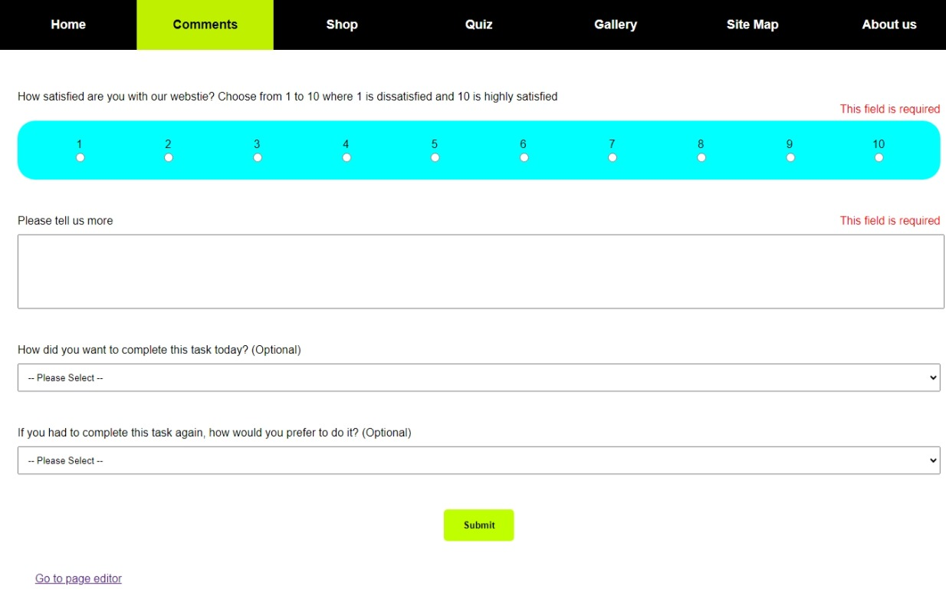

## Appendix D: Individual Statement

| Student Name: | Isira Herath | Student Id: | 20223184/W1986703 |
| --- | --- | --- | --- |
| State what tasks you carried out in the project. | | | |
| * Created home page  * Created global navbar  * Created comments section  * Linked all webpages together  * Acted as the project manager | | | |
| State what you enjoyed and did not enjoy about teamwork. | | | |
| * Everyone was very helpful | | | |
| State what you learnt about teamwork. | | | |
| * That everyone and what they do is important | | | |
| State what skills you gained/learnt from undertaking the project. | | | |
| * Team work  * Project Management | | | |
| State any strengths about yourself that emerged whilst undertaking the project. | | | |
| * Confidence  * Management skills | | | |
| State any weaknesses about yourself that emerged whilst undertaking the project. | | | |
| * Weak communication skill | | | |
| State how you would do things better if you were to undertake the project again. | | | |
|  | | | |
| Additional general or project specific comments: | | | |
|  | | | |

## Appendix E: Task Completion Checklist

Complete the table to indicate if any of your tasks were not completed or partially completed.

|  |  |  |  |  |
| --- | --- | --- | --- | --- |
| **Student 2 Tasks** | **Completed** | | | **Student Comments** |
| **Yes** | **No** | **Partially** |
| 2a - Main (Home) Page | **Yes** |  |  |  |
| 2b - Main site navigation | **Yes** |  |  |  |
| 3 - Query Form | **Yes** |  |  |  |
| 9b - External CSS (9a reused) | **Yes** |  |  |  |
| 10 - Extra content page/anchors | **Yes** |  |  |  |
| 11 - Page Editor | **Yes** |  |  |  |
| 12 - Logo/Page Editor | **Yes** |  |  |  |
| 13 - Additional Interactivity |  |  | **Partially** |  |
| 14 - Uploaded to Server | **Yes** |  |  |  |