Coursework Report Template for Module INM433 “Visual Analytics”

Thomas Fishwick

**Abstract**—Put here a brief summary of your work: analysis task, data, approach, main findings. Length: up to 200 words.

# Problem Statement

First paragraph...

Following paragraphs...

*<250 words*

# State of the Art

First paragraph...

Following paragraphs...

*<500 words*

# Properties of the Data

First paragraph...

Following paragraphs...

*<500 words, <=2 images*

# Analysis

## Approach

First paragraph...

Following paragraphs...

*<500 words, 1 diagram*

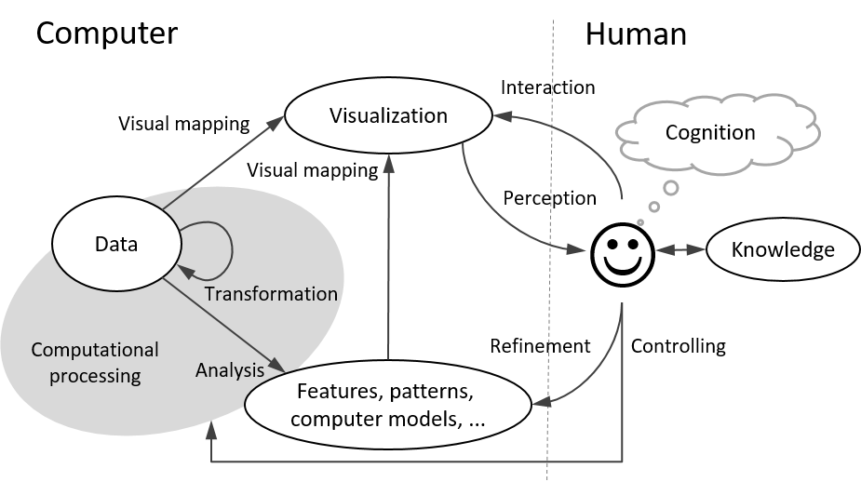

Fig. 1. An example of including a diagram in the document.

## Process

First paragraph...

Following paragraphs...

*<1500 words, <=7 images*

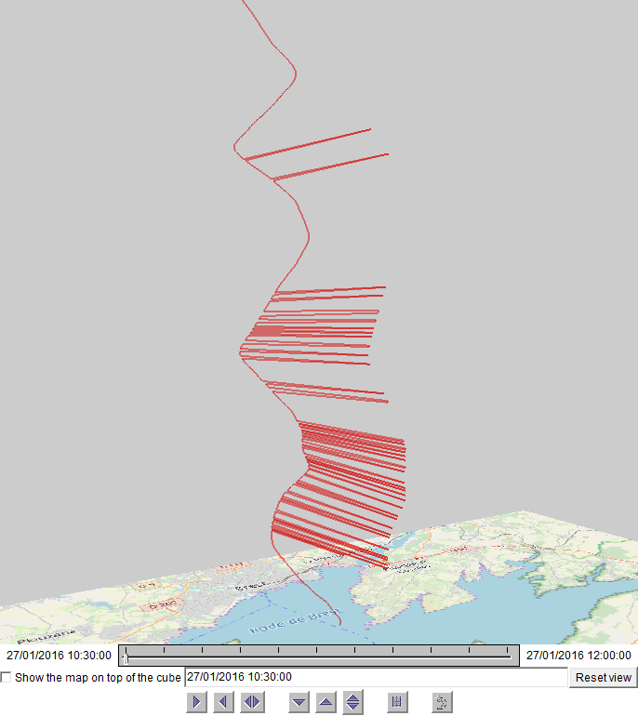

Fig. 2. An example of including a screenshot in the document.

## Results

First paragraph...

Following paragraphs...

*<200 words, <=2 images*

# Critical reflection

First paragraph...

Following paragraphs...

*<500 words*

Table of word counts

|  |  |
| --- | --- |
| Problem statement | 250 |
| State of the art | 500 |
| Properties of the data | 500 |
| Analysis: Approach | 500 |
| Analysis: Process | 1500 |
| Analysis: Results | 200 |
| Critical reflection | 500 |

References

The list below provides examples of formatting references.

1. M.Ankerst, M.Breunig, H.-P.Kriegel, J.Sander. OPTICS: Ordering points to identify the clustering structure. In: *ACM SIGMOD* 1999, pp. 49–60.
2. M. Bögl, W. Aigner, P. Filzmoser, T. Lammarsch, S. Miksch, and A. Rind. Visual Analytics for Model Selection in Time Series Analysis, *IEEE Trans. Visualization and Computer Graphics*, 19(12): 2237-2246, 2013.
3. T.F. Cox, M.A.A. Cox. *Multidimensional Scaling*. Chapman and Hall, 2001.
4. S. van den Elzen and J.J. van Wijk. BaobabView: Interactive construction and analysis of decision trees, *Proc. IEEE Conf. Visual Analytics Science and Technology (VAST’11)*, pp. 151-160, 2011.
5. M.Harrower, C.A.Brewer: Colorbrewer.org: An online tool for selecting color schemes for maps. *The Cartographic Journal* 40(1): 27–37, 2003.
6. T. Mühlbacher and H. Piringer. A Partition-Based Framework for Building and Validating Regression Models, *IEEE Trans. Visualization and Computer Graphics*, 19(12): 1962-1971, 2013.
7. D. Phan, L. Xiao, R. Yeh, P. Hanrahan, T. Winograd. Flow map layout. In *Proceedings of the IEEE Symposium on Information Visualization (InfoVis 2005)*, pp.219-224, Oct. 2005.
8. J.W. Sammon. A nonlinear mapping for data structure analysis. IEEE Transactions on Computers, 18(5): 401–409, May 1969.
9. J. Sewall, D. Wilkie, and M.C. Lin. Interactive Hybrid Simulation of Large-Scale Traffic, *ACM Transactions on Graphics*, 30(6), Article 135.
10. N. Willems, H. van de Wetering, J.J. van Wijk. Visualization of vessel movements. *Computer Graphics Forum*, 28(3): 959-966, Jun. 2009.